**Requirements**

**Introduction**

This project aims to develop automatic seat heater using Atmega Microcontroller.If at all any person sit on a seat, it should heat. Otherwise it will be in normal state. Seat heat can be controlled by temperature knob based on our requirement and this temperature is displayed on Display.

**Objective**

The main objectives of this project is:

* To heat the seat when a person sit on a seat
* Display that heat on Display

**SWOT Analysis**

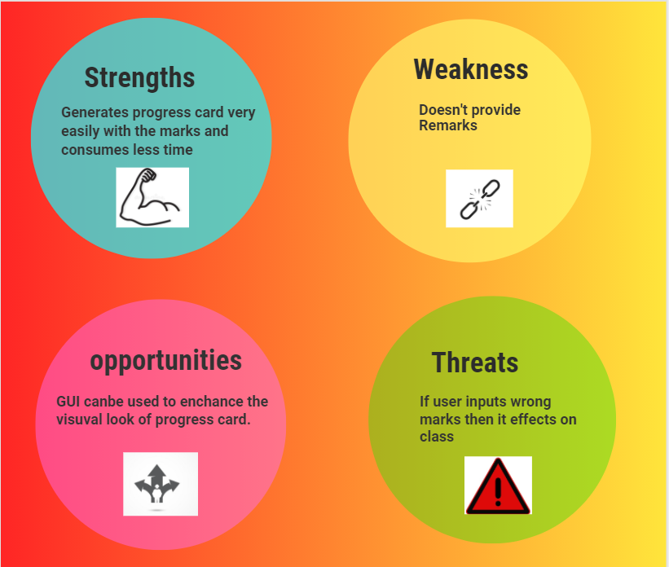

Causes serious health issues

Demand for cool Areas

Toasted skin syndrome

Seat heat can be controlled

***4 W's and 1 H***

**Who**

People living in cold areas can use this project.

**What**

This project is concerned about seat heat using Atmega Micro controller.

**When**

Whenever there is a requirement of generating Heat we can use it.

**Why**

As this project uses heat controller it can be easy to provide required heat.

**How**

Implemented using Embedded C.

Basic requirements that are very essential are:

* Atmega Microcontroller
* Buttons
* Temperature controller
* Display

## HIGH LEVEL REQUIREMENTS:

|  |  |  |  |
| --- | --- | --- | --- |
| ID | Description | Category | Status |
| HR01 | User shall be able to adjust temperature. | Technical | Implemented |
| HR02 | User shall be able to see all the temperatures on Display | Technical | Implemented |
| HR03 | Seat should heat only if person sits. | Technical | Implemented |
| HR04 | Adding an voice assistant makes easy usage. | Technical | Future |

## LOW LEVEL REQUIREMENTS:

**BASIC OPERATIONS**

|  |  |  |  |  |
| --- | --- | --- | --- | --- |
| ID | Operation | Description | HLR ID | Status |
| LR01 | Temperature control | Temperature is controlled by control knob | HR01 | Implemented |
| LR02 | Display | Displays temperature information on ocr Display. | HR02 | Implemented |
| LR03 | Seat heating | Heating action will be performed if a person takes his seat | HR03 | Implemented |