**AUTOMATIC SEAT HEATER**

**Activity-1**

|  |  |  |
| --- | --- | --- |
| Before Turn on | After turn on | When both actions takes place |
|  |  |  |

**Code**

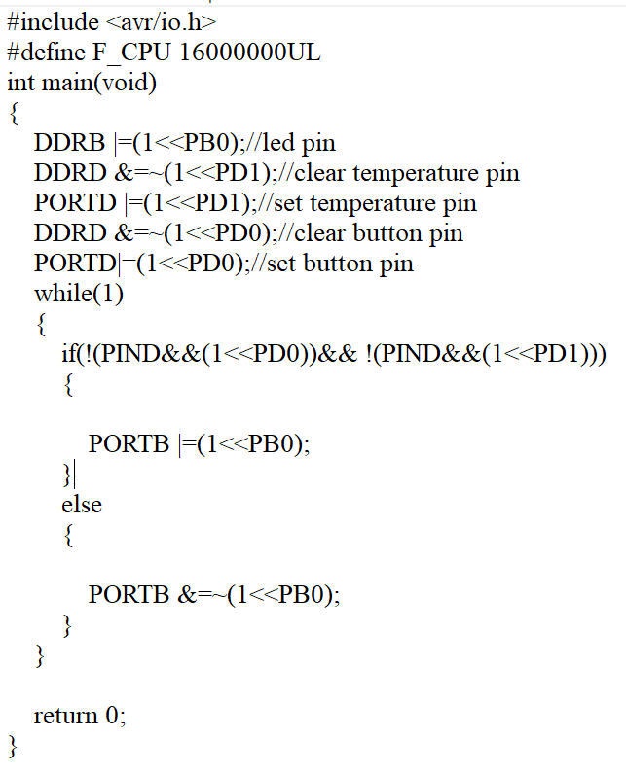

**Activity-2**

|  |  |
| --- | --- |
| Before turn ON | ADC working |
|  |  |

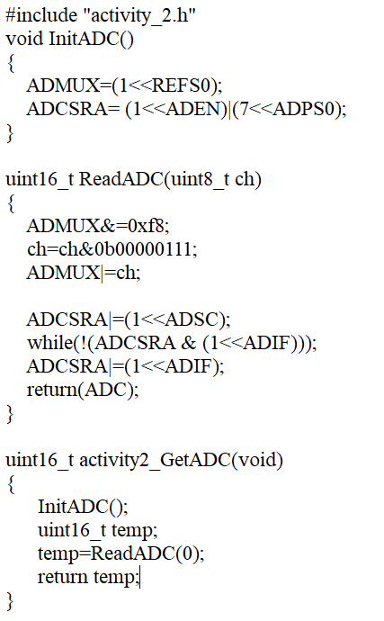

**Activity-3**

|  |  |
| --- | --- |
| Before ON | Display |
|  |  |

