**Requirements**

**Introduction**

In this project the user is able to Display student progress card using structures. Based on the marks provided by the user a progress card is done, on whether the marks provided is valid or not. If all the marks provided by the user is valid then the progress card is Displayed.

**Objective**

The main objectives of this project is:

* To Display Student progress card

**SWOT Analysis**

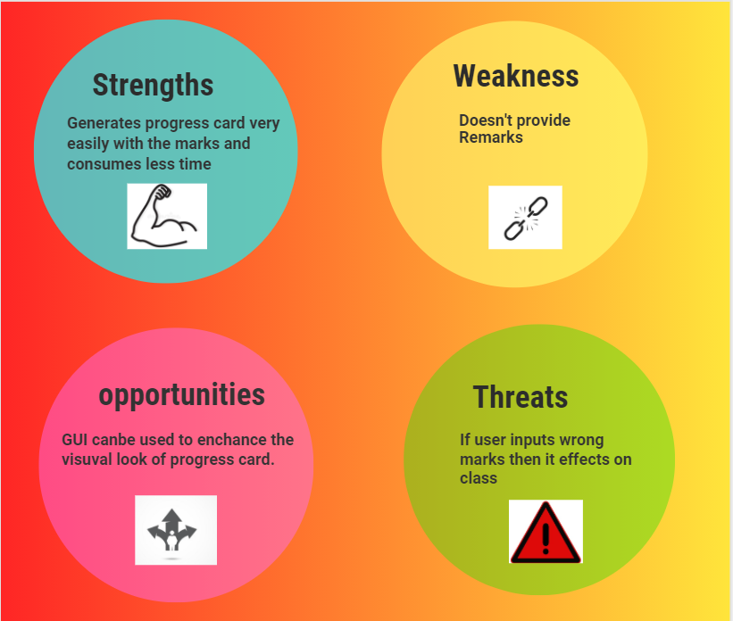

***4 W's and 1 H***

**Who**

Anyone who wants to provide progress card can use this project.

**What**

This project is concerned about Displaying student progress card using structures method.

**When**

Whenever there is a requirement of generating huge number of student progress cards digitally this project helps in solving it.

**Why**

As this project uses structures algorithm it can be easy to provide progress cards.

**How**

Implemented using structure, Strings and other functionalities of C.

Basic requirements that are very essential are:

* A sample Student Progress Card
* gcc compiler with a good system.
* Any of the two linux / windows.

## HIGH LEVEL REQUIREMENTS:

|  |  |  |  |
| --- | --- | --- | --- |
| ID | Description | Category | Status |
| HR01 | User shall be able to provide marks, name and roll number to identify student status. | Technical | Implemented |
| HR02 | User shall be able to see all the steps needed to display the progress sheet on the console. | Technical | Implemented |
| HR03 | User should follow the all steps | Technical | Implemented |
| HR04 | Adding an option to view the remarks of student which will increase the effectiveness. | Technical | Future |

## LOW LEVEL REQUIREMENTS:

**VALIDATION**

|  |  |  |  |  |
| --- | --- | --- | --- | --- |
| ID | Function | Description | HLR ID | STATUS |
| LR01 | Isnotvalid | checks if all the Nodes entered by the user is valid or not | HR01 | Implemented |

**BASIC OPERATIONS**

|  |  |  |  |  |
| --- | --- | --- | --- | --- |
| ID | Operation | Description | HLR ID | Status |
| LR02 | Total | performs total operation on marks | HR01 | Implemented |
| LR03 | Average | performs average operation on marks | HR01 | Implemented |
| LR03 | Class | Provides class based on marks | HR02 | Implemented |