**Project Report**

**Student Progress Card System**

**Abstract**

This Online Grading System is a student project titled “**student progress card system**“. It is a web-based application developed using c language. The main purpose of this project is to facilitate calculation of the average marks or grades of a student through online.

**Folder structure**

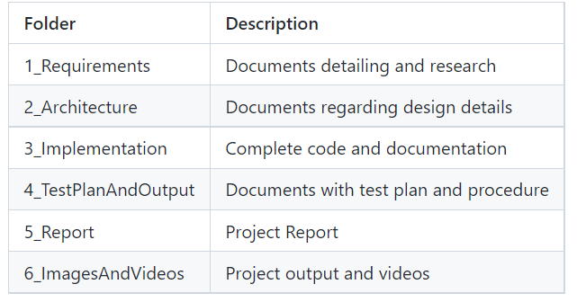

**Introduction**

In this project the user is able to Display student progress card using structures. Based on the marks provided by the user a progress card is done, on whether the marks provided is valid or not. If all the marks provided by the user is valid then the progress card is Displayed.

**Objective**

The main objectives of this project is:

* To Display Student progress card

**SWOT Analysis**

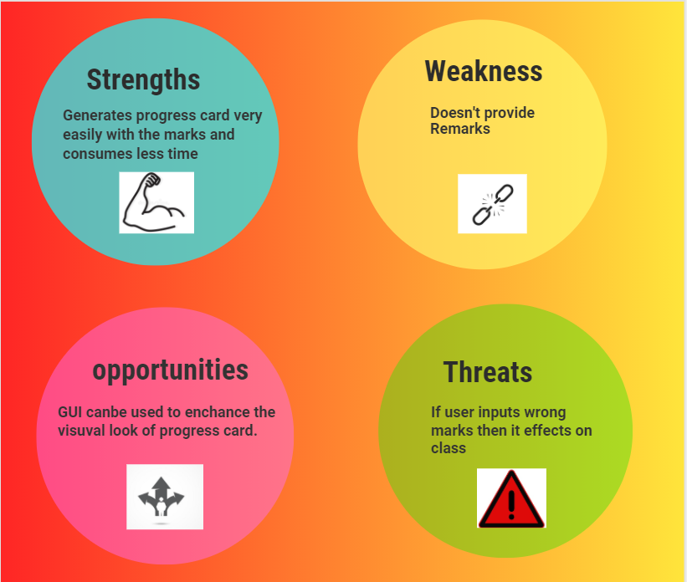

***4 W's and 1 H***

**Who**

Anyone who wants to provide progress card can use this project.

**What**

This project is concerned about Displaying student progress card using structures method.

**When**

Whenever there is a requirement of generating huge number of student progress cards digitally this project helps in solving it.

**Why**

As this project uses structures algorithm it can be easy to provide progress cards.

**How**

Implemented using structure, Strings and other functionalities of C.

Basic requirements that are very essential are:

* A sample Student Progress Card
* gcc compiler with a good system.
* Any of the two linux / windows.

## HIGH LEVEL REQUIREMENTS:

|  |  |  |  |
| --- | --- | --- | --- |
| ID | Description | Category | Status |
| HR01 | User shall be able to provide marks, name and roll number to identify student status. | Technical | Implemented |
| HR02 | User shall be able to see all the steps needed to display the progress sheet on the console. | Technical | Implemented |
| HR03 | User should follow the all steps | Technical | Implemented |
| HR04 | Adding an option to view the remarks of student which will increase the effectiveness. | Technical | Future |

## LOW LEVEL REQUIREMENTS:

**VALIDATION**

|  |  |  |  |  |
| --- | --- | --- | --- | --- |
| ID | Function | Description | HLR ID | STATUS |
| LR01 | Isnotvalid | checks if all the Nodes entered by the user is valid or not | HR01 | Implemented |

**BASIC OPERATIONS**

|  |  |  |  |  |
| --- | --- | --- | --- | --- |
| ID | Operation | Description | HLR ID | Status |
| LR02 | Total | performs total operation on marks | HR01 | Implemented |
| LR03 | Average | performs average operation on marks | HR01 | Implemented |
| LR03 | Class | Provides class based on marks | HR02 | Implemented |

**Design**

**Structural Diagrams**

**1.Block Diagram**

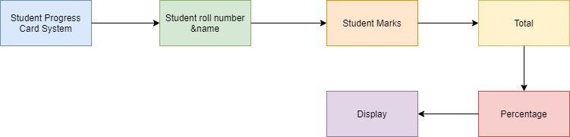

**2.Schematic Diagram**

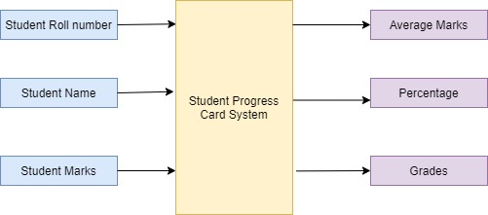

**Behavioral Diagrams**

**1.flow chart**

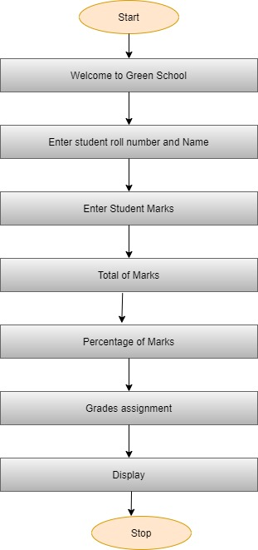

**2.Data flow Diagrams**

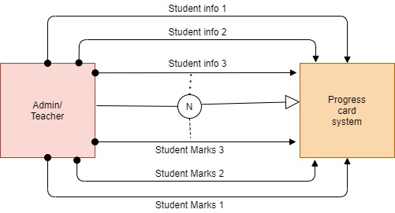

**UML Diagrams**

**1.Class Diagram**

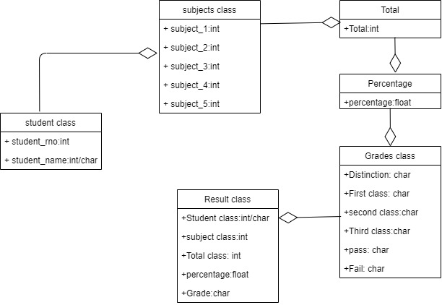

**2.Component Diagram**

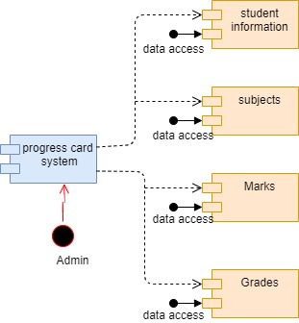

**Test Plan and Output**

**High Level Test plan**

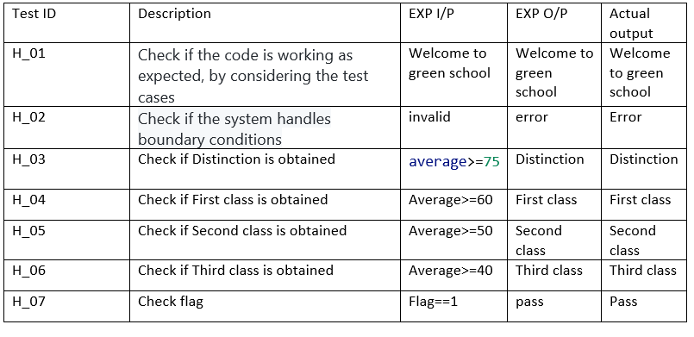

**Low Level Test Plan**

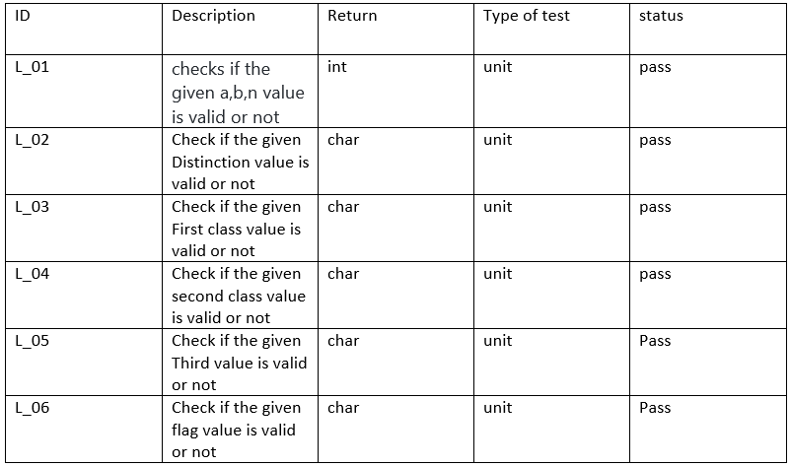

**Badges**

**1.build -** image

**2.code inspector -** image

**3.unit testing -** image

**4.static analysis -** image

**5.dyanamic analysis -** image

**Images and Videos Related to the project**

**Input images**

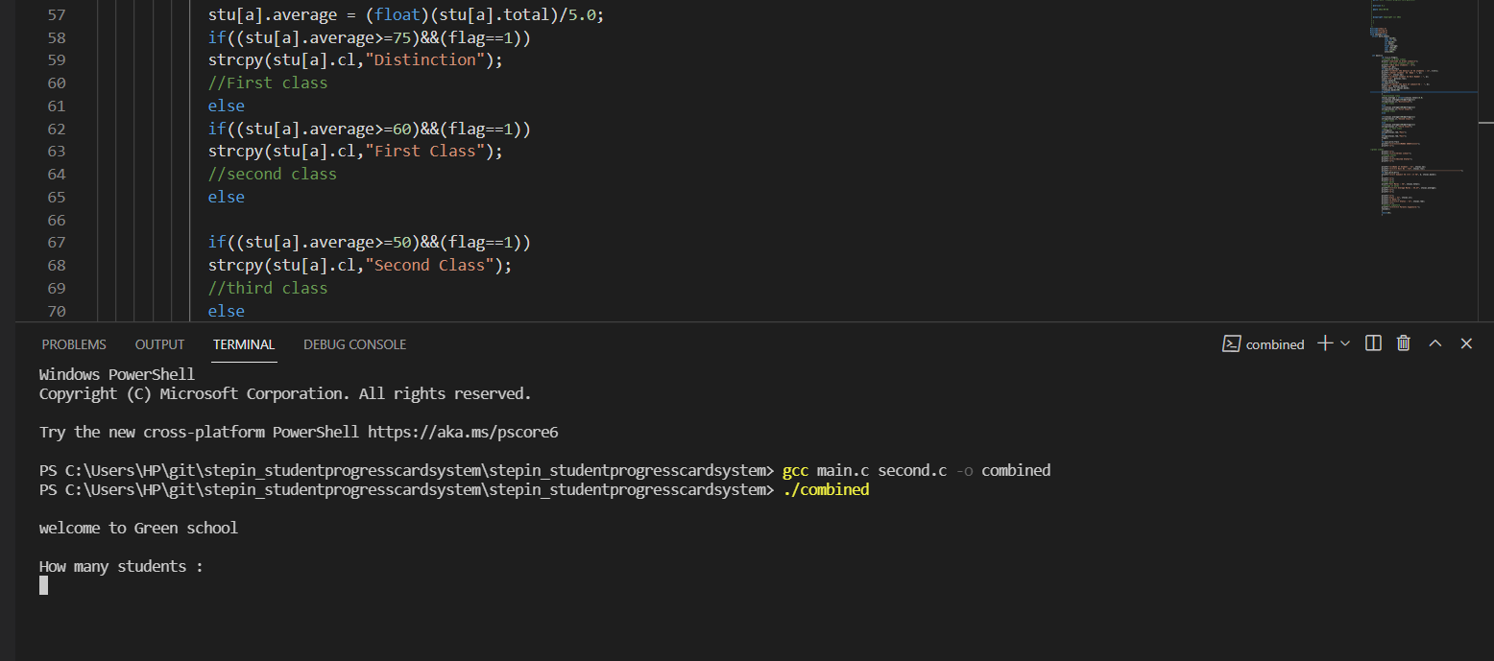

**Output Image**

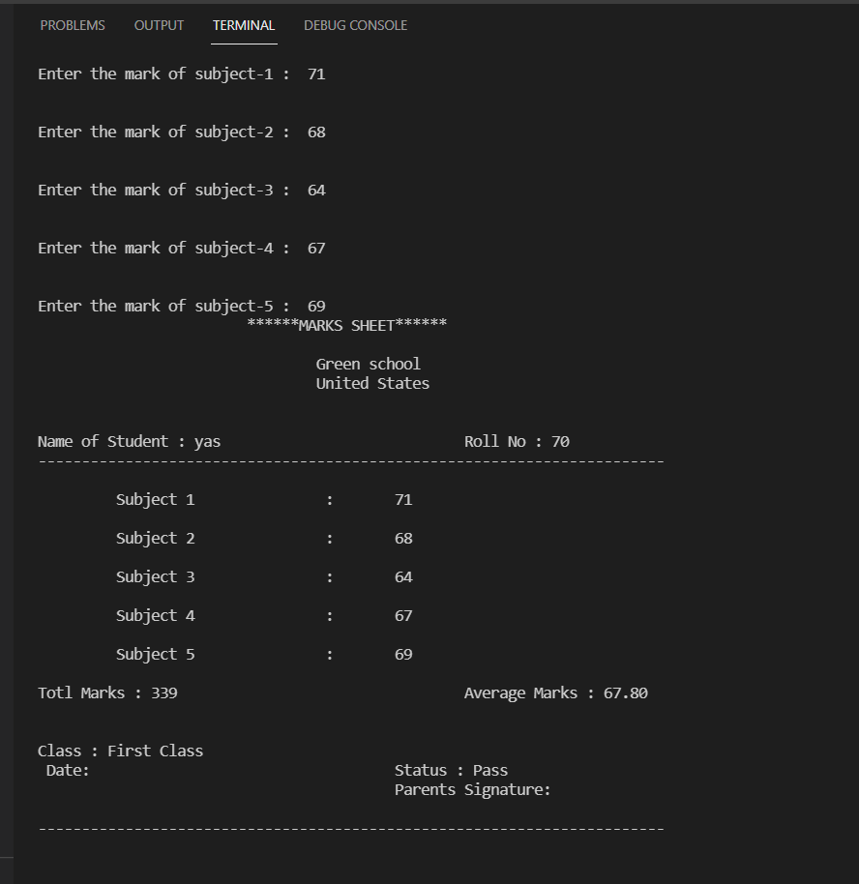

**Implementation Video**

