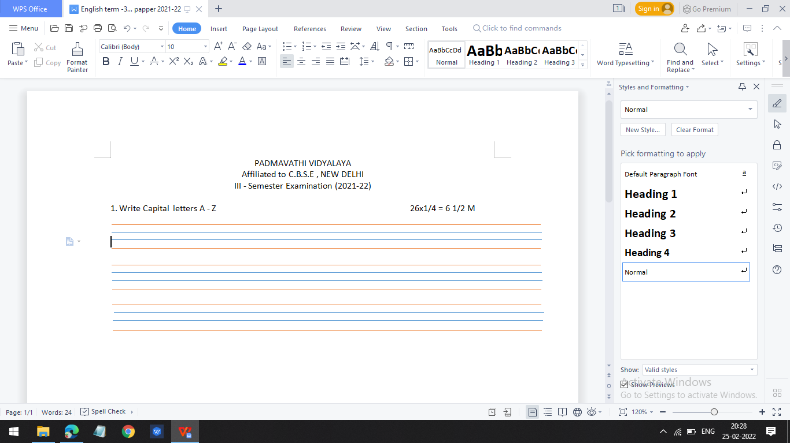



Dance

Sit

Jump

Run

Sing