EXPERIMENT-6
OBJECTIVE 1
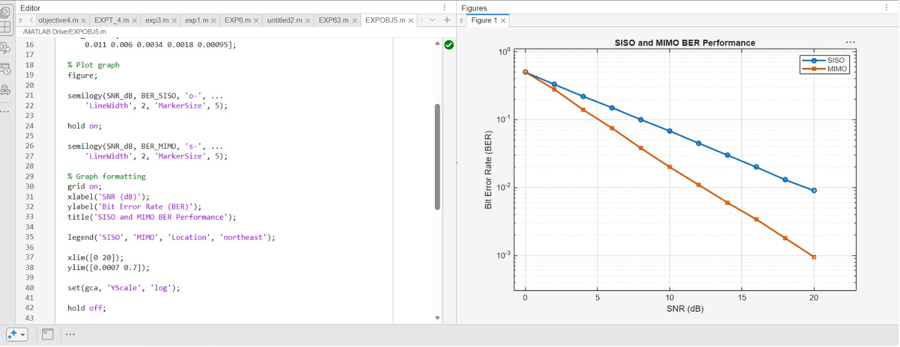

OBJECTIVE 2



