EXPERIMENT- 7
OBJECTIVE 1
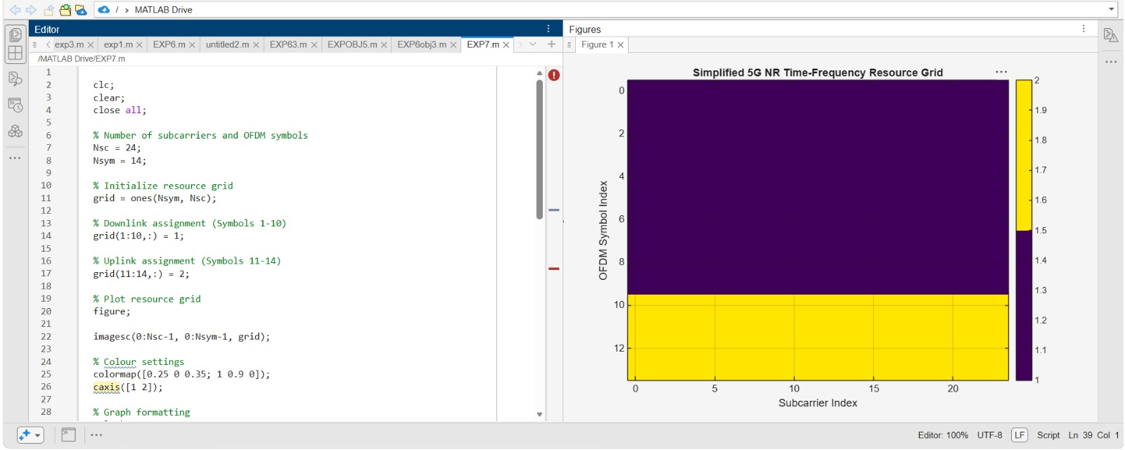

OBJECTIVE 2

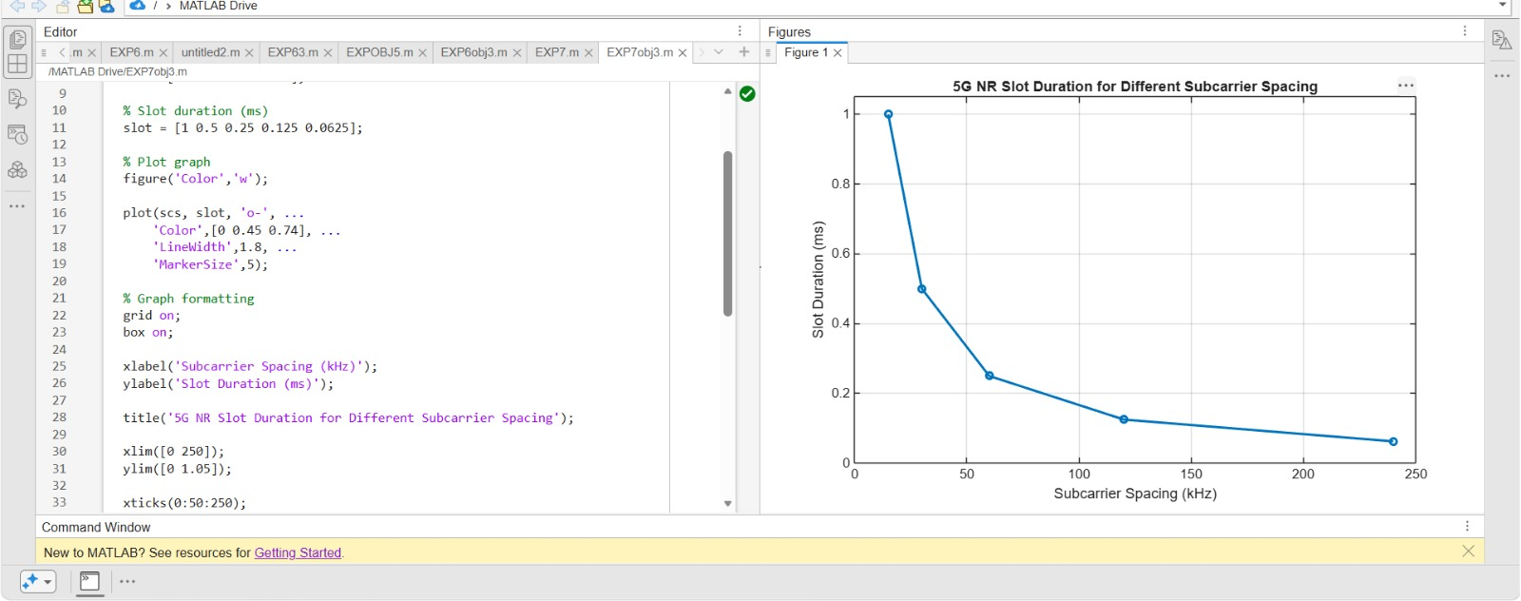
OBJECTIVE-3


