EXPERIMENT- 5

OBJECTIVE 1
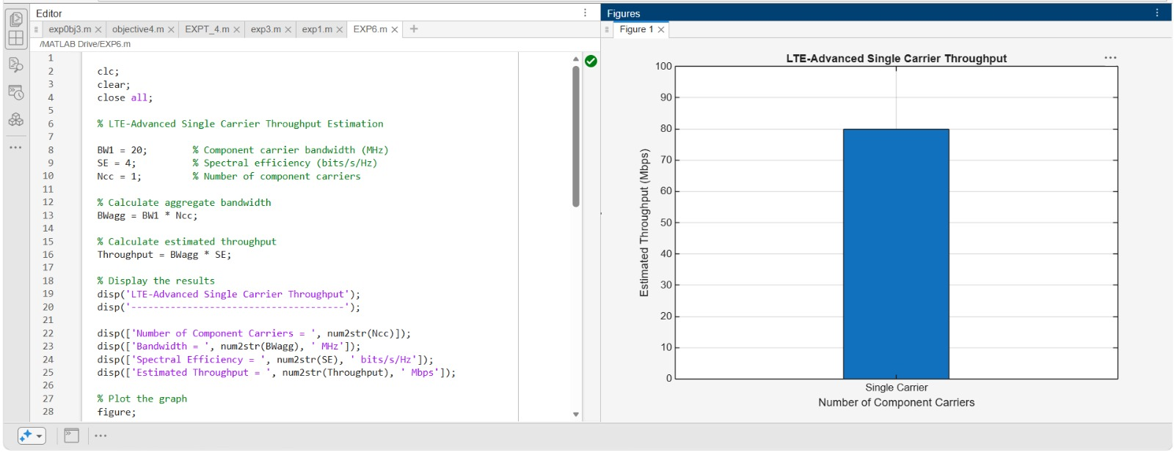

OBJECTIVE 2

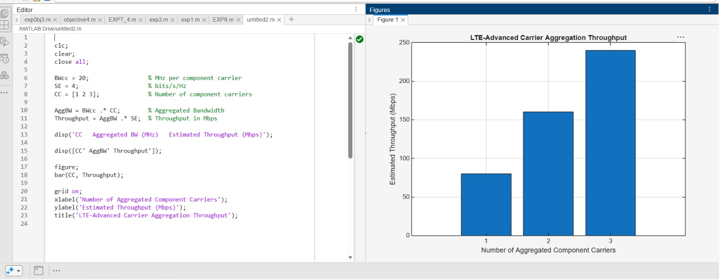

OBJECTIVE 3



