Database & Integration Layer

Technologies

|  |  |  |
| --- | --- | --- |
| Technologies |  |  |
| Java Stack | Hibernate | 4.X |
|  | Spring Restful |  |
| DB | MySql/ MariaDB | 10.1.38-MariaDB |

DB Tables:

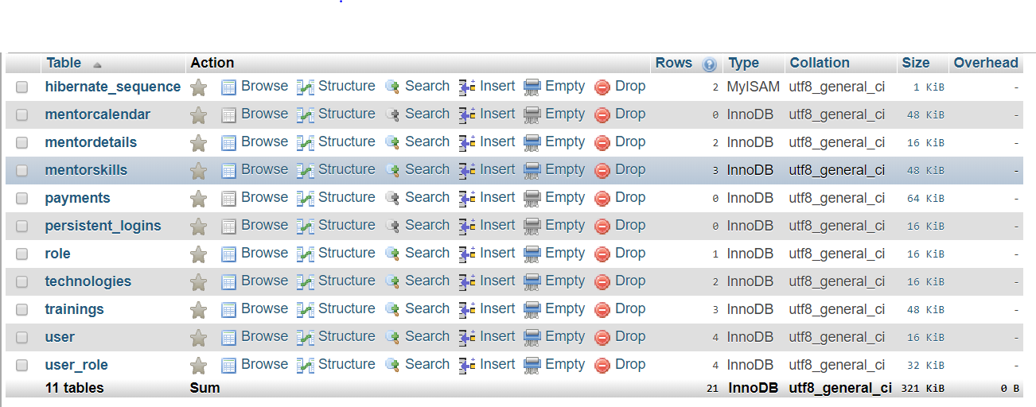

DB Dictionary:

**mentorcalendar**

|  |  |  |  |  |  |  |
| --- | --- | --- | --- | --- | --- | --- |
| **Column** | **Type** | **Null** | **Default** | **Links to** | **Comments** | **MIME** |
| id *(Primary)* | int(11) | No |  |  |  |  |
| start_time | time | No |  |  |  |  |
| end_time | time | No |  |  |  |  |
| mentor_id | int(11) | No |  | user -> id |  |  |
| training_id | int(11) | No |  | trainings -> id |  |  |
| training_date | date | No |  |  |  |  |

**Indexes**

| **Keyname** | **Type** | **Unique** | **Packed** | **Column** | **Cardinality** | **Collation** | **Null** | **Comment** |
| --- | --- | --- | --- | --- | --- | --- | --- | --- |
| PRIMARY | BTREE | Yes | No | id | 0 | A | No |  |
| training_id | BTREE | No | No | training_id | 0 | A | No |  |
| mentorcalendar_ibfk_1 | BTREE | No | No | mentor_id | 0 | A | No |  |

**mentordetails**

|  |  |  |  |  |  |  |
| --- | --- | --- | --- | --- | --- | --- |
| **Column** | **Type** | **Null** | **Default** | **Links to** | **Comments** | **MIME** |
| mentor_id *(Primary)* | int(11) | No |  | user -> id |  |  |
| expertise | varchar(255) | No |  |  |  |  |
| experience | float | No |  |  |  |  |
| rating | float | No |  |  |  |  |

**Indexes**

| **Keyname** | **Type** | **Unique** | **Packed** | **Column** | **Cardinality** | **Collation** | **Null** | **Comment** |
| --- | --- | --- | --- | --- | --- | --- | --- | --- |
| PRIMARY | BTREE | Yes | No | mentor_id | 2 | A | No |  |

**mentorskills**

|  |  |  |  |  |  |  |
| --- | --- | --- | --- | --- | --- | --- |
| **Column** | **Type** | **Null** | **Default** | **Links to** | **Comments** | **MIME** |
| id *(Primary)* | int(11) | No |  |  |  |  |
| mentor_id | int(11) | No |  | user -> id |  |  |
| tech_id | int(11) | No |  | technologies -> id |  |  |
| experience | float | No |  |  |  |  |

**Indexes**

| **Keyname** | **Type** | **Unique** | **Packed** | **Column** | **Cardinality** | **Collation** | **Null** | **Comment** |
| --- | --- | --- | --- | --- | --- | --- | --- | --- |
| PRIMARY | BTREE | Yes | No | id | 2 | A | No |  |
| tech_id | BTREE | No | No | tech_id | 2 | A | No |  |
| mentorskills_ibfk_1 | BTREE | No | No | mentor_id | 2 | A | No |  |

**payments**

|  |  |  |  |  |  |  |
| --- | --- | --- | --- | --- | --- | --- |
| **Column** | **Type** | **Null** | **Default** | **Links to** | **Comments** | **MIME** |
| id *(Primary)* | int(11) | No |  |  |  |  |
| candidate_id | int(11) | No |  | user -> id |  |  |
| mentor_id | int(11) | No |  | user -> id |  |  |
| amount | int(11) | No |  |  |  |  |
| training_id | int(11) | No |  | trainings -> id |  |  |
| transactionsDate | datetime | No |  |  |  |  |
| transactionsid | varchar(255) | No |  |  |  |  |

**Indexes**

| **Keyname** | **Type** | **Unique** | **Packed** | **Column** | **Cardinality** | **Collation** | **Null** | **Comment** |
| --- | --- | --- | --- | --- | --- | --- | --- | --- |
| PRIMARY | BTREE | Yes | No | id | 0 | A | No |  |
| training_id | BTREE | No | No | training_id | 0 | A | No |  |
| payments_ibfk_1 | BTREE | No | No | mentor_id | 0 | A | No |  |
| payments_ibfk_2 | BTREE | No | No | candidate_id | 0 | A | No |  |

**persistent_logins**

|  |  |  |  |  |  |  |
| --- | --- | --- | --- | --- | --- | --- |
| **Column** | **Type** | **Null** | **Default** | **Links to** | **Comments** | **MIME** |
| username | varchar(64) | No |  |  |  |  |
| series *(Primary)* | varchar(64) | No |  |  |  |  |
| token | varchar(64) | No |  |  |  |  |
| last_used | timestamp | No | CURRENT_TIMESTAMP |  |  |  |

**Indexes**

| **Keyname** | **Type** | **Unique** | **Packed** | **Column** | **Cardinality** | **Collation** | **Null** | **Comment** |
| --- | --- | --- | --- | --- | --- | --- | --- | --- |
| PRIMARY | BTREE | Yes | No | series | 0 | A | No |  |

**role**

|  |  |  |  |  |  |  |
| --- | --- | --- | --- | --- | --- | --- |
| **Column** | **Type** | **Null** | **Default** | **Links to** | **Comments** | **MIME** |
| role_id *(Primary)* | int(11) | No |  |  |  |  |
| role | varchar(255) | Yes | *NULL* |  |  |  |

**Indexes**

| **Keyname** | **Type** | **Unique** | **Packed** | **Column** | **Cardinality** | **Collation** | **Null** | **Comment** |
| --- | --- | --- | --- | --- | --- | --- | --- | --- |
| PRIMARY | BTREE | Yes | No | role_id | 0 | A | No |  |

**technologies**

|  |  |  |  |  |  |  |
| --- | --- | --- | --- | --- | --- | --- |
| **Column** | **Type** | **Null** | **Default** | **Links to** | **Comments** | **MIME** |
| id *(Primary)* | int(11) | No |  |  |  |  |
| name | varchar(255) | No |  |  |  |  |

**Indexes**

| **Keyname** | **Type** | **Unique** | **Packed** | **Column** | **Cardinality** | **Collation** | **Null** | **Comment** |
| --- | --- | --- | --- | --- | --- | --- | --- | --- |
| PRIMARY | BTREE | Yes | No | id | 2 | A | No |  |

**trainings**

|  |  |  |  |  |  |  |
| --- | --- | --- | --- | --- | --- | --- |
| **Column** | **Type** | **Null** | **Default** | **Links to** | **Comments** | **MIME** |
| id *(Primary)* | int(11) | No |  |  |  |  |
| name | varchar(255) | No |  |  |  |  |
| tech_id | int(11) | No |  | technologies -> id |  |  |
| start_date | date | No |  |  |  |  |
| end_date | date | No |  |  |  |  |
| mentor_id | int(11) | No |  | user -> id |  |  |
| status | varchar(255) | No |  |  |  |  |
| email | varchar(255) | Yes | *NULL* |  |  |  |
| last_date | datetime | Yes | *NULL* |  |  |  |

**Indexes**

| **Keyname** | **Type** | **Unique** | **Packed** | **Column** | **Cardinality** | **Collation** | **Null** | **Comment** |
| --- | --- | --- | --- | --- | --- | --- | --- | --- |
| PRIMARY | BTREE | Yes | No | id | 3 | A | No |  |
| tech_id | BTREE | No | No | tech_id | 3 | A | No |  |
| trainings_ibfk_2 | BTREE | No | No | mentor_id | 3 | A | No |  |

**user**

|  |  |  |  |  |  |  |
| --- | --- | --- | --- | --- | --- | --- |
| **Column** | **Type** | **Null** | **Default** | **Links to** | **Comments** | **MIME** |
| id *(Primary)* | int(11) | No |  |  |  |  |
| firstname | varchar(255) | No |  |  |  |  |
| lastname | varchar(255) | No |  |  |  |  |
| email | varchar(255) | No |  |  |  |  |
| password | varchar(255) | No |  |  |  |  |
| active | int(11) | Yes | *NULL* |  |  |  |
| is_mentor | int(11) | Yes | 0 |  |  |  |

**Indexes**

| **Keyname** | **Type** | **Unique** | **Packed** | **Column** | **Cardinality** | **Collation** | **Null** | **Comment** |
| --- | --- | --- | --- | --- | --- | --- | --- | --- |
| PRIMARY | BTREE | Yes | No | id | 2 | A | No |  |

**user_role**

|  |  |  |  |  |  |  |
| --- | --- | --- | --- | --- | --- | --- |
| **Column** | **Type** | **Null** | **Default** | **Links to** | **Comments** | **MIME** |
| user_id *(Primary)* | int(11) | No |  | user -> id |  |  |
| role_id *(Primary)* | int(11) | No |  | role -> role_id |  |  |

**Indexes**

| **Keyname** | **Type** | **Unique** | **Packed** | **Column** | **Cardinality** | **Collation** | **Null** | **Comment** |
| --- | --- | --- | --- | --- | --- | --- | --- | --- |
| PRIMARY | BTREE | Yes | No | user_id | 2 | A | No |  |
| role_id | 2 | A | No |
| user_role_key | BTREE | No | No | role_id | 2 | A | No |  |

API Integration with DB:

1. **Spring Data Dependency:**

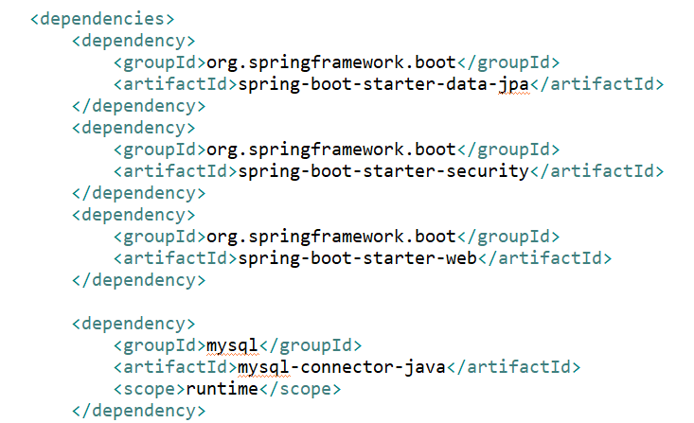

1. **API Configurations:**

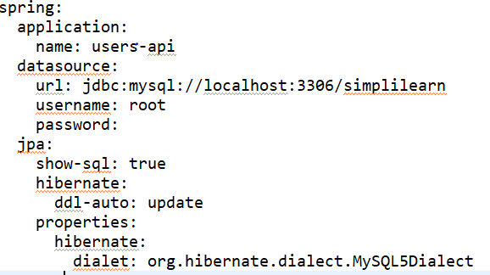

1. **JPA Repository:**

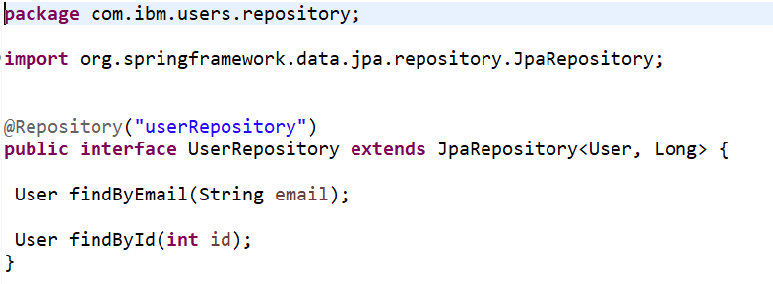

1. **Data Model Classes:**

