Mentor On Demand – Final Doc

# UI Screens

1. Login  
   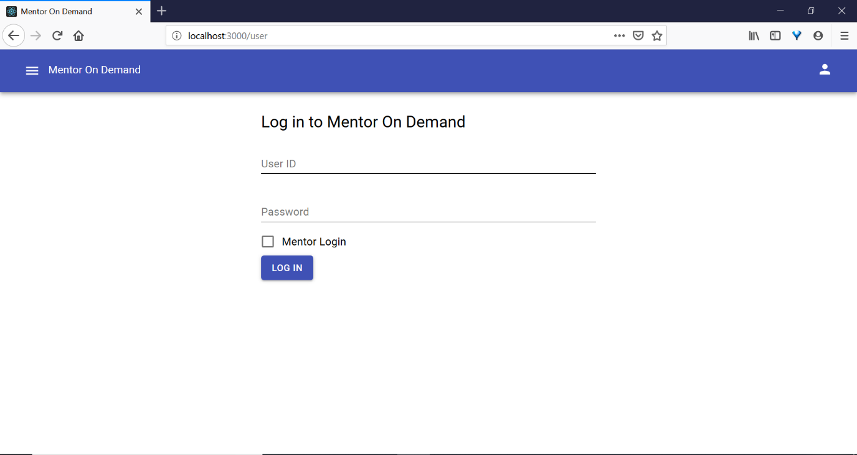
2. Search Mentors based on technologies  
   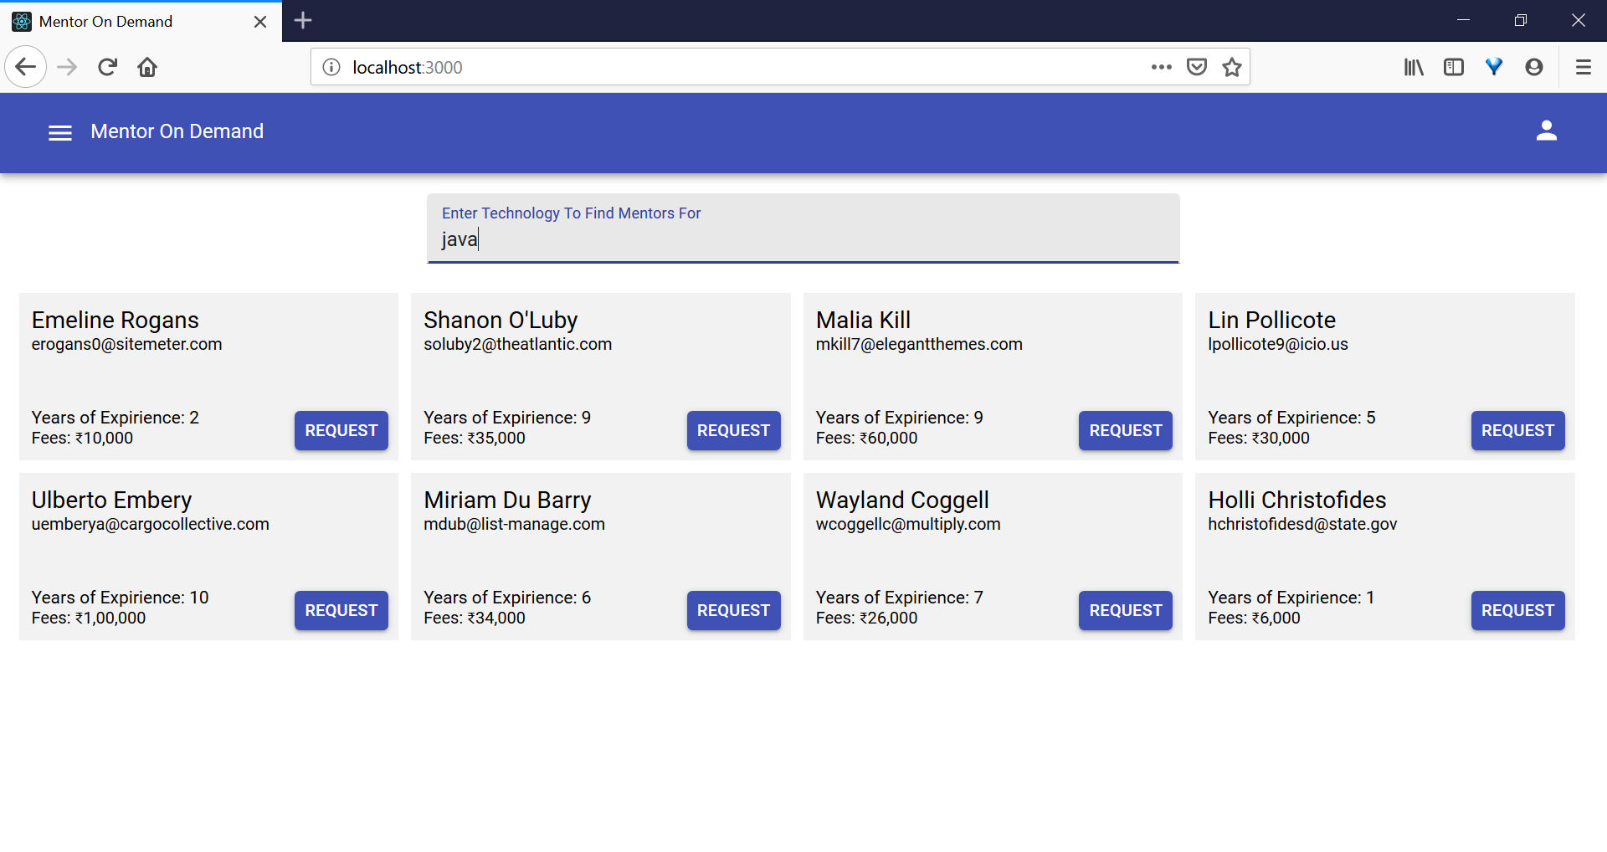
3. Request Training  
   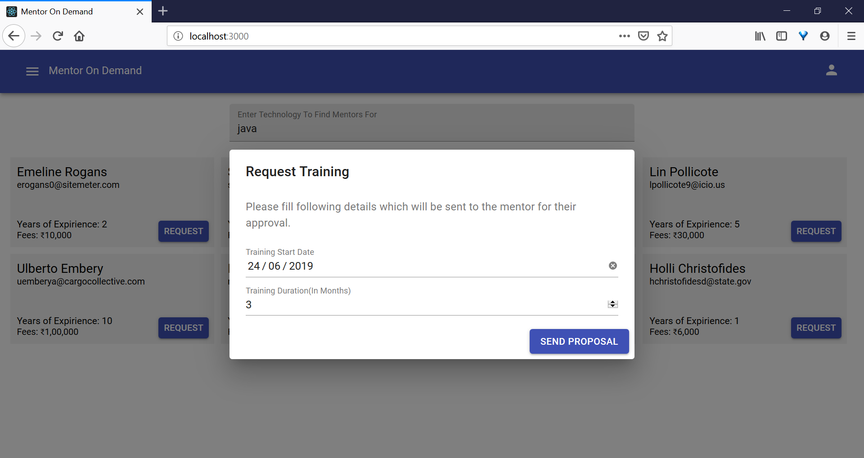
4. Mentor proposal creation  
   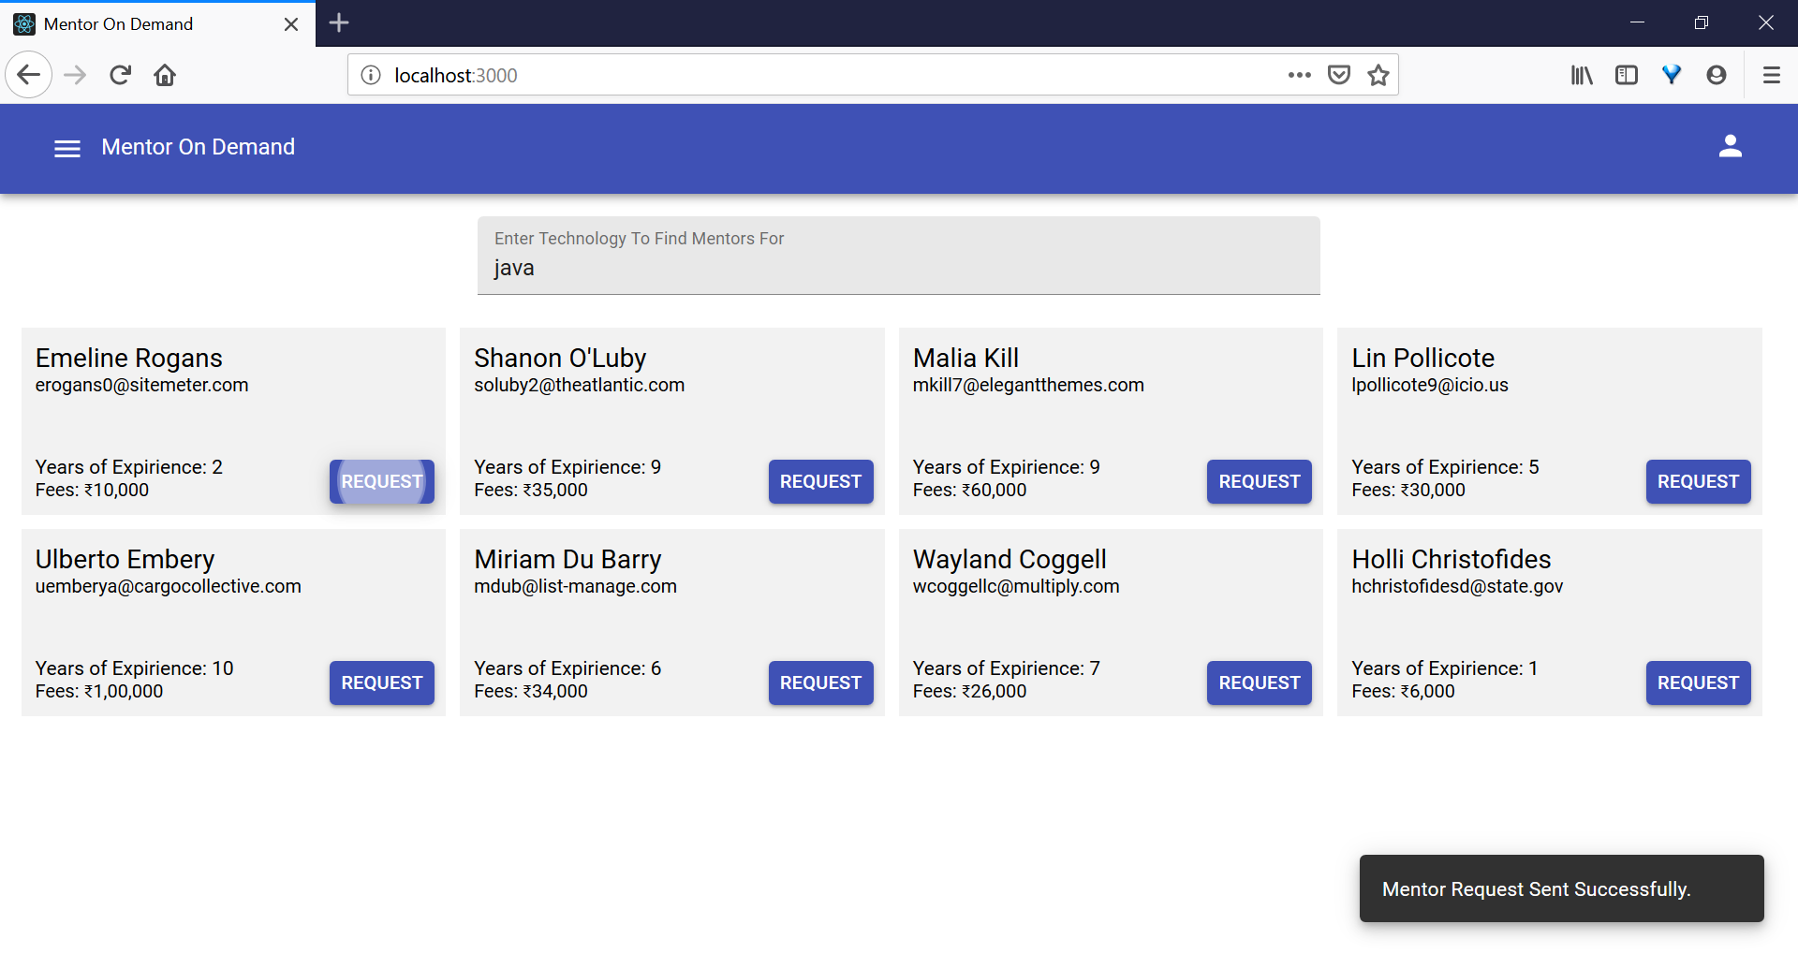
5. Proposals  
   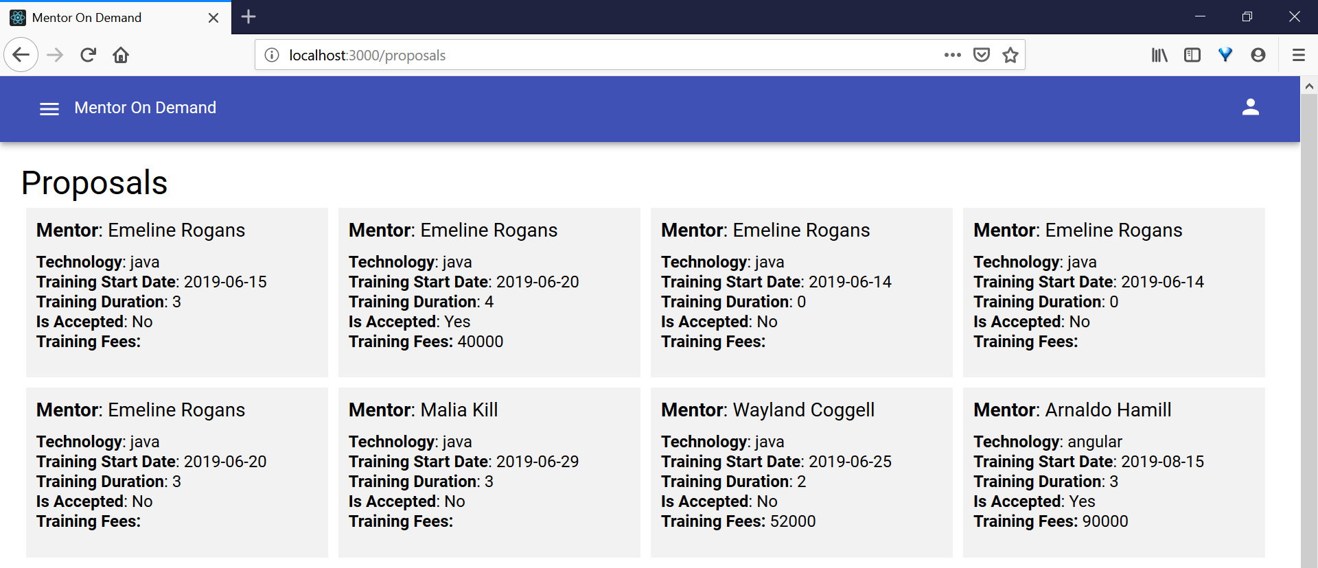
6. Payments  
   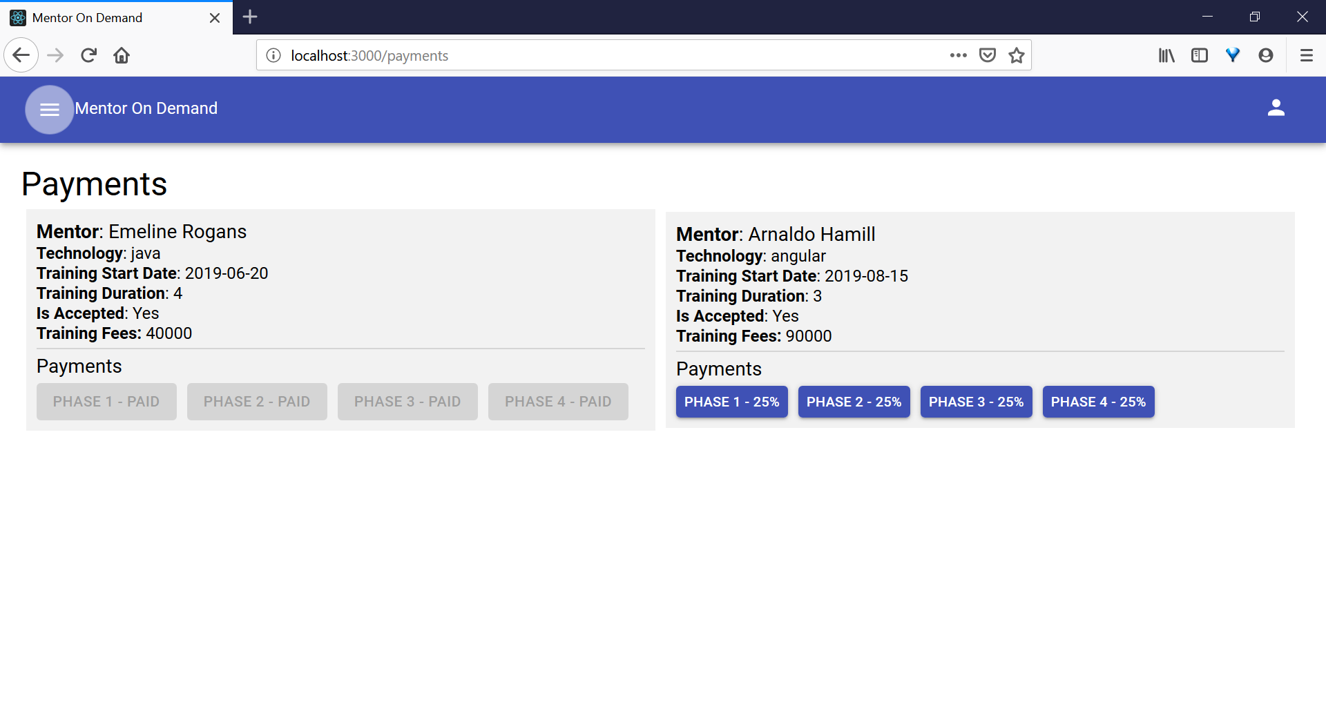
7. Block User:  
   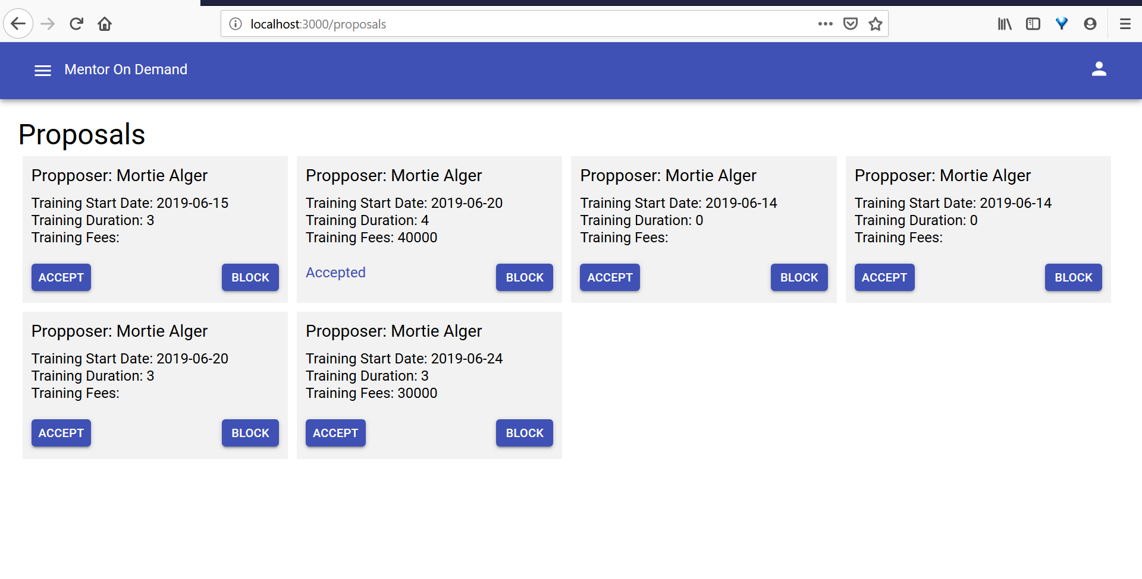
8. Blocked User  
   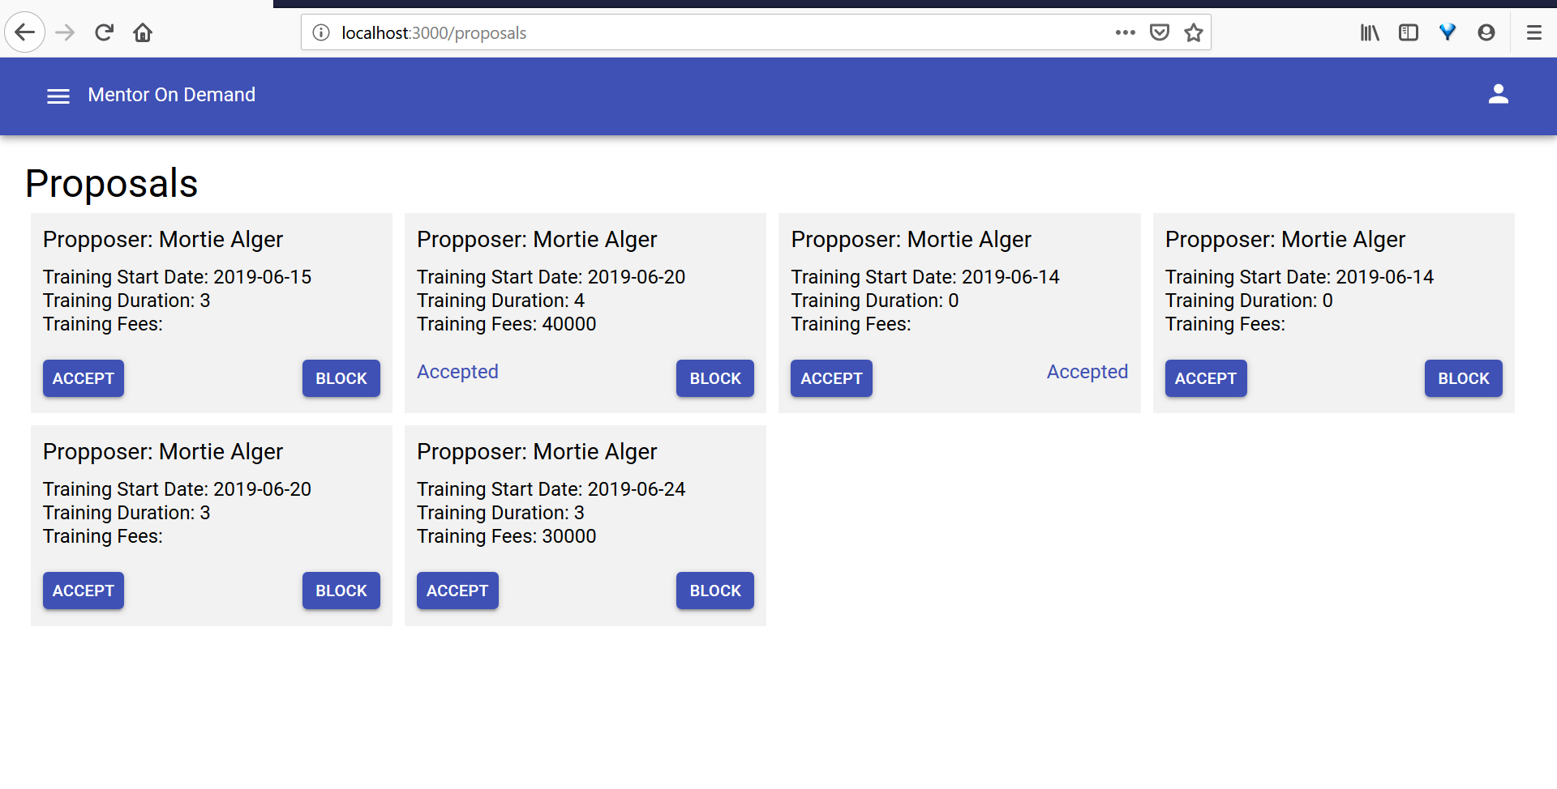
9. Mentor not shown in search results  
   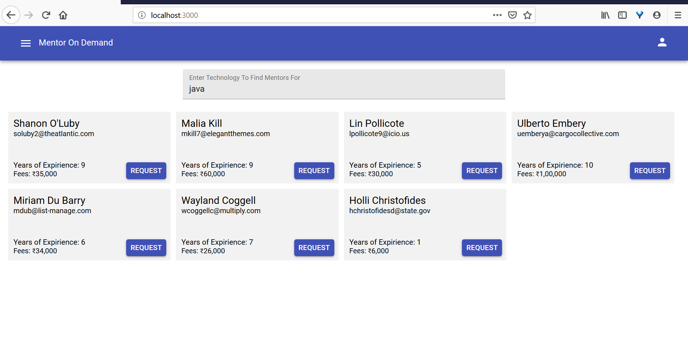

# Middle Tier Layer

Technologies

|  |  |  |
| --- | --- | --- |
| Technologies |  |  |
| Java Stack | Spring Boot | 2.X |
|  | JDK | 1.8 |
|  | MAVEN | 3.X |
| DB | MySql/ MariaDB | 10.1.38-MariaDB |

Microservices:

|  |  |  |
| --- | --- | --- |
| Microservice | Functions | PORT |
| EUREKA-DISCOVERY | Service Discovery Server | 8761 |
| MODZUUL-GATEWAY | Common API Gateway | 9000 |
| USERS-API | Provides services to get user details & login authentications | 8081 |
| TRAININGS-API | Provides services to get training schedules by technologies | 8082 |
| MENTORS-API | Provides services to get mentor details or mentor search by technologies | 8083 |
| PAYMENTS-API | Provides services to post payment to mentor for conducted trainings | 8084 |

Users API

Mentors API

Eurka Server

Zuul Gateway

Trainings API

Payments API

Zuul Enabled Edge Service

1. EUREKA-DISCOVERY

Eureka Service Discovery with below Netflix dependencies.

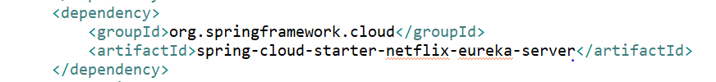

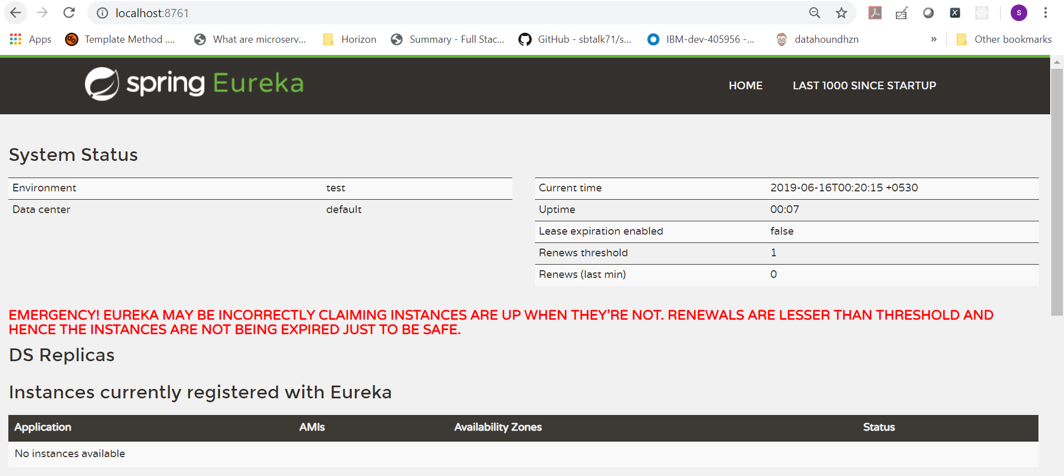

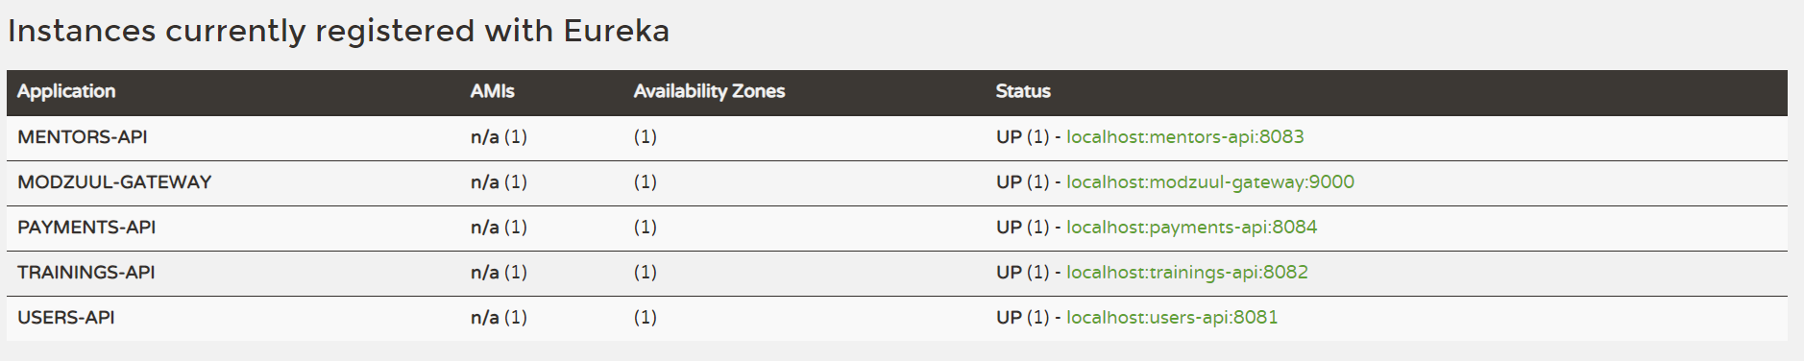

1. MODZUUL-GATEWAY

Common API Gateway built with below Netflix dependencies.

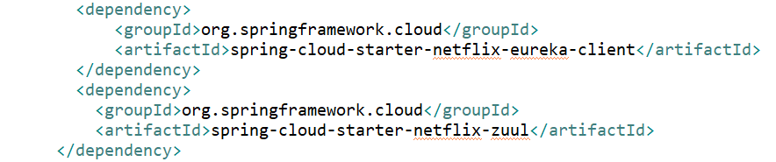

REST URL to connect to API through Zuul common gateway.

USERS API – <SERVER_HOST>:9000/users-api/users/login

MENTORS API – <SERVER_HOST>:9000/mentors-api/mentors/1/profile

TRAININGS API – <SERVER_HOST>:9000/trainings-api/ technologies/2/trainings

PAYMENTS API – <SERVER_HOST>:9000/payments-api/trainings/payment

1. USERS-API

|  |  |  |  |
| --- | --- | --- | --- |
| REST End Point | Method | Request | Response |
| /users/login | POST | {  "email":"john@gmail.com",  "password":"abc"  } | {  "description": null,  "errors": [],  "user": {  "id":1,  "email": "john@gmail.com",  "firstname": "john",  "lastname": "Doe",  "password": "$2a$10$iK6Hi8B.W0oBosRtBu7hz.6m9ShIaADzhGLZO6L0Hkr4s/ibly0NC",  "active": 1,  "isMentor": 0,  "roles": [  {  "id": 1,  "role": "ADMIN"  }  ]  }  } |
| /users/signup | POST | {  "email":"john@gmail.com",  "firstname":"john",  "lastname":"Doe",  "password":"abc"  } | {  "id": 1,  "email": "john@gmail.com",  "firstname": "john",  "lastname": "Doe",  "password": "$2a$10$iK6Hi8B.W0oBosRtBu7hz.6m9ShIaADzhGLZO6L0Hkr4s/ibly0NC",  "active": 1,  "isMentor": 0,  "roles": [  {  "id": 1,  "role": "ADMIN"  }  ]  } |
| /users/{id} | GET | /users/1 | {  "id": 1,  "email": "john@gmail.com",  "firstname": "john",  "lastname": "Doe",  "password": "$2a$10$iK6Hi8B.W0oBosRtBu7hz.6m9ShIaADzhGLZO6L0Hkr4s/ibly0NC",  "active": 1,  "isMentor": 0,  "roles": [  {  "id": 1,  "role": "ADMIN"  }  ]  } |

1. MENTORS-API

|  |  |  |  |
| --- | --- | --- | --- |
| End Point | Method | Request | Response |
| /mentors/{mentorId}/profile | POST | /mentors/1/profile | {  "mentorId": 1",  "mentorName": "JohnDoe",  "mentorEmail": "john@gmail.com",  "mentorSkills": [  {  "mentorId": 1,  "technology": "Core Java",  "yearofExperience": 10  },  {  "mentorId": 1,  "technology": "Spring",  "yearofExperience": 5  }  ],  "expertise": "Full Stack Developer",  "yearOfExp": 11  } |
| /mentors/search | POST | {  "technologies":[1]  } | {  "mentors": [  {  "mentorId": "1",  "mentorName": " JohnDoe ",  "mentorEmail": "john@gmail.com",  "mentorSkills": [  {  "mentorId": 1,  "technology": "Core Java",  "technologyId": 1,  "yearofExperience": 10  },  {  "mentorId": 1,  "technology": "Spring",  "technologyId": 2,  "yearofExperience": 5  }  ],  "expertise": "Full Stack Developer",  "yearOfExp": 11  },  {  "mentorId": "2",  "mentorName": "SumitJoshi",  "mentorEmail": "sumitjoshi@gmail.com",  "mentorSkills": [  {  "mentorId": 2,  "technology": "Core Java",  "technologyId": 1,  "yearofExperience": 5  }  ],  "expertise": "AWS Developer",  "yearOfExp": 10  }  ]  } |
|  |  |  |  |

1. TRAININGS-API

|  |  |  |  |
| --- | --- | --- | --- |
| End Point | Method | Request | Response |
| /technologies/{technologyId}/trainings | GET | /technologies/2/trainings?searchStartDate=2019-06-01&searchEndDate=2019-06-30 | {  "trainings": [  {  "trainerId": 1,  "mentorName": " JohnDoe ",  "mentorEmail": "john@gmail.com",  "technology": "Spring",  "trainingStartDate": "2019-06-02T18:30:00.000+0000",  "trainingEndDate": "2019-06-27T18:30:00.000+0000",  "trainigStauts": "NOT STARTED"  },  {  "trainerId": 3,  "mentorName": " JohnDoe ",  "mentorEmail": " john @gmail.com",  "technology": "Spring",  "trainingStartDate": "2019-06-09T18:30:00.000+0000",  "trainingEndDate": "2019-06-27T18:30:00.000+0000",  "trainigStauts": "NOT STARTED"  }  ]  } |

1. PAYMENTS_API

|  |  |  |  |
| --- | --- | --- | --- |
| End Point | Method | Request | Response |
| /trainings/payment | POST | {  "mentorId":"1",  "candidateId":"1",  "amount":"5000",  "trainingId":"3"  } | {  "payments": [  {  "mentorId":"1",  "candidateId":"1",  "amount":"5000",  " trainingId ": 1,  "transactionsDate": "2019-06-02T18:30:00.000+0000",  "transactionsId": "201sadsad90627T1",  } |

# Database & Integration Layer

Technologies

|  |  |  |
| --- | --- | --- |
| Technologies |  |  |
| Java Stack | Hibernate | 4.X |
|  | Spring Restful |  |
| DB | MySql/ MariaDB | 10.1.38-MariaDB |

DB Tables:

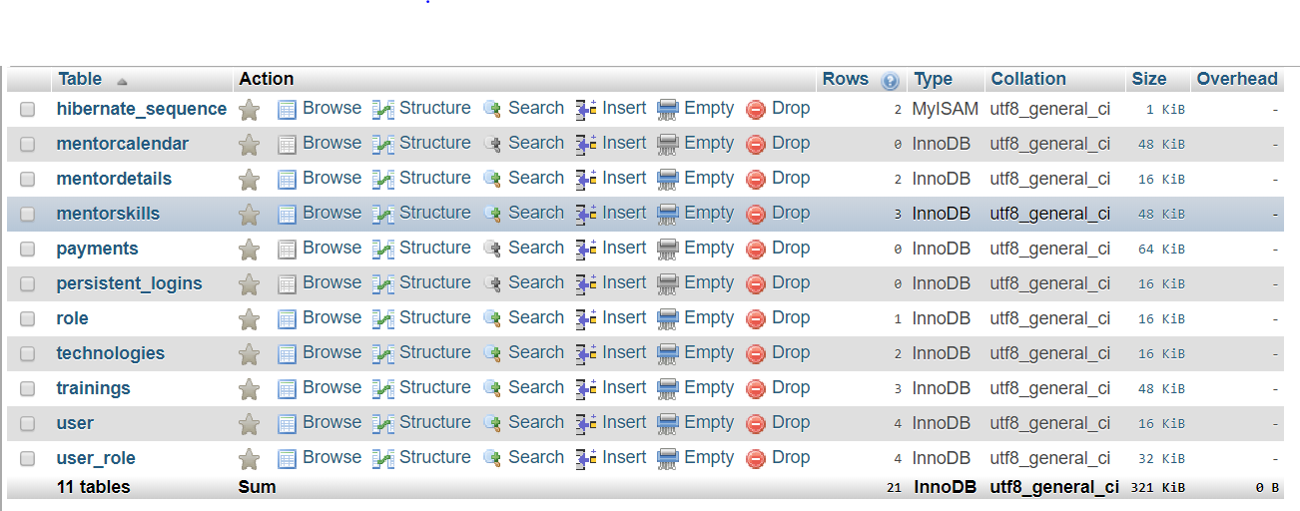

DB Dictionary:

**mentorcalendar**

|  |  |  |  |  |  |  |
| --- | --- | --- | --- | --- | --- | --- |
| **Column** | **Type** | **Null** | **Default** | **Links to** | **Comments** | **MIME** |
| id *(Primary)* | int(11) | No |  |  |  |  |
| start_time | time | No |  |  |  |  |
| end_time | time | No |  |  |  |  |
| mentor_id | int(11) | No |  | user -> id |  |  |
| training_id | int(11) | No |  | trainings -> id |  |  |
| training_date | date | No |  |  |  |  |

**Indexes**

| **Keyname** | **Type** | **Unique** | **Packed** | **Column** | **Cardinality** | **Collation** | **Null** | **Comment** |
| --- | --- | --- | --- | --- | --- | --- | --- | --- |
| PRIMARY | BTREE | Yes | No | id | 0 | A | No |  |
| training_id | BTREE | No | No | training_id | 0 | A | No |  |
| mentorcalendar_ibfk_1 | BTREE | No | No | mentor_id | 0 | A | No |  |

**mentordetails**

|  |  |  |  |  |  |  |
| --- | --- | --- | --- | --- | --- | --- |
| **Column** | **Type** | **Null** | **Default** | **Links to** | **Comments** | **MIME** |
| mentor_id *(Primary)* | int(11) | No |  | user -> id |  |  |
| expertise | varchar(255) | No |  |  |  |  |
| experience | float | No |  |  |  |  |
| rating | float | No |  |  |  |  |

**Indexes**

| **Keyname** | **Type** | **Unique** | **Packed** | **Column** | **Cardinality** | **Collation** | **Null** | **Comment** |
| --- | --- | --- | --- | --- | --- | --- | --- | --- |
| PRIMARY | BTREE | Yes | No | mentor_id | 2 | A | No |  |

**mentorskills**

|  |  |  |  |  |  |  |
| --- | --- | --- | --- | --- | --- | --- |
| **Column** | **Type** | **Null** | **Default** | **Links to** | **Comments** | **MIME** |
| id *(Primary)* | int(11) | No |  |  |  |  |
| mentor_id | int(11) | No |  | user -> id |  |  |
| tech_id | int(11) | No |  | technologies -> id |  |  |
| experience | float | No |  |  |  |  |

**Indexes**

| **Keyname** | **Type** | **Unique** | **Packed** | **Column** | **Cardinality** | **Collation** | **Null** | **Comment** |
| --- | --- | --- | --- | --- | --- | --- | --- | --- |
| PRIMARY | BTREE | Yes | No | id | 2 | A | No |  |
| tech_id | BTREE | No | No | tech_id | 2 | A | No |  |
| mentorskills_ibfk_1 | BTREE | No | No | mentor_id | 2 | A | No |  |

**payments**

|  |  |  |  |  |  |  |
| --- | --- | --- | --- | --- | --- | --- |
| **Column** | **Type** | **Null** | **Default** | **Links to** | **Comments** | **MIME** |
| id *(Primary)* | int(11) | No |  |  |  |  |
| candidate_id | int(11) | No |  | user -> id |  |  |
| mentor_id | int(11) | No |  | user -> id |  |  |
| amount | int(11) | No |  |  |  |  |
| training_id | int(11) | No |  | trainings -> id |  |  |
| transactionsDate | datetime | No |  |  |  |  |
| transactionsid | varchar(255) | No |  |  |  |  |

**Indexes**

| **Keyname** | **Type** | **Unique** | **Packed** | **Column** | **Cardinality** | **Collation** | **Null** | **Comment** |
| --- | --- | --- | --- | --- | --- | --- | --- | --- |
| PRIMARY | BTREE | Yes | No | id | 0 | A | No |  |
| training_id | BTREE | No | No | training_id | 0 | A | No |  |
| payments_ibfk_1 | BTREE | No | No | mentor_id | 0 | A | No |  |
| payments_ibfk_2 | BTREE | No | No | candidate_id | 0 | A | No |  |

**persistent_logins**

|  |  |  |  |  |  |  |
| --- | --- | --- | --- | --- | --- | --- |
| **Column** | **Type** | **Null** | **Default** | **Links to** | **Comments** | **MIME** |
| username | varchar(64) | No |  |  |  |  |
| series *(Primary)* | varchar(64) | No |  |  |  |  |
| token | varchar(64) | No |  |  |  |  |
| last_used | timestamp | No | CURRENT_TIMESTAMP |  |  |  |

**Indexes**

| **Keyname** | **Type** | **Unique** | **Packed** | **Column** | **Cardinality** | **Collation** | **Null** | **Comment** |
| --- | --- | --- | --- | --- | --- | --- | --- | --- |
| PRIMARY | BTREE | Yes | No | series | 0 | A | No |  |

**role**

|  |  |  |  |  |  |  |
| --- | --- | --- | --- | --- | --- | --- |
| **Column** | **Type** | **Null** | **Default** | **Links to** | **Comments** | **MIME** |
| role_id *(Primary)* | int(11) | No |  |  |  |  |
| role | varchar(255) | Yes | *NULL* |  |  |  |

**Indexes**

| **Keyname** | **Type** | **Unique** | **Packed** | **Column** | **Cardinality** | **Collation** | **Null** | **Comment** |
| --- | --- | --- | --- | --- | --- | --- | --- | --- |
| PRIMARY | BTREE | Yes | No | role_id | 0 | A | No |  |

**technologies**

|  |  |  |  |  |  |  |
| --- | --- | --- | --- | --- | --- | --- |
| **Column** | **Type** | **Null** | **Default** | **Links to** | **Comments** | **MIME** |
| id *(Primary)* | int(11) | No |  |  |  |  |
| name | varchar(255) | No |  |  |  |  |

**Indexes**

| **Keyname** | **Type** | **Unique** | **Packed** | **Column** | **Cardinality** | **Collation** | **Null** | **Comment** |
| --- | --- | --- | --- | --- | --- | --- | --- | --- |
| PRIMARY | BTREE | Yes | No | id | 2 | A | No |  |

**trainings**

|  |  |  |  |  |  |  |
| --- | --- | --- | --- | --- | --- | --- |
| **Column** | **Type** | **Null** | **Default** | **Links to** | **Comments** | **MIME** |
| id *(Primary)* | int(11) | No |  |  |  |  |
| name | varchar(255) | No |  |  |  |  |
| tech_id | int(11) | No |  | technologies -> id |  |  |
| start_date | date | No |  |  |  |  |
| end_date | date | No |  |  |  |  |
| mentor_id | int(11) | No |  | user -> id |  |  |
| status | varchar(255) | No |  |  |  |  |
| email | varchar(255) | Yes | *NULL* |  |  |  |
| last_date | datetime | Yes | *NULL* |  |  |  |

**Indexes**

| **Keyname** | **Type** | **Unique** | **Packed** | **Column** | **Cardinality** | **Collation** | **Null** | **Comment** |
| --- | --- | --- | --- | --- | --- | --- | --- | --- |
| PRIMARY | BTREE | Yes | No | id | 3 | A | No |  |
| tech_id | BTREE | No | No | tech_id | 3 | A | No |  |
| trainings_ibfk_2 | BTREE | No | No | mentor_id | 3 | A | No |  |

**user**

|  |  |  |  |  |  |  |
| --- | --- | --- | --- | --- | --- | --- |
| **Column** | **Type** | **Null** | **Default** | **Links to** | **Comments** | **MIME** |
| id *(Primary)* | int(11) | No |  |  |  |  |
| firstname | varchar(255) | No |  |  |  |  |
| lastname | varchar(255) | No |  |  |  |  |
| email | varchar(255) | No |  |  |  |  |
| password | varchar(255) | No |  |  |  |  |
| active | int(11) | Yes | *NULL* |  |  |  |
| is_mentor | int(11) | Yes | 0 |  |  |  |

**Indexes**

| **Keyname** | **Type** | **Unique** | **Packed** | **Column** | **Cardinality** | **Collation** | **Null** | **Comment** |
| --- | --- | --- | --- | --- | --- | --- | --- | --- |
| PRIMARY | BTREE | Yes | No | id | 2 | A | No |  |

**user_role**

|  |  |  |  |  |  |  |
| --- | --- | --- | --- | --- | --- | --- |
| **Column** | **Type** | **Null** | **Default** | **Links to** | **Comments** | **MIME** |
| user_id *(Primary)* | int(11) | No |  | user -> id |  |  |
| role_id *(Primary)* | int(11) | No |  | role -> role_id |  |  |

**Indexes**

| **Keyname** | **Type** | **Unique** | **Packed** | **Column** | **Cardinality** | **Collation** | **Null** | **Comment** |
| --- | --- | --- | --- | --- | --- | --- | --- | --- |
| PRIMARY | BTREE | Yes | No | user_id | 2 | A | No |  |
| role_id | 2 | A | No |
| user_role_key | BTREE | No | No | role_id | 2 | A | No |  |

API Integration with DB:

1. **Spring Data Dependency:**

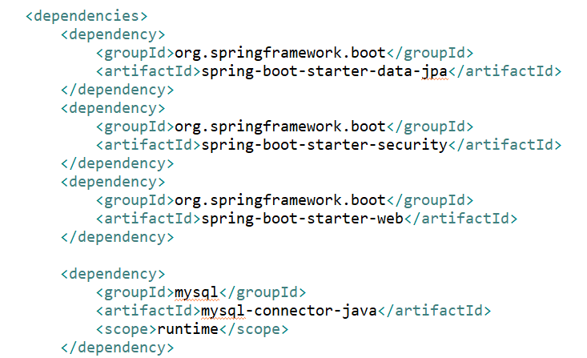

1. **API Configurations:**

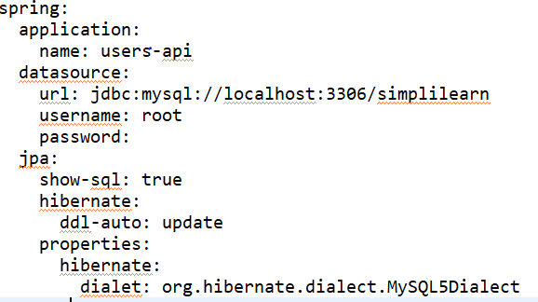

1. **JPA Repository:**

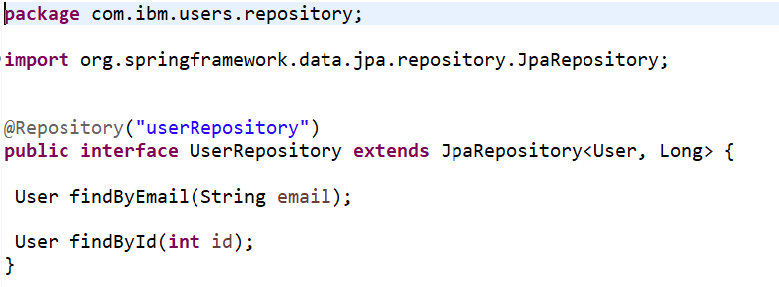

1. **Data Model Classes:**

