**EC2**

1. Go to Services->Computer>EC2 or search “EC2” on search bar.

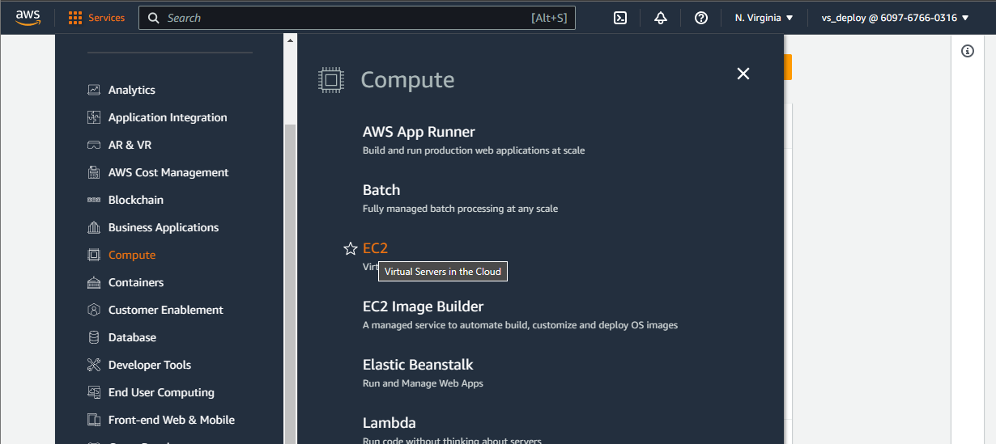

1. Navigate to “Instances” and click “Launch instances”

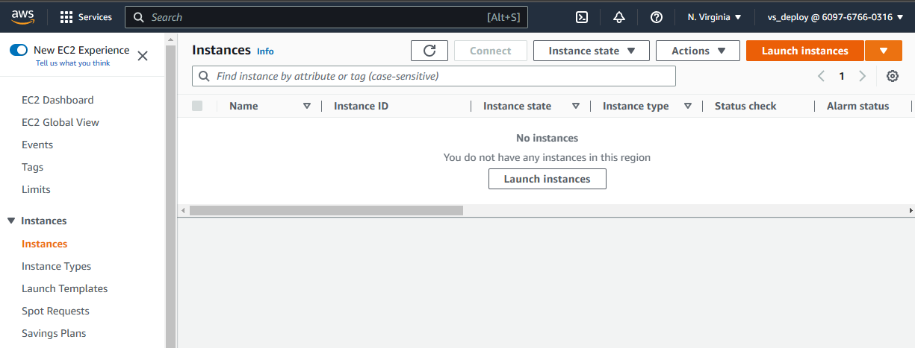

1. Setup like this and click “Launch instance”
2. Enter server name
3. Select operating system
4. Enable “Termination protection” for restrict server deletion

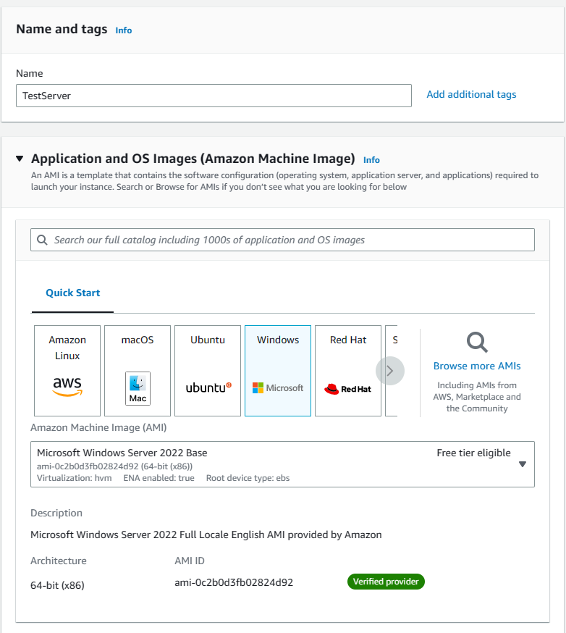

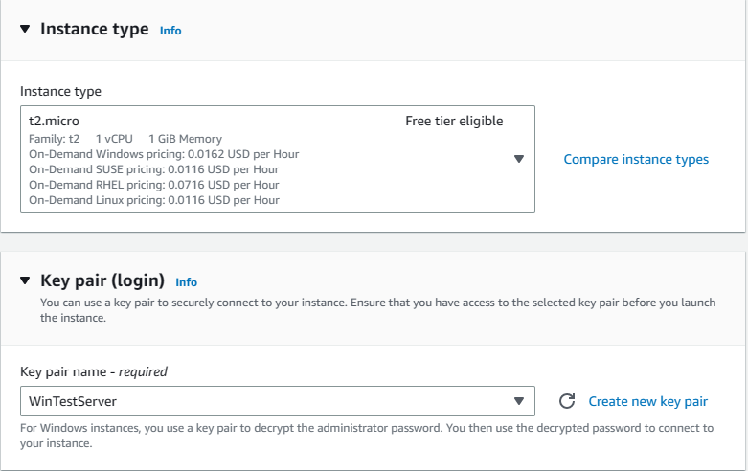

1. Create key pair

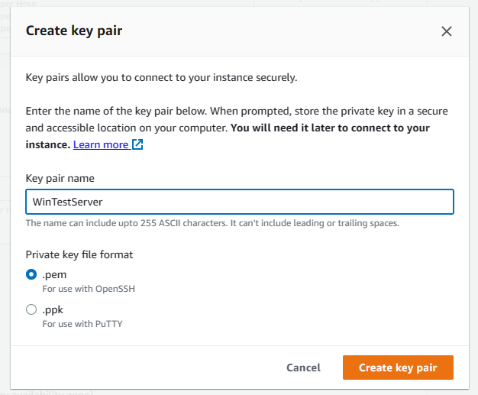

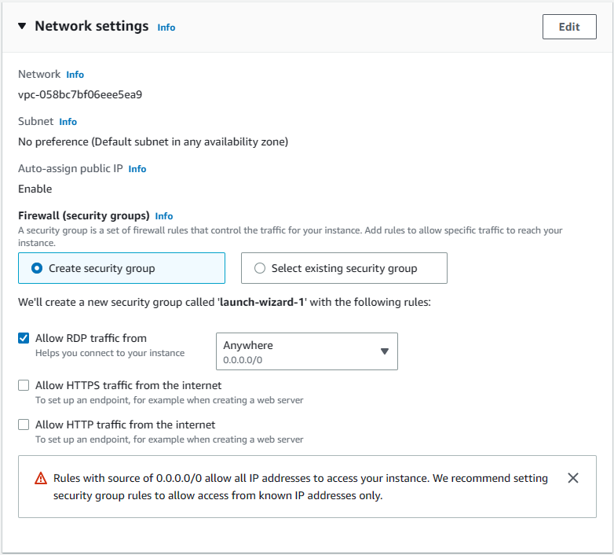

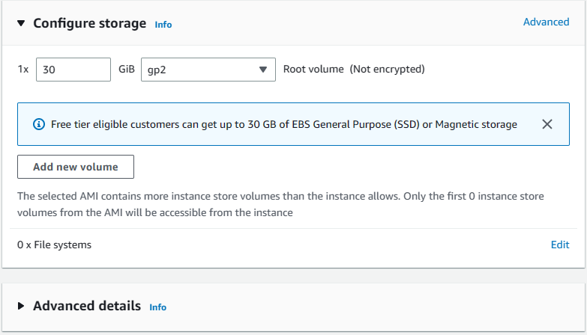

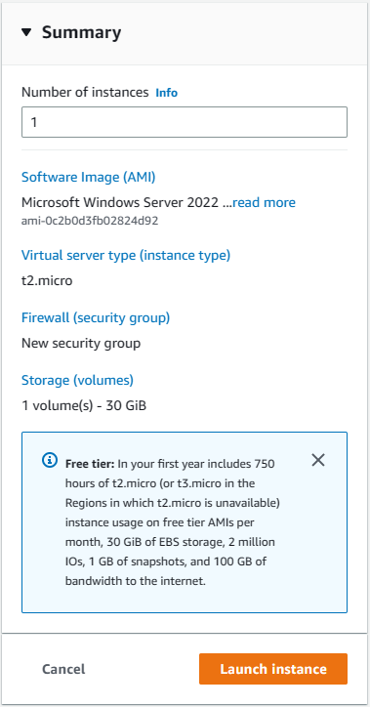

1. Connect to instance/server

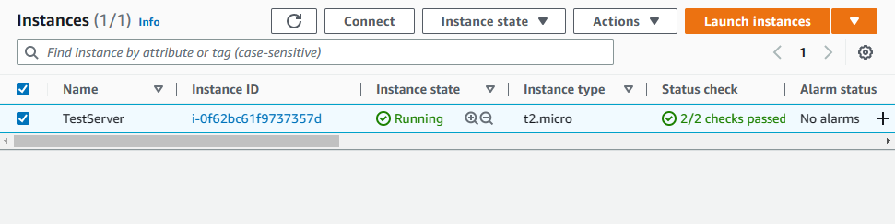

1. Select instance and click to “Connect”

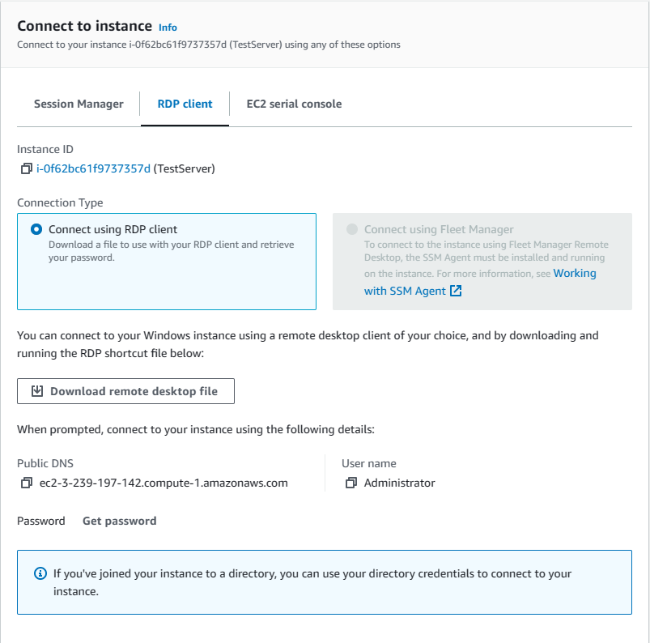

1. Select RDP client
2. Download remote desktop file
3. Open file it will open Remote desktop connection
4. Click “Get Password”

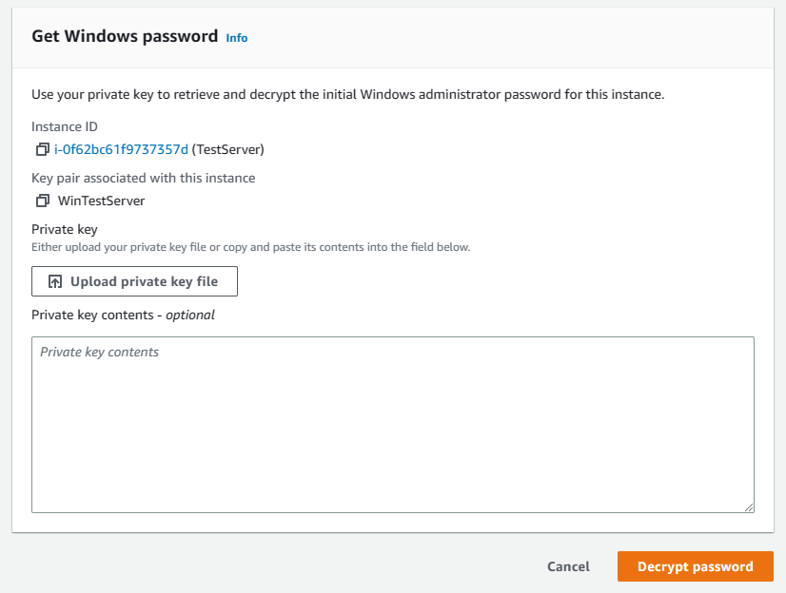

1. Upload private key from downloaded file in step 3 (Create key pair) and click “Decrypt password”
2. It will show the password.
3. Login RDC with this password
4. For Linux server
5. Select operating system as any Linux OS like Red Hat
6. Create a key pair like previous and store downloaded file.
7. Click “Launch instance”.
8. Connect Linux server from Putty:
9. Download and install Putty software from [Download Putty](https://www.puttygen.com/download-putty)
10. Copy the Public IPv4 address and click “Connect”

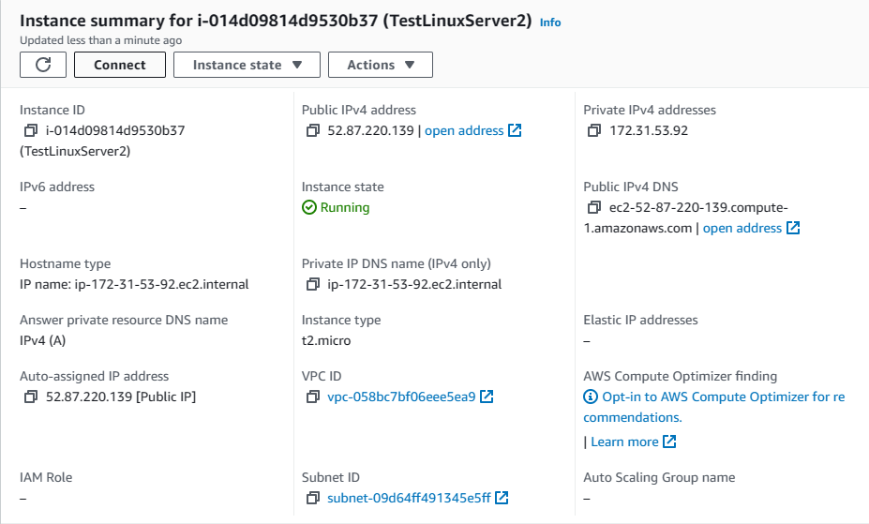

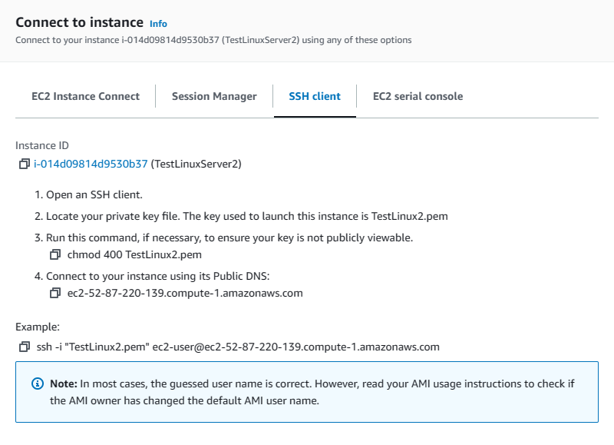

1. Open Putty application and enter copied IP here.

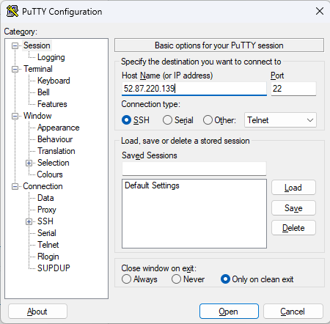

1. Navigate to Connection->SSH->Auth->Credentials

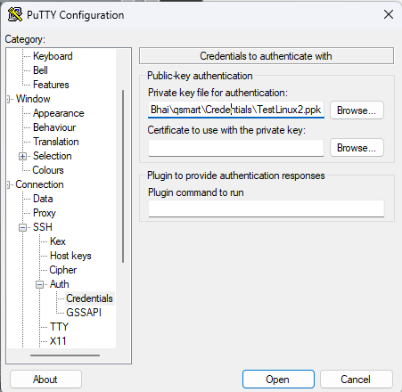

1. Select downloaded ppk file and click to open.
2. A terminal will open like this

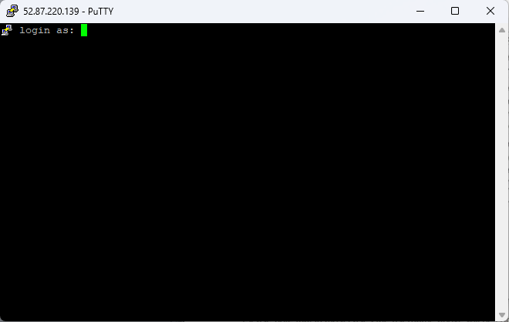

1. Enter username from

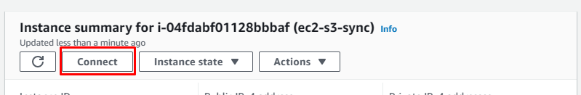

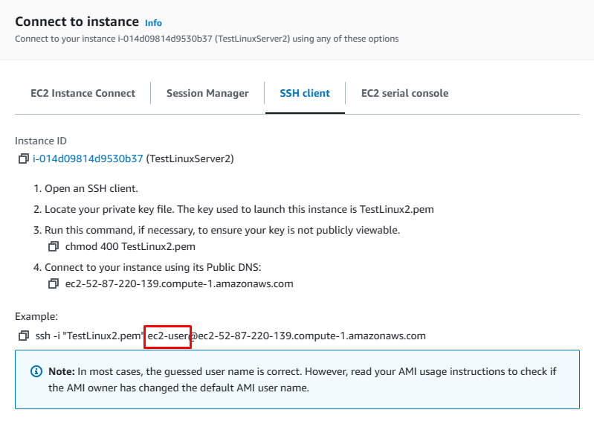

1. If server connect successfully it show like this:

