**SNS**

Create Topic and rule:

1. Create Topic:
2. Go to SNS->Topics

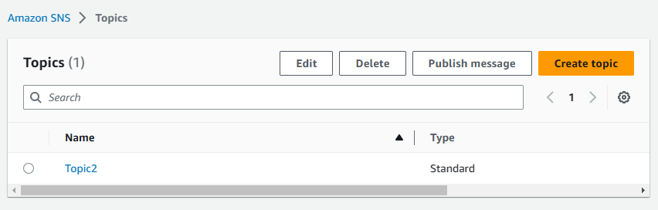

1. Enter topic name and description and click to Create topic

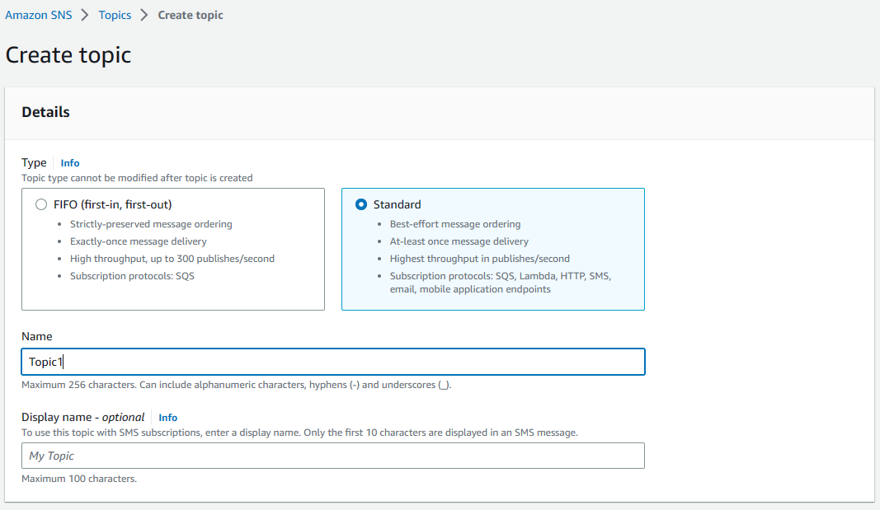

1. For add subscription click to Create subscription and select topic, protocol and enter destination email address.

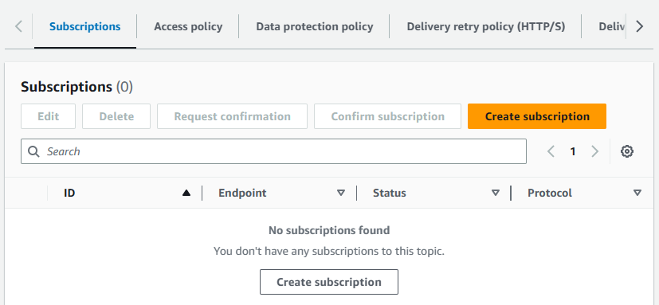

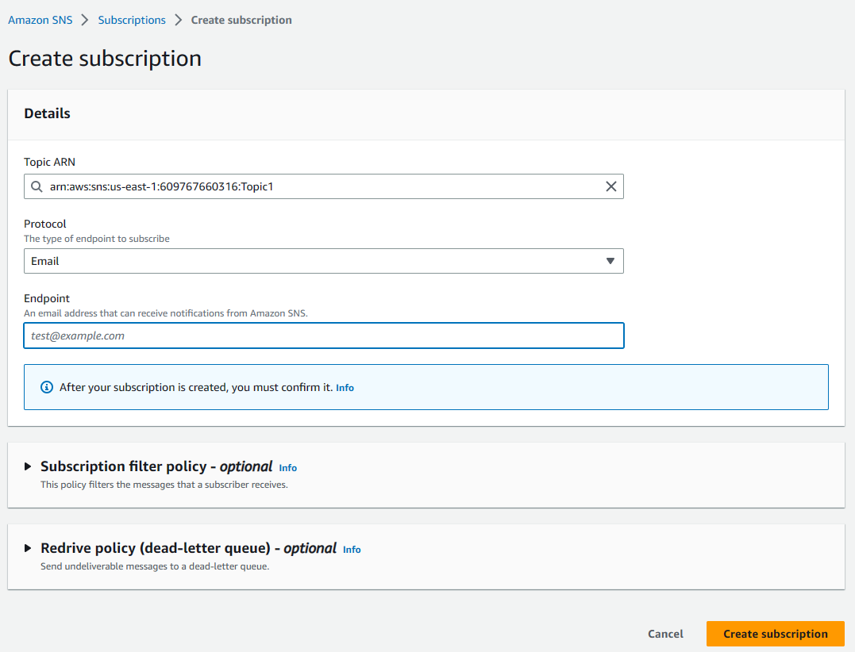

1. Create rule:
2. Navigate to CloudWatch->Events->Rules and click to Create rule

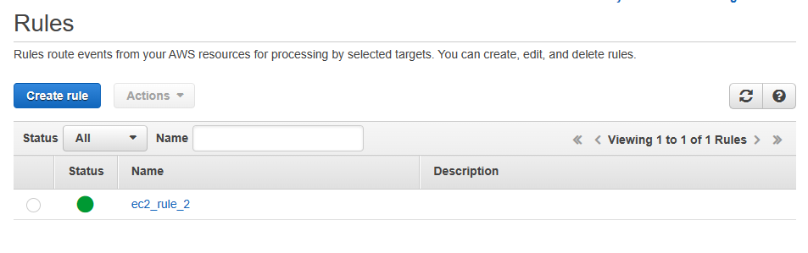

1. Enter preferred data and click to Configure details

