**VPC**

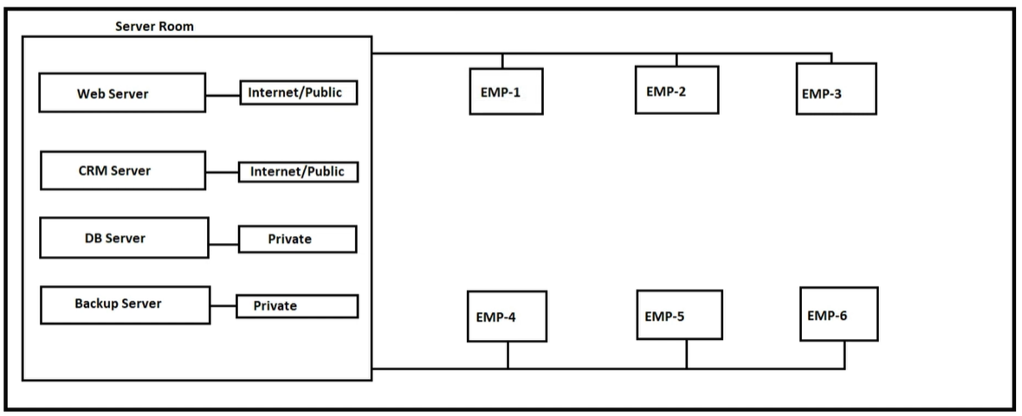

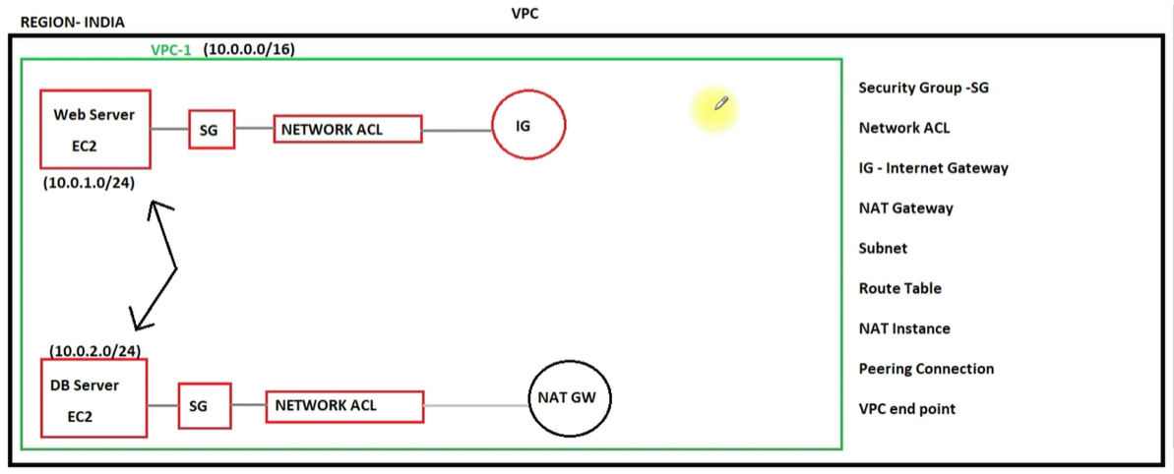

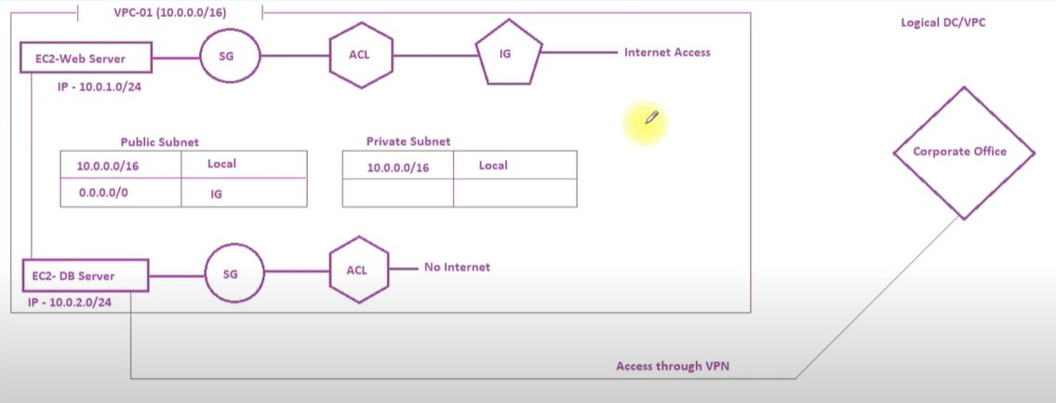

Navigate to Services->Networking & Content Delivery->VPC

1. **VPC Creation**
2. Navigate to Your VPCs and click “Create VPC”

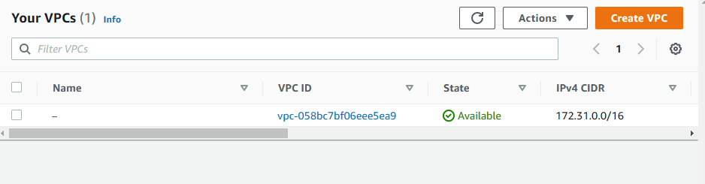

1. Enter information like this and Create VPC. When VPC created it also create one Route Table and one Network ACLs.

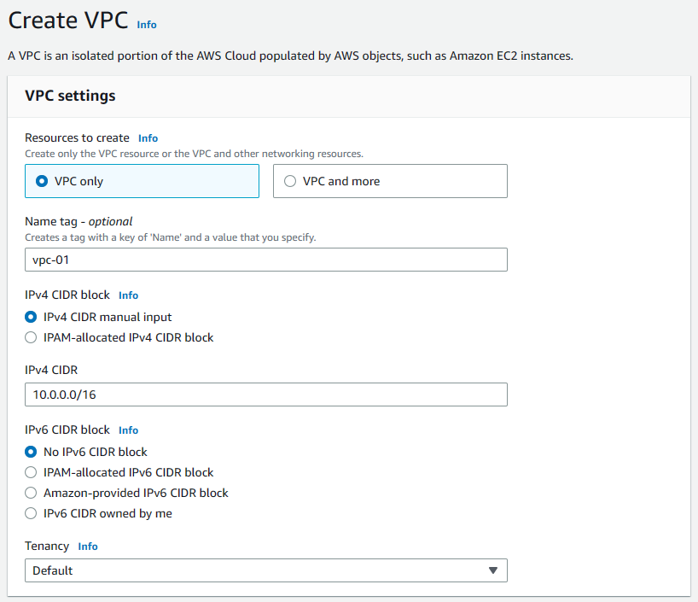

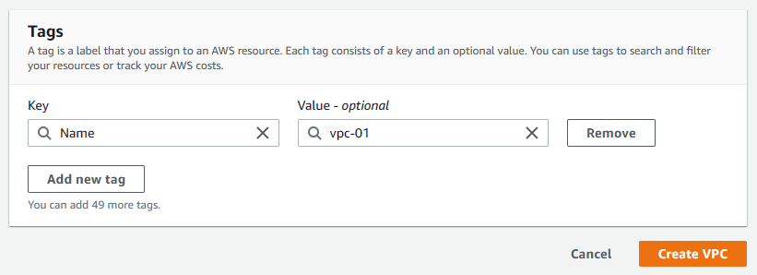

1. **Subnet Creation**
2. Navigate to Subnets and click to Create subnet
3. For IP calculation [CIDR to IPv4 Address Range Utility Tool](https://www.ipaddressguide.com/cidr)

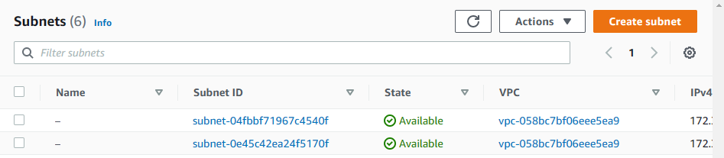

1. Select previously created VPC

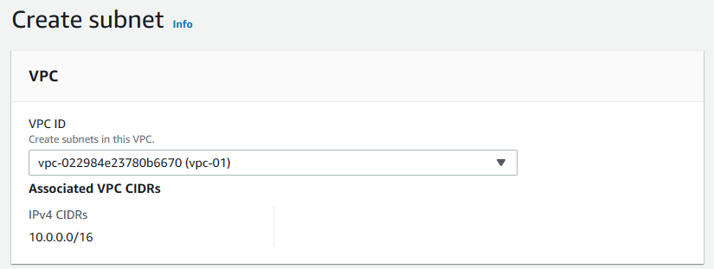

1. Enter subnet name and subnet IP and create first subnet

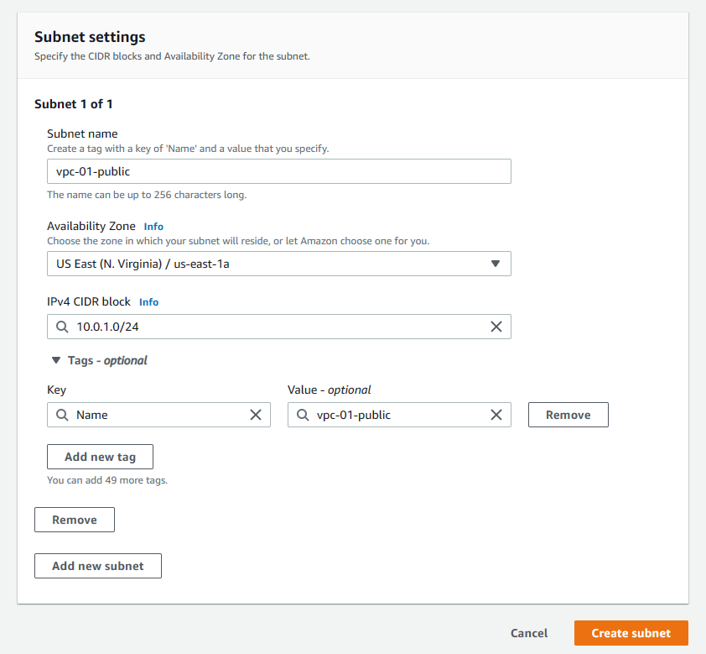

1. Create second Subnet as like previous
2. After IG created and assigned to VPC, for enable Auto-assign public IPv4 address, select subnet and click “Edit subnet settings” under Actions.

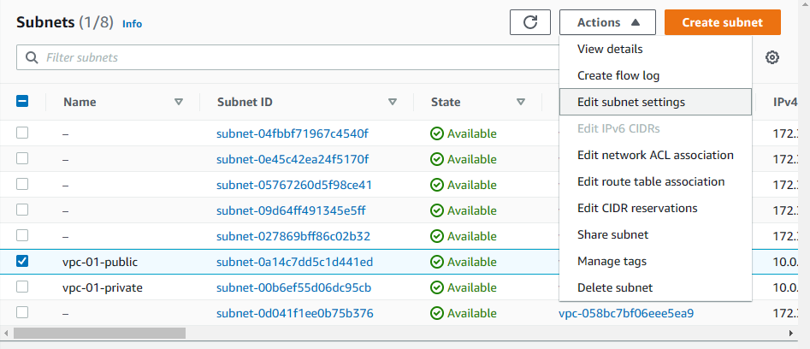

1. Enable auto-assign public IPv4 address (for enable internet connection to selected subnets) and save it.

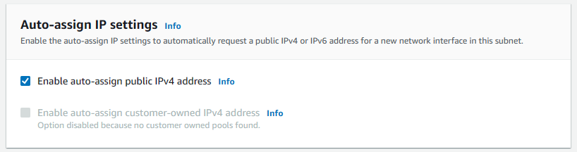

1. Setup route table
2. **IG Creation**
3. Navigate to Internet Gateways and click to Create internet Gateway

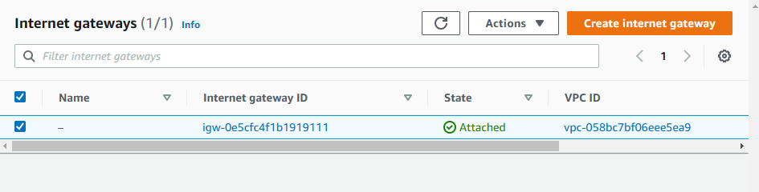

1. Enter IG name and create IG

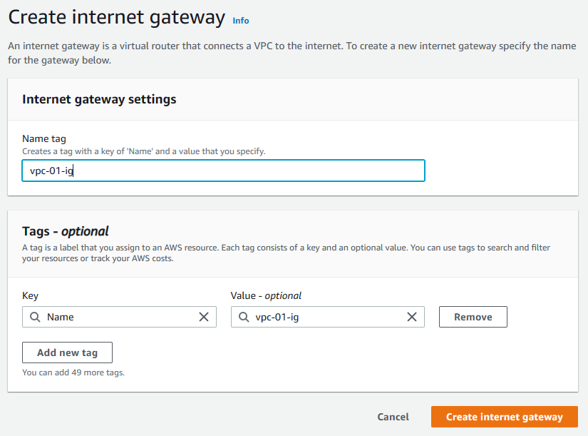

1. For attach IG to VPC select IG and Click to Attach to VPC under Actions dropdown

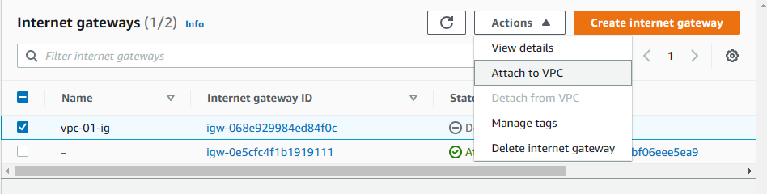

1. Select VPC and click to Attach internet gateway

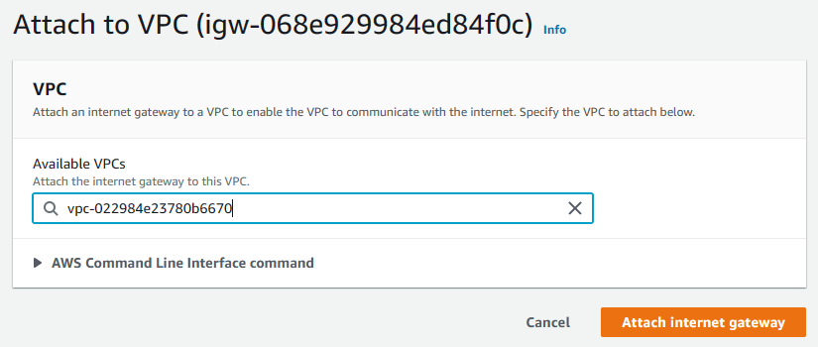

1. **Route Table**
2. Navigate to Route table select the auto created route table, click to Subnet associations

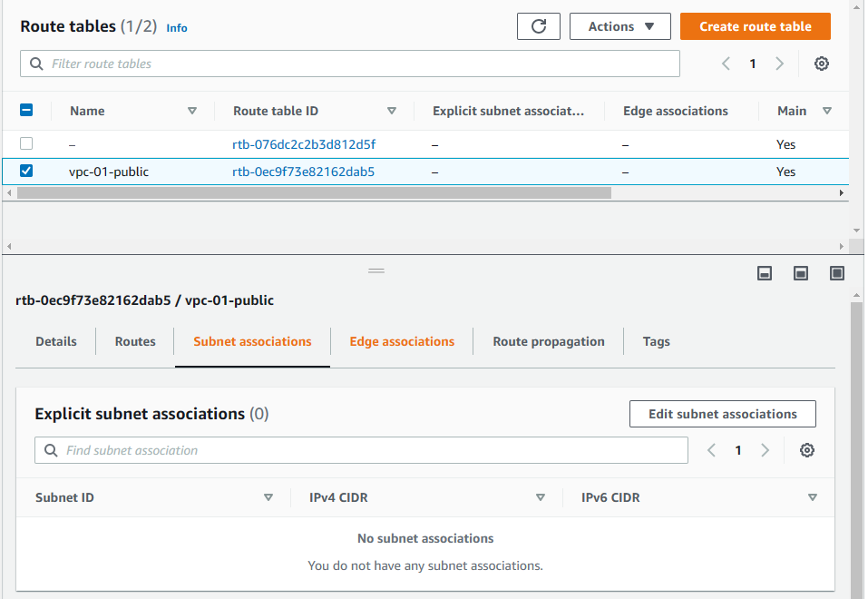

1. Edit subnet associations, select subnet and save it.

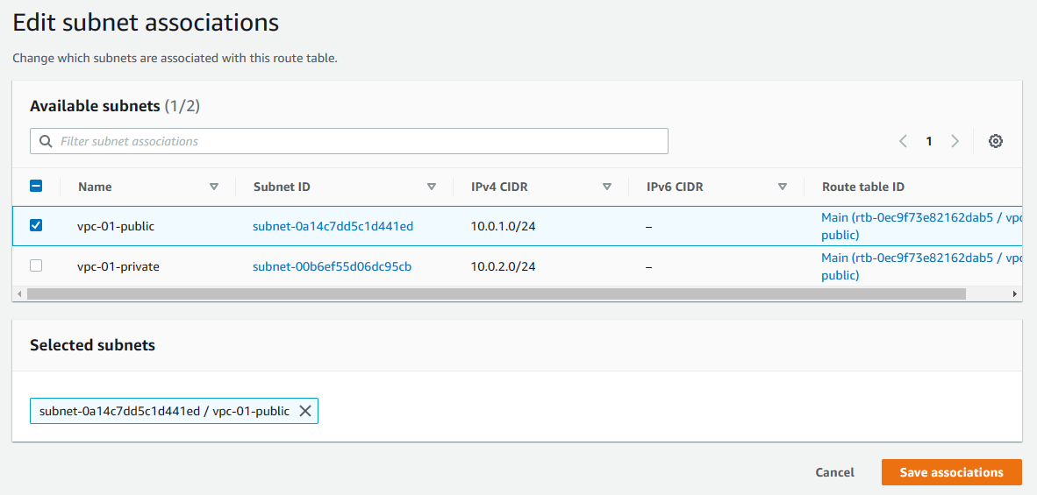

1. Click Routes and edit it

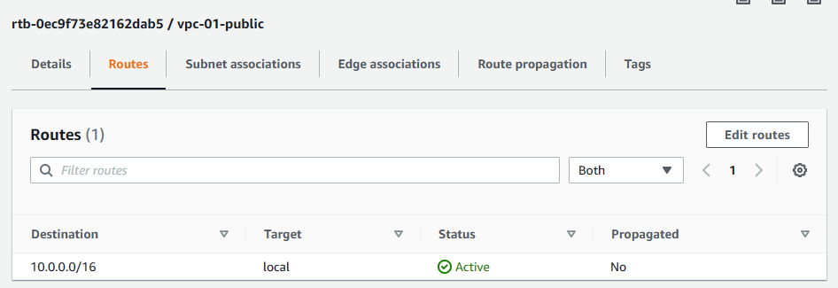

1. Setup like image below. “0.0.0.0/0” for allow all request from any IP address and select target as previously created Internet gateway.

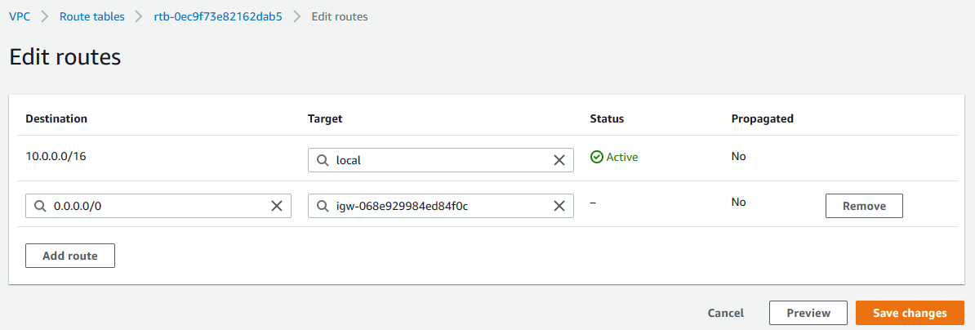

1. Save it.
2. Create another route

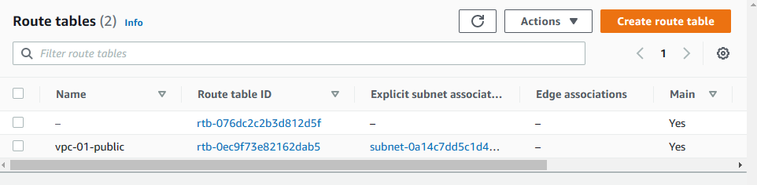

1. Enter route name and select VPC and click to create

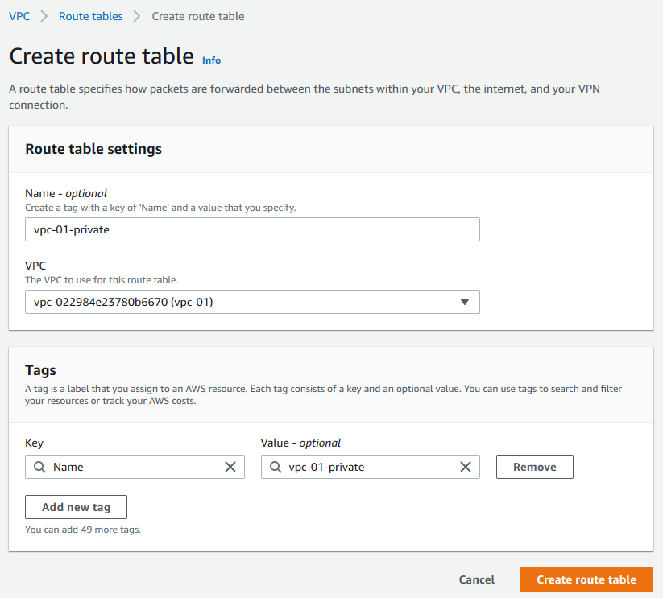

1. Associate private subnet into newly created Route

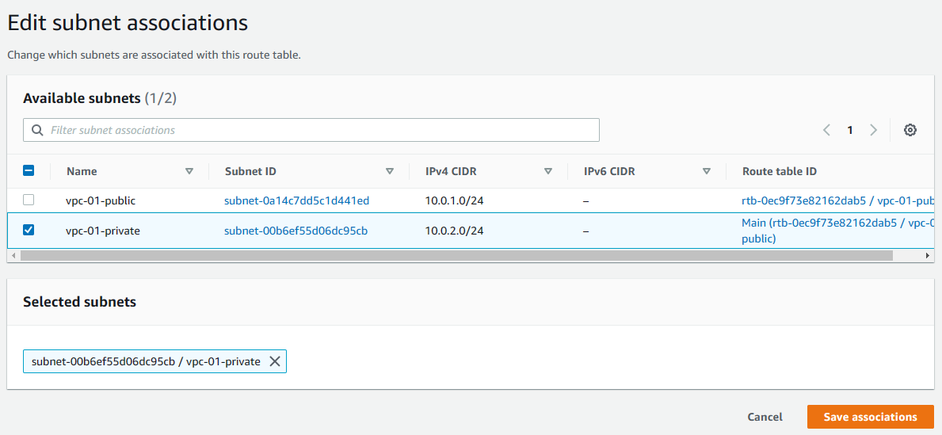

1. Create two instance/server
2. Navigate to Instances
3. Create two instances
4. Setup VPC and subnet for **public server** in network settings like this

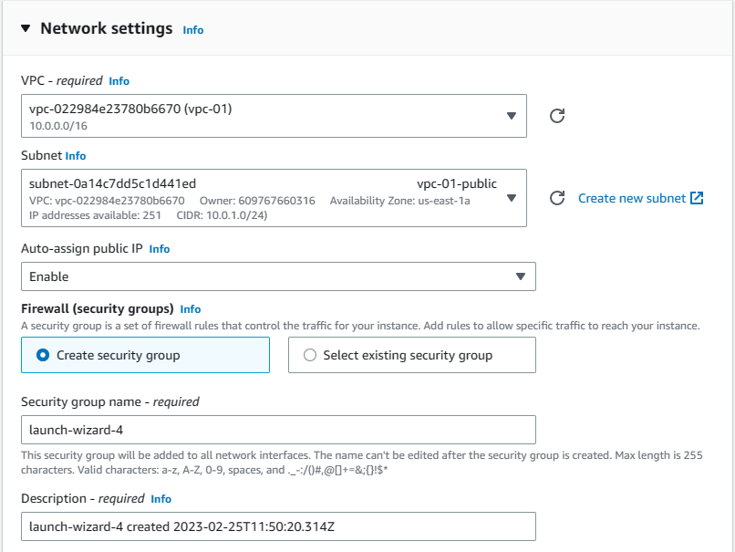

1. Setup VPC and subnet for **private server** in network settings like this

