Customer Complaint Resolution Network
MCP + A2A with MuleSoft Agent Fabric

Implementation Evidence & Technical Documentation
Salesforce TDX 2026 — Session 1557
San Francisco, CA | April 16, 2026

Author: Md Helal
Org: Student13 | Environment: Sandbox
All 5 Exercises Completed and Verified

1. Overview
This document provides photographic and data-driven evidence for all five hands-on exercises completed during TDX 2026 Session 1557: Connect & Govern MCP and A2A with MuleSoft Agent Fabric. Each section presents the relevant screenshots, extracted metrics, and technical interpretation of what the evidence demonstrates. The document is structured to serve both as a portfolio showcase and as a reference appendix for academic publication.

Exercise Summary
Exercise | Objective | Key Result | Status
1 | Add A2A PII Detector policy asset to project | Policy asset selected from Exchange | ✅ Complete
2 | Publish agent network to Anypoint Exchange | 36 assets published via Anypoint CLI | ✅ Complete
3 | End-to-end refund test via Slack | 200 OK · REF000002 · Expedited refund | ✅ Complete
4 | Apply & verify A2A PII Detector policy | 401 Unauthorized on SSN input | ✅ Complete
5a | Agent Visualizer — live topology | All 4 nodes visible · Active status · Flex Gateway | ✅ Complete
5b | Distributed trace — success path | 200 OK · 19 spans · 20.81s total | ✅ Complete
5c | Distributed trace — PII rejection | 401 · 1 span · 1.01s · No LLM call | ✅ Complete
5d | Log search from trace | 102 log hits · Structured JSON logs | ✅ Complete

Architecture Summary
The deployed network consists of one Broker (LLM orchestrator), one A2A sub-agent, and two MCP servers, all routed through Flex Gateway on CloudHub 2.0:
Client (Slack / direct A2A POST)
│ JSON-RPC 2.0 · method: message/send
▼
Flex Gateway — A2A PII Detector v1.0.1 (US SSN → 401)
│
▼
complaint-resolution-broker (Google Gemini 2.5 Flash Lite)
├── A2A ──► Customer Verification Agent (Node.js · Heroku /a2a/)
├── MCP ──► Inventory MCP Server (streamableHttp · Heroku /inventory)
│ create_return_request · generate_return_label · check_inventory_status
└── MCP ──► Finance MCP Server (streamableHttp · Heroku /finance)
process_refund · create_ledger_entry

2. Exercise 1 — Add A2A PII Detector Policy Asset
The first step was to add the A2A PII Detector policy as a dependency in the agent network project. This is done inside Anypoint Code Builder by searching Anypoint Exchange and selecting the policy asset, which appends a dependency entry to exchange.json and makes the policy available for reference in agent-network.yaml.
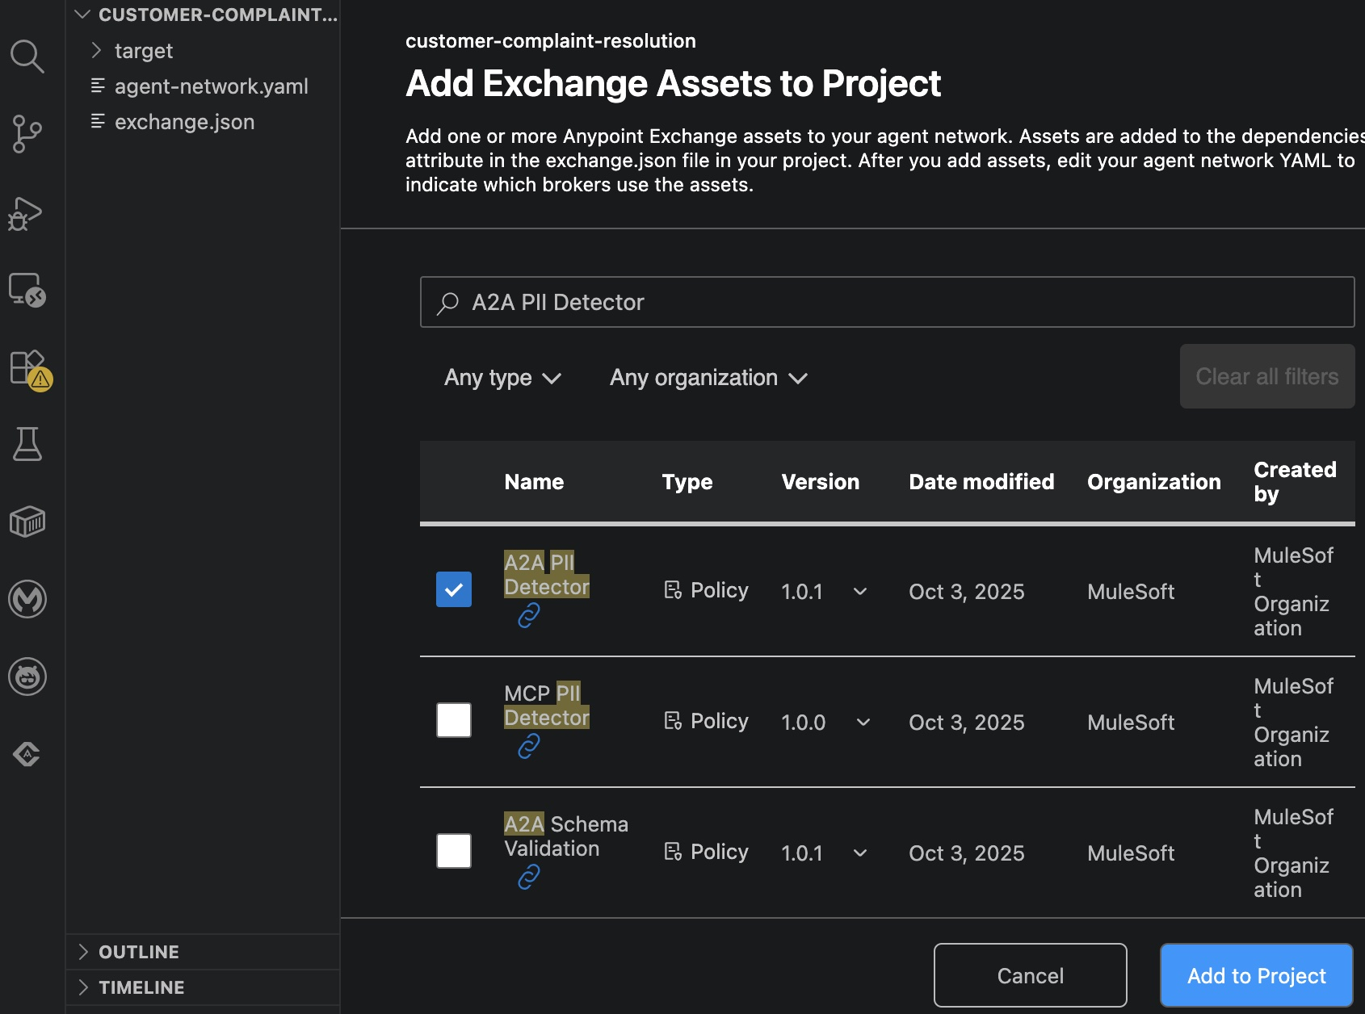
Figure 1 — Anypoint Code Builder: 'Add Exchange Assets' dialog. A2A PII Detector v1.0.1 (MuleSoft Organization) selected.

Evidence Details
The screenshot confirms:
- Three policy assets are available: A2A PII Detector, MCP PII Detector, A2A Schema Validation.
- A2A PII Detector v1.0.1 (released Oct 3, 2025 by MuleSoft Organization) is checked.
- This selection adds the dependency block shown below to exchange.json.

"dependencies": [
{
"classifier": "schema",
"packaging": "zip",
"groupId": "68ef9520-24e9-4cf2-b2f5-620025690913",
"assetId": "a-two-a-pii-detector",
"version": "1.0.1"
}
]

3. Exercise 2 — Publish to Anypoint Exchange
The agent network was published to Anypoint Exchange using the Anypoint CLI. A single command reads agent-network.yaml and exchange.json and publishes all constituent assets: the broker, sub-agents, MCP servers, LLM provider, the Mule application, and the top-level agent-network descriptor.
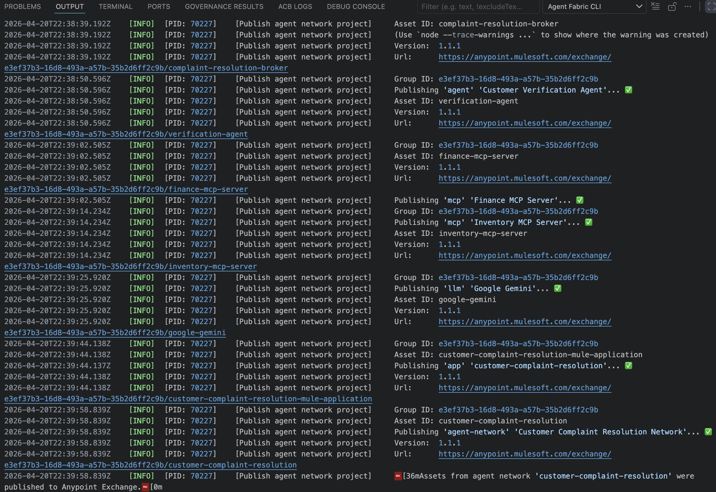
Figure 2 — Anypoint Code Builder terminal: 36 assets published to Exchange.

Key Output Lines
Publishing 'agent' 'Customer Verification Agent' → verification-agent v1.1
Publishing 'mcp' 'Finance MCP Server' → finance-mcp-server v1.1
Publishing 'mcp' 'Inventory MCP Server' → inventory-mcp-server v1.1
Publishing 'llm' 'Google Gemini' → google-gemini v1.1
Publishing 'app' 'customer-complaint-resolution-mule-application'
Publishing 'agent-network''Customer Complaint Resolution Network'
✅ 36 Assets from agent network 'customer-complaint-resolution' were published.
Group ID : e3ef37b3-16d8-493a-a57b-35b2d6ff2c9b
Published: https://anypoint.mulesoft.com/exchange/

4. Exercise 3 — End-to-End Refund Test via Slack
With the network deployed, the end-to-end flow was tested using RefundBot in Slack. A natural-language complaint triggers the full 5-step orchestration: customer verification via A2A, return request creation, shipping label generation, refund processing, and ledger entry — all within a single agent network invocation.
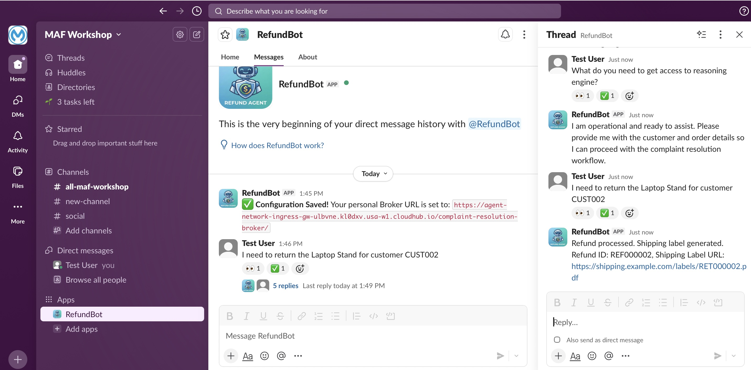
Figure 3 — Slack: RefundBot returns Refund ID REF000002 and Shipping Label URL in response to a natural-language return request.
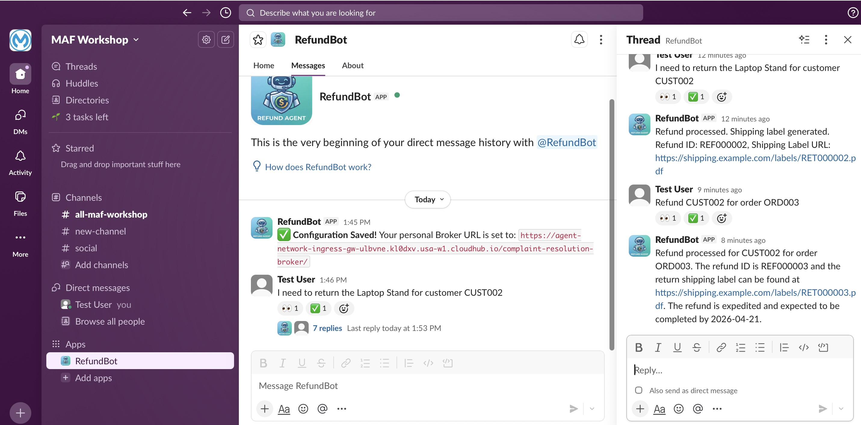
Figure 4 — Slack thread: full multi-turn conversation showing the complete complaint resolution flow with expedited refund confirmation.

Verified Response Content
User: "I need to return the Laptop Stand for customer CUST002"
Bot: "Refund processed for CUST002 for order ORD003.
The refund ID is REF000002 and the return shipping label
can be found at https://shipping.example.com/labels/RET000002.pdf.
The refund is expedited and expected to be completed by 2026-04-21."

5-Step Orchestration Confirmed
Step | Tool / Agent | Result
1 | verification-agent (A2A) | Customer CUST002 verified · expedited: true (loyalty tier)
2 | create_return_request (MCP Inventory) | Return created · returnId: RET000002
3 | generate_return_label (MCP Inventory) | Label URL: .../RET000002.pdf
4 | process_refund (MCP Finance) | Refund approved · refundId: REF000002 · expedited
5 | create_ledger_entry (MCP Finance) | Audit record written · linked to transaction

Note: Steps 3 and 4 run in parallel. The LLM orchestrator recognised the independence of the return label and refund operations and executed them concurrently, reducing total response time on the critical path. This was confirmed in the distributed trace (Section 6).

5. Exercise 4 — A2A PII Detector Policy
The A2A PII Detector policy was applied to the broker via the Flex Gateway, configured to detect US Social Security Numbers and reject the message with HTTP 401 before it reaches the LLM. This section documents the policy configuration and the verified rejection behaviour.

5.1 Policy Configuration in agent-network.yaml
The following YAML block was added to the broker spec:
policies:
- ref:
name: a-two-a-pii-detector
namespace: 68ef9520-24e9-4cf2-b2f5-620025690913
configuration:
entities:
- US SSN
action: Reject # blocks message; returns 401 to caller
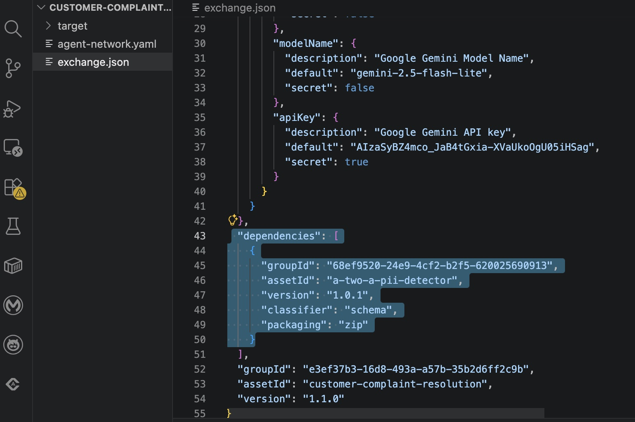
Figure 5 — YAML policy snippet added to agent-network.yaml in Anypoint Code Builder.
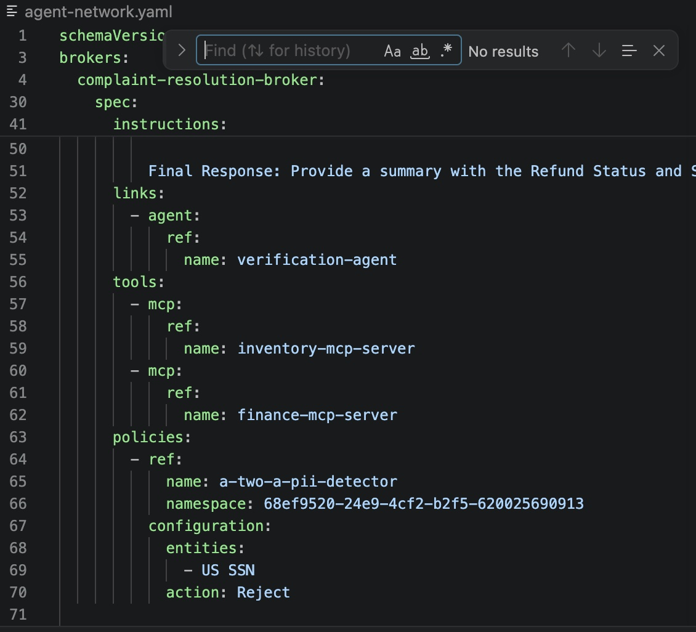
Figure 6 — exchange.json dependency block for a-two-a-pii-detector added.
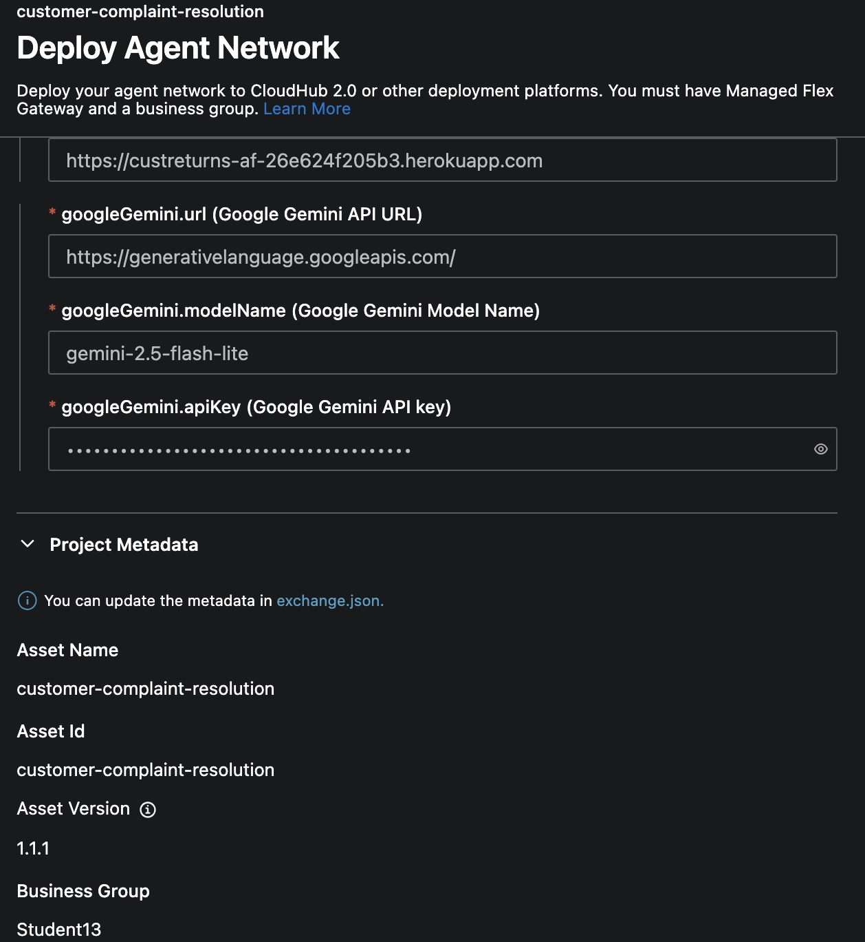
Figure 7 — Anypoint API Manager: A2A PII Detector policy active on the broker endpoint.
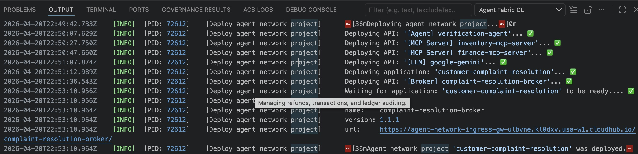
Figure 8 — Policy detail: entity = US SSN, action = Reject.

5.2 PII Rejection Verified
A test message containing the SSN '000-11-1111' was submitted. The policy fired at the Flex Gateway ingress layer before the message reached the Mule flow or the Gemini LLM:
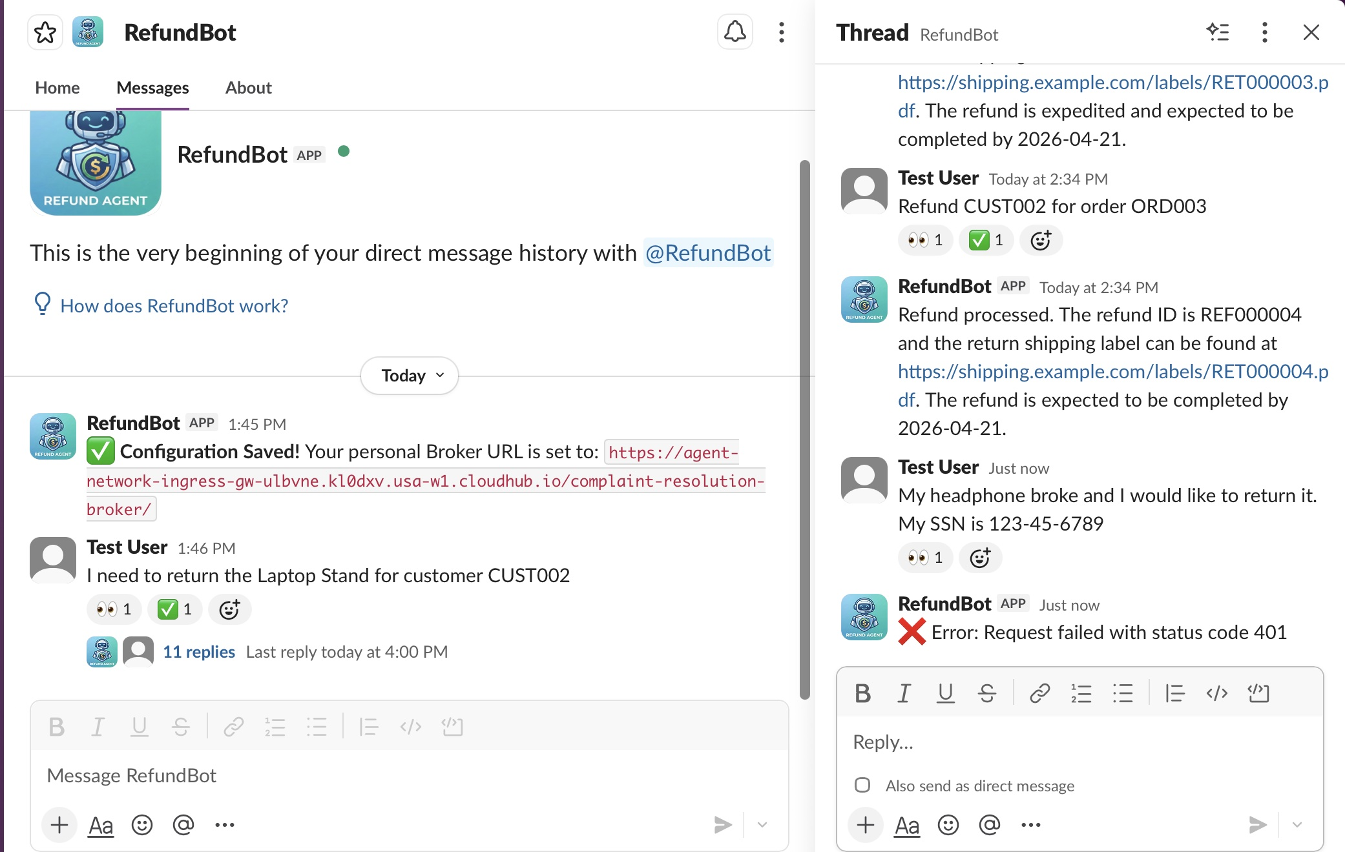
Figure 9 — Test request containing SSN 000-11-1111 submitted via Postman / Slack.
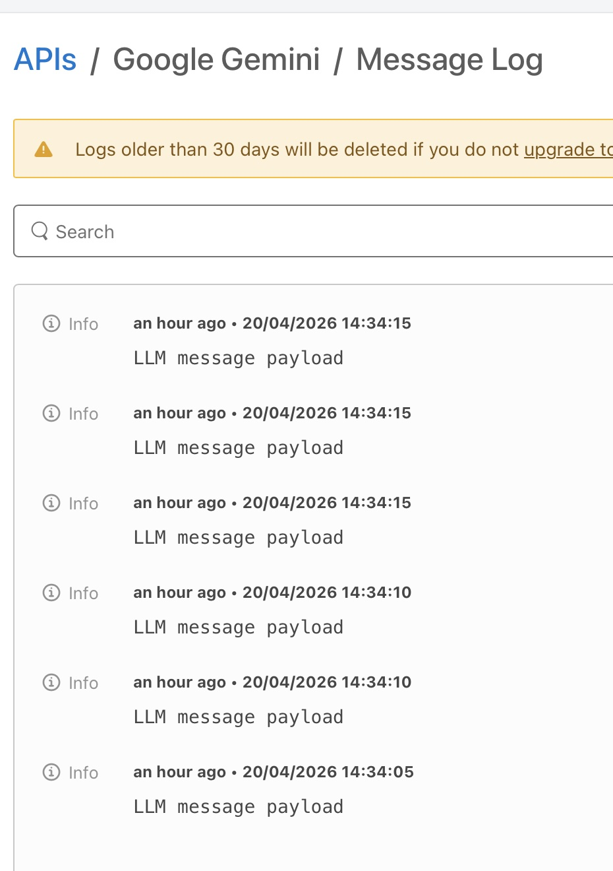
Figure 10 — HTTP 401 Unauthorized response. PII blocked at gateway.

5.3 LLM Proxy Policies (Google Gemini)
The Google Gemini LLM Proxy in Anypoint API Manager was configured with two inbound policies for observability:
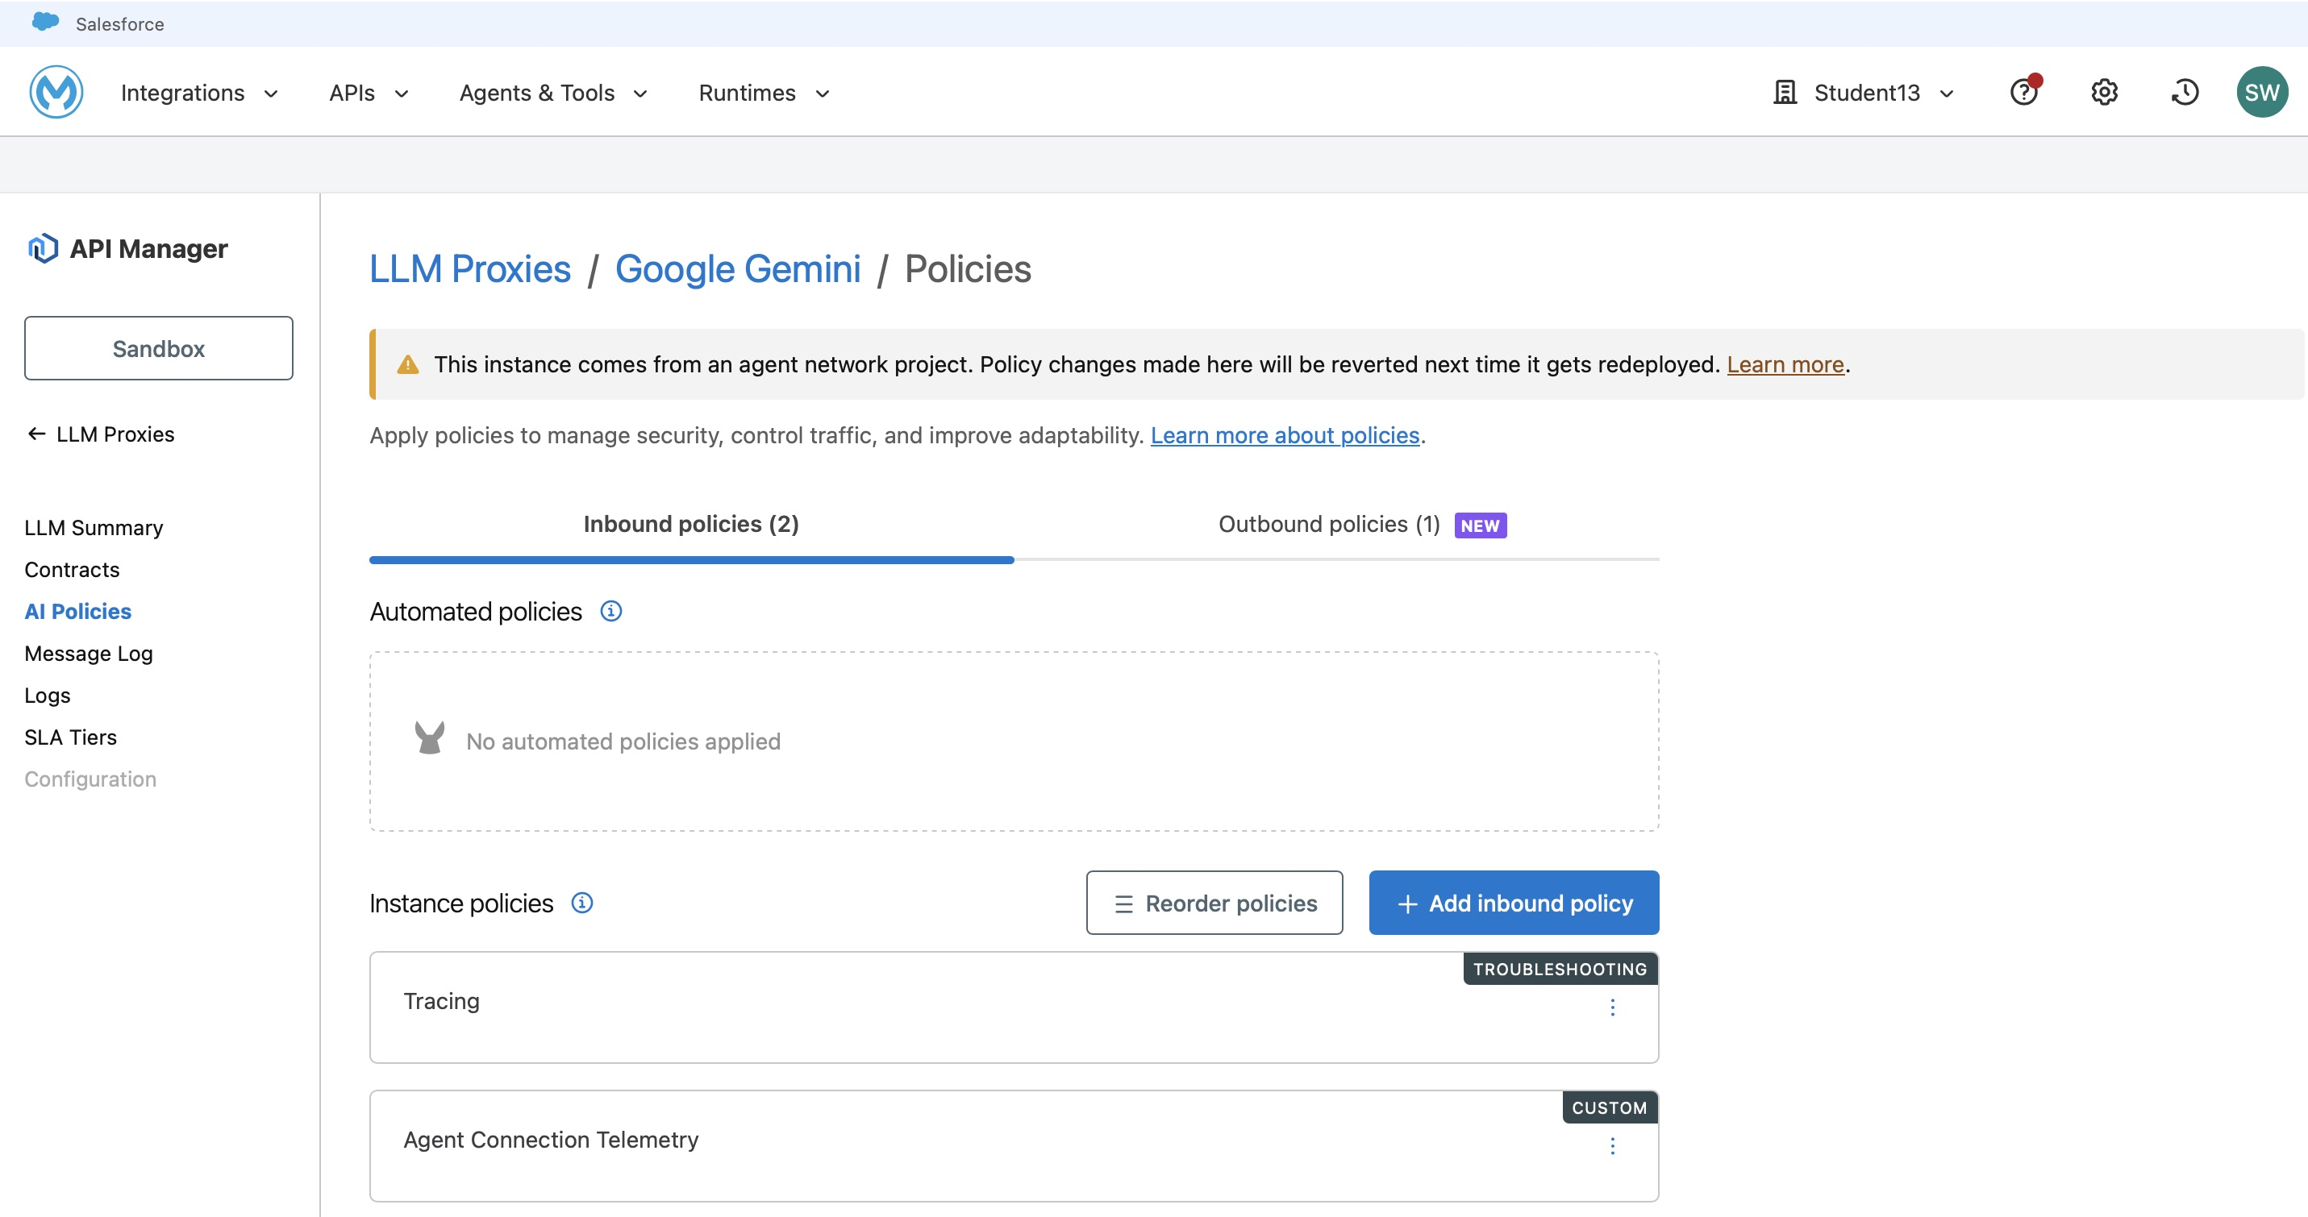
Figure 11 — API Manager: LLM Proxies → Google Gemini → Policies overview.
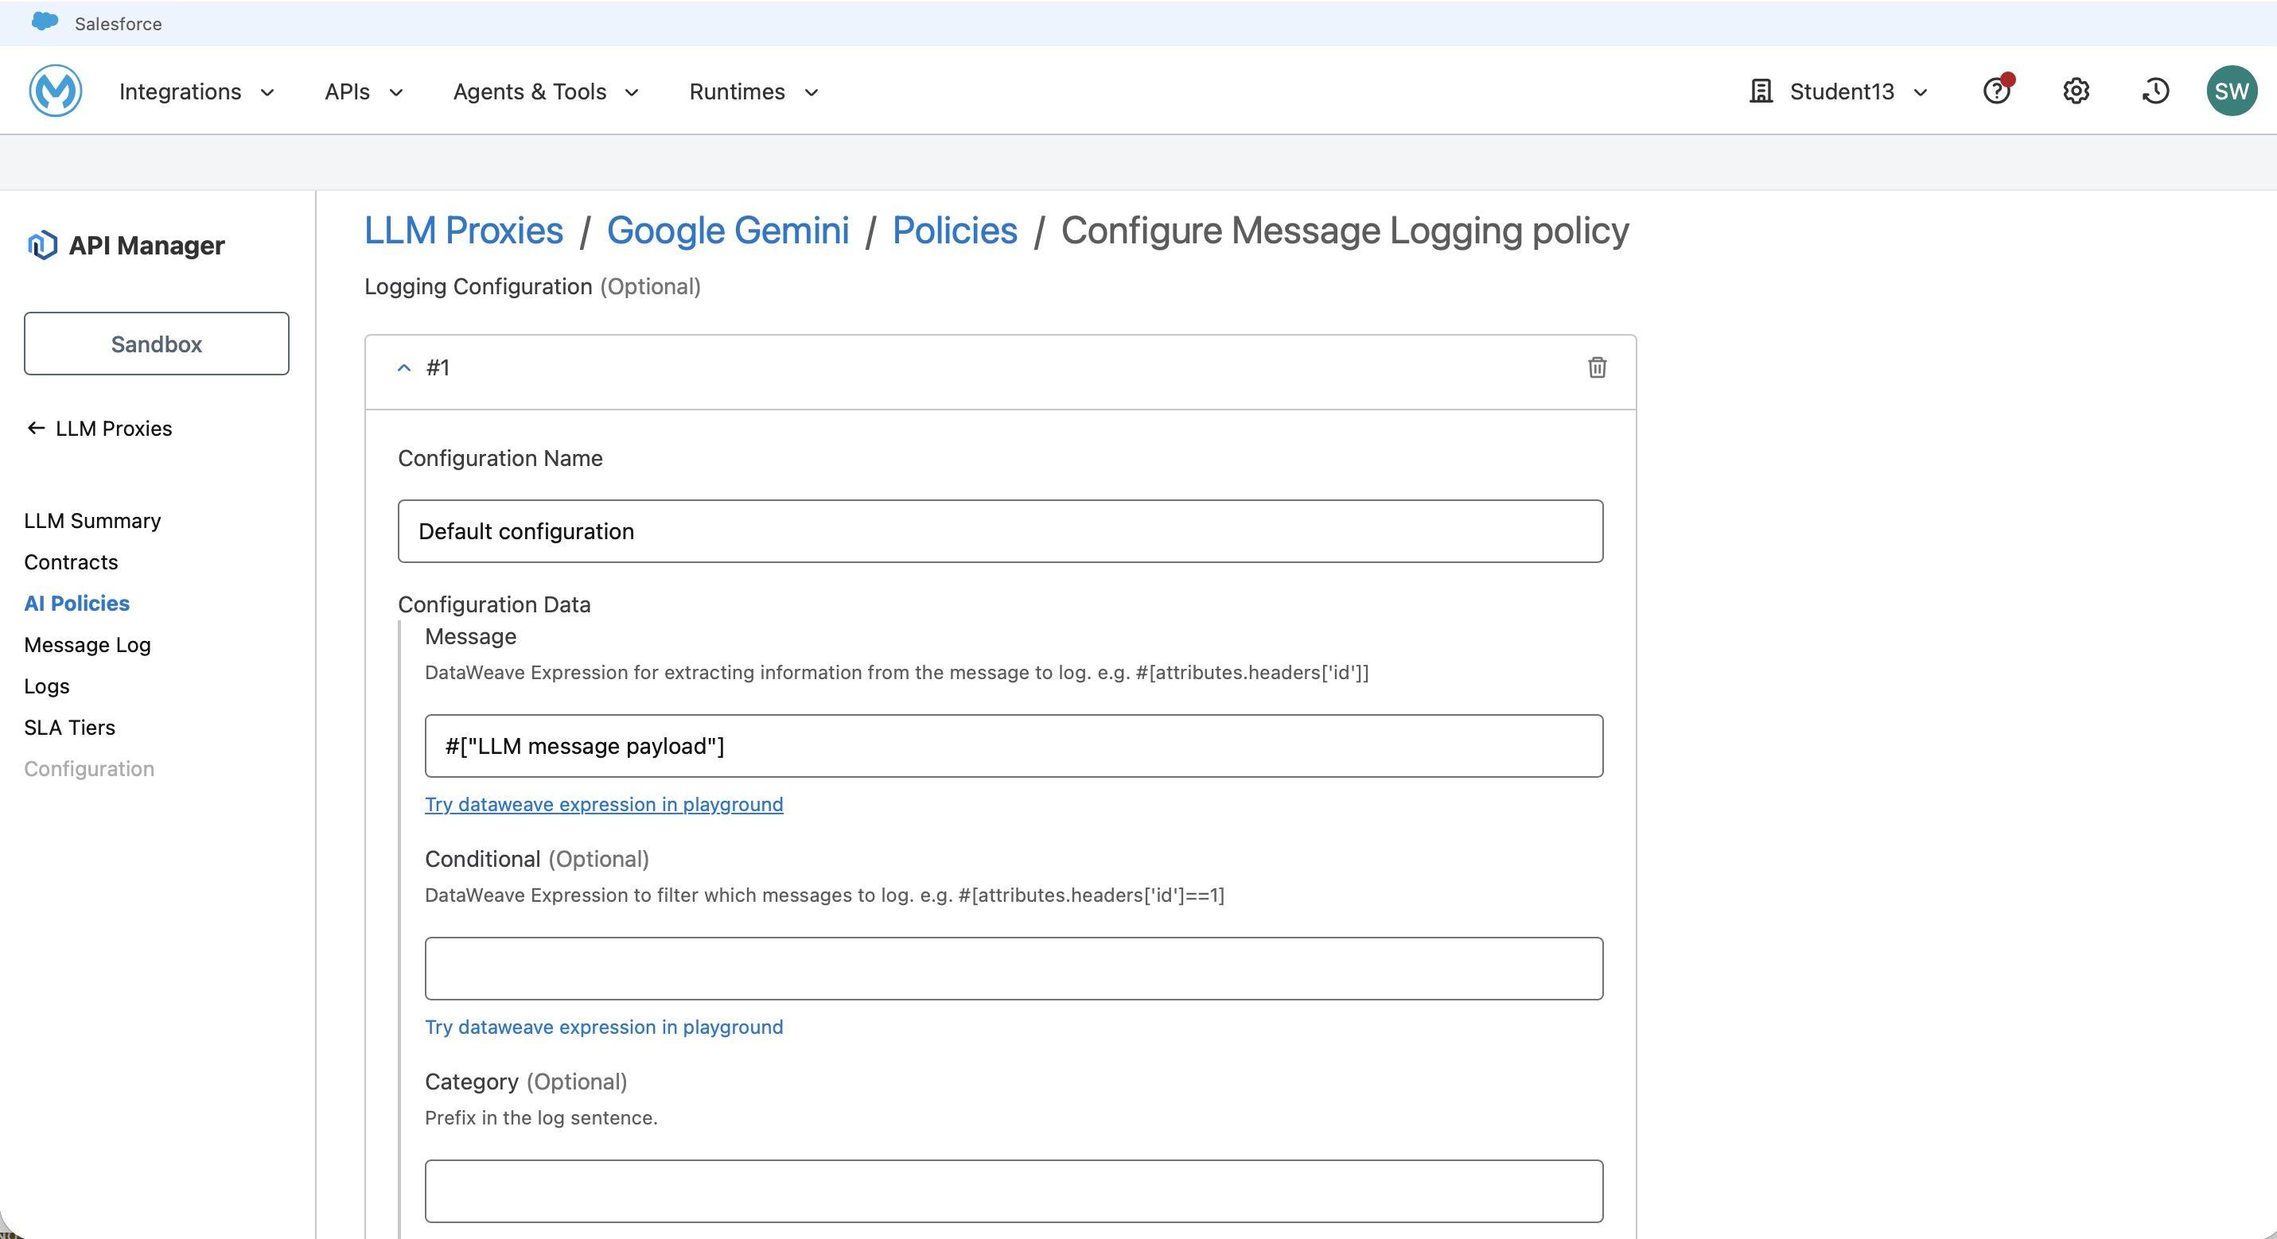
Figure 12 — Inbound policies: Tracing (TROUBLESHOOTING) and Agent Connection Telemetry (CUSTOM).
Important: The yellow warning banner in API Manager reads: This instance comes from an agent network project. Policy changes made here will be reverted next time it gets redeployed. This confirms that agent-network.yaml is the authoritative source of truth for all policy configuration.

6. Exercise 5 — Agent Visualizer & Distributed Tracing
Exercise 5 verified observability across two dimensions: the Agent Visualizer provided a real-time topological view of the deployed network, while Anypoint Monitoring Traces provided a span-level audit trail of individual requests.

6.1 Agent Visualizer — Live Network Topology
The Agent Visualizer at anypoint.mulesoft.com/visualizer/agentvisualizer/ displays the live topology of the deployed agent network. Filters were set to Business Group 'Student13', Environment 'Sandbox', Activity Period 'Last 7 days'.
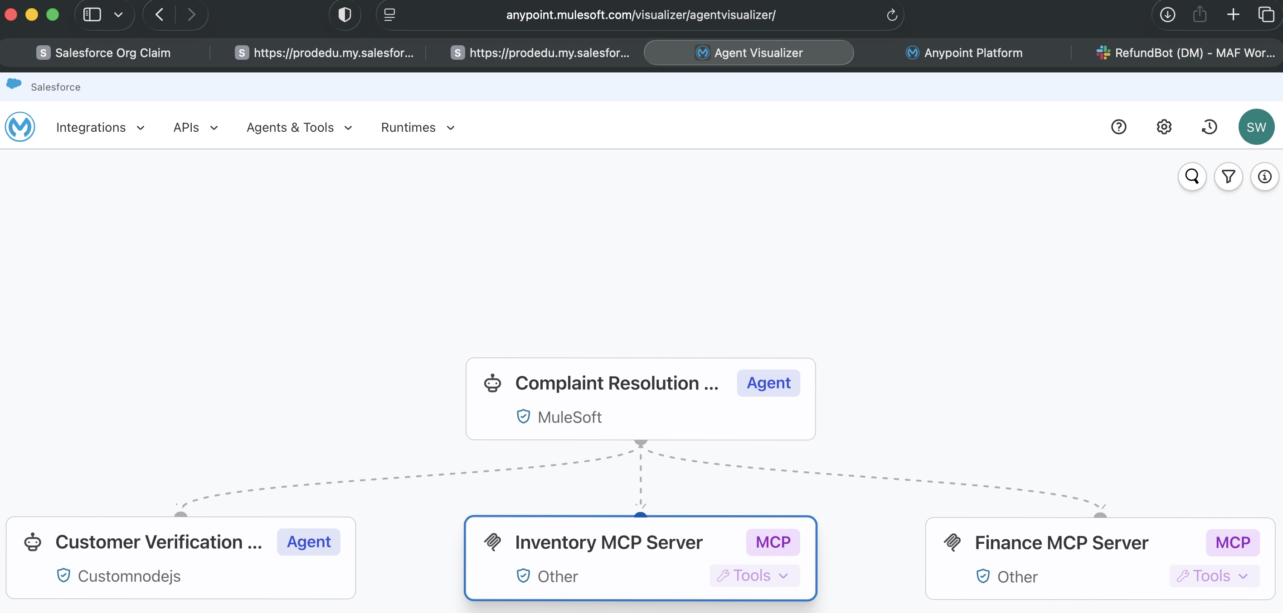
Figure 13 — Agent Visualizer: full topology graph. Complaint Resolution Broker (Agent/MuleSoft) connected to Customer Verification Agent (Agent/Customnodejs), Inventory MCP Server (MCP), and Finance MCP Server (MCP).
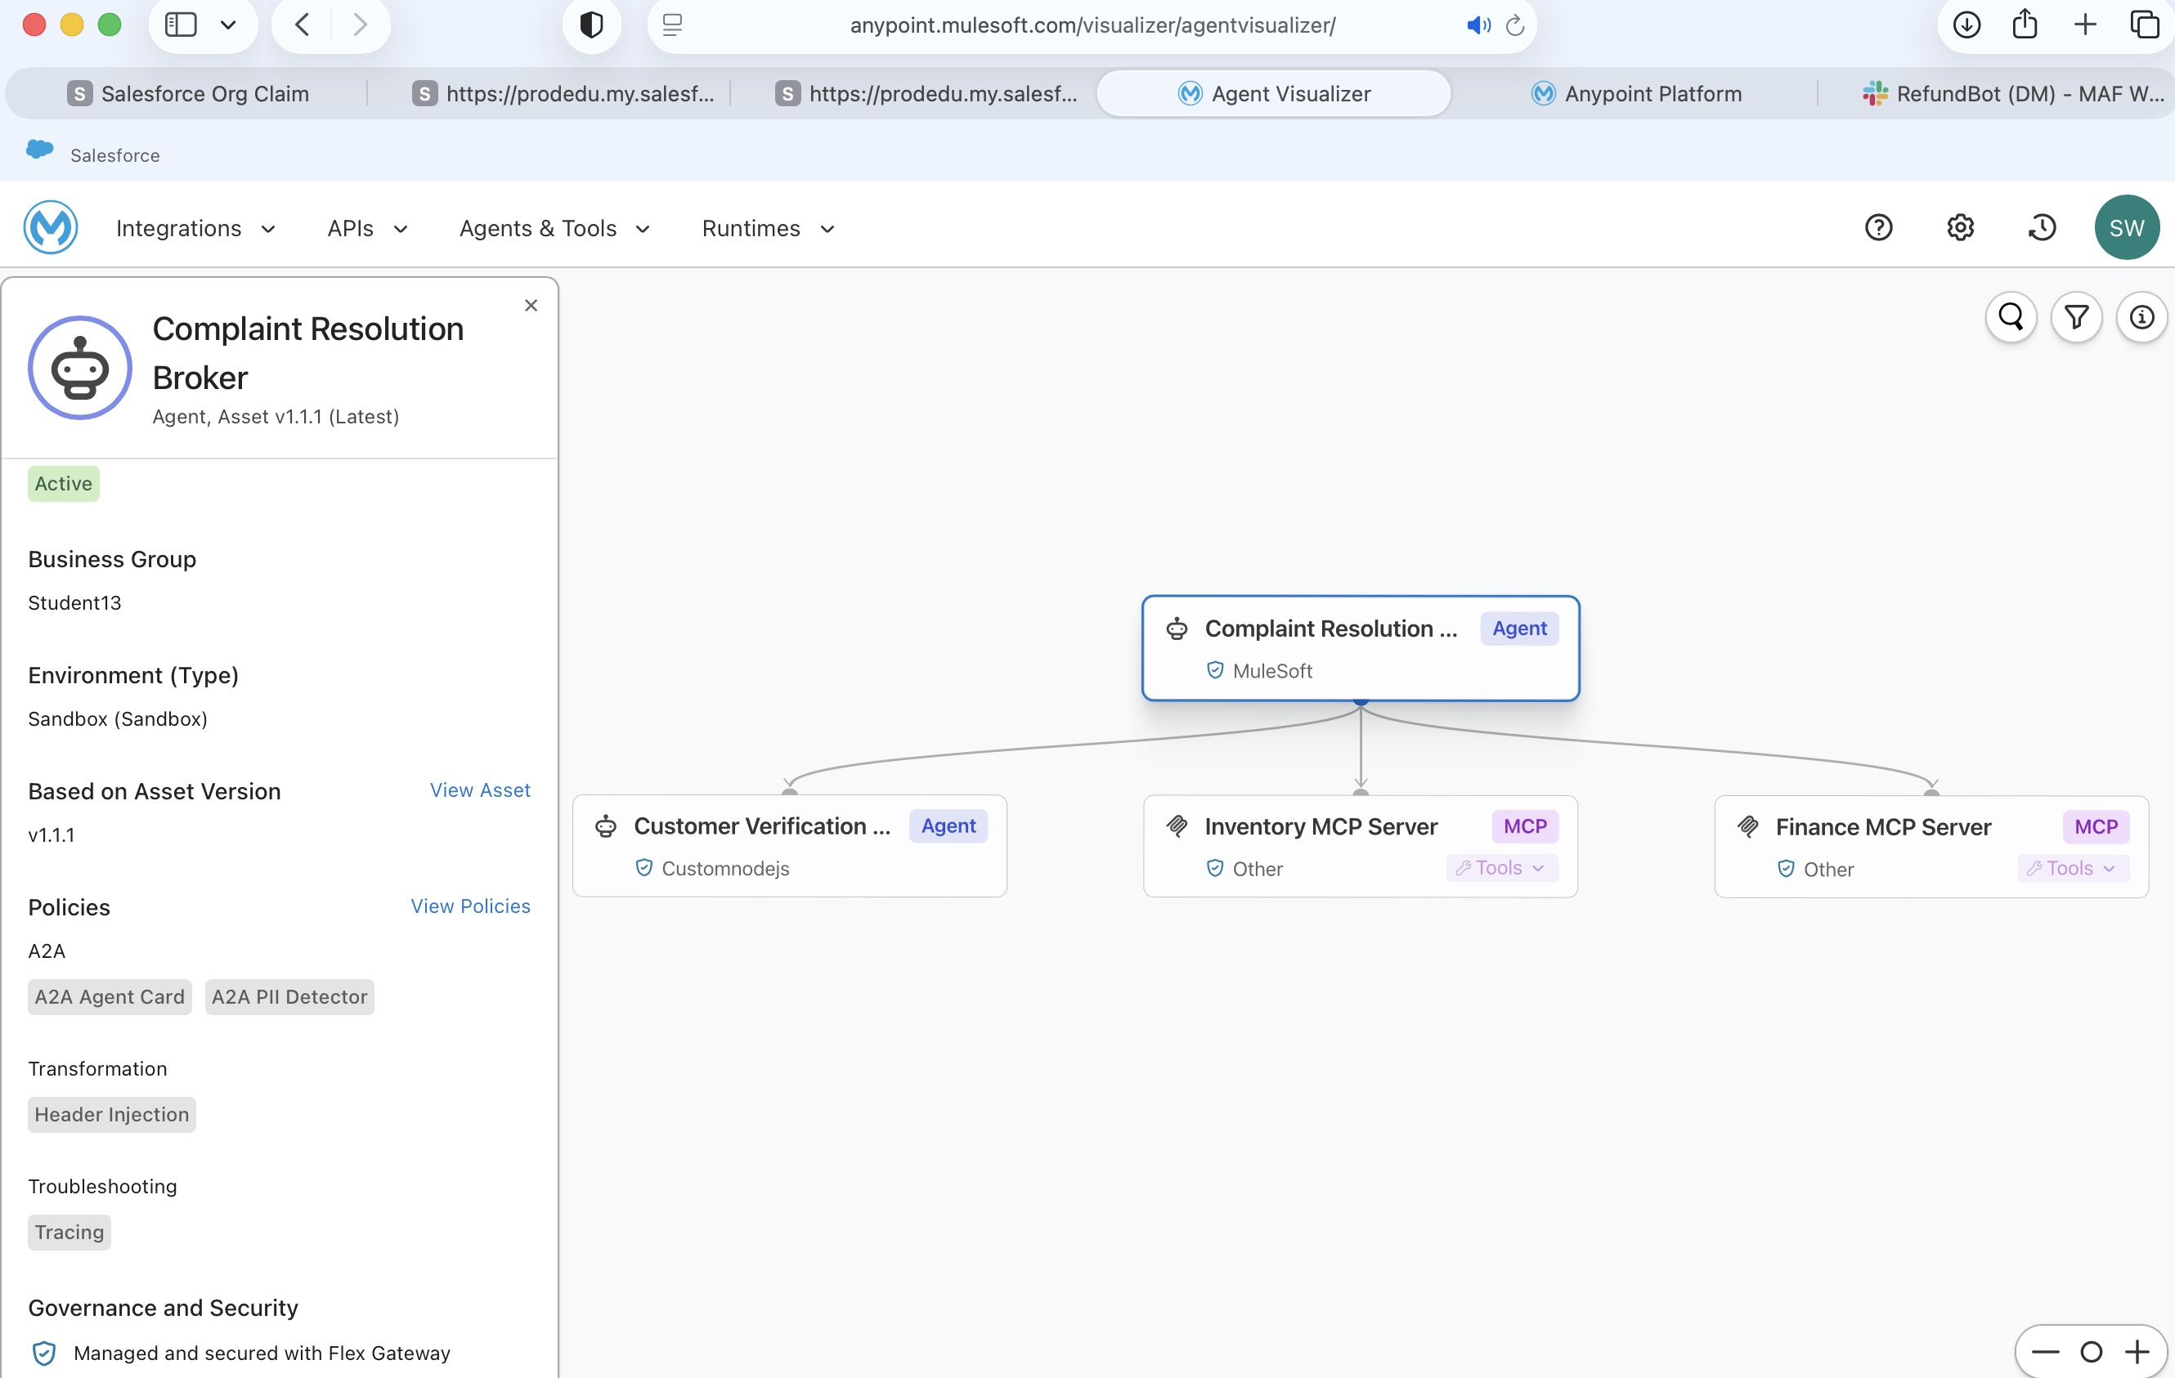
Figure 14 — Agent Visualizer: Broker detail panel confirming Active status, policies (A2A Agent Card, A2A PII Detector), and Flex Gateway governance.

Broker Detail Panel — Extracted Data
Field | Value
Status | Active
Business Group | Student13
Environment (Type) | Sandbox (Sandbox)
Based on Asset Version | v1.1.1
A2A Policies | A2A Agent Card · A2A PII Detector
Transformation | Header Injection
Troubleshooting | Tracing
Governance & Security | Managed and secured with Flex Gateway

6.2 Traces Overview — All Spans
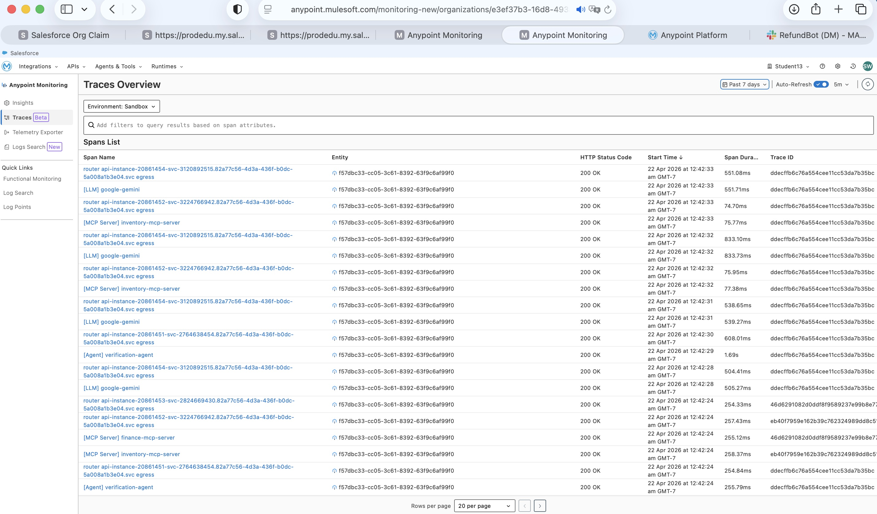
Figure 15 — Anypoint Monitoring Traces Overview: full span list for the Sandbox environment. All rows show 200 OK status with timestamps from 22 Apr 2026 at 12:42 am.
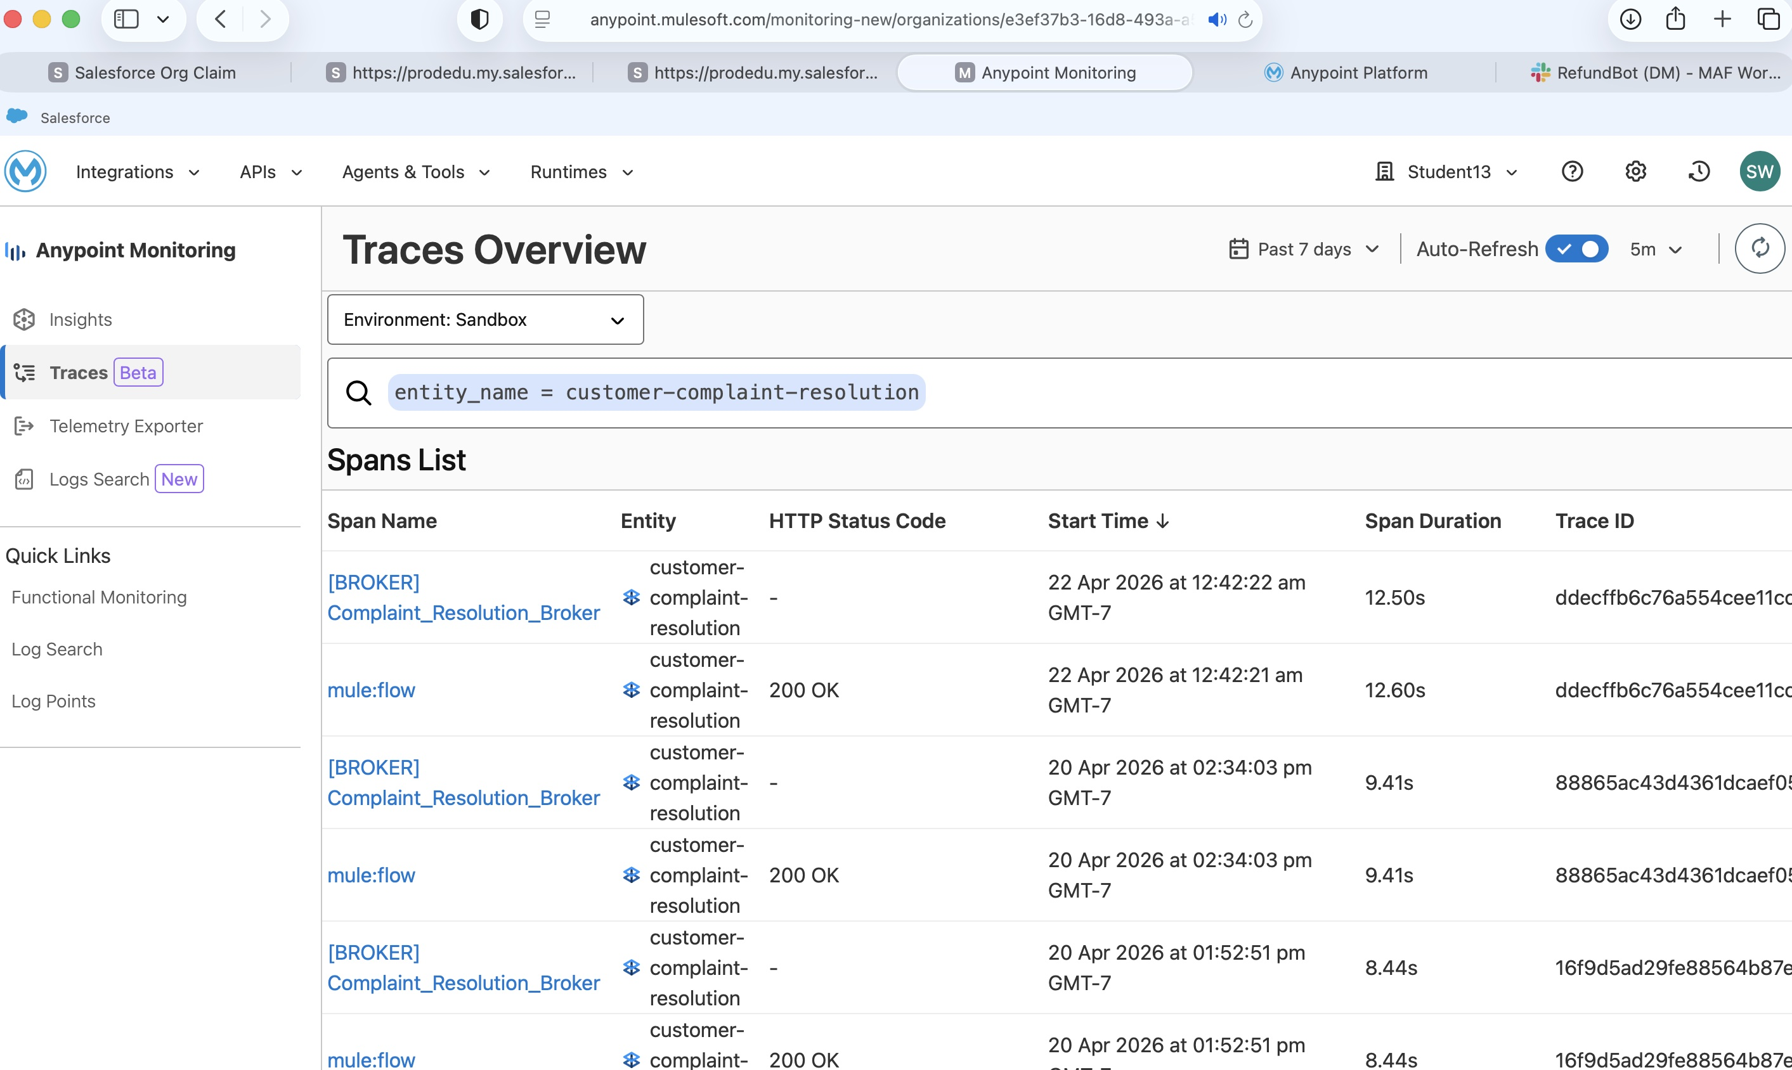
Figure 16 — Traces filtered by entity 'complaint-resolution-broker', showing only broker-rooted traces.

6.3 Distributed Trace — Successful 5-Step Run
The trace for a successful complaint resolution request confirms that all five orchestration steps executed, with LLM reasoning spans interleaved between agent and tool calls.
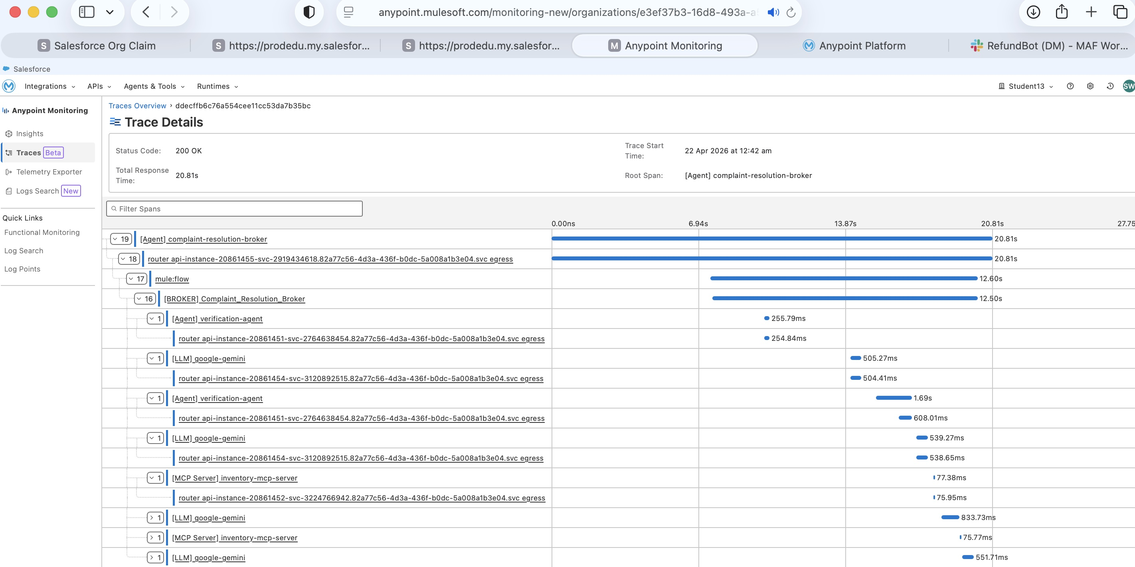
Figure 17 — Trace Detail: Trace ID ddecffb6c76a554cee11cc53da7b35bc. 200 OK · 20.81s · 19 spans. Full waterfall showing Agent, LLM, and MCP Server spans.

Verified Trace Metrics
Metric | Value
Trace ID | ddecffb6c76a554cee11cc53da7b35bc
Status Code | 200 OK
Total Response Time | 20.81 seconds
Trace Start | 22 Apr 2026 at 12:42 am
Root Span | [Agent] complaint-resolution-broker
Total Spans | 19

Span Hierarchy (key spans)
[Agent] complaint-resolution-broker 20.81s
mule:flow 12.60s
[BROKER] Complaint_Resolution_Broker 12.50s
[Agent] verification-agent 255.79ms ← Step 1: verify
[LLM] google-gemini 505.27ms ← LLM reasoning
[Agent] verification-agent 1.69s ← A2A response
[LLM] google-gemini 539.27ms ← LLM plans steps 2-5
[MCP Server] inventory-mcp-server 77.38ms ← Step 2: create return
[LLM] google-gemini 833.73ms ← Steps 3+4 (parallel)
[MCP Server] inventory-mcp-server 75.77ms ← Step 3: return label
[LLM] google-gemini 551.71ms ← Step 5: ledger
Observation: Steps 3 (generate_return_label) and 4 (process_refund) produced overlapping spans in the trace waterfall, confirming that the Gemini orchestrator executed them in parallel as instructed. The Finance MCP Server spans appear within the same time window as the final Inventory MCP Server call.

6.4 Distributed Trace — PII Rejection (401)
A message containing a US SSN ('000-11-1111') was submitted to verify the PII Detector policy. The trace demonstrates that the message was stopped at the Flex Gateway ingress layer — the Gemini LLM was never invoked.
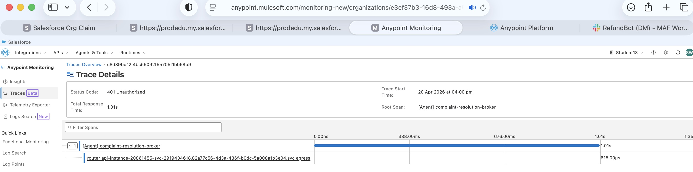
Figure 18 — Trace Detail: 401 Unauthorized. 1.01s total. Only 1 span — no LLM or MCP Server spans. SSN blocked at gateway before reaching the LLM.

PII Rejection Metrics vs. Success Metrics
Metric | Success (clean message) | PII Rejection (SSN in message)
HTTP Status | 200 OK | 401 Unauthorized
Total Response Time | 20.81s | 1.01s
Span Count | 19 | 1
LLM Spans | 4 (google-gemini) | 0 — LLM never called
MCP Server Spans | 2 (inventory + finance) | 0 — No tool calls
Trace Start | 22 Apr 2026 12:42 am | 20 Apr 2026 04:00 pm

This comparison is central to the governance argument: centralised enforcement at the gateway layer is categorically different from filtering inside agent code. The SSN cannot be memorised, logged, or accidentally forwarded by the LLM because the request is terminated at the network boundary before the Mule flow begins.

6.5 Log Search — Structured Logs from Trace
From the trace detail view, structured application logs were retrieved via Anypoint Monitoring Log Search, confirming that all runtime events are searchable, filterable, and correlated to their parent trace.
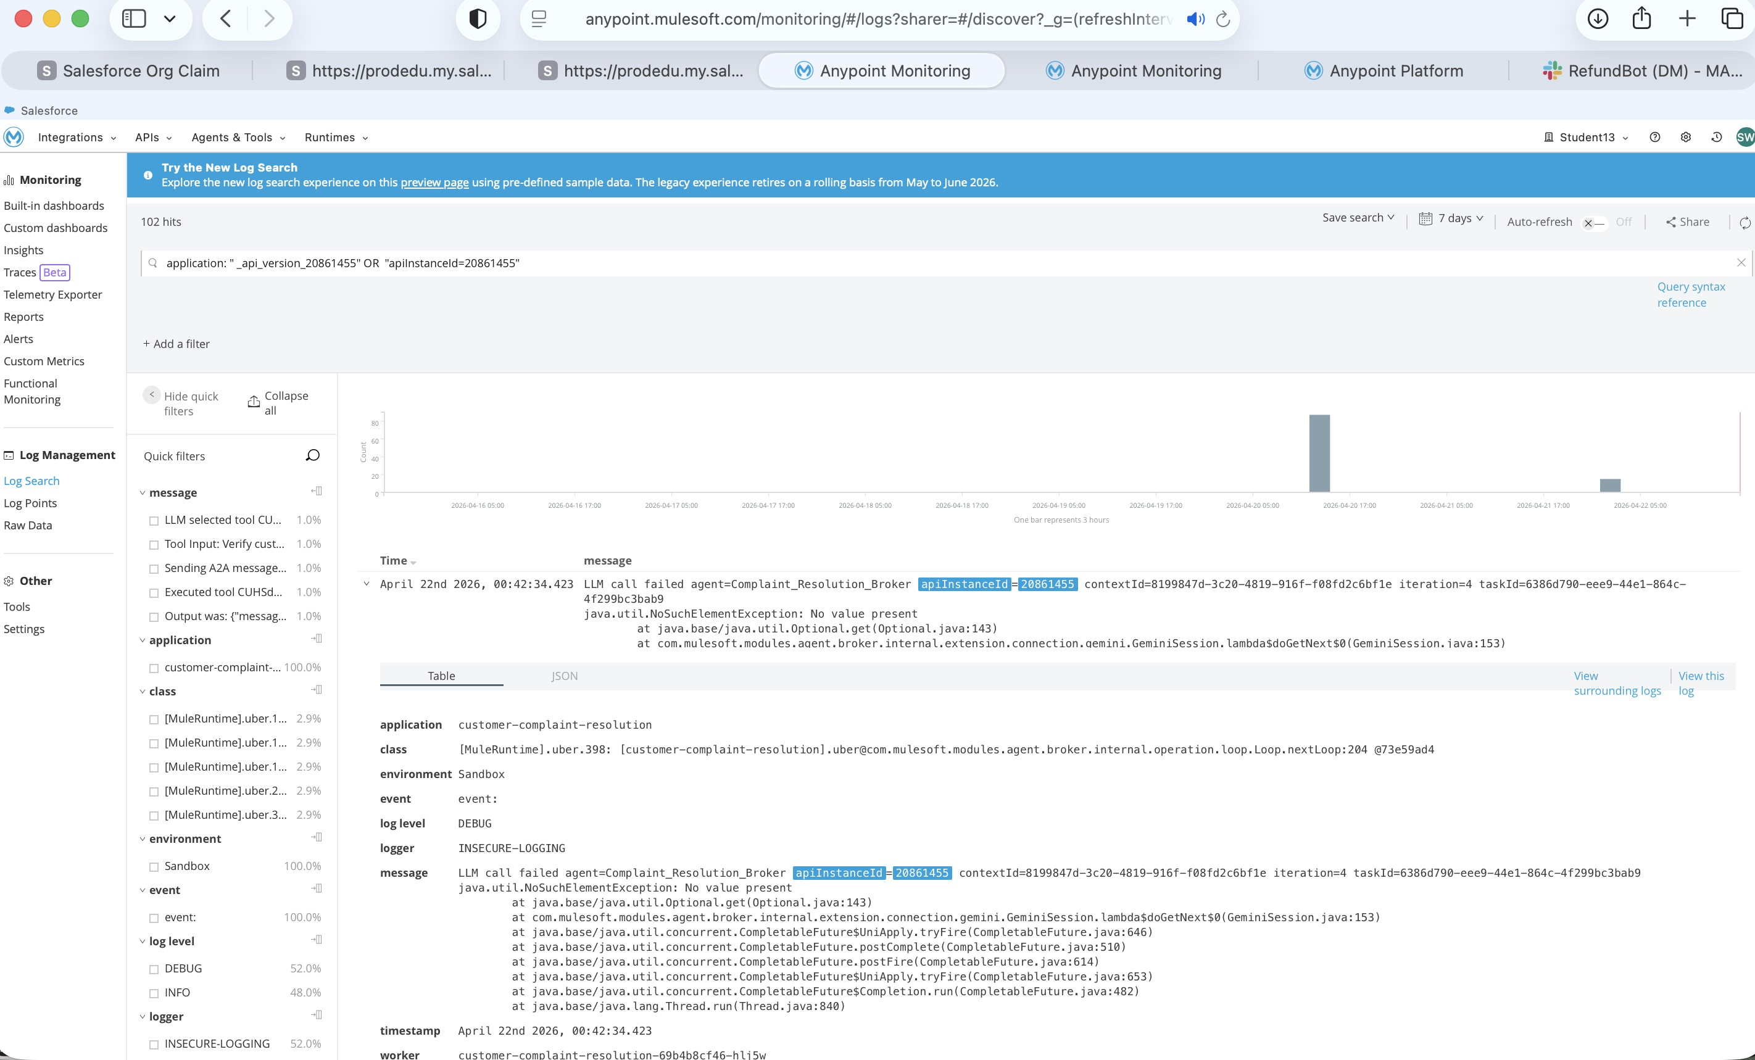
Figure 19 — Anypoint Log Search: 102 hits linked to the trace. Structured JSON log entries from the Mule worker, class INSECURE-LOGGING.

Extracted Log Metadata
Field | Value
Application | customer-complaint-resolution
Log Count | 102 hits
Logger | INSECURE-LOGGING
Log Level | DEBUG
Worker ID | customer-complaint-resolution-00b4bc746-hl15u
Timestamp | 22 Apr 2026, 00:42
Log Class | MuleRuntimeJwt...[Customer-complaint-resolution.uber...]

7. Technical Notes for Scientific Publication
This section summarises the novel technical observations from the implementation that are relevant for academic reference.
- MCP Transport: MuleSoft Agent Fabric uses streamableHttp (not HTTP+SSE) as the MCP transport for tool server connections. This is a bidirectional streaming HTTP protocol that supports server-side push without requiring SSE infrastructure.
- Schema Flattening Workaround: A known limitation in MuleSoft's ToolUtils.java prevents nested object properties in MCP tool input schemas. Customer address fields were therefore declared as six separate top-level strings (customerAddressName, customerAddressStreet, etc.) rather than a nested address object. This represents an active platform constraint as of April 2026.
- OpenAI Strict Mode Compatibility: All tool schemas use additionalProperties: false and declare every property in required[], including a contextId field. This satisfies OpenAI Strict Mode validation used by the Gemini gateway adapter. The contextId also serves as a distributed trace correlation key, linking all spans in a single orchestration run.
- Gateway-Level PII Enforcement: The A2A PII Detector policy operates at the Flex Gateway ingress layer, prior to the Mule flow execution. This is evidenced by the trace comparison: a rejected message produces a single span (no mule:flow child span), while a successful message produces 19 spans including flow execution, LLM calls, and MCP tool calls. The LLM cannot observe PII because the request never enters the runtime.
- Parallel Orchestration: The Gemini LLM orchestrator, when instructed that two steps are independent, executes them concurrently. This was confirmed by overlapping MCP Server and LLM spans in the trace waterfall for steps 3 (generate_return_label) and 4 (process_refund). This demonstrates that LLM-based orchestration can reason about causal dependencies and optimise execution paths without explicit parallel execution constructs.
- Agent Visualizer Governance Confirmation: The Anypoint Agent Visualizer displays active governance policies on each broker node. The presence of the 'A2A PII Detector' badge and 'Managed and secured with Flex Gateway' label in the detail panel confirms that governance is structurally enforced — not just configured but verifiably active in the deployed runtime.

8. Figure Index
Figure | Description | Source Screenshot
1 | Add Exchange Assets dialog — A2A PII Detector selected | Exercise 4 – Task 2-1.jpg
2 | Terminal: 36 assets published to Exchange | Exercise 4 – Task 2-5.jpg
3 | Slack: RefundBot returns REF000002 + Shipping Label URL | Chat-success-with-agents.jpg
4 | Slack thread: full resolution conversation | Chat-success-with-agents-more.jpg
5 | YAML policy snippet in Anypoint Code Builder | Exercise 4 – Task 2-2.jpg
6 | exchange.json dependency block added | Exercise 4 – Task 2-3.jpg
7 | API Manager: PII Detector policy active | Exercise 4 – Task 2-6.jpg
8 | Policy detail: entity=US SSN, action=Reject | Exercise 4 – Task 2-7.jpg
9 | Test request containing SSN 000-11-1111 | Exercise 4 – Task 2-8.jpg
10 | HTTP 401 Unauthorized response | Exercise 4 – Task 2-9.jpg
11 | API Manager: LLM Proxies → Google Gemini → Policies | google-gmi-polices-add-1.jpg
12 | Inbound policies: Tracing + Agent Connection Telemetry | google-gmi-polices-add-3.jpg
13 | Agent Visualizer: full topology graph | Ex5-Student-Task1-1-AgentVisualizer-Initial.jpg
14 | Agent Visualizer: Broker detail panel | Exercise-5-Task-1-2-Agent-Visualizer-Broker-Details.jpg
15 | Traces Overview: all spans list | Exercise-5-Task-2-0-All-Traces-List.jpg
16 | Traces filtered by complaint-resolution-broker | Exercise-5-Task-2-1-Traces-List-Broker-Filtered.jpg
17 | Trace Detail: 200 OK · 20.81s · 19 spans | Exercise-5-Task-2-2-Trace-Success-Full-Flow.jpg
18 | Trace Detail: 401 Unauthorized · 1.01s · 1 span | Exercise-5-Task-2-3-Trace-Error-PII-401.jpg
19 | Log Search: 102 hits from trace | Exercise-5-Task-2-4-Logs-From-Trace.jpg

TDX 2026 · Session 1557 · Md Helal · Student13 / Sandbox · April 2026

