Heaven’s Light is Our Guide



*Rajshahi University of Enginnering & Technology*

*Course No : CSE 3200*

*Course title : Software Development Project II*

***Submitted To :***

Md. Shahid Uz Zaman

*Professor,*

*Department of Computer Science and Engineering*

*Rajshahi University of Engineering and Technology*

***Submitted by :***

*Sujon Ali*

*Roll : 1803100*

*Section : B*

*Department of Computer Science and Engineering*

*Rajshahi University of Engineering and Technology*

***Project Type :*** Web Based Application.

***Project Title :*** Gymnasium Management Website.

**Github Link :** ***https://github.com/sujoncse1803100/PROJECT-CSE-3200***

***Description :***

This is a gymnasium management website , where a organization provides health support by various kinds of exercise.

As a public visitor of the website can see the functionality related to the gym. He can get the information about the gym organization, kinds of services, quality of services, price of these services.

If anyone is interested to enroll to the any type of service then he can do it by provides some basic information and after make payment he can confirm his membership.

As a member of this organization a person can see his details after login .

**Technology :**

1. **Frontend : -** React.js, Bootstrap, JavaScript
2. **Backend :-** Node.js, express.js
3. ***Database :-*** MongoDB

***Functionality and Word Flow :-***

Classes Page

Home Page

Pricing Page

Membership Page

Form Fillup Page

Make Payment Page

Payment Succefull ?

NO

YES

**Live Screenshoot :**

**Home Page:**

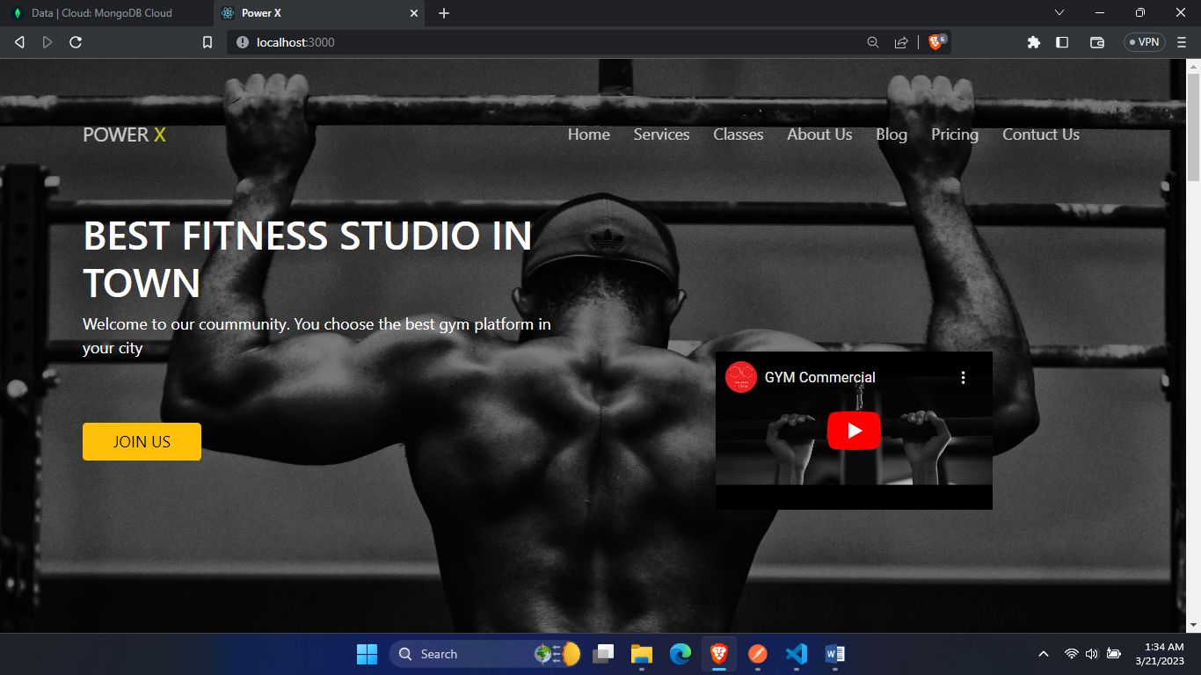

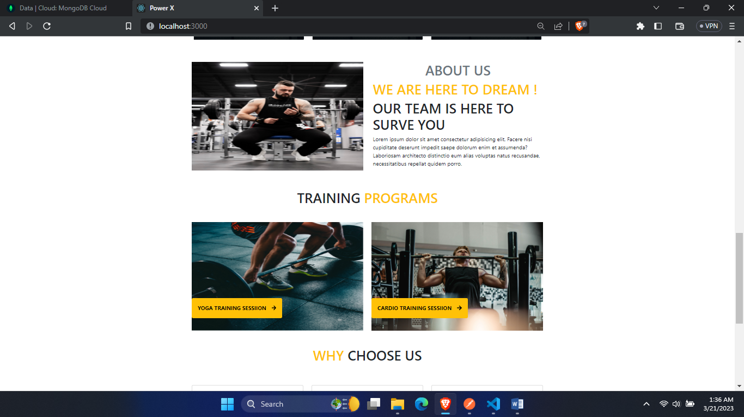

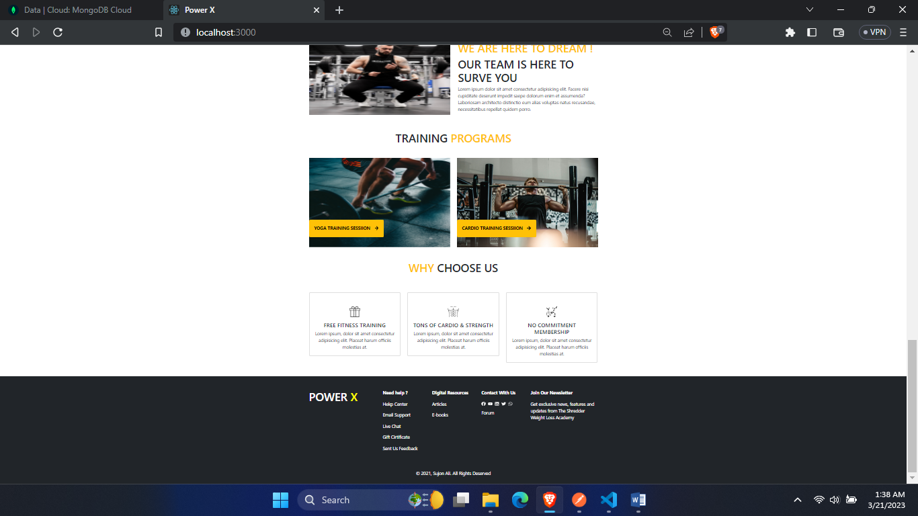

**Pricing Page :**



**Classes Page :**

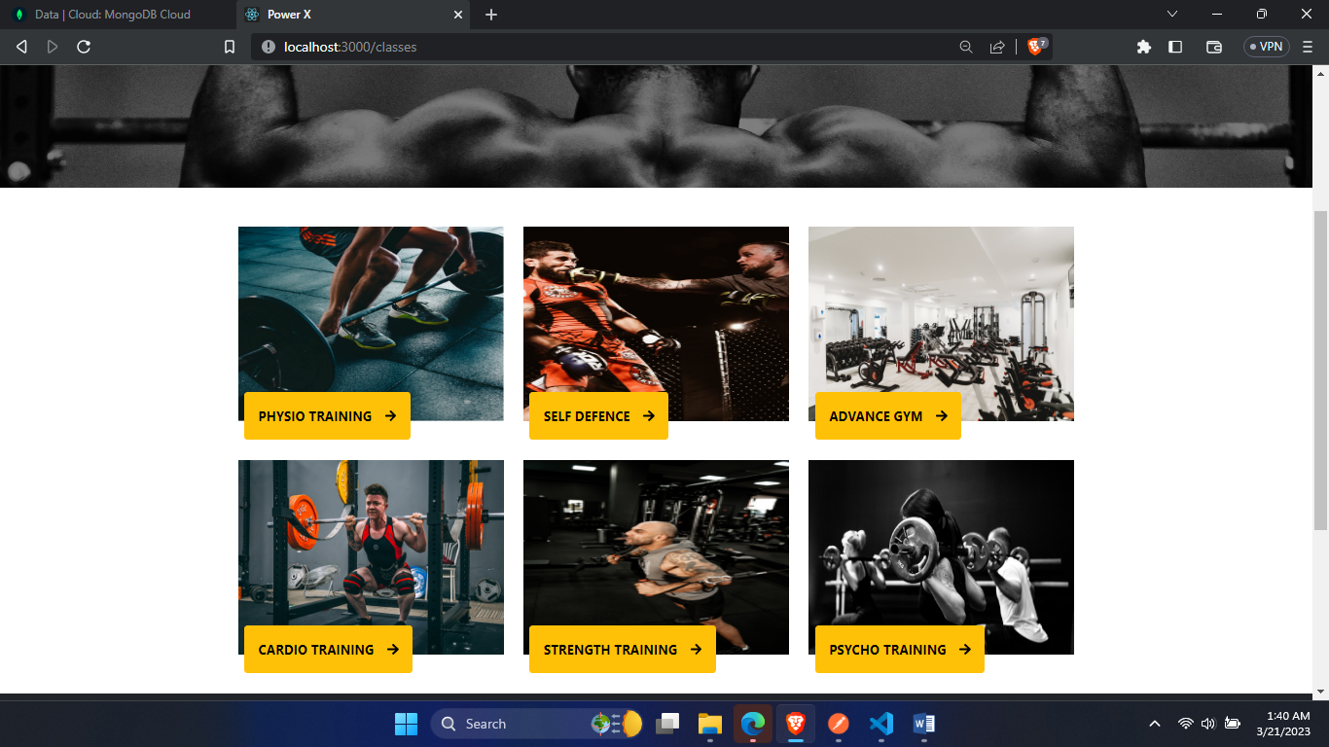

**Particular Class Page:**

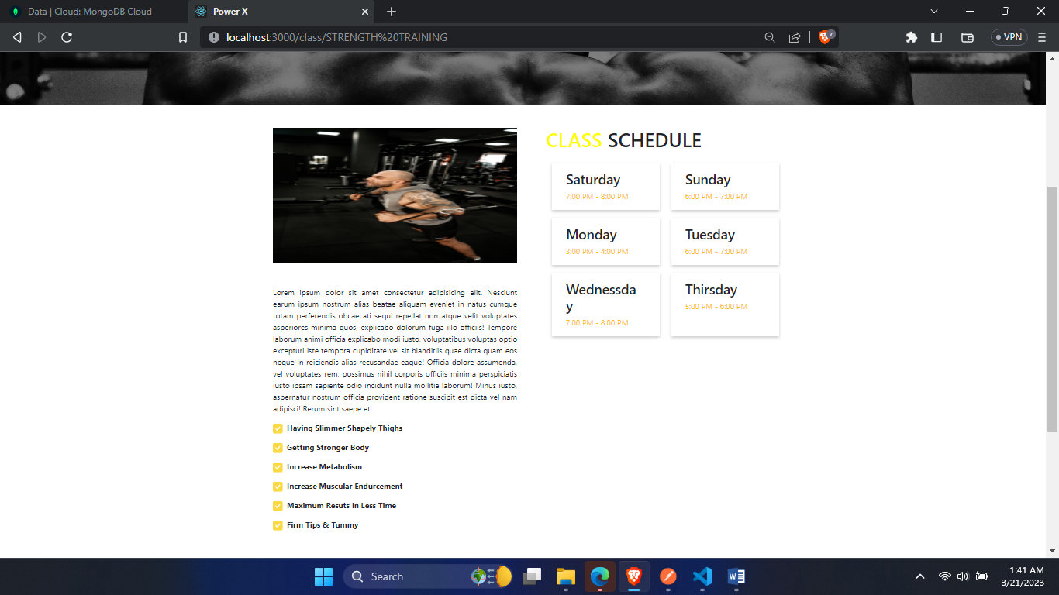

**Membership Page :**

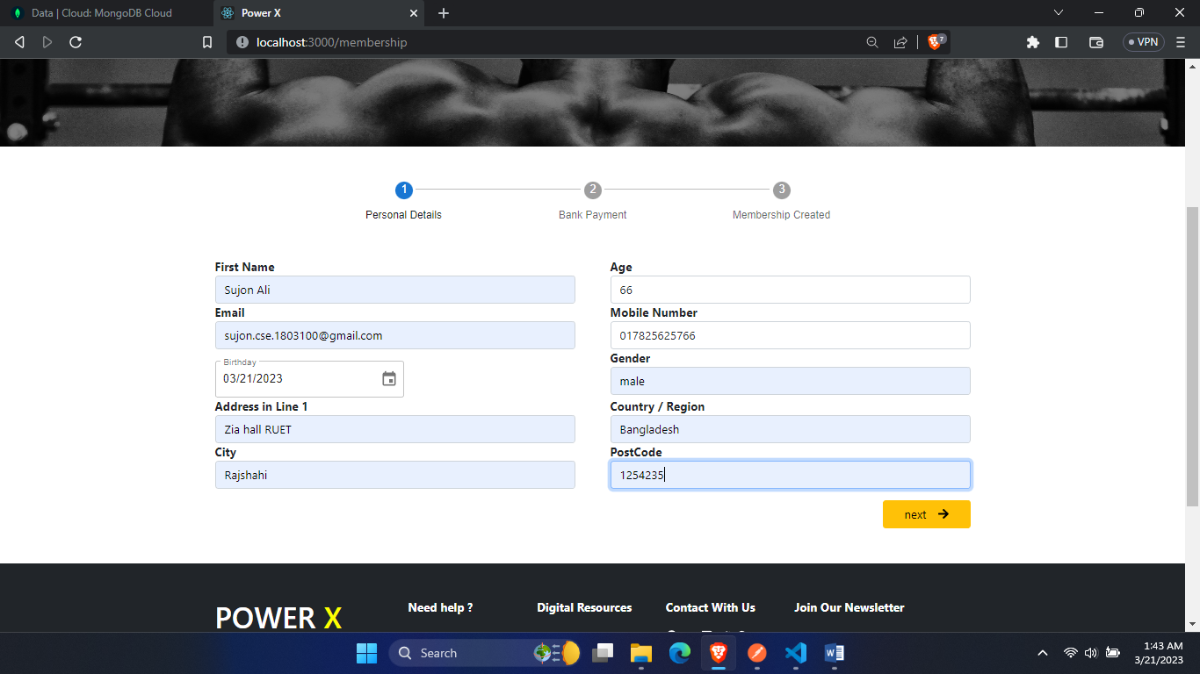

**Payment Page :**

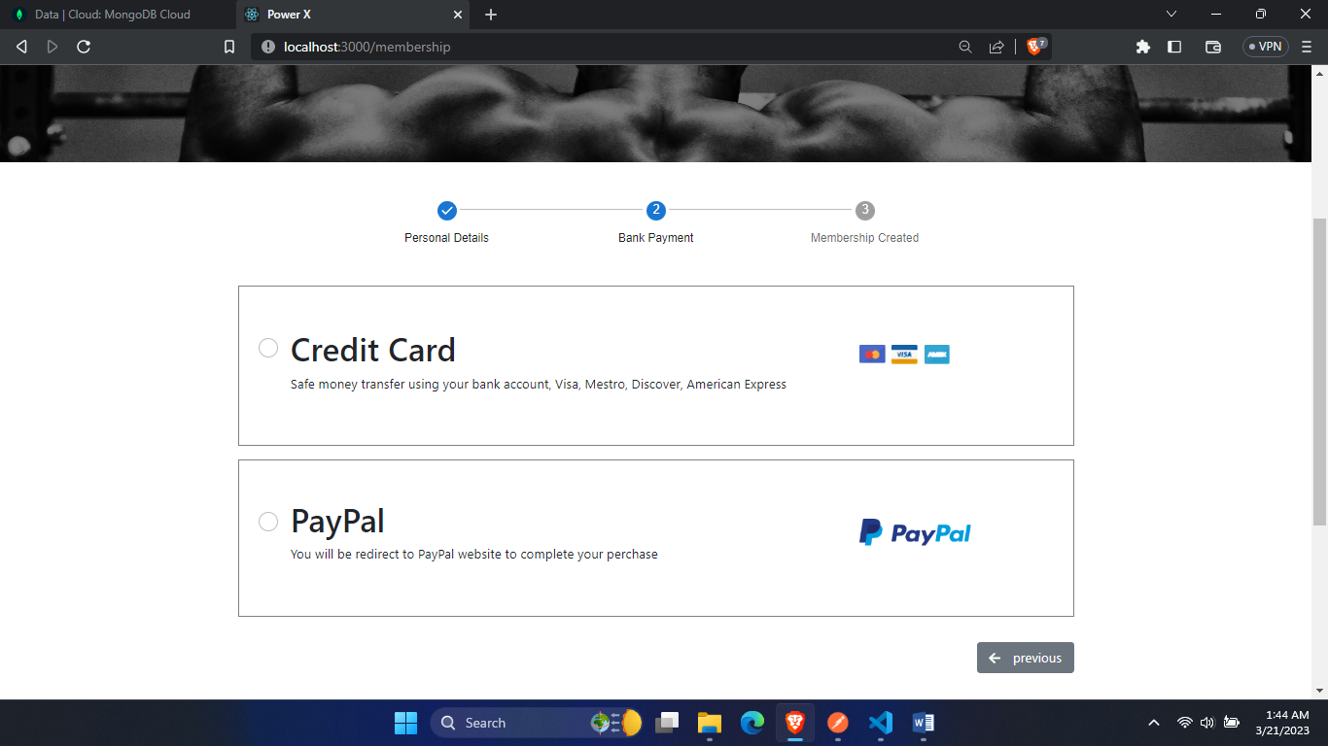

**Congratulations Page :**

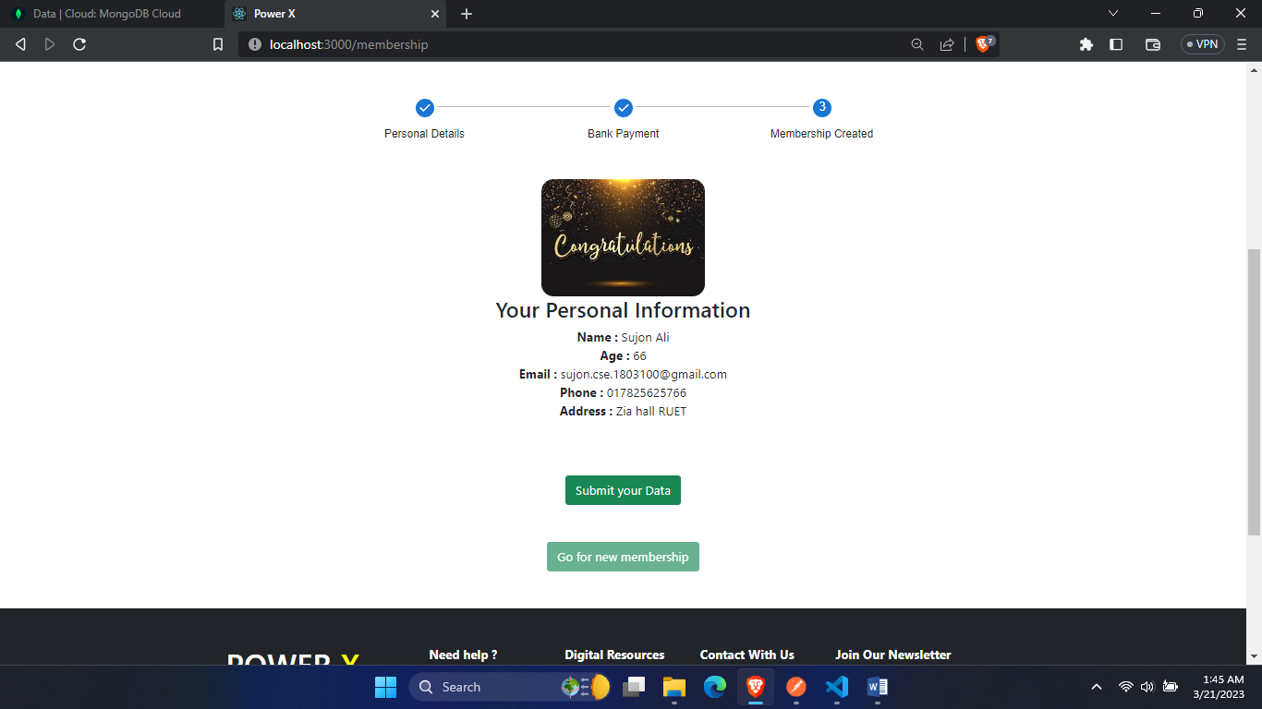

**Footer Page :**

