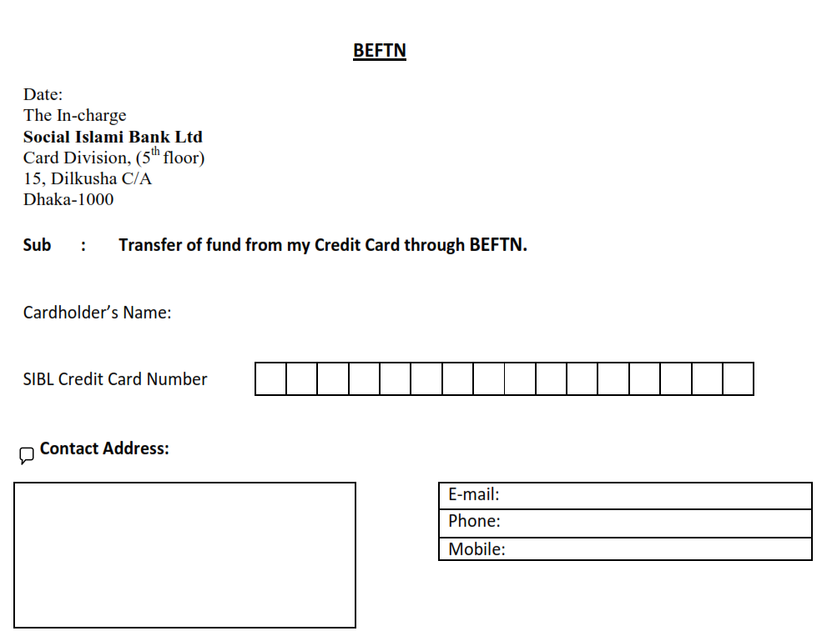

12-Jun-16

**Md. Mahfuzur Rahman**

**4 3 7 5 9 5 6 5 3 2 0 3 9 1 7 1**

438/3 West Shewrapara, Mirpur, **mahfuzak08@gmail.com**

Dhaka.

**01922592321**

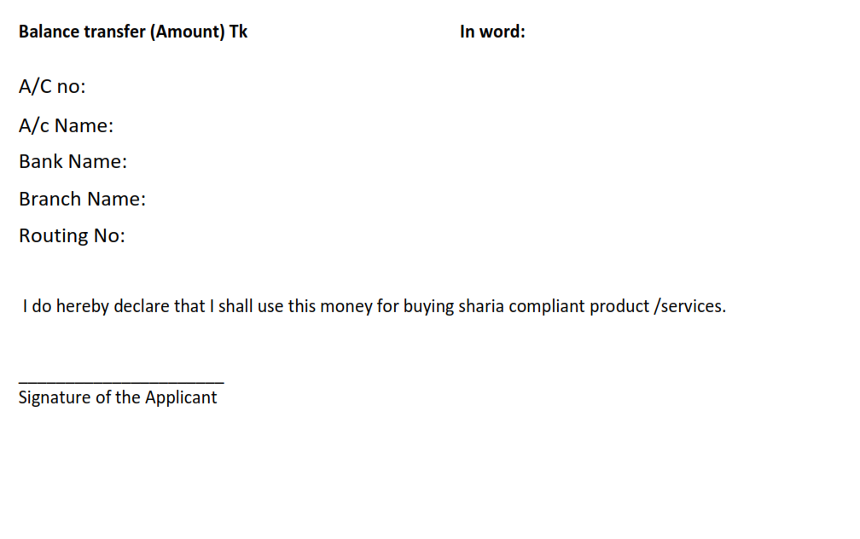

**50,000.00** **Fifty thousand taka only**.

**116.101.137870**

**Md. Mahfuzur Rahman**

**Dutch-Bangla Bank Limited**

**Gulshan Branch**

**090261725**