Anas Malkawi

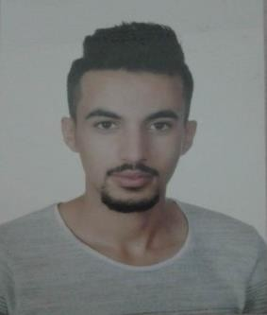

# P E R S O N A L I N F O R M A T I O N

Date of Birth: 27/8/1997

E-MAIL: [anas.malkawi997@gmail.com](mailto:anas.malkawi997@gmail.com) Address: Amman

Nationality: Jordanian Phone: 0787618080

# E D U C A T I O N

High school (information technology) in 2015.

# E X P E R I E N C E

Call center at Al akeel restaurant

Driver at Al akeel restaurant

Sales at Markdown

Workers supervisor at Ibrahim Al Jaloudy construction

# S K I L L S

Ability to work within groups

Driven license

**Anas Malkawi**

Ability to work under stress

Good communication skills

# L A N G U A G E S

Arabic (Mother Language).

English (Good Writing, Reading and Speaking).

Page 2