|  |
| --- |
| Anas Malkawi |

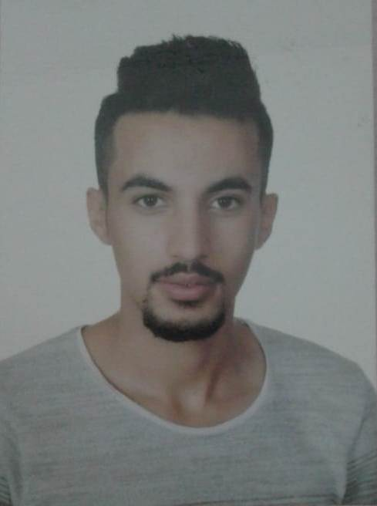

**Personal Information**

# Date of Birth: 27/8/1997

# E-MAIL: anas.malkawi997@gmail.com

# Address: Amman

# Nationality: Jordanian

# Phone: 0787618080

# Education

# High school (information technology) in 2015.

# experience

#  Call center at Al akeel restaurant

#  Driver at Al akeel restaurant

#  Sales at Markdown

#  Workers supervisor at ibrahim al jaloudy construction

# Skills

#  Ability to work within groups

#  Driven license

#  Good planning

#  Ability to work under stress

#  Good communication skills

# Languages

 Arabic (Mother Language).

 English (Good Writing, Reading and Speaking).