Python-Based Analysis of Coastal Water Level Variability and Extreme Events (1986–2024)
Long-term tidal observation analysis using a reproducible Python workflow

Abstract
Extreme coastal water levels are important indicators of coastal hazards, especially in low-lying deltaic environments. This study presents a reproducible Python-based workflow for analysing long-term tidal water level observations from 1986 to 2024. The analysis included data preprocessing, descriptive statistics, annual maximum extraction, seasonal assessment, and threshold-based identification of extreme high-water events. After quality control, 12,694 daily observations were analysed using Pandas, NumPy, and Matplotlib. The highest observed daily maximum water level was 2.950 mMSL on 27 May 2024. The developed workflow demonstrates the application of open-source computational tools for coastal hydrological data analysis.
Keywords: Coastal water level; Extreme events; Tidal variability; Python; Time-series analysis; Coastal hazards

1. Introduction
Coastal environments are continuously influenced by natural processes including astronomical tides, meteorological forcing, storm surges, and local coastal conditions. In Bangladesh, where large populations and infrastructure are concentrated in low-lying coastal areas, understanding water level variability is essential for coastal hazard assessment and planning.
Extreme high-water events represent short-duration but high-impact conditions that can increase coastal flooding risk and affect communities, infrastructure, and ecosystems. Therefore, long-term observational records are valuable for identifying patterns, evaluating variability, and understanding the temporal behaviour of extreme events.
With the advancement of computational techniques, reproducible data analysis frameworks have become increasingly important in hydrological research. Python provides an efficient environment for processing large time-series datasets, performing statistical analysis, and producing scientific visualizations. The objectives of this study were to: (i) evaluate annual maximum water level variability, (ii) identify extreme high-water events, and (iii) investigate seasonal characteristics of extreme water levels.

2. Data and Methodology

2.1 Dataset Description
The dataset consists of daily tidal water level observations covering the period 1986–2024. After preprocessing and removal of incomplete records, 12,694 observations were retained. The variables used in the analysis are summarized in Table 1.
Table 1. Description of variables used in the coastal water level analysis.
Variable | Description
Date | Observation date
Daily Max WL (mMSL) | Daily maximum water level
Daily Min WL (mMSL) | Daily minimum water level
Daily Avg WL (mMSL) | Daily average water level

2.2 Data Processing and Analysis
The analysis followed a structured workflow consisting of data import, preprocessing, statistical analysis, extreme event identification, and visualization. Pandas was used for data management, NumPy for numerical calculations, and Matplotlib for graphical representation.

3. Results and Discussion

3.1 Annual Maximum Water Level Variability
Annual maximum water levels were extracted from daily observations to evaluate temporal variability. As shown in Figure 1, considerable year-to-year variation was observed. Linear trend analysis indicated an increasing tendency of approximately 0.00517 m/year, corresponding to approximately 0.207 m over the study period. However, the low R² value (0.033) indicates that extreme water level variability is controlled by multiple interacting processes rather than a simple linear trend.
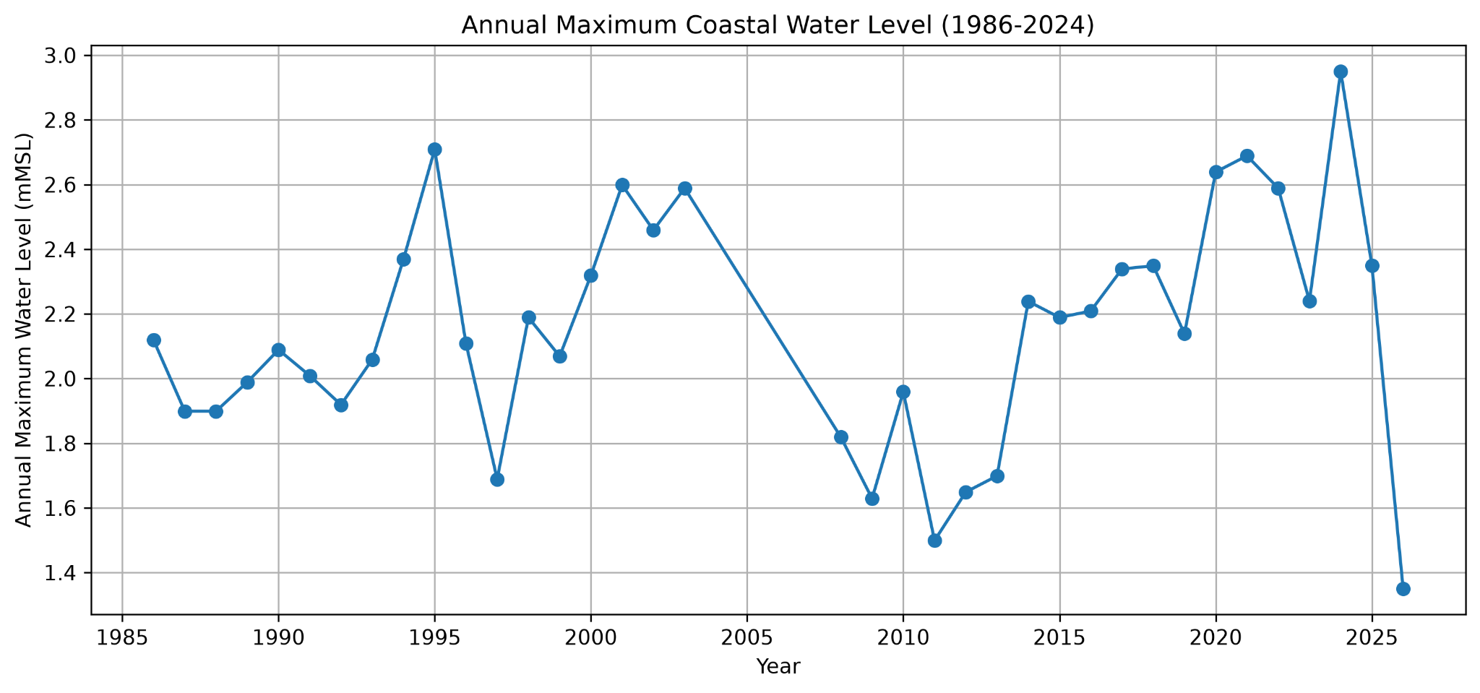
Figure 1. Annual maximum coastal water level variability during 1986–2024.

3.2 Identification of Extreme High-Water Events
Extreme events were identified using a threshold of Daily Maximum Water Level greater than 2.5 mMSL. As presented in Figure 2, twelve extreme events were detected during the study period. The highest recorded event occurred on 27 May 2024, reaching 2.950 mMSL.
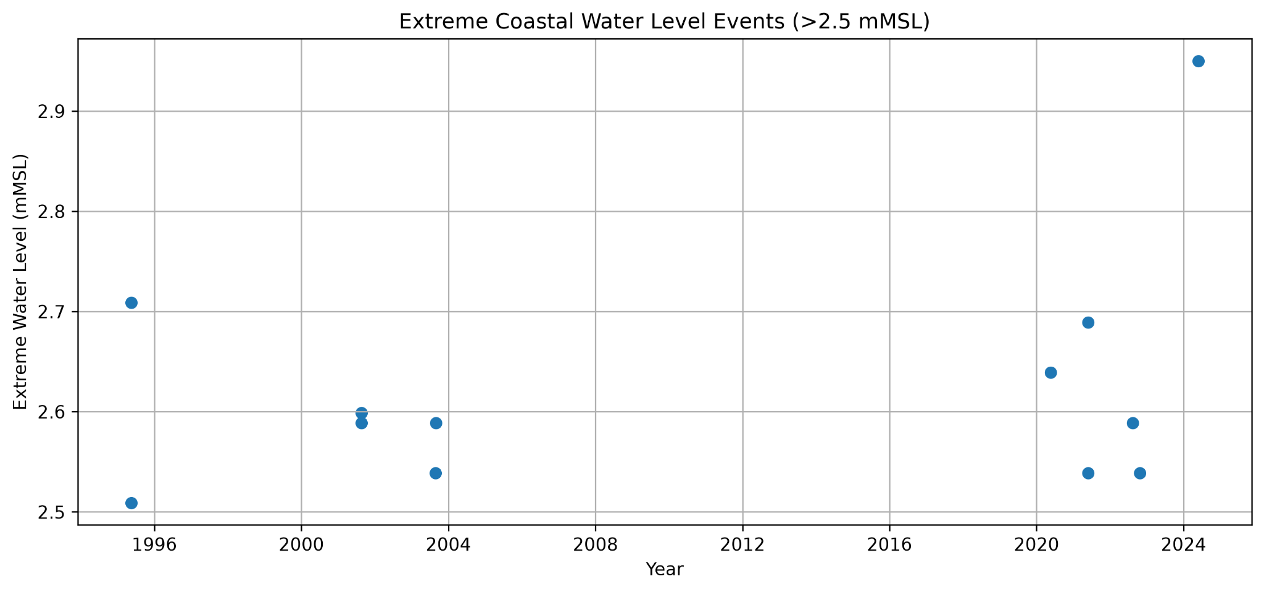
Figure 2. Temporal distribution of extreme coastal water level events (>2.5 mMSL).

3.3 Seasonal Characteristics of Extreme Water Levels
Monthly analysis was performed to investigate seasonal behaviour. Figure 3 shows that the highest extreme water level occurred during May, while August and October also showed comparatively elevated values, indicating that extreme conditions are not evenly distributed throughout the year.
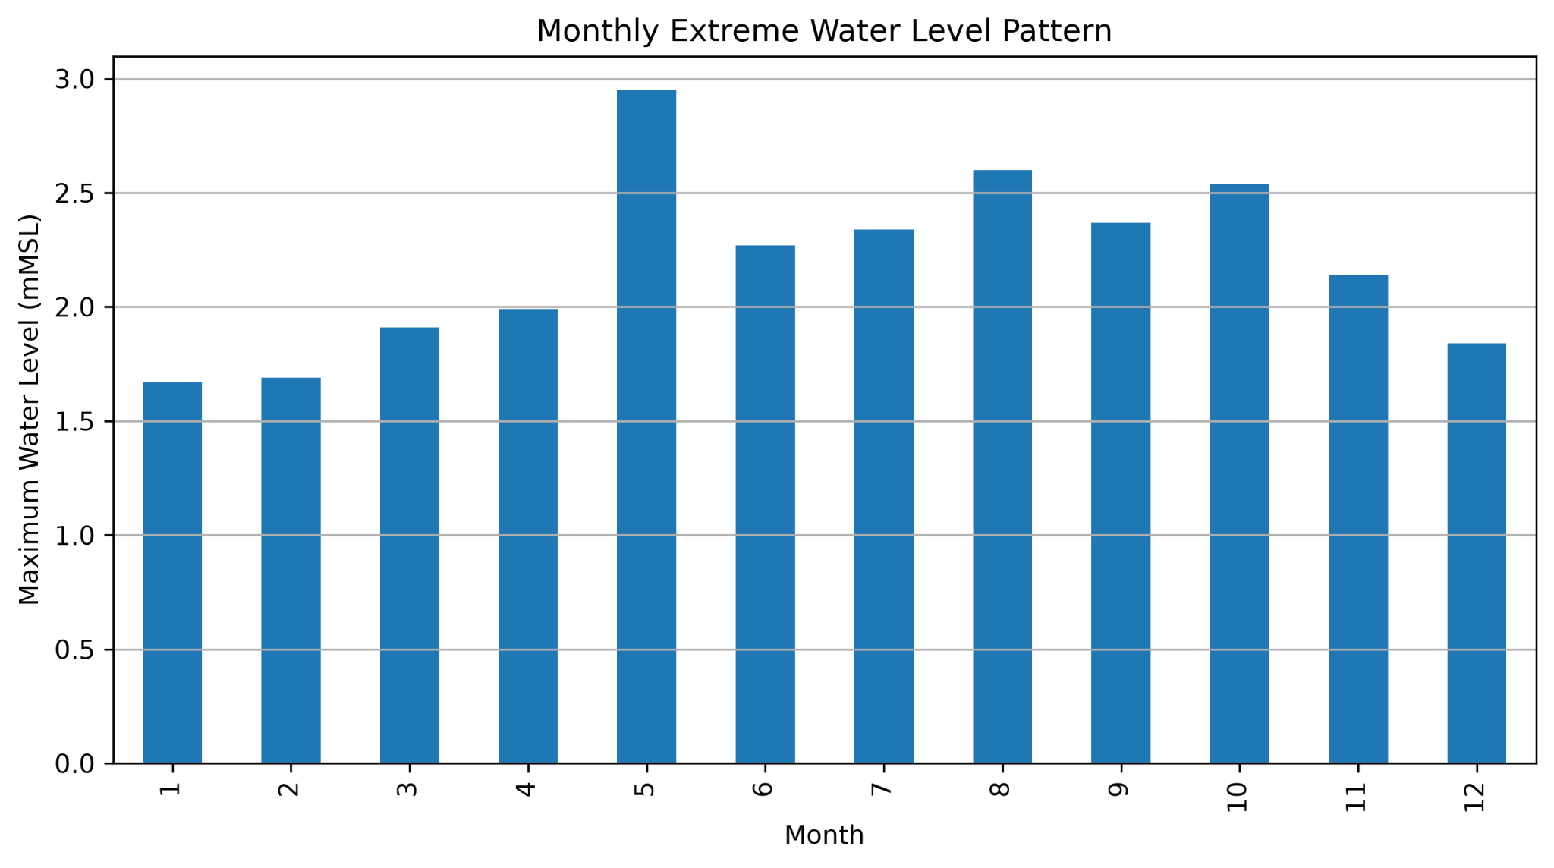
Figure 3. Monthly pattern of maximum observed water levels.

3.4 Extreme Event Summary
Table 2 presents the detected extreme events, including their occurrence date, year, month, and corresponding daily maximum water level.
Table 2. Summary of identified extreme coastal water level events.
Date | Year | Month | Daily Max WL (mMSL)
1995-05-15 | 1995 | 5 | 2.509
1995-05-16 | 1995 | 5 | 2.709
2001-08-20 | 2001 | 8 | 2.589
2001-08-21 | 2001 | 8 | 2.599
2003-08-27 | 2003 | 8 | 2.539
2003-08-29 | 2003 | 8 | 2.589
2020-05-20 | 2020 | 5 | 2.639
2021-05-26 | 2021 | 5 | 2.689
2021-05-27 | 2021 | 5 | 2.539
2022-08-14 | 2022 | 8 | 2.589
2022-10-24 | 2022 | 10 | 2.539
2024-05-27 | 2024 | 5 | 2.95

4. Conclusion
This study developed a reproducible Python workflow for analysing long-term coastal water level observations. The approach successfully processed historical records, identified extreme high-water events, quantified annual variability, and revealed seasonal characteristics. The developed framework provides a foundation for further coastal hazard assessment, statistical modelling, and hydrological research.

References
Hunter, J. D. (2007). Matplotlib: A 2D Graphics Environment. Computing in Science & Engineering, 9(3), 90–95.
McKinney, W. (2010). Data Structures for Statistical Computing in Python. Proceedings of the 9th Python in Science Conference.
Python Software Foundation. Python Documentation. https://docs.python.org/
Pandas Development Team. pandas Documentation. https://pandas.pydata.org/

