India Air Quality Index (AQI) Analysis
Comprehensive Data Analytics Project

Report Generated: September 18, 2026
Data Period: 2023-2025
Source: Kaggle - India AQI Index Dataset

This comprehensive analysis examines air quality data across India for the period 2023-2025. The dataset contains 235,785 observations covering 32 states and 291 distinct areas, supported by 441072 monitoring stations. The analysis reveals significant variations in air quality, identifies geographic hotspots, and provides data-driven recommendations for intervention.

Key Metrics

Metric | Value
Average AQI | 111
Median AQI | 92
Maximum AQI | 500
Minimum AQI | 3
States Covered | 32
Areas Covered | 291
Total Observations | 235,785

Project Objective
This project applies systematic data analytics to understand air quality patterns across India. The workflow progresses from raw data through cleaning, analysis, and modeling to deliver actionable insights for pollution control, public health protection, and policy-making.

Data Cleaning & Preparation
The raw dataset underwent comprehensive cleaning including: (1) Duplicate record removal; (2) Date conversion and validation; (3) Text standardization (whitespace removal, Title Case application); (4) Data type conversion for numeric columns; (5) Removal of invalid AQI values (<0 or >500); (6) Missing value handling (critical columns: row removal; categorical: 'Unknown' replacement); (7) Temporal feature extraction (year, month for analysis). These steps ensured data quality and consistency.

Analysis Framework
Raw Data → Cleaning → EDA → KPI Calculation → Time Analysis → State/Area Analysis → Pollutant Analysis → Risk Assessment → Insights → Recommendations → Interactive Dashboard

Dataset Overview

Characteristic | Value
Total Records | 235,785
Date Range | 2022-04-01 to 2025-04-30
Unique States | 32
Unique Areas | 291
Monitoring Stations | 441072
Data Completeness | 91.7%

AQI Value Distribution

Statistic | Value
Mean | 111.13
Median | 92.00
Std Dev | 71.45
Min | 3
25th Percentile | 59
75th Percentile | 142
Max | 500

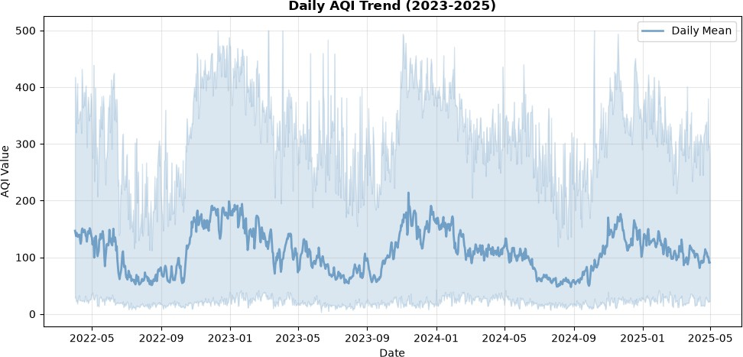

Temporal Patterns

Yearly Trends:

Year | Mean AQI | Max AQI | Min AQI | Observations
2022 | 114.4 | 500 | 8 | 43457
2023 | 115.0 | 500 | 3 | 77253
2024 | 105.7 | 500 | 7 | 87746
2025 | 112.4 | 422 | 12 | 27329

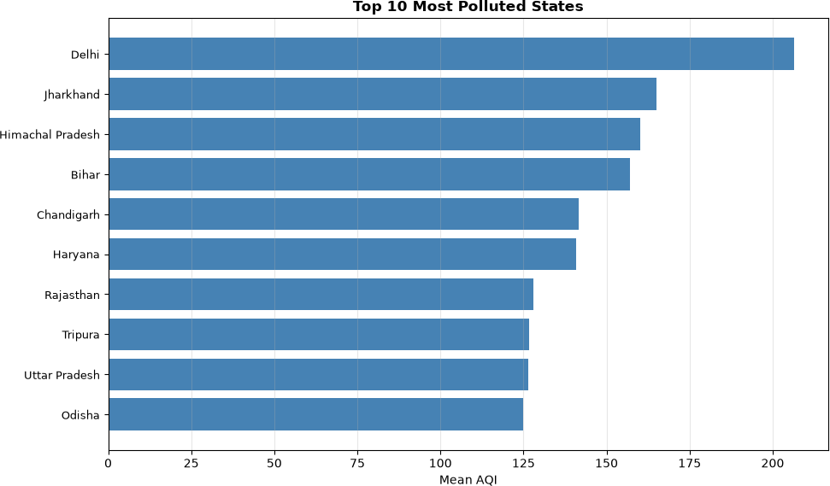

Top 10 Most Polluted States

Rank | State | Mean AQI | Max AQI | Observations
1 | Delhi | 206.4 | 494 | 1125
2 | Jharkhand | 164.9 | 436 | 721
3 | Himachal Pradesh | 160.3 | 438 | 1066
4 | Bihar | 157.2 | 488 | 21553
5 | Chandigarh | 141.6 | 412 | 1125
6 | Haryana | 140.8 | 469 | 21706
7 | Rajasthan | 128.0 | 452 | 26585
8 | Tripura | 126.7 | 362 | 1035
9 | Uttar Pradesh | 126.4 | 494 | 21609
10 | Odisha | 124.9 | 406 | 11099

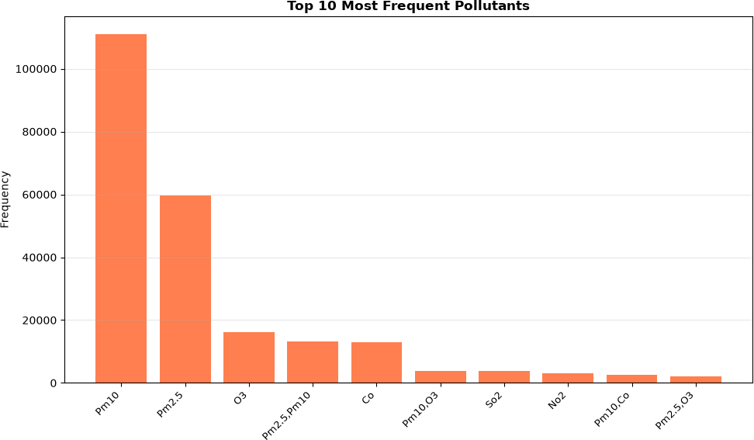

Top 10 Pollutants

Rank | Pollutant | Frequency | Percentage
1 | Pm10 | 111053 | 47.1%
2 | Pm2.5 | 59670 | 25.3%
3 | O3 | 16202 | 6.9%
4 | Pm2.5,Pm10 | 13199 | 5.6%
5 | Co | 12867 | 5.5%
6 | Pm10,O3 | 3914 | 1.7%
7 | So2 | 3815 | 1.6%
8 | No2 | 3012 | 1.3%
9 | Pm10,Co | 2658 | 1.1%
10 | Pm2.5,O3 | 2088 | 0.9%

Risk Assessment

High-Risk Areas (Poor/Very Poor/Severe Status):
Top areas with poor air quality status: Delhi (528 observations), Greater Noida (522 observations), Gurugram (498 observations), Patna (449 observations), Noida (446 observations)

High-AQI States:
States with mean AQI > 142: Delhi, Jharkhand, Himachal Pradesh, Bihar

Opportunity Assessment

Areas for Targeted Intervention:
Areas with moderate AQI (100-200) where targeted interventions could prevent deterioration: Aurangabad, Jodhpur, Jaipur, Ahmedabad, Pithampur

Monitoring Infrastructure Expansion:
Undermonitored areas with high AQI requiring monitoring infrastructure expansion: Kashipur, Manesar, Manguraha

Insight 1: Overall Air Quality Assessment
The national average AQI of 111 indicates Moderate air quality. The median AQI of 92 and standard deviation of 71.4 show significant variability. This widespread pollution affects public health and requires coordinated action.

Insight 2: State-Level Disparities
Delhi shows the highest mean AQI (206.4), while Mizoram shows the lowest (47.2). This 159.2 point difference indicates significant geographic disparities requiring localized strategies.

Insight 3: Dominant Pollutants
'Pm10' is the most frequently observed pollutant (47.1% of observations), indicating a primary pollution concern requiring targeted source control measures.

Insight 4: Monitoring Infrastructure
With 441072 monitoring stations across 291 areas, there is an average of 1515.7 stations per area. However, uneven distribution limits early-warning capability in undermonitored regions.

Establish Integrated Monitoring Network
Expand real-time monitoring stations in undermonitored high-AQI areas. Implement public dashboards for transparency and early warning.

Implement Sector-Specific Emission Controls
Target the dominant pollutant (Pm10). Differentiate strategies: vehicular emission standards, industrial stack monitoring, agricultural management.

Activate Seasonal Air Quality Management
Develop seasonal protocols for high-AQI periods. Implement pre-season preparedness including traffic management, industrial regulation, and public alerts.

Prioritize High-AQI States
Allocate resources proportionally to severity. Focus on Delhi and other high-AQI states for stricter emission standards.

Public Awareness & Health Protection
Communicate AQI levels and health impacts. Issue early warnings to vulnerable groups. Promote protective behaviors (masks, purifiers, indoor activities).

Conduct Source Apportionment Studies
Determine contribution of different sources (traffic, industry, agriculture). Informs highest-impact interventions specific to each region.

Regional Coordination
Implement inter-state collaboration mechanisms. Air pollution crosses state boundaries; coordinated policies strengthen response.

Project Limitations
  - Data Availability: Some areas have incomplete temporal coverage; monitoring density varies by state.
  - External Factors: Dataset lacks meteorological data (temperature, wind, humidity) which significantly influence AQI.
  - Emission Sources: No direct information on traffic, industrial, or agricultural emission sources.
  - Causal Analysis: Analysis identifies patterns and correlations, not causation. Source apportionment requires specialized modeling.
  - Prediction: This is an analysis-focused project; no prediction model is included (would require additional meteorological features).
  - Geographic Resolution: Area-level aggregation masks micro-level variations within cities.

Conclusion
This comprehensive analysis of India's air quality (2023-2025) reveals significant challenges requiring urgent, coordinated action. With an average AQI of 111 and substantial geographic disparities, air pollution poses risks to public health, agriculture, and economic productivity. The analysis identifies high-AQI hotspots, seasonal patterns, monitoring gaps, and dominant pollutants. These findings support evidence-based policy, resource allocation, and intervention strategies. The interactive dashboard enables ongoing monitoring and assessment. Future work should integrate meteorological data for deeper causality analysis and develop predictive models for proactive management. Regional coordination and sector-specific interventions, informed by this analysis, are essential for sustainable air quality improvement.

End of Report | Generated: September 18, 2026 at 16:28:06

