A Project Report On

**Automation using selenium python**

Submitted By

Sujoy Kayet (16971021012) Department- MCA, Semester- 4th Subject: MAJOR PROJECT (MCAN-482)

Under the guidance of

Sanghamitra Biswas

A Project Report

To be submitted in the partial fulfillment of the requirements for the degree of

Master of Computer Application



Department of Master of Computer Application, Academy Of Technology,

Affiliated to



Maulana Abul Kalam Azad University of Technology, West Bengal 2023

**Academy Of Technology**

**CERTIFICATE**

This is to certify that the project entitled: **Automation using selenium python**

Submitted to MAULANA ABUL KALAM AZAD UNIVERSITY OF

TECHNOLOGY in the partial fulfillment of the requirement for the award of the MCA degree of **Major Project (MCAN-482)** is carried out by

Sujoy Kayet (16971021012)

(Name of the students with university roll no.)

Under my guidance. The matter embodied in this project is genuine work done by the students and has not been submitted whether to this University or to any other University/Institute for the fulfillment of the requirement of any course of study.



SANGHAMITRA BISWAS (Guide) Sr. DEVELOPMENT MANAGER

Cost Management & Engineering

Teoco Software Private Limited

Contact No. - 40251310

Address – 8th Floor, Tower A, DLF IT Park-1 8 M.A.R., Block AF, Action Area-1 New Town, Kolkata-700163

Dated:

Countersigned By

## **Uday Kumar Mandal**

Head, Department of MCA.

Academy of Technology, Aedconagar, Hooghly-712121, West Bengal, India

## **STATEMENT BY THE CANDIDATE**

Sujoy Kayet Roll 16971021012

MCA 4th Semester Dept. of MCA

Academy of Technology

We hereby state that the Project Report entitled **Automation using selenium python**

has been prepared by us to fulfill the requirements of MAJOR PROJECT (MCAN-482) during the period January 2023 to June 2023.

Signature of the student

**TABLE OF CONTENTS**

**Contents Page No**

1. **Chapter 1** Introduction 5
2. **Chapter 2** Advantages 7
3. **Chapter 3** Literature Overview 7
4. **Chapter 4** Feasibility Analysis in QA Automation 11
5. **Chapter 5** Life cycle of Software Test Automation 11
6. **Chapter 6** Code Structure 12
7. **Chapter 7** Log Result 25

**Chapter 1: Introduction**

This a website automation project using Selenium framework & python programming language using excel to read & write data.

* What is Selenium?

Ans: Selenium is an open-source, automated testing tool used to test web applications across multiple browsers. It's primarily built in Java and supports several browsers and programming languages. The Selenium test suite comprises of four tools: Selenium Integrated Development Environment (IDE).

Selenium Framework is a suite of automation testing tools based on the [JavaScript framework](https://www.browserstack.com/guide/top-javascript-testing-frameworks).

It could run the tests directly on the target browser, drive the interactions on the required web page and rerun them without any manual input. It eliminates repetitive manual testing that consumes lots of time and effort. Conforms to the idea of [Agile](https://www.browserstack.com/guide/continuous-integration-with-agile) and [DevOps](https://www.browserstack.com/guide/devops-for-beginners), which endorse the continuous delivery workflow.

Thus, Selenium remains one of the favorite tools for testing as it meets the requirement of quick and reliable testing, which helps enterprises save time and money on testing.

* What is Selenium web driver?

Ans: [Selenium WebDriver](https://www.browserstack.com/guide/selenium-webdriver-tutorial), also known as Selenium 2.0, is a collection of language-specific bindings that drive a browser how it has to be driven. It is the successor of Selenium Remote Control and consists of API, Library, Driver, and Framework that work together to enable test execution.

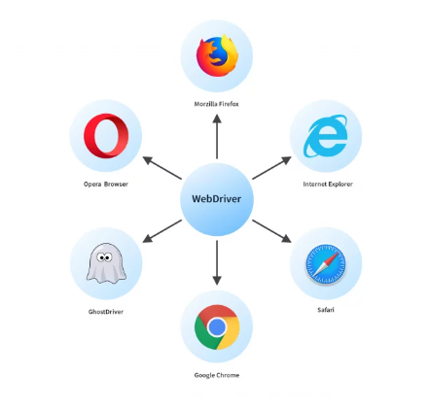

**Chapter 2: Advantages**

* Reduce manual effort
* Save a lot of time
* Increase perfection
* Reduce scope of mistakes
* Increase code reusability

**Chapter 3: Literature Overview**

As example, here in this project you just need to update all of the data in the excel (.xlsx) file code will do the rest automatically. You just don’t need to change anything inside the code.

This excel file can contains thousands of employee data. Each row will contains individual employee information. Code will pick each employee information one by one & execute accordingly.

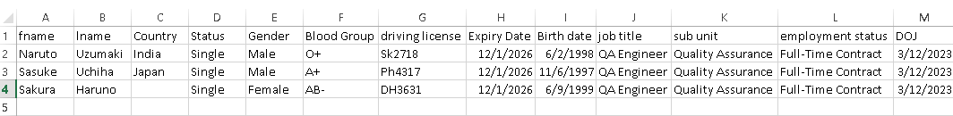Fetch Employee Data from excel :

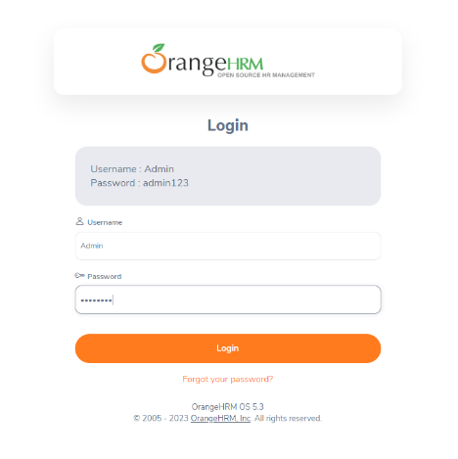Step 1: Login to the website -

Step 2: Check the ID & Password are valid or not -

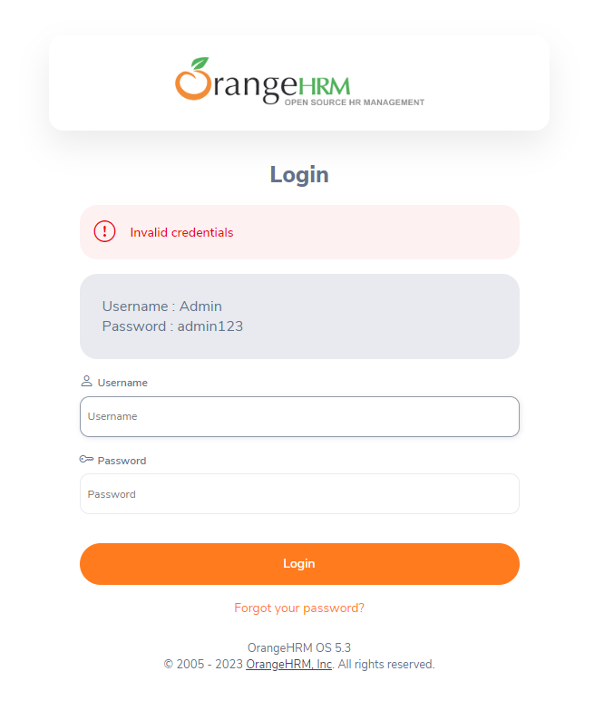

Step 3: Check Dashboard page is open or not -

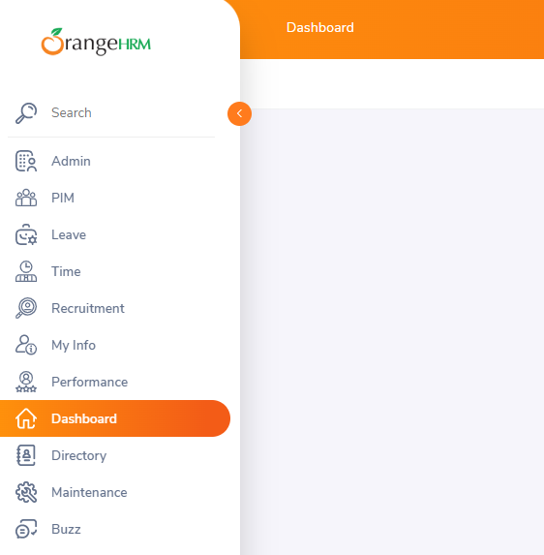

Step 4: Go to PIM section -

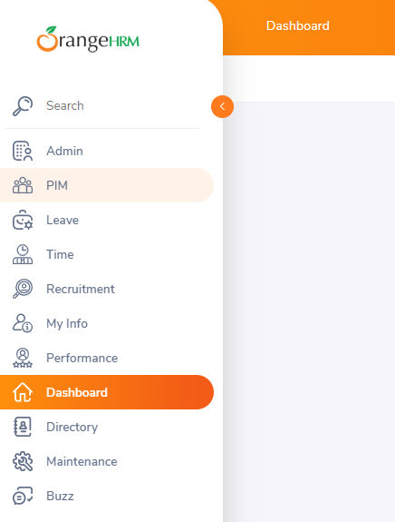

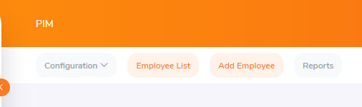Step 5: Select Add Employee -

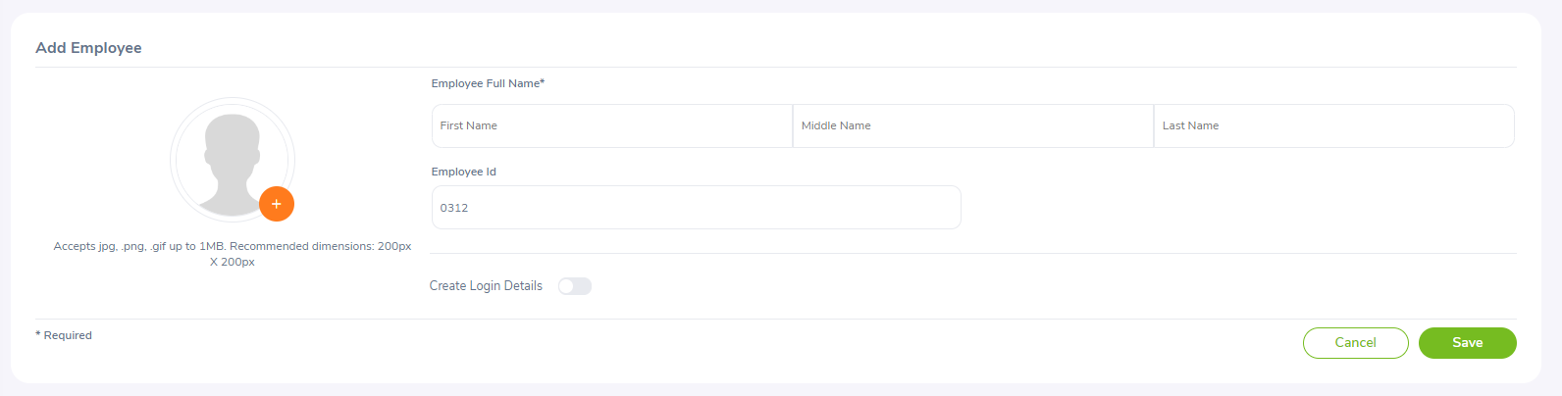Step 6: Provide information from excel file & save it -

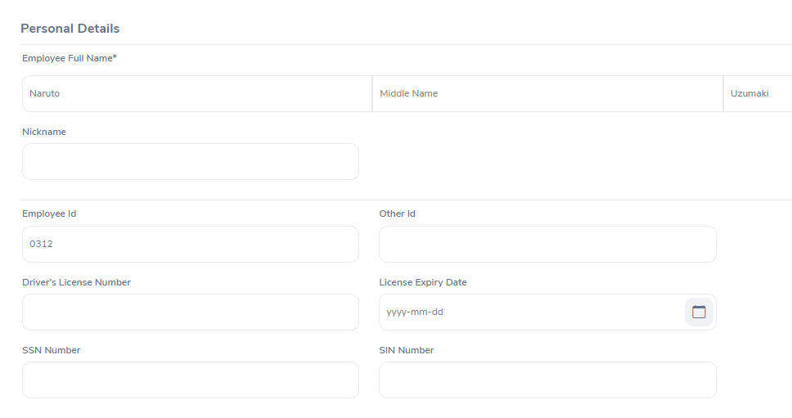Step 7: Fill details in the personal details section & save -



Step 8: Goto Employee List -

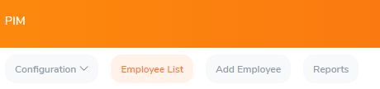

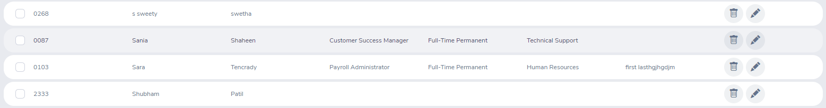Step 9: Highlight the latest Employee row from the list -

**Chapter 4: Feasibility Analysis in QA Automation**

Before we proceed with automating any application, the automation tester must possess the knowledge of the application. Without having this understanding when any test scenario is considered for automation and we may get into several problems and the task either would be left incomplete or likely delayed.

As an automation tester the focus would be to gain sufficient functional knowledge, get the relevant test cases from the functional (manual) team then conduct feasibility analysis to know how many scenarios can be automated. If at all some cases can’t be automated there must be a valid rationale and the agreement with the stakeholders must be taken.

The analysis helps the test team to showcase their deliverables because after thorough examination team will be in a position to understand what will be covered in automation and how long they require to complete them.

Feasibility study on infrastructure availability

In order to proceed with hassle-free automation the test team must not have any issues at infra level, the possible issues that might fall under this category are Not having access to create project/ branch in a chosen configuration management tool Not having access to the application/ DB servers to work independently Software license procurement by the business Network availability and kind of access to Application, which will delay the execution and cause failures at times Not holding admin rights to perform certain tasks. The above-listed problems will prohibit automation activities from point to

Point. Test team must raise the access requests to all the needed things in the project and gain access.

* Chapter 5: Life cycle of Software Test Automation –

Life Cycle in layman definition is the series of steps/changes that happens in a process to get the desired result.

Life cycle denotes the subsequent actions in a timely fashion. Below are the lists of things to be considered for [test automation life cycle](https://codoid.com/automation-testing-in-ci-cd-pipeline/).

Feasibility study

Tool identification

Framework identification

Proof of concept

Test scripts design

Test scripts execution

Test scripts review

CODES:

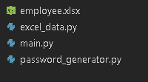

1. main.py code:
2. from selenium import webdriver
3. from selenium.webdriver.support import expected_conditions as EC
4. from selenium.webdriver.support.wait import WebDriverWait as wait
5. from selenium.webdriver.common.by import By
6. from selenium.webdriver.common.keys import Keys
7. import time
8. import password_generator as pg
9. import random as r
10. from selenium.webdriver import ActionChains
11. import excel_data as ed
12. def runner(fname,lname,country,status,gender,blood_group,driving_license,expiry_date,birth_date,job_title,sub_unit,employment_status,doj):
13. #openURL
14. driver = webdriver.Chrome()
15. driver.maximize_window()
16. #Hit url
17. try:
18. driver.get("https://opensource-demo.orangehrmlive.com/web/index.php/auth/login")
19. time.sleep(5)
20. print("+++Url hit successful+++")
21. except:
22. print("---Url hit unsuccessful---")
23. #Login page
24. try:
25. wait(driver, 90).until(EC.presence_of_element_located((By.XPATH,'//*[@id="app"]/div[1]/div/div[1]/div/div[2]/h5')))
26. time.sleep(5)
27. print("+++Login page loaded successfully+++")
28. except:
29. print("---Login page open unsuccessful---")
30. #Give id & password
31. try:
32. driver.find_element(By.XPATH,'//*[@id="app"]/div[1]/div/div[1]/div/div[2]/div[2]/form/div[1]/div/div[2]/input').send_keys("Admin")
33. time.sleep(3)
34. print("+++User id given successfully+++")
35. driver.find_element(By.XPATH,'//*[@id="app"]/div[1]/div/div[1]/div/div[2]/div[2]/form/div[2]/div/div[2]/input').send_keys("admin123")
36. time.sleep(3)
37. print("+++Password given successfully+++")
38. except:
39. print("---Unable to insert Id & Password---")
40. #Click login button
41. try:
42. wait(driver, 10).until(EC.element_to_be_clickable((By.XPATH,'//*[@id="app"]/div[1]/div/div[1]/div/div[2]/div[2]/form/div[3]/button'))).click()
43. time.sleep(3)
44. print("+++Login button click successfully+++")
45. except:
46. print("---Unable to click login button---")
47. #check id password are correct or not
48. try:
49. wait(driver, 30).until(EC.presence_of_element_located((By.XPATH,'//*[@id="app"]/div[1]/div/div[1]/div/div[2]/div[2]/div/div[1]/div[1]/p')))
50. print("Please give correct id & password")
51. driver.quit()
52. except:
53. pass
54. #Check dashboard is open or not
55. try:
56. wait(driver, 30).until(EC.element_to_be_clickable((By.XPATH,'//*[@id="app"]/div[1]/div[1]/header/div[1]/div[1]/span/h6')))
57. print("+++Dashboard loaded successfully+++")
58. time.sleep(1)
59. except:
60. print("---Unable to load dashboard page---")
61. #Select PIM
62. try:
63. wait(driver, 10).until(EC.element_to_be_clickable((By.XPATH,'//*[@id="app"]/div[1]/div[1]/aside/nav/div[2]/ul/li[2]/a'))).click()
64. time.sleep(2)
65. print("+++Click on PIM successful+++")
66. except:
67. print("---Unable to select PIM---")
68. #Check all othe info
69. try:
70. wait(driver, 20).until(EC.element_to_be_clickable((By.XPATH, '//*[@id="app"]/div[1]/div[2]/div[2]/div/div[2]/div[3]/div/div[1]/div/div[1]/div/label/span'))).click()
71. # print("+++Admin page loaded successfully+++")
72. print("+++All details select successfully+++")
73. time.sleep(3)
74. except:
75. print("---Unable to select all info---")
76. #Delete all previous info
77. try:
78. wait(driver, 10).until(EC.element_to_be_clickable((By.XPATH, '//*[@id="app"]/div[1]/div[2]/div[2]/div/div[2]/div[2]/div/div/button'))).click()
79. print("+++All previous INFO deleted successfully+++")
80. time.sleep(3)
81. except:
82. print("---Unable to delete previous INFOs---")
83. #Confirm to delete
84. try:
85. wait(driver, 10).until(EC.element_to_be_clickable((By.XPATH, '//*[@id="app"]/div[3]/div/div/div/div[3]/button[2]'))).click()
86. print("+++Old records Delete confirm+++")
87. time.sleep(5)
88. except:
89. print("---Unable to confirm delete previous INFOs---")
90. #Goto add employee
91. try:
92. wait(driver,30).until(EC.element_to_be_clickable((By.XPATH,'//*[@id="app"]/div[1]/div[1]/header/div[2]/nav/ul/li[3]/a'))).click()
93. print("+++PIM page loaded successfully+++")
94. print("+++Click on add employee successful+++")
95. time.sleep(2)
96. except:
97. print("---Unable to click on add employee---")
98. #upload img
99. try:
100. # driver.switch_to_frame()
101. wait(driver,30).until(EC.element_to_be_clickable((By.XPATH, '//*[@id="app"]/div[1]/div[2]/div[2]/div/div/form/div[1]/div[1]/div/div[2]/input'))).send_keys("D:\myProject\img\images.jpg")
102. print("+++Upload picture successfully+++")
103. time.sleep(3)
104. except:
105. print("---Unable to upload picture---")
106. #provide add employee details
107. try:
108. # fname = "Naruto"
109. # lname = "Uzumaki"
110. emp_id = r.randint(111,999)
111. wait(driver,30).until(EC.element_to_be_clickable((By.XPATH,'//*[@id="app"]/div[1]/div[2]/div[2]/div/div/form/div[1]/div[2]/div[1]/div[1]/div/div/div[2]/div[1]/div[2]/input'))).send_keys(fname)
112. print("+++First name given successfully+++")
113. time.sleep(1)
114. wait(driver,30).until(EC.element_to_be_clickable((By.XPATH,'//*[@id="app"]/div[1]/div[2]/div[2]/div/div/form/div[1]/div[2]/div[1]/div[1]/div/div/div[2]/div[3]/div[2]/input'))).send_keys(lname)
115. print("+++Last name given successfully+++")
116. time.sleep(1)
117. for i in range(4):
118. wait(driver,30).until(EC.element_to_be_clickable((By.XPATH,'//*[@id="app"]/div[1]/div[2]/div[2]/div/div/form/div[1]/div[2]/div[1]/div[2]/div/div/div[2]/input'))).send_keys(Keys.BACKSPACE)
119. time.sleep(2)
120. print("+++Employee id text box clear successfully+++")
121. wait(driver,30).until(EC.element_to_be_clickable((By.XPATH,'//*[@id="app"]/div[1]/div[2]/div[2]/div/div/form/div[1]/div[2]/div[1]/div[2]/div/div/div[2]/input'))).send_keys(emp_id)
122. time.sleep(2)
123. print("+++Employee id given successfully+++")
124. except:
125. print("---Unable to provide the 'Add Employee' INFO---")
126. #Save add employee details
127. try:
128. driver.find_element(By.XPATH, '//*[@id="app"]/div[1]/div[2]/div[2]/div/div/form/div[2]/button[2]').click()
129. time.sleep(7)
130. print("+++Employee details saved successfully+++")
131. except:
132. print("---Unable to save employee details---")
133. #Personal details page
134. try:
135. wait(driver,30).until(EC.visibility_of_element_located((By.XPATH, '//*[@id="app"]/div[1]/div[2]/div[2]/div/div/div/div[2]/div[1]/h6')))
136. print("+++Personal details page loaded successfully+++")
137. time.sleep(2)
138. except:
139. print("---Personal details page not loaded---")
140. #Personal details full up
141. try:
142. wait(driver,30).until(EC.element_to_be_clickable((By.XPATH, '//*[@id="app"]/div[1]/div[2]/div[2]/div/div/div/div[2]/div[1]/form/div[2]/div[2]/div[1]/div/div[2]/input'))).send_keys(driving_license)
143. print("+++Driver's License Number provided+++")
144. time.sleep(1)
145. wait(driver,30).until(EC.element_to_be_clickable((By.XPATH, '//*[@id="app"]/div[1]/div[2]/div[2]/div/div/div/div[2]/div[1]/form/div[2]/div[2]/div[2]/div/div[2]/div/div/input'))).send_keys(expiry_date) #"2026-12-01"
146. print("+++License Expiry Date provided+++")
147. time.sleep(1)
148. # wait(driver,30).until(EC.element_to_be_clickable((By.XPATH, '//*[@id="app"]/div[1]/div[2]/div[2]/div/div/div/div[2]/div[1]/form/div[2]/div[3]/div[1]/div/div[2]/input'))).send_keys("26648")
149. # print("+++SSN Number provided+++")
150. time.sleep(7)
151. # wait(driver,30).until(EC.element_to_be_clickable((By.XPATH, '//*[@id="app"]/div[1]/div[2]/div[2]/div/div/div/div[2]/div[1]/form/div[2]/div[3]/div[2]/div/div[2]/input'))).send_keys("156487")
152. # print("+++SIN Number provided+++")
153. try:
154. driver.find_element(By.XPATH, '//*[@id="app"]/div[1]/div[2]/div[2]/div/div/div/div[2]/div[1]/form/div[3]/div[1]/div[1]/div/div[2]/div/div/div[2]/i').click()
155. print("+++click on nation+++")
156. time.sleep(2)
157. nations = driver.find_elements(By.XPATH, '//div[@class = "oxd-select-option"]')
158. for nation in nations:
159. if nation.text.__contains__(country): #"India"
160. nation.click()
161. print("+++Successfully select nation+++")
162. break
163. except:
164. print("---Unable to select nation---")
165. time.sleep(5)
166. try:
167. driver.find_element(By.XPATH, '//*[@id="app"]/div[1]/div[2]/div[2]/div/div/div/div[2]/div[1]/form/div[3]/div[1]/div[2]/div/div[2]/div/div/div[2]/i').click()
168. print("+++click on status+++")
169. time.sleep(2)
170. nations = driver.find_elements(By.XPATH, "//div[@class = 'oxd-select-option']")
171. for nation in nations:
172. if nation.text.__contains__(status): #"Single"
173. nation.click()
174. print("+++Successfully select status+++")
175. break
176. except:
177. print("---Unable to select status---")
179. time.sleep(5)
180. wait(driver,10).until(EC.element_to_be_clickable((By.XPATH, '//*[@id="app"]/div[1]/div[2]/div[2]/div/div/div/div[2]/div[1]/form/div[3]/div[2]/div[1]/div/div[2]/div/div/input'))).send_keys(birth_date) #"1998-06-02"
181. print("+++birth date provided successfully+++")
182. time.sleep(3)
183. try:
184. # driver.find_element(By.XPATH, '//*[@id="app"]/div[1]/div[2]/div[2]/div/div/div/div[2]/div[1]/form/div[3]/div[2]/div[2]/div/div[2]/div[1]/div[2]/div/label/span').click()
185. # print("+++Select male option successfully+++")
186. genders = driver.find_elements(By.XPATH, "//div[@class = 'oxd-radio-wrapper']/label")
187. # print(gender.text)
188. for g in genders:
189. print(g.text)
190. # if g.text.__contains__(gender): #"Male"
191. if gender == "Male":
192. if g.text.__contains__(gender):
193. driver.find_element(By.XPATH, '//*[@id="app"]/div[1]/div[2]/div[2]/div/div/div/div[2]/div[1]/form/div[3]/div[2]/div[2]/div/div[2]/div[1]/div[2]/div/label/span').click()
194. print("+++Select male option successfully+++")
195. time.sleep(3)
196. break
197. else:
198. driver.find_element(By.XPATH, '//*[@id="app"]/div[1]/div[2]/div[2]/div/div/div/div[2]/div[1]/form/div[3]/div[2]/div[2]/div/div[2]/div[2]/div[2]/div/label/span').click()
199. print("+++Select female option successfully+++")
200. time.sleep(3)
201. break
202. except:
203. print("---Unable to select gender---")
204. driver.find_element(By.XPATH, '//*[@id="app"]/div[1]/div[2]/div[2]/div/div/div/div[2]/div[1]/form/div[5]/button').click()
205. print("+++Click on 1st submit button successfully+++")
206. time.sleep(3)
207. try:
208. driver.find_element(By.XPATH, '//*[@id="app"]/div[1]/div[2]/div[2]/div/div/div/div[2]/div[2]/div/form/div[1]/div/div/div/div[2]/div/div/div[2]/i').click()
209. time.sleep(5)
210. blood_groups = driver.find_elements(By.XPATH, "//div[@class = 'oxd-select-option']")
211. for type in blood_groups:
212. print(type.text)
213. if(type.text == blood_group):
214. type.click()
215. print("+++Successfully select blood group+++")
216. time.sleep(3)
217. break
218. except:
219. print("---Unable to choose blood group---")
220. wait(driver,10).until(EC.element_to_be_clickable((By.XPATH, '//*[@id="app"]/div[1]/div[2]/div[2]/div/div/div/div[2]/div[2]/div/form/div[2]/button'))).click()
221. print("+++2nd submit option click successfully+++")
222. time.sleep(7)
223. except:
224. print("---Unable to pass Details---")
225. #Job section
226. try:
227. time.sleep(4)
228. driver.find_element(By.XPATH, '//*[@id="app"]/div[1]/div[2]/div[2]/div/div/div/div[1]/div[2]/div[10]/a').click()
229. time.sleep(5)
230. print("++++Clisk on qualifications successfully++++")
231. wait(driver,30).until(EC.element_to_be_clickable((By.XPATH, '//*[@id="app"]/div[1]/div[2]/div[2]/div/div/div/div[1]/div[2]/div[6]/a'))).click()
232. print("+++Job section clicked loaded successfully+++")
233. time.sleep(5)
234. wait(driver,30).until(EC.element_to_be_clickable((By.XPATH, '//*[@id="app"]/div[1]/div[2]/div[2]/div/div/div/div[2]/div[1]/h6')))
235. print("+++Job details page loaded successfully+++")
236. time.sleep(7)
237. #inputs
238. wait(driver,30).until(EC.element_to_be_clickable((By.XPATH, '//*[@id="app"]/div[1]/div[2]/div[2]/div/div/div/div[2]/div[1]/form/div[1]/div/div[1]/div/div[2]/div/div/input'))).send_keys(doj) #"2023-03-12"
239. print("+++DOJ provided successfully+++")
240. time.sleep(1)
241. try:
242. driver.find_element(By.XPATH, '//*[@id="app"]/div[1]/div[2]/div[2]/div/div/div/div[2]/div[1]/form/div[1]/div/div[2]/div/div[2]/div/div/div[2]/i').click()
243. print("+++Click on job title successfully+++")
244. time.sleep(2)
245. job_titles = driver.find_elements(By.XPATH, '//div[@class = "oxd-select-option"]')
246. for title in job_titles:
247. print(title.text)
248. if(title.text.__contains__(job_title)): #"QA Engineer"
249. title.click()
250. print("+++Successfully select job title+++")
251. time.sleep(5)
252. break
253. except:
254. print("---Unable to select job title---")
255. try:
256. driver.find_element(By.XPATH, '//*[@id="app"]/div[1]/div[2]/div[2]/div/div/div/div[2]/div[1]/form/div[1]/div/div[5]/div/div[2]/div/div/div[2]/i').click()
257. print("+++Click on sub unit successfully+++")
258. time.sleep(2)
259. subunits = driver.find_elements(By.XPATH, '//div[@class = "oxd-select-option --indent-2"]')
260. for title in subunits:
261. print(title.text)
262. if(title.text.__contains__(sub_unit)): #"Quality Assurance"
263. title.click()
264. print("+++Successfully select sub unit+++")
265. time.sleep(5)
266. break
267. except:
268. print("---Unable to select sub unit---")
269. try:
270. wait(driver,30).until(EC.element_to_be_clickable((By.XPATH, '//*[@id="app"]/div[1]/div[2]/div[2]/div/div/div/div[2]/div[1]/form/div[1]/div/div[7]/div/div[2]/div/div/div[2]/i'))).click()
271. print("+++Successfully click on employment status+++")
272. time.sleep(3)
273. empstatus = driver.find_elements(By.XPATH, '//div[@class = "oxd-select-option"]')
274. for emp in empstatus:
275. print(emp.text)
276. if(emp.text == employment_status): #"Full-Time Contract"
277. emp.click()
278. print("+++Select employment status successfully+++")
279. time.sleep(5)
280. break
281. except:
282. print("---Unable to select employment status---")
283. try:
284. wait(driver, 30).until(EC.element_to_be_clickable((By.XPATH, '//*[@id="app"]/div[1]/div[2]/div[2]/div/div/div/div[2]/div[1]/form/div[3]/button'))).click()
285. print("+++Successfully submit job details+++")
286. time.sleep(5)
287. except:
288. print("---Unable to submit---")
289. except:
290. print("---Unable to goto job section---")
291. try:
292. wait(driver,30).until(EC.element_to_be_clickable((By.XPATH, '//*[@id="app"]/div[1]/div[1]/header/div[2]/nav/ul/li[2]/a'))).click()
293. print("+++Successfully click on Employee List+++")
294. time.sleep(7)
295. except:
296. print("---Unable to click on---")
297. try:
298. act=ActionChains(driver)
299. names = driver.find_elements(By.XPATH, "//div[@class = 'oxd-table-cell oxd-padding-cell']")
300. for name in names:
301. if(name.text.__contains__(fname)):
302. act.move_to_element(name).perform()
303. print("+++Successfully hover on latest employee details+++")
304. time.sleep(18)
305. break
307. except:
308. print("---Unable to hover on current employee record---")
309. excel_data_list = ed.excel_datas()
310. # print(excel_data_list[0][0])
311. for row_num in range(len(excel_data_list)):
312. fname = excel_data_list[row_num][0]
313. lname = excel_data_list[row_num][1]
314. country = excel_data_list[row_num][2]
315. status = excel_data_list[row_num][3]
316. gender = excel_data_list[row_num][4]
317. blood_group = excel_data_list[row_num][5]
318. driving_license = excel_data_list[row_num][6]
319. expiry_date = excel_data_list[row_num][7]
320. birth_date = excel_data_list[row_num][8]
321. job_title = excel_data_list[row_num][9]
322. sub_unit = excel_data_list[row_num][10]
323. employment_status = excel_data_list[row_num][11]
324. doj = excel_data_list[row_num][12]
325. time.sleep(7)
326. runner(fname,lname,country,status,gender,blood_group,driving_license,str(expiry_date).split()[0],str(birth_date).split()[0],job_title,sub_unit,employment_status,str(doj).split()[0])
327. # print(fname)
328. # print(lname)
329. # print(country)
330. # print(status)
331. # print(gender)
332. # print(blood_group)
333. # print(driving_license)
334. # print(str(expiry_date).split()[0])
335. # print(str(birth_date).split()[0])
336. # print(job_title)
337. # print(sub_unit)
338. # print(employment_status)
339. # print(str(doj).split()[0])

2) password_generator code:

import random as r

def create_password():

    lstA_Z = []

    lsta_z = []

    lst0_9 = []

    lst_symbol = []

    password = []

    str_password = ""

    for i in range(65,91):

        lstA_Z.append(chr(i))

    # print(lstA_Z)

    for i in range(97,123):

        lsta_z.append(chr(i))

    # print(lsta_z)

    for i in range(10):

        lst0_9.append(str(i))

    # print(lst0_9)

    for i in range(33,42):

        lst_symbol.append(chr(i))

    # print(lst_symbol)

    for l in range(2):

        password.append(r.choice(lstA_Z))

    for l in range(2):

        password.append(r.choice(lsta_z))

    for l in range(2):

        password.append(r.choice(lst0_9))

    for l in range(2):

        password.append(r.choice(lst_symbol))

    r.shuffle(password)

    for k in password:

        str_password += k

    print("Your password is: ",str_password)

    return str_password

3) excel_data code:

import random as r

def create_password():

    lstA_Z = []

    lsta_z = []

    lst0_9 = []

    lst_symbol = []

    password = []

    str_password = ""

    for i in range(65,91):

        lstA_Z.append(chr(i))

    # print(lstA_Z)

    for i in range(97,123):

        lsta_z.append(chr(i))

    # print(lsta_z)

    for i in range(10):

        lst0_9.append(str(i))

    # print(lst0_9)

    for i in range(33,42):

        lst_symbol.append(chr(i))

    # print(lst_symbol)

    for l in range(2):

        password.append(r.choice(lstA_Z))

    for l in range(2):

        password.append(r.choice(lsta_z))

    for l in range(2):

        password.append(r.choice(lst0_9))

    for l in range(2):

        password.append(r.choice(lst_symbol))

    r.shuffle(password)

    for k in password:

        str_password += k

    print("Your password is: ",str_password)

    return str_password

**Chapter 7 : Log Result:**

DevTools listening on ws://127.0.0.1:57569/devtools/browser/82fc3769-7df4-4682-a93c-65de4b7ef3d6

+++Url hit successful+++

+++Login page loaded successfully+++

+++User id given successfully+++

+++Password given successfully+++

+++Login button click successfully+++

+++Dashboard loaded successfully+++

+++Click on PIM successful+++

+++PIM page loaded successfully+++

+++Click on add employee successful+++

---Unable to upload picture---

+++First name given successfully+++

+++Last name given successfully+++

+++Employee id text box clear successfully+++

+++Employee id given successfully+++

+++Employee details saved successfully+++

+++Personal details page loaded successfully+++

+++Driver's License Number provided+++

+++License Expiry Date provided+++

+++click on nation+++

[17060:13860:0412/183407.224:ERROR:gpu_init.cc (525)] Passthrough is not supported, GL is disabled, and ANGLE is

+++Successfully select nation+++

+++click on status+++

+++Successfully select status+++

+++birth date provided successfully+++

Male

+++Select male option successfully+++

+++Click on 1st submit button successfully+++

+++Successfully select blood group+++

+++2nd submit option click successfully+++

++++Click on qualifications successfully++++

+++Job section clicked loaded successfully+++

+++Job details page loaded successfully+++

+++DOJ provided successfully+++

+++Click on job title successfully+++

+++Successfully select job title+++

+++Click on sub unit successfully+++

+++Successfully select sub unit+++

+++Successfully click on employment status+++

+++Select employment status successfully+++

+++Successfully submit job details+++

+++Successfully click on Employee List+++

+++Successfully hover on latest employee details+++

DevTools listening on ws://127.0.0.1:57630/devtools/browser/89877401-a958-40df-aa7c-63eb7b5d341a

+++Url hit successful+++

+++Login page loaded successfully+++

+++User id given successfully+++

+++Password given successfully+++

+++Login button click successfully+++

+++Dashboard loaded successfully+++

+++Click on PIM successful+++

+++PIM page loaded successfully+++

+++Click on add employee successful+++

---Unable to upload picture---

+++First name given successfully+++

+++Last name given successfully+++

+++Employee id text box clear successfully+++

+++Employee id given successfully+++

+++Employee details saved successfully+++

+++Personal details page loaded successfully+++

+++Driver's License Number provided+++

+++License Expiry Date provided+++

+++click on nation+++

[6320:23232:0412/183820.040:ERROR:gpu_init.cc (525)] Passthrough is not supported, GL is disabled, and ANGLE is

+++Successfully select nation+++

+++click on status+++

+++Successfully select status+++

+++birth date provided successfully+++

Male

+++Select male option successfully+++

+++Click on 1st submit button successfully+++

+++Successfully select blood group+++

+++2nd submit option click successfully+++

++++Click on qualifications successfully++++

+++Job section clicked loaded successfully+++

+++Job details page loaded successfully+++

+++DOJ provided successfully+++

+++Click on job title successfully+++

+++Successfully select job title+++

+++Click on sub unit successfully+++

+++Successfully select sub unit+++

+++Successfully click on employment status+++

+++Select employment status successfully+++

+++Successfully submit job details+++

+++Successfully click on Employee List+++

DevTools listening on ws://127.0.0.1:57677/devtools/browser/1237ff1f-c4b0-4ca9-b98a-eba2942e9d83

+++Url hit successful+++

+++Login page loaded successfully+++

+++User id given successfully+++

+++Password given successfully+++

+++Login button click successfully+++

+++Dashboard loaded successfully+++

+++Click on PIM successful+++

+++PIM page loaded successfully+++

+++Click on add employee successful+++

---Unable to upload picture---

+++First name given successfully+++

+++Last name given successfully+++

+++Employee id text box clear successfully+++

+++Employee id given successfully+++

+++Employee details saved successfully+++

+++Personal details page loaded successfully+++

+++Driver's License Number provided+++

+++License Expiry Date provided+++

+++click on nation+++

+++Successfully select nation+++

+++click on status+++

+++Successfully select status+++

+++birth date provided successfully+++

+++Select female option successfully+++

+++Click on 1st submit button successfully+++

+++Successfully select blood group+++

+++2nd submit option click successfully+++

++++Click on qualifications successfully++++

+++Job section clicked loaded successfully+++

+++Job details page loaded successfully+++

+++DOJ provided successfully+++

+++Click on job title successfully+++

+++Successfully select job title+++

+++Click on sub unit successfully+++

+++Successfully select sub unit+++

+++Successfully click on employment status+++

+++Select employment status successfully+++

+++Successfully submit job details+++

+++Successfully click on Employee List+++

+++Successfully hover on latest employee details+++

PS D:\myProject>