# Title page

**Project Name**

**Hospital Management System**

**(RASEL RANA, 00163511)**

**Daffodil International Academy**

# Abstract

The Hospital Management System has been created only for two main purposes. The administrative panel can maintain patients, doctor, beds and essential information easily and in a short time another purpose is the exterior patients can make online appointment with available doctor. As the system is an online based and computer centric all the information will be kept into database. These records will be displayed in system so the staff will be able to check available information.

1. Contents

a) Title page 1

b) Abstract 2

d) Acknowledgement 6

1. Introduction 7

1.1 System Development 7

1.2 Justification of Methodology 8

1.3 Advantage and Disadvantage 9

Advantage 9

Disadvantage 10

1. 4. Solution 10

1.5. The Aims Objectives of the system 11

Aims 11

Objectives 11

1.6 Review of remaining chapter 12

Initial study 12

Feasibility study 12

Analysis 13

Design 13

Implementation 13

2 Feasibility study 14

2.1 Feasibility factor 14

2.2 Economic feasibility 14

2.3 Technical Feasibility 15

2.4. Operational feasibility 16

3. Analysis 17

3.1 Requirement 17

3.1.1 Functional requirements 17

3.1.2 Non-functional requirements 18

Moscow prioritization of functional requirements 19

3.2 Use case diagram 20

3.3 Architecture 24

3.3.1 System architecture 24

4. Design 25

4.1 Architecture model 25

4.1.1 Initial class diagram 27

4.1.2 Details class diagram 27

4.2 Behavior Model 29

4.2.1 Activity diagram 30

4.2.2 ER diagram 31

5. Implementation 32

5.1 Using programming languages 32

5.2 System cutover from the development architecture to implementation architecture 33

5.3 Data migration from the development architecture and/or existing system to the implementation architecture 33

5.4 Training 35

6 Other project matters 35

6.1 Project management 35

6.2 Risk Management 36

6.3 Configurations Management 37

6.4 Testing 38

➢ Unit testing 38

➢ Integration testing 38

6.4.1 Unit Testing 38

6.4.2 Integration Testing 41

7 Conclusions 44

7.1 Strengths and weakness of the system 44

Strengths 44

Weaknesses 45

7.2 Problems identified and resolved 46

7.3 Further Development 47

8. References 48

9. Appendices 50

9.1 Requirement catalogue 50

9.2 Use case description 51

9.3 Details class Definition 53

9.4 Test scripts 55

Unit testing scripts 55

Integration Testing 56

9.5 User Guide 56

9.6 System code 57

# d) Acknowledgement

By the kindness of almighty Allah, finally I have finished the project documentation according to proposed system. In this case, I have met all system requirements whose were essential to complete. A special thanks from my bottom of heart to my course teacher Mohammad Azizur Rahamn for his supreme observation in each work of the project. He assists me with his great measure by sharing his significant learning and knowledge.

# 1. Introduction

Analyzing the existing system properly is very important task to develop the proposed system more efficiently than existing system. Some hospital management system has been investigated and gathered information how they are maintaining their business activities and managing patient and doctor information. After analyzing existing system, it is going to provide background development process of the proposed system, problems of the existing system with proper solutions, aims and objectives, justification and feasibility study of the proposed system. It will be also provided about technology those are used to develop the proposed system.

# 1.1 System Development

The systems, those have been investigated, all are backward and hand to hand system and the systems management process is also complex. Due to these problems, they want to develop an online based system. The system management process will be an online reservation so the system users and exterior patients can check their essential information smoothly. The patient can check the profile and schedule of any specific doctor. They can also make online doctor meet. The hospital room facilities and rents of specific bed information are also available in website. If any exterior patient wants to make online doctor meet, they can also make appointment through the online. They can check online treatment in their profile. The system user can also manage the interior patients and doctors. They can enroll patients and assign doctor on a particular patient. To manage all the system information properly all the records have been stored in a database. The patient will be provided an invoice copy to print. There are several payment systems are available but bKash and Dutch bangle payment processes are principal method for the development system.

# 1.2 Justification of Methodology

Methodology is combination of specific rules, processes and best practices these discuss about every step of the project and assists carry out to deliver project rapidly. As, a project will be developed, a methodology need to be selected to manage system development processes. It guides me, what need to be accomplished to manage the project from early stage to final stage of the project development life cycle and it also reduces risk. Different project are consisted of different requirements and functionalities. In order to different requirements and functionalities, there are also different methodologies as like Waterfall, Agile, Extreme Programing (XP), Kanban and Lean etc. (LINKY, 2009). As the project that has been developed is sequential and manufacturing workflows so waterfall methodology has to be used. The waterfall methodology is sequential and manufacturing working process. It is consisted of each eight stages as like conceptual, initiation, analysis, design, construction, testing, implementation and maintenance. If each stage are accomplished the developer can be turned into next stage. Since the development process is sequential the developer cannot move back to a previous step. For this reason, the outcomes and plan of the project should be set from the beginning very carefully. The project is planed from top to bottom at once time as it is an incremental development process. The whole development process is chunked into six successive phases (Ledbrook, 2012).

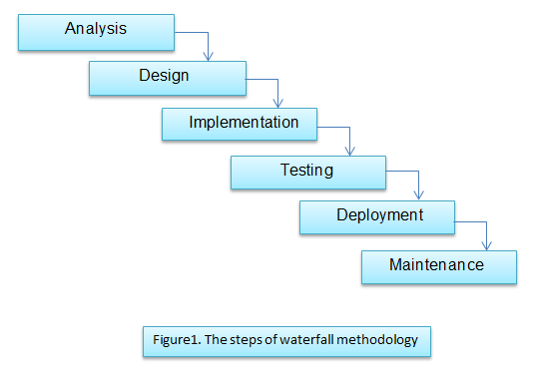

If the project is planed properly from the beginning and worked in this way, the project will be delivered successfully.

# 1.3 Advantage and Disadvantage

# Advantage

* It is simple model so the developer can easily understand and use in the project.
* These required fulfillments of each phase, developer cannot move the next stage before completing the previous stage.
* In each phase testing and customization are done. It ensures the project is developing in the right track.
* Waterfall model is suitable for small project where all requirements are well understood.

# Disadvantage

* More revision and reflection are not allowed in this approach so the requirements may be uncompleted.
* It may bring high amount of risk and incertitude.
* It takes more time to change and update the project at the time of documentation.
* It is not proper approach for the complex and object-oriented project. As the proposal project will be developed by object oriented approach it may face some unexpected issues (PERIYASAMY, 2013).

# 4. Solution

The system, that has been developed is upgraded and can provide better performance than old system. Now, any patient can see the available doctor schedule and overall hospital room beds facilities from the website. Now, the system users can maintain interior patients, doctors and other information of the hospital very easily. The system user can control the information from anywhere as it is an online based system. All the records are saved in a database so data can be backed up in new system. As, in the old system maximum works were accomplished with paper based so data loss occurrence was more.

# 1.5. The Aims Objectives of the system

# Aims

* **Manage patients:** First patients will be enrolled and assign the patients on specific bed.
* **Manage doctor:** The doctor information will be checked because specific doctor will assigned on particular doctor for treatment.
* **Manage beds:** Which bed is available to enroll the patients. So All the beds information will be checked.
* **Online appointment:** If any exterior patient wants to make online doctor appointment he can accomplish this easily.
* **Manage billing system:** Every patient will be given an invoice sheet by printed copy where all the payments details information’s are scripted.

# Objectives

* The system users can enroll patients so they need to collect details patients’ information.
* The doctor information will be saved in data as doctor need to log in to make treatment against patients and check other necessary information.
* The user will add all beds information in the database. They will fixed several room types and other accessories cost.
* As the exterior patients can make online appointment so an appointment form will be given in the website.
* A payment invoice sheet will generated the patient so they need to buy a printer machine.

# 1.6 Review of remaining chapter

From the remaining chapter I will discuss about the following topics

# Initial study

In the initial study, the existing systems will be analyzed. Some well-known hospital has been looked over and overlooked their system. Some lacking things have been found out in their system. For this reason, some additional things will be provided in the proposed system in order that it can overcome the existing system lacking.

# Feasibility study

The feasibility is an analytical process that ensures proposed project success approach. In this part, some feasibility components will be discussed including, financial, technical, and operational and socio feasibility. All the feasibilities will be described in the proposed system. In the financial part, are described the total project development cost and return on investment. In the technical part, it will ensure how this system will be delivered and which materials will be used. The operational factors measure proposed system solving process. How much benefits are getting the mass people by using this system is descripted in the socio feasibility (Investopedia, 2018).

# Analysis

Both of the existing system and proposed system have been analyzed. Some functional and non-functional requirements are found out from the analysis. Must have, should have, could have are mostly focused for these requirements. To provide visual overview in the system I will draw use case diagram, initial diagram and class diagram.

# Design

In this part, structural interface about the proposed system has been described. This interface will provide a visualize structure about the system with all attributes and functionalities. Collaboration diagram is also described according with use case diagram.

# Implementation

In this part will be described about the technology and languages these will be used to develop the project. There will be defined the database and several tables. The tables will be described according with particular task. To manage the system properly, the user will be well trained. So, a well training session will be described also.

# 2 Feasibility study

# 2.1 Feasibility factor

A feasibility study is a type of investigation that is done before starting project. It estimates potential project outcomes. The project developer works with feasibility study to ensure the company how much profit will come if they establish the system or likelihood loss. To determine project outcomes properly they divided the total feasibility study into several factors as like economic, technical, and operational and socio factors. All the factors will be discussed.

# 2.2 Economic feasibility

Economic feasibility showcases logistical outlook of a project cost and revenue. The project developer investigates whole records and data to found out potential cost. There will be needed some important equipment’s for specific service to establish the proposed system. The equipment’s those will be used name, quantities, description why need and total cost in the below table (LLC, 2018).

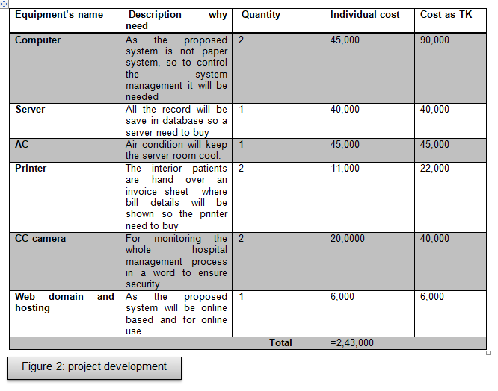

# 2.3 Technical Feasibility

The technical feasibility study is considered as an assessment of the logistical perspective of the business functions. Before investigating the business requirements, the developer and company both of are being needed to contact with this study. This feasibility study, they estimate technical and financial requirements. To establish this proposed system some necessary equipment’s will be needed. As the whole system is a computer centred so computer will be needed to manage this system. All the hospital information will be stored so the server is needed. When an enrolled patient will be discharged he will be given an invoice sheet where all billing information is shown. So, printer needs to be bought. The server room needs to keep in standard temperature to get high performance from the system. Due to this, AC needs to be bought. For ensuring, better security in the hospital CC camera will be needed. As the proposed system is an online based and it will be publicly used from anywhere and any devices. So they need to buy domain to host the website in server (LLC, 2018).

# 2.4. Operational feasibility

The operational feasibility should have ability to fulfill, support and perform the necessary jobs of the system. It must fulfill the demand and requirements by the business. At the earlier of the system, there was no confidentiality working process. All the tasks were accomplished by hand to hand. For this reason, there would take more time and complexity to manage hospital management process. There was also no data integrity in the paper based working approach. It was not comfortable data management process for the system users. After establishing the system, it has made the whole hospital management process ease and minimized complexity. Now the whole management has brought into computer centric. So, the hospital management system is more comfortable and trusted than previous system (LLC, 2018).

# 3. Analysis

# 3.1 Requirement

Before starting project development, the developer should analysis project requirements to deliver project proper time. In a project, some constraints, necessity and demands those are must be met there are consider as project requirements. These requirements must be accomplished in certain timeframe. In a project there are two types’ requirements such as functional requirements those must be accomplished and non-functional requirements those are less prioritize than functional requirements.

# 3.1.1 Functional requirements

In a project, the functional demands are described as base objects. These requirements are must be accomplished in certain timeframe. For the proposed system, the functional requirements are divided into several section reservations of information, enrolled and assign patient on particular doctor, make online appointment by exterior patient. The main functional requirements are below

* Reserve the information
* Make new staff
* View beds records
* Enrolled patients
* Assign patients on particular doctor
* Make prescription by doctor
* View enrolled patients list
* Doctor can define his online schedule for online treatment
* Display available doctor in website for online treatment
* Make online appointment by exterior patients
* View exterior patient treatment status
* Discharge patients and make invoice details
* Add and delete essential information

# 3.1.2 Non-functional requirements

The non-functional requirements narrate how the system should be behave and define system quality attributes. Although any non-functional requirement is absent from system further the base functionalities of system can perform properly. So the non-functionalities requirements are not mandatory for any system (Eriksson, 2015).

Topically some non-functional requirements for the system are

* Any logical database requirement
* System design constrain
* Scalability
* Maintainability
* Manageability
* Availability
* Reliability
* Serviceability

# Moscow prioritization of functional requirements

|  |  |  |
| --- | --- | --- |
| Requirements no. | Requirements | Moscow priority |
| 1 | The administrative can reserve information in the database | Must have |
| 2 | Admin will be allowed to make new staff | Should have |
| 3 | The room type, room and available beds information will be displayed | Must have |
| 4 | The staffs are allow to enroll new patient | Must have |
| 5 | The enrolled patients will be assigned on particular doctor | Must have |
| 6 | The doctors are allowed to make prescription according to their schedule. | Must have |
| 7 | The system users are allowed to view enrolled patients list and details. | Should have |
| 8 | The doctors are allowed to define their own online schedule for online treatment | Should have |
| 9 | Display available doctor in the website and their details profile | Must have |
| 10 | The exterior patient can make online appointment through registration | Should have |
| 11 | The exterior patient can view their treatment status | Should have |
| 12 | The staffs can discharge patient and also allowed to make invoice details | Must have |
| 13 | The staffs are allowed add and delete essential information from system | Would have |

# 3.2 Use case diagram

The symbols are used those are described bellow

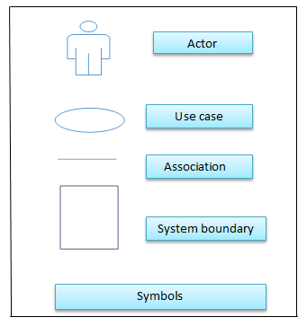

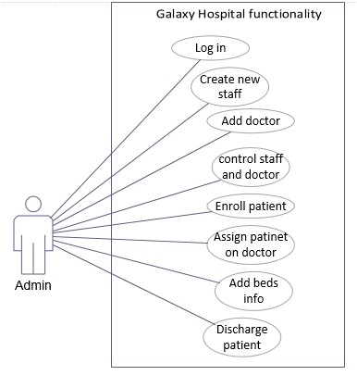

**Figure 3**: Admin functionalities

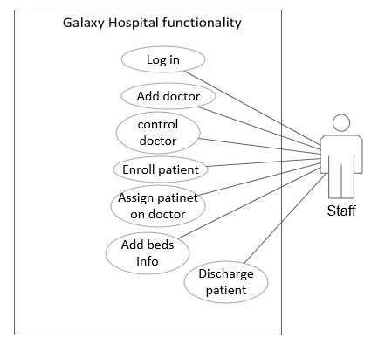

**Figure 4:** Staff functionalities

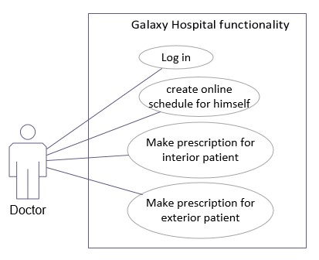

**Figure 5:** Doctor Functionalities

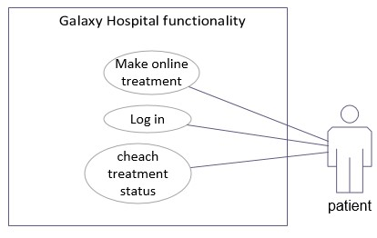

**Figure 6:** Exterior patient functionalities

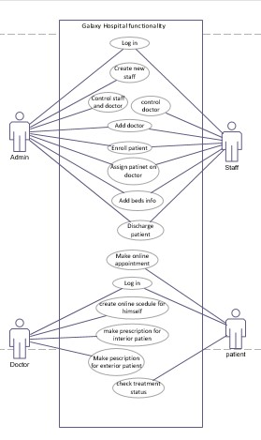

**Figure 7:** All actors’ functionalities in one

# 3.3 Architecture

# 3.3.1 System architecture

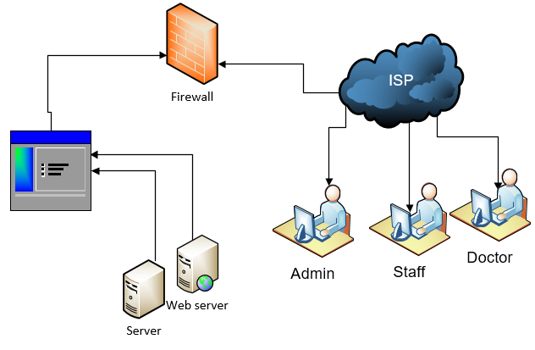

**Figure 8:** System architecture

# 4. Design

# 4.1 Architecture model

The symbols are used this portion are described in bellow (Microsoft, 2018).

**Class:**

It defines the definition of an object. In generation, it can make relation with other classes and shares structural and behavior attributes and characteristics.

**Association:**

An association represents a family of link. It makes relation any number of classes. A binary association is represent by a single line

**Generalization**

It indicates inheritance relation among the classifier. The arrow edge is located into super class and another edge is located into subclass. It means all the super class properties are available into subclass.

**Aggregation** 

It represents “has a” relationship between classes. It occurs, when a class is collection or container of other class. Although the container is destroyed, the contents of container still exist.

**Plus +:** It represents public property of a class.

**Minus - :** It represents private property of a class

Those classes are used to develop the proposed system are listed in the bellow

* Database
* Format
* Admin
* Staff
* Doctor
* Patient
* Room
* Appointment
* FondPage
* Session
* Sessiontwo

# 4.1.1 Initial class diagram

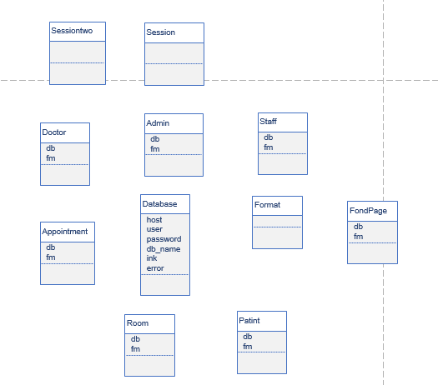

**Figure 9:** initial class diagram

# 4.1.2 Details class diagram

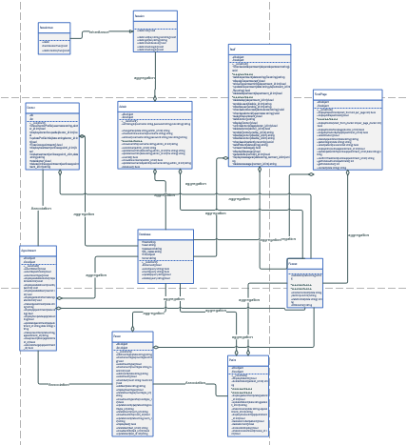

**Figure 10:** details class diagram

# 4.2 Behavior Model

Those symbols are used in this segment are described (SmartDraw, 1994).

**Start point:**

A small filled circle with an arrow represents the starting point of an activity diagram.

**Action state:**

A rectangle with rounded is represented an action state. It defines which action will be accomplished of an object.

**Action flow**

An action usually is shown with an arrow line. It represents working flow sequential working flow one action to another.

**Decision**

A diamond represent decision symbol of activity diagram. Usually condition is checked in this stage to move the next action. So it is used between two actions

**Final point**

With an arrow a filled circle nested into another blank circle is consider as final point of activity diagram.

# 4.2.1 Activity diagram

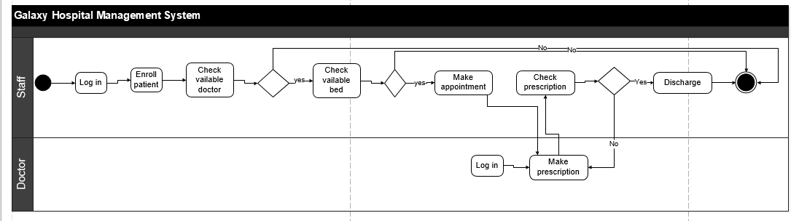

**Figure 11:** activity diagram of galaxy hospital for administrative panel

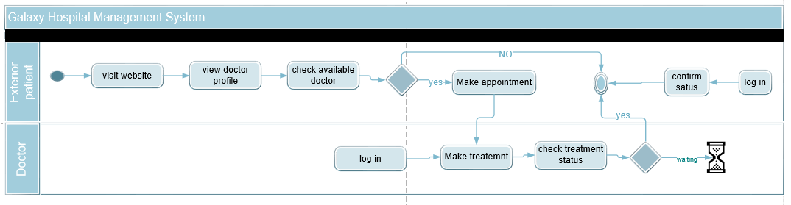

**Figure 12: activity diagram for exterior patient**

# 4.2.2 ER diagram

The following symbols are used in ER diagram

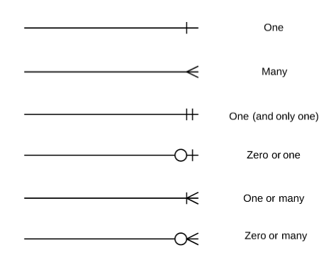

The following tables are used in database

* admin
* appointment
* backuponlineappointment
* be*d*
* room
* roomtype
* department
* doctor
* invoice
* patient
* onlineappointment
* contract

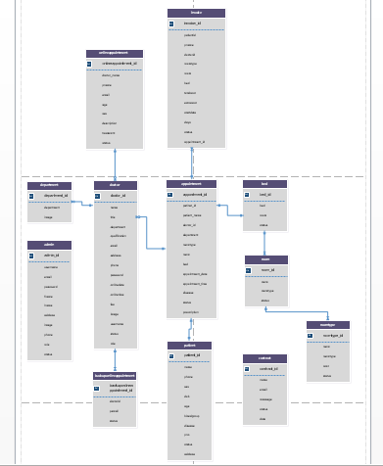

**Figure 13:** ER diagram

# 5. Implementation

# 5.1 Using programming languages

For developing a dynamic website several types of programing languages can be used. As the proposed system will be a dynamic website so the following languages are used

* HTML-5
* CSS
* Bootstraps
* Javascript
* Jquery
* Ajax
* PHP
* MySQL

These selected languages are used for several purposes. HTML-5, CSS, bootstrap are used to design the website. Some essential form is created by HTML-5 and style is given by using CSS. Bootstrap has been used for make the website responsible since user can visit the site from any devices and anywhere. In a word, for design part HTML-5, CSS and bootstraps are used. JavaScript, query and Ajax are used fronded validation. In the proposed system, there are some dropdown boxed are very essential to used Ajax technology. Basically, JQuery is used to support Ajax and other purposes. As the proposed system is totally dynamic approach all information will be managed from database. So, PHP has been used backend work also some validation which is work as a controller between database and website. Insert, updated, login checking adding patient records, doctor records will be accomplished by PHP. All the information has to store in database to manage records so MySQL database is used as storage.

# 5.2 System cutover from the development architecture to implementation architecture

The parallel strategy has been used to implement the proposed system from project planning stage to final development. The new system is run alongside the old system in project developing period. When any feature of project, is completed alongside this completed feature is tested to ensure the completed feature is providing right output. As the proposed system is totally a new system so I gathered knowledge from old system and found out drawbacks for new system. In the development time, it has been made a discussion with project manages so that implementation plan can be implemented thoroughly. These activities those are discussed above are followed from project planning to final development for the proposed project.

# 5.3 Data migration from the development architecture and/or existing system to the implementation architecture

As the existing system is not computerized system so it’s working functionalities are managed hand to hand. The records are managed on paper based by staffs. Previous information has to insert into the new system before using the new system. The staff will insert the data as like patient records, doctor details, room, bet and other essential information into the database table. The database will be placed on secure place and must have back up system. The staff can retrieve data, update, delete and show in the website easily.

Those tables are used to keep record in database are described below.

|  |  |
| --- | --- |
| Table name | Purpose |
| admin | The table is created to keep admin record as well as staff records. |
| doctor | All the doctor information will be kept in this table. From here doctor can update information and these update information also store in this table |
| patient | The staff will enroll patient. Details patient information will be stored here. The enrolled patient status also be stored whether assigned or not assigned |
| appointment | The enrolled patient will be assigned on particular doctor. So the all the appointment record will be stored here like appointment schedule, specific doctor. |
| bed | The bed information is stored here. Here also store bed status like available bed or blocked |
| department | In this table department information are kept. Which department is existing in this hospital shown |
| room | All the room records are kept in this table. It shows total room number and it status. |
| roomtype | Which room type is available in galaxy hospital are stored and cost for per bed. |
| invoice | When a patient will be discharged he will be given an invoice sheet with details information. So all the invoice records are stored in this table. |
| onlineappointment | The exterior patient can make online appointment with a specific doctor. So this appointment recorded is stored here. |
| backuponlineappointment | The online appointment information will be stored here as back up data. So that the strategic level users can analysis data in future. |

# 5.4 Training

A training staff is very essential for an organization management. Almost an organization success depends on better management system. So for the proposed system, the trained staffs can manage hospital functionalities in proper way and improve productivity and profitability. In the galaxy hospital, there are several functionalities like adding, modifying and how check appointment information. A well trained staff can manage all these functionalities properly. If they enter incorrect information in input field there will be shown several type of massage and error massage will show them for making correction. It may take 5-7 days to train the staffs about the system maintain (BRL, 2016).

# 6 Other project matters

# 6.1 Project management

The project management is defined as application of knowledge, tools and some techniques, of a project activity to obtain the project goals and requirements. A project has to accomplish all the demands according the agreement within a timescale and limited budget. The project management brings an individual focus that is formed by the objectives and goals and schedule for every project (PMI, 2018).

The total project management processes are grouped into five steps

* Initiating
* Planning
* Executing
* Monitoring and controlling
* Closing

These five steps are most important to develop an efficient project. So, to develop the proposed system all these steps have been followed.

# 6.2 Risk Management

The risk can be defined as an uncertain event and situation that can make negative effect on a project. A risk can hamper the company reputation as well as the company revenue and financial site can be hampered. So the project management team should take risk management approach to reduce the potential risks. In the risk management process, it identifies the risk, analysis the risk, assessment and response against any type of risk that can be arose throughout the project life. So a risk management process can be major factor for project success. As the proposed system is a computerized system so all the records need to kept in a database. But there is not available high security method in the system. So risk should identify those can be occurred (Business, 2018). I have followed three steps to identify the risks

* Identifying the probable risks
* Determine its impact on project
* Determine its likelihood

# 6.3 Configurations Management

The effective configuration management (CA) involves the practice of processing system, variation systematic with initial intention of updating system when keep up system integrity. To achieve these objectives, the CM accomplishes trifles policies, process and several techniques, whilst employing the excellent configuration management tools are essential to maintain track revision status and document throughout the whole process. A proper configuration system demand adjustment, customize and upgrade current hardware, software and documentation elements. As, the current system is not well configured it should be well configured (M., 2018). The following outcomes will come if the system is well configured.

* Enhance performance
* Improve system reliability
* Lower error rate
* Improve online availability

# 6.4 Testing

Testing is a process that assesses a system and identifies the deference between given input and expected output. It also assesses the system quality. This process is accomplished during development time. In the proposed system two types of testing will be accomplished to detect deference between given input and expected output (Rehman Zafar, 2012). The following testing will be accomplished.

# Unit testing

A unit testing is the testing that is accomplished with an individual or group of related units. It is consider as white box testing and usually done by the programmer to produce expected result according to given input.

# Integration testing

The integration is a testing where the individual units are merged in a group to test and for producing expected output. It tests hardware and software if there have any relation between components.

# 6.4.1 Unit Testing

|  |  |  |  |  |
| --- | --- | --- | --- | --- |
| Unit Test: 1 | Test class: Enrolled Patient | | Designed by: Rasel Rana | |
| Data source: From patient and staff will insert | Objective: Test basic functionality | | Tested by: Rasel Rana | |
| Test class | Description | Task | Expected result | Actual result |
| 1.1 | Test for the basic functionality | Staff will enroll the patient first. | The information will be stored in database and display in system | As expected |

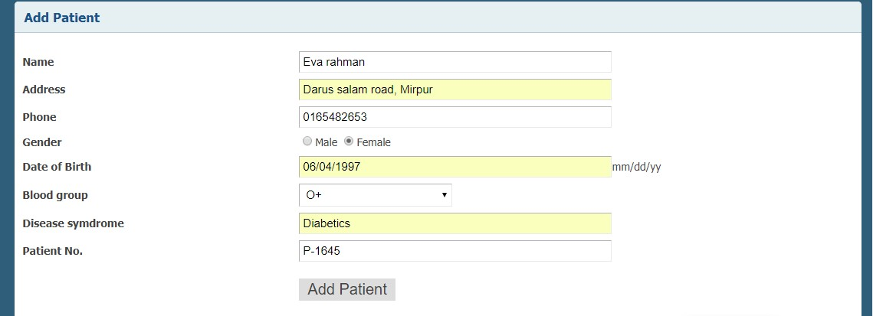

**Figure 14:** Enroll patient

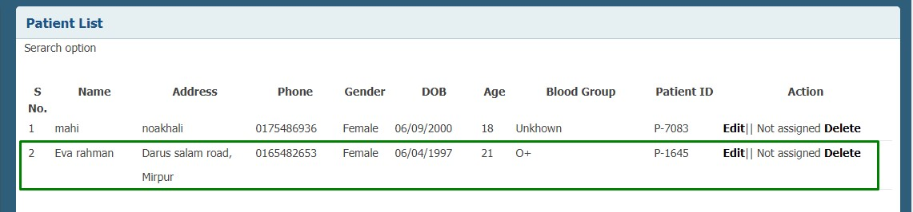

**Figure 15:** Enrolled patient is displayed here.

|  |  |  |  |  |
| --- | --- | --- | --- | --- |
| Unit Test: 2 | Test class: Make appointment | | Designed by: Rasel Rana | |
| Data source: From data are kept before | Objective: Test basic functionality | | Tested by: Rasel Rana | |
| Test class | Description | Task | Expected result | Actual result |
| 1.1 | Test for the basic functionality | The staff will make an appointment to prescription | A patient will assigned on a particular doctor and these records will be shown in system | As expected |

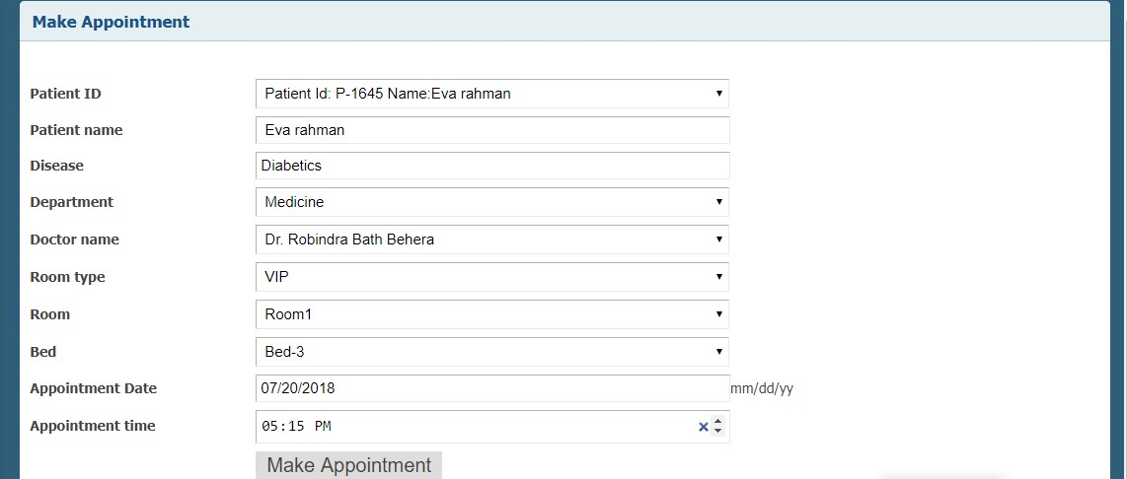

**Figure 16:** Make appointment

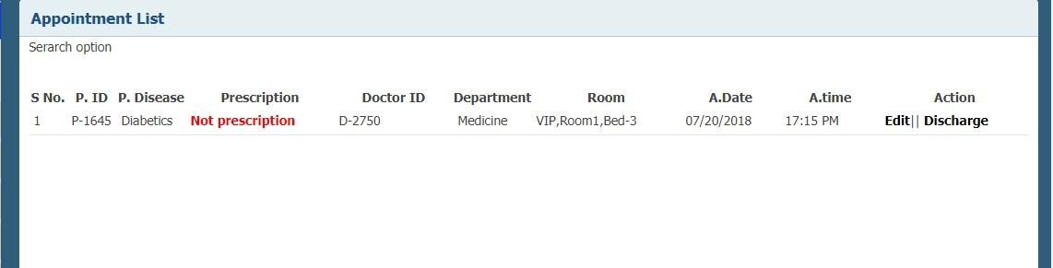

**Figure 17:** Appointment list displayed here

# 6.4.2 Integration Testing

|  |  |  |  |  |
| --- | --- | --- | --- | --- |
| Integration Test: 1 | Test class: invoice | | Designed by: Rasel Rana | |
| Data source: after responding button | Objective: Test for the basic functionality | | Tested by: Rasel Rana | |
| Test class | Description: | Task | Expected result | Actual result |
| 1..1 | Click on button to check that is working properly or not | Click on the invoice button | After log in staff will click on invoice button and the previous invoice records will be displayed as list | As expected |

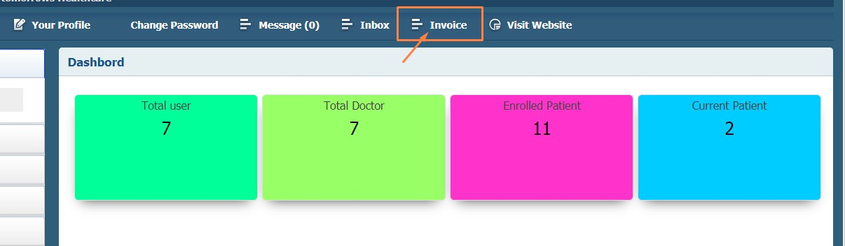

**Figure 18:** Staff will click on invoice button

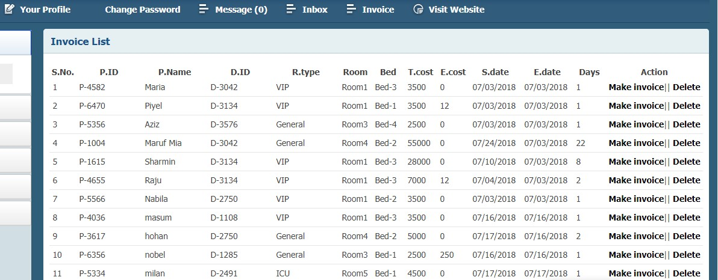

**Figure 18:** After clicking on invoice button this page will be dispelled

|  |  |  |  |  |
| --- | --- | --- | --- | --- |
| Integration Test: 2 | Test class: update profile | | Designed by: Rasel Rana | |
| Data source: from button working | Objective: Test for the basic functionality | | Tested by: Rasel Rana | |
| Test class | Description | Task | Expected result | Actual result |
| 1.1 | Click on the update button to check that is working properly | Here on the update button will be clicked profile page and shown update form. | An update from will displayed with user information. | As actual |

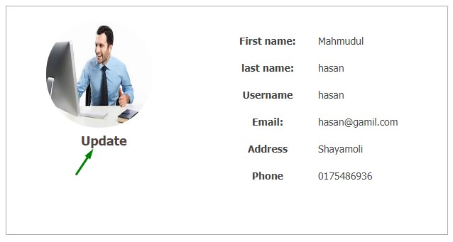

**Figure 19:** On the update button will be clicked

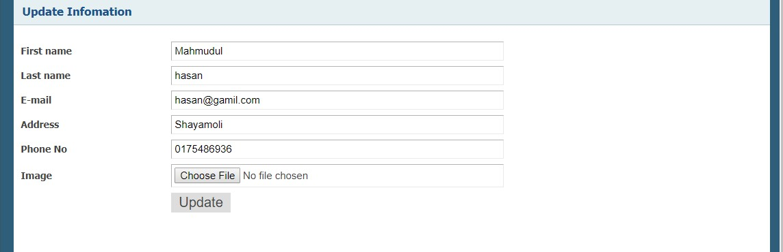

**Figure 20:** This page will be displayed after clicking on update button

# 7 Conclusions

Finally I have been able to complete the proposal system successfully according to the plans. To accomplish the system I have faced some problems throughout development life cycle. I have learned about several types of technologies as like PHP, MySQL, JavaScript, JQuery, HTML, CSS, bootstrap and Ajax from this project. As this is my first project, so I cannot use all these technologies properly. From this project, I have also learned how to create used friendly system as well as learnt how to controlled unauthorized uses access. How an error can be maintained easily is learnt from this system. I have learnt how several types of testing can be accomplished. Testing ensure that expected outcome are getting against input. I have learned how different types validation.

# 7.1 Strengths and weakness of the system

# Strengths

* **More Validation**

In the proposed project there has been used more validation check when it was needed so that can be process properly.

* **User friendly**

The system interface is user friendly. Very simple functionality, effective color combinations is available in the system. So, the used can used system easily.

* **Access control**

There are several types access levels are used in this system. For admin, staff, and doctors has different type’s accessibility for better maintain.

* **Online appointment**

As the system is an online based so the exterior patient can make appointment with available doctor from anywhere and any devices

* **Simple functionality**

In the system all the functionalities are placed proper place. So the user and exterior patient can find out the information easily

* **Platform independent**

No required any special browser to run this system. From any browser, the system can be run.

# Weaknesses

* **Security issue**

There are not available good security branches. So, different types of attack can occur any time.

* **Data backup**

In database I cannot keep data in proper organized way. No back up policy in system. If somehow database is crushed all the data can be lost.

* **Only appointment date and time**

Staff can define online appointment data and time. There is no functionality, how much time doctor has spread with patient.

* **Search data**

If system users want to search data from database they cannot it, because the search option is not available in the system. So, it is great drawback for the system.

* **Limited doctor access**

In the system doctor are not permitted to add any information in database and discharge patient.

# 7.2 Problems identified and resolved

In the developing life cycle, I have faced many types of troubles and also able to overcame troubleshoot. First problem was in login segment. As several types of user login from a same login panel so $_SESSION was not working properly. To resolved this problem I have used individual $_SESSION from each user. Next problem was in SQL injection and the apostrophe was allowed from input field that too much risk for the system. So, to resolved this problem, I have used some essential MySQL function and PHP function like mysqli_real_escape_string(), trim(), strislashes(), htmlspecialchars(). The worst difficult problem was for me that when any error messages are shown me I could not understand easily the given massages. I have had to spread too much time on error massages. Finely, I took help from online and resolved. I have faced problem with Ajax. When I select any option from dropdown box the related information was not shown properly. I also took help from online to resolve this here. Another problem was, when I would make invoice sheet for patient this invoice data was not stored in other table as backup data. So I have checked all the data from invoice table to ensure that whether data availability in database table and overcame to from this problem.

# 7.3 Further Development

There is some functionality; these have to add in in future to give to provide complete form for the proposed system. The following feature cam be added,

* **Search option**

There is no any search option in the proposed system. So user can make search to retrieve data from database table. So, it is not usability system. In future I will develop search option so that user can get from any pages.

* **More than one time prescription**

In the proposed system, a doctor can make prescription only one time on a particular patient per appointment. But it may need for doctor to make several time prescriptions on a patient. So, this functionality will be developed so that a doctor can make prescription more than one time.

* **Doctor schedule**

Doctor schedule is not available in this system. Due to this staff cannot check which doctor is available in which time. A doctor schedule page will be created.

* **Design for mobile device**

The administrative segment is not supported in all devices. So the staffs cannot use this system from all devices. In future, the system will be redesigned for support all devices.

* **Payment system**

Here payment system is not card payment system. In future card payment system will be developed.

# 8. References

BRL (2016) *Employee Training*, 5 September, [Online], Available: <http://trainingtoday.blr.com/category/employee-training/> [3 July 2018].

Business,S. (2018)*Risk management*,5 February , [Online], Available: <https://www.smallbusiness.wa.gov.au/business-advice/insurance-and-risk-management/risk-management> [8 July 2018].

Eriksson, U. (2015) *The difference between functional and non-functional requirements*, 3 April, [Online], Available: <https://reqtest.com/requirements-blog/understanding-the-difference-between-functional-and-non-functional-requirements/> [18 June 2018].

Investopedia, L. (2018) *Feasibility Study*, 10 Seeptember, [Online], Available: <https://www.investopedia.com/terms/f/feasibility-study.asp> [10 June 2018].

Ledbrook, L. (2012) *Waterfall Project Management: An Overview*, 13 June, [Online], Available: <http://projectcommunityonline.com/waterfall-project-management-an-overview.html> [3 June 2018].

LINKY (2009) *Project management advice, tips, tools and recommended resources for existing and aspiring project managers.*, 6 December , [Online], Available: <http://www.virtualprojectconsulting.com/pmmethodologies/#sthash.aXB9mOS1.xAXguaKl.dpbs> [2 June 2018].

LLC (2018) *What Is Economic Feasibility?*, 2 March, [Online], Available: <https://www.reference.com/world-view/economic-feasibility-44e5a7ca3098f75c> [12 June 2018].

LLC (2018) *What Is Operational Feasibility?*, 15 January, [Online], Available: [https://www.reference.com/business-finance/operational-feasibility-300ab6b96428cf68#](https://www.reference.com/business-finance/operational-feasibility-300ab6b96428cf68) [16 June 2018].

LLC (2018) *What Is the Technical Study of Feasibility?*, 12 August , [Online], Available: [https://www.reference.com/business-finance/technical-study-feasibility-c11df584b43aa9ec#](https://www.reference.com/business-finance/technical-study-feasibility-c11df584b43aa9ec) [15 June 2018].

M., P. (2018) *What Is Configuration Management? - Definition, Process & Tools*, 9 March, [Online], Available: <https://study.com/academy/lesson/what-is-configuration-management-definition-process-tools.html> [10 July 2018].

Microsoft (2018) *UML Class Diagrams: Reference*, 5 January, [Online], Available: <https://msdn.microsoft.com/en-us/library/dd409437.aspx> [25 June 2018].

PERIYASAMY, J. (2013) *What is Waterfall model and list its advantages, disadvantages*, 26 December, [Online], Available: <http://jobsandnewstoday.blogspot.com/2013/04/what-is-waterfall-model.html> [June May 2018].

PMI (2018) *What is Project Management?*, 8 January, [Online], Available: <https://www.pmi.org/about/learn-about-pmi/what-is-project-management> [7 July 2018].

Rehman Zafar (2012) *What is software testing? What are the different types of testing?*, 20 March, [Online], Available: <https://www.codeproject.com/tips/351122/what-is-software-testing-what-are-the-different-ty> [12 July 20].

SmartDraw, L. (1994) *Activity Diagram*, 20 March, [Online], Available: <https://www.smartdraw.com/activity-diagram/> [29 June 2018].

# 9. Appendices

# 9.1 Requirement catalogue

In this part I have define all the functional requirement’s priority as High, Medium and low

|  |  |  |  |
| --- | --- | --- | --- |
| Requirements No | Requirements | Priority | Requirement type |
| 1 | The staff can reserve records in database | High | Functional |
| 2 | Admin can create new staff | Medium | Functional |
| 3 | All the beds details information will be displayed | High | Functional |
| 4 | Staff enrolls the patients | High | Functional |
| 5 | Staff can enrolled patient on specific doctor | High | Functional |
| 6 | Doctor will create prescription according to schedule | High | Functional |
| 7 | The administrative panel can see patient and doctor details | Medium | Functional |
| 8 | Doctor can update their online schedule | Medium | Functional |
| 9 | Display all the doctor profile in the website and available doctor for online appointment | High | Functional |
| 10 | The exterior patient can make online appointment | Medium | Functional |
| 11 | The exterior patient can view their treatment status | Medium | Functional |
| 12 | The staff will discharge patient and will make invoice details | High | Functional |
| 13 | The staff can add, delete essential information | Low | Functional |

# 9.2 Use case description

|  |  |
| --- | --- |
| UCD:1 | Log in |
| Use case description | Admin will log in in the system |
| Actor (Primary) | Admin |
| Basic flow of events | * He will provide username and password and match these with database. * Logged in and redirect system |

|  |  |
| --- | --- |
| UCD:2 | Add new staff |
| Use case description | Add new staff and store information database |
| Actor (primary) | Admin |
| Basic flow of events | * Full-fill form fields * Data will be inserted in database |

|  |  |
| --- | --- |
| UCD:3 | Add and update information |
| Use case description | Update and add new information |
| Actor | Admin |
| Basic flow of events | * Insert records into database * Update essential data and stored into database |

|  |  |
| --- | --- |
| UCD:4 | Log in |
| Use case description | Staff will log in |
| Actor | Staff |
| Basic flow of events | * Provide username and password * Match information * Logged in and redirect dashboard |

|  |  |
| --- | --- |
| UCD:5 | Add and edit information |
| Use case description | Staff will add and can edit information |
| Actor | Staff |
| Basic flow of events | * Full-fill the form field * Store records in database * Make appointment * Discharge patient |

|  |  |
| --- | --- |
| UCD:5 | Log in |
| Use case description | Doctor will log in |
| Actor | Doctor |
| Basic flow of events | * Provide username and password * Match these information from database * Redirect the system |

|  |  |
| --- | --- |
| UCD:6 | Make prescription and update profile |
| Use case description | Doctor will make prescription and update online schedule |
| Actor | Doctor |
| Basic flow of events | * Full-fill form field to make prescription * Update online schedule * Make treatment against online treatment * All the record will be stored in database |

|  |  |
| --- | --- |
| UCD:7 | Online appointment |
| Use case description | Exterior patient will make online appointment |
| Actor | Exterior patient |
| Basic flow of events | * Full-fill the form field to make online appointment * He will log in * Check treatment status |

# 9.3 Details class Definition

|  |  |
| --- | --- |
| Class name | Description |
| Admin | The admin class is used for describing admin details information.This class make association relation with Database and Format class. So Admin class is container of these classes. Inside its constructor object of Database and Format class are created. In this class two private attributes db and fm are declared. There are also have methods like adminlogin(), checkadminusername(),adduser(),showuserInfo(),selectUser() and some more methods. |
| Appointment | The Appointment class is used for describing details appointment information. This is a container class of Database class and Format. fm and db are two private attributes of this class. Some method are for this class makeAppointment(),displayAppointment(),updateAppointment(),makeprescrition and some one methods, |
| Doctor | To describe about doctor information this class is used. There is a “has a” relation between Doctor and Database class and Doctor and Format class. db and fm are two private attribute of this class. Some method are showDoctorProfile(), displaydoctorforupadte(),updateProfileInfo(),displaytreatment() and some more methods. |
| FondPage | The FondPage class is created for describing website information. All records will be displayed in website from database. This creates association relation with Database and Format class. db and fm are private attribute. There also some methods displayDepartment(),displayDoctor(), makeAppointment(),patientlogin(),displayinfo(),updatepatientInfo and some more methods. |
| Patient | This class is created for describing patient’s information. It make “has a” relation with Database and Format class. So it is container of thses classes. Two private attribute are db and fm. Some essential method are displaypatientforUpdate(), updatePatient(),taotalenrrolledpatient(),deletePatient() and some more methods. |
| Room | This class is created for describing about room type, room and bets information. This class is association with Database and Format class, So it is a container of these classes. db and fm are two private attributes. There some methods like addroomtype(),checkeroomtype(),checkeroom(),selectroom(),addBed(),updateroomtype() and some more methods. |
| Staff | This class is used for describing details staff information. It is container of Database and Format class as there are “has a” relation among them. There two private attributes db and fm. Some methods updateDepartment(),checkedoctoremail(),addDoctor(),displayDoctor(),unlinkdoctorimage(),disableDoctor() and some more methods. |
| Format | This class is used to get some extra help like data validation, formatting any string and apostrophe etc. There are no attributes in this class but some methods like validation(), shortenContent(),dateformat(),tittlename(). |
| Database | This is created for build database connection with MySQL database. There are some public attribute like host, user password, db_name and some methos like dbConnect (), select(),insert(),update(),delete(). |
| Session | This class is used for make $_SESSION. This is the super class of Sessiontwo class. There are no attributes but some static methos like init(),set(),get(),checkSession(),checkLogin(),destroy() are created. |
| Sessiontwo | This class is also created to make $_SESSION. It inherited the Session class so it is subclass of Session class. No attributes are available in this class but some static methods are available like checkSessionTwo(),destroyTwo() |

# 9.4 Test scripts

# Unit testing scripts

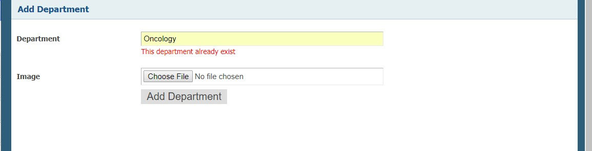

**Figure 21:** Check existing department

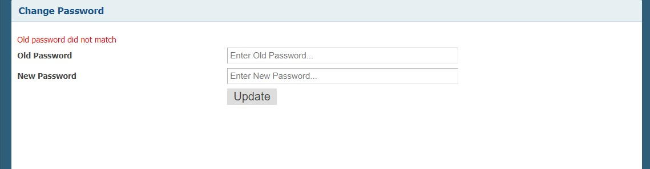

**Figure 22:** password validation

# Integration Testing

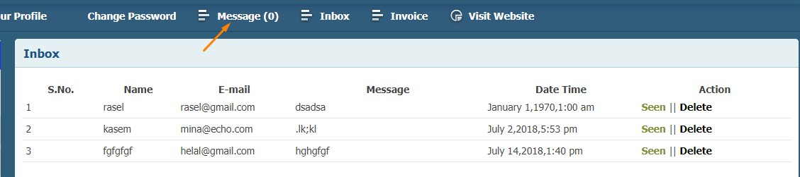

**Figure 23:** after clicking Message button

# 9.5 User Guide

A user guide means how the system user will use this system without any problem. They may face different kind of problem when they use this system as the staffs are new with online based application. The problems like how to make appointment, how doctor will make prescription and discharge patient etc. So in the website help option I have given video where total system working process is shown properly.

# 9.6 System code

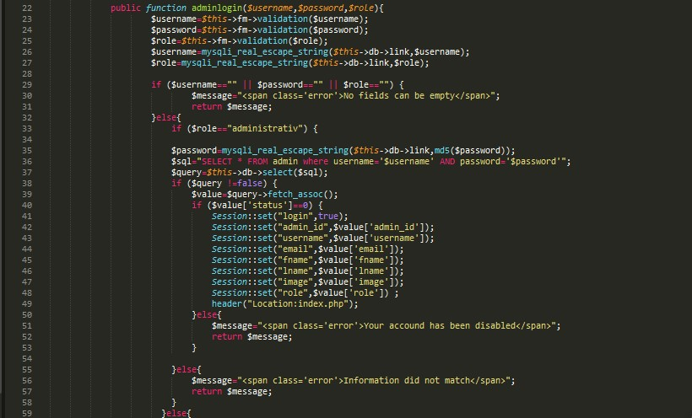

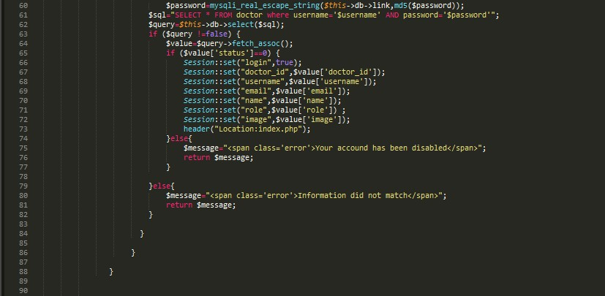

**Figure 24:** log in code

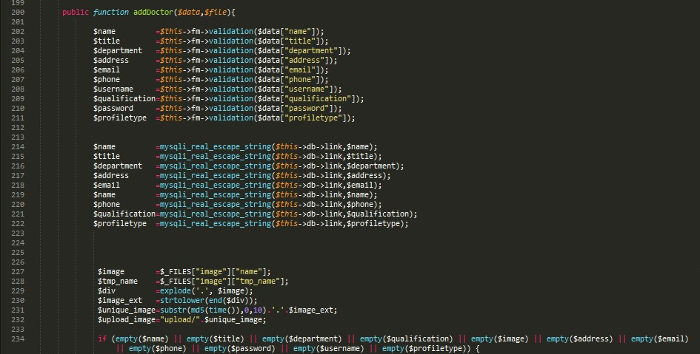

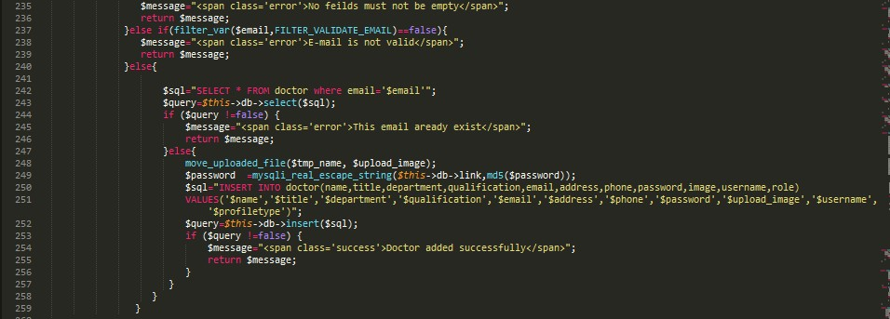

**Figure 25:** add doctor

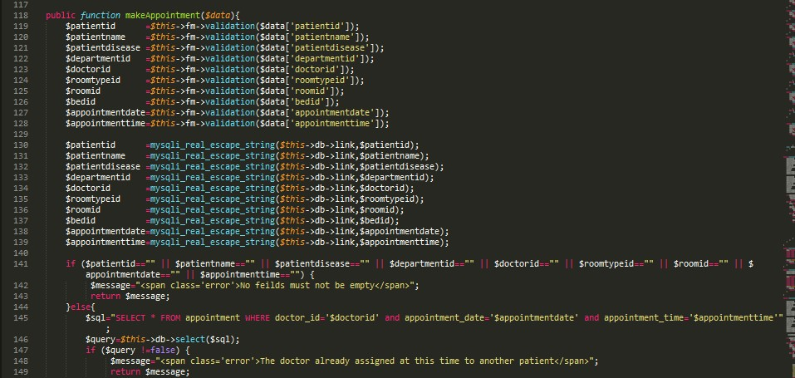

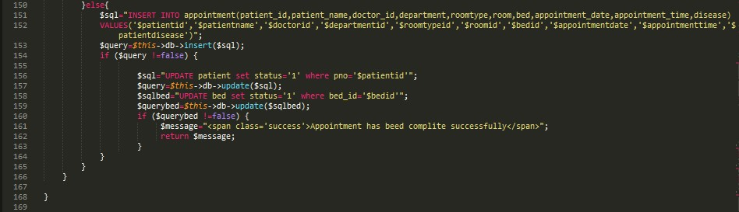

**Figure 26:** make appointment

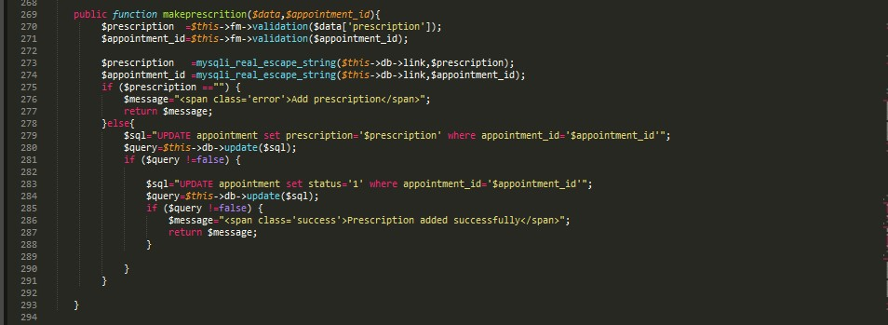

**Figure 27:** make prescription

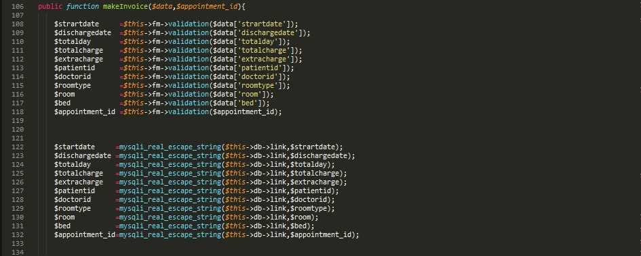

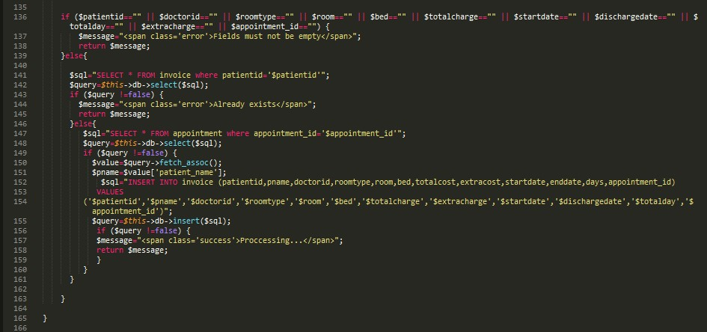

**Figure 28:** make invoice

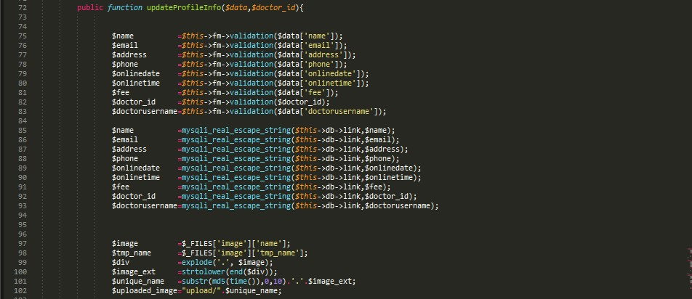

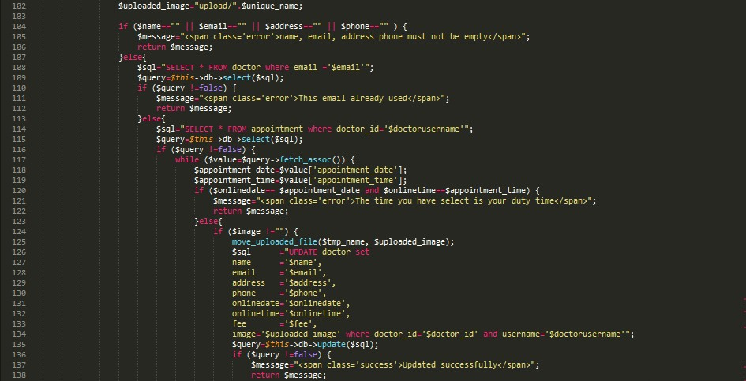

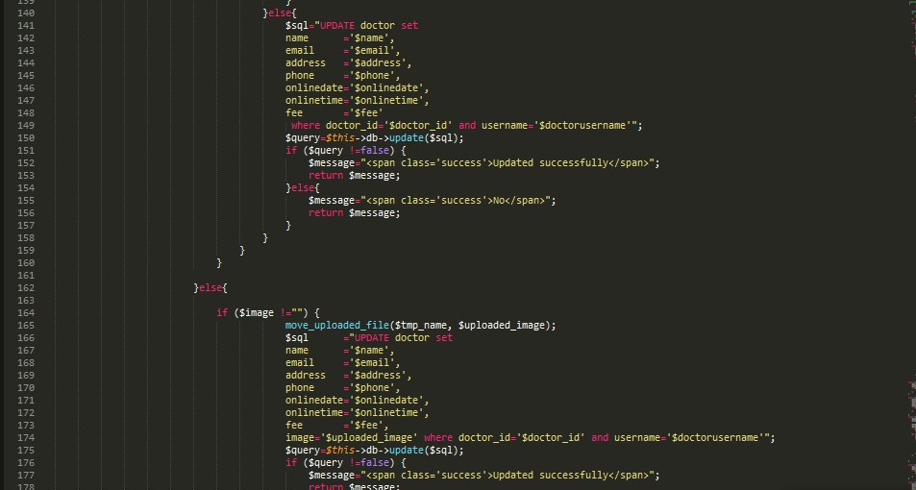

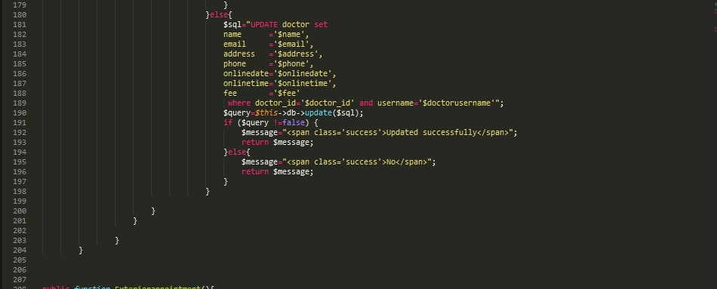

**Figure 29:** Doctor Profile update