**SOCIAL SHARE BUTTONS**

**A MINI PROJECT REPORT**

***Submitted by***

**Group/Team No: G29/T10**

**SUJAL RASTOGI -** 2210990869

**SUKOON -** 2210990870

**SULABH GARG -** 2210990871

**SUMAN RANJAN –** 2210990872

***in partial fulfilment for the***

***award of the degree of***

**BACHELOR OF ENGINEERING**

***in***

**Computer Science and Engineering**



CHANDIGARH-PATIALA NATIONAL HIGHWAY

RAJPURA (PATIALA) PUNJAB-140401 (INDIA)

MAY, 2023

**Table of Contents**

|  |  |
| --- | --- |
| Topics | Page No. |
| Abstract | 3 |
| Introduction | 4 |
| Case Study | 5 |
| Problem statement / Use Case | 6 |
| Technical Details | 7 |
| Key Features | 8 |
| Project Advantages | 9 |
| Results | 10 |
| Code Snippets | 11 |

**Abstract**

This project focused on the implementation of social share buttons on a website using HTML, CSS, and JavaScript. The main goal was to enable visitors to easily share website content on their social media platforms, thereby increasing the website's reach and engagement. The code implemented four popular social media platforms' share buttons: Facebook, Twitter, LinkedIn, WhatsApp, Reddit, and many more. The project also included the use of JS to add buttons dynamically without need to add HTML or CSS to existing code. Overall, the project aimed to improve the website's user experience by providing an efficient and user-friendly way to share content on social media.

**Introduction**

In today's digital age, social media has become an integral part of our lives. It has revolutionized the way we communicate, share information, and connect with people. Social share buttons are one such innovation that has made it easier for us to share content on various social media platforms with just a click of a button.

Social share buttons are small icons that are placed on websites, blogs, or other online platforms, allowing visitors to quickly and easily share the content they are viewing on their social media profiles. These buttons provide a convenient way for users to share interesting articles, products, or services with their friends, family, and followers on social media platforms such as Facebook, Twitter, LinkedIn, WhatsApp, and more.

The Social Share Buttons project is an essential tool for website owners who want to increase their online presence and attract more visitors to their site. The project is easy to use and visually appealing, making it an excellent addition to any website. The use of SVG ensures that the icons are of high quality, and the project is easily customizable through CSS.

**Case Study**

The project was to develop a simple and easy to plugin to enable developers to add social share buttons to their website without writing excess code.

* Features :-
  + Use direct share api for Facebook, Twitter, LinkedIn, WhatsApp, Reddit and Email, which will auto fill message box with link.
  + When api allows it, also write website title in message.
  + Directly modify and add share buttons for custom sites.
* Roadmap :-
  + Design layout of modal. Modal should have a section with share buttons, shows URL of current page and also have copy button.
  + Code modal in HTML and CSS in separate file for better workflow.
  + Copy HTML code to JS so that we can allow users to only include script file to make sharing possible, without adding any HTML.
  + Make a JS array object with data such as icon, name, and share api of all supported websites.
  + Make functions to populate webpage with modal. And add event listeners on this modal and any button with the class name “socialShareBtn” to show/hide the share modal.
  + Create multiple basic sites to showcase working of this plugin.
  + Custom share button.
  + Custom share message with website URL.

**Problem statement / Use Case**

Despite the prevalence of social share buttons on websites and blogs, many users still struggle to effectively share content on their preferred social media platforms. This can result in frustration, decreased engagement, and missed opportunities for website owners to expand their reach. Additionally, the use of social share buttons can potentially compromise user privacy and security, raising concerns about data collection and tracking practices. Therefore, there is a need for a user-friendly and secure social share button solution that can enhance content sharing while respecting user privacy.

**Technical Details**

The code uses the following technical details:

* **HTML5:** The code is written in HTML5 markup language that provides a clear structure to web pages.
* **CSS3:** Cascading Style Sheets version 3 is used to style the HTML elements and layout of the web page. The code uses various CSS properties and selectors to define the appearance of the web page, such as color, font, margin, padding, border, background, and so on.
* **JAVASCRIPT:** The code uses JavaScript for interactivity and dynamic behavior of the web page. The code uses various JavaScript methods and functions to manipulate the HTML elements, such as adding elements dynamically and adding click functionality to them.
* **DOM:** The Document Object Model (DOM) is a programming interface for HTML and XML documents. The code uses the DOM to access and modify the HTML elements of the web page. For example, the code uses the *document.querySelector()* method to get the reference to share button container and buttons themselves, and the *document.addEventListener()* method to add an event listener to the buttons.

**Key Features**

* Very easy to use and implement in any webpage: One of the most significant advantages of this code is its ease of use. The code is simple and easy to understand, making it effortless to implement on any website. It also does not require any complex coding knowledge, making it accessible to a wide range of users.
* Visually appealing modern design: The social share buttons have a modern design that is visually appealing and fits well with most website themes. This design helps to enhance the user experience of the website visitors.
* Includes buttons for popular social media platforms: The code includes buttons for popular social media platforms such as Facebook, Twitter, LinkedIn, Instagram, WhatsApp, and more. This feature ensures that visitors to the website can share the content on their preferred social media platforms with ease.
* Customizable share buttons: The code allows for customization of the share buttons, including the size and color of the buttons. This feature is important as it enables website owners to match the buttons' design to the overall theme of their website.
* Uses SVG as icons in buttons for better visual experience: The code uses Scalable Vector Graphics (SVG) as icons in the buttons, which enhances the visual experience of the website visitors. SVG graphics are high quality and look great on all devices.
* Dynamically takes URL and Title from webpage: The social share buttons code dynamically takes the URL and Title of the webpage, making it easier for website visitors to share the correct link and title when sharing content on social media platforms. This feature also helps to improve the website's search engine optimization (SEO) by ensuring that the correct title and URL are shared.

**Project Advantage**

There are several advantages of this project, including:

* **Improves social media presence:** The social share buttons make it easier for users to share content on their preferred social media platforms. This can help increase the visibility of the website and improve its social media presence.
* **Easy to use and implement:** The code is easy to use and implement in any webpage. It does not require any advanced programming knowledge or expertise, making it accessible to users of all levels.
* **Customizable:** The code allows for customization of the share buttons, including the size and color of the buttons. This enables users to personalize the buttons to match the look and feel of their website.
* **Modern design:** The social share buttons have a visually appealing modern design. They use SVG as icons in buttons for a better visual experience.
* **Dynamic URL and title:** The code dynamically takes the URL and title from the webpage, making it easy for users to share content without having to manually enter the information.
* **Popular social media platforms:** The social share buttons include buttons for popular social media platforms such as Facebook, Twitter, LinkedIn, Instagram, WhatsApp, and more. This makes it easier for users to share content on the platforms they use most frequently.

**Result**

The Social Share Buttons project is a visually appealing and modern design that provides easy-to-use social media sharing options for webpages. It includes buttons for popular social media platforms such as Facebook, Twitter, LinkedIn, Instagram, WhatsApp, and more.

One of the main advantages of this project is its flexibility and customization options. The code allows for easy modification of the share buttons' size, color, and other attributes, making it easy to adapt to the design of any webpage. Additionally, the project uses SVG icons in the buttons, providing a better visual experience for users.

Furthermore, this project dynamically takes the URL and title from the webpage, making the sharing process more seamless and efficient. This feature eliminates the need for users to manually enter the page's URL and title when sharing, enhancing the user experience.

In summary, the Social Share Buttons project is an efficient and user-friendly solution for website owners looking to incorporate social media sharing options into their webpages. Its customizable design and dynamic features make it an attractive and practical solution for users.

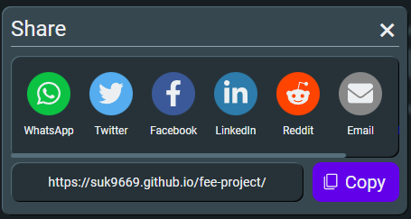

**Code Snippets**

Variable fillData with share buttons title, icon and click action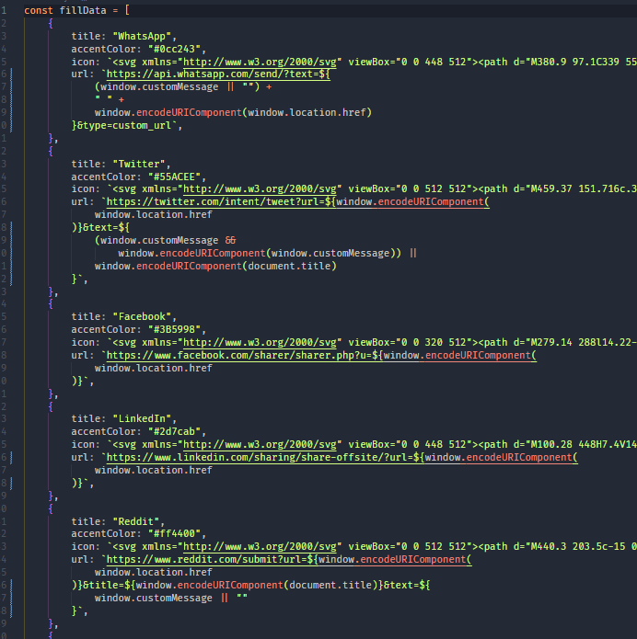

Dynamically adding buttons to share modal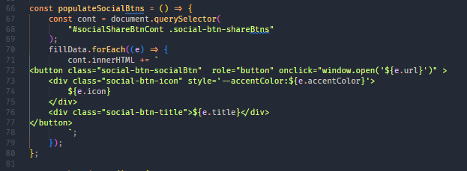

Dynamically adding Share modal

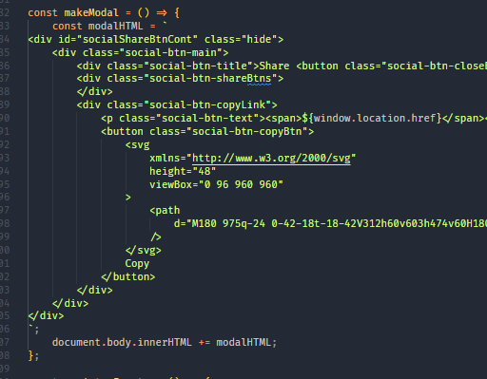

Registering events

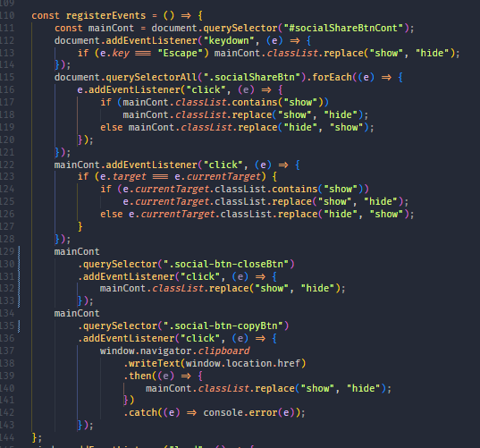

Code to add custom buttons and custom message

