CAR SALES DATA ANALYSIS
PROJECT REPORT
Exploratory Data Analysis using Python
Tools: Pandas, NumPy, Matplotlib, Seaborn and Jupyter Notebook
Student Name: ______________________________
College / Institution: ________________________
Course / Internship: __________________________
Submission Date: ______________________________

1. Introduction
This project performs an exploratory data analysis of a small car sales dataset using Python. The analysis focuses on understanding the structure of the data, checking data quality, calculating basic sales statistics, comparing sales across categorical attributes, studying relationships between numerical variables, and presenting the results with visualizations.
The analysis was implemented in a Jupyter Notebook using Pandas for data loading and grouping, NumPy for numerical support, Matplotlib for charts, and Seaborn for the correlation heatmap.

2. Objectives
- Load and inspect the car sales dataset.
- Understand the columns, record count, data types, and data completeness.
- Calculate total, average, maximum, and minimum sale values.
- Compare total sales by fuel type, transmission type, and company.
- Examine the relationship between car year and sale value.
- Examine the relationship between engine capacity and sale value.
- Examine the relationship between mileage and sale value.
- Use correlation analysis to summarize relationships among numerical variables.
- Present analytical findings in a clear and reproducible project report.

3. Dataset Description
The dataset contains 15 records and 8 columns. The fields include car name, company, year, sale value, fuel type, transmission type, mileage, and engine capacity.
Column | Description | Data Type
Car_Name | Car/model name | String
Company | Manufacturer/company | String
Year | Year value associated with the car | Integer
sale | Sale value recorded in the dataset | Integer
Fuel_Type | Fuel category | String
Transmission | Transmission category | String
Mileage | Mileage value | Integer
Engine_CC | Engine capacity in CC | Integer

4. Data Inspection and Data Quality
The DataFrame information output shows 15 entries across 8 columns. Each column has 15 non-null values, so no missing values were detected in the dataset used for this analysis.
Property | Observed Result
Rows / records | 15
Columns | 8
Integer columns | 4
String columns | 4
Missing values | 0 detected
Approx. memory usage | 1.1 KB
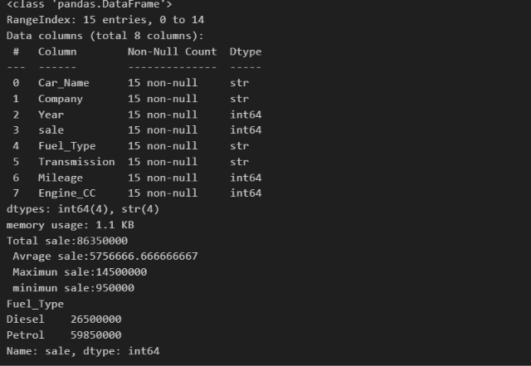
Figure 1. Dataset structure, data types, non-null counts and basic sales outputs.

5. Methodology / Implementation
The analysis followed a simple exploratory workflow: load the CSV file, inspect the DataFrame, check for missing values, calculate descriptive statistics, group sales by selected categorical columns, create scatter plots for numerical relationships, and calculate a correlation matrix.
Core analytical operations used in the notebook include:
df = pd.read_csv("sale.csv")
df.shape
df.info()
df.describe()
df.isnull().sum()
df.groupby("Fuel_Type")["sale"].sum()
df.groupby("Transmission")["sale"].sum()
df.groupby("Company")["sale"].sum().sort_values(ascending=False)
df[["Year", "sale", "Mileage", "Engine_CC"]].corr()

6. Descriptive Sales Analysis
Measure | Result
Total sale | 86,350,000
Average sale | 5,756,666.67
Maximum sale | 14,500,000
Minimum sale | 950,000
The total recorded sale value is 86,350,000 and the average sale value is approximately 5,756,666.67. The maximum and minimum values are 14,500,000 and 950,000 respectively, showing a wide range of sale values within the 15 records.

7. Analysis by Fuel Type
Fuel Type | Total Sale | Percentage of Total
Diesel | 26,500,000 | 30.69%
Petrol | 59,850,000 | 69.31%
In this dataset, petrol cars account for the larger total recorded sale value, representing about 69.31% of the total. Diesel cars account for about 30.69%.
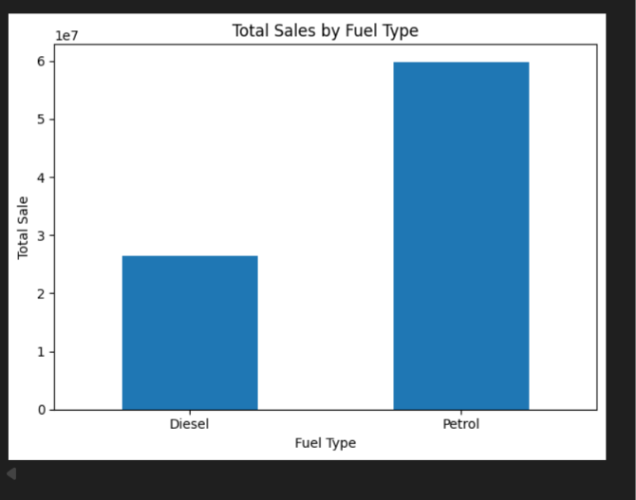
Figure 2. Total sales by fuel type.

8. Analysis by Transmission Type
Transmission | Total Sale | Percentage of Total
Automatic | 62,100,000 | 71.92%
Manual | 24,250,000 | 28.08%
Automatic transmission cars account for the larger total recorded sale value in this dataset, representing approximately 71.92% of total sales. Manual transmission cars represent approximately 28.08%.
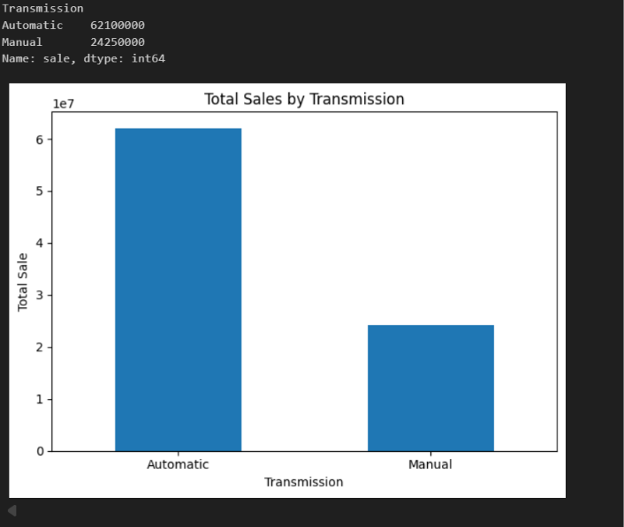
Figure 3. Total sales by transmission type.

9. Analysis by Company
Company | Total Sale
Toyota | 33,900,000
Hyundai | 22,800,000
Honda | 12,800,000
Kia | 8,500,000
Suzuki | 8,350,000
Among the five companies represented in the dataset, Toyota has the highest total recorded sale value at 33,900,000, followed by Hyundai at 22,800,000. Honda, Kia and Suzuki have lower total values in the analyzed records.
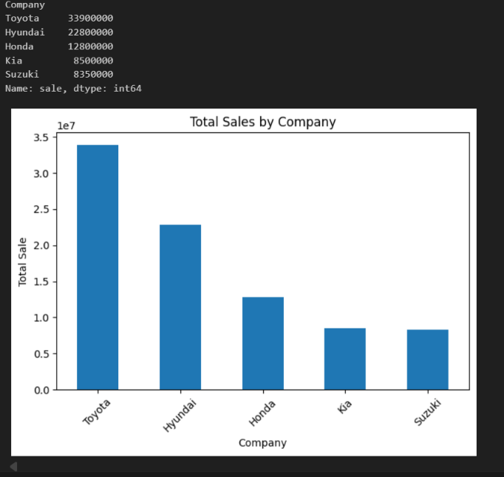
Figure 4. Total sales by company.

10. Numerical Relationship Analysis

10.1 Car Year vs Sale
The scatter plot indicates an overall upward pattern in sale values across the more recent years represented in the dataset. The correlation between Year and sale is approximately 0.55, which indicates a moderate positive linear association in these records.
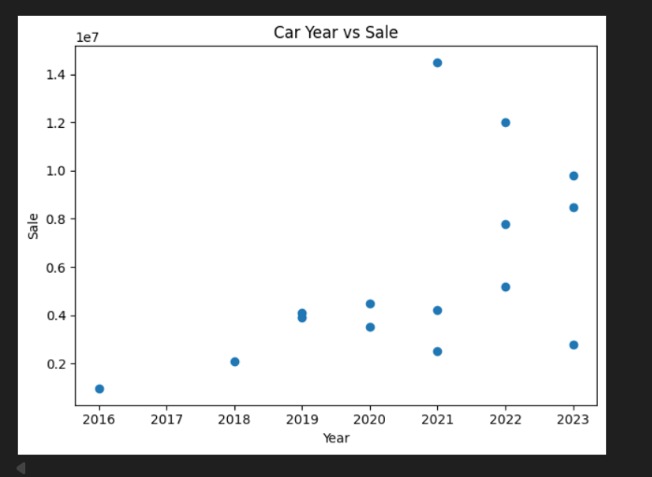
Figure 5. Car year versus sale value.

10.2 Engine Capacity vs Sale
The scatter plot shows a strong positive pattern between Engine_CC and sale. The correlation coefficient is approximately 0.93, indicating a very strong positive linear association within this dataset.
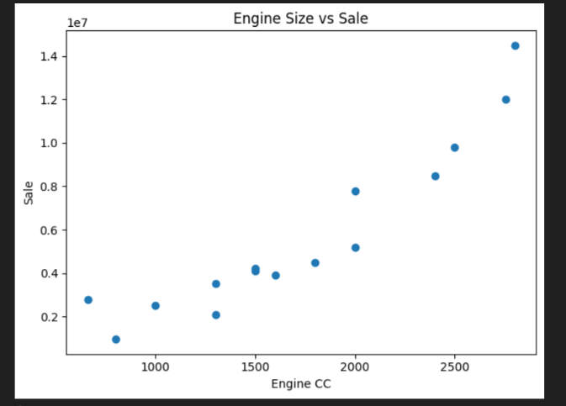
Figure 6. Engine capacity versus sale value.

10.3 Mileage vs Sale
The scatter plot shows an overall downward pattern between Mileage and sale. The correlation coefficient is approximately -0.87, indicating a strong negative linear association in these records.
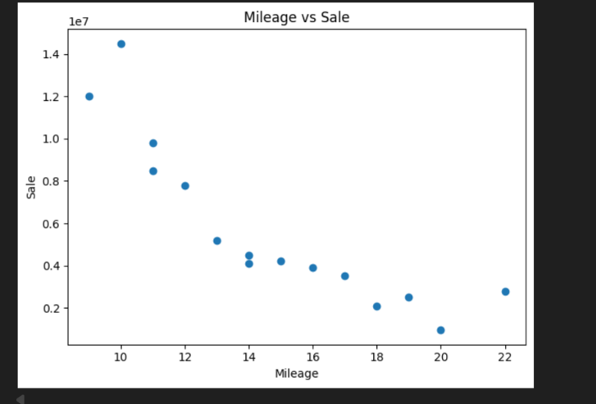
Figure 7. Mileage versus sale value.

11. Correlation Analysis
The correlation matrix summarizes the linear relationships among Year, sale, Mileage and Engine_CC. Values closer to +1 indicate a strong positive relationship, while values closer to -1 indicate a strong negative relationship.
Variable Pair | Correlation
Year and sale | 0.548958
Year and Mileage | -0.448605
Year and Engine_CC | 0.485320
sale and Mileage | -0.871392
sale and Engine_CC | 0.930662
Mileage and Engine_CC | -0.972587
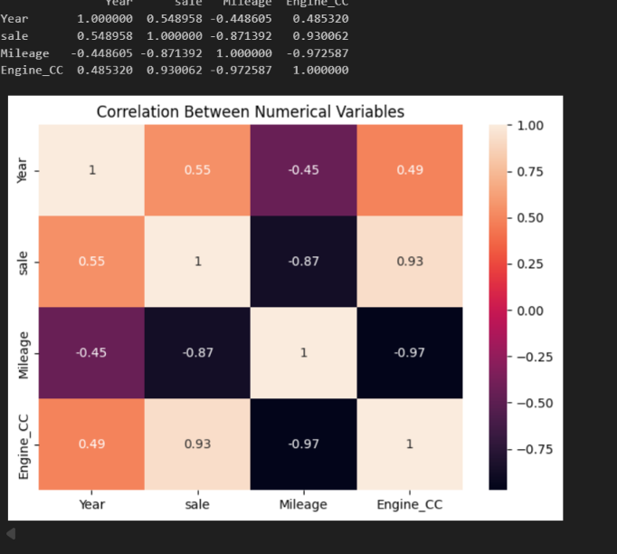
Figure 8. Correlation heatmap for numerical variables.

12. Key Findings
- The dataset contains 15 records and 8 columns, with no missing values detected.
- The total recorded sale value is 86,350,000 and the average sale value is approximately 5,756,666.67.
- Petrol cars have a higher total recorded sale value than diesel cars in this dataset.
- Automatic transmission cars have a higher total recorded sale value than manual cars in this dataset.
- Toyota has the highest total recorded sale value among the five companies represented.
- Year has a moderate positive correlation with sale (0.55 approximately).
- Engine_CC has a very strong positive correlation with sale (0.93 approximately).
- Mileage has a strong negative correlation with sale (-0.87 approximately).
- Mileage and Engine_CC show a very strong negative correlation (-0.97 approximately), which is a notable relationship in this small dataset.

13. Interpretation of Results
The exploratory results suggest that car characteristics are associated with sale values in the analyzed records. In particular, Engine_CC has the strongest positive linear relationship with sale among the numerical variables, while Mileage has a strong negative relationship with sale. The categorical analysis also shows substantial differences in total sale values across fuel type, transmission type, and company.
These findings describe patterns in the available 15 records. They should not be interpreted as causal effects, and they should not be generalized to the entire automobile market without a larger and more representative dataset.

14. Limitations
- The sample size is very small (15 records), so statistical conclusions are limited.
- The dataset contains only a small selection of companies and categories.
- Correlation measures association and does not establish causation.
- The analysis is exploratory and does not include predictive machine learning.
- The units and meaning of numeric fields depend on the source definition of the dataset.

15. Future Scope
- Use a larger and more representative car sales dataset.
- Add variables such as ownership history, vehicle condition, location, and number of owners.
- Perform outlier detection and deeper data-cleaning procedures.
- Build an interactive dashboard using Power BI, Streamlit, or another visualization platform.
- After collecting sufficient data, develop regression models for sale-value prediction.
- Compare predictive models using appropriate evaluation metrics.

16. Conclusion
This project demonstrates an end-to-end introductory data analytics workflow using Python. The data was loaded and inspected with Pandas, summarized using descriptive statistics, grouped by important categorical fields, visualized with charts, and examined using correlation analysis.
The results reveal clear differences in total sale values by fuel type, transmission type, and company. The numerical analysis also identifies strong relationships involving sale, engine capacity, and mileage. Overall, the project shows how exploratory data analysis can transform raw tabular data into structured insights that are easier to understand and communicate.

17. Tools and Technologies Used
Tool / Library | Purpose
Python | Programming and analysis
Pandas | Data loading, inspection, grouping and calculations
NumPy | Numerical computing support
Matplotlib | Charts and scatter plots
Seaborn | Correlation heatmap
Jupyter Notebook | Interactive project development and presentation

