Blinkit Data Analysis

1. Data Import & Cleaning
The Blinkit dataset was imported into Excel for data understanding. Before moving to SQL and Power BI, I cleaned and standardized the dataset. Below are the cleaning steps:
Column | Cleaning Performed
Item_Fat_Content | Standardized values (LF → Low Fat, reg → Regular, low fat → Low Fat)
Outlet_Size | Missing values filled using Mode (most frequent size)
Item_Type | Format consistency checked & corrected
Item_Visibility | Converted to numeric format
Total_Sales | Checked for outliers & ensured numeric formatting
Duplicates | Removed duplicate rows
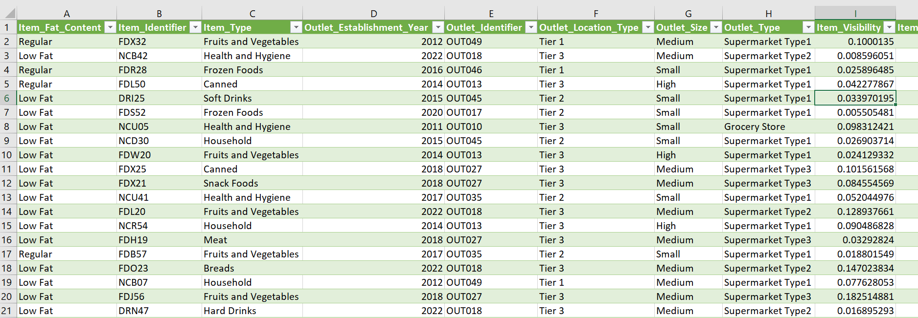

2. SQL Queries
To do the data analysis , I converted major queries into SQL views. These views were directly loaded into Power BI for Dashboard.
1. TOTAL SALES
CREATE VIEW v_total_sales AS
SELECT SUM(Total_Sales) AS
Total_Sales FROM blinkitdata;

2. TOTAL NUMBER OF ITEMS
CREATE VIEW v_total_items
AS SELECT COUNT(*) AS Total_Items
FROM blinkitdata;

3. AVERAGE SALES
CREATE VIEW v_avg_sales AS
SELECT ROUND(AVG(Total_Sales),2) AS Avg_Sales
FROM blinkitdata;

4. AVERAGE RATING
CREATE VIEW v_avg_rating AS
SELECT ROUND(AVG(Rating),2) AS Avg_Rating
FROM blinkitdata;

5. FAT CONTENT
CREATE VIEW v_fat_content_sales AS
SELECT Item_Fat_Content, SUM(Total_Sales) AS Total_Sales
FROM blinkitdata GROUP BY Item_Fat_Content;

6. FAT BY OUTLET
CREATE VIEW v_fat_by_outlet AS
SELECT Outlet_Location_Type, Item_Fat_Content, SUM(Total_Sales) AS Total_Sales
FROM blinkitdata
GROUP BY Outlet_Location_Type, Item_Fat_Content;

7. ITEM TYPE
CREATE VIEW v_item_type_sales AS SELECT Item_Type, SUM(Total_Sales) AS Total_Sales
FROM blinkitdata GROUP BY Item_Type;

8. OUTLET ESTABLISHMENT YEAR
CREATE VIEW v_establishment_sales AS
SELECT Outlet_Establishment_Year, SUM(Total_Sales) AS Total_Sales
FROM blinkitdata
GROUP BY Outlet_Establishment_Year;

9. OUTLET SIZE
CREATE VIEW v_outlet_size_sales AS
SELECT Outlet_Size, SUM(Total_Sales) AS Total_Sales
FROM blinkitdata
GROUP BY Outlet_Size;

10. OUTLET LOCATION
CREATE VIEW v_outlet_location_sales AS
SELECT Outlet_Location_Type, SUM(Total_Sales) AS Total_Sales
FROM blinkitdata
GROUP BY Outlet_Location_Type;

3. Power BI Dashboard
Below is the final Power BI dashboard created using SQL views:

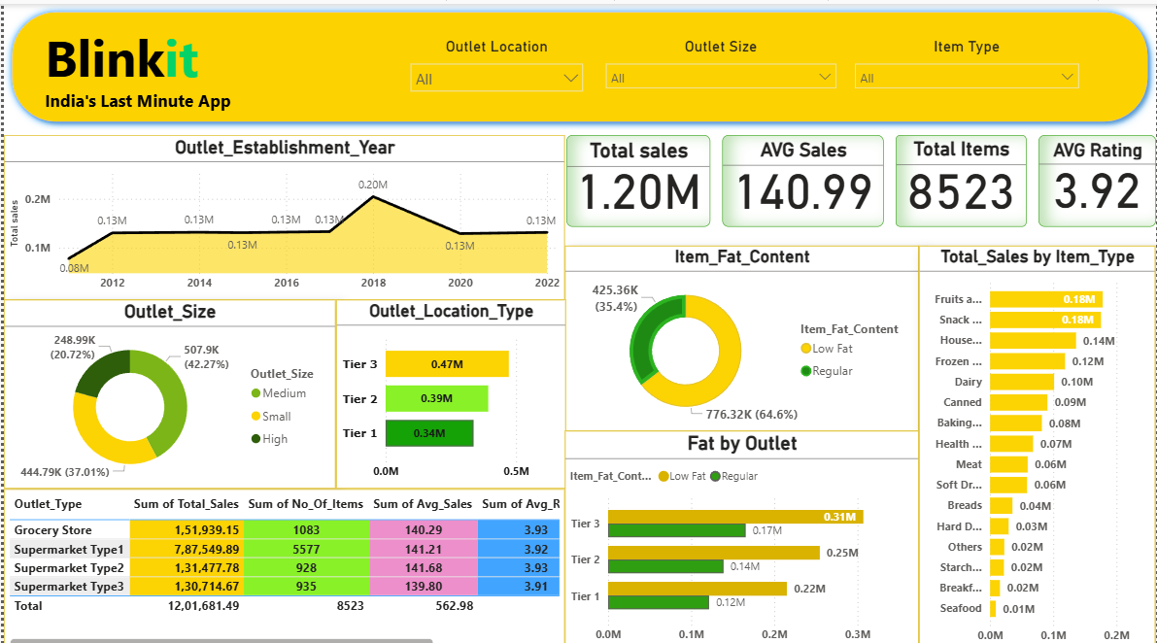

4. Insights & Storytelling
• Total sales generated: $1.20M+ across all stores.
• Average sales per item: $140.99.
• Total listed items: 8,523.
• Average rating: 3.92 — shows moderate customer satisfaction.
• Regular Fat category contributes 64.6% of total sales.
• Medium-size outlets are the highest revenue generators.
• Tier 3 locations outperform Tier 1 and Tier 2 in revenue contributions.
• Supermarket Type 1 is the top-performing store category ($787K+).
• 2018 recorded the highest sales spike.
• Fruits & Vegetables and Snack Foods lead as top-performing product categories.

