NAND

|  |  |  |  |
| --- | --- | --- | --- |
| A | B | A.B | (A.B)’ |
| 0 | 0 | 0 | 1 |
| 0 | 1 | 0 | 1 |
| 1 | 0 | 0 | 1 |
| 1 | 1 | 1 | 0 |

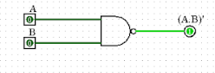

NOR

|  |  |  |  |
| --- | --- | --- | --- |
| A | B | A+B | (A+B)’ |
| 0 | 0 | 0 | 1 |
| 0 | 1 | 1 | 0 |
| 1 | 0 | 1 | 0 |
| 1 | 1 | 1 | 0 |

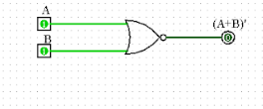

XOR

|  |  |  |
| --- | --- | --- |
| A | B | A+B |
| 0 | 0 | 0 |
| 0 | 1 | 1 |
| 1 | 0 | 1 |
| 1 | 1 | 0 |

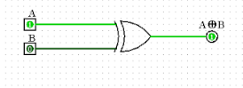

XNOR

|  |  |  |
| --- | --- | --- |
| A | B | A+B |
| 0 | 0 | 1 |
| 0 | 1 | 0 |
| 1 | 0 | 0 |
| 1 | 1 | 1 |

