PROB 3

3.1
Q1 ) What data would you advise the engineers and what your ideal dataset look like ?

1)When it comes to Real Estate business users are more interested in pictures . User behavior with and without picture should be analyzed
2)Tracking the first 1-3 user clicks on as soon as he enters the website can tell us a lot of answers regarding user behavior
3)User search and filters should be tracked

Q2)How would data be used for reporting and monitoring product usage ?
Reports :
Most searched location
Number of users who look for nearby shops,schools before selecting location
Number of users who prefer image click

Q3) How would data be built back into product/website ?

Embed more images
Embed commute time to nearby offices as another filter
Analyze outliers and bring new filters to the website

3.2
Analysis on Brooklyn Data
Plot :Square ft vs Sale Price
Observation :
There are less outliers or people who want luxuries houses . More people tend to buy at low price and minimal sq ft . There is large number of unnecessary data with sale price =0 . So analysis is made with sale price >0
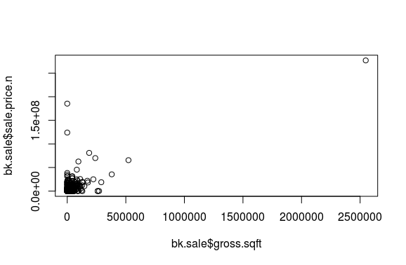

Observation :
Log gives a range of values for analysis. From log data we can see sale is more spread out where price is from 5-15 and square feet is from 6-10
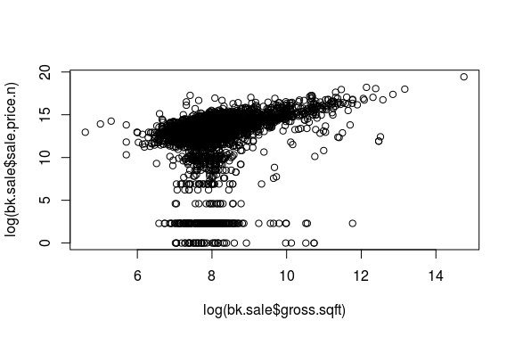
Observation : With names =Family
Families are more likely to buy average square feet and price
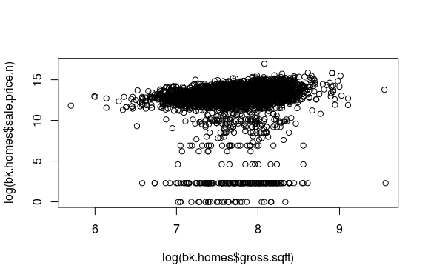
Observation :
With sale price <100000 and removing outliers [sale price<=5]
Sale is more in log(sq ft) ranging from 7-8.5 and price from 12 to 15

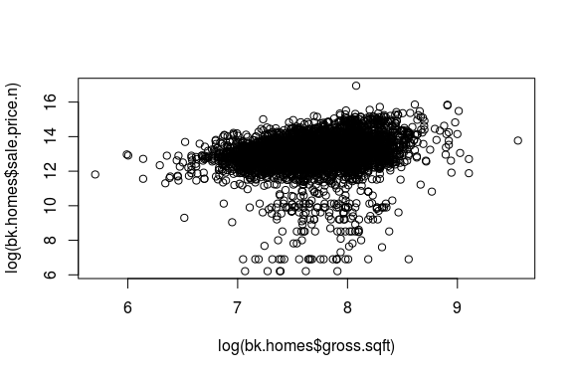

Extended Analysis
Plot :Square ft vs Sale Price
Observation :
There are less outliers or people who want luxuries houses . More people tend to buy at low price and minimal sq ft . There is large number of unnecessary data with sale price =0 . So analysis is made with sale price >0
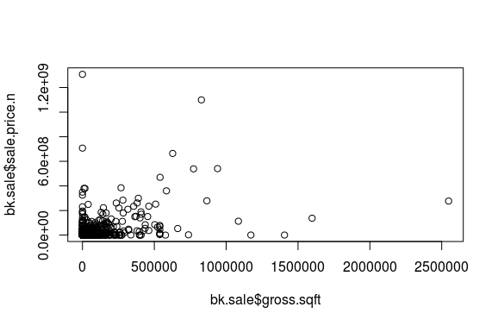

Observation :
Log gives a range of values for analysis. From log data we can see sale is more spread out where price is from 5-15 and square feet is from 6-10
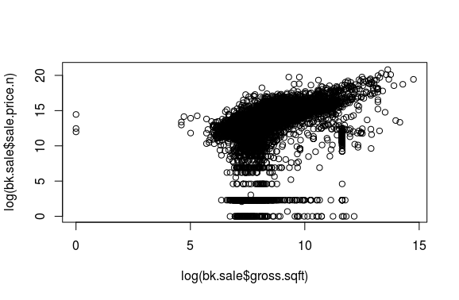

Observation : With names =Family
Families are more likely to buy average square feet and price

Observation :
With sale price <100000 and removing outliers [sale price<=5]
Sale is more in log(sq ft) ranging from 7-8.5 and log(price) from 12 to 16

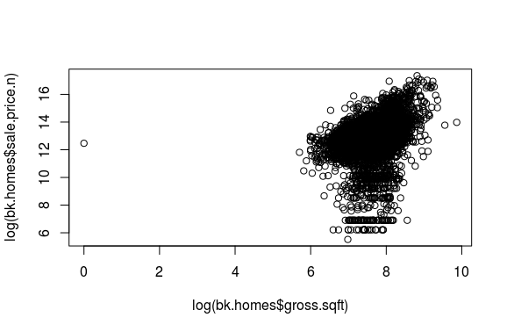
3.3

The analysis shows that there are more middle class buyers than lower or luxuries buyers .This states that the company should focus more on average square feet and average price to attract more buyers

3.4
Its good to talk to a real estate expert and understand the pricing phenomena

3.5
Data analysis is done on multiple fields and understanding the field better will give us better insight on how the analysis should be done and what is the end product expected from customer

