EXPERIMENT-9

224G1A05A8 M SUKANYA

Primary key :

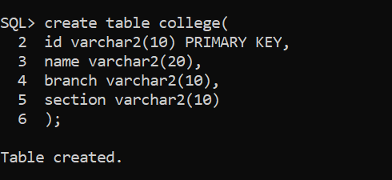

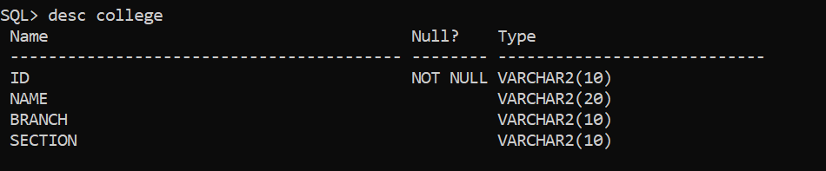

Foreign key :

