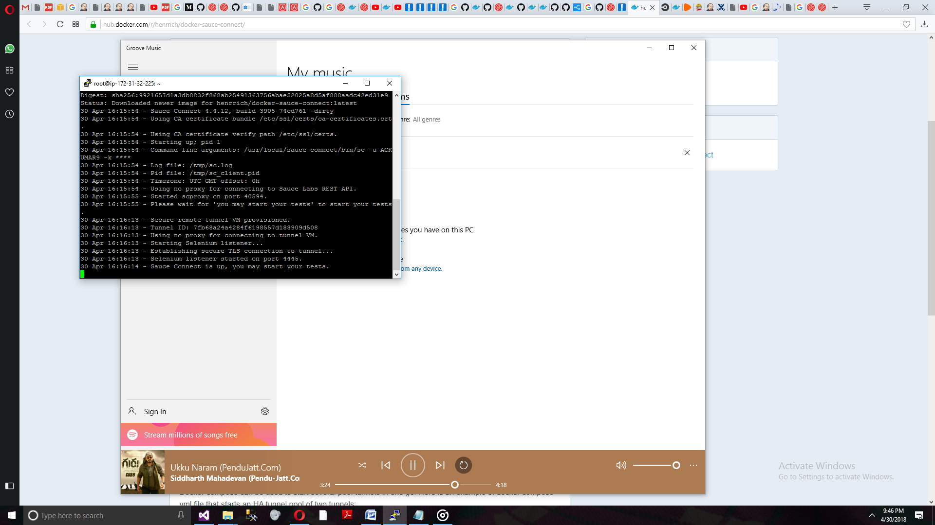

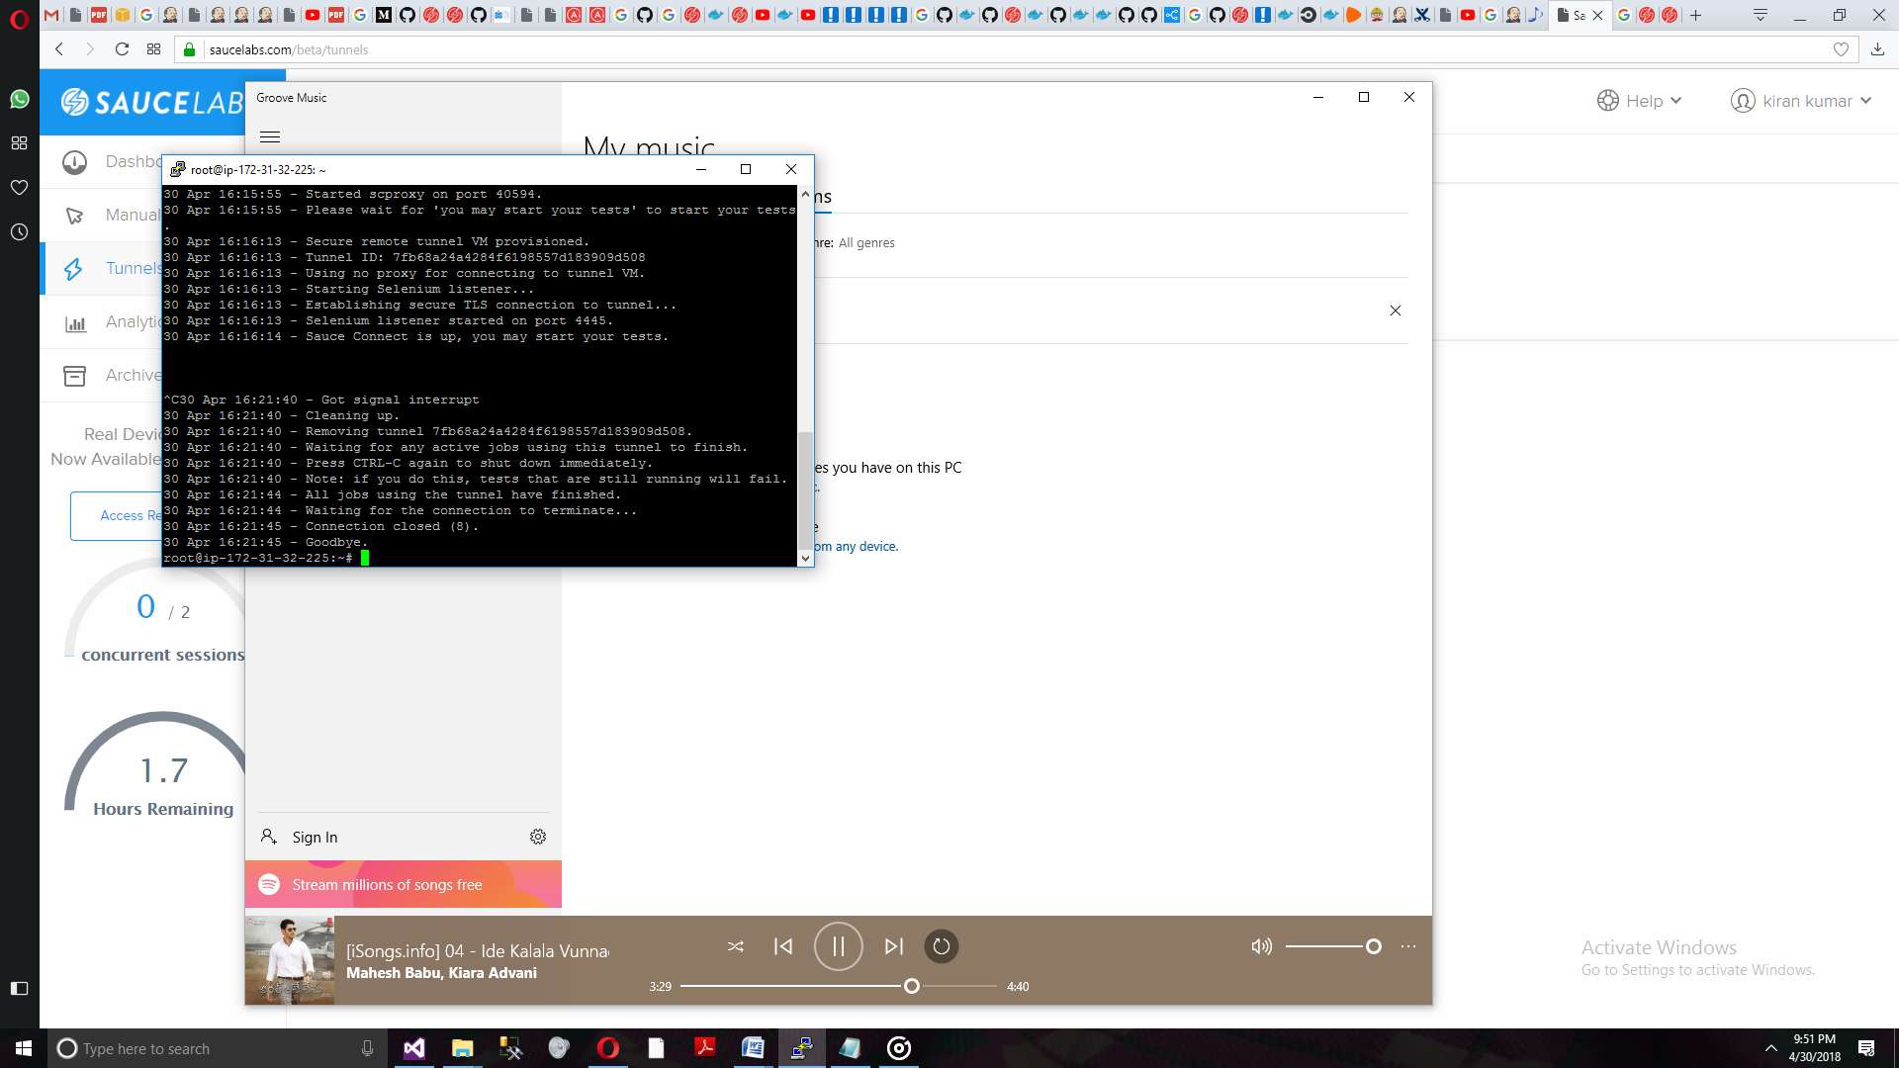

Docker version 18.03.1-ce, build 9ee9f40

ubuntu@ip-172-31-32-225:~$ docker run --rm -it \

> -p 0.0.0.0:8000:8000 \

> joscha/sauce-connect -P 8000 \

> -u $ACKUMAR9 \

> -k $cf21cc2a-d169-4198-800f-78aad40f33a5 \

> --tunnel-identifier foo

docker: Got permission denied while trying to connect to the Docker daemon socket at unix:///var/run/docker.sock: Post http://%2Fvar%2Frun%2Fdocker.sock/v1.37/containers/create: dial unix /var/run/docker.sock: connect: permission denied.

See 'docker run --help'.

ubuntu@ip-172-31-32-225:~$ sudo su -

root@ip-172-31-32-225:~# docker run --rm -it \

> -p 0.0.0.0:8000:8000 \

> joscha/sauce-connect -P 8000 \

> -u $ACKUMAR9 \

> -k $cf21cc2a-d169-4198-800f-78aad40f33a5 \

> --tunnel-identifier foo

Unable to find image 'joscha/sauce-connect:latest' locally

docker: Error response from daemon: pull access denied for joscha/sauce-connect, repository does not exist or may require 'docker login'.

See 'docker run --help'.

root@ip-172-31-32-225:~# clear

root@ip-172-31-32-225:~# docker run --rm -it -p 4445:4445 henrrich/docker-sauce-connect:latest -u ACKUMAR9 -k cf21cc2a-d169-4198-800f-78aad40f33a5

Unable to find image 'henrrich/docker-sauce-connect:latest' locally

latest: Pulling from henrrich/docker-sauce-connect

f2b6b4884fc8: Pull complete

f8a6a5b562ac: Pull complete

c9dac1e5f781: Pull complete

bf50a542631a: Pull complete

9a320c2f78b8: Pull complete

78fb704f0c29: Pull complete

9f63716af07d: Pull complete

Digest: sha256:9921657d1a3db8832f868ab25491363756abae52025a8d5af888aadc42ed31e9

Status: Downloaded newer image for henrrich/docker-sauce-connect:latest

30 Apr 16:15:54 - Sauce Connect 4.4.12, build 3905 74cd761 -dirty

30 Apr 16:15:54 - Using CA certificate bundle /etc/ssl/certs/ca-certificates.crt.

30 Apr 16:15:54 - Using CA certificate verify path /etc/ssl/certs.

30 Apr 16:15:54 - Starting up; pid 1

30 Apr 16:15:54 - Command line arguments: /usr/local/sauce-connect/bin/sc -u ACKUMAR9 -k ****

30 Apr 16:15:54 - Log file: /tmp/sc.log

30 Apr 16:15:54 - Pid file: /tmp/sc_client.pid

30 Apr 16:15:54 - Timezone: UTC GMT offset: 0h

30 Apr 16:15:54 - Using no proxy for connecting to Sauce Labs REST API.

30 Apr 16:15:55 - Started scproxy on port 40594.

30 Apr 16:15:55 - Please wait for 'you may start your tests' to start your tests.

30 Apr 16:16:13 - Secure remote tunnel VM provisioned.

30 Apr 16:16:13 - Tunnel ID: 7fb68a24a4284f6198557d183909d508

30 Apr 16:16:13 - Using no proxy for connecting to tunnel VM.

30 Apr 16:16:13 - Starting Selenium listener...

30 Apr 16:16:13 - Establishing secure TLS connection to tunnel...

30 Apr 16:16:13 - Selenium listener started on port 4445.

30 Apr 16:16:14 - Sauce Connect is up, you may start your tests.

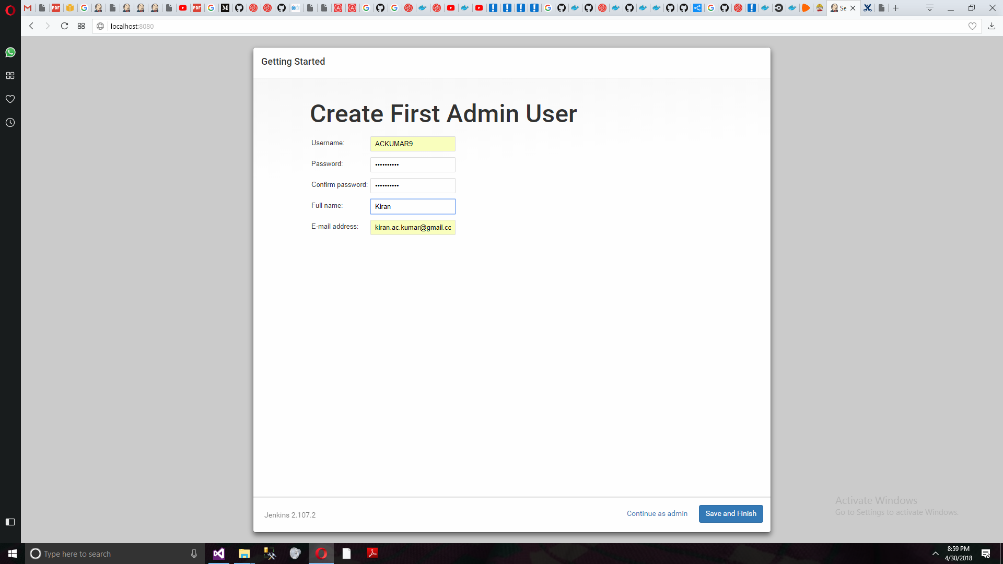

Docker version 18.03.1-ce, build 9ee9f40

ubuntu@ip-172-31-32-225:~$ docker run --rm -it \

> -p 0.0.0.0:8000:8000 \

> joscha/sauce-connect -P 8000 \

> -u $ACKUMAR9 \

> -k $cf21cc2a-d169-4198-800f-78aad40f33a5 \

> --tunnel-identifier foo

docker: Got permission denied while trying to connect to the Docker daemon socket at unix:///var/run/docker.sock: Post http://%2Fvar%2Frun%2Fdocker.sock/v1.37/containers/create: dial unix /var/run/docker.sock: connect: permission denied.

See 'docker run --help'.

ubuntu@ip-172-31-32-225:~$ sudo su -

root@ip-172-31-32-225:~# docker run --rm -it \

> -p 0.0.0.0:8000:8000 \

> joscha/sauce-connect -P 8000 \

> -u $ACKUMAR9 \

> -k $cf21cc2a-d169-4198-800f-78aad40f33a5 \

> --tunnel-identifier foo

Unable to find image 'joscha/sauce-connect:latest' locally

docker: Error response from daemon: pull access denied for joscha/sauce-connect, repository does not exist or may require 'docker login'.

See 'docker run --help'.

root@ip-172-31-32-225:~# clear

root@ip-172-31-32-225:~# docker run --rm -it -p 4445:4445 henrrich/docker-sauce-connect:latest -u ACKUMAR9 -k cf21cc2a-d169-4198-800f-78aad40f33a5

Unable to find image 'henrrich/docker-sauce-connect:latest' locally

latest: Pulling from henrrich/docker-sauce-connect

f2b6b4884fc8: Pull complete

f8a6a5b562ac: Pull complete

c9dac1e5f781: Pull complete

bf50a542631a: Pull complete

9a320c2f78b8: Pull complete

78fb704f0c29: Pull complete

9f63716af07d: Pull complete

Digest: sha256:9921657d1a3db8832f868ab25491363756abae52025a8d5af888aadc42ed31e9

Status: Downloaded newer image for henrrich/docker-sauce-connect:latest

30 Apr 16:15:54 - Sauce Connect 4.4.12, build 3905 74cd761 -dirty

30 Apr 16:15:54 - Using CA certificate bundle /etc/ssl/certs/ca-certificates.crt.

30 Apr 16:15:54 - Using CA certificate verify path /etc/ssl/certs.

30 Apr 16:15:54 - Starting up; pid 1

30 Apr 16:15:54 - Command line arguments: /usr/local/sauce-connect/bin/sc -u ACKUMAR9 -k ****

30 Apr 16:15:54 - Log file: /tmp/sc.log

30 Apr 16:15:54 - Pid file: /tmp/sc_client.pid

30 Apr 16:15:54 - Timezone: UTC GMT offset: 0h

30 Apr 16:15:54 - Using no proxy for connecting to Sauce Labs REST API.

30 Apr 16:15:55 - Started scproxy on port 40594.

30 Apr 16:15:55 - Please wait for 'you may start your tests' to start your tests.

30 Apr 16:16:13 - Secure remote tunnel VM provisioned.

30 Apr 16:16:13 - Tunnel ID: 7fb68a24a4284f6198557d183909d508

30 Apr 16:16:13 - Using no proxy for connecting to tunnel VM.

30 Apr 16:16:13 - Starting Selenium listener...

30 Apr 16:16:13 - Establishing secure TLS connection to tunnel...

30 Apr 16:16:13 - Selenium listener started on port 4445.

30 Apr 16:16:14 - Sauce Connect is up, you may start your tests.

^C30 Apr 16:21:40 - Got signal interrupt

30 Apr 16:21:40 - Cleaning up.

30 Apr 16:21:40 - Removing tunnel 7fb68a24a4284f6198557d183909d508.

30 Apr 16:21:40 - Waiting for any active jobs using this tunnel to finish.

30 Apr 16:21:40 - Press CTRL-C again to shut down immediately.

30 Apr 16:21:40 - Note: if you do this, tests that are still running will fail.

30 Apr 16:21:44 - All jobs using the tunnel have finished.

30 Apr 16:21:44 - Waiting for the connection to terminate...

30 Apr 16:21:45 - Connection closed (8).

30 Apr 16:21:45 - Goodbye.

root@ip-172-31-32-225:~#

