Week 4 Project
Business Dashboard & Stakeholder Insights Summary
Tableau / Power BI Fundamentals — Dashboards, Filters & Calculated Fields | Storytelling with Data

1. Project Overview
This project builds an interactive business dashboard from the Financial Sample dataset (700 transaction-level records covering 5 customer segments, 5 countries, and 6 products across FY2013–2014) and summarizes the key findings for a stakeholder audience.
Because a native Power BI / Tableau file (.pbix / .twbx) can't be opened outside those desktop applications, the dashboard was built as a browser-based interactive app with equivalent functionality: live filters, a calculated field, and linked charts that update together. A link to the live, interactive version is included at the end of this document; static snapshots of each view are included below for reference.

2. Key Metrics
TOTAL SALES  $118.73M  700 line items | TOTAL PROFIT  $16.89M  Profitable | PROFIT MARGIN  14.2%  Profit ÷ Sales | UNITS SOLD  1.13M  across FY13–14

3. Dashboard Views

3.1 Monthly Sales vs. Profit Trend
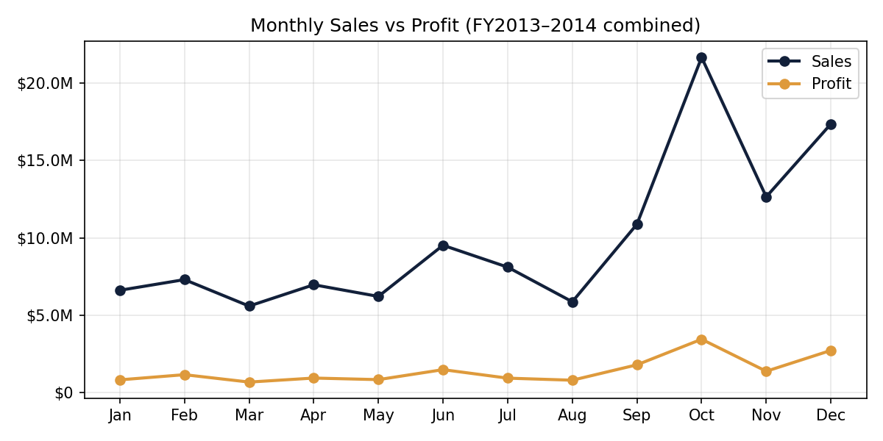
Sales and profit summed by calendar month across both fiscal years.

3.2 Sales Mix by Segment
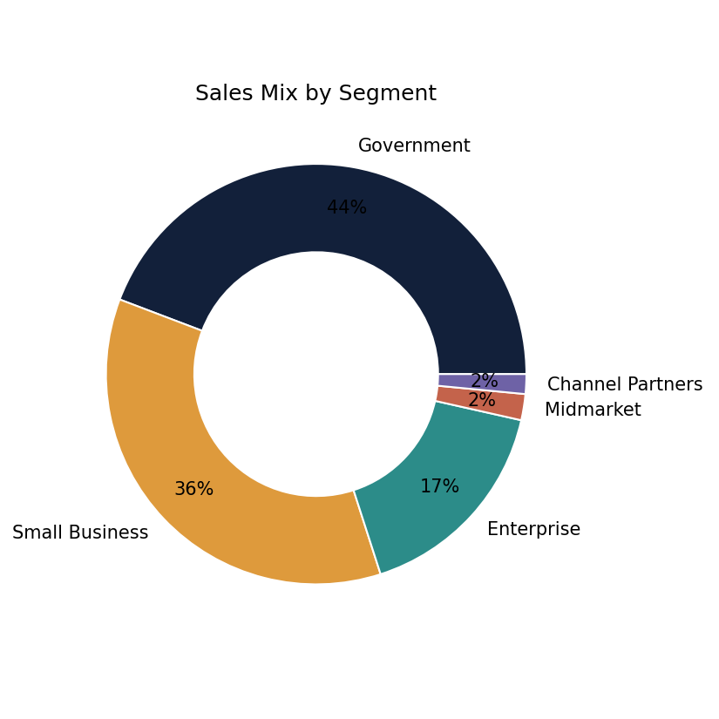
Share of total sales contributed by each customer segment.

3.3 Sales by Country
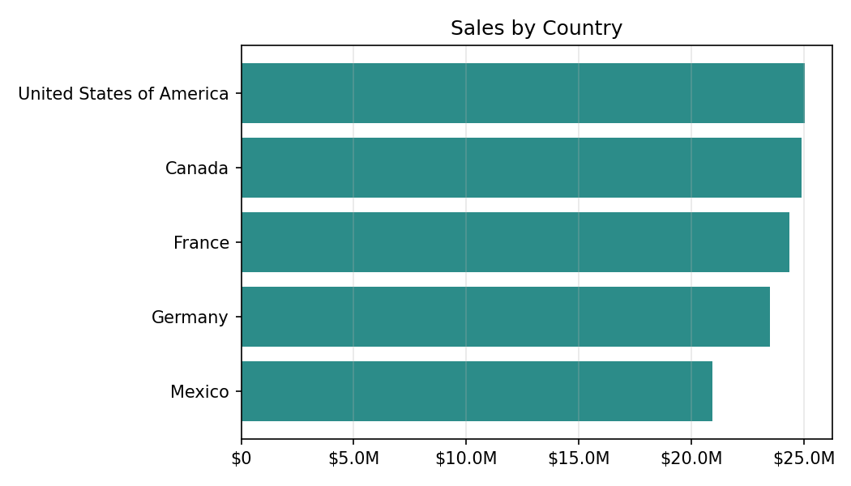
Total sales ranked by country.

3.4 Profit Margin by Product (Calculated Field)
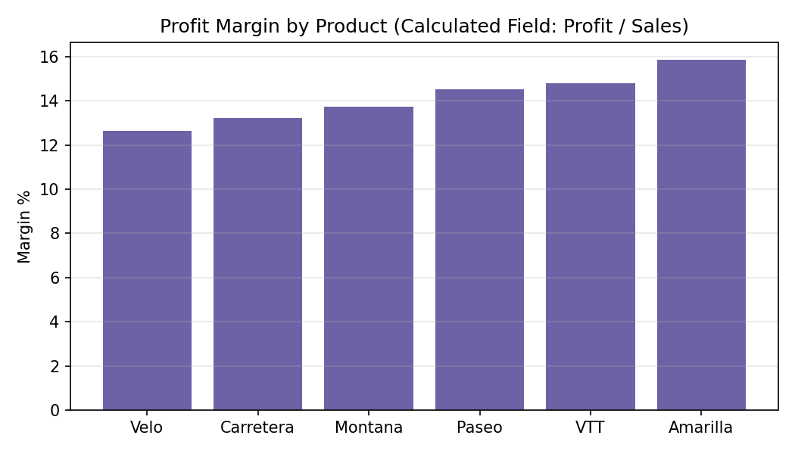
Calculated field — Profit Margin = SUM(Profit) / SUM(Sales) — computed per product.

4. Stakeholder Insights Summary
- Government is the leading segment, generating $52.50M in sales — 44.2% of total revenue, more than double any other segment.
- Enterprise is the one segment running at a loss overall ($-614.5K), despite solid sales volume — its pricing or cost structure needs review.
- Country performance is well balanced: the top market (United States of America, $25.03M) and the smallest (Mexico, $20.95M) are within about 20% of each other, so growth isn't overly dependent on one region.
- Amarilla carries the healthiest margin (15.9%), while Velo runs thinnest (12.6%) — a candidate for a pricing or cost review.
- 58 of 700 orders (8.3%) lost money, concentrated in the "High" discount band — tightening discount approval on large orders is the clearest lever to improve profitability.
- Sales are seasonal, peaking sharply in October and December each year — useful for planning inventory and staffing ahead of year-end.

5. Recommendations
- Review pricing and cost allocation for the Enterprise segment to close the profitability gap.
- Audit discount approvals in the High discount band, where the large majority of loss-making orders originate.
- Investigate why Velo's margin lags the portfolio — either a cost or a pricing issue.
- Use the Oct/Dec seasonal peak to plan procurement and staffing 6–8 weeks ahead.

6. Interactive Dashboard
The live version of this dashboard — with working Segment, Country, Product, and Year filters, and a self-recalculating insights panel — is available here:
https://claude.ai/artifact/5Zh2Yy8jN3pjs8UCN52G6H
Data source: Sample_data (1).xlsx — Financial Sample dataset.

