**Open project in RIDE**

1. Download the code from GITHUB and unzip the folder westpacassement-master.zip.
2. Open the westpacassement-master folder and unzip project KiwiSaverSchemeRetirementCalculator.zip
3. Open the project KiwiSaverSchemeRetirementCalculator and its shows below folders

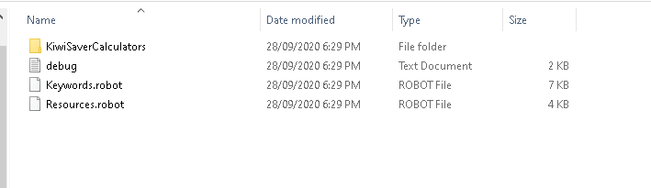

1. Open IDE ride.py from your desktop. If you cannot find is on the desktop, please search for ride.py and open it.



1. Now open the project KiwiSaverSchemeRetirementCalculator in RIDE. To open the project, click menu File -> Open Directory -> select the folder KiwiSaverSchemeRetirementCalculator.

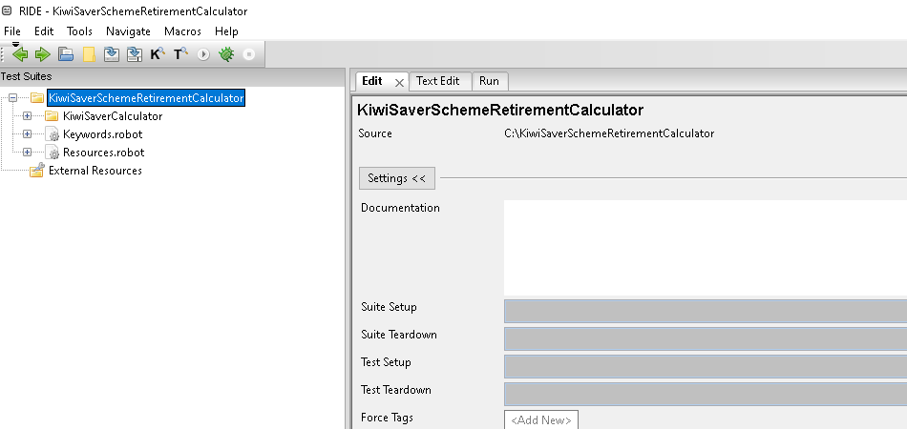

1. Click on ‘+’ before each file, to expand the project

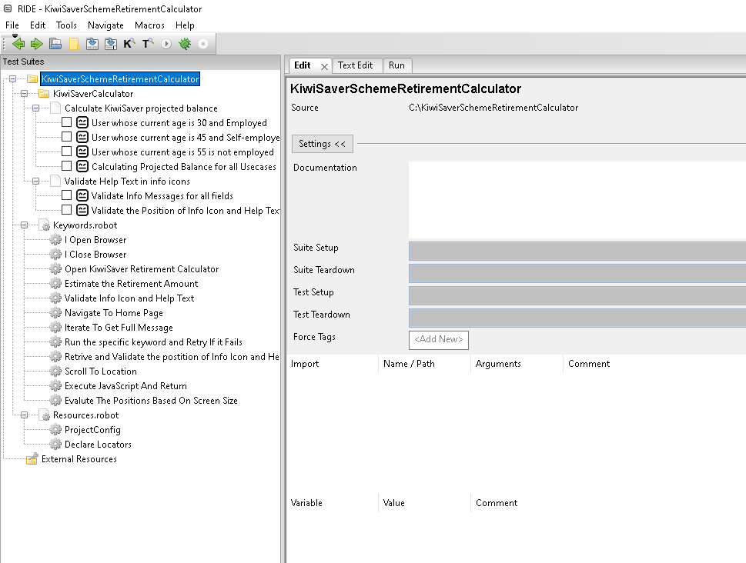

**Execution**

Click on checkbox before any testcase and click Run tab and select the Execution Profile as ‘robot’. And click Start

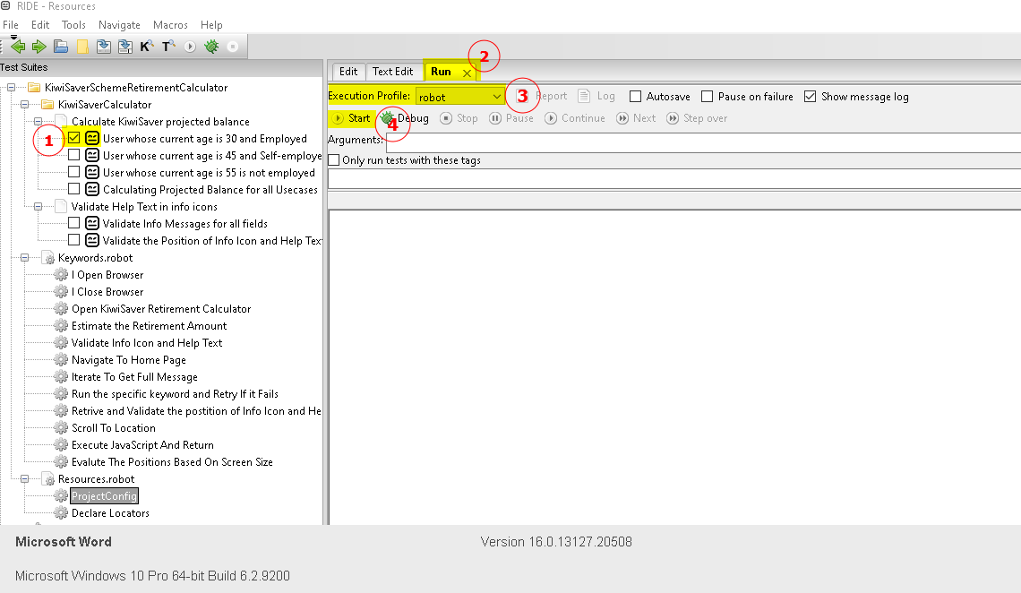

**Execution Logs**

After completed the execution to check the logs please click on Log on. It will open the logs in chrome browser

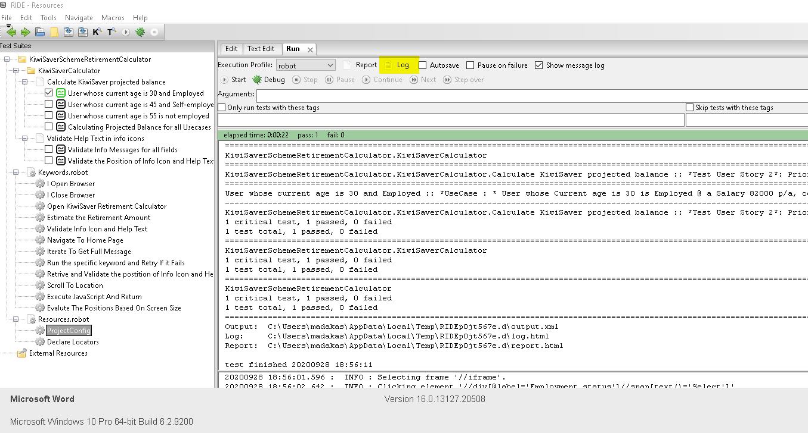

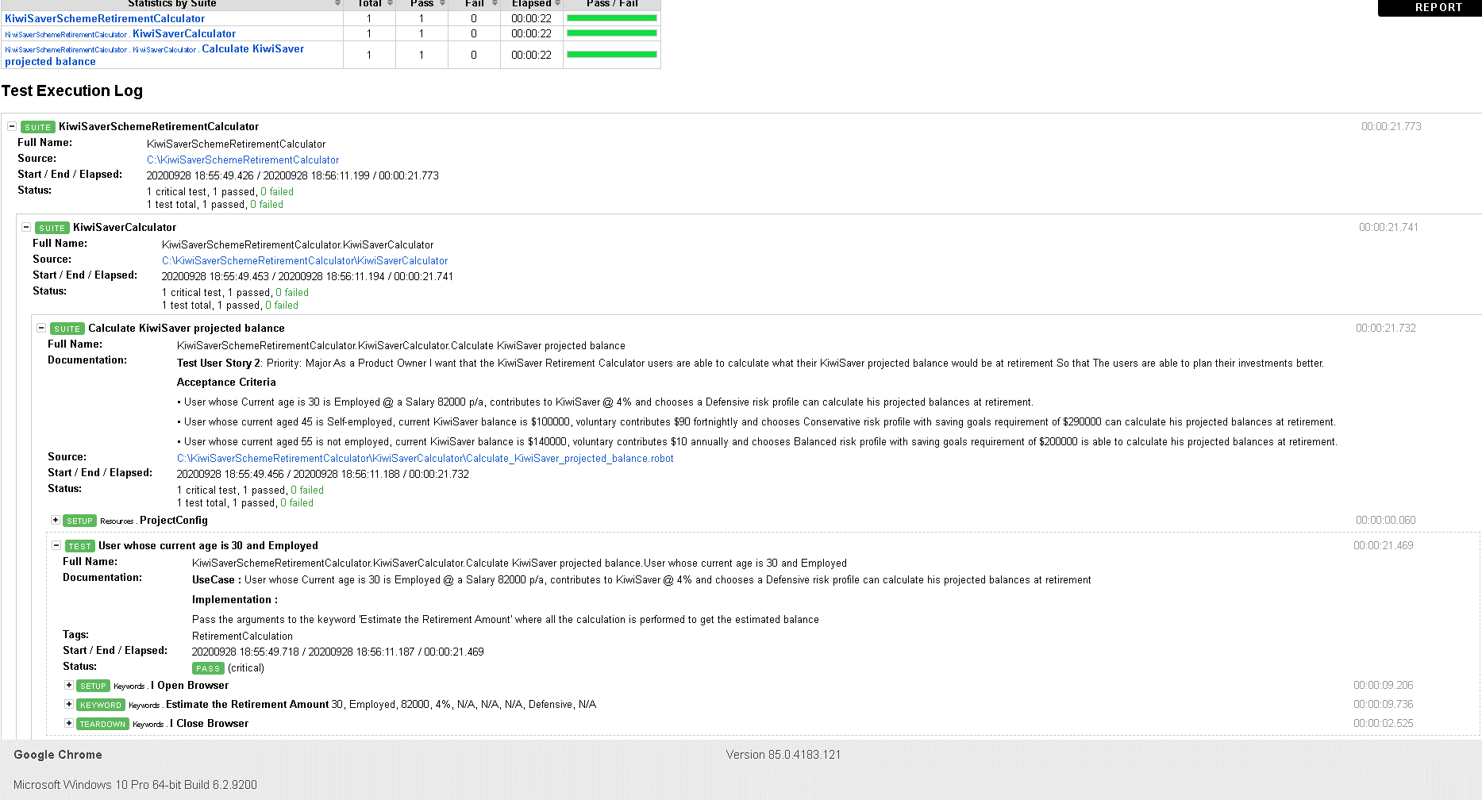

To run on different browser Open ProjectConfig under Resources.robot and select the specific browser. Here its set to chrome

