Question 1

Description

The application involves creating a server which has all the crud operations
I created a file which stores all my data, acts as a database where I stored the footballs players and I then imported the file to the server where I created the routes.
The data is in Json format because its light weight and easy to send over the internet.
There for routes with different HTTP protocol methods that is the POST ,DELETE, PUT,GET
The server is at local host on port 2000.
The following are the out put after HTTP requests using Postman.

Creating a new Player

expected Results is the Server should return the posted data or the newly created Player

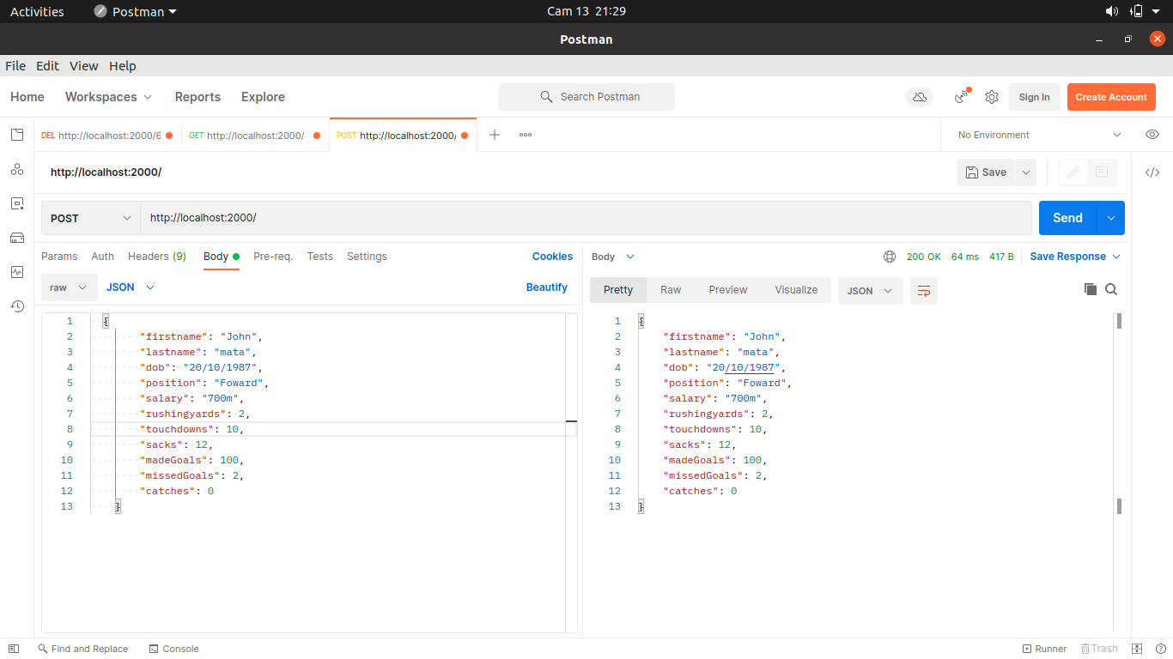

on the left is the data sent to the server, a player ,and on the right it shows the results,the server returns the newly created player

Getting all the Player from the server

Expected Result

After a GET request the server should return all the data from the players

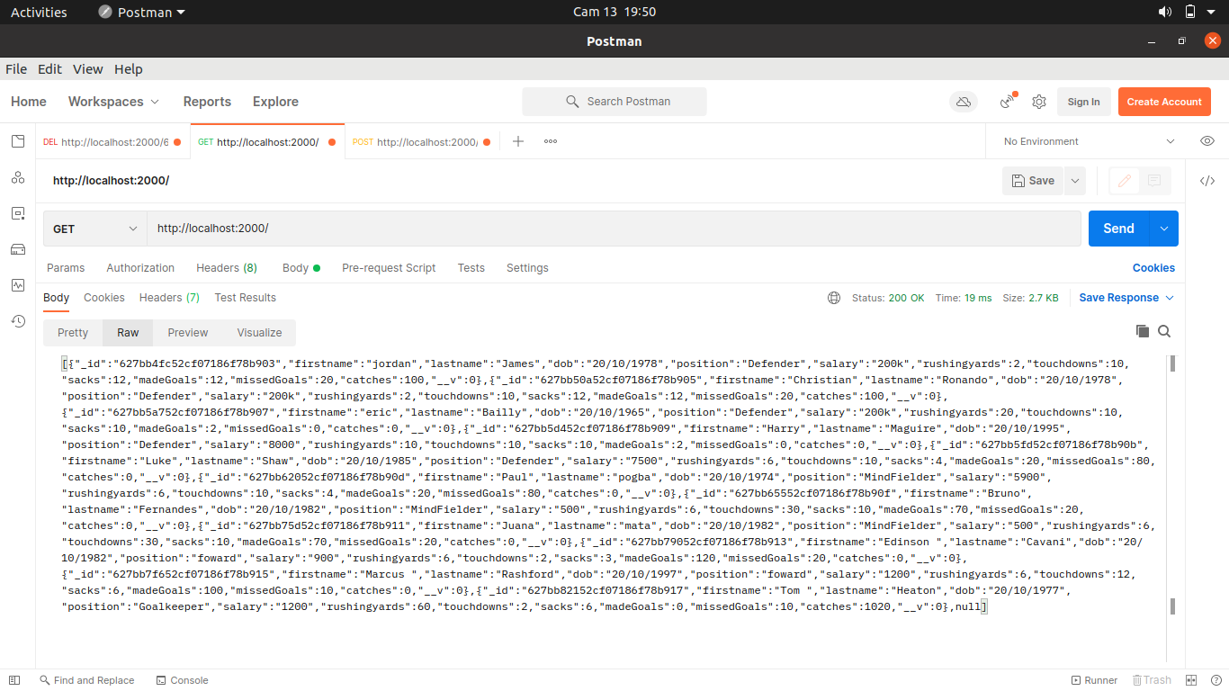

The following image shows all the data returned by the server after a GET request in a Raw format

Updating an existing Player

Expected results
when a player is updated the server should return the updated data as show in the following image.
The server Receives the id as a parameter for the Player to be updated

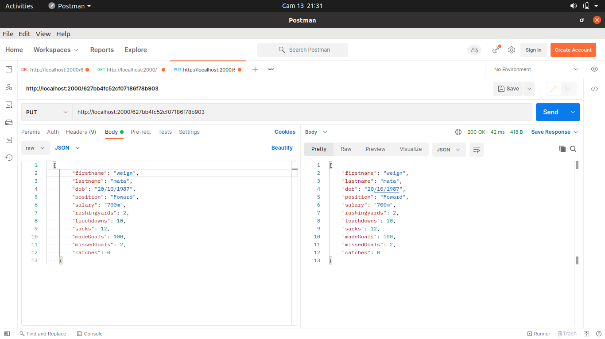
on the left is the updated data which is sent to the server for update the the server returns the updated version of the player back, as show on the right hand side of the server.

Deleting an existing Player

Expected Result

The server receives an id of the Player to be updated during the request as a parameter value
The sever then deletes and return a success message if it was successful as shown on the figure bellow.
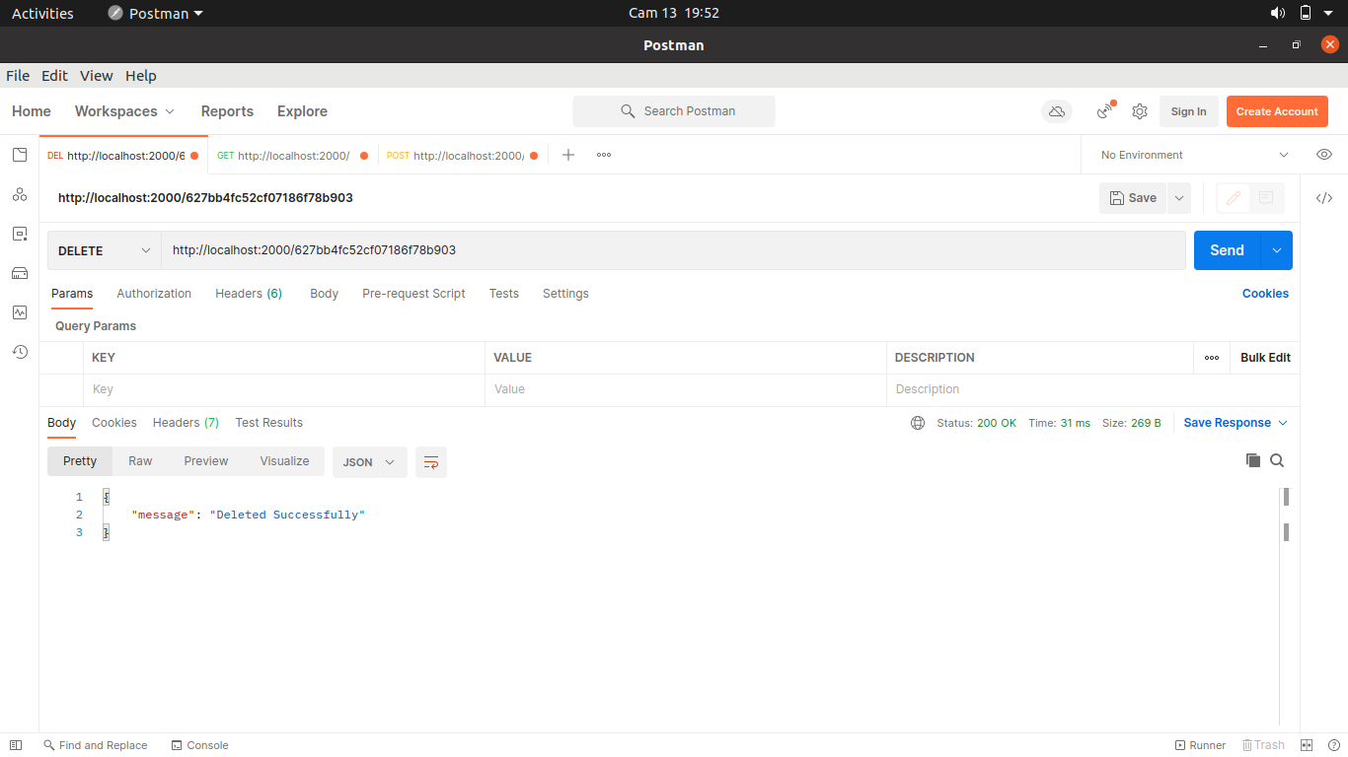

Challenges

when I was working on this project I got only one challenge I forgot to use the express Json for the data and this was result as body being undefined
but I was able to figure it out sooner and fixed the problem and it works as expected

