Description

The implementation of the end points and connecting to the databases was fairly easy because i was able to write queries on MongoDB on the terminal and also because I had created endpoints for the first question.
The only issue or struggles were to be able to stole images into the databases and as well as fetching the images.
But apart from images I was able to implement the crud operation successfully
The following are screenshots of the output.

Creating a new Player
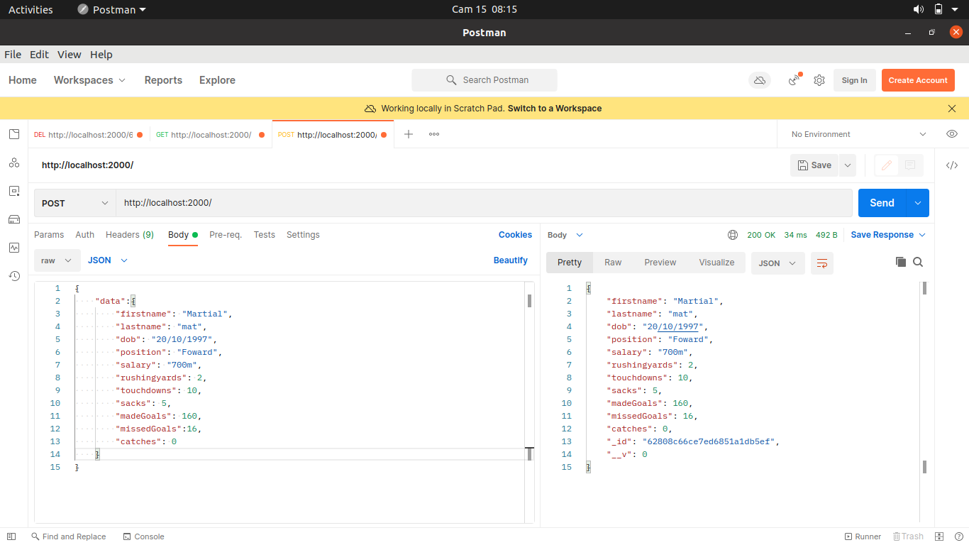

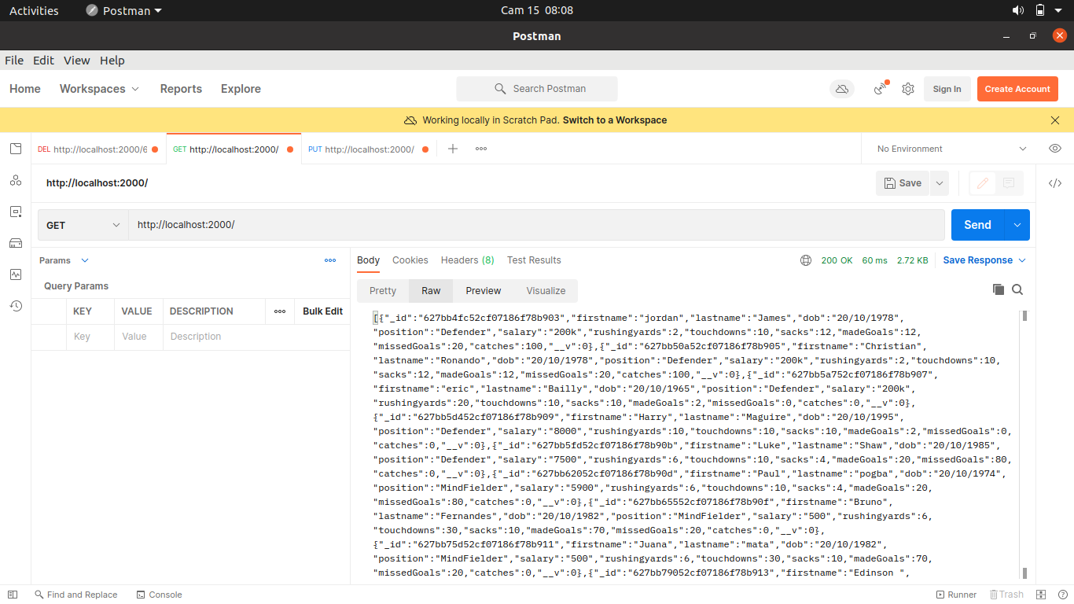
Getting all the players from in the databases

Update an existing Player
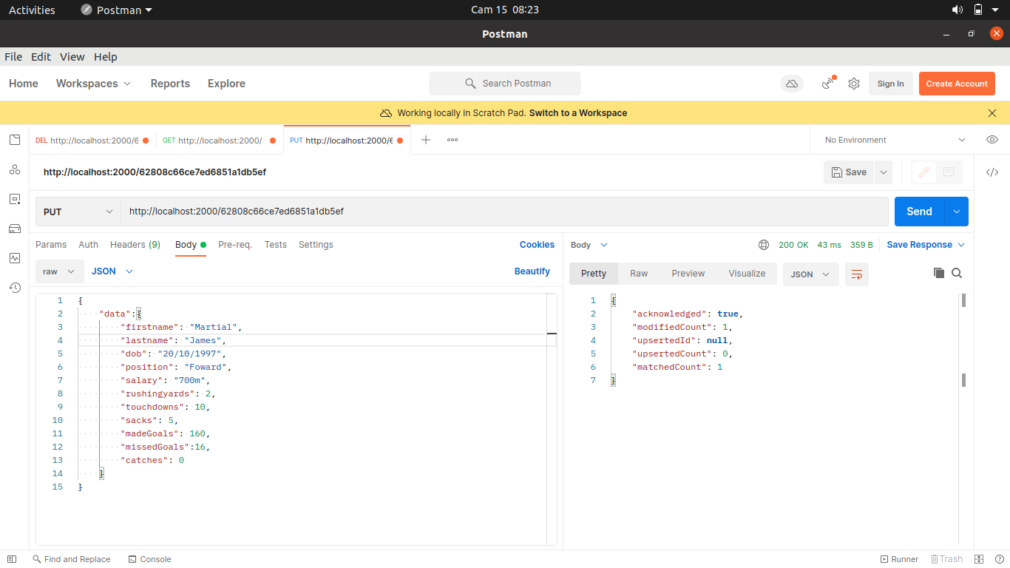

Deleting an Existing Player

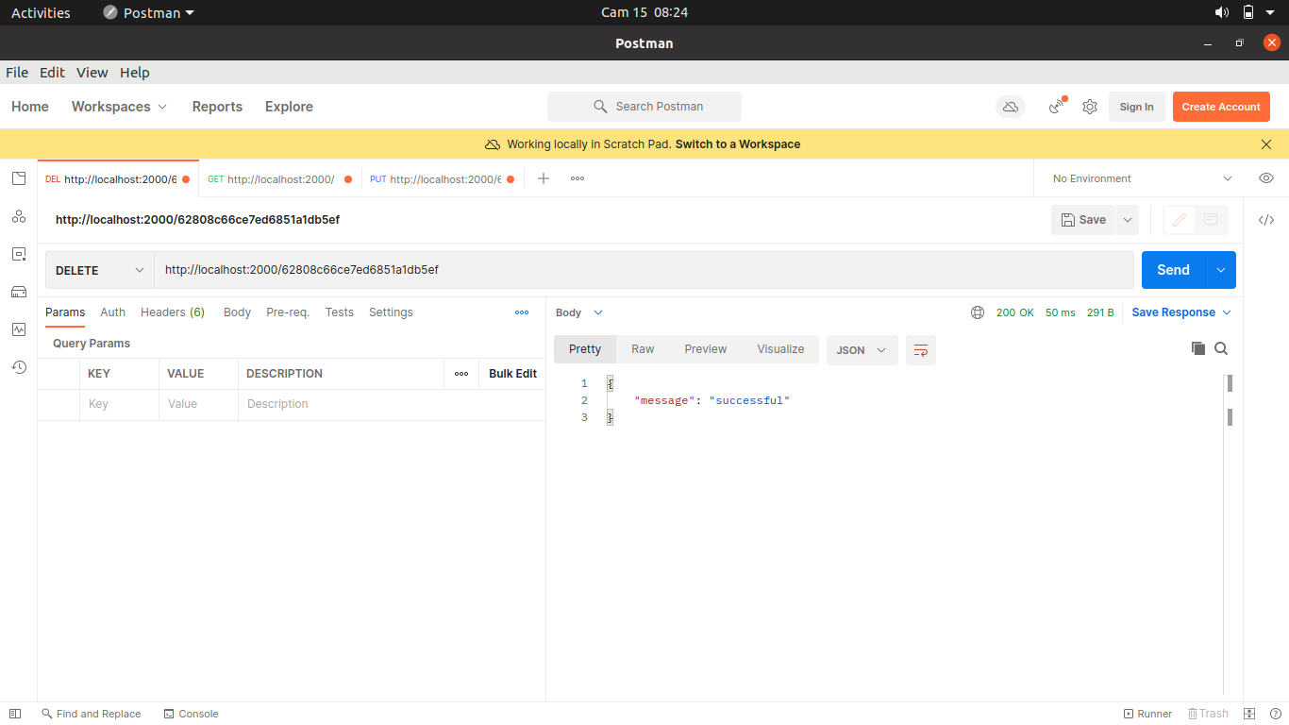

Challenges

My goal was to create a cool player team with each player with an image but storing and retrieving images was a issue with me at this moment something I will have to research more about.

