LPS: SERS Spectrum Compared with the Molecular Simulation
Surface-enhanced Raman bands of lipopolysaccharide on etched silicon and the calculated spectrum of the lipid A model

1. Executive summary
A reproducible set of ten bands was found in the SERS spectra of LPS on etched silicon (on 21 of 35 LPS spots). These bands were compared with the calculated Raman spectrum of the whole-molecule lipid A model, and with the bulk LPS reference spectrum. Each of the ten SERS bands has a calculated vibration within 11 cm⁻¹: 9 agree within 10 cm⁻¹ and 1 is shifted by 11 cm⁻¹. The two bands with a published assignment, 1330 cm⁻¹ (C–H deformation) and 1455 cm⁻¹ (CH₂/CH₃ deformation), fall within 1.1 cm⁻¹ of calculated C–H bending vibrations of the expected type.
The agreement cannot be counted as evidence that the bands belong to LPS. The model has 354 vibrations between 400 and 1800 cm⁻¹, so a calculated vibration lies near almost any position: when the calculated positions are displaced by a random 15 to 70 cm⁻¹, 9.6 of the ten bands still fall within 10 cm⁻¹ of a calculated vibration, against 9 for the real positions (p = 0.93). The overall shape also does not match (correlation 0.14 with the calculation and 0.20 with the bulk LPS spectrum). The bulk LPS peaks, including the strongest at 425 cm⁻¹, are absent from the SERS spectra. The SERS pattern is consistent with CH₂ and CH₃ groups of an organic layer on the silicon, with LPS as one possible source; it is not an identification.

2. Objective
To test whether the bands seen in the SERS spectra of LPS correspond to vibrations predicted for the molecular structure of lipid A, the conserved core of LPS, and to explain bands that are shifted. SERS (surface-enhanced Raman spectroscopy) is Raman spectroscopy in which molecules on a roughened metal-coated surface give a strongly amplified signal; it often enhances different bands than ordinary Raman spectroscopy of the bulk powder, so the SERS and bulk spectra of one molecule do not have to look alike.

3. Data and approach
- SERS data: Ten bands that repeat on 21 of 35 LPS spots (mean spectrum of those spots; positions are the means of the spots). Spectra were processed with background subtraction, spike removal, smoothing and baseline removal, and scaled to the silicon peak at 518 cm⁻¹.
- Simulation: A whole-molecule model of lipid A with two Kdo sugars (201 atoms, charge −4, with shortened fatty-acid chains), calculated for the isolated molecule with density functional theory (B3LYP, small 3-21G basis set). A calculated spectrum is a prediction of the Raman signals expected from the structure. Frequencies were multiplied by 0.965 and each vibration was drawn as a peak 12 cm⁻¹ wide. The type of each vibration (for example C–H bending, C–O and C–C stretching, skeletal deformation) was assigned from which atoms move; these labels are tentative.
- Comparison: No spectrum was shifted or rescaled to improve the match; each is scaled to its own maximum, and the silicon region is left out. Each SERS band is matched to the nearest calculated vibration within 50 cm⁻¹ that has appreciable intensity. For bands with a published assignment (1009, 1330 and 1455 cm⁻¹) the calculated vibration must also be of the matching type. For the other seven bands no vibration type is assigned in the literature (two of them, 785 and 1592 cm⁻¹, lie at or near peaks listed as common to commercial endotoxins without an assignment), so the match is by position only. 'Agrees' means a difference of 10 cm⁻¹ or less; 'shifted' means 10 to 50 cm⁻¹.

4. Results

4.1 The SERS spectrum of LPS
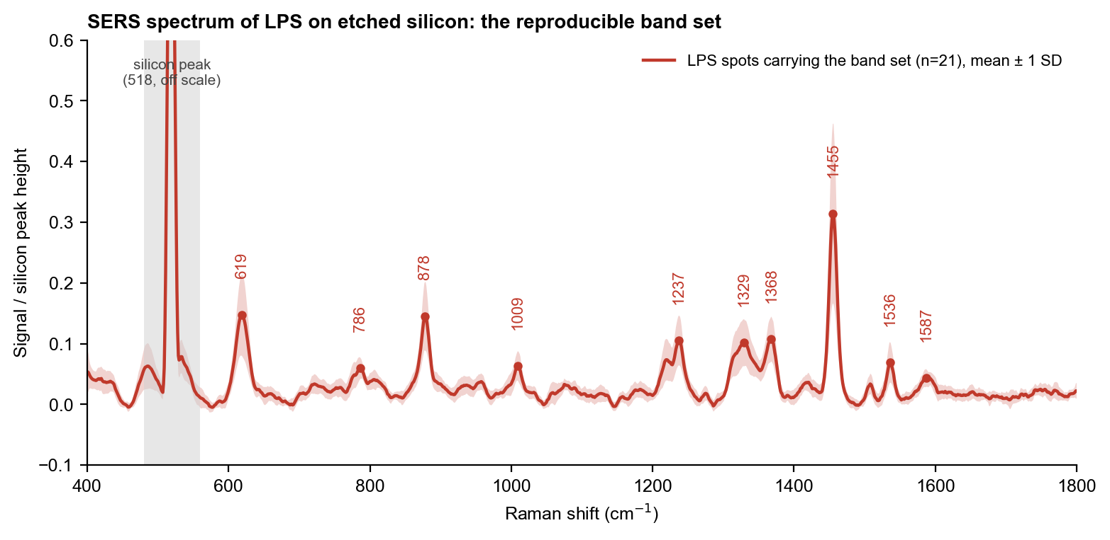
Figure 1. Mean SERS spectrum of the LPS spots that carry the band set (red line, with ± 1 standard deviation as the shaded band), scaled to the height of the silicon peak. Each number marks a band at its position on the curve.
The strongest band is at 1455 cm⁻¹; the others are weaker and several are broad or overlapping (1330 and 1368 cm⁻¹ sit on one broad feature).

4.2 SERS, simulation and bulk spectrum together
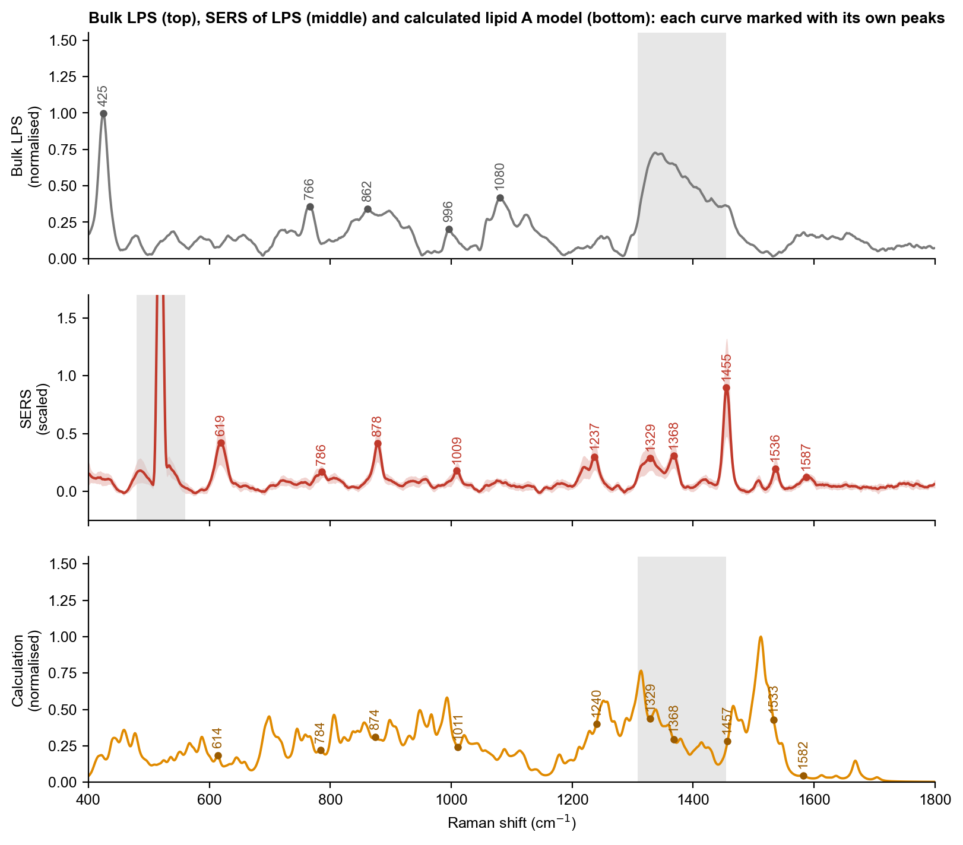
Figure 2. Bulk LPS reference (top), SERS mean spectrum (middle) and calculated spectrum of the lipid A model (bottom). In each panel the dots and numbers mark only the peaks of that curve, at the position where they occur on it: the bulk peaks (top), the SERS bands (middle) and the calculated vibrations that correspond to the SERS bands (bottom). Because each curve is marked separately, a mark and the neighbouring curve may not line up: the same vibration appears at slightly different positions in the three spectra (see the table). Numbers on the curves are read from the plotted curve (the apex of the mean spectrum) and can differ by a few cm⁻¹ from the band positions in the table, which are averages over individual spots. Grey bands: silicon peak (middle) and glass zone (top, bottom), which are not compared.
None of the bulk LPS peaks (425, 766, 861, 996 and 1080 cm⁻¹) appears in the SERS spectrum, although the calculation has vibrations near all of them. Conversely, the strongest SERS bands (1455, 619, 878) correspond to calculated vibrations of moderate intensity, and the strongest calculated peak, near 1516 cm⁻¹, has no strong SERS counterpart (the nearest SERS band is 1536 cm⁻¹).

4.3 Band-by-band comparison
Table 1. SERS bands of LPS and the corresponding calculated vibrations. Difference = SERS minus calculated.
SERS band (cm⁻¹) | Calculated (cm⁻¹) | Difference | Calculated vibration | Published assignment | Result
619 | 614 | +5 | skeletal / ring deformation | none in the literature checked | Agrees (type not assigned)
785 | 784 | +1 | C-O and C-C stretching (backbone) | 794, listed as a common LPS peak without assignment (9 cm⁻¹ away) | Agrees (type not assigned)
878 | 874 | +4 | C-O and C-C stretching (backbone) | none in the literature checked | Agrees (type not assigned)
1009 | 1011 | -2 | C-O and C-C stretching (backbone) | C-H bending / sugar C-O-C (published bands at 988 and 1003) | Agrees
1238 | 1240 | -3 | C-H bending / CH2 rocking and twisting | none in the literature checked | Agrees (type not assigned)
1330 | 1329 | +1 | C-H / O-H bending (CH2, CH3) | C-H deformation (published bands at 1330 and 1333) | Agrees
1368 | 1368 | -0 | C-H / O-H bending (CH2, CH3) | none in the literature checked | Agrees (type not assigned)
1455 | 1457 | -1 | C-H / O-H bending (CH2, CH3) | CH2 / CH3 deformation (published band at 1450) | Agrees
1536 | 1533 | +3 | C-H / O-H bending (CH2, CH3) | none in the literature checked | Agrees (type not assigned)
1592 | 1582 | +11 | N-H bending (ammonium / amide) | 1592, listed as a common LPS peak without assignment | Shifted (type not assigned)

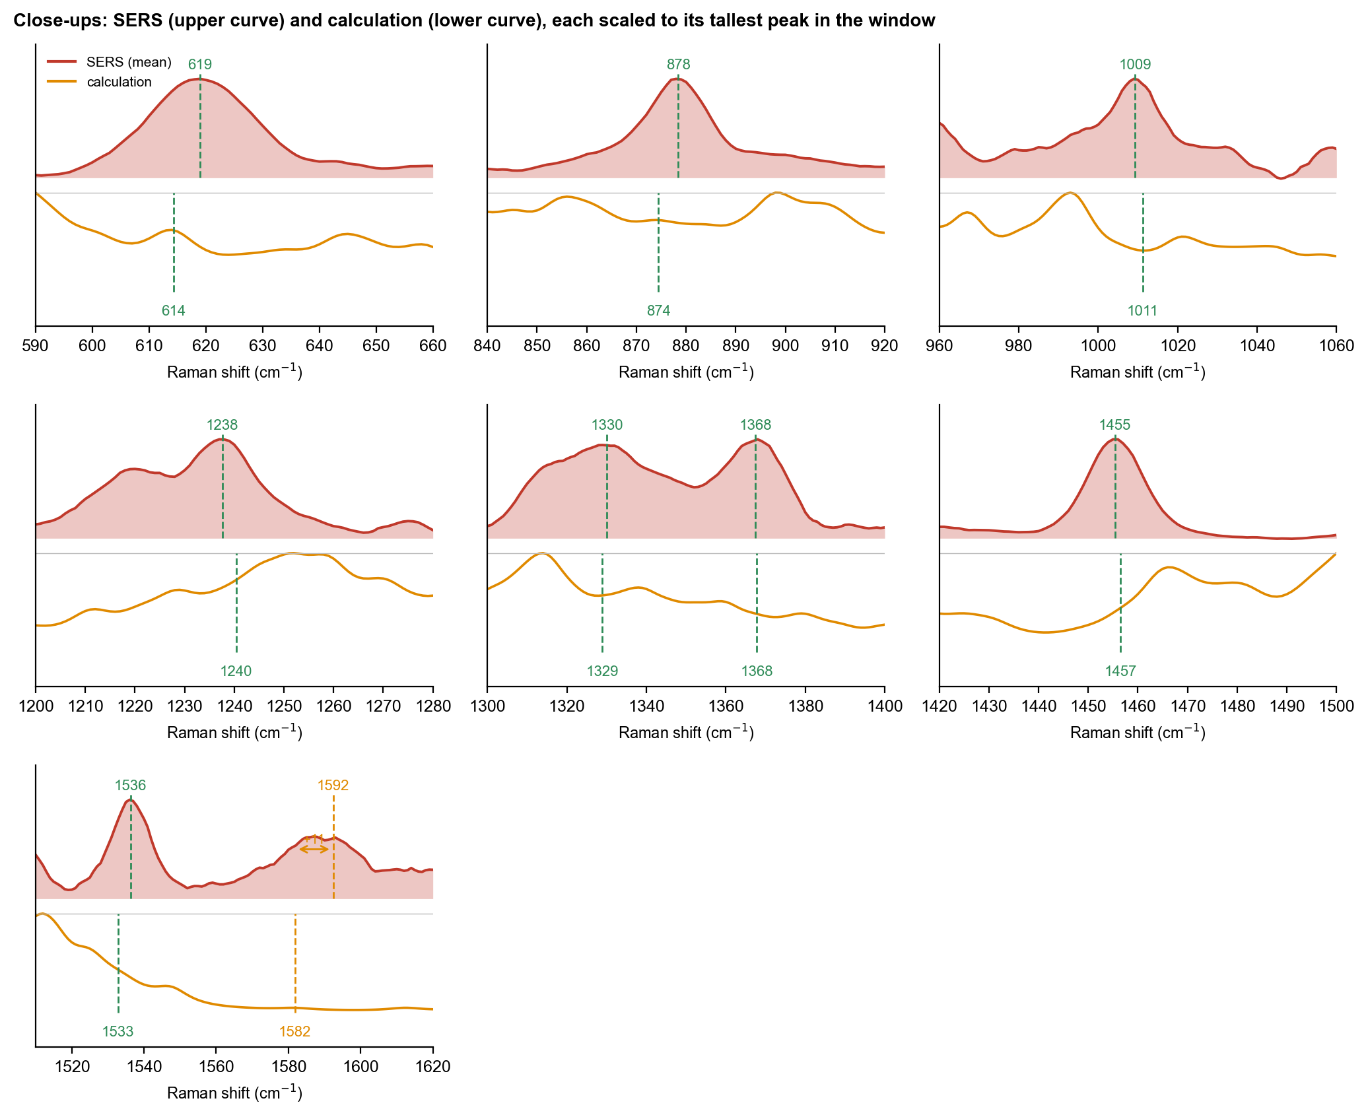
Figure 3. Close-ups of the SERS bands. Upper curve: SERS mean; lower curve: calculation; each is scaled to its tallest peak in the window. Dashed lines mark the SERS band (above) and the corresponding calculated vibration (below); the arrow gives the shift where it exceeds 10 cm⁻¹.
In several windows the calculated spectrum shows only a shoulder or no distinct peak at the matched position (for example at 1329 and 1457 cm⁻¹). The match rests on the position of an individual calculated vibration, not on a visible calculated peak, which is another reason to treat the agreement with caution.

4.4 The shifted band
The SERS band at 1592 cm⁻¹ is matched to a calculated vibration at 1582 cm⁻¹ (difference +11 cm⁻¹), which the analysis labels as N–H bending (amide and ammonium-type motion). No vibration type is assigned to this band in the literature, so the correspondence is by position only. A calculated frequency 11 cm⁻¹ lower than the measured one is the size of offset expected from the small basis set and the isolated, gas-phase charged model; on a surface the molecule binds, hydrogen bonds and is oriented, which shifts and re-weights bands. The assignment is therefore tentative.

4.5 Where the matched vibrations are in the molecule
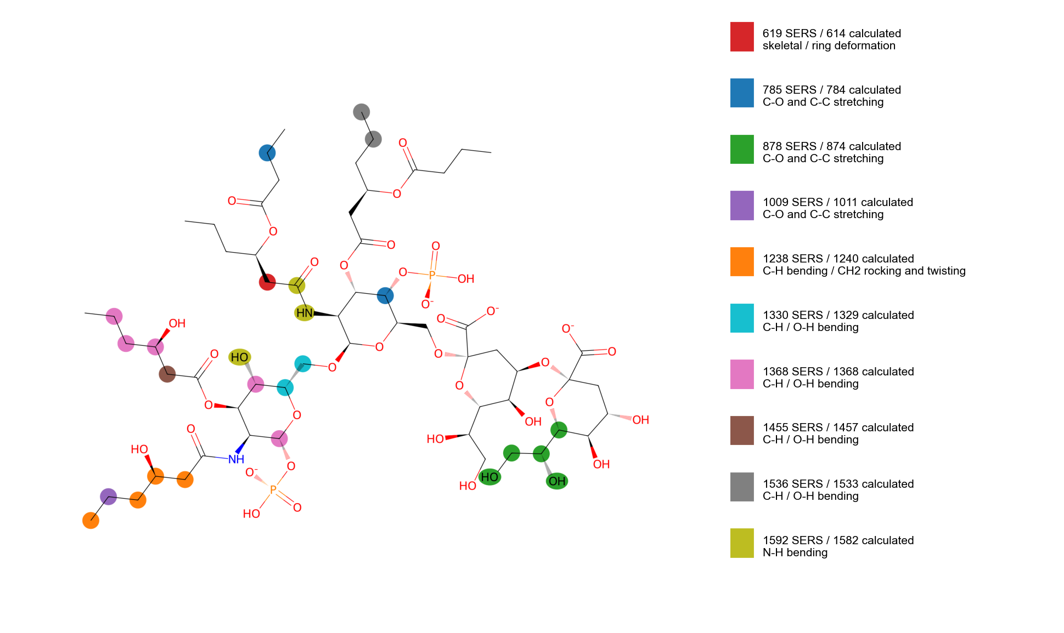
Figure 4. Atoms that move most in the calculated vibrations that correspond to the SERS bands. Each colour is one vibration (key at right); hydrogen atoms are assigned to the atom they are bonded to. The vibrations are spread over several groups rather than one bond.

5. Interpretation
- Positions: all ten SERS bands lie within 11 cm⁻¹ of a calculated vibration of the lipid A model, and the two bands with a published assignment, 1330 and 1455 cm⁻¹, match calculated C–H bending vibrations within about 1 cm⁻¹. This is consistent with CH₂/CH₃ and C–H groups, which are present in LPS (acyl chains and sugars) and in many other organic layers.
- Chance: because the model has many vibrations, the same level of agreement is reached for randomly displaced positions about nine times in ten (p = 0.93). The position agreement is therefore not evidence that the bands belong to LPS.
- Pattern: the SERS spectrum does not reproduce the bulk LPS peaks or the calculated intensity pattern. This can happen because SERS enhances only the groups close to or lying on the metal surface, but it also removes the support a match would have given.
- Sample controls: there was no blank or solvent-only control recorded in the same period as the LPS spots, so contamination from preparation or handling cannot be excluded.

6. Conclusion and next step
The SERS bands of the LPS spots are consistent with the vibration types predicted by the lipid A model, but this agreement is not stronger than chance and the overall spectra do not match, so the bands are not yet attributed to LPS. The most useful next steps are to repeat the LPS measurement on a fresh substrate with a solvent-only control prepared in the same way and a blank at the start and end of the set, and to measure bulk LPS on the same type of silicon to see directly which bands LPS gives there. On the calculation side, a larger basis set with water and counter-ions, and a model that includes the sugar-bound surface orientation, would test whether the bands near 619, 878 and 1238 cm⁻¹ can be assigned.

