Computed Raman Spectrum of an LTA Model Molecule
Full report: what was done, why, how, every parameter, and every file. Calculation run on 28 October 2026 on the lab PC (Gaussian 16W Rev. C.01).

1. Summary
- A 93-atom model of lipoteichoic acid (LTA) was built and its Raman spectrum was calculated as ONE whole molecule using density functional theory (DFT), not as a sum of fragments.
- Level of theory: quick reference run, B3LYP/3-21G in the gas phase, after a PM6 pre-optimisation. A higher-level run (B3LYP/6-31+G(d,p), water) was started afterwards and is still in progress; it is NOT part of this report's results.
- Result: the optimised geometry is a true minimum (273 vibrational modes, none imaginary). The strongest computed bands are near 689 and 1490-1503 cm-1 (scaled).
- Use: peak positions help assign bands in measured LTA spectra. Absolute intensities are only rough because of the quick level.

2. Why this calculation
LTA is the cell-wall polymer of Gram-positive bacteria and the counterpart of LPS in Gram-negative bacteria. S. aureus LTA is a chain of about 23 glycerol-phosphate repeats on a Glc2-diacylglycerol membrane anchor. On the glycerols, position 2 can be unsubstituted, esterified with D-alanine, or carry N-acetylglucosamine (GlcNAc).
The aim is a computed Raman spectrum from a single molecule, to assign bands in measured spectra of powder or dilute samples. The earlier approach (separate small fragments: D-alanine, GlcNAc, glycerol-phosphate, then adding spectra) was set aside by request, because a fragment sum ignores the bonds that join the pieces. The real polymer is far too large for quantum calculation, so a short model carrying all three substituent types was used.

3. The molecule
Item | Value
Name | LTA model (3 glycerol-phosphate units, 2 D-Ala esters, 1 alpha-GlcNAc)
Formula | C23 H45 N3 O20 P2 (93 atoms: 23 C, 45 H, 3 N, 20 O, 2 P)
Net charge / spin | 0 / singlet. Two phosphodiesters are -1 each, two alanine ammonium groups are +1 each.
Source | No PubChem entry exists for LTA (it is a polymer), so the structure was BUILT, not downloaded.
Parts taken from files | GlcNAc stereochemistry from LTA\N-Acetyl-D-Glucosamine\N-Acetyl-D-Glucosamine.sdf (a beta-anomer). The anomeric tag was flipped to the alpha-anomer because LTA GlcNAc is alpha-linked. D-alanine set to R (D) configuration, checked with RDKit CIP labels.
Starting 3D structure | Best of 300 RDKit ETKDGv3 conformers (random seed 7), each MMFF-optimised; lowest MMFF energy -311.4 kcal/mol

SMILES: CC(=O)N[C@@H]1[C@@H](O)[C@H](O)[C@@H](CO)O[C@@H]1O[C@H](COP(=O)([O-])OC[C@H](OC(=O)[C@@H](C)[NH3+])CO)COP(=O)([O-])OC[C@H](OC(=O)[C@@H](C)[NH3+])CO

Choices and assumptions
- Three glycerol-phosphate units instead of about 23, and no Glc2-diacylglycerol anchor, to keep the molecule computable.
- The two outer glycerol arms were set to the same configuration. This was not checked against the true S. aureus sn-glycerol-1-phosphate form.
- No counter-ions (Na+, Mg2+, Ca2+) and no water molecules in the model.

4. How it was calculated

4.1 Software
- RDKit 2026.03.3 (Python) to build the molecule, enumerate stereo-isomers, generate conformers, and write the Gaussian input.
- Gaussian 16W Revision C.01 (C:\G16W\g16.exe) for the quantum calculation.
- Python (numpy, scipy, matplotlib) to turn Gaussian output into a spectrum.

4.2 Steps
- Step 1 - build: SMILES to 3D, 300 conformers, MMFF optimisation, pick the lowest energy (build_lta.py).
- Step 2 - PM6 pre-optimisation: a cheap semi-empirical optimisation to bring the force-field geometry close to a quantum minimum.
- Step 3 - B3LYP/3-21G optimisation: relax the geometry fully. Converged at step 75 (Stationary point found).
- Step 4 - Raman frequencies: analytic second derivatives plus polarisability derivatives at the optimised geometry.
- Step 5 - spectrum: scale frequencies, convert activity to intensity at 785 nm, broaden, plot (make_spectrum.py).

4.3 Timeline (28 October 2026)
Time | Event
~09:00 | Job started automatically after the lipid A job finished
09:29 | PM6 stage finished (normal termination)
12:16 | B3LYP/3-21G optimisation finished (75 steps)
13:05 | Raman frequency stage finished; normal termination of Gaussian

5. Every parameter explained

5.1 Gaussian route lines
Keyword | What it does | Why it was chosen
# opt pm6 | Optimise geometry with the PM6 semi-empirical method | Fast; gives a sensible start for the expensive DFT stage
opt | Search for a minimum of the energy (zero forces) | Frequencies are only valid at a minimum
freq=raman | Compute vibrational frequencies and Raman activities | Raman activity needs polarisability derivatives; plain freq gives only IR
b3lyp | Hybrid DFT functional (Becke 3-parameter, Lee-Yang-Parr) | Standard, well tested for organic vibrations; same as the NAM run
3-21G | Small split-valence basis set (a few hundred functions here) | Quick reference only; fast but no polarisation or diffuse functions, so rough for anions
geom=allcheck | Read geometry, charge and spin from the checkpoint | Continues from the PM6 result
guess=read | Read starting orbitals from the checkpoint | Faster SCF convergence
--Link1-- | Chains the PM6 job and the DFT job in one input | One launch for both stages

5.2 Resource and file directives
Directive | Meaning | Value used
%nprocshared | Number of CPU threads | 28 (all logical processors of the i7-14700)
%mem | Memory for Gaussian | 54 GB of 64 GB (about 10 GB left for Windows)
%chk | Checkpoint file (geometry, orbitals, results) | lta_model.chk
Charge, multiplicity | Total electric charge and spin state | 0, 1 (singlet)

5.3 Spectrum-processing parameters
Parameter | Meaning | Value and reason
Frequency scale factor | Harmonic DFT frequencies are too high; a factor corrects this | 0.965. Typical for B3LYP, NOT fitted or benchmarked for 3-21G
Laser wavelength | Raman intensity depends on excitation frequency | 785 nm, the laser of the reference SERS paper
Temperature | Used in the Boltzmann (thermal population) term | 298.15 K
Intensity formula | I = S (v0 - v)^4 / [ v (1 - exp(-hcv/kT)) ] | Converts Gaussian Raman activity S into relative scattered intensity
Broadening | Each stick replaced by a Lorentzian peak | FWHM 12 cm-1; mimics experimental line width
Range / grid | Plotted wavenumber window | 200-3300 cm-1, 6200 points; normalised to the tallest peak

5.4 Terms used in this report
- Raman activity: Gaussian's measure of how strongly a vibration scatters, in A^4/amu. Already averaged over molecular orientation, so comparable to powder or solution.
- Imaginary frequency: a negative value in the output; means the structure is not a true minimum. None were found.
- Stationary point: geometry where all forces are essentially zero.
- PCM: polarisable continuum model, a way to include water as a continuous medium. Used only in the higher-level run, not in this one.

6. Results
Frequency check: 273 modes (3N-6 = 273), none imaginary, lowest mode 31 cm-1. Strongest features in the fingerprint region (scaled):
Position (cm-1) | Relative height | Note
689 | 1.00 | Strongest band. Probably a phosphate P-O-C or ring deformation (assignment not verified)
1490, 1503 | 0.80, 0.66 | Probably NH3+ / amide region (assignment not verified)
654 | 0.34 | Lower-frequency skeletal modes
816 | 0.33 | -
1325 | 0.34 | Near the 1330 cm-1 phosphate/amide reference band of the LPS SERS paper
1240 | 0.32 | -
914 | 0.31 | -
972, 1006 | 0.30, 0.29 | Sugar/glycerol C-O and C-C region

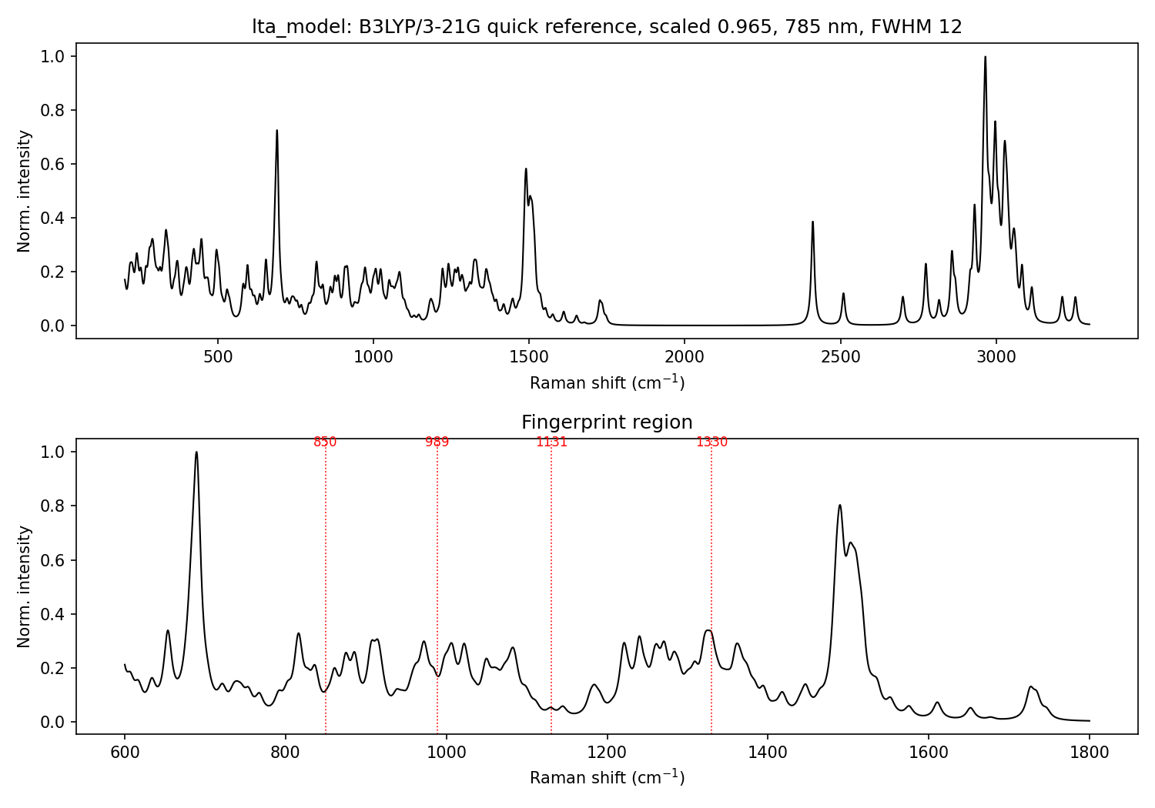
Figure 1. Computed Raman spectrum of the LTA model (B3LYP/3-21G, scaled 0.965, 785 nm, FWHM 12 cm-1). Top: full range. Bottom: fingerprint region with the four LPS reference bands marked for orientation.

7. Limitations - read before using
- Quick level: gas phase and the small 3-21G basis. Positions are approximate and intensities are distorted, especially for the charged phosphate and ammonium groups.
- Probable artefacts: peaks at about 2410, 2510 and 2700-2800 cm-1 are probably strongly hydrogen-bonded N-H/O-H stretches between NH3+ and phosphate groups, which occur with no water around. Ignore that region.
- Model size: 3 repeat units, not about 23, and no anchor. Chain-end effects are exaggerated and repeat-unit bands under-represented.
- Unverified: band assignments, the glycerol stereochemistry, and the 0.965 scale factor at this level.
- Comparing with experiment: compare peak positions, not absolute heights. Powder packing, counter-ions, aggregation, water bands in solution, and SERS enhancement all change real spectra.

8. What comes next
- Higher-level LTA run (B3LYP/6-31+G(d,p), water PCM, same level as the NAM calculation), started from this geometry. In progress; live files are in new lta\high.
- Higher-level lipid A run (B3LYP/6-31G(d), water) is queued after it.
- Overlay with the user's measured powder or solution spectrum (a CSV of wavenumber vs intensity is enough).

9. File inventory
Folder: C:\Users\COMPUTER\Downloads\sukesh\lta output\
File | Type | Content
LTA_Raman_Full_Report.docx | Report | This document
LTA_Raman_Methods.md | Report | Short text version of the methods
quick_...\lta_model.smi | Original/input | SMILES of the model
quick_...\lta_model.sdf | Original/input | Starting 3D structure (best MMFF conformer, before DFT)
quick_...\lta_model.gjf | Original/input | Gaussian input file (both jobs)
quick_...\build_lta.py | Original/script | Builds the molecule and the Gaussian input
quick_...\lta_model.out | Log | Complete Gaussian output (geometry steps, energies, frequencies)
quick_...\lta_model_raman_act.csv | Processed | 273 unscaled frequencies and Raman activities
quick_...\lta_model_spectrum_785nm.csv | Processed | Scaled, broadened spectrum data (wavenumber, normalised intensity)
quick_...\lta_model_spectrum_785nm.png | Processed | Plot used as Figure 1
quick_...\make_spectrum.py | Original/script | Converts activities to the 785 nm spectrum and plot
high_...\README.txt | Note | Placeholder; higher-level results will be copied here
quick_... = quick_B3LYP-3-21G; high_... = high_B3LYP-6-31+Gdp_water. Not copied here: the large checkpoint file lta_model.chk (about 32 MB, binary) stays in new lta\. Related earlier files: the fragment calculations in the LTA\ folder (D-alanine, GlcNAc, glycerol-phosphate) and the lipid A work in new lps\.

