Experimental Bulk Raman Spectra versus DFT Simulation: NAM, LPS and LTA
Do the simulations match the measured library spectra, what is happening, and why or why not
SERS Sepsis project, bulk-powder Raman spectral library. Version 1.3, 28 October 2026. Experimental data: library v3.3 reference spectra (glass slide, 785 nm). Simulation data: DFT files held in C:\Users\sukes\Downloads\mtp (listed in Section 9); LPS whole-molecule model: SERS_Sepsis_Spectral_Library/08_Methodology/simulation/LPS_LipidA_Model_20261028 (Gaussian 16W, 27-28 Oct 2026); LTA whole-molecule model: SERS_Sepsis_Spectral_Library/08_Methodology/simulation/LTA_Model_20261028 (Gaussian 16W, 28 Oct 2026). LTA experimental reference: pooled v2.1 (n = 17) of 28 Oct 2026.
The simulations reproduce the position of many individual bands, and the agreement is best for NAM, the only small molecule calculated as a whole. LPS and LTA each now have two calculations: separate fragments, and a whole-molecule model (shortened Kdo2-lipid A, 201 atoms; three glycerol-phosphate units with two D-alanine esters and one alpha-GlcNAc, 93 atoms). For LPS the model puts all five library bands within 2.4 cm-1 of a calculated mode, but this is no better than chance. For LTA the model puts all nine primary and supporting bands of the new pooled reference (v2.1, 17 spots) within 4.5 cm-1 of a calculated mode (mean difference 2.5 cm-1, against 15.8 cm-1 for the three fragments) and, at the strict 5 cm-1 tolerance, this is above chance (9 of 9 against 6.1 +/- 1.0 expected, p < 0.001); at 10 and 18 cm-1 it is not (p = 0.07 and 0.19). The LTA modes that sit on the library bands are weak (relative activity 0.01 to 0.15), the strongest calculated modes (690, 654 and 1490-1510 cm-1) have no counterpart in the measured spectrum, and the whole-spectrum correlation is zero (-0.01). The overall spectral shapes do not match for any molecule (correlation 0.15 or less). The DFT results can support tentative assignments of individual bands, but they cannot be used to confirm identity, and several strong experimental bands remain unexplained: NAM 829 and 955 cm-1, the assignment of LPS 425 cm-1, and for LTA the strong 1092 and 1010 cm-1 bands, which match only very weak modes.

1. Result at a glance
Molecule | What was simulated | Bands tested | Bands matched within 5 / 10 / 18 cm-1 | Mean abs. error (cm-1) | Matches expected by chance at 10 cm-1 (p) | Whole-spectrum r | Overall agreement
NAM | Whole molecule, beta anomer, gas phase (Gaussian 16) | 11 | 5 / 7 / 8 | 14.1 | 7.5 (p = 0.75) | 0.12 | Partial
LPS (5 fragments) | Five separate fragments, not whole LPS | 5 | 4 / 4 / 5 | 3.5 | 4.0 (p = 0.68) | 0.14 | Weak
LTA (3 fragments) | Three separate fragments, not whole LTA | 9 | 3 / 5 / 7 | 15.8 | 4.3 (p = 0.40) | 0.09 | Weak
LPS (whole-molecule model) | Kdo2-lipid A with shortened chains, 201 atoms, charge -4, B3LYP/3-21G, gas phase | 5 | 5 / 5 / 5 | 1.2 | 4.6 (p = 0.57) | -0.01 | Positions agree; not above chance; shape no
LTA (whole-molecule model) | 3 glycerol-phosphates, 2 D-Ala esters, 1 alpha-GlcNAc; 93 atoms, net charge 0, B3LYP/3-21G, gas phase | 9 | 9 / 9 / 9 | 2.5 | 7.5 (p = 0.07) | -0.01 | Positions agree, above chance at 5 cm-1 only; matched modes weak; shape no

The bands tested are the primary and supporting bands of the library reference that lie outside the glass zone. A band counts as matched when the nearest calculated mode is within the stated distance. The chance column gives the number of matches expected if the calculated modes were shifted by a random amount; a real agreement should clearly exceed it, and only the LTA whole-molecule model does, and only at the 5 cm-1 tolerance. The whole-spectrum r compares the shape of the simulated spectrum with the experimental reference over 400-1800 cm-1, leaving out the glass zone (1308-1455 cm-1).

2. What was simulated
DFT (density functional theory) computes the vibrational frequencies and Raman activities of a molecule from its electronic structure. The result is a list of "modes": each has a frequency and a Raman activity (how strongly it should scatter). A simulated spectrum is built by drawing each mode as a broadened peak. All three simulations are of the isolated molecule or fragment, not of the powder on the glass slide.
Item | NAM | LPS | LTA
What was calculated | Whole NAM molecule (C11H19NO8, 39 atoms), beta anomer only | Five fragments: KDO, D-glucosamine, heptose, myristic acid, phosphoric acid Also: whole-molecule model of Kdo2-lipid A (PubChem CID 5771770) with the six acyl chains shortened to C3-C4: C60H98N2O39P2, 201 atoms, charge -4. | Three fragments: glycerol-phosphate (two units, charge -2), D-alanine, N-acetyl-D-glucosamine Also: whole-molecule model (built, no PubChem entry): three glycerol-phosphate units joined by two phosphodiesters, D-alanine ester on each outer glycerol, alpha-GlcNAc on the central glycerol; C23H45N3O20P2, 93 atoms, net charge 0 (two phosphate anions, two ammonium groups).
Why fragments | Not needed (small enough) | LPS is far too large for a full calculation. For the whole-molecule model the chains were cut because full Kdo2-lipid A (355 atoms) was too large for this PC at a higher level; the core sugars beyond Kdo and the O-antigen are not in it. | LTA is a polymer with variable substitution. For the whole-molecule model the chain was kept to three units and the glycolipid anchor left out so that the molecule stays computable; about 23 repeats are present in the real polymer.
Method | Gaussian 16, B3LYP-D3BJ, 6-311++G(d,p), tight optimisation, no imaginary frequencies | B3LYP/6-31G(d), opt freq=raman scf=tight integral=ultrafine (LPS documentation) Whole-molecule model: Gaussian 16W Rev C.01, PM6 pre-optimisation then B3LYP/3-21G opt freq=raman; 109 optimisation steps; 597 modes, no imaginary frequency. | Gaussian 16, B3LYP/6-31G(d), SMD water, opt + freq=raman Whole-molecule model: Gaussian 16W Rev C.01, PM6 pre-optimisation then B3LYP/3-21G opt freq=raman; 75 optimisation steps; 273 modes, no imaginary frequency (lowest 31 cm-1).
Environment | Gas phase | Gas phase (no solvent keyword in the documented route); whole-molecule model: gas phase, no counter-ions | Implicit water (SMD); whole-molecule model: gas phase, no counter-ions, no water
Frequency scaling | 0.980 below 1800 cm-1, 0.967 above | 0.9613; whole-molecule model 0.965 (typical B3LYP value, not fitted for 3-21G) | 0.96 (0.96-0.97 range evaluated); whole-molecule model 0.965 (typical B3LYP value, not fitted for 3-21G)
Modes in 400-1800 cm-1 | 67 | 150; whole-molecule model 354 | 47 (peaks picked from broadened curves); whole-molecule model 165
Modes per 100 cm-1 | 4.8 | 10.7; whole-molecule model 25.3 | 3.4; whole-molecule model 11.8
Experimental sample | Sigma A3007, lot BCCK5768 (anomeric mixture) | Sigma L2630, E. coli O111:B4 | Sigma L2515-10MG, S. aureus LTA, lot 0000419622; library reference v2.1 (pooled n = 17, 28 Oct 2026). The earlier fragment comparison used the preliminary April 2026 reference (n = 4).

A calculation on a single small fragment cannot reproduce a polymer. LPS has phosphorylated, acylated and branched sugars; LTA has a charged phosphodiester backbone. The five LPS fragments and the three LTA fragments contain none of the linkages between units, so bands that come from those linkages cannot appear in them. The whole-molecule LPS model does contain the glycosidic bond between the two glucosamines, the Kdo links, both phosphate esters and both amide links of the lipid A backbone, but not the long acyl chains, the outer core sugars or the O-antigen. The whole-molecule LTA model contains two phosphodiester links, two D-alanine ester links and the glycosidic link to GlcNAc, but only three repeating units instead of about 23 and no glycolipid anchor. Both are therefore parts of the molecule and not the whole.

3. How the comparison was made
- Experimental side: the library reference spectrum (mean of the spectra that passed QC) and its primary and supporting bands from 03_Reference_Spectra. Bands inside the glass zone are not used.
- Simulation side: calculated mode frequencies already scaled by the authors (see Section 2). Modes below 400 and above 1800 cm-1 are ignored.
- Band matching: each experimental band is paired with the nearest calculated mode. The difference is exp minus calc. Within 5 cm-1 is a tight match (about 3 detector pixels); within 10 cm-1 is a match; 10-18 cm-1 is "near"; beyond 18 cm-1 is no match.
- Chance test: because DFT gives many modes, some always fall near an experimental band. To measure this, all calculated modes are rigidly shifted by a random amount between 15 and 70 cm-1 (5000 trials) and the matching is repeated. A real agreement should beat this baseline.
- Whole-spectrum agreement: simulated modes are drawn as Gaussian peaks (12 cm-1 FWHM where the broadened curve was not supplied), normalised, and correlated with the experimental reference (Pearson r). A non-negative least-squares (NNLS) fit of the fragment spectra to the experimental one is also reported; it is optimistic because the weights are fitted.
- Intensity check: calculated activity is compared with experimental height for the matched bands (NAM only, because only NAM has a whole-molecule calculation).

4. NAM

4.1 Result
Of 11 library bands, 5 agree within 5 cm-1, 7 within 10 cm-1 and 8 within 18 cm-1. The mean absolute difference is 14.1 cm-1, pulled up by three bands (829, 955 and 1589 cm-1) with no nearby calculated mode. For the 8 bands within 18 cm-1 the mean difference is about 5 cm-1.
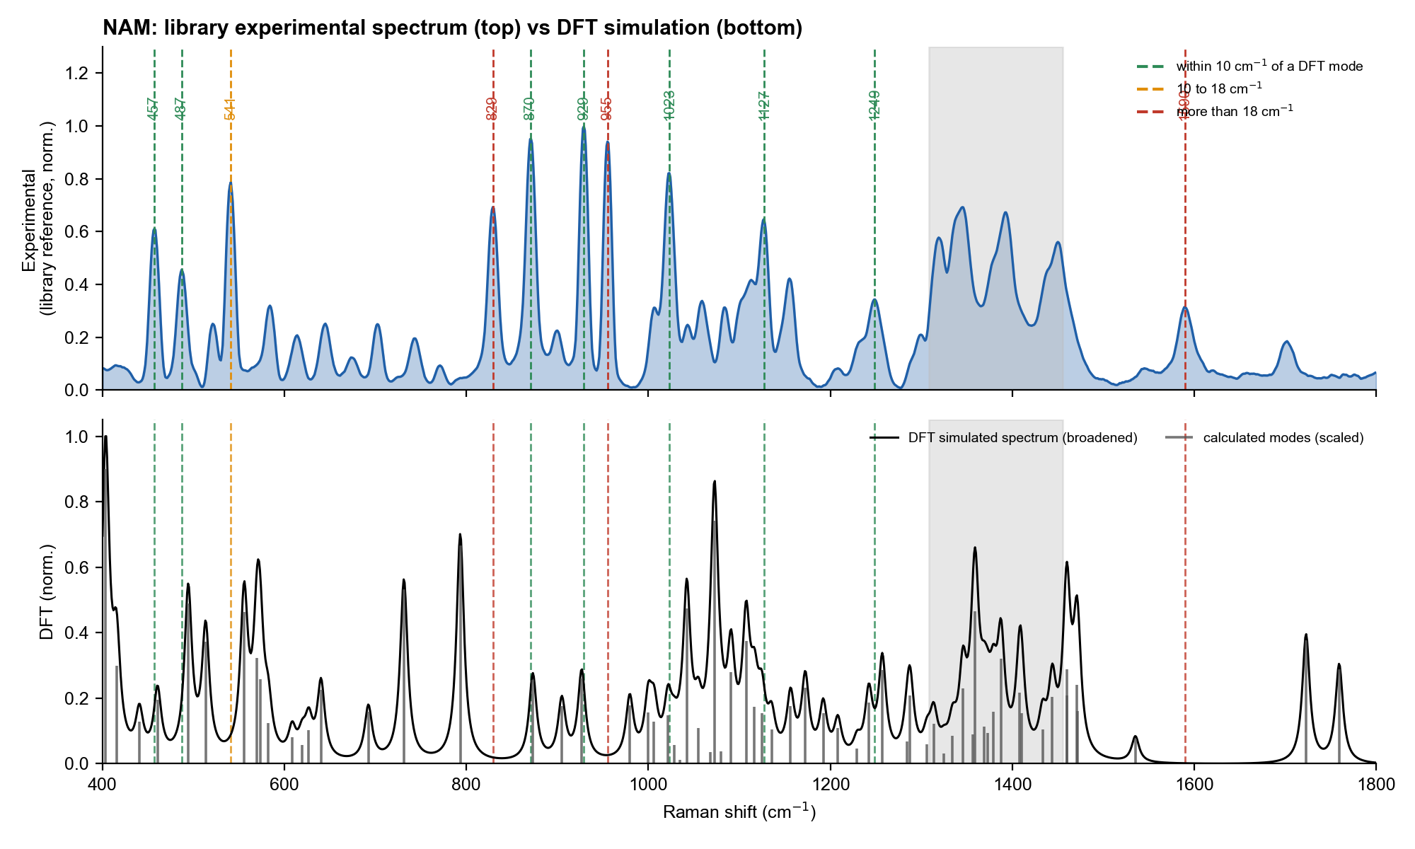
Figure 1. NAM. Top: library experimental reference. Bottom: DFT modes (grey sticks) and simulated spectrum (black). Dashed lines mark the experimental bands, coloured by how close the nearest DFT mode is.

4.2 Band-by-band
Exp. band (cm-1) | Class | Nearest DFT mode (cm-1) | Exp - calc (cm-1) | Calc. rel. activity | Mode type / fragment | Verdict | Why
541.0 | Primary | 555.6 | -14.6 | 0.52 | Skeletal bending / ring torsion | NEAR (10-18) | A skeletal-bending mode exists (556) but 15 cm-1 away; several skeletal modes lie at 556 and 570, so the pairing is ambiguous. Position shift is plausible for a hydrogen-bonded solid but this was not tested.
829.0 | Primary | 793.2 | +35.8 | 0.74 | Skeletal deformation + δ(C–C–O) | NO MATCH | Strong experimental band with NO calculated mode within 35 cm-1 (nearest 793, a skeletal deformation). Not explained by the beta-anomer model. The alpha-anomer calculation (11 Aug 2026) did not help (p = 0.46 against a random decoy). Unresolved.
870.5 | Primary | 873.0 | -2.5 | 0.28 | γ(CH₂) hydroxymethyl wagging | MATCH | Hydroxymethyl (CH2OH) wagging calculated at 873. Good agreement; consistent with the 872 assignment in the NAM archive.
929.0 | Primary | 926.7 | +2.3 | 0.29 | Ring breathing / ν(C–C–O) | MATCH | Ring breathing / C-C-O stretch calculated at 927. Good agreement. This is also the strongest experimental band.
955.0 | Primary | 979.5 | -24.5 | 0.20 | Ring breathing / ν(C–C–O) | NO MATCH | Nearest calculated mode is 979 (24 cm-1 away). Too far to call a match. The library literature note suggests a methyl rocking; no calculated mode supports it. Unresolved.
1022.7 | Primary | 1021.5 | +1.2 | 0.16 | ν(C–O) + δ(C–O–H) | MATCH | C-O stretch coupled with C-O-H bending calculated at 1021.5. Good agreement.
1127.0 | Primary | 1124.6 | +2.4 | 0.17 | ν(C–O) + δ(C–O–H) | MATCH | C-O stretch with C-O-H bending calculated at 1125. Good agreement.
457.0 | Supporting | 460.5 | -3.5 | 0.22 | Skeletal bending / ring torsion | MATCH | Low-frequency ring skeletal bending is reproduced. Consistent with a skeletal mode of the sugar ring.
487.0 | Supporting | 494.2 | -7.2 | 0.54 | Skeletal bending / ring torsion | MATCH | Skeletal bending/ring torsion mode within 7 cm-1. Consistent.
1248.7 | Supporting | 1242.3 | +6.4 | 0.21 | δ(C–H) + ν(C–O) coupled | MATCH | Coupled C-H bend and C-O stretch calculated at 1242. Consistent (6 cm-1).
1589.5 | Supporting | 1535.2 | +54.3 | 0.08 | Amide II: δ(N–H) + ν(C–N) | NO MATCH | Nearest calculated mode is the amide II-like mode at 1535, 54 cm-1 away and weak. Not a match; the experimental band is reproducible but its origin is not established.

4.3 What is happening and why
- Agreement where the chemistry is simple. The bands at 870.5, 929, 1022.7, 1127 and 1249 cm-1 sit within 1 to 6.5 cm-1 of calculated modes whose character is hydroxymethyl wagging, ring breathing and C-O/C-C stretching. These are the motions a pyranose sugar is expected to show, so the match is chemically sensible. This supports (not proves) the tentative assignments in the marker-explanation document.
- Missing bands. 829 and 955 cm-1 are two of the strongest experimental bands, yet no calculated mode lies within 24 cm-1 of them. The calculated spectrum has its strong features near 400, 793 and 1070 cm-1 instead.
- Intensity disagreement. The strongest experimental bands (929, 870, 955, 1023) are weak to medium in the simulation (activity 0.16 to 0.29), while the strongest calculated modes (near 410, 793, 1070) are not the strongest experimental ones.
- Positional correlation reported earlier (r = 0.9996, 41 bands, 30 matched, MAE 9.3, RMSE 10.3 cm-1) measures how well the two lists of numbers line up along the same axis. Since both lists span the same 400-1800 range this is almost automatically very high, and it does not test whether the right modes pair with the right bands.
Intensity rank check on the 7 matched bands: Spearman rank correlation between experimental height and calculated activity = 0.07 (p = 0.88). A value near zero or negative means the strong calculated modes are not the strong experimental bands, so the match is in position only.

4.4 Likely reasons for the differences (not all tested)
- Gas phase versus solid. The calculation is an isolated molecule; the powder is a hydrogen-bonded solid. Hydroxyl, carboxylic acid and amide groups shift by tens of cm-1 on hydrogen bonding, which fits the misfit being worst for bands involving these groups (1589 amide II-like, 955, 829).
- Anomeric mixture. The reagent is an alpha/beta mixture but only beta was calculated. The alpha calculation (11 Aug 2026) did not fix the unmatched bands once tested against random decoys (p = 0.46), so this is not the whole explanation.
- Harmonic approximation and scaling. A single scale factor corrects frequencies on average but cannot fix individual modes; errors of 10 to 20 cm-1 are normal for B3LYP.
- Raman activity is not measured intensity. At 785 nm the observed intensity also depends on the frequency, the laser, optics and sample, and for a powder on the crystal packing. Relative intensities are therefore only a rough guide.
- Ionisation state. The carboxylic acid may be partly ionised in the powder, which would remove the 1720 cm-1 C=O mode of the calculation. A weak band near 1700 cm-1 is seen experimentally, consistent with a shifted C=O, but this was not tested.

5. LPS

5.1 What was calculated
Two calculations are compared with the same five library bands (the primary and supporting bands of the LPS reference, 60 %, 40 s, 5 acc, n = 10).
 | Five fragments | Whole-molecule model
What | KDO, D-glucosamine, heptose, myristic acid, phosphoric acid, each on its own | Kdo2-lipid A (E. coli, PubChem CID 5771770) with the six acyl chains shortened: 2 glucosamines, 2 Kdo, 2 phosphates, 2 amides, all in one molecule
Atoms and charge | Not recorded for the fragments | 201 atoms, C60H98N2O39P2, charge -4 (both Kdo carboxylates and both phosphates ionised), no counter-ions
Level | B3LYP/6-31G(d), gas phase, scale 0.9613 | PM6 then B3LYP/3-21G, gas phase, scale 0.965; Gaussian 16W Rev C.01
Modes in 400-1800 cm-1 | 150 (10.7 per 100 cm-1) | 354 (25.3 per 100 cm-1)
Result file | dft_candidates_all.csv (mtp) | lipidA_raman_act.csv (lps output simulation)

5.2 Result
Whole-molecule model: all five bands have a calculated mode within 2.4 cm-1 (four of them within 1.1 cm-1); mean absolute difference 1.2 cm-1. The five fragments gave 4 of 5 within 5 cm-1 and a mean difference of 3.5 cm-1; the 766 cm-1 band was 12.4 cm-1 away. Against random shifts of the calculated modes the whole-molecule model gets 5 of 5 within 5 cm-1 where chance gives 4.4 (p = 0.47), so the positions are not evidence of agreement: with 354 modes there is nearly always one close. The whole-spectrum correlation is -0.01. The strongest calculated mode is at 1516 cm-1, which is weak in the experiment (0.05 of the 425 band), and the experimental 425 cm-1 band, the strongest in the spectrum, falls on a calculated mode of moderate strength.
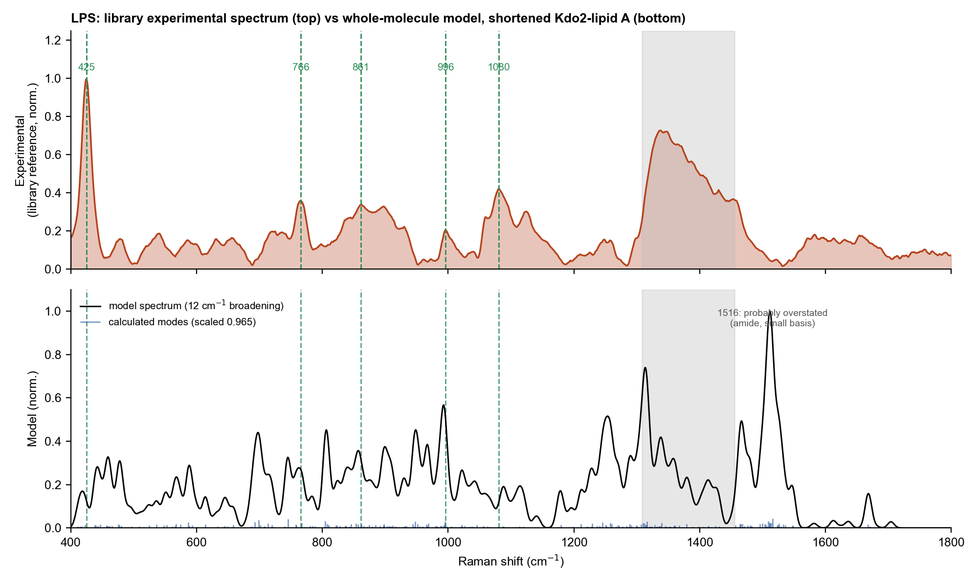
Figure 2. LPS. Top: library experimental reference (10 spectra). Bottom: whole-molecule model (shortened Kdo2-lipid A), calculated modes (blue sticks) and broadened spectrum. Dashed lines mark the experimental bands; all five are within 10 cm-1 of a calculated mode (green).

5.3 Band-by-band
Exp. band (cm-1) | Class | Lipid A model: nearest mode | Exp - calc | Rel. activity | Fragments: nearest mode | Exp - calc | Rel. activity (fragment) | Verdict (model) | Why
424.8 | Primary | 422.4 | +2.4 | 0.34 | 425.9 | -1.1 | 0.06 (phosphoric acid) | MATCH | Calculated mode at 422.4, relative activity 0.34. The fragments gave only a weak phosphoric-acid mode (0.06). The motion of the 422 mode was not analysed, so the band stays unassigned.
765.5 | Supporting | 764.4 | +1.1 | 0.08 | 777.9 | -12.4 | 0.24 (phosphoric acid) | MATCH | Mode at 764.4, weak (0.08). The fragments were 12.4 cm-1 away. Position now agrees; the strength does not (the experimental band is among the stronger bands).
861.1 | Supporting | 862.0 | -0.9 | 0.37 | 858.1 | +3.0 | 0.02 (glucosamine) | MATCH | Mode at 862.0, relative activity 0.37 (fragments: 0.02). Consistent with the sugar-ring region of the two glucosamines and Kdo.
995.8 | Supporting | 996.2 | -0.4 | 0.08 | 995.5 | +0.3 | 0.04 (phosphoric acid) | MATCH | Nearest mode 996.2 is weak (0.08), but the strongest mode of the 900-1000 region lies at 994.7 (relative activity 0.72), 1 cm-1 away, so the band has a strong calculated counterpart.
1080.5 | Primary | 1079.5 | +1.0 | 0.12 | 1081.1 | -0.6 | 0.05 (glucosamine) | MATCH | Mode at 1079.5, activity 0.12 (fragments: 0.05). The band is broad and about 14 % glass-affected, so a 1 cm-1 agreement is not meaningful.

5.4 What is happening and why
- Positions: the whole-molecule model is closer than the fragments (mean difference 1.2 against 3.5 cm-1) and explains the 766 cm-1 band that the fragments missed by 12 cm-1. Having the glycosidic, phosphate-ester and Kdo links in one molecule moves modes to where they are in the sample.
- Strength: at 425 and 861 cm-1 the model has modes of 0.34 and 0.37 of the maximum activity, against 0.06 and 0.02 for the fragments. These two bands are therefore no longer calculated as almost invisible. The model still puts its largest intensity in places where the measured LPS spectrum is weak: 1516 cm-1 (0.05 of the 425 band), 745 cm-1 (0.18) and 699 cm-1 (0.08).
- Not better than chance: a mode list this dense (25 per 100 cm-1) matches almost any set of five bands. Random shifts of 15 to 70 cm-1 give 4.4 to 4.7 matches of 5, so 5 of 5 is p = 0.47 to 0.66. Using only the stronger modes (activity 0.15 or more, 190 modes) gives 4 of 5 within 5 cm-1, chance 3.6 (p = 0.61). The fragments gave p = 0.32 to 0.68. Neither calculation can claim an agreement beyond chance.
- Shape: the whole-spectrum correlation is -0.01, compared with 0.14 for the equal-weight fragment composite. The cut chains remove most of the CH2 and CH3 bands, the 1516 cm-1 mode (probably an amide mode that the small basis set overstates; not verified) dominates the model, and the three artefact peaks at 2420 to 2750 cm-1 lie outside the compared range.
- Combining both: fitting the whole-molecule spectrum together with the five fragments (non-negative least squares) gives r = 0.37, with a weight of 7 % for the lipid A model; the five fragments alone give 0.40. The model does not improve the fit, and these fitted weights are not the composition of LPS.
- Literature SERS bands of endotoxin (850, 989, 1131 and 1330 cm-1, from the thesis used for the model): the model has modes at 854, 989 to 995, 1137 (weak) and 1329 (and 1316), as reported in the model methods. These bands are SERS bands and are not all present as bands of the bulk spectrum, so this is a check on the model, not on the library spectrum.

5.5 Whole-molecule model against the five fragments
The whole-molecule model is the better of the two calculations for band positions and for the strength of the 425 and 861 cm-1 modes. It is not better for the overall shape, and neither is better than chance for positions. The fragments remain useful for the regions the shortened model leaves out (long acyl chains, core sugars).
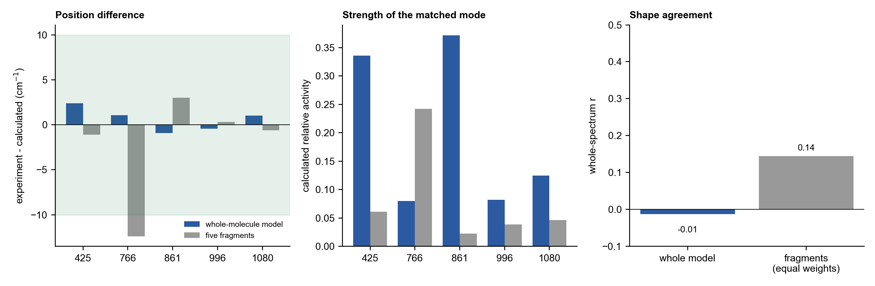
Figure 3. LPS: whole-molecule model against the five fragments. Left: difference between each library band and the nearest calculated mode. Middle: calculated relative activity of that mode. Right: whole-spectrum correlation with the library reference.
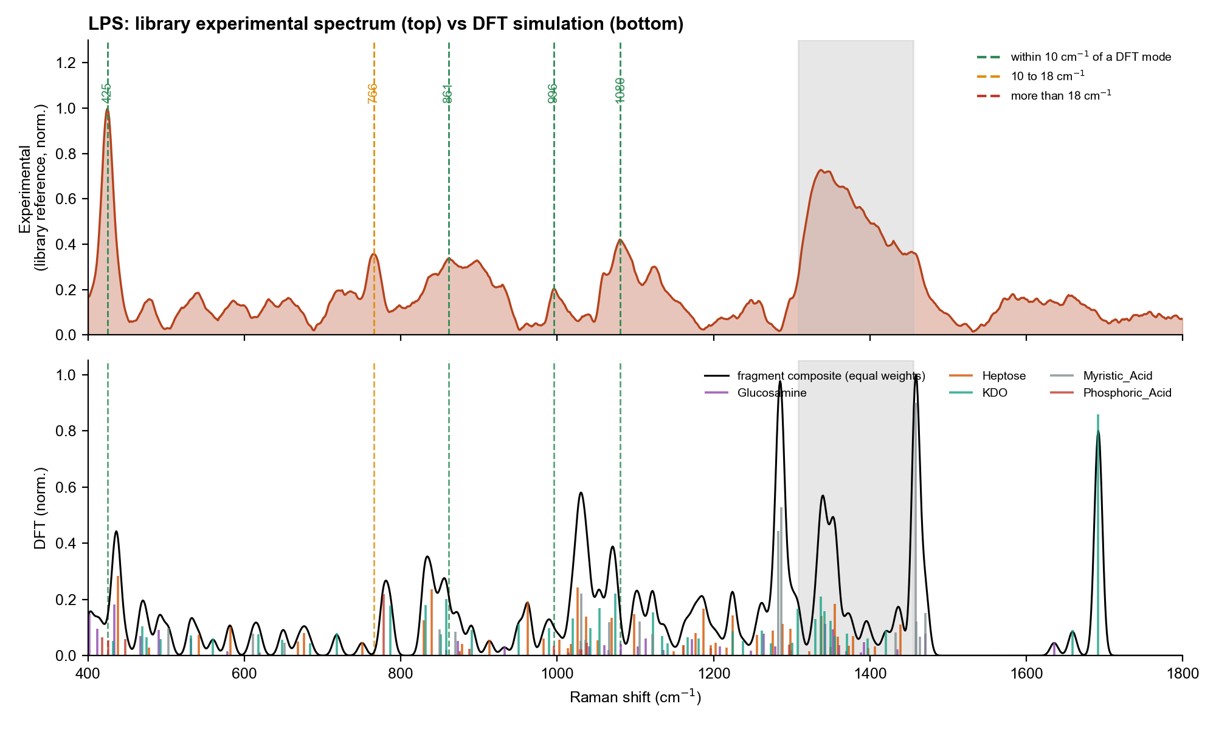
Figure 4. LPS, fragment calculation. Top: library experimental reference. Bottom: scaled DFT modes of five fragments (coloured by fragment) and their equal-weight composite.

5.6 Likely reasons for the differences
- Shortened chains and missing core. The model has C3-C4 chains instead of C12-C14 and no heptose or O-antigen, so the lipid, core and outer-chain bands of real LPS are not represented. This is the largest limit of the whole-molecule model.
- Low level of theory. B3LYP/3-21G has no polarisation or diffuse functions; positions are approximate, intensities of charged groups are distorted and gas-phase hydrogen bonds to the charged groups produce artefact peaks at 2420 to 2750 cm-1. The 0.965 scale factor was not fitted for this level.
- Gas phase and charge -4 without counter-ions. The sample is a salt (Na+, Ca2+, Mg2+ counter-ions) in a powder; both change band positions and intensities.
- One conformer. A single low-energy shape of a flexible molecule was calculated; the stereocentres left open by PubChem were set by the embedding.
- Dense mode list. With 354 modes the position test cannot separate a real agreement from chance (Section 7).
- Different experimental reference from the older fragment work, as described in the earlier version of this document: the fragment results were first compared with an older LPS measurement; both models here use the library reference (60 %, 40 s, 5 acc).

6. LTA

6.1 Result
The LTA reference used here is the pooled v2.1 reference of 28 October 2026 (17 independent spots, clean dark, 80 % power; 10 spots at 45 s x 2 acc and 7 at 30 s x 3 acc). Nine primary and supporting bands outside the glass zone were tested (primary 539, 862 and 1092 cm-1). The whole-molecule model puts all nine within 5 cm-1 of a calculated mode (mean absolute difference 2.5 cm-1). The three fragments reach 3, 5 and 7 of nine within 5, 10 and 18 cm-1 (mean difference 15.8 cm-1).
Chance test. If the model modes are shifted by a random 15 to 70 cm-1, 6.1 +/- 1.0 bands still fall within 5 cm-1 by chance; the real model gets 9 of 9 (none of 5000 random shifts did as well, p < 0.001). At 10 cm-1 chance gives 7.5 +/- 0.7 and the model is not clearly better (p = 0.07); at 18 cm-1 it is not (p = 0.19). The fragments are indistinguishable from chance at all three tolerances (p = 0.46, 0.40, 0.32). The model has 165 modes in 400-1800 cm-1 (11.8 per 100 cm-1), the fragments only 47 peaks (3.4 per 100 cm-1), so the model has a much higher baseline.
What the agreement does not show. The calculated modes that sit on the library bands are weak. Their relative activities are 0.01 to 0.15 on a scale where the strongest calculated mode is 1.0, so counting only strong modes (activity 0.15 or more) the model matches 2 of 9 bands within 5 cm-1 and is not above chance (p = 0.60). The whole-spectrum correlation with the reference is -0.01 for the model and 0.09 for the fragments. Fitting weights to the fragments and the model together (NNLS) gives r = 0.08, with the model taking 13 % of the weight; the fragments alone give r = 0.11.
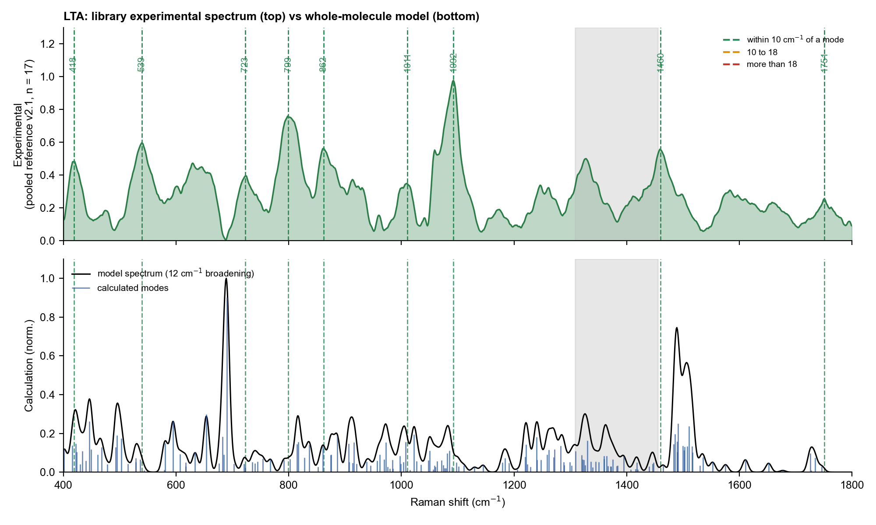
Figure 5. LTA. Top: library reference v2.1 (17 spots), dashed lines mark the nine primary and supporting bands (green: nearest calculated mode within 10 cm-1). Bottom: whole-molecule model, calculated modes (blue sticks, scaled 0.965) and broadened spectrum (black). The model's strongest mode, 690 cm-1, falls where the measured spectrum has a minimum.
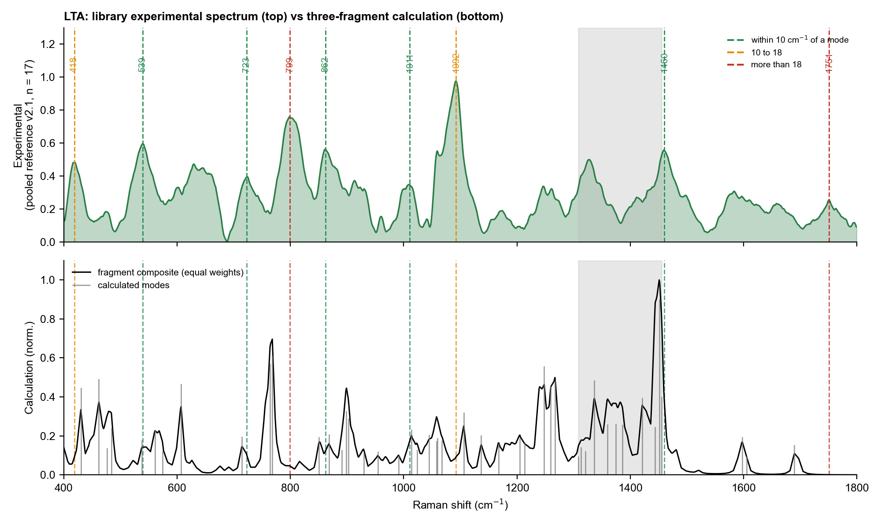
Figure 6. LTA, fragment calculation against the same v2.1 reference: broadened DFT curves of the three fragments (scaled 0.96) and their equal-weight average.

6.2 Band-by-band
Exp. band (cm-1) | Class | Model: nearest mode | Exp - calc | Rel. activity | Fragments: nearest mode | Exp - calc | Rel. activity (fragment)
418.4 | Supporting | 415.5 | +2.9 | 0.15 | 430.1 | -11.7 | 0.26
539.3 | Primary | 536.4 | +2.9 | 0.07 | 537.6 | +1.7 | 0.10
722.6 | Supporting | 722.5 | +0.1 | 0.04 | 714.2 | +8.4 | 0.11
799.1 | Supporting | 802.4 | -3.3 | 0.08 | 768.0 | +31.1 | 0.35
861.9 | Primary | 860.7 | +1.2 | 0.15 | 867.8 | -5.9 | 0.12
1010.6 | Supporting | 1009.6 | +1.0 | 0.01 | 1013.8 | -3.2 | 0.13
1092.0 | Primary | 1089.5 | +2.5 | 0.03 | 1105.9 | -13.9 | 0.18
1460.1 | Supporting | 1464.4 | -4.3 | 0.04 | 1455.4 | +4.7 | 0.23
1750.8 | Supporting | 1746.3 | +4.5 | 0.03 | 1689.6 | +61.2 | 0.09

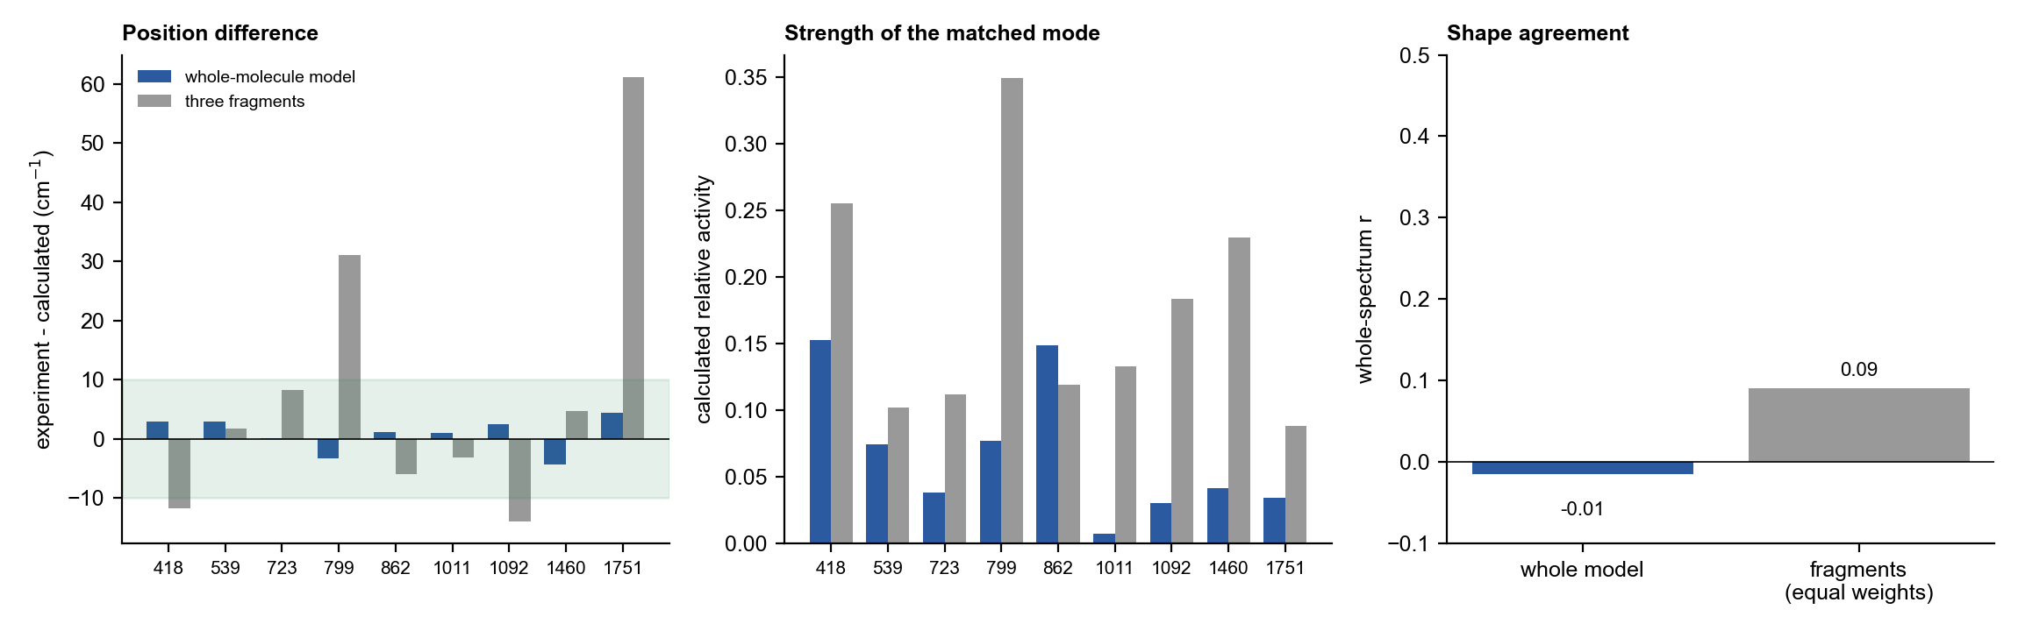
Figure 7. LTA: whole-molecule model against the three fragments. Left: difference between each library band and the nearest calculated mode. Middle: relative activity of that mode. Right: whole-spectrum correlation with the reference.

6.3 What is happening and why
- Positions. Every library band has a model mode within 4.5 cm-1, including the two that the fragments missed by more than 30 cm-1 (799 cm-1 against 768; 1751 cm-1 against 1690) and the 1092 cm-1 primary band (model 1089.5; nearest fragment peak 14 cm-1 away). Part of the reason is that the model contains the phosphodiester and ester links. Part is density: the model has 165 modes in the window, so a mode is rarely more than a few cm-1 from any band.
- Intensities. The 1092 cm-1 band is the strongest measured band (SNR 30), but the model mode near it has a relative activity of only 0.03; the strong measured 799 and 1010 cm-1 bands match activities of 0.08 and 0.01. The model's strongest modes are 690 cm-1 (1.00), 654, 594, 446 and a group at 1490-1510 cm-1 (0.2 to 0.3). The measured spectrum has no band at 690 (a minimum) and only weak features at 1583 and 1459 cm-1. The 1490-1510 group is probably NH3+ and amide motion exaggerated by the small basis set and the lack of water; this was not checked against the displacement vectors.
- Shape. The correlation is zero (-0.01) for the model and 0.09 for the fragments, so neither reproduces the measured pattern. Adding the model to the fragments in the NNLS fit does not improve the fit (r 0.08).
- The 5 cm-1 result is therefore a modest finding: positions are consistent with a phosphate-ester, glycerol and D-alanine/GlcNAc model, which supports tentative assignments, but the modes are not the ones that dominate the measured spectrum and the 10 and 18 cm-1 tests are within chance.

6.4 Likely reasons for the differences
- Model, not polymer. Three repeating units instead of about 23, no glycolipid anchor; chain-end effects are exaggerated and repeat-unit bands are under-represented. Glycerol stereochemistry of the two outer arms was set equal and not checked against the S. aureus form.
- Low-level theory. B3LYP/3-21G has no polarisation or diffuse functions and is poor for charged phosphate and ammonium groups; the 0.965 scale factor was not fitted for it. Peaks near 2410, 2510 and 2700-2800 cm-1 are probably artefacts of intramolecular NH3+...phosphate hydrogen bonds (outside the window used here).
- Gas phase, one conformer, no counter-ions. The powder contains Na+, Mg2+ or Ca2+ and probably water; the experimental bands are broad and sit on a fluorescence background.
- Experiment. The reference is better than the April one (17 spots, clean darks), but the primary-band heights vary by about 26-35 % between spots, and normalisation to the maximum compresses the weaker bands.

7. Is the agreement better than chance?
Any list of calculated modes will land close to some experimental bands. The question is whether the real DFT list does better than the same list moved by a meaningless amount. Figure 8 and the table below show that it does not for NAM, the LPS fragments, the LPS whole-molecule model or the LTA fragments. The LTA whole-molecule model is the exception at the strict 5 cm-1 tolerance only.
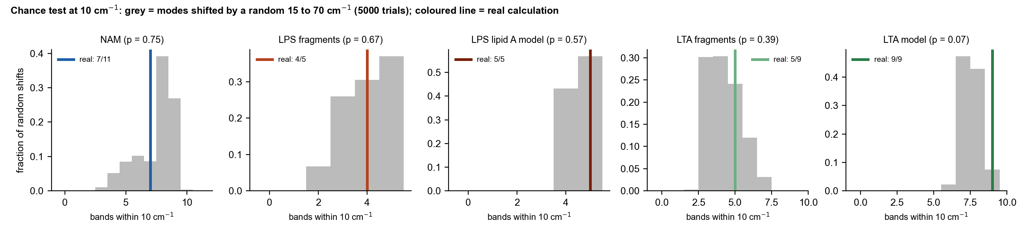
Figure 8. Grey: number of experimental bands within 10 cm-1 of a calculated mode after random shifts of the modes. Coloured line: real calculation. All five calculations are shown (LTA tested against reference v2.1).
Molecule | Tolerance (cm-1) | Real DFT matches | Random-shift matches (mean +/- SD) | p (real is as good by chance) | Using only strong modes (activity 0.15 or more)
NAM | 5 | 5 of 11 | 4.4 +/- 1.6 | 0.55 | 5 of 11 (chance 3.2, p = 0.19)
NAM | 10 | 7 of 11 | 7.5 +/- 1.5 | 0.75 | 7 of 11 (chance 6.2, p = 0.47)
NAM | 18 | 8 of 11 | 9.4 +/- 0.7 | 1.00 | 8 of 11 (chance 8.5, p = 0.98)
LPS (5 fragments) | 5 | 4 of 5 | 3.1 +/- 1.1 | 0.32 | 1 of 5 (chance 1.3, p = 0.84)
LPS (5 fragments) | 10 | 4 of 5 | 4.0 +/- 0.9 | 0.68 | 3 of 5 (chance 2.2, p = 0.34)
LPS (5 fragments) | 18 | 5 of 5 | 4.6 +/- 0.6 | 0.67 | 4 of 5 (chance 2.9, p = 0.38)
LPS (whole model) | 5 | 5 of 5 | 4.4 +/- 0.6 | 0.47 | 4 of 5 (chance 3.6, p = 0.61)
LPS (whole model) | 10 | 5 of 5 | 4.6 +/- 0.5 | 0.57 | 5 of 5 (chance 4.3, p = 0.30)
LPS (whole model) | 18 | 5 of 5 | 4.7 +/- 0.5 | 0.66 | 5 of 5 (chance 4.5, p = 0.49)
LTA (3 fragments) | 5 | 3 of 9 | 2.5 +/- 1.1 | 0.46 | 1 of 9 (p = 0.45)
LTA (3 fragments) | 10 | 5 of 9 | 4.3 +/- 1.1 | 0.40 | 1 of 9 (p = 0.77)
LTA (3 fragments) | 18 | 7 of 9 | 5.9 +/- 0.9 | 0.32 | 3 of 9 (p = 0.40)
LTA (whole model) | 5 | 9 of 9 | 6.1 +/- 1.0 | < 0.001 | 2 of 9 (p = 0.60)
LTA (whole model) | 10 | 9 of 9 | 7.5 +/- 0.7 | 0.07 | 2 of 9 (p = 0.82)
LTA (whole model) | 18 | 9 of 9 | 8.1 +/- 0.5 | 0.19 | 3 of 9 (p = 0.96)

Here p is the fraction of random shifts that did as well as or better than the real calculation. All p values are 0.19 or higher except the LTA whole-molecule model at 5 cm-1 (p < 0.001) and at 10 cm-1 (p = 0.07); using only the strong modes, no calculation is above chance. This is the main reason the agreement is described as not demonstrated rather than good, with the LTA model at 5 cm-1 as a limited exception.
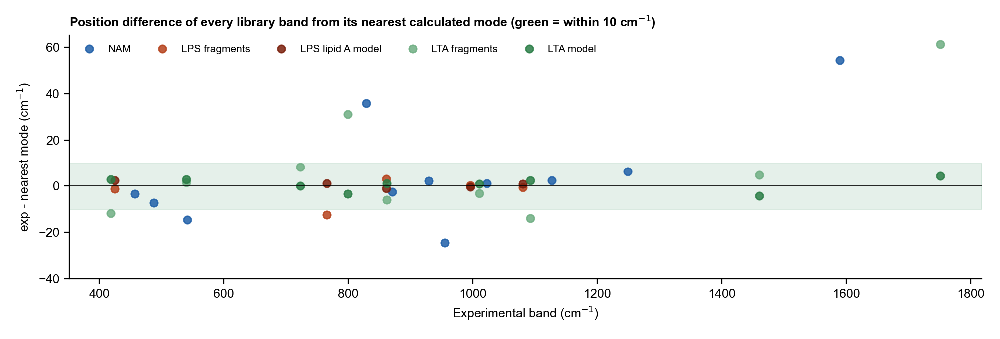
Figure 9. Difference between every library band and its nearest calculated mode, all five calculations. Points outside the green band (10 cm-1) are bands the calculation does not explain.

8. Overall conclusion
Question | NAM | LPS | LTA
Do individual band positions agree? | Yes for 7 of 11 bands within 10 cm-1; no for 829, 955, 1589 and 541 (near) | Yes: all 5 within 2.4 cm-1 (whole-molecule model); fragments: 4 of 5 within 5 cm-1, weak calculated activity | Yes: all 9 bands within 4.5 cm-1 (whole-molecule model); fragments: 5 of 9 within 10 cm-1, 1092 and 1751 off by 14 and 61 cm-1
Is that better than chance? | No (p = 0.75) | No (p = 0.57 whole model; p = 0.68 fragments) | Whole model: yes at 5 cm-1 (p < 0.001), no at 10 and 18 cm-1 (p = 0.07, 0.19); fragments: no (p = 0.40)
Does the overall spectral shape agree? | No (r = 0.12) | No (whole model r = -0.01; fragments 0.14, fitted 0.40) | No (whole model r = -0.01; fragments 0.09, fitted 0.11)
Are the strongest experimental bands explained? | Partly: 870, 929, 1023 yes; 829, 955 no | Partly: the model has modes of moderate strength at 422 and 862 for the 425 and 861 bands, but its strongest mode (1516) is weak in the experiment; 425 is not assigned to a group | Positions of 1092, 799, 862 and 539 are matched, but by weak modes (activity 0.01 to 0.15); the strongest model modes (690, 1490-1510) are not seen in the measurement
What can be claimed? | Tentative assignment of 870, 929, 1023, 1127, 1249, 457, 487 as sugar-ring modes (consistent with) | Position consistency with sugar, phosphate and amide modes of lipid A; no firm assignment gained; 425 cm-1 stays unassigned | Position consistency with a phosphodiester / glycerol / D-alanine / GlcNAc model supports the existing tentative assignments (1092 phosphate PO2-, 862 and 799 glycerol-phosphate and sugar, 1459 CH2, 1751 ester C=O); no new assignment gained
Overall | PARTIAL agreement | POSITIONS AGREE, not above chance; shape not matched; not demonstrated | POSITIONS AGREE (above chance at 5 cm-1 only); intensities and shape not matched; not demonstrated

- The library bands are real and reproducible measurements. A mismatch with DFT does not make a band wrong; it means the simulation is too simple to explain it.
- DFT here is used as supporting evidence for "consistent with" statements. It must not be cited as confirming the identity of NAM, LPS or LTA.
- The identification of each molecule in this library rests on the reproducible fingerprint of the measured spectra, on literature where it exists, and on separation from the other two molecules and from glass (see the marker-explanation document).

8.1 What would make the comparison stronger
- NAM: calculate the alpha anomer together with beta and combine them by Boltzmann weight; model a dimer or small cluster to capture hydrogen bonding; test the carboxylate (ionised) form.
- LPS: the shortened Kdo2-lipid A is a first whole-molecule result. Next steps: rerun at B3LYP/6-31G(d) or B3LYP/6-31+G(d,p) with water (planned, days of run time), starting from the optimised geometry; keep longer acyl chains and add the core sugars beyond Kdo; add Na+ or Ca2+ counter-ions; look at which atoms move in the 422 and 862 cm-1 modes; and check the 1516 cm-1 mode against a larger basis set.
- LTA: the three-unit model is a first whole-molecule result at a quick level. Next steps: finish the B3LYP/6-31+G(d,p) water (PCM) run that was started on 28 Oct; add counter-ions, a longer chain (4-5 units) and the Glc2-diacylglycerol anchor; check the glycerol stereochemistry; look at the atoms that move in the 1089, 862 and 802 cm-1 modes and in the strong 690 cm-1 mode, which the measurement does not show.
- All: report the same chance test with any new calculation, and the LTA comparison now uses the v2.1 reference (17 spots).
- Calibration of the frequency scale can matter: the instrument silicon band reads about 517.8 cm-1 on the substrate project (offset of 2 to 3 cm-1), which is smaller than the discrepancies discussed here and does not change the conclusions.

9. Sources and traceability
Item | File used
NAM modes (111, scaled, with activity and mode character) | mtp\05_Experimental_Data\NAM\NAM_Raman_Archive\02_DFT_Calculation\NAM_calculated_modes_all_111.csv
NAM simulated spectrum | mtp\05_Experimental_Data\NAM\NAM_Raman_Archive\03_Processed_Results\DFT_simulated_spectrum.csv
NAM alpha-anomer test | mtp\05_Experimental_Data\NAM\NAM_Raman_Archive\02_DFT_Calculation\ALPHA_ANOMER_RESULT.md
LPS fragment modes (scaled 0.9613) | mtp\05_Experimental_Data\LPS\lps research\reanalysis_2026-08-30\dft_candidates_all.csv; summary in LPS_DFT_Reference_Bands.docx
LTA fragment curves (scaled 0.96) and settings | mtp\06_Simulation_DFT\LTA-simulation-main\06_Simulation_DFT\LTA-simulation-main\LTA_combined_data.csv; mtp\10_Working_Archive\20-04\Computational Simulation Settings Used for Lipoteichoic Acid.docx
Experimental references and markers | SERS_Sepsis_Spectral_Library\03_Reference_Spectra\{NAM,LPS,LTA}
Code | SERS_Sepsis_Spectral_Library\08_Methodology\code\dft_compare_1.py and dft_compare_2.py
LPS whole-molecule model (lipid A, 354 modes in range) | SERS_Sepsis_Spectral_Library\08_Methodology\simulation\LPS_LipidA_Model_20261028 (copy of C:\Users\sukes\Downloads\sukesh\lps output simulation): lipidA_raman_act.csv, lipidA_short.gjf, lipidA_short.out (Gaussian log), Lipid_A_Raman_Methods.md
Whole-molecule comparison results and code | 05_Tables\LipidA_vs_LPS_results.json; 08_Methodology\code\lipidA_compare.py, lipidA_figures.py, update_docs_lipidA.py; figures in 04_Figures\LipidA_Model_20261028
LTA whole-molecule model (165 modes in range) | SERS_Sepsis_Spectral_Library\08_Methodology\simulation\LTA_Model_20261028 (copy of C:\Users\sukes\Downloads\sukesh\simulation\lta output simulation): lta_model_raman_act.csv, lta_model.gjf, lta_model.out (Gaussian log), LTA_Raman_Methods.md, LTA_Raman_Full_Report.docx
LTA reference used | 03_Reference_Spectra\LTA\LTA_Bulk_Reference_20261028_Pooled_Mean_SD.csv and LTA_Reference_20261028_Pooled_Marker_Peaks.csv (v2.1, n = 17)
LTA comparison results and code | 05_Tables\LTAmodel_vs_LTA_results.json; 08_Methodology\code\lta_model_compare.py, lta_figures.py, update_docs_lta.py; figures in 04_Figures\LTA_Model_20261028

10. Limitations
- LPS fragment and LTA calculated modes were taken from the exported files as supplied. The Gaussian logs for the five LPS fragments and for D-alanine and GlcNAc were not found, so their charge states and atom counts are Not recorded; the levels of theory are as documented. The LPS whole-molecule model has its full Gaussian log. Full simulation details are in Simulation_Methods_and_Spectra_NAM_LPS_LTA.docx.
- LTA fragment peaks were picked from broadened curves (prominence 0.04), so weak modes may be missed; the whole-molecule model has a full mode list.
- Only primary and supporting library bands were tested (NAM 11, LPS 5, LTA 9). Small numbers limit the statistics; the chance test is a baseline, not a formal proof.
- The LPS whole-molecule model is a shortened piece of lipid A at a low level (B3LYP/3-21G, gas phase). Its strong 1516 cm-1 mode is not verified, and the motions behind the 422 and 862 cm-1 modes were not analysed.
- The LTA comparison in Section 6 uses the pooled v2.1 reference of 28 Oct 2026 (17 spots, pending operator confirmation). The LTA whole-molecule model is a three-unit, gas-phase B3LYP/3-21G calculation; its band assignments were not checked against displacement vectors, the glycerol stereochemistry was not verified, and the scale factor 0.965 was not fitted for this basis set. The 5 cm-1 chance test depends on random shifts of 15 to 70 cm-1 and on the high mode density.
- An agreement between a calculated mode and a band shows consistency only and does not prove identity.

