Experimental Bulk Raman Spectra versus DFT Simulation: NAM, LPS and LTA
Do the simulations match the measured library spectra, what is happening, and why or why not
SERS Sepsis project, bulk-powder Raman spectral library. Version 1.1, 27 October 2026 (v1.1 corrects the LPS basis set and the LTA fragment charge state). Experimental data: library v3.3 reference spectra (glass slide, 785 nm). Simulation data: DFT files held in C:\Users\sukes\Downloads\mtp (listed in Section 9).
Short answer. The simulations agree with experiment in POSITION for many individual bands, and the best agreement is for NAM, where a full-molecule calculation exists. But the agreement is NOT better than what random chance gives, and the overall spectral shapes do not match (correlation about 0.1 for all three molecules). So the DFT results can support tentative assignments of individual bands ("consistent with"), but they cannot be used to confirm identity, and they do not explain several of the strongest experimental bands (NAM 829 and 955 cm-1, LPS 425 cm-1 intensity, LTA 802 cm-1).

1. Result at a glance
Molecule | What was simulated | Bands tested | Bands matched within 5 / 10 / 18 cm-1 | Mean abs. error (cm-1) | Matches expected by chance at 10 cm-1 (p) | Whole-spectrum r | Overall agreement
NAM | Whole molecule, beta anomer, gas phase (Gaussian 16) | 11 | 5 / 7 / 8 | 14.1 | 7.5 (p = 0.75) | 0.12 | Partial
LPS | Five separate fragments, not whole LPS | 5 | 4 / 4 / 5 | 3.5 | 4.0 (p = 0.68) | 0.14 | Weak
LTA | Three separate fragments, not whole LTA | 4 | 1 / 2 / 3 | 14.5 | 2.1 (p = 0.71) | 0.11 | Weak

How to read the table: "Bands tested" are the primary and supporting bands of the library reference that lie outside the glass zone. "Matched" means the nearest calculated mode is within the stated distance. The chance column shows how many bands would be matched on average if the calculated modes were shifted by a random amount; a real match should clearly beat that number (p well below 0.05). It does not for any molecule. Whole-spectrum r compares the simulated spectrum shape with the experimental reference over 400-1800 cm-1 with the glass zone (1308-1455 cm-1) excluded.

2. What was simulated
DFT (density functional theory) computes the vibrational frequencies and Raman activities of a molecule from its electronic structure. The result is a list of "modes": each has a frequency and a Raman activity (how strongly it should scatter). A simulated spectrum is built by drawing each mode as a broadened peak. All three simulations are of the isolated molecule or fragment, not of the powder on the glass slide.
Item | NAM | LPS | LTA
What was calculated | Whole NAM molecule (C11H19NO8, 39 atoms), beta anomer only | Five fragments: KDO, D-glucosamine, heptose, myristic acid, phosphoric acid | Three fragments: glycerol-phosphate (two units, charge -2), D-alanine, N-acetyl-D-glucosamine
Why fragments | Not needed (small enough) | LPS is far too large for a full calculation | LTA is a polymer with variable substitution
Method | Gaussian 16, B3LYP-D3BJ, 6-311++G(d,p), tight optimisation, no imaginary frequencies | B3LYP/6-31G(d), opt freq=raman scf=tight integral=ultrafine (LPS documentation) | Gaussian 16, B3LYP/6-31G(d), SMD water, opt + freq=raman
Environment | Gas phase | Gas phase (no solvent keyword in the documented route) | Implicit water (SMD)
Frequency scaling | 0.980 below 1800 cm-1, 0.967 above | 0.9613 | 0.96 (0.96-0.97 range evaluated)
Modes in 400-1800 cm-1 | 67 | 150 | 47 (peaks picked from broadened curves)
Modes per 100 cm-1 | 4.8 | 10.7 | 3.4
Experimental sample | Sigma A3007, lot BCCK5768 (anomeric mixture) | Sigma L2630, E. coli O111:B4 | LTA, 3 Apr 2026 (supplier Not recorded)

Why this matters: a calculation of a single small fragment can never reproduce a polymer. LPS has phosphorylated, acylated and branched sugars; LTA has a charged phosphodiester backbone. Fragments contain none of the linkages between units, so bands that come from those linkages cannot appear in the simulation.

3. How the comparison was made
- Experimental side: the library reference spectrum (mean of the spectra that passed QC) and its primary and supporting bands from 03_Reference_Spectra. Bands inside the glass zone are not used.
- Simulation side: calculated mode frequencies already scaled by the authors (see Section 2). Modes below 400 and above 1800 cm-1 are ignored.
- Band matching: each experimental band is paired with the nearest calculated mode. The difference is exp minus calc. Within 5 cm-1 is a tight match (about 3 detector pixels); within 10 cm-1 is a match; 10-18 cm-1 is "near"; beyond 18 cm-1 is no match.
- Chance test: because DFT gives many modes, some always fall near an experimental band. To measure this, all calculated modes are rigidly shifted by a random amount between 15 and 70 cm-1 (5000 trials) and the matching is repeated. A real agreement should beat this baseline.
- Whole-spectrum agreement: simulated modes are drawn as Gaussian peaks (12 cm-1 FWHM where the broadened curve was not supplied), normalised, and correlated with the experimental reference (Pearson r). A non-negative least-squares (NNLS) fit of the fragment spectra to the experimental one is also reported; it is optimistic because the weights are fitted.
- Intensity check: calculated activity is compared with experimental height for the matched bands (NAM only, because only NAM has a whole-molecule calculation).

4. NAM

4.1 Result
Of 11 library bands, 5 agree within 5 cm-1, 7 within 10 cm-1 and 8 within 18 cm-1. The mean absolute difference is 14.1 cm-1, pulled up by three bands (829, 955 and 1589 cm-1) with no nearby calculated mode. For the 8 bands within 18 cm-1 the mean difference is about 5 cm-1.
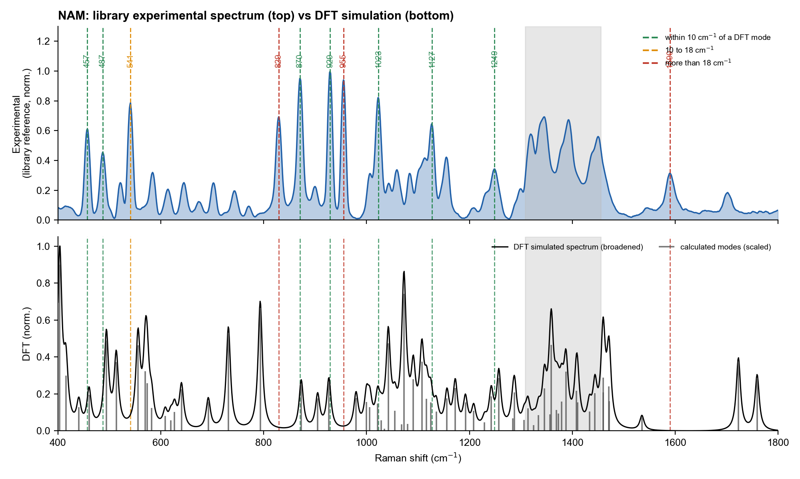
Figure 1. NAM. Top: library experimental reference. Bottom: DFT modes (grey sticks) and simulated spectrum (black). Dashed lines mark the experimental bands, coloured by how close the nearest DFT mode is.

4.2 Band-by-band
Exp. band (cm-1) | Class | Nearest DFT mode (cm-1) | Exp - calc (cm-1) | Calc. rel. activity | Mode type / fragment | Verdict | Why
541.0 | Primary | 555.6 | -14.6 | 0.52 | Skeletal bending / ring torsion | NEAR (10-18) | A skeletal-bending mode exists (556) but 15 cm-1 away; several skeletal modes lie at 556 and 570, so the pairing is ambiguous. Position shift is plausible for a hydrogen-bonded solid but this was not tested.
829.0 | Primary | 793.2 | +35.8 | 0.74 | Skeletal deformation + δ(C–C–O) | NO MATCH | Strong experimental band with NO calculated mode within 35 cm-1 (nearest 793, a skeletal deformation). Not explained by the beta-anomer model. The alpha-anomer calculation (11 Aug 2026) did not help (p = 0.46 against a random decoy). Unresolved.
870.5 | Primary | 873.0 | -2.5 | 0.28 | γ(CH₂) hydroxymethyl wagging | MATCH | Hydroxymethyl (CH2OH) wagging calculated at 873. Good agreement; consistent with the 872 assignment in the NAM archive.
929.0 | Primary | 926.7 | +2.3 | 0.29 | Ring breathing / ν(C–C–O) | MATCH | Ring breathing / C-C-O stretch calculated at 927. Good agreement. This is also the strongest experimental band.
955.0 | Primary | 979.5 | -24.5 | 0.20 | Ring breathing / ν(C–C–O) | NO MATCH | Nearest calculated mode is 979 (24 cm-1 away). Too far to call a match. The library literature note suggests a methyl rocking; no calculated mode supports it. Unresolved.
1022.7 | Primary | 1021.5 | +1.2 | 0.16 | ν(C–O) + δ(C–O–H) | MATCH | C-O stretch coupled with C-O-H bending calculated at 1021.5. Good agreement.
1127.0 | Primary | 1124.6 | +2.4 | 0.17 | ν(C–O) + δ(C–O–H) | MATCH | C-O stretch with C-O-H bending calculated at 1125. Good agreement.
457.0 | Supporting | 460.5 | -3.5 | 0.22 | Skeletal bending / ring torsion | MATCH | Low-frequency ring skeletal bending is reproduced. Consistent with a skeletal mode of the sugar ring.
487.0 | Supporting | 494.2 | -7.2 | 0.54 | Skeletal bending / ring torsion | MATCH | Skeletal bending/ring torsion mode within 7 cm-1. Consistent.
1248.7 | Supporting | 1242.3 | +6.4 | 0.21 | δ(C–H) + ν(C–O) coupled | MATCH | Coupled C-H bend and C-O stretch calculated at 1242. Consistent (6 cm-1).
1589.5 | Supporting | 1535.2 | +54.3 | 0.08 | Amide II: δ(N–H) + ν(C–N) | NO MATCH | Nearest calculated mode is the amide II-like mode at 1535, 54 cm-1 away and weak. Not a match; the experimental band is reproducible but its origin is not established.

4.3 What is happening and why
- Agreement where the chemistry is simple. The bands at 870.5, 929, 1022.7, 1127 and 1249 cm-1 sit within 1 to 6.5 cm-1 of calculated modes whose character is hydroxymethyl wagging, ring breathing and C-O/C-C stretching. These are the motions a pyranose sugar is expected to show, so the match is chemically sensible. This supports (not proves) the tentative assignments in the marker-explanation document.
- Missing bands. 829 and 955 cm-1 are two of the strongest experimental bands, yet no calculated mode lies within 24 cm-1 of them. The calculated spectrum has its strong features near 400, 793 and 1070 cm-1 instead.
- Intensity disagreement. The strongest experimental bands (929, 870, 955, 1023) are weak to medium in the simulation (activity 0.16 to 0.29), while the strongest calculated modes (near 410, 793, 1070) are not the strongest experimental ones.
- Positional correlation reported earlier (r = 0.9996, 41 bands, 30 matched, MAE 9.3, RMSE 10.3 cm-1) measures how well the two lists of numbers line up along the same axis. Since both lists span the same 400-1800 range this is almost automatically very high, and it does not test whether the right modes pair with the right bands.
Intensity rank check on the 7 matched bands: Spearman rank correlation between experimental height and calculated activity = 0.07 (p = 0.88). A value near zero or negative means the strong calculated modes are not the strong experimental bands, so the match is in position only.

4.4 Likely reasons for the differences (not all tested)
- Gas phase versus solid. The calculation is an isolated molecule; the powder is a hydrogen-bonded solid. Hydroxyl, carboxylic acid and amide groups shift by tens of cm-1 on hydrogen bonding, which fits the misfit being worst for bands involving these groups (1589 amide II-like, 955, 829).
- Anomeric mixture. The reagent is an alpha/beta mixture but only beta was calculated. The alpha calculation (11 Aug 2026) did not fix the unmatched bands once tested against random decoys (p = 0.46), so this is not the whole explanation.
- Harmonic approximation and scaling. A single scale factor corrects frequencies on average but cannot fix individual modes; errors of 10 to 20 cm-1 are normal for B3LYP.
- Raman activity is not measured intensity. At 785 nm the observed intensity also depends on the frequency, the laser, optics and sample, and for a powder on the crystal packing. Relative intensities are therefore only a rough guide.
- Ionisation state. The carboxylic acid may be partly ionised in the powder, which would remove the 1720 cm-1 C=O mode of the calculation. A weak band near 1700 cm-1 is seen experimentally, consistent with a shifted C=O, but this was not tested.

5. LPS

5.1 Result
Of 5 library bands (2 primary, 3 supporting), 4 agree within 5 cm-1 and all 5 within 18 cm-1, with a mean absolute difference of 3.5 cm-1. This looks good but is misleading: the five fragments together contribute 150 modes in 400-1800 cm-1, about 11 per 100 cm-1, so a mode lies within a few cm-1 of almost any position. Randomly shifted modes give 3.1 of 5 within 5 cm-1, against 4 for the real calculation (p = 0.32).
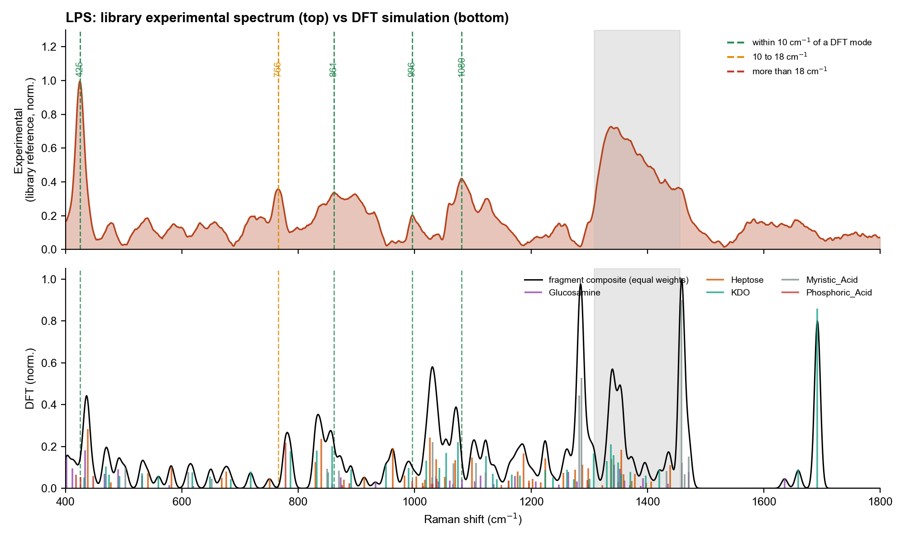
Figure 2. LPS. Top: library experimental reference (10 spectra). Bottom: scaled DFT modes of five fragments (coloured by fragment) and their equal-weight composite.

5.2 Band-by-band
Exp. band (cm-1) | Class | Nearest DFT mode (cm-1) | Exp - calc (cm-1) | Calc. rel. activity | Mode type / fragment | Verdict | Why
424.8 | Primary | 425.9 | -1.1 | 0.06 | Phosphoric acid | MATCH | A phosphoric-acid mode is calculated at 425.9, but its calculated activity is low (0.06 of the strongest mode) whereas 425 is the strongest experimental band. Glucosamine, heptose and KDO also have modes within 15 cm-1, so the position is not specific. Position-compatible, intensity-inconsistent.
765.5 | Supporting | 777.9 | -12.4 | 0.24 | Phosphoric acid | NEAR (10-18) | Phosphoric-acid mode at 777.9 (12 cm-1 away). Near, not a match; the band stays unassigned.
861.1 | Supporting | 858.1 | +3.0 | 0.02 | D-glucosamine | MATCH | Glucosamine mode at 858 (3 cm-1) but very weak in the calculation (0.02). Position agrees; intensity does not.
995.8 | Supporting | 995.5 | +0.3 | 0.04 | Phosphoric acid | MATCH | Phosphoric-acid mode at 995.5, weak (0.04). Position agrees, but the fragment is a small inorganic acid, not LPS phosphate.
1080.5 | Primary | 1081.1 | -0.6 | 0.05 | D-glucosamine | MATCH | Glucosamine mode at 1081, weak (0.05). Position agrees; the experimental band is broad and about 14 % glass-affected, so a 0.6 cm-1 agreement is not meaningful.

5.3 What is happening and why
- Positions can be paired but not trusted. Four of five bands fall within 5 cm-1 of a calculated mode, yet the calculated activity at those modes is low (0.02 to 0.06) while those bands are strong or primary in the experiment.
- The key LPS fingerprint, 425 cm-1, is the strongest experimental band and is not explained: the only calculated mode at that position (phosphoric acid, 425.9) is weak, and three other fragments also have modes within 15 cm-1. DFT therefore does not tell us what produces it.
- Whole-spectrum agreement is poor. An equal-weight composite correlates at r = 0.14. Even with fitted weights (glucosamine 45 %, phosphoric acid 39 %, others small) r reaches only 0.40 and R-squared is -0.38 (negative: worse than a flat line at the mean). An earlier reanalysis on older LPS data (30 Aug 2026) gave R-squared = 0.05 with 4 confident and 22 uncertain matches out of 43 peaks, which tells the same story.
- Fitted weights favour glucosamine and phosphoric acid over KDO and heptose, but because the fit itself is poor these weights should not be read as the composition of LPS.

5.4 Likely reasons for the differences
- Fragments, not LPS. No fragment contains the phosphate esters on lipid A, the acyl-chain ester linkages, or the glycosidic bonds that dominate real LPS. Phosphoric acid is a poor stand-in for a bound phosphomonoester.
- Dense mode list. With about 10 modes per 100 cm-1 a position match is not informative (Section 7).
- Different spectra compared. The previously published fragment calculations were done against an older LPS measurement (60 s, 20 %, 30 acc); this document uses the library reference (60 %, 40 s, 5 acc).
- Solid-state effects and harmonic error apply as for NAM. The fragments were calculated at B3LYP/6-31G(d), a smaller basis set than the 6-311++G(d,p) used for NAM.

6. LTA

6.1 Result
Of 4 library bands, 1 agree within 5 cm-1, 2 within 10 cm-1 and 3 within 18 cm-1; the mean absolute difference is 14.5 cm-1. The chance test gives 2.1 matches at 10 cm-1 for random shifts, so the result is indistinguishable from chance. Note that the library LTA reference has only 4 spectra and is preliminary, so this comparison is itself provisional.
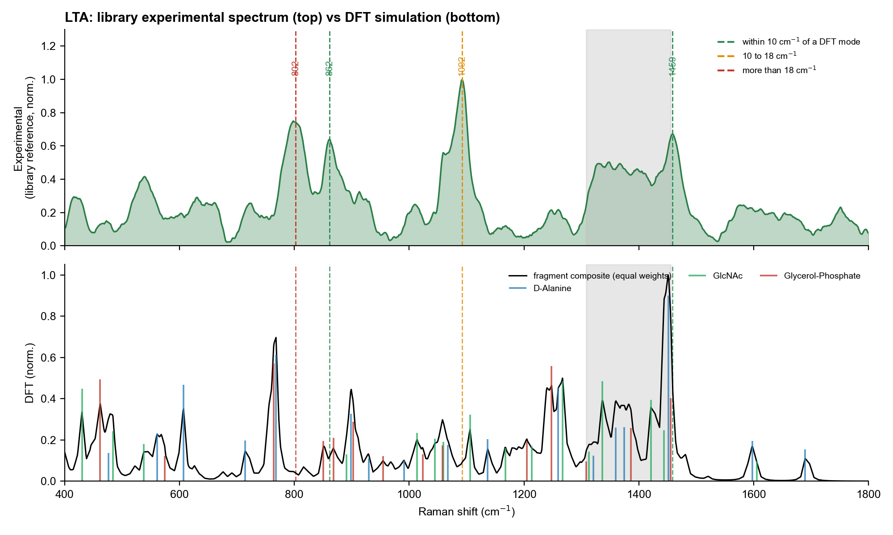
Figure 3. LTA. Top: library preliminary reference (4 spectra). Bottom: broadened DFT curves of the three fragments (scaled by 0.96) and their equal-weight average. Sticks mark the peaks found in the curves.

6.2 Band-by-band
Exp. band (cm-1) | Class | Nearest DFT mode (cm-1) | Exp - calc (cm-1) | Calc. rel. activity | Mode type / fragment | Verdict | Why
802.2 | Primary | 768.0 | +34.2 | 0.35 | D-alanine | NO MATCH | Nearest calculated peak is D-alanine at 768, 34 cm-1 away. The experimental band is broad (position SD 5 cm-1). No match.
861.5 | Primary | 867.8 | -6.3 | 0.12 | Glycerol-phosphate | MATCH | Glycerol-phosphate peak at 867.8 (6 cm-1). Consistent with the glycerol/phosphate region.
1091.8 | Primary | 1105.9 | -14.1 | 0.18 | N-acetyl-D-glucosamine | NEAR (10-18) | Nearest peak is GlcNAc at 1105.9 (14 cm-1). The expected phosphate PO2- stretch is not reproduced by the glycerol-phosphate fragment; the modelled phosphates are already ionised (charge -2, implicit water), so the miss is not simply an un-ionised-phosphate artefact.
1458.8 | Supporting | 1455.4 | +3.4 | 0.23 | Glycerol-phosphate | MATCH | Glycerol-phosphate CH2 bending peak at 1455 (3 cm-1). Consistent, but CH2 bending is non-specific.

6.3 What is happening and why
- The most important LTA marker, 1092 cm-1 (consistent with a phosphodiester PO2- stretch), is not reproduced by the glycerol-phosphate fragment; the nearest peak belongs to GlcNAc, 14 cm-1 away. The 802 cm-1 band has no calculated peak within 34 cm-1.
- Whole-spectrum agreement is poor: equal-weight average r = 0.11; with fitted weights (GlcNAc 50 %, D-alanine 25 %, glycerol-phosphate 25 %) r = 0.11 and R-squared = -0.69. The earlier fit on April data gave R-squared = -0.29 with a NaN branch unresolved, so the problem is not new.
- Only 47 peaks are available in 400-1800 cm-1 (about 3 per 100 cm-1) because they are read from broadened curves, so the chance baseline is lower than for NAM and LPS, yet the real result is still not better than chance.

6.4 Likely reasons for the differences
- Fragments, not the polymer. The glycerol-phosphate fragment is a two-unit dianion (charge -2) in implicit water, which is closer to LTA than a single neutral unit, but it still lacks the long chain, the D-alanine ester links and the counter-ions.
- Low-level theory. B3LYP/6-31G(d) is a small basis set and is known to be less reliable for phosphate and hydrogen-bonded groups than the 6-311++G(d,p) used for NAM.
- Implicit water. The calculation used water solvation (SMD) but the measurement is on dry powder.
- Reference quality. The experimental reference is 4 spectra with broad, variable bands (802: position SD 5 cm-1), so part of the disagreement may be measurement uncertainty. This is why the re-acquisition is needed before drawing conclusions.

7. Is the agreement better than chance?
Any list of calculated modes will land close to some experimental bands. The question is whether the real DFT list does better than the same list moved by a meaningless amount. Figure 4 shows that it does not, for any of the three molecules.
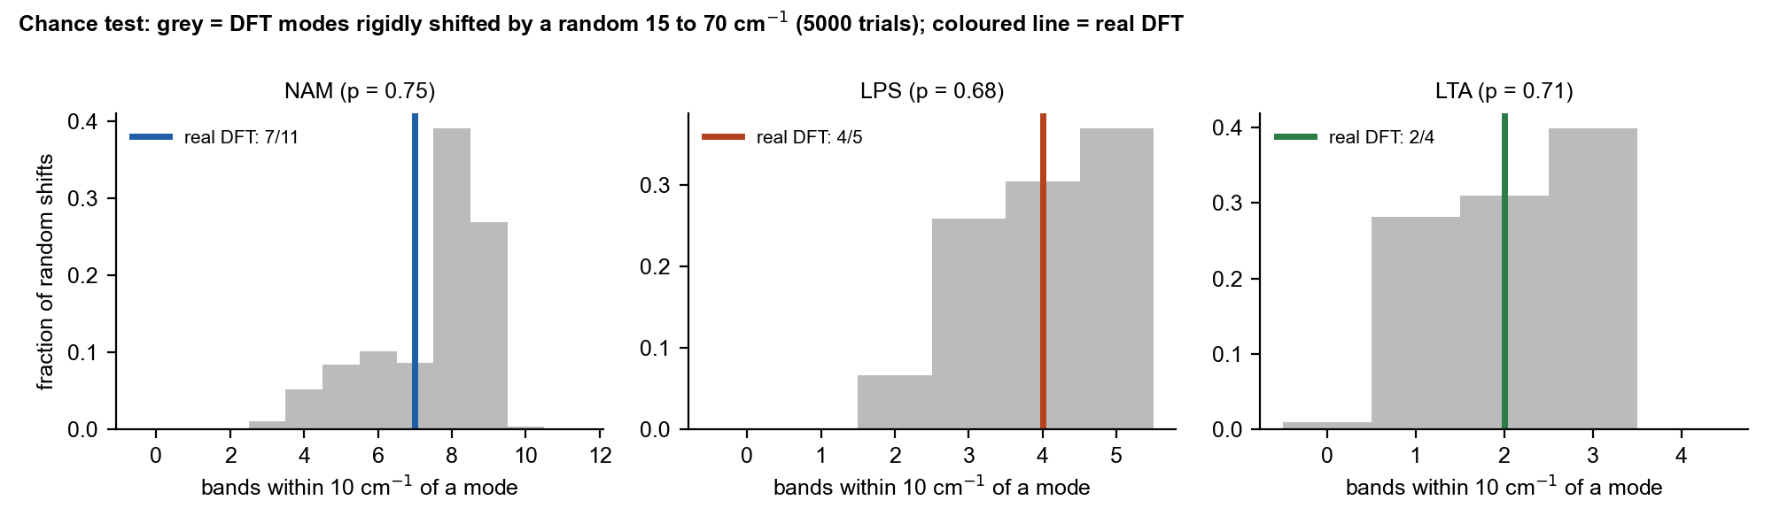
Figure 4. Grey: number of experimental bands within 10 cm-1 of a calculated mode after random shifts of the modes. Coloured line: real DFT.
Molecule | Tolerance (cm-1) | Real DFT matches | Random-shift matches (mean +/- SD) | p (real is as good by chance) | Using only strong modes (activity 0.15 or more)
NAM | 5 | 5 of 11 | 4.4 +/- 1.6 | 0.55 | 5 of 11 (chance 3.2, p = 0.19)
NAM | 10 | 7 of 11 | 7.5 +/- 1.5 | 0.75 | 7 of 11 (chance 6.2, p = 0.47)
NAM | 18 | 8 of 11 | 9.4 +/- 0.7 | 1.00 | 8 of 11 (chance 8.5, p = 0.98)
LPS | 5 | 4 of 5 | 3.1 +/- 1.1 | 0.32 | 1 of 5 (chance 1.3, p = 0.84)
LPS | 10 | 4 of 5 | 4.0 +/- 0.9 | 0.68 | 3 of 5 (chance 2.2, p = 0.34)
LPS | 18 | 5 of 5 | 4.6 +/- 0.6 | 0.67 | 4 of 5 (chance 2.9, p = 0.38)
LTA | 5 | 1 of 4 | 1.2 +/- 0.9 | 0.79 | 1 of 4 (chance 0.4, p = 0.29)
LTA | 10 | 2 of 4 | 2.1 +/- 0.8 | 0.71 | 1 of 4 (chance 0.7, p = 0.53)
LTA | 18 | 3 of 4 | 2.8 +/- 0.6 | 0.73 | 2 of 4 (chance 1.3, p = 0.48)

Reading: p is the fraction of random shifts that did as well as or better than the real calculation. All p values are 0.19 or higher; none comes near 0.05. Restricting to strong modes does not change the conclusion. This is the main reason the match is described as "not demonstrated" rather than "good".
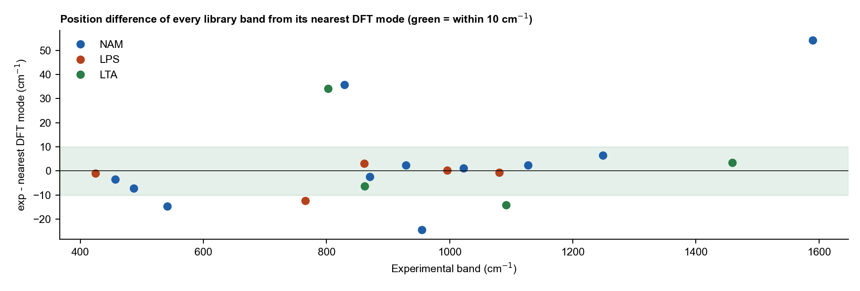
Figure 5. Difference between every library band and its nearest DFT mode. Points outside the green band (10 cm-1) are bands the calculation does not explain.

8. Overall conclusion
Question | NAM | LPS | LTA
Do individual band positions agree? | Yes for 7 of 11 bands within 10 cm-1; no for 829, 955, 1589 and 541 (near) | Yes within 5 cm-1 for 4 of 5, but with weak calculated activity | Partly: 861.5 and 1459 within 10 cm-1; 802 and 1092 not
Is that better than chance? | No (p = 0.75) | No (p = 0.68) | No (p = 0.71)
Does the overall spectral shape agree? | No (r = 0.12) | No (r = 0.14; fitted 0.40) | No (r = 0.11)
Are the strongest experimental bands explained? | Partly: 870, 929, 1023 yes; 829, 955 no | No: 425 not explained | Partly: 1092 and 802 not explained
What can be claimed? | Tentative assignment of 870, 929, 1023, 1127, 1249, 457, 487 as sugar-ring modes (consistent with) | Position consistency only; no assignment gained | Nothing beyond the existing tentative assignments
Overall | PARTIAL agreement | WEAK, not demonstrated | WEAK, not demonstrated; provisional

- The library bands are real and reproducible measurements. A mismatch with DFT does not make a band wrong; it means the simulation is too simple to explain it.
- DFT here is used as supporting evidence for "consistent with" statements. It must not be cited as confirming the identity of NAM, LPS or LTA.
- The identification of each molecule in this library rests on the reproducible fingerprint of the measured spectra, on literature where it exists, and on separation from the other two molecules and from glass (see the marker-explanation document).

8.1 What would make the comparison stronger
- NAM: calculate the alpha anomer together with beta and combine them by Boltzmann weight; model a dimer or small cluster to capture hydrogen bonding; test the carboxylate (ionised) form.
- LPS: use larger models that contain the real linkages (lipid A disaccharide with phosphates and acyl chains, a KDO-glucosamine linked unit) and record the basis set and phosphate protonation state.
- LTA: model a repeating glycerol-phosphate dimer or trimer with its counter-ion, with D-alanine attached as an ester; use the same larger basis set as NAM.
- All: report the same chance test with any new calculation, and compare against the new LTA reference once 12 to 15 spots are acquired.
- Calibration of the frequency scale can matter: the instrument silicon band reads about 517.8 cm-1 on the substrate project (offset of 2 to 3 cm-1), which is smaller than the discrepancies discussed here and does not change the conclusions.

9. Sources and traceability
Item | File used
NAM modes (111, scaled, with activity and mode character) | mtp\NAM_Raman_Archive\02_DFT_Calculation\NAM_calculated_modes_all_111.csv
NAM simulated spectrum | mtp\NAM_Raman_Archive\03_Processed_Results\DFT_simulated_spectrum.csv
NAM alpha-anomer test | mtp\NAM_Raman_Archive\02_DFT_Calculation\ALPHA_ANOMER_RESULT.md
LPS fragment modes (scaled 0.9613) | mtp\lps research\reanalysis_2026-08-30\dft_candidates_all.csv; summary in LPS_DFT_Reference_Bands.docx
LTA fragment curves (scaled 0.96) and settings | mtp\LTA-simulation-main\LTA-simulation-main\LTA_combined_data.csv; mtp\20-04\Computational Simulation Settings Used for Lipoteichoic Acid.docx
Experimental references and markers | SERS_Sepsis_Spectral_Library\03_Reference_Spectra\{NAM,LPS,LTA}
Code | SERS_Sepsis_Spectral_Library\08_Methodology\code\dft_compare_1.py and dft_compare_2.py

10. Limitations
- LPS and LTA calculated modes were taken from the exported files as supplied. The Gaussian logs for the five LPS fragments and for D-alanine and GlcNAc were not found, so their charge states and atom counts are Not recorded; the levels of theory are as documented. Full simulation details are in Simulation_Methods_and_Spectra_NAM_LPS_LTA.docx.
- LTA peaks were picked from broadened curves (prominence 0.04), so weak modes may be missed.
- Only primary and supporting library bands were tested (NAM 11, LPS 5, LTA 4). Small numbers limit the statistics; the chance test is a baseline, not a formal proof.
- Wording: all agreements are "consistent with"; none proves identity.

