LTA Bulk-Powder Raman Reference: Re-acquisition on Glass, 28 October 2026
Quality control, reference spectrum, bands, and the parameters that worked
SERS sepsis project, bulk-powder Raman spectral library. Version 1.0, 28 October 2026. Raw data: bulk-lta (28 spots and 8 blanks). Supersedes the preliminary reference of 3 April 2026 (4 spectra), which is kept unchanged.

1. Summary
The re-acquisition worked. Of 28 LTA spots measured at 80 % power, 45 s and 2 accumulations, 10 pass every quality-control check and form a new reference. The new mean spectrum matches the April reference (r = 0.95) and is clearly different from NAM (r = 0.17) and LPS (r = 0.50). The strongest band, 1092 cm-1, is present on every reference spot at a signal-to-noise ratio of about 29. Two points need attention before the next session: the eight blanks do not look like glass, and about one spot in three was lost to saturation or marginal ripple because the signal varies so much from spot to spot.
Item | Result
Condition | 785 nm, 80 % power, 45 s, 2 accumulations, bulk powder on a glass slide, shutter-closed dark
Spots measured | 28 (SP_9 to SP_36) plus 8 blanks; SP_1 to SP_8 of the spot folder are copies of the blanks
Quality control | PASS 10, REVIEW 8 (ripple 50 to 58), EXCLUDE 3 (atypical shape), FAIL 7 (5 saturated, 2 weak)
Reference v2 | Mean of 10 spots; mean and median agree (r = 0.993); mean of all 18 PASS and REVIEW spots gives r = 0.986
Primary bands | 1092 cm-1 (SNR 29), 539 cm-1 (SNR 16), 861 cm-1 (SNR 16)
Supporting bands | 419, 629, 723, 798, 1459, 1583 and 1751 cm-1; 1246 cm-1 (phosphate region) is seen on 7 of 10 spots
Identity | r to April LTA 0.95; to LPS 0.50; to NAM 0.17 (glass zone excluded)
Sample | Sigma-Aldrich L2515-10MG, lipoteichoic acid from Staphylococcus aureus, lot 0000419622, source number 0000404178
Not recorded | Purity (no figure on the supplier page found; lot certificate not obtained); objective

2. Sample and instrument
Item | Detail
Sample | Lipoteichoic acid from Staphylococcus aureus, Sigma-Aldrich L2515-10MG, lot 0000419622, source number 0000404178 (as given by the operator; the label reads bacterial cell wall polymer); powder placed directly on a glass slide. The same vial was used for the 3 Apr 2026 data (operator). The supplier product information sheet (L2515, sheet date 10/03, supplied by the operator) gives no purity figure and no physical form; the certificate of analysis for the lot has not been obtained, so purity is Not recorded. The supplier describes LTA as a linear polymer of phosphodiester-linked glycerol phosphate bound to a lipid, with the C2 position usually glycosylated and/or D-alanylated, and gives a water solubility of 5 mg/ml.
Instrument | B&W Tek i-Raman Plus, BWS465-785H, 785 nm; usable range ends at 2842 cm-1 (no C-H stretching region)
Laser power | 80 % (instrument setting, not converted to mW)
Time of measurement | 28 Oct 2026, 02:11 to 04:30 (instrument clock): blanks 02:11 to 02:25, spots from 02:29
Dark | Median dark 1504 to 1512 counts, in line with a shutter-closed dark (true dark about 1480 to 1525 counts)

3. Parameters used
Parameter | Setting
Laser wavelength / power | 785 nm / 80 %
Integration time / accumulations | 45 s / 2
Spots | 28 different spots on the powder (SP_9 to SP_36)
Blanks | 8 spectra at the same settings (see Section 5)
Processing | Pipeline v3: dark-subtracted signal; two defective detector pixels repaired; 400-1800 cm-1; despiking (MAD z > 6, width 2 pixels or less); Savitzky-Golay 11/3; ALS baseline (lambda 1e5, p 0.01, 10 iterations); noise = 1.4826 x MAD; min-max normalisation
QC limits | No saturation in 400-1800 cm-1; ripple 50 counts or less; SNR 10 or more; glass-dominated spots excluded (area ratio above 8); atypical-shape spots excluded (r to the core mean below 0.80)
Band classes | C1 primary (all spots, SNR 15 or more, glass share below 25 %, relative CV 30 % or less); C2 supporting (80 % of spots, SNR 5 or more); C3 glass; C4 uncertain
Glass zone | 1308-1455 cm-1, left out of all correlations

4. Findings

4.1 Quality control of the 28 spots
Class | Spots | Reason
PASS | S11, S21, S22, S23, S24, S26, S29, S30, S32, S34 | All checks met; used for the reference
REVIEW | S14, S15, S16, S28, S31, S33, S35, S36 | Ripple 50 to 58 counts (limit 50); the brightest spots (SNR 26 to 34); kept as a check set
EXCLUDE | S12, S13, S25 | Shape differs from the core (r to the core mean 0.48 to 0.76): off-powder or mixed spots
FAIL | S09, S10, S17, S18, S19, S20, S27 | S17-S20 and S27 saturated at 65,535 counts; S09 and S10 weak (SNR of the 1092 band 7 and 4)

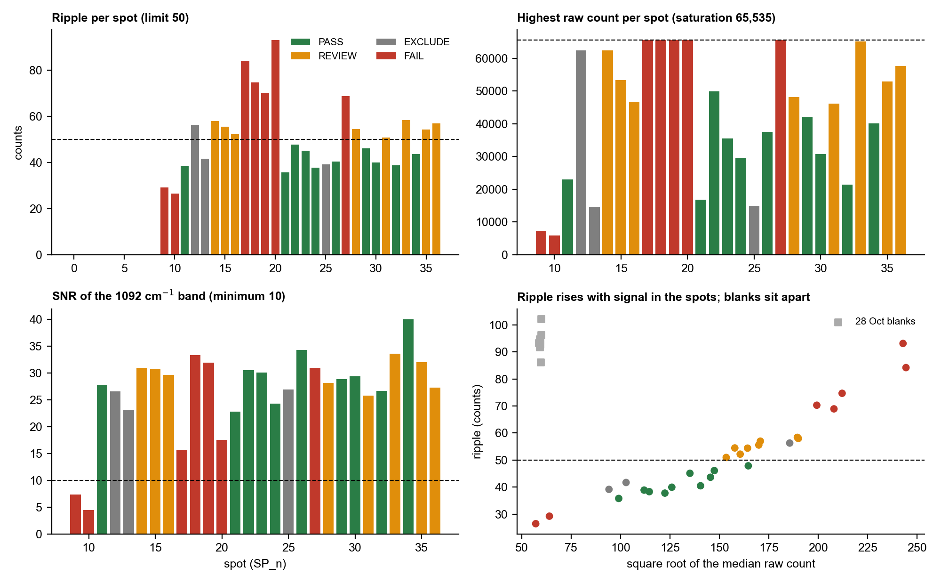
Figure 1. QC per spot: ripple, highest raw count, SNR of the 1092 cm-1 band, and ripple against signal. Green = PASS, orange = REVIEW, grey = EXCLUDE, red = FAIL.
The signal varies about 40 times between spots (highest raw count from 5,900 to 65,535), which is typical of powder focus and packing. The first spot (S09) satisfied the ripple check (29 counts) but was weak, so it did not count towards the reference. The ripple measured on the spots rises with the square root of the signal (r = 0.95 with the median raw count), so a spot that is very bright fails the ripple limit even though its signal-to-noise ratio is best. The glass-zone ratio of every spot is below 8 (highest 4.9).

4.2 Reference spectrum
The reference is the mean of 10 spots (S11, S21, S22, S23, S24, S26, S29, S30, S32, S34). Mean pairwise correlation between spots is 0.90 (lowest 0.72); the mean and median agree at r = 0.993; adding the eight REVIEW spots changes the mean very little (r = 0.986).
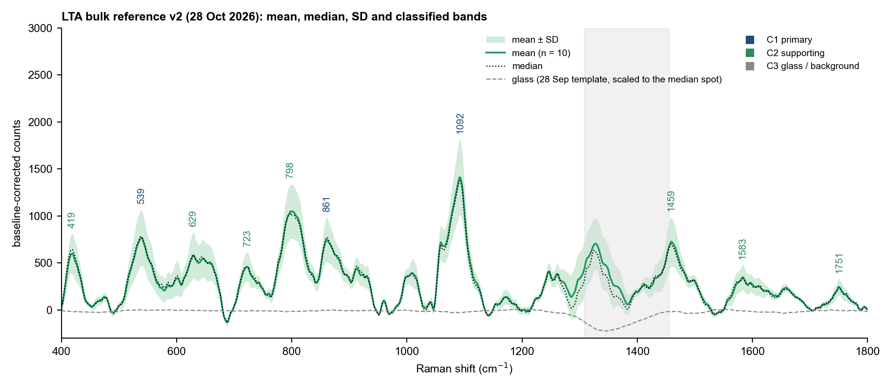
Figure 2. LTA reference v2: mean, median and SD of 10 spots with the classified bands. The dashed line is the glass shape from the 28 Sep blanks scaled to the median spot; the grey block is the glass zone.
Spot | Time | Highest raw count | Ripple | SNR 1092 | Glass ratio | r to core | r to April LTA
SP_11 | 02:36 | 22960 | 38 | 28 | 0.8 | 0.99 | 0.93
SP_21 | 03:13 | 16754 | 36 | 23 | 1.5 | 0.90 | 0.77
SP_22 | 03:43 | 49938 | 48 | 30 | 0.5 | 0.94 | 0.90
SP_23 | 03:47 | 35448 | 45 | 30 | 0.5 | 0.95 | 0.93
SP_24 | 03:49 | 29599 | 38 | 24 | 0.6 | 0.95 | 0.93
SP_26 | 03:54 | 37484 | 40 | 34 | 0.5 | 0.97 | 0.95
SP_29 | 04:09 | 41935 | 46 | 29 | 0.6 | 0.95 | 0.93
SP_30 | 04:12 | 30741 | 40 | 29 | 0.5 | 0.96 | 0.96
SP_32 | 04:19 | 21378 | 39 | 27 | 1.5 | 0.91 | 0.78
SP_34 | 04:26 | 40172 | 44 | 40 | 0.5 | 0.97 | 0.97

4.3 Bands
Band (cm-1) | Class | Found in | Position SD | SNR (median) | Height CV | Glass share (estimate)
418.7 | Supporting | 10/10 | 1.8 | 13 | 35 % | 0.7 %
539.2 | Primary | 10/10 | 1.2 | 16 | 38 % | 0.1 %
629.2 | Supporting | 8/10 | 1.0 | 13 | 42 % | 0.2 %
721.7 | Supporting | 10/10 | 1.9 | 10 | 34 % | 0.5 %
799.6 | Supporting | 9/10 | 2.1 | 22 | 27 % | 0.4 %
861.6 | Primary | 10/10 | 2.1 | 16 | 31 % | 0.2 %
1092.0 | Primary | 10/10 | 0.4 | 29 | 29 % | 0.5 %
1246.4 | Uncertain | 7/10 | 0.5 | 9 | 23 % | 1.2 %
1460.3 | Supporting | 9/10 | 2.1 | 15 | 36 % | 0.6 %
1583.2 | Supporting | 8/10 | 1.1 | 7 | 37 % | 0.7 %
1750.7 | Supporting | 9/10 | 0.7 | 5 | 35 % | 0.6 %

The three primary bands are present on all ten spots. The band at 1246 cm-1 lies in the 1225 to 1250 cm-1 phosphate region used in the project detection rule, and 1459 cm-1 is the lipid CH2 band, so the phosphate-plus-lipid combination (1092 with 1459, and 1246 on most spots) is present in the bulk powder. The glass share is a rough estimate: the 28 Sep glass shape was scaled to each spot on 1290 to 1520 cm-1; it is below 7 % at every band, so the glass slide contributes little under the powder.

4.4 Comparison with the preliminary April reference
April reference (cm-1) | 28 Oct reference (cm-1) | Comment
802.2 (SD 5) | 799.6 | Broad; moves by 3 cm-1, within the position tolerance
861.5 | 861.6 | Same
1091.8 | 1092.0 | Same
1458.8 | 1460.3 | Same within 2 cm-1
541.2 (uncertain) | 539.2 | Now reproducible on 10 of 10 spots; promoted to primary
1367 (glass, 1 of 4 spots) | 1328 (glass zone) | Glass feature in the glass zone; not used

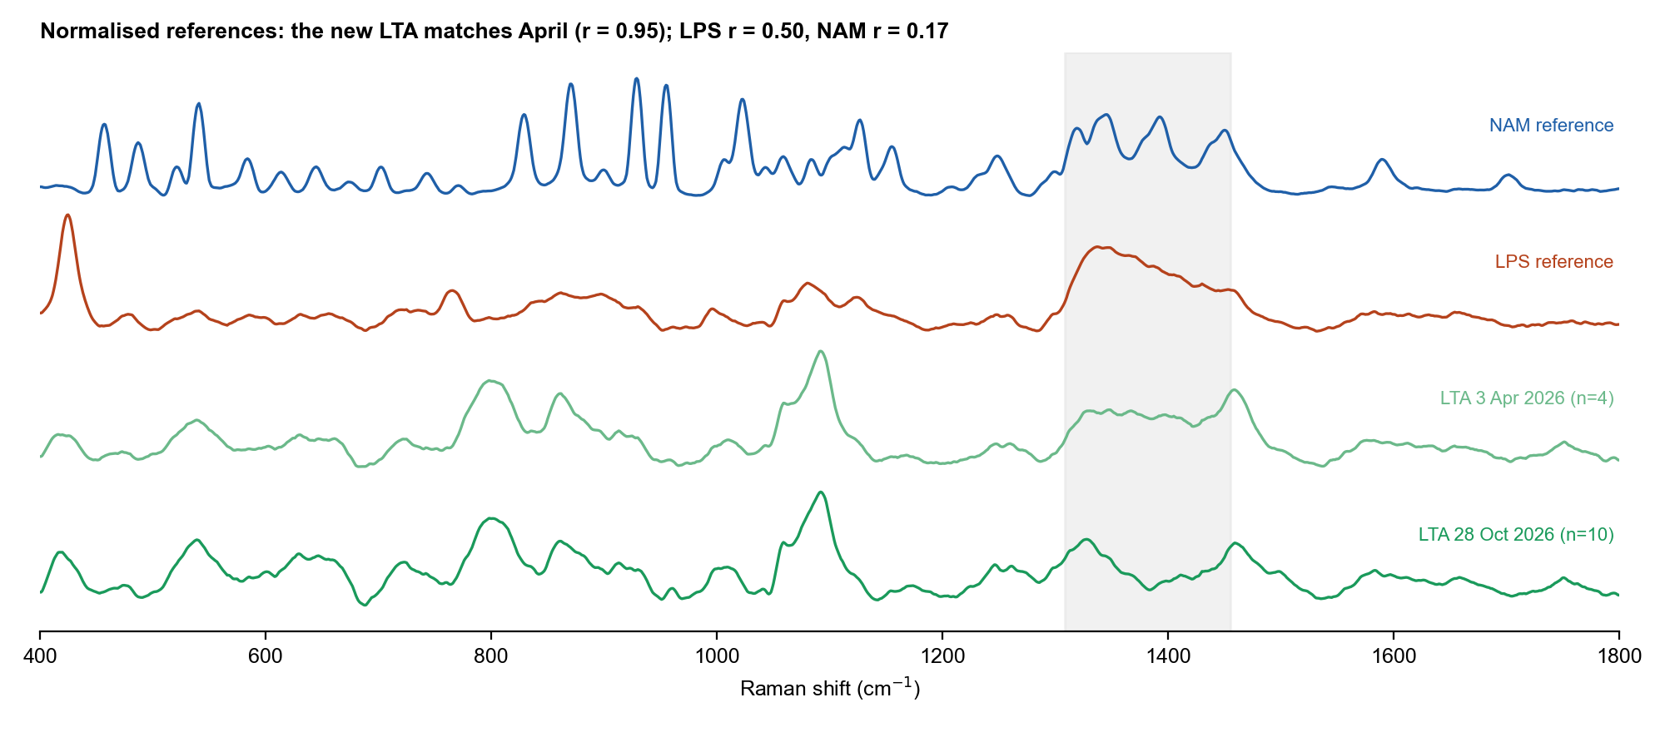
Figure 3. New LTA reference against the April LTA, LPS and NAM references (normalised). r to April = 0.95.

4.5 Tentative interpretation
Band (cm-1) | Consistent with | Basis
1092 | Symmetric stretch of the phosphodiester PO2- group of the glycerol-phosphate backbone | Group frequency 1090 to 1095 (Movasaghi 2007; Czamara 2015); FTIR of the related wall teichoic acid (Grunert 2018); supplier sheet: phosphodiester-linked glycerol phosphate backbone
1459 | CH2 bending of the acyl chains of the lipid anchor | Lipid group frequencies 1440 to 1460 (Czamara 2015); non-specific
861 | C-C / C-O-C modes of glycerol and sugar | Carbohydrate region 800 to 950 (Wiercigroch 2017)
798 | O-P-O stretching region | April proposal 813 (Movasaghi 2007); now found 13 cm-1 lower, so only region-level
539, 419, 723 | Skeletal ring and backbone deformations | Region only; no checked literature band
1246 | Phosphate asymmetric stretch / amide III region | Project detection rule (1225 to 1250 cm-1); tentative
1751 | Ester C=O region | Lipid ester group frequencies (Czamara 2015); supplier sheet: glycerol phosphate usually D-alanylated and/or glycosylated; tentative
629, 1583 | Unassigned; both also appear as sharp bands in the polystyrene-like blanks, so a contribution from the same contaminant should be checked | No checked source

5. The blanks
The eight blanks show sharp bands at 619, 1000, 1030, 1154, 1583 and 1602 cm-1, the strongest at 1000 cm-1 (SNR above 200), together with the broad glass band at about 1330 cm-1. Their correlation with the glass blanks of 28 September is only 0.07. The pattern is polystyrene-like; the project flagged a polystyrene-like set on 9 February 2026, but the two were not compared directly here. The blanks are therefore flagged as suspect and were not used for the glass estimate. They show that something other than clean glass was measured: possible sources are a plastic surface, a contaminated slide or residue on the slide. The LTA spots do not carry the strongest of these bands (the 1000 cm-1 band is 6 to 10 times the noise on the spots, not 200), so the reference is not dominated by it, but the point should be settled with a clean blank.
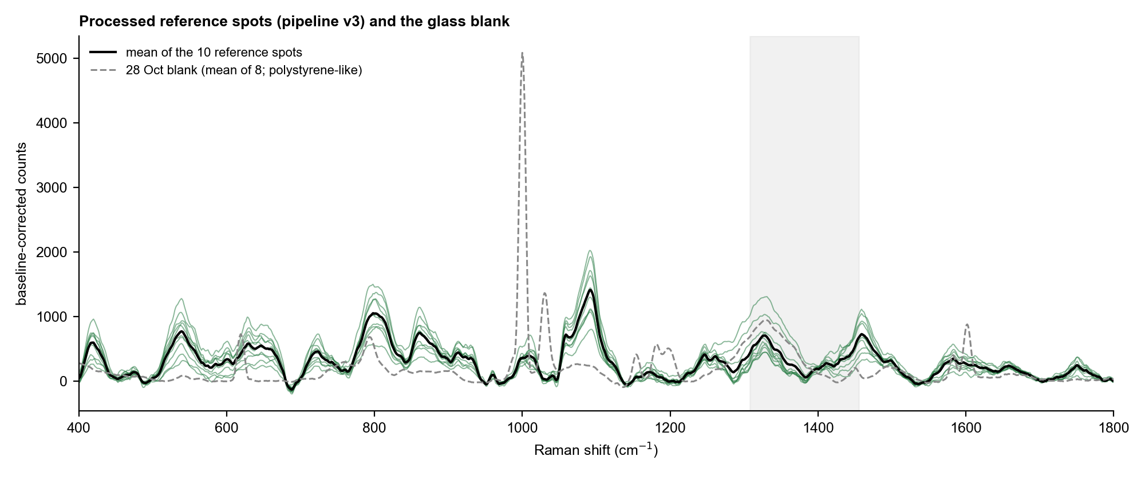
Figure 4. Baseline-corrected reference spots (green), their mean (black) and the mean of the 28 Oct blanks (dashed).

6. What to change in the next session
Issue | Evidence | Change
Blanks are not glass-like | Sharp bands at 1000 and 1030 cm-1 (SNR above 200); r = 0.07 to the 28 Sep glass blanks | Measure 3 blanks on the same clean glass slide used for the powder, away from the powder; clean the slide with the same solvent as before; note what the surface is
Saturation on bright spots | Spots S17-S20 and S27 reach 65,535 counts; S12, S14 and S33 reach 62,000 to 65,000 | Before the full 45 s spot, take a short test (5 s, 1 acc) and move on if its highest count is above about 6,000 (this predicts roughly 54,000 at 45 s, assuming counts scale with time); passing spots had 15,000 to 50,000
Ripple limit and bright spots | Ripple follows the square root of the signal; 8 bright spots fall at 50 to 58 counts | Keep 80 %, 45 s, 2 acc and the ripple limit of 50; pick spots in the middle signal range rather than lowering power (the project found ripple grows above about 70 %)
Weak first spots | S09 and S10 had SNR 7 and 4 | Focus on a thick part of the powder before starting; the first spot must still show ripple of 50 or less
Number of spots | 10 pass; the plan was 12 to 15 | Measure 5 more spots in the 15,000 to 50,000 count range to reach 15
Duplicate files | SP_1 to SP_8 of the spot folder are the blank files (identical) | Keep blanks and spots in separate folders and check the file count before copying
Sample record | Supplier, catalogue, lot and source number are now recorded; purity is not | Download the certificate of analysis for lot 0000419622 and record the purity; the April data came from the same vial
Dark | Dark 1504 to 1512 counts, consistent with a shutter-closed dark | No change; keep closing the shutter by hand at the start and end

7. Status and open points
- Status of the LTA reference: ESTABLISHED, pending your confirmation (n = 10, one session, one powder).
- The main library report should be updated to v3.4 with a new section for this LTA reference once you confirm.
- The glass estimate is exploratory; it should be repeated with a clean glass blank.
- A second session or lot would test whether 1092, 539 and 861 cm-1 are reproducible beyond one powder.

8. Files
Content | Location (SERS_Sepsis_Spectral_Library)
Copies of the raw files | 01_Raw_Data_Renamed/LTA_Bulk (LTA_Bulk_20261028_*) and Glass_Blank (Glass_Blank_20261028_*)
Processed spectra | 02_Processed_Spectra/LTA and Glass_Blank
Reference, members, marker peaks | 03_Reference_Spectra/LTA/*_20261028_* ; status in README_LTA_reference_status.txt
QC log and exclusions | 07_QC_and_Exclusions/LTA_Reference_Session_20261028_QC_Log.csv ; Excluded_and_Flagged_Spectra.csv
Figures | 04_Figures/LTA_Reference_20261028 (FigL1 to FigL5)
Workbook sheets | 05_Tables/Spectral_Library_Metadata_and_Peaks.xlsx, sheets 43 to 47
Code | 08_Methodology/code/lt1 to lt7
Original files | bulk-lta (unchanged)

