Experimental Bulk Raman Spectra of Lipoteichoic acid (LTA)
Reference spectrum of the bulk pure biomarker

1. Executive summary
Lipoteichoic acid (LTA) is a phosphate-and-glycerol polymer anchored in the membrane of Gram-positive bacteria, the Gram-positive counterpart of LPS. All 99 available LTA spectra, recorded at nine laser-power and integration settings, were examined. A reference spectrum was built from the 17 spectra of highest quality, all at 80 % of the maximum laser power. The strongest LTA peak is at 1092 cm⁻¹, with further main peaks at 539 and 862 cm⁻¹ and supporting peaks at 418, 723, 799, 1010, 1460 and 1751 cm⁻¹.
A strong band near 1367 cm⁻¹ and its neighbours (1308 to 1455 cm⁻¹) come from the glass slide, not from the molecule; this zone is shaded in all figures and is not used as evidence. The spectrum is distinct from the other two molecules (correlation with NAM: 0.18; with LPS: 0.50; 1.0 would mean identical).

2. Objective
To record a reliable, repeatable Raman spectrum of lipoteichoic acid (LTA) as a bulk pure biomarker, to identify its characteristic peaks, and to confirm that those peaks come from the molecule and not from the glass background of the measurement. This spectrum is the experimental reference for comparison with the molecular simulation and for later detection work.

3. Data and approach

3.1 What was measured
Sample: lipoteichoic acid from Staphylococcus aureus (Sigma-Aldrich L2515). The bulk pure biomarker was measured with a 785 nm Raman instrument (B&W Tek i-Raman Plus). Laser power is given as a percentage of the instrument maximum. Reference condition: 80 % of maximum laser power, 30 s with 3 accumulations or 45 s with 2 accumulations. Each file is one spectrum, averaged over its accumulations; the number of independent measurement spots is stated where it matters.

3.2 How the spectra were processed
Only steps that were actually applied are listed. Each is intended to make real peaks easier to see without changing their positions.
- Background subtraction: The instrument background (dark signal) was subtracted, and two defective detector pixels were repaired by interpolation.
- Spike removal: Narrow random spikes (for example cosmic rays) were removed.
- Smoothing: A Savitzky–Golay filter (window of 11 points) reduced random fluctuation while keeping peak shapes.
- Baseline correction: The slowly changing fluorescence-type background was estimated (asymmetric least-squares method) and subtracted, leaving only the peaks.
- Normalisation: Each spectrum was scaled to run from 0 to 1 so spectra of different overall brightness can be compared by shape. Normalised plots show shape only; heights in counts are used where stated.
The range 400 to 1800 cm⁻¹ was used. Correlations between spectra exclude the glass zone (1308 to 1455 cm⁻¹).

4. Results

4.1 The reference spectrum
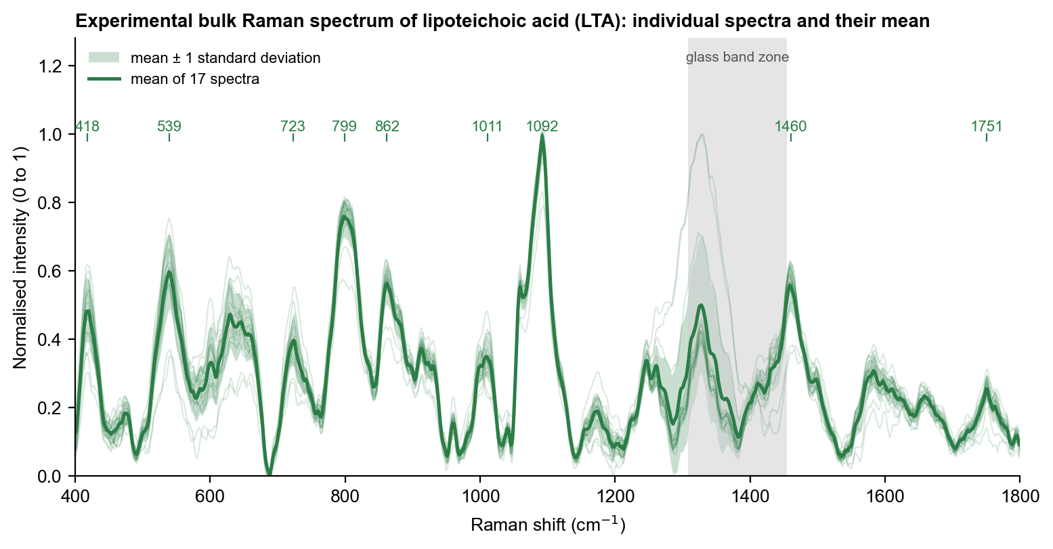
Figure 1. Raman spectra of bulk pure lipoteichoic acid (LTA). Thin lines: each of the 17 spectra; bold line: mean; shaded band: ± 1 standard deviation. Numbers mark the main and supporting peaks. Grey: glass-slide zone.
The individual spectra overlap closely, which shows that the pattern is a property of the material and not of one measurement spot. Peaks are broad, as expected for a polymer; heights vary by about 25 to 35 % between spots, but peak positions are stable (standard deviation about 1 to 2 cm⁻¹).

4.2 Effect of processing
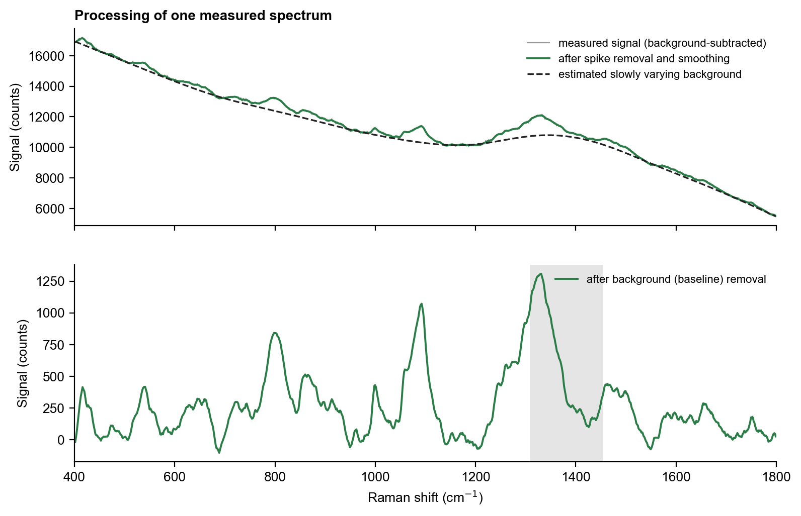
Figure 2. One measured spectrum before and after processing. Top: the measured signal (grey), the signal after spike removal and smoothing (colour) and the estimated background (dashed). Bottom: the final spectrum after the background is removed.
Smoothing lowers the random fluctuation, and baseline removal flattens the rising background so that peak heights can be read from zero. Peak positions do not change.

4.3 Main peaks
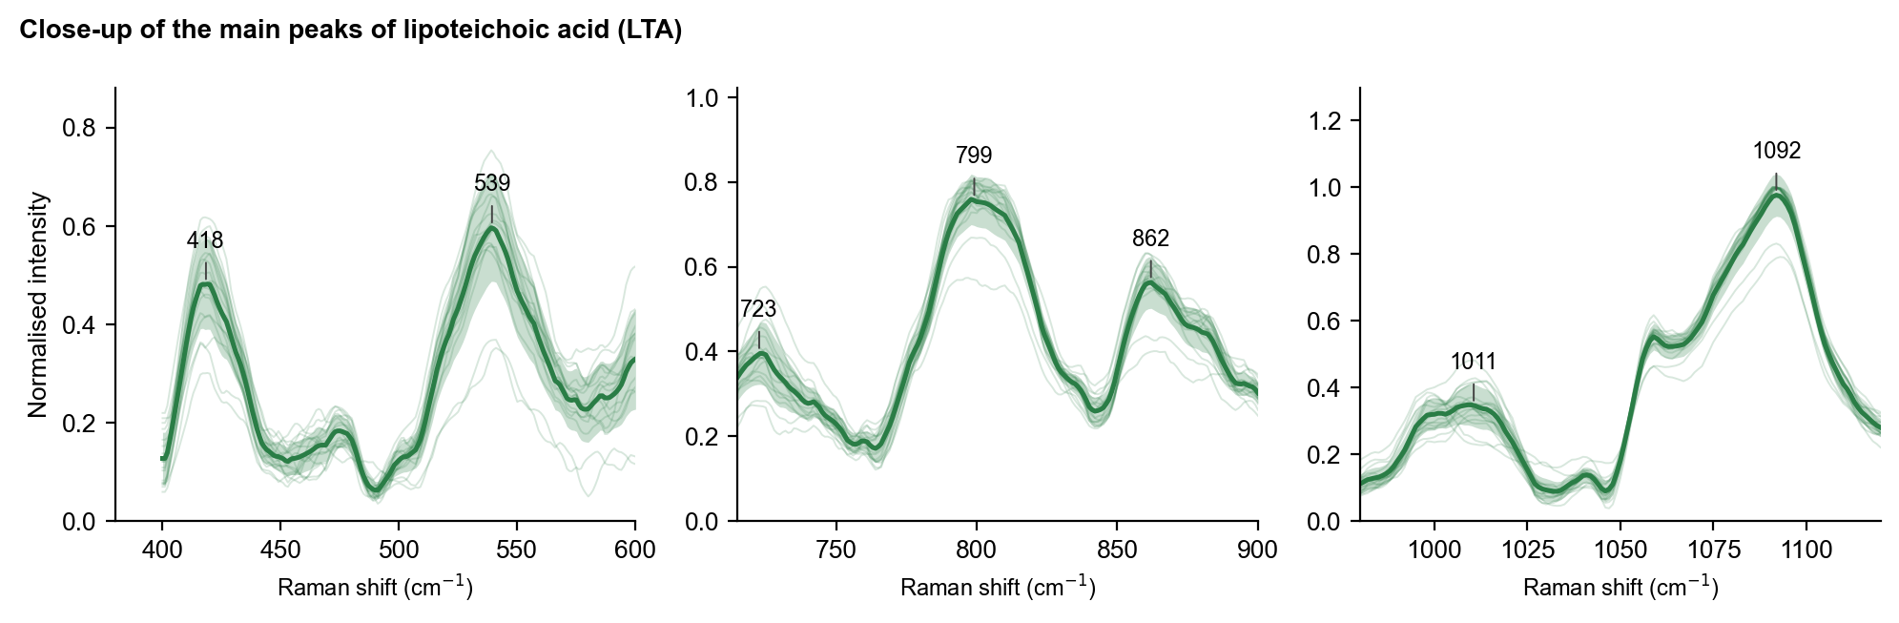
Figure 3. Close-ups of the main peaks. Thin lines: individual spectra; bold line: mean; band: ± 1 standard deviation. Numbers give the mean peak position.
Table 1. Peaks of the LTA reference spectrum (outside the glass zone). Assignments are tentative and based on general group frequencies of the molecular groups present.
Raman shift (cm⁻¹) | Peak role | Tentative assignment | Evidence from the measurements
418 ± 1.7 | supporting | low-frequency skeletal deformation (no firm assignment) | present in 17/17 spectra; signal-to-noise 13
539 ± 1.1 | main | skeletal / ring deformation | present in 17/17 spectra; signal-to-noise 17
723 ± 1.9 | supporting | C-O / C-C stretching (no firm assignment) | present in 17/17 spectra; signal-to-noise 10
799 ± 2.2 | supporting | O-P-O stretching of the phosphodiester (P-O-C ester stretching) | present in 16/17 spectra; signal-to-noise 22
862 ± 1.9 | main | C-C and C-O-C stretching of glycerol and sugar | present in 17/17 spectra; signal-to-noise 16
1011 ± 2.5 | supporting | C-O / C-C stretching | present in 14/17 spectra; signal-to-noise 9
1092 ± 0.5 | main | symmetric PO2- stretch of the phosphodiester backbone | present in 17/17 spectra; signal-to-noise 30
1460 ± 1.8 | supporting | CH2 / CH3 bending | present in 16/17 spectra; signal-to-noise 16
1751 ± 0.6 | supporting | ester C=O stretch (supported by the calculation only) | present in 16/17 spectra; signal-to-noise 6

4.4 Comparison with the glass slide
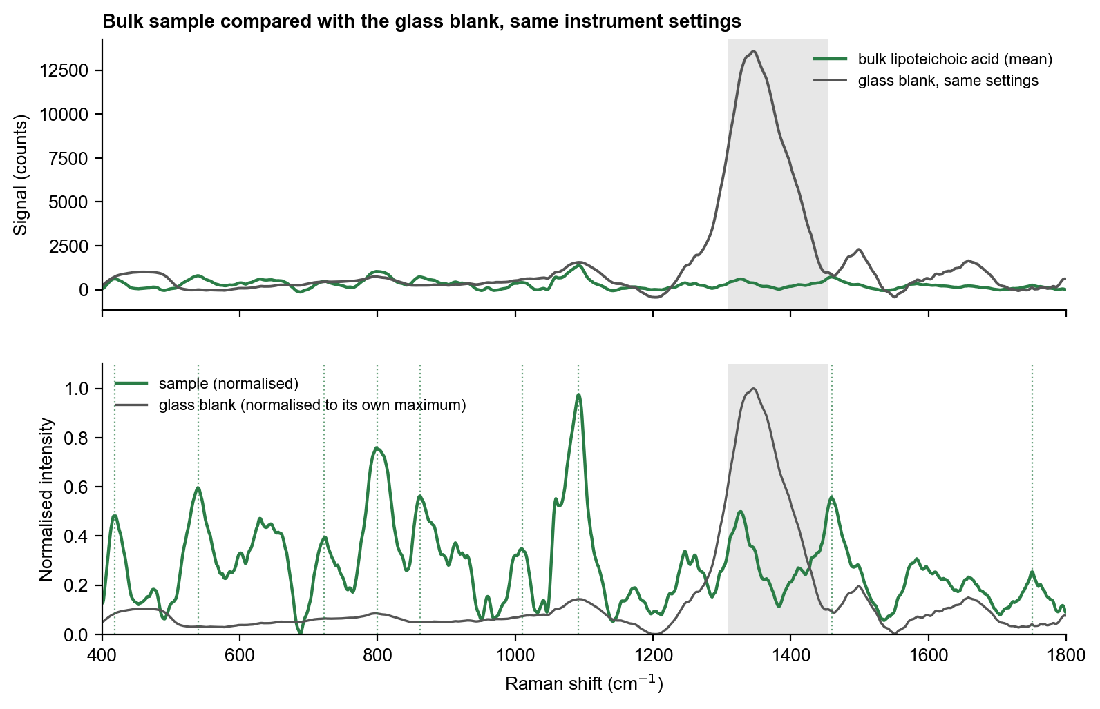
Figure 4. The bulk sample compared with the glass blank. Top: signal in counts, same settings. Bottom: both normalised. Grey: the glass zone; dotted lines mark the LTA peaks.
The glass slide gives its strong band at 1308 to 1455 cm⁻¹. The LTA main peaks (539, 862 and 1092 cm⁻¹) are not present in the blank slides; a peak that appears near 1328 cm⁻¹ in the LTA spectra falls inside the glass zone and is not used.

4.5 Choice of measurement condition
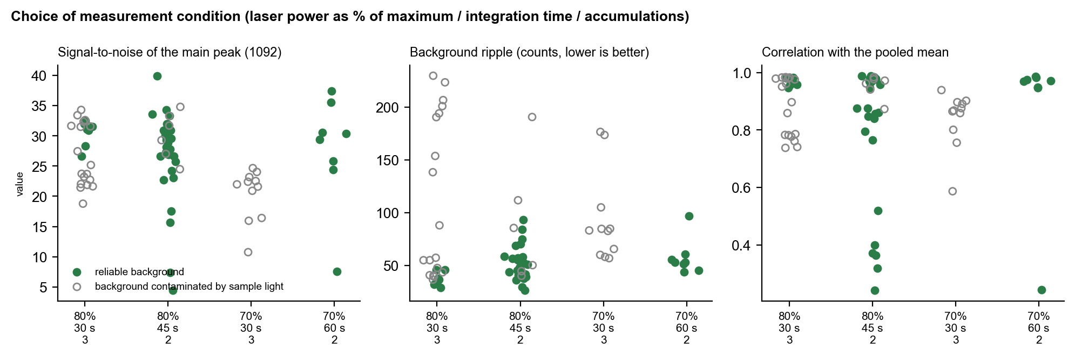
Figure 5. Signal-to-noise, background ripple and similarity to the reference for the settings compared. Each point is one spectrum: filled points have a reliable background reading; open points have a background that contained sample light.
All 99 LTA spectra were compared on four criteria: signal-to-noise of the 1092 cm⁻¹ peak, background ripple, similarity to the pooled mean, and whether the background (dark) signal was free of sample light. At 80 % laser power the main peak is strong (median signal-to-noise about 28 to 29), the ripple is low (about 47 to 50 counts) and agreement with the mean is high. Two integration settings at 80 % (45 s × 2 and 30 s × 3 accumulations, equal total exposure) give the same pattern (correlation 0.98) and were pooled. The 30 s × 3 setting is preferred for new measurements because all seven spectra recorded with a fresh background reading passed every check. Settings at 60 % or below have weaker peaks, and the 70 % settings give similar or lower signal-to-noise with either higher ripple or poorer agreement with the mean.

5. Interpretation
The strongest LTA peak, 1092 cm⁻¹, falls where the symmetric stretch of the phosphodiester group (PO₂⁻) of the glycerol-phosphate backbone is expected, and the 799 cm⁻¹ peak is where O–P–O stretching is expected; both are consistent with, but do not prove, an LTA backbone. The 1460 cm⁻¹ peak is CH₂ bending of the lipid anchor and is not specific. The 862 and 539 cm⁻¹ peaks lie in the glycerol and sugar regions. The spectrum differs from NAM (correlation 0.18) and moderately resembles LPS (0.50), as both are phosphorylated glycolipids.
A strong signal alone does not identify a molecule. Here the identification rests on the combination of reproducible peak positions, the agreement of the whole pattern across spectra, absence of the peaks from the glass slide, and separation from the other two molecules.

6. Conclusion and next step
The LTA reference is established and agrees with the earlier preliminary measurements (correlation 0.95). The next useful steps are to confirm the reference with new spots at 80 % power, 30 s and 3 accumulations using a freshly recorded background.

