Surface-Enhanced Raman Spectra of NAM, LPS and LTA on Etched Silicon
Results of the most recent measurement session and whether any biomarker was detected

1. Executive summary
In the most recent session, 119 spectra were recorded for NAM (75), LPS (35) and LTA (9) on etched silicon, with 5 spectra of the bare etched substrate (blank) for comparison. No biomarker was detected with confidence. NAM and LTA show nothing that separates them from the blank or from chance. LPS gives one lead worth following up: a reproducible set of ten bands appears on 21 of the 35 LPS spots and on none of the blank or bare-silicon spectra. This set does not meet the detection rule set for LPS and does not match the bulk LPS spectrum, so it cannot yet be attributed to LPS.
Table 1. Outcome for each molecule.
Molecule | Spectra | Outcome | Reason
NAM | 75 | Not detected | No bulk NAM band is stronger than in the blank, and the hit rate is no better than random positions
LPS | 35 | Lead, not confirmed | Ten-band set reproducible on 21 spots and absent from the blank; the two bands required by the detection rule are not both present
LTA | 9 | Not detected | No band above chance; only nine spectra

2. Objective
To test whether the three sepsis-related molecules can be seen by surface-enhanced Raman spectroscopy (SERS) on etched silicon, and to compare what is seen with the reference bulk spectra of the same molecules. SERS is Raman spectroscopy in which the signal of molecules lying on a roughened metal-coated surface is strongly amplified, so that very small amounts can be detected. A biomarker is a substance that may indicate a biological condition; here a molecule counts as detected only if its characteristic peaks appear in the spectra and are absent from the blank.

3. Data and approach

3.1 What was measured
All spectra were recorded in one session with the same 785 nm Raman instrument used for the bulk reference spectra (B&W Tek i-Raman Plus). Laser power is given as a percentage of the instrument maximum. The blank was recorded first, then NAM, LPS and LTA in turn. Sample concentration, volume and the way each sample was applied were not recorded, and no reference-dye check was made in this session.
Table 2. Measurements in the session.
Sample | Spectra | Laser power (% of max) | Integration (s) | Accumulations
Blank | 5 | 15 | 10 | 2
NAM | 75 | 15 to 70 | 5 to 15 | 2 to 3
LPS | 35 | 30 to 50 | 10 to 15 | 2
LTA | 9 | 10 and 50 | 10 | 2

3.2 How the spectra were analysed
- Processing: The same processing as for the bulk reference spectra: background subtraction, repair of two defective detector pixels, 400 to 1800 cm⁻¹, spike removal, smoothing and baseline removal. The baseline step removes the slowly changing background so that peaks are easier to see.
- Detection rule: A band counts as detected in a spectrum when a peak lies within 5 cm⁻¹ of the target position, is at least three detector pixels wide and rises at least three times the noise above its surroundings.
- Targets: The bulk reference peaks of each molecule (NAM 541, 829, 870.5, 929, 955, 1023, 1127; LPS 425, 766, 861, 997, 1080; LTA 802, 861.5, 1092, 1459 cm⁻¹) and the SERS bands used for LPS (989 and 1330 cm⁻¹) and LTA (a phosphate band at 1225 to 1250 cm⁻¹ and a lipid band at 1131 or 1450 cm⁻¹).
- Comparison: Each band is compared with the blank and with bare silicon, and its height relative to the silicon peak is compared with the blank. A chance test shifts all target positions by a random 20 to 80 cm⁻¹ (400 times) to see how often a detection rate as high as the real one occurs by chance.

4. Results

4.1 What every spectrum contains
Every spectrum is dominated by the crystalline-silicon peak at 518 cm⁻¹ (the instrument reads it 2 to 3 cm⁻¹ below the true value). A broad silicon feature near 935 cm⁻¹ appears in about a third of the spectra and also in bare silicon, so it is not molecular; this matters for NAM, whose 929 and 955 cm⁻¹ targets lie on its edge. The molecular signals are weak and sit on top of the silicon peak. No spectrum is saturated.
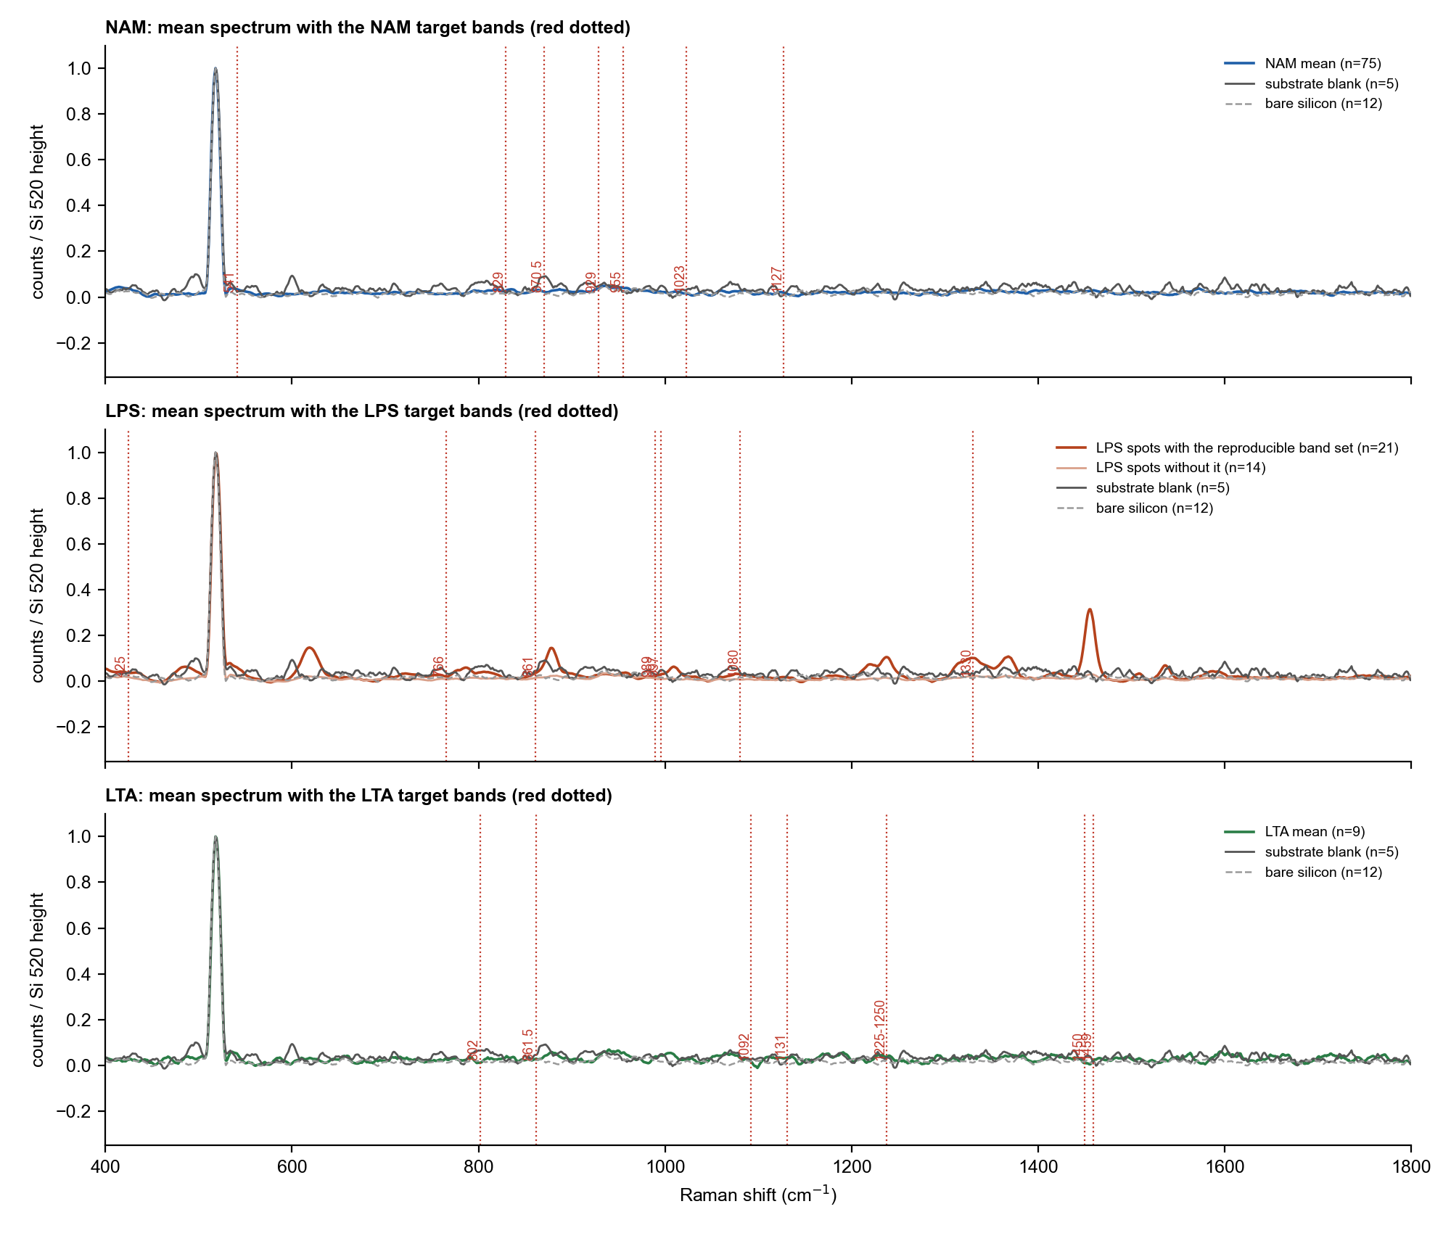
Figure 1. Mean spectrum of each molecule (coloured) with the blank (dark grey) and bare silicon (dashed grey), each scaled to the silicon peak. Red dotted lines mark the target bands. For LPS, the red curve is the mean of the spots that carry the ten-band set.

4.2 NAM
No bulk NAM peak is found in more than 14 of the 75 spectra (the most frequent is 929 cm⁻¹, 19 %), and in every case the NAM spectra are no stronger than the blank. The detection rate over all NAM target positions is 6.7 %, against 3.9 % for random positions (p = 0.14). Peaks found outside silicon change from one spectrum to the next and do not repeat. NAM is not detected. This agrees with the earlier finding for NAM: it has no group that binds strongly to silver, so it is not expected to stay at the surface without a capture agent.

4.3 LPS
None of the bulk LPS peaks (425, 766, 861, 997, 1080 cm⁻¹) is found, and neither is the SERS band at 989 cm⁻¹. The SERS band at 1330 cm⁻¹ is found in 15 of the 35 spectra and in none of the blank spectra, but the detection rule needs both 989 and 1330 cm⁻¹, so LPS is not detected by that rule.
The spectra nevertheless contain more than silicon. Ten bands repeat on 21 of the 35 LPS spots. Their median spectrum-to-spectrum correlation is 0.85, against 0.43 for the other LPS spots, 0.45 for the blank and 0.25 for NAM (1.0 would be identical). The spots that carry the set have a weaker silicon peak (median 1019 counts against 2326), as expected if a surface layer covers the silicon. The set is absent from the blank (0 of 5) and bare silicon (0 of 12).
Table 3. The ten bands that repeat on the LPS spots.
Band (cm⁻¹) | On the spots with the set | On other LPS spots | On the blank | Signal-to-noise | Nearest published LPS band
619 ± 1.8 | 100 % | 29 % | 0 % | 9 | no match in the checked LPS list
785 ± 2.2 | 43 % | 0 % | 0 % | 4 | no match in the checked LPS list
878 ± 1.3 | 100 % | 7 % | 0 % | 9 | no match in the checked LPS list
1009 ± 1.6 | 48 % | 0 % | 0 % | 5 | 988 and 1003; 6 to 21 cm-1 away
1238 ± 1.4 | 95 % | 14 % | 0 % | 6 | no match in the checked LPS list
1330 ± 2.6 | 62 % | 14 % | 0 % | 5 | 1330 and 1333 in published SERS lists (LPS-1, LPS-2)
1368 ± 1.6 | 76 % | 29 % | 0 % | 5 | no match in the checked LPS list
1455 ± 0.5 | 100 % | 29 % | 0 % | 17 | 1450, CH2/CH3 deformation (LPS-1, SERS); 5 cm-1 above
1536 ± 1.2 | 76 % | 0 % | 0 % | 5 | no match in the checked LPS list
1592 ± 3.9 | 48 % | 14 % | 0 % | 4 | no match in the checked LPS list

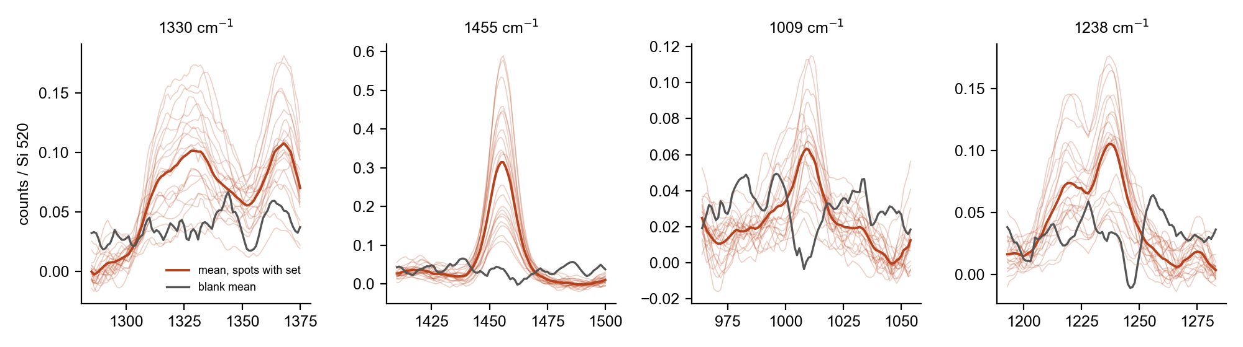
Figure 2. Four bands of the ten-band LPS set. Thin lines: individual LPS spots that carry the set; red: their mean; grey: the blank mean. All spectra are scaled to the silicon peak.
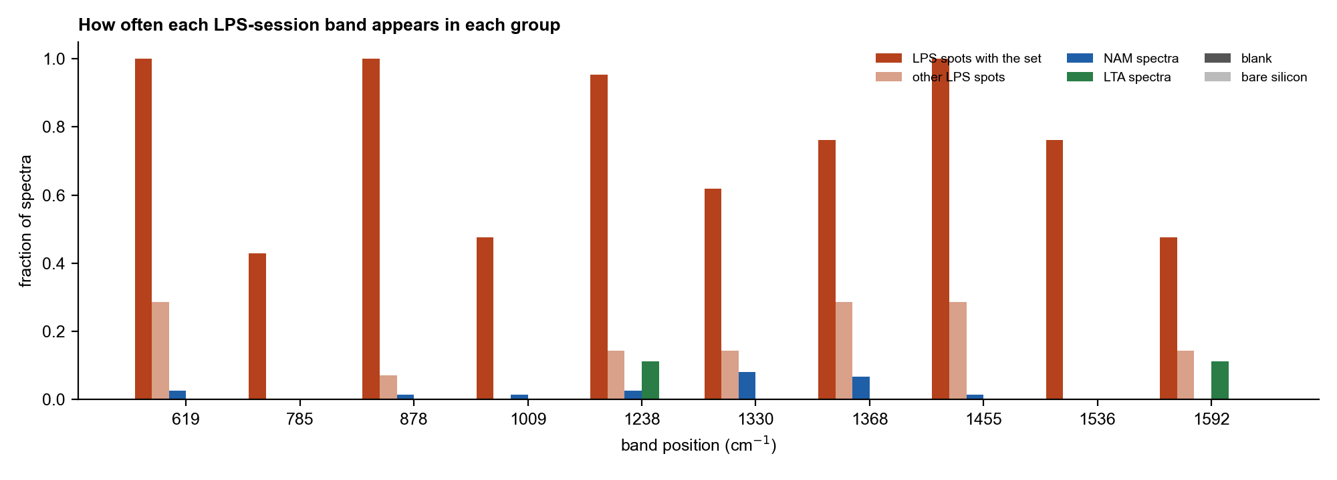
Figure 3. How often each band of the set appears in each group of spectra. The set is common on the LPS spots that carry it and rare or absent elsewhere.
What this does and does not show. The strongest band, at 1455 cm⁻¹, lies 5 cm⁻¹ above the CH₂/CH₃ deformation listed for SERS of LPS, and the 1330 cm⁻¹ band matches a band at 1330 to 1333 cm⁻¹ in published LPS SERS lists. The 1009 cm⁻¹ band lies 6 to 21 cm⁻¹ from published bands, and the other six bands have no match in the checked lists. The mean spectrum of the spots with the set correlates with the bulk LPS reference at only 0.20, no better than with the bulk LTA (0.29) or NAM (0.15) references. The pattern is consistent with an organic layer containing CH₂ and CH₃ groups on the silicon, and LPS is one possible source, but it is not an identification.

4.4 LTA
None of the LTA bands is detected above chance: the detection rate over all target positions is 1.6 % against 1.6 % for random positions (p = 0.68). The phosphate region (1225 to 1250 cm⁻¹) gives one detection in nine spectra and the 1092 cm⁻¹ position none. Four of the nine spectra were taken at 10 % power, where the silicon peak is only about 250 to 340 counts and sensitivity is very low. LTA is not detected, but nine spectra and no matching blank are a weak test.

4.5 Comparison with chance
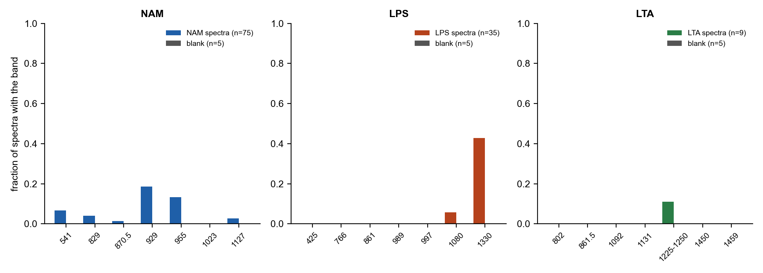
Figure 4. Fraction of spectra in which each target band is detected, for the sample (colour) and the blank (grey).
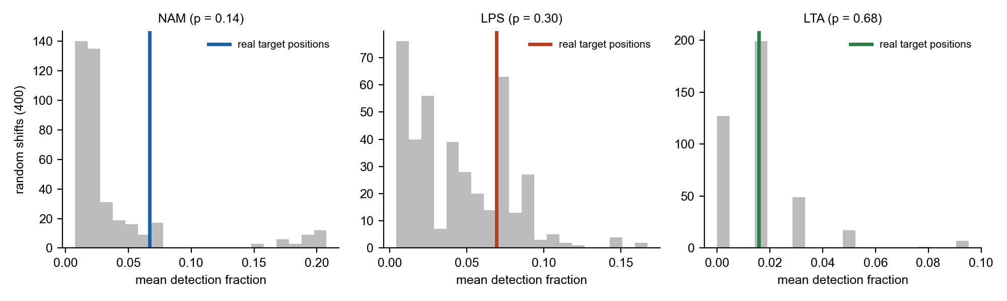
Figure 5. Detection rate over all target positions (coloured line) compared with 400 random shifts of the positions (grey). None of the three exceeds chance.

5. Interpretation
The session does not show a detected biomarker. NAM and LTA give no evidence of surface signal, and the LPS result is a lead rather than a detection: a reproducible, blank-free band pattern that is consistent with an organic layer on silicon but does not match the bulk LPS spectrum. A SERS spectrum can differ from the bulk spectrum in which bands are enhanced, so the lack of overlap is not proof against LPS, but it also does not support it. Two features limit what can be concluded: the blank was recorded about five hours before the first LPS spectrum and eight hours before the LTA spectra, and there is no solvent-only control prepared like the LPS spots, so contamination from preparation or handling cannot be excluded.

6. Conclusion and next step
No molecule was detected with confidence; LPS is the one result worth building on. The most useful next step is to repeat LPS on a fresh substrate with a solvent-only control prepared in the same way and a blank at the start and end of the set, keeping the 50 % power, 15 s, 2 accumulation setting, and to record concentration, volume and application method. Measuring bulk LPS on the same type of silicon would show directly which bands LPS gives there. For NAM, a capture agent on the silver surface is needed before further measurements; for LTA, more spectra at 50 % power or higher with a same-session blank.

