Experimental Bulk Raman Spectra of Lipopolysaccharide (LPS)
Reference spectrum of the neat powder on a glass slide

1. Executive summary
Lipopolysaccharide (LPS) is the main lipid-sugar molecule of the outer membrane of Gram-negative bacteria (endotoxin), a trigger of sepsis. Its Raman fingerprint was established from 10 spectra of the neat powder recorded at one setting (60 % of maximum laser power, 40 s integration, 5 accumulations). The spectrum has one clearly strongest peak at 425 cm⁻¹ and weaker peaks near 766, 861, 996 and 1080 cm⁻¹. The 425 cm⁻¹ peak is present in every spectrum; the weaker peaks are present in 8 to 10 of the 10.
A strong band near 1367 cm⁻¹ and its neighbours (1308 to 1455 cm⁻¹) come from the glass slide, not from the molecule; this zone is shaded in all figures and is not used as evidence. The spectrum is distinct from the other two molecules (correlation with NAM: 0.15; with LTA: 0.50; 1.0 would mean identical).

2. Objective
To record a reliable, repeatable Raman spectrum of lipopolysaccharide (LPS) as a neat powder, to identify its characteristic peaks, and to confirm that those peaks come from the molecule and not from the glass slide on which it was measured. This spectrum is the experimental reference for comparison with the molecular simulation and for later detection work.

3. Data and approach

3.1 What was measured
Sample: lipopolysaccharide from Escherichia coli O111:B4 (Sigma-Aldrich L2630). The powder was placed on a clean glass slide and measured with a 785 nm Raman instrument (B&W Tek i-Raman Plus). Laser power is given as a percentage of the instrument maximum. Reference condition: 60 % of maximum laser power, 40 s integration, 5 accumulations. Each file is one spectrum, averaged over its accumulations; the number of independent measurement spots is stated where it matters.

3.2 How the spectra were processed
Only steps that were actually applied are listed. Each is intended to make real peaks easier to see without changing their positions.
- Background subtraction: The instrument background (dark signal) was subtracted, and two defective detector pixels were repaired by interpolation.
- Spike removal: Narrow random spikes (for example cosmic rays) were removed.
- Smoothing: A Savitzky–Golay filter (window of 11 points) reduced random fluctuation while keeping peak shapes.
- Baseline correction: The slowly changing fluorescence-type background was estimated (asymmetric least-squares method) and subtracted, leaving only the peaks.
- Normalisation: Each spectrum was scaled to run from 0 to 1 so spectra of different overall brightness can be compared by shape. Normalised plots show shape only; heights in counts are used where stated.
The range 400 to 1800 cm⁻¹ was used. Correlations between spectra exclude the glass zone (1308 to 1455 cm⁻¹).

4. Results

4.1 The reference spectrum
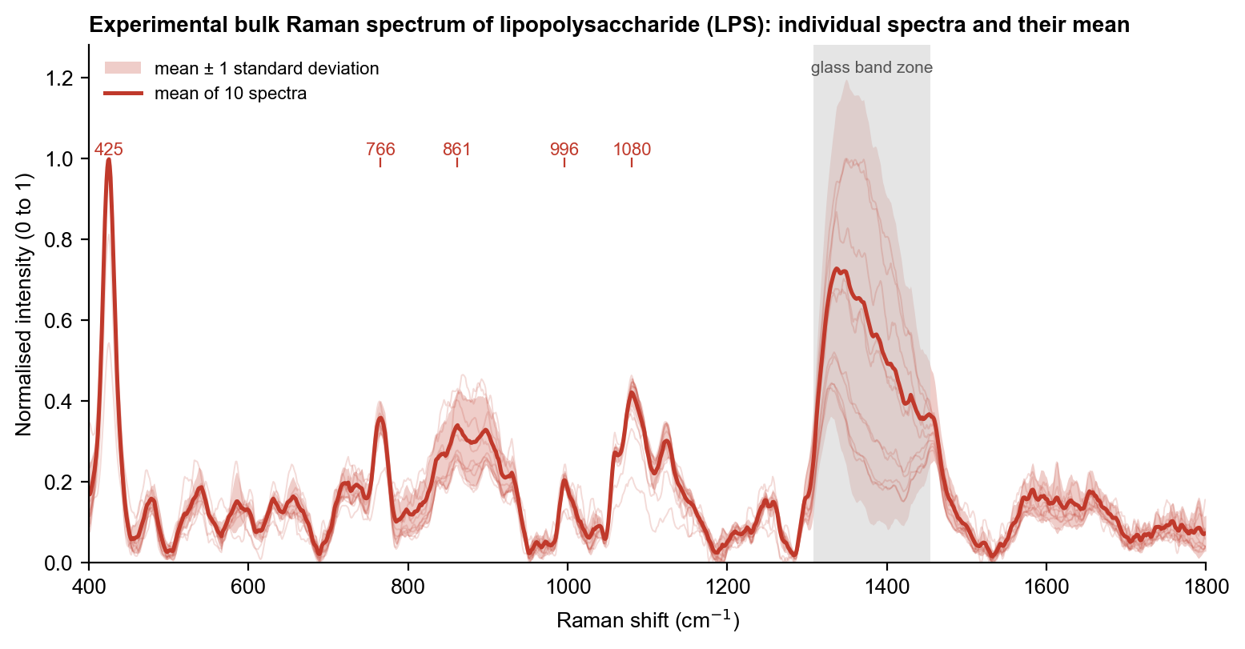
Figure 1. Raman spectra of lipopolysaccharide (LPS) powder. Thin lines: each of the 10 spectra; bold line: mean; shaded band: ± 1 standard deviation. Numbers mark the main and supporting peaks. Grey: glass-slide zone.
The individual spectra overlap closely, which shows that the pattern is a property of the material and not of one measurement spot. The peaks are broader and weaker than for NAM, as expected for a large, heterogeneous molecule; spot-to-spot variation in height is larger, so intensities are compared as ratios to the 425 cm⁻¹ peak.

4.2 Effect of processing
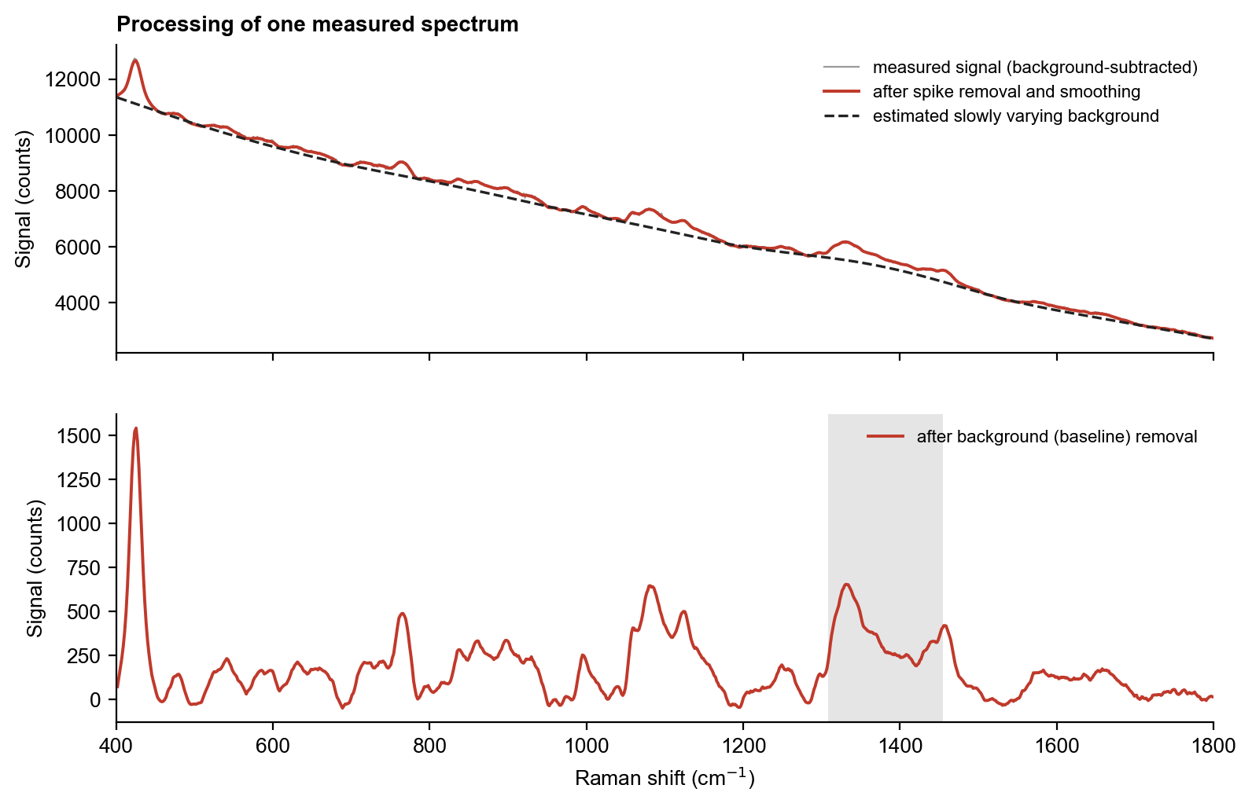
Figure 2. One measured spectrum before and after processing. Top: the measured signal (grey), the signal after spike removal and smoothing (colour) and the estimated background (dashed). Bottom: the final spectrum after the background is removed.
Smoothing lowers the random fluctuation, and baseline removal flattens the rising background so that peak heights can be read from zero. Peak positions do not change.

4.3 Main peaks
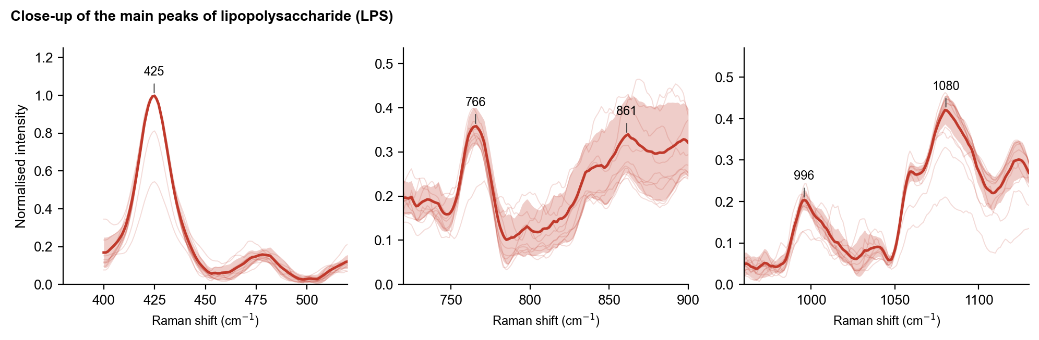
Figure 3. Close-ups of the main peaks. Thin lines: individual spectra; bold line: mean; band: ± 1 standard deviation. Numbers give the mean peak position.
Table 1. Peaks of the LPS reference spectrum (outside the glass zone). Assignments are tentative and based on general group frequencies of the molecular groups present.
Raman shift (cm⁻¹) | Peak role | Tentative assignment | Evidence from the measurements
425 ± 0.9 | main | low-frequency skeletal / ring deformation (not assigned in the literature) | present in 10/10 spectra; signal-to-noise 38
766 ± 1.2 | supporting | no assignment in the literature | present in 8/10 spectra; signal-to-noise 17
861 ± 0.9 | supporting | glycosidic C-O-C and sugar ring modes | present in 8/10 spectra; signal-to-noise 13
996 ± 0.8 | supporting | C-H bending or sugar C-O-C | present in 9/10 spectra; signal-to-noise 9
1080 ± 1.1 | main | C-O stretching of sugars and / or symmetric PO2- stretch | present in 10/10 spectra; signal-to-noise 15

4.4 Comparison with the glass slide
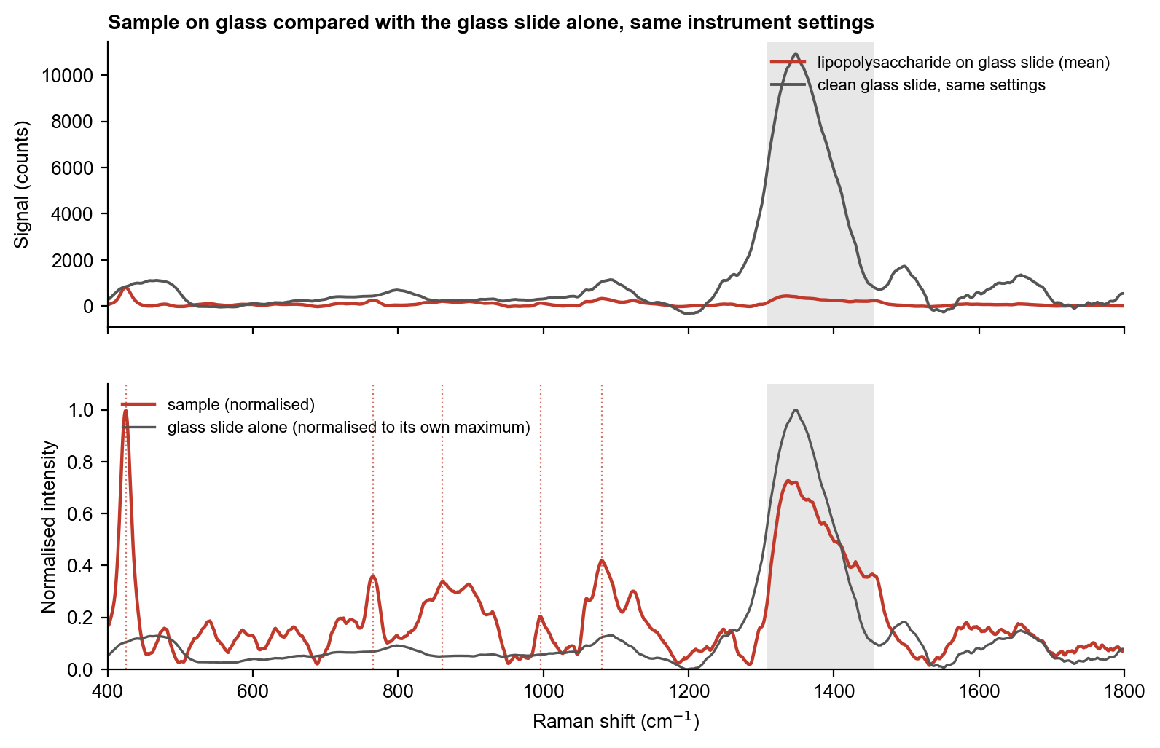
Figure 4. The sample on glass compared with the glass slide alone. Top: signal in counts, same settings. Bottom: both normalised. Grey: the glass zone; dotted lines mark the LPS peaks.
The glass slide gives its strong band at 1308 to 1455 cm⁻¹ and little else. The 425 cm⁻¹ peak is absent from the blank slides and is therefore from LPS; the 1080 cm⁻¹ peak overlaps weakly with the glass background (about 14 % of its area), so it is treated with more caution.

4.5 Choice of measurement condition
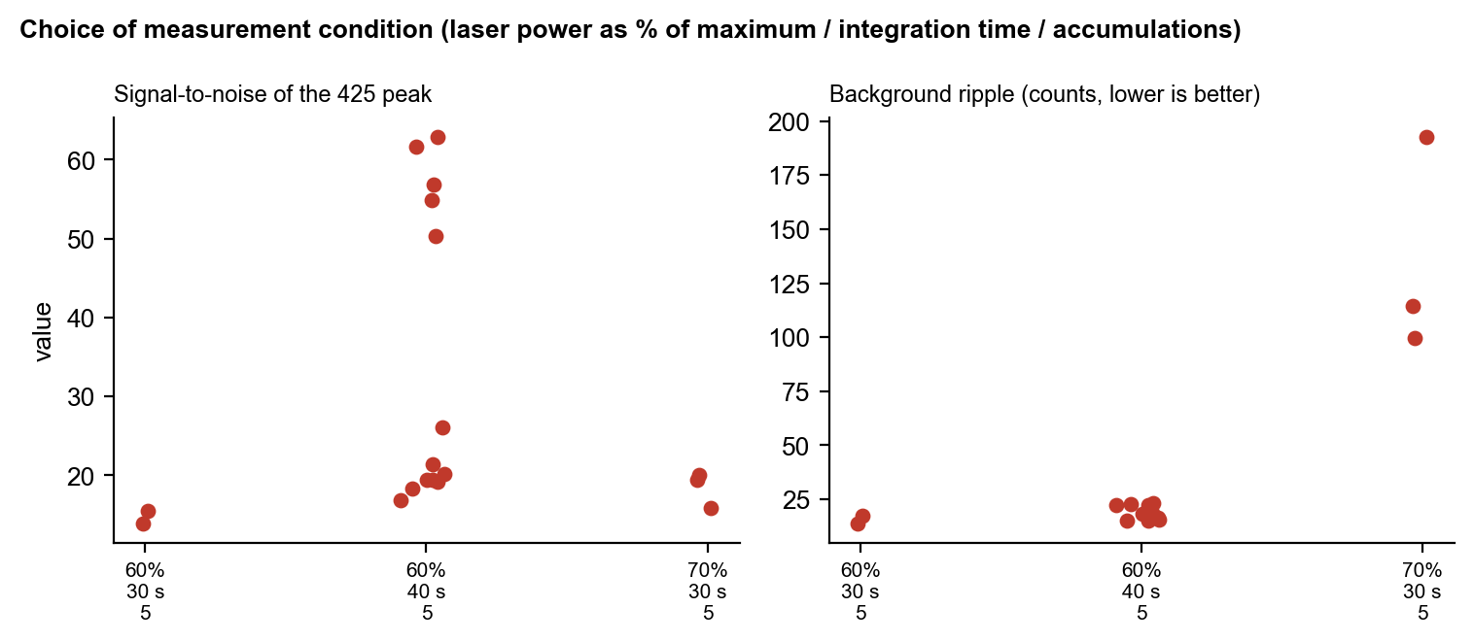
Figure 5. Signal-to-noise, background ripple and similarity to the reference for the settings compared. Each point is one spectrum.
Three conditions were compared (figure). Raising the integration time from 30 s to 40 s at 60 % laser power raised the signal-to-noise of the 425 cm⁻¹ peak (median about 21 against 15) with the same low ripple (about 16 to 18 counts). Raising the power to 70 % did not improve the peak but increased the ripple pattern about six-fold (about 115 counts), and at 80 % the ripple was larger still, so 60 % with 40 s and 5 accumulations was chosen. Peak heights still vary three- to five-fold between spots, which is a property of this heterogeneous material.

5. Interpretation
LPS gives a recognisable but weaker and more variable spectrum. The 425 cm⁻¹ peak is the strongest and the most reproducible, but it has no assignment in the published LPS literature; it lies in the low-frequency skeletal region of carbohydrates. The 861, 996 and 1080 cm⁻¹ peaks are consistent with sugar C–O–C and C–O stretching and, for 1080 cm⁻¹, possibly the symmetric PO₂⁻ stretch. The spectrum is distinct from NAM and LTA, but because the material is a mixture of molecules of different size, the pattern is less sharp than for NAM.
A strong signal alone does not identify a molecule. Here the identification rests on the combination of reproducible peak positions, the agreement of the whole pattern across spectra, absence of the peaks from the glass slide, and separation from the other two molecules.

6. Conclusion and next step
The LPS reference is established at 60 % power. The next useful step is to repeat it with a fresh background reading on a second sample vial, and to assign the 425 cm⁻¹ peak by comparison with a calculation of the lipid A core (see the simulation reports).

