Experimental Bulk Raman Spectra of N-acetylmuramic acid (NAM)
Reference spectrum of the neat powder on a glass slide

1. Executive summary
N-acetylmuramic acid (NAM) is a sugar unit of the bacterial cell-wall peptidoglycan (a Gram-positive and Gram-negative cell-wall marker). Its Raman fingerprint was established from 15 spectra of the neat powder recorded at one setting (90 % of maximum laser power, 30 s integration, 5 accumulations), out of 311 NAM spectra measured at many powers and integration times. The spectrum is dominated by a group of sharp peaks between 450 and 1130 cm⁻¹ at 541, 829, 871, 929, 955, 1023, 1127 cm⁻¹ (main peaks) and is highly reproducible: every main peak is present in all 15 spectra and the signal-to-noise ratio of the strongest peaks is above 40.
A strong band near 1367 cm⁻¹ and its neighbours (1308 to 1455 cm⁻¹) come from the glass slide, not from the molecule; this zone is shaded in all figures and is not used as evidence. The spectrum is distinct from the other two molecules (correlation with LTA: 0.18; with LPS: 0.15; 1.0 would mean identical).

2. Objective
To record a reliable, repeatable Raman spectrum of N-acetylmuramic acid (NAM) as a neat powder, to identify its characteristic peaks, and to confirm that those peaks come from the molecule and not from the glass slide on which it was measured. This spectrum is the experimental reference for comparison with the molecular simulation and for later detection work.

3. Data and approach

3.1 What was measured
Sample: N-acetylmuramic acid powder (Sigma-Aldrich A3007; a mixture of the alpha and beta forms). The powder was placed on a clean glass slide and measured with a 785 nm Raman instrument (B&W Tek i-Raman Plus). Laser power is given as a percentage of the instrument maximum. Reference condition: 90 % of maximum laser power, 30 s integration, 5 accumulations. Each file is one spectrum, averaged over its accumulations; the number of independent measurement spots is stated where it matters.

3.2 How the spectra were processed
Only steps that were actually applied are listed. Each is intended to make real peaks easier to see without changing their positions.
- Background subtraction: The instrument background (dark signal) was subtracted, and two defective detector pixels were repaired by interpolation.
- Spike removal: Narrow random spikes (for example cosmic rays) were removed.
- Smoothing: A Savitzky–Golay filter (window of 11 points) reduced random fluctuation while keeping peak shapes.
- Baseline correction: The slowly changing fluorescence-type background was estimated (asymmetric least-squares method) and subtracted, leaving only the peaks.
- Normalisation: Each spectrum was scaled to run from 0 to 1 so spectra of different overall brightness can be compared by shape. Normalised plots show shape only; heights in counts are used where stated.
The range 400 to 1800 cm⁻¹ was used. Correlations between spectra exclude the glass zone (1308 to 1455 cm⁻¹).

4. Results

4.1 The reference spectrum
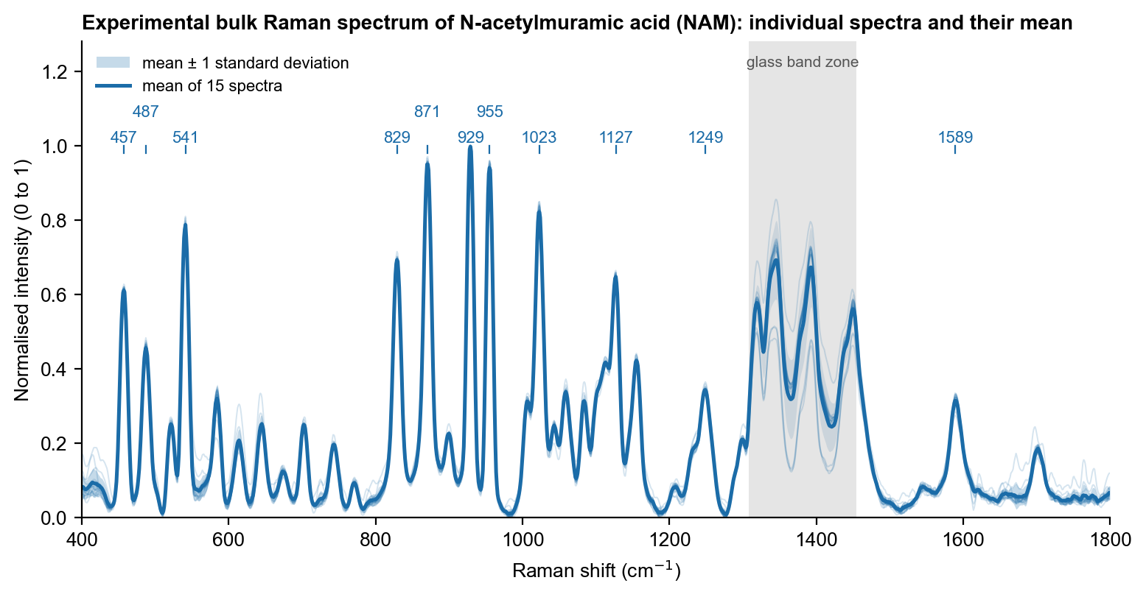
Figure 1. Raman spectra of N-acetylmuramic acid (NAM) powder. Thin lines: each of the 15 spectra; bold line: mean; shaded band: ± 1 standard deviation. Numbers mark the main and supporting peaks. Grey: glass-slide zone.
The individual spectra overlap closely, which shows that the pattern is a property of the material and not of one measurement spot. The peaks are narrow, which is typical of a crystalline sugar derivative.

4.2 Effect of processing
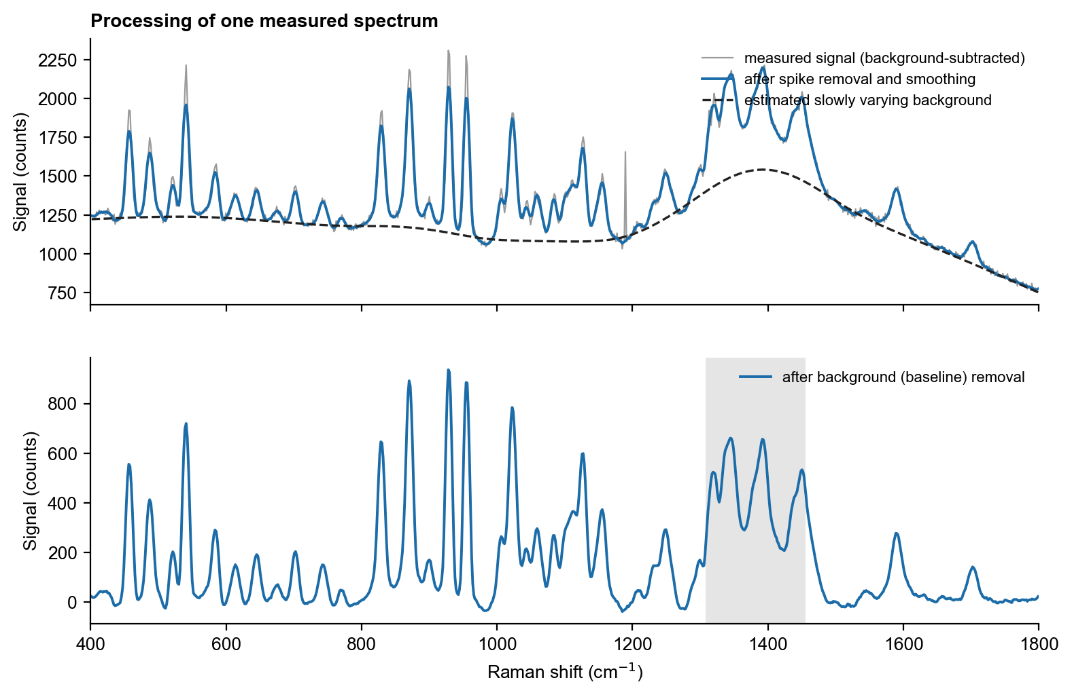
Figure 2. One measured spectrum before and after processing. Top: the measured signal (grey), the signal after spike removal and smoothing (colour) and the estimated background (dashed). Bottom: the final spectrum after the background is removed.
Smoothing lowers the random fluctuation, and baseline removal flattens the rising background so that peak heights can be read from zero. Peak positions do not change.

4.3 Main peaks
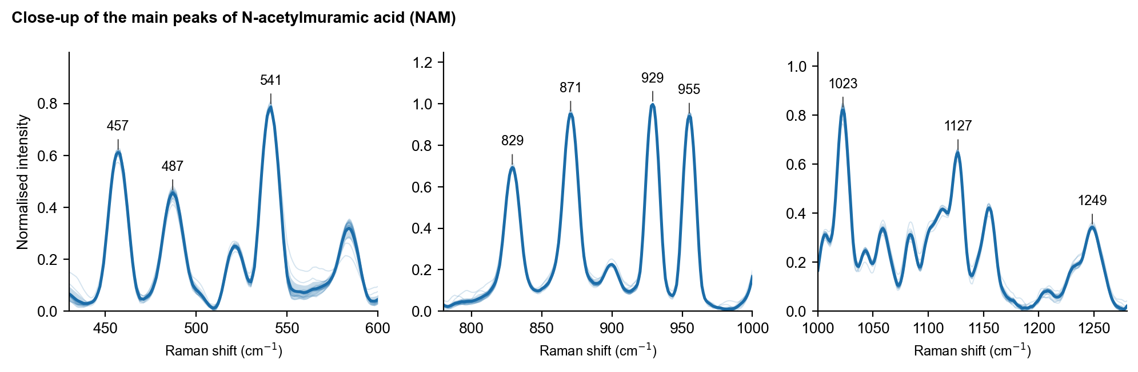
Figure 3. Close-ups of the main peaks. Thin lines: individual spectra; bold line: mean; band: ± 1 standard deviation. Numbers give the mean peak position.
Table 1. Peaks of the NAM reference spectrum (outside the glass zone). Assignments are tentative and based on general group frequencies of the molecular groups present.
Raman shift (cm⁻¹) | Peak role | Tentative assignment | Evidence from the measurements
457 ± 0.4 | supporting | pyranose-ring skeletal deformation | present in 15/15 spectra; signal-to-noise 30
487 ± 0.0 | supporting | skeletal deformation | present in 15/15 spectra; signal-to-noise 22
541 ± 0.0 | main | ring deformation, C-C-O / C-C-C | present in 15/15 spectra; signal-to-noise 40
829 ± 0.0 | main | C-O-C and ring stretching (sugar "anomeric" region) | present in 15/15 spectra; signal-to-noise 35
871 ± 0.5 | main | C-O-C and C-C ring stretching | present in 15/15 spectra; signal-to-noise 49
929 ± 0.0 | main | C-O-C / C-C stretching (lactyl side chain may contribute) | present in 15/15 spectra; signal-to-noise 51
955 ± 0.0 | main | C-C stretching or CH3 rocking (tentative) | present in 15/15 spectra; signal-to-noise 48
1023 ± 0.5 | main | C-O / C-C stretching of the ring | present in 15/15 spectra; signal-to-noise 42
1127 ± 0.0 | main | C-O-C stretching (lactyl ether / ring) | present in 15/15 spectra; signal-to-noise 32
1249 ± 0.5 | supporting | no firm assignment (amide III or C-H deformation region) | present in 15/15 spectra; signal-to-noise 16
1589 ± 0.5 | supporting | no firm assignment | present in 15/15 spectra; signal-to-noise 15

4.4 Comparison with the glass slide
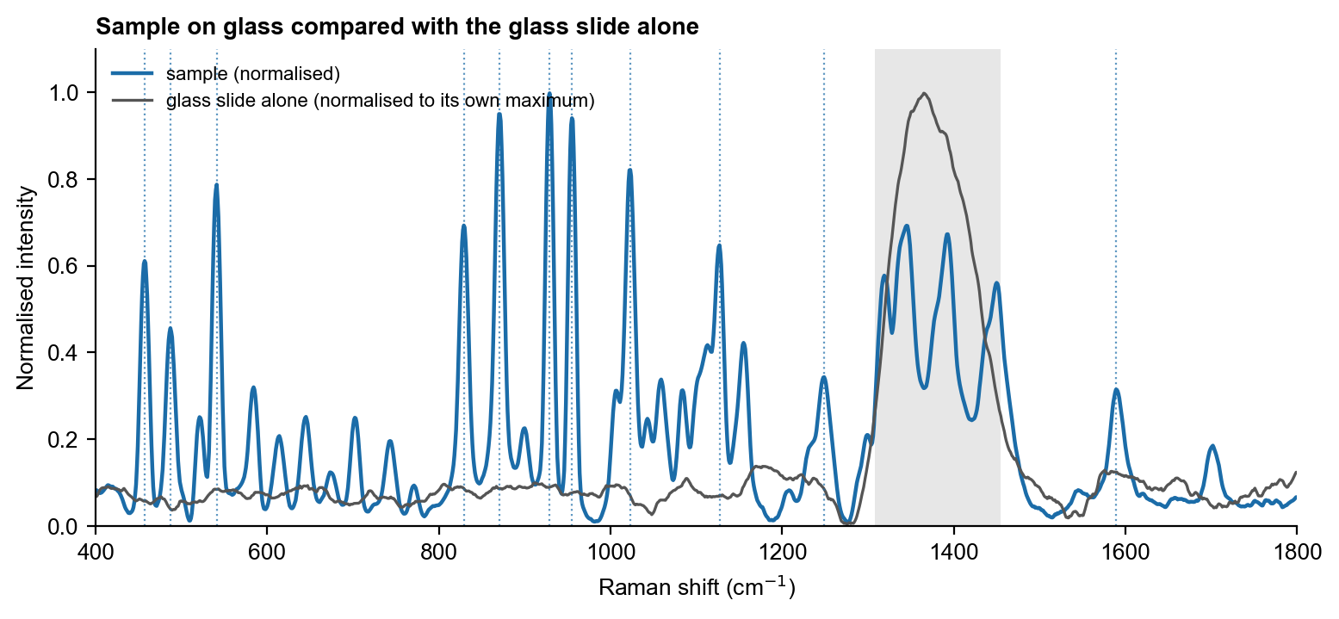
Figure 4. The sample on glass compared with the glass slide alone. Both curves are normalised; the glass slide was measured at low laser power because at the power used for the sample the glass band exceeds the detector range. Grey: the glass zone; dotted lines mark the NAM peaks.
The glass slide contributes a strong broad band at 1308 to 1455 cm⁻¹ and weak, broad features elsewhere. None of the NAM main peaks coincides with a glass feature, so they belong to NAM.

4.5 Choice of measurement condition
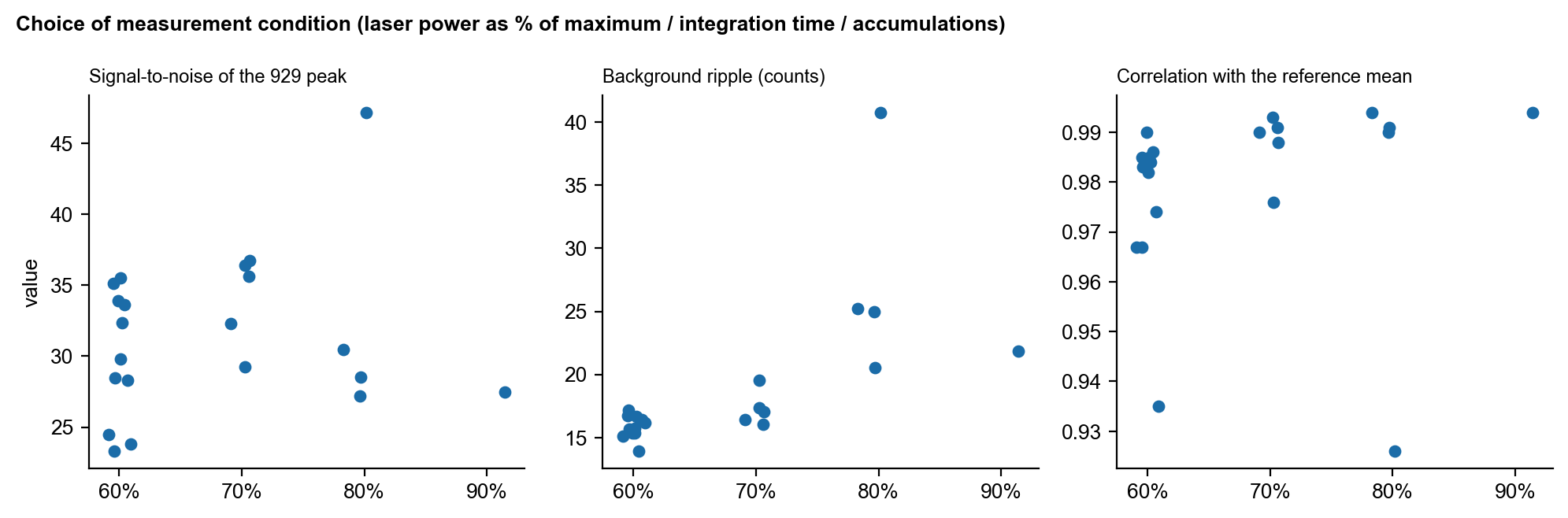
Figure 5. Signal-to-noise, background ripple and similarity to the reference for the settings compared. Each point is one spectrum.
Signal-to-noise, background ripple and agreement with the reference mean were compared for spectra recorded at 60, 70 and 80 % laser power, and the reference was recorded at 90 %. Higher power gives stronger peaks; the reference condition (90 %, 30 s, 5 accumulations) was kept because it gave the strongest peaks (signal-to-noise of the 929 cm⁻¹ peak about 50) without saturating the detector in the region of interest, and the lower-power spectra reproduce the same peak pattern (see figure).

5. Interpretation
The NAM fingerprint is the clearest of the three: seven main peaks (541, 829, 871, 929, 955, 1023 and 1127 cm⁻¹) appear in every spectrum with high signal-to-noise and a position scatter of under 1 cm⁻¹. The peaks lie where sugar-ring skeletal, C–O–C and C–C stretching modes are expected. Because no pure-compound Raman reference for NAM was found in the literature, assignments rest on group frequencies and on the calculation (separate reports) and remain tentative. The weaker peaks at 1249 and 1589 cm⁻¹ are reproducible but have no firm assignment.
A strong signal alone does not identify a molecule. Here the identification rests on the combination of reproducible peak positions, the agreement of the whole pattern across spectra, absence of the peaks from the glass slide, and separation from the other two molecules.

6. Conclusion and next step
The NAM reference spectrum is final. More spots at 90 % power can be added, and the 1249 and 1589 cm⁻¹ peaks would benefit from a firm assignment, which the molecular simulation reports address.

