Molecular Simulation of Lipopolysaccharide (LPS)
Calculated Raman spectrum and assignment of the main vibrations

1. Executive summary
A computer calculation of the Raman spectrum of the core of lipopolysaccharide: lipid A with two Kdo sugars, a whole-molecule model of 201 atoms (C₆₀H₉₈N₂O₃₉P₂, charge −4) in which the six long fatty-acid chains were shortened to 3–4 carbons was carried out to predict which Raman peaks this structure should give and which part of the molecule each peak comes from. The calculation gives 354 vibrations between 400 and 1800 cm⁻¹. Its main product is a list of calculated peak positions with the atoms that move in each, which lets the measured peaks be assigned to groups such as the phosphate, the sugar ring or the ester carbonyl. The calculation reproduces peak positions more reliably than peak heights.

2. Objective
Raman peaks depend on how the atoms of a molecule vibrate. The experimental spectrum of lipopolysaccharide (LPS) shows several reproducible peaks but their origin is not documented in the literature for the pure compound. The simulation was run to predict the Raman spectrum from the molecular structure, so that measured peaks can be linked to specific vibrations and the identification of the molecule is supported by an independent line of evidence.

3. Molecular model and approach
Model: the core of lipopolysaccharide: lipid A with two Kdo sugars, a whole-molecule model of 201 atoms (C₆₀H₉₈N₂O₃₉P₂, charge −4) in which the six long fatty-acid chains were shortened to 3–4 carbons. Method: a quick two-step calculation: a fast semi-empirical optimisation (PM6) followed by density functional theory (B3LYP) with a small basis set (3-21G), for the isolated molecule. In plain terms, the computer first finds the lowest-energy shape of the molecule, then calculates how each group of atoms vibrates and how strongly each vibration would scatter laser light. A calculated spectrum is therefore a prediction of the Raman signals expected from the structure.
Table 1. Calculations carried out and the one used.
Step | What was calculated | Outcome
1 | Five small fragments of LPS calculated separately (Kdo, glucosamine, heptose, myristic acid and phosphoric acid) and their spectra summed | Earlier approach; the sum ignores the bonds that join the pieces, so it was set aside
2 | One whole-molecule model of lipid A with shortened chains | Final model used for all comparisons: 597 vibrations, none unstable, 354 between 400 and 1800 cm⁻¹
3 | Higher-level calculation of the whole model (larger basis set with water) | Planned; not yet available

3.1 Why the final calculation is suitable
Real LPS carries long polysaccharide chains and is far too large to calculate. Lipid A with its Kdo sugars is the conserved core that contains the phosphate groups, the glucosamine sugars, the amide links and the glycosidic bond. Keeping all of these bonds in one molecule is more realistic than summing separate fragments. The fatty-acid chains were shortened so that the molecule could be calculated on the available computer.

3.2 From vibrations to a spectrum
Calculated frequencies were multiplied by 0.965, a typical value for this method; it was not fitted for the small basis set. Raman intensities were calculated for 785 nm light at room temperature, and each vibration was drawn as a Lorentzian peak 12 cm⁻¹ wide. The nature of each vibration (for example phosphate stretch, ring deformation or CH bending) was assigned by measuring which atoms move most in it; these labels are tentative.

4. Results

4.1 Molecular structure
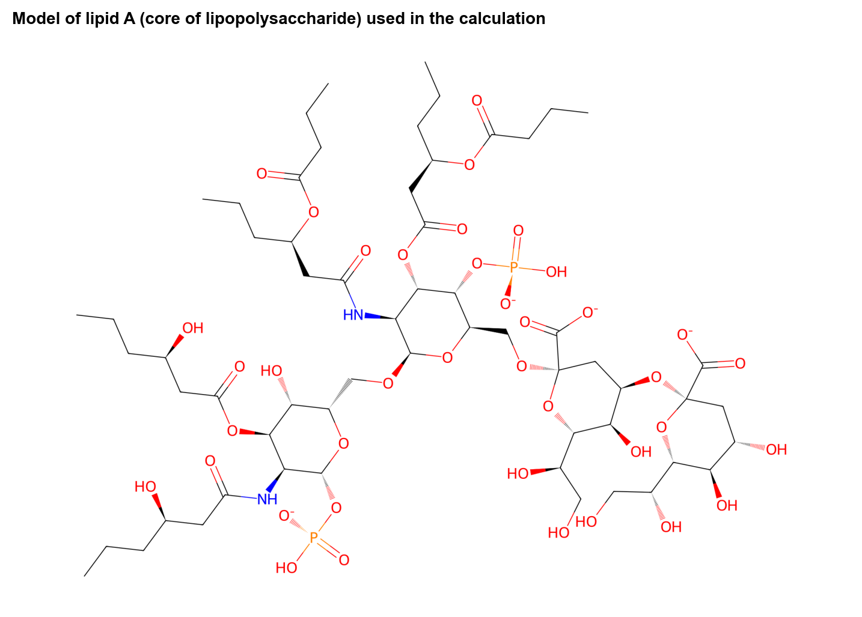
Figure 1. Structure of the model that was calculated.

4.2 Calculated Raman spectrum
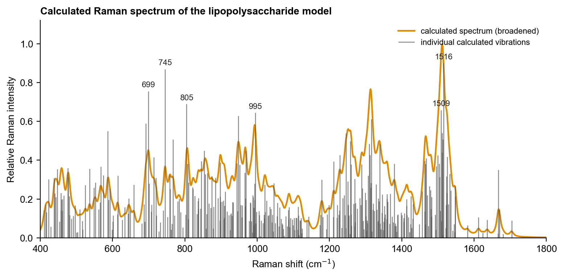
Figure 2. Calculated Raman spectrum. Orange curve: all vibrations broadened to peaks; grey lines: the individual calculated vibrations (heights are relative Raman intensities); numbers: the six strongest.

4.3 Important calculated peaks and their assignment
Table 2. The eight strongest calculated vibrations between 400 and 1800 cm⁻¹ (intensity 1.0 = strongest).
Calculated peak (cm⁻¹) | Type of vibration | Relative intensity | Counterpart in the measured spectrum
699 | C-O and C-C stretching (backbone) | 0.84 | not seen as a distinct peak
745 | phosphate P-O deformation | 0.97 | not seen as a distinct peak
805 | C-O and C-C stretching (backbone) | 0.77 | not seen as a distinct peak
948 | C-O and C-C stretching (backbone) | 0.70 | not seen as a distinct peak
995 | phosphate P-O stretch | 0.72 | yes (996)
1316 | C-H / O-H bending (CH2, CH3) | 0.68 | not seen as a distinct peak
1509 | C-H / O-H bending (CH2, CH3) | 0.73 | not seen as a distinct peak
1516 | C-H / O-H bending (CH2, CH3) | 1.00 | not seen as a distinct peak

The strongest calculated peaks are not always the strongest measured peaks; Raman intensities from small calculations are only a rough guide. The comparison report matches calculated peaks to measured ones by position and by type of vibration.

4.4 Assignment of the peaks seen in the measurement
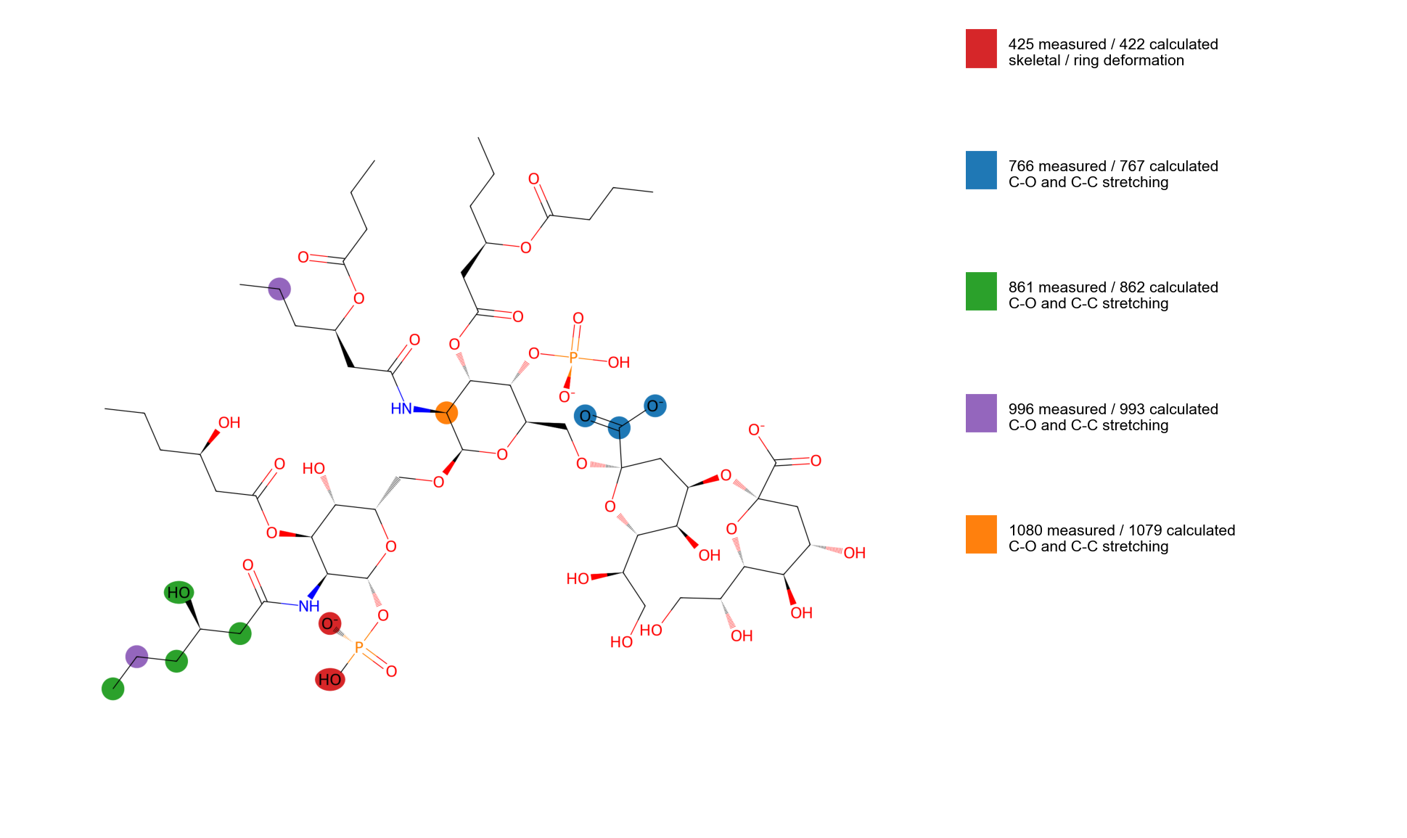
Figure 3. Atoms that move most in the calculated vibrations that correspond to measured peaks. Each colour is one vibration (key at right); the highlighted atoms carry most of the motion. Hydrogen atoms are assigned to the atom they are bonded to.
Table 3. Calculated vibrations matched to measured peaks. 'Confident' means the calculated peak lies within 10 cm⁻¹ of the measured peak and has the expected type of motion; 'tentative' means larger offset (see the comparison report).
Calculated (cm⁻¹) | Matching measured (cm⁻¹) | Assignment (type of vibration) | Confidence
422 | 425 | skeletal / ring deformation | confident
767 | 766 | C-O and C-C stretching (backbone) | confident
862 | 861 | C-O and C-C stretching (backbone) | confident
993 | 996 | C-O and C-C stretching (backbone) | confident
1079 | 1080 | C-O and C-C stretching (backbone) | confident

5. Interpretation and limitations
The calculation supports the assignment of the measured peaks to the vibration types listed above and shows which groups of the molecule are responsible. It does not by itself prove the identity of the sample.
- The basis set is small (3-21G), so positions are approximate and intensities distorted, especially for the charged phosphate groups.
- The model lacks the long fatty-acid chains, the outer core sugars, the O-antigen chain and counter-ions, and was calculated without water.
- The strong calculated peak near 1516 cm⁻¹ involves the amide groups and is probably overstated by the small basis set; it is not seen in the measurement.

6. Conclusion and next step
The calculation gives a usable prediction of the positions and types of the Raman vibrations of lipopolysaccharide (LPS) between 400 and 1800 cm⁻¹ and is the simulation used in the comparison with the measured spectrum. Next step: Repeat the calculation with a larger basis set and water, add sodium or calcium counter-ions and longer chains, and analyse the motions behind the calculated peaks near 422 and 862 cm⁻¹, to decide what the unassigned 425 cm⁻¹ measured peak is.

