Molecular Simulation of Lipoteichoic acid (LTA)
Calculated Raman spectrum and assignment of the main vibrations

1. Executive summary
A computer calculation of the Raman spectrum of a whole-molecule model of 93 atoms (C₂₃H₄₅N₃O₂₀P₂) with three glycerol-phosphate units joined by two phosphodiester links, a D-alanine ester on each outer glycerol and one alpha-N-acetylglucosamine on the central glycerol (net charge zero) was carried out to predict which Raman peaks this structure should give and which part of the molecule each peak comes from. The calculation gives 165 vibrations between 400 and 1800 cm⁻¹. Its main product is a list of calculated peak positions with the atoms that move in each, which lets the measured peaks be assigned to groups such as the phosphate, the sugar ring or the ester carbonyl. The calculation reproduces peak positions more reliably than peak heights.

2. Objective
Raman peaks depend on how the atoms of a molecule vibrate. The experimental spectrum of lipoteichoic acid (LTA) shows several reproducible peaks but their origin is not documented in the literature for the pure compound. The simulation was run to predict the Raman spectrum from the molecular structure, so that measured peaks can be linked to specific vibrations and the identification of the molecule is supported by an independent line of evidence.

3. Molecular model and approach
Model: a whole-molecule model of 93 atoms (C₂₃H₄₅N₃O₂₀P₂) with three glycerol-phosphate units joined by two phosphodiester links, a D-alanine ester on each outer glycerol and one alpha-N-acetylglucosamine on the central glycerol (net charge zero). Method: a quick two-step calculation: a fast semi-empirical optimisation (PM6) followed by density functional theory (B3LYP) with a small basis set (3-21G), for the isolated molecule. In plain terms, the computer first finds the lowest-energy shape of the molecule, then calculates how each group of atoms vibrates and how strongly each vibration would scatter laser light. A calculated spectrum is therefore a prediction of the Raman signals expected from the structure.
Table 1. Calculations carried out and the one used.
Step | What was calculated | Outcome
1 | Three small fragments calculated separately (glycerol-phosphate, D-alanine and N-acetylglucosamine) and their spectra summed | Earlier approach; the sum ignores the bonds that join the pieces, so it was set aside
2 | One whole-molecule model with the three substituent types | Final model used for all comparisons: 273 vibrations, none unstable, 165 between 400 and 1800 cm⁻¹
3 | Higher-level calculation (larger basis set with water) | Started; not yet available

3.1 Why the final calculation is suitable
LTA is a polymer of about 23 glycerol-phosphate units on a lipid anchor, with D-alanine or sugar groups on the glycerols; no single structure exists for it. A short chain that carries all three kinds of group keeps the real bonds (phosphodiester, ester and the sugar link) in a calculable molecule.

3.2 From vibrations to a spectrum
Calculated frequencies were multiplied by 0.965, a typical value for this method; it was not fitted for the small basis set. Raman intensities were calculated for 785 nm light at room temperature, and each vibration was drawn as a Lorentzian peak 12 cm⁻¹ wide. The nature of each vibration (for example phosphate stretch, ring deformation or CH bending) was assigned by measuring which atoms move most in it; these labels are tentative.

4. Results

4.1 Molecular structure
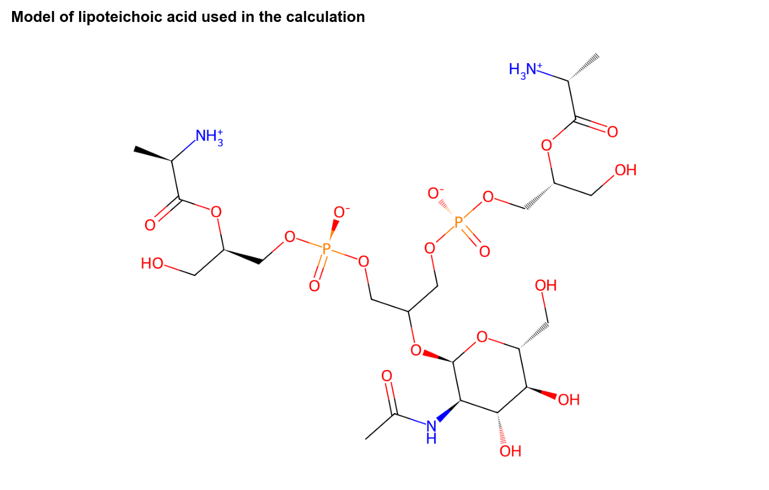
Figure 1. Structure of the model that was calculated.

4.2 Calculated Raman spectrum
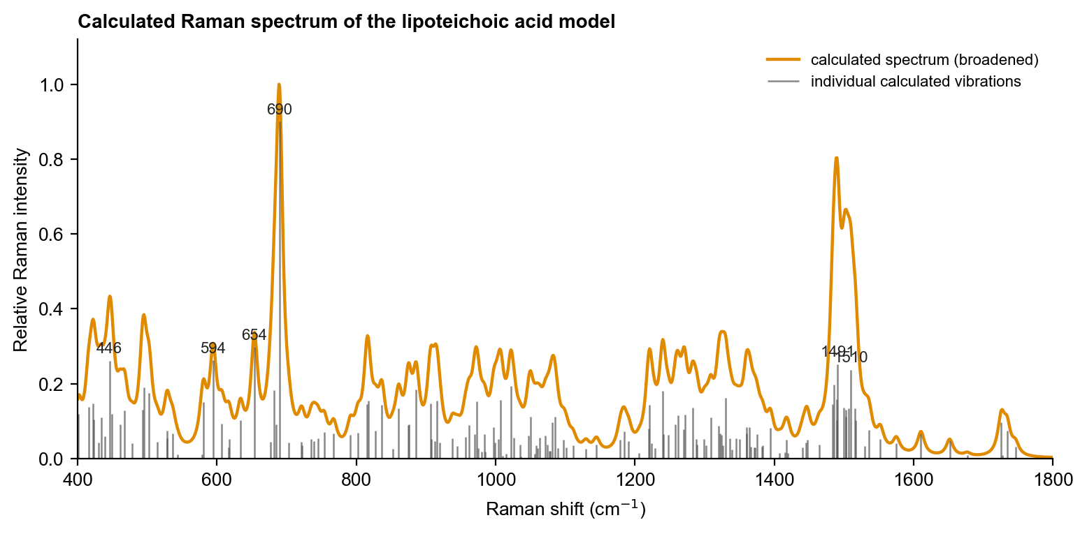
Figure 2. Calculated Raman spectrum. Orange curve: all vibrations broadened to peaks; grey lines: the individual calculated vibrations (heights are relative Raman intensities); numbers: the six strongest.

4.3 Important calculated peaks and their assignment
Table 2. The eight strongest calculated vibrations between 400 and 1800 cm⁻¹ (intensity 1.0 = strongest).
Calculated peak (cm⁻¹) | Type of vibration | Relative intensity | Counterpart in the measured spectrum
446 | skeletal / ring deformation | 0.29 | not seen as a distinct peak
594 | C-H bending / CH2 rocking and twisting | 0.29 | not seen as a distinct peak
654 | phosphate P-O deformation | 0.33 | not seen as a distinct peak
690 | C-O and C-C stretching (backbone) | 1.00 | not seen as a distinct peak
1022 | C-O and C-C stretching (backbone) | 0.22 | yes (1011)
1486 | C-H / O-H bending (CH2, CH3) | 0.22 | not seen as a distinct peak
1491 | C-H / O-H bending (CH2, CH3) | 0.28 | not seen as a distinct peak
1510 | C-H / O-H bending (CH2, CH3) | 0.26 | not seen as a distinct peak

The strongest calculated peaks are not always the strongest measured peaks; Raman intensities from small calculations are only a rough guide. The comparison report matches calculated peaks to measured ones by position and by type of vibration.

4.4 Assignment of the peaks seen in the measurement
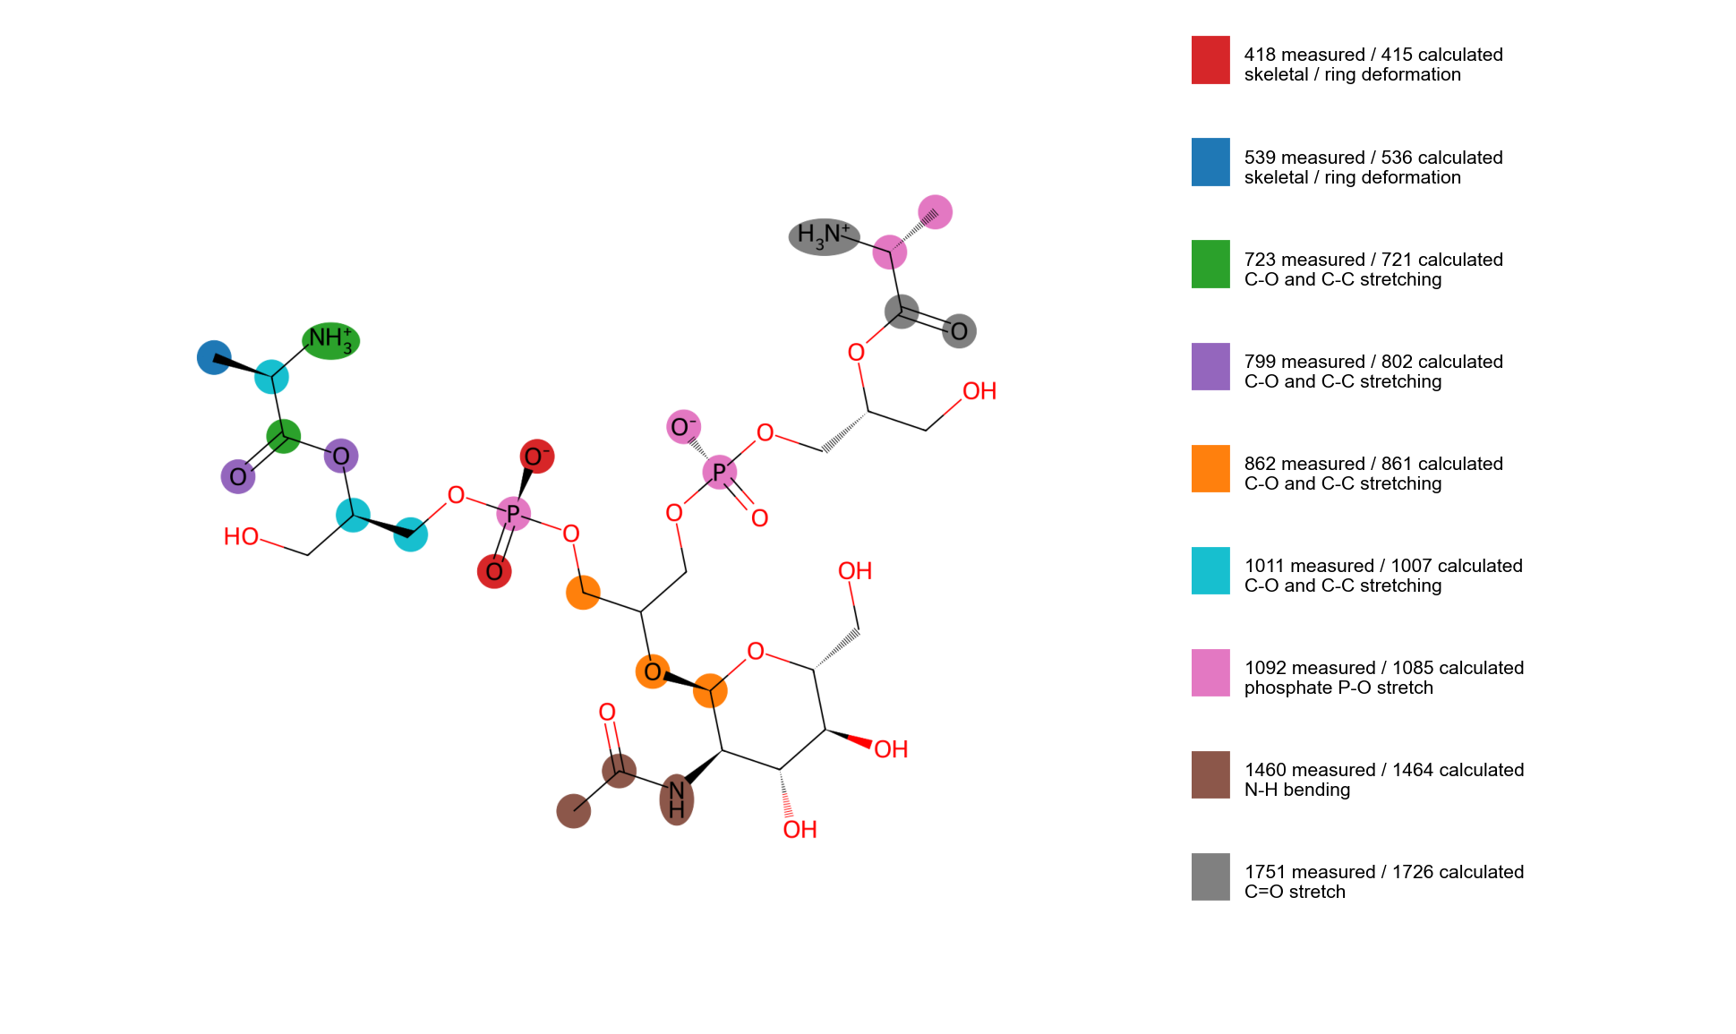
Figure 3. Atoms that move most in the calculated vibrations that correspond to measured peaks. Each colour is one vibration (key at right); the highlighted atoms carry most of the motion. Hydrogen atoms are assigned to the atom they are bonded to.
Table 3. Calculated vibrations matched to measured peaks. 'Confident' means the calculated peak lies within 10 cm⁻¹ of the measured peak and has the expected type of motion; 'tentative' means larger offset (see the comparison report).
Calculated (cm⁻¹) | Matching measured (cm⁻¹) | Assignment (type of vibration) | Confidence
415 | 418 | skeletal / ring deformation | confident
536 | 539 | skeletal / ring deformation | confident
721 | 723 | C-O and C-C stretching (backbone) | confident
802 | 799 | C-O and C-C stretching (backbone) | confident
861 | 862 | C-O and C-C stretching (backbone) | confident
1007 | 1011 | C-O and C-C stretching (backbone) | confident
1085 | 1092 | phosphate P-O stretch | confident
1464 | 1460 | N-H bending (ammonium / amide) | confident
1726 | 1751 | C=O stretch (carbonyl) | tentative

5. Interpretation and limitations
The calculation supports the assignment of the measured peaks to the vibration types listed above and shows which groups of the molecule are responsible. It does not by itself prove the identity of the sample.
- The basis set is small (3-21G), so positions are approximate and intensities distorted, especially for the charged phosphate and ammonium groups; calculated peaks above about 2400 cm⁻¹ (outside the range used here) are probably artefacts of internal hydrogen bonds.
- Only three repeating units and no lipid anchor: end-of-chain effects are exaggerated and repeat-unit bands are under-represented.
- No counter-ions or water; the geometry of the two glycerol arms was assumed rather than checked against the natural form.

6. Conclusion and next step
The calculation gives a usable prediction of the positions and types of the Raman vibrations of lipoteichoic acid (LTA) between 400 and 1800 cm⁻¹ and is the simulation used in the comparison with the measured spectrum. Next step: Finish the higher-level calculation with water, then extend the chain to four or five units with counter-ions and the lipid anchor, and check which atoms move in the calculated peaks near 1085, 860 and 800 cm⁻¹.

