Calculated and Measured Raman Spectra of Lipopolysaccharide (LPS)
Comparison of the simulation with the experimental bulk spectrum

1. Executive summary
The calculated Raman spectrum of the LPS model was compared with the measured spectrum of the neat powder (mean of 10 spectra). Of the 5 measured main and supporting peaks, 5 have a calculated vibration of the expected type within 10 cm⁻¹, 0 have one of the same type that is shifted by 10 to 50 cm⁻¹, and 0 have no calculated counterpart of that type. The two spectra agree in where the peaks fall and in the type of vibration behind them, but not in overall shape (correlation -0.01, glass zone excluded), because calculated intensities are unreliable. The calculation therefore supports the assignment of the measured peaks but does not by itself identify the molecule.

2. Objective
To test whether the peaks measured for the neat powder correspond to vibrations predicted for the molecular structure, and to explain peaks that are shifted or not reproduced, so the calculation can be used as supporting evidence for the identification of the molecule.

3. How the spectra were compared
- Alignment: No shift was applied to either spectrum. The calculated frequencies carry only the single scale factor described in the simulation report (a general correction for the method, not tuned to this measurement).
- Normalisation: Each spectrum was scaled to its own maximum between 400 and 1800 cm⁻¹, so only shape and position are compared, not absolute signal. In the close-ups each curve is scaled to its tallest peak in that window.
- Matching: The measured peaks are the main and supporting peaks of the reference spectrum (mean of repeated spectra). For each, the calculated vibration of the expected type (for example phosphate stretch, ring deformation, CH bending) nearest in position within 50 cm⁻¹ and with appreciable intensity was selected. 'Agrees' means a difference of 10 cm⁻¹ or less. 'Shifted' means 10 to 50 cm⁻¹ with the same type of vibration, so the peak is judged to come from the same bond or group but at a displaced position. 'Not reproduced' means no vibration of that type within 50 cm⁻¹.
- Glass: The glass zone (1308 to 1455 cm⁻¹) is shaded and not used.

4. Results

4.1 Whole spectrum
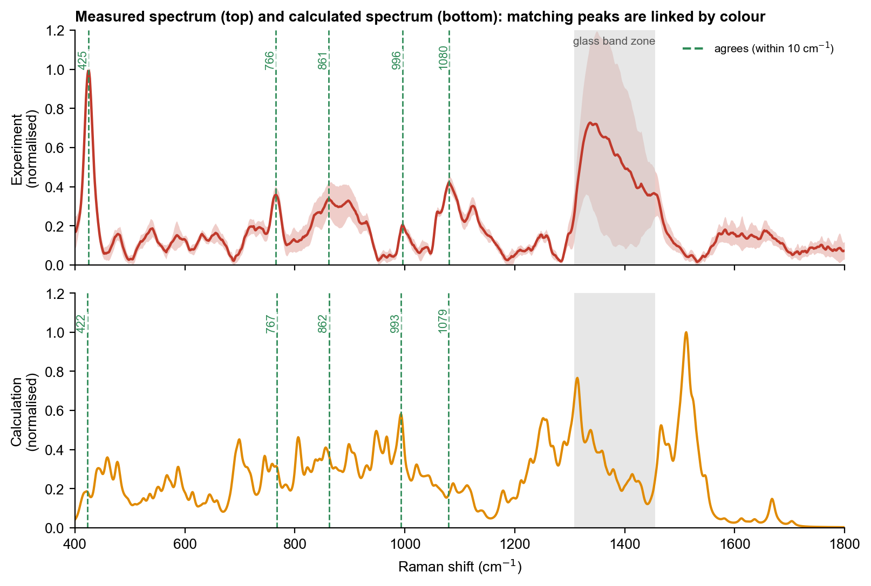
Figure 1. Measured spectrum (top, mean ± 1 standard deviation) and calculated spectrum (bottom), each normalised. Dashed lines join peaks that correspond: green, agree within 10 cm⁻¹; orange, shifted but of the same vibration type; grey, no counterpart of that type.
The calculated spectrum has more peaks than the measurement, because it lists every vibration while the measured peaks are broadened and overlap, and the calculated heights do not follow the measured heights. The overall correlation is therefore low (-0.01) and is not used as evidence of identity. The meaningful comparison is peak by peak.

4.2 Peak-by-peak comparison
Table 1. Measured peaks and the corresponding calculated vibrations. Difference = measured minus calculated.
Measured (cm⁻¹) | Calculated (cm⁻¹) | Difference | Calculated vibration (type) | Result
425 | 422 | +2 | skeletal / ring deformation | Agrees
766 | 767 | -2 | C-O and C-C stretching (backbone) | Agrees
861 | 862 | -1 | C-O and C-C stretching (backbone) | Agrees
996 | 993 | +3 | C-O and C-C stretching (backbone) | Agrees
1080 | 1079 | +1 | C-O and C-C stretching (backbone) | Agrees

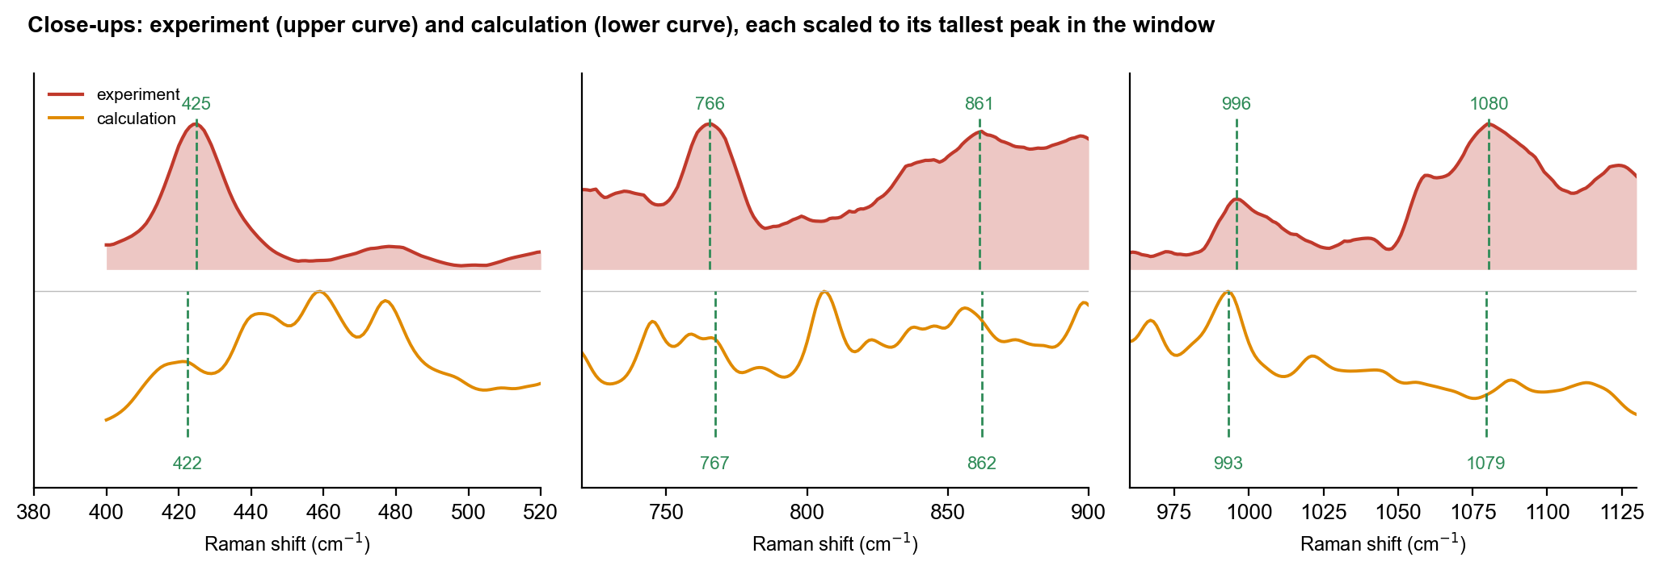
Figure 2. Close-ups of the important regions. Upper curve: measurement; lower curve: calculation. Dashed lines mark the measured peak (above) and the corresponding calculated peak (below); arrows and numbers give the size of the shift where it exceeds 10 cm⁻¹.

4.3 Shifted peaks: same vibration, different position
No peak is shifted by more than 10 cm⁻¹ while keeping the same vibration type.
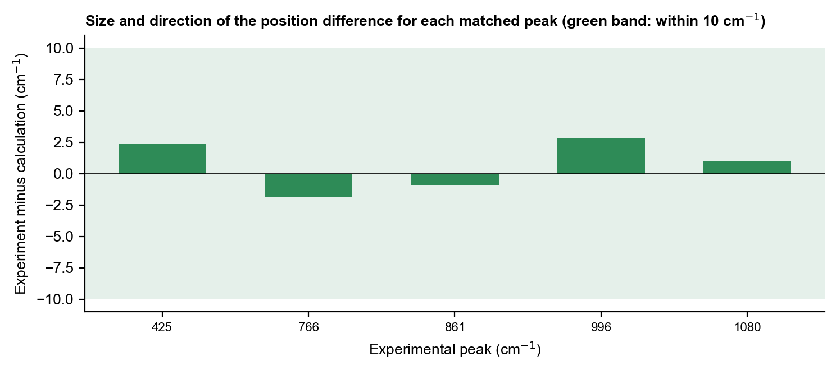
Figure 3. Position difference (measured minus calculated) for every matched peak. Green band: within 10 cm⁻¹.

4.4 Molecule or glass?
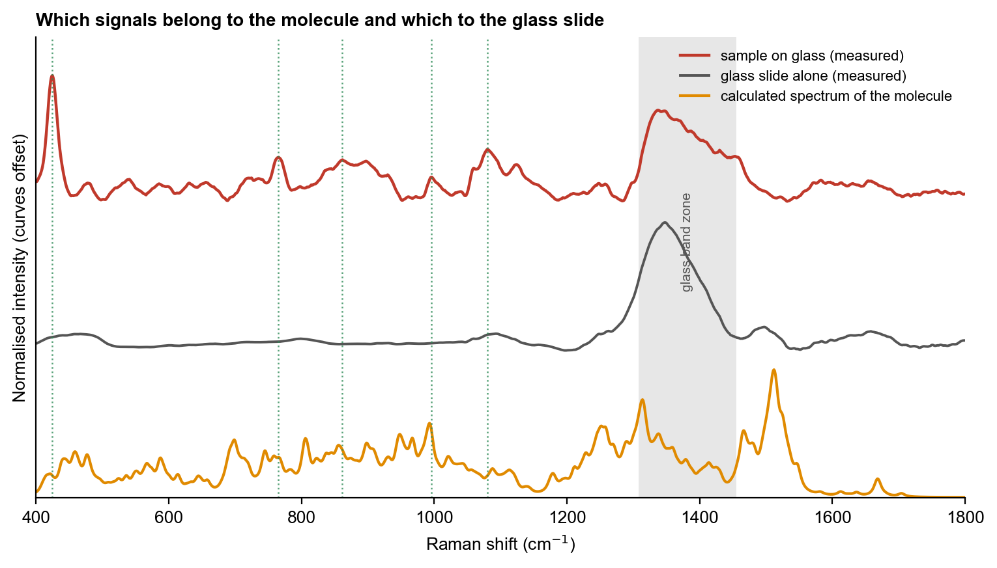
Figure 4. Measured sample on glass, glass slide alone and calculated spectrum. Grey: glass zone; dotted lines: measured molecular peaks. The calculated spectrum is for the molecule only and contains no glass signal.
Measured peaks that fall outside the glass zone and are absent from the blank slide, and that have a calculated molecular vibration at or near the same position, are attributed to the molecule. Peaks in the glass zone are not compared.

4.5 Assignment on the molecular structure
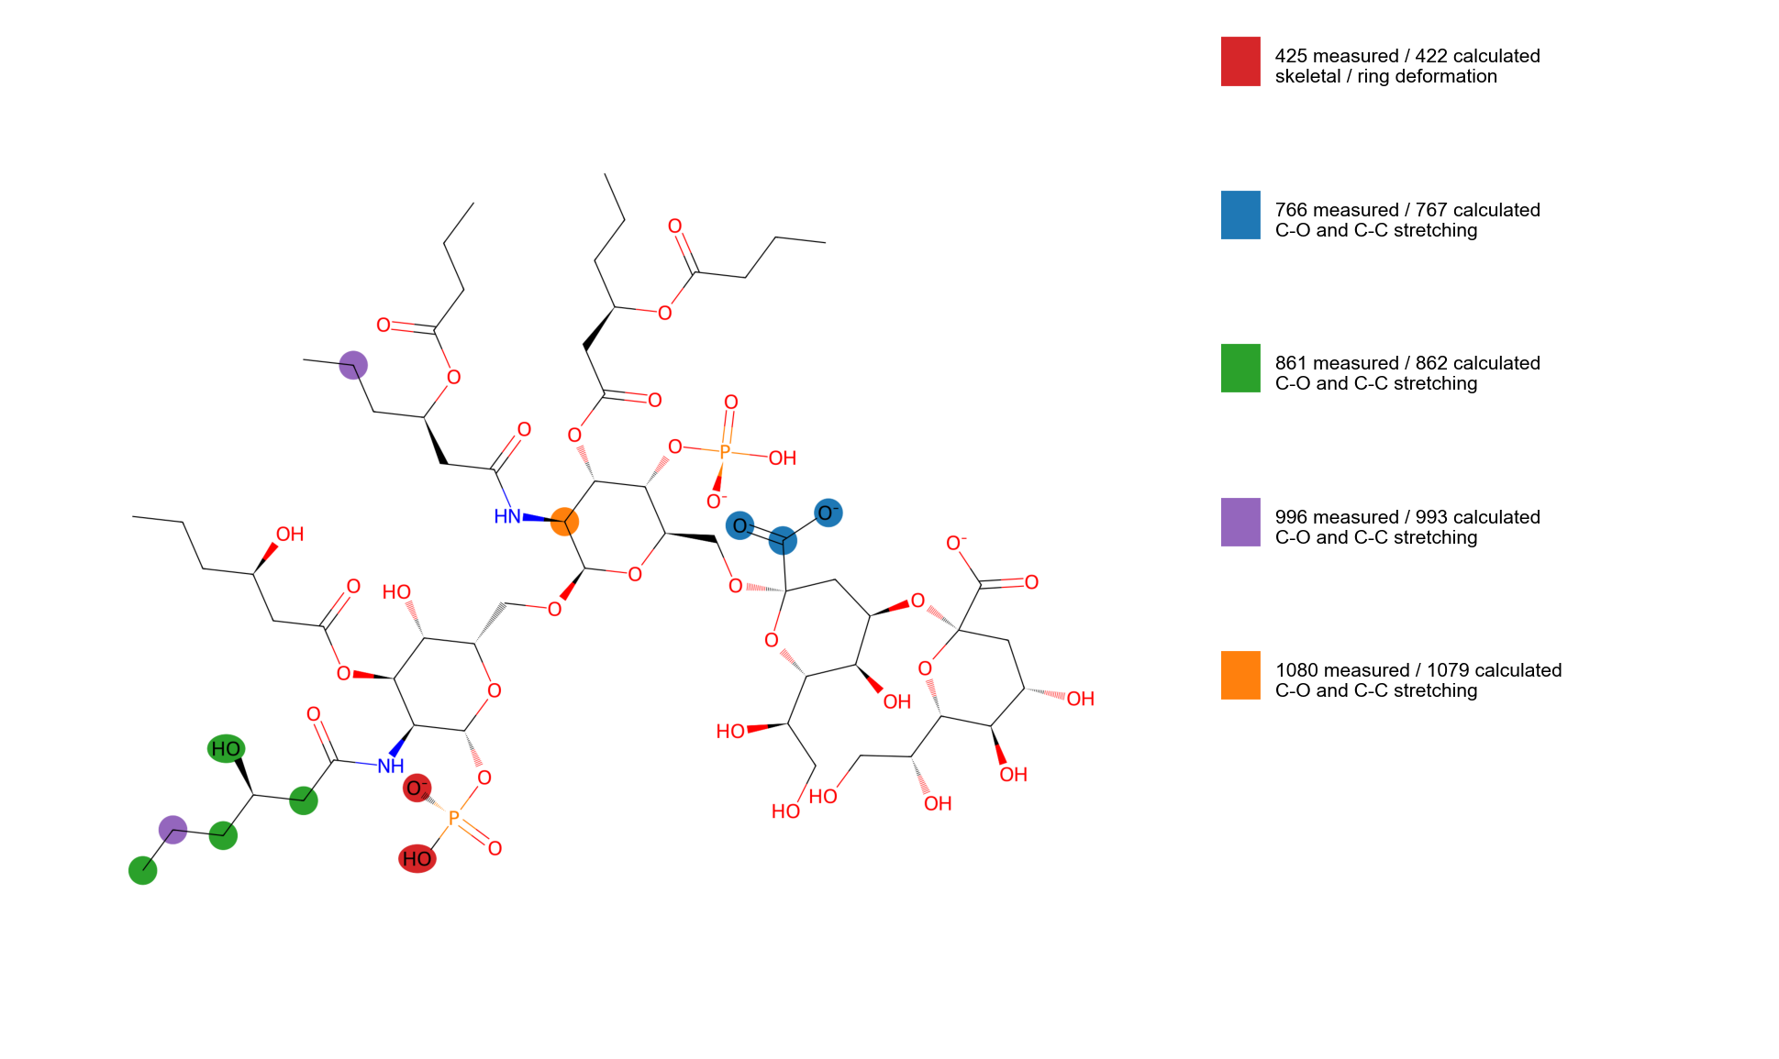
Figure 5. Atoms that move most in the calculated vibrations that correspond to measured peaks. Colours link each calculated vibration to its measured peak (key at right).
Highlighted atoms are heavy atoms only; the vibrations of this large molecule are spread over several groups.

5. Interpretation
All five measured LPS peaks have a calculated vibration of the expected type within 3 cm⁻¹. This includes the 425 cm⁻¹ peak, which the calculation places on a low-frequency skeletal deformation of lipid A, and the 861, 996 and 1080 cm⁻¹ peaks on sugar C–O and C–C stretching. The agreement should be read with care: the model has 354 vibrations between 400 and 1800 cm⁻¹, so a calculated peak is almost always close to any measured peak, and a test with randomly displaced calculated peaks reached the same level of agreement about every second time (p = 0.57). The measured 1080 cm⁻¹ peak is matched by a sugar C–O stretch rather than by a phosphate vibration. Together, this supports the assignment of the LPS peaks to sugar and phosphate backbone motions, but does not establish the origin of the 425 cm⁻¹ peak.

6. Conclusion and next step
The calculation and the measurement agree on peak positions and vibration types for 5 of 5 LPS peaks, with the shifts explained by the isolated-molecule, small-model and gas-phase nature of the calculation. They do not agree on intensities or overall shape. The calculation is used as supporting evidence for peak assignment ('consistent with'), not as proof of identity; identification rests on the reproducible measured fingerprint and its separation from the other two molecules. Next step: Repeat the calculation with a larger basis set and water, add sodium or calcium counter-ions and longer chains, and analyse the motions behind the calculated peaks near 422 and 862 cm⁻¹, to decide what the unassigned 425 cm⁻¹ measured peak is.

