Calculated and Measured Raman Spectra of Lipoteichoic acid (LTA)
Comparison of the simulation with the experimental bulk spectrum

1. Executive summary
The calculated Raman spectrum of the LTA model was compared with the measured spectrum of the neat powder (mean of 17 spectra). Of the 9 measured main and supporting peaks, 8 have a calculated vibration of the expected type within 10 cm⁻¹, 1 have one of the same type that is shifted by 10 to 50 cm⁻¹, and 0 have no calculated counterpart of that type. The two spectra agree in where the peaks fall and in the type of vibration behind them, but not in overall shape (correlation 0.01, glass zone excluded), because calculated intensities are unreliable. The calculation therefore supports the assignment of the measured peaks but does not by itself identify the molecule.

2. Objective
To test whether the peaks measured for the neat powder correspond to vibrations predicted for the molecular structure, and to explain peaks that are shifted or not reproduced, so the calculation can be used as supporting evidence for the identification of the molecule.

3. How the spectra were compared
- Alignment: No shift was applied to either spectrum. The calculated frequencies carry only the single scale factor described in the simulation report (a general correction for the method, not tuned to this measurement).
- Normalisation: Each spectrum was scaled to its own maximum between 400 and 1800 cm⁻¹, so only shape and position are compared, not absolute signal. In the close-ups each curve is scaled to its tallest peak in that window.
- Matching: The measured peaks are the main and supporting peaks of the reference spectrum (mean of repeated spectra). For each, the calculated vibration of the expected type (for example phosphate stretch, ring deformation, CH bending) nearest in position within 50 cm⁻¹ and with appreciable intensity was selected. 'Agrees' means a difference of 10 cm⁻¹ or less. 'Shifted' means 10 to 50 cm⁻¹ with the same type of vibration, so the peak is judged to come from the same bond or group but at a displaced position. 'Not reproduced' means no vibration of that type within 50 cm⁻¹.
- Glass: The glass zone (1308 to 1455 cm⁻¹) is shaded and not used.

4. Results

4.1 Whole spectrum
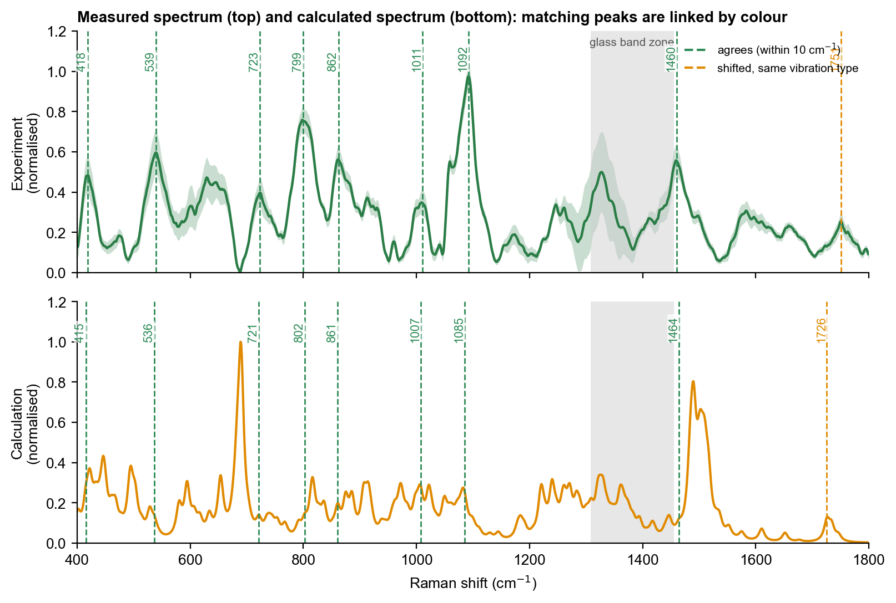
Figure 1. Measured spectrum (top, mean ± 1 standard deviation) and calculated spectrum (bottom), each normalised. Dashed lines join peaks that correspond: green, agree within 10 cm⁻¹; orange, shifted but of the same vibration type; grey, no counterpart of that type.
The calculated spectrum has more peaks than the measurement, because it lists every vibration while the measured peaks are broadened and overlap, and the calculated heights do not follow the measured heights. The overall correlation is therefore low (0.01) and is not used as evidence of identity. The meaningful comparison is peak by peak.

4.2 Peak-by-peak comparison
Table 1. Measured peaks and the corresponding calculated vibrations. Difference = measured minus calculated.
Measured (cm⁻¹) | Calculated (cm⁻¹) | Difference | Calculated vibration (type) | Result
418 | 415 | +3 | skeletal / ring deformation | Agrees
539 | 536 | +3 | skeletal / ring deformation | Agrees
723 | 721 | +2 | C-O and C-C stretching (backbone) | Agrees
799 | 802 | -3 | C-O and C-C stretching (backbone) | Agrees
862 | 861 | +1 | C-O and C-C stretching (backbone) | Agrees
1011 | 1007 | +3 | C-O and C-C stretching (backbone) | Agrees
1092 | 1085 | +7 | phosphate P-O stretch | Agrees
1460 | 1464 | -4 | N-H bending (ammonium / amide) | Agrees
1751 | 1726 | +25 | C=O stretch (carbonyl) | Shifted, same vibration

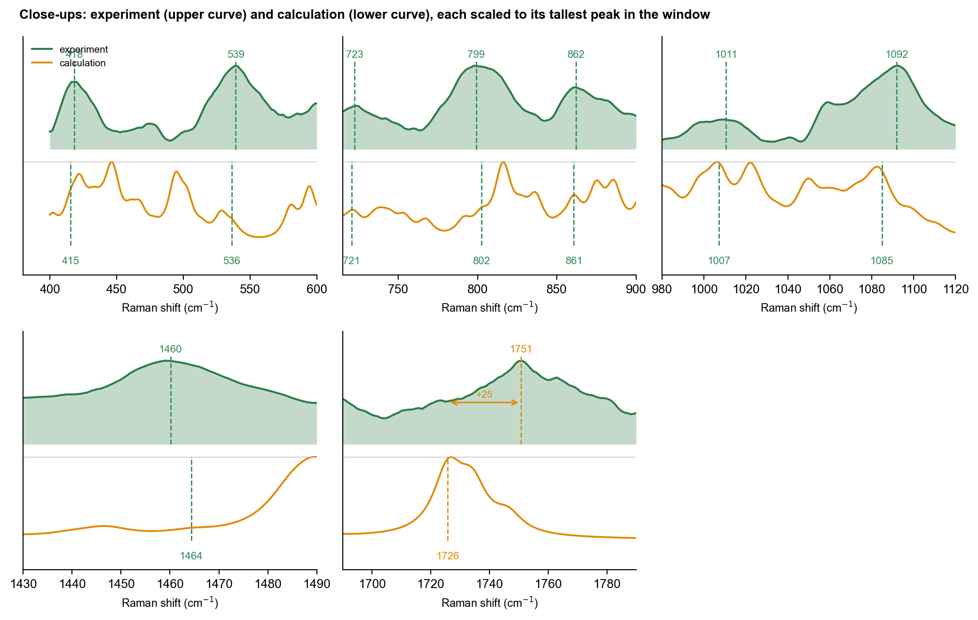
Figure 2. Close-ups of the important regions. Upper curve: measurement; lower curve: calculation. Dashed lines mark the measured peak (above) and the corresponding calculated peak (below); arrows and numbers give the size of the shift where it exceeds 10 cm⁻¹.

4.3 Shifted peaks: same vibration, different position
The following peaks do not coincide in position, but the calculated vibration that lies nearest is of the same type as the one expected for the measured peak, so they are treated as the same peak and the same bond or group, displaced:
- measured 1751, calculated 1726 (+25 cm⁻¹): C=O stretch (carbonyl). Expected assignment: ester C=O stretch (supported by the calculation only). The calculated peak lies at lower wavenumber than the measured one. A small basis set and isolated charged or hydrogen-bonded groups (no counter-ions or neighbouring molecules) can lower the calculated frequency, and the powder environment can raise the measured one.
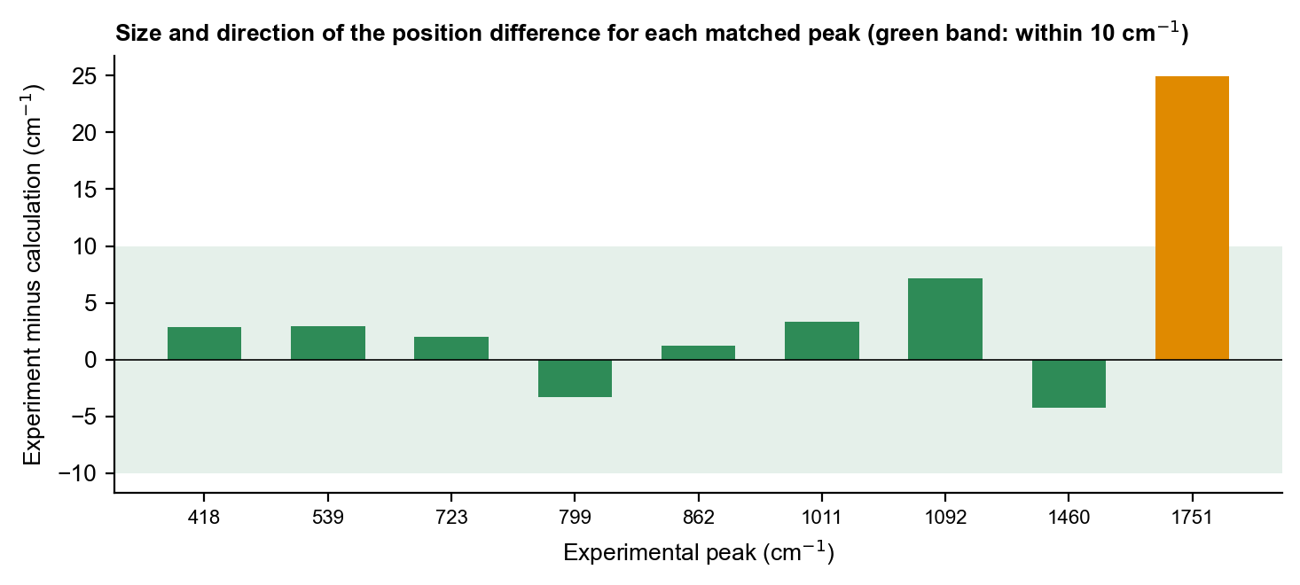
Figure 3. Position difference (measured minus calculated) for every matched peak. Green band: within 10 cm⁻¹.

4.4 Molecule or glass?
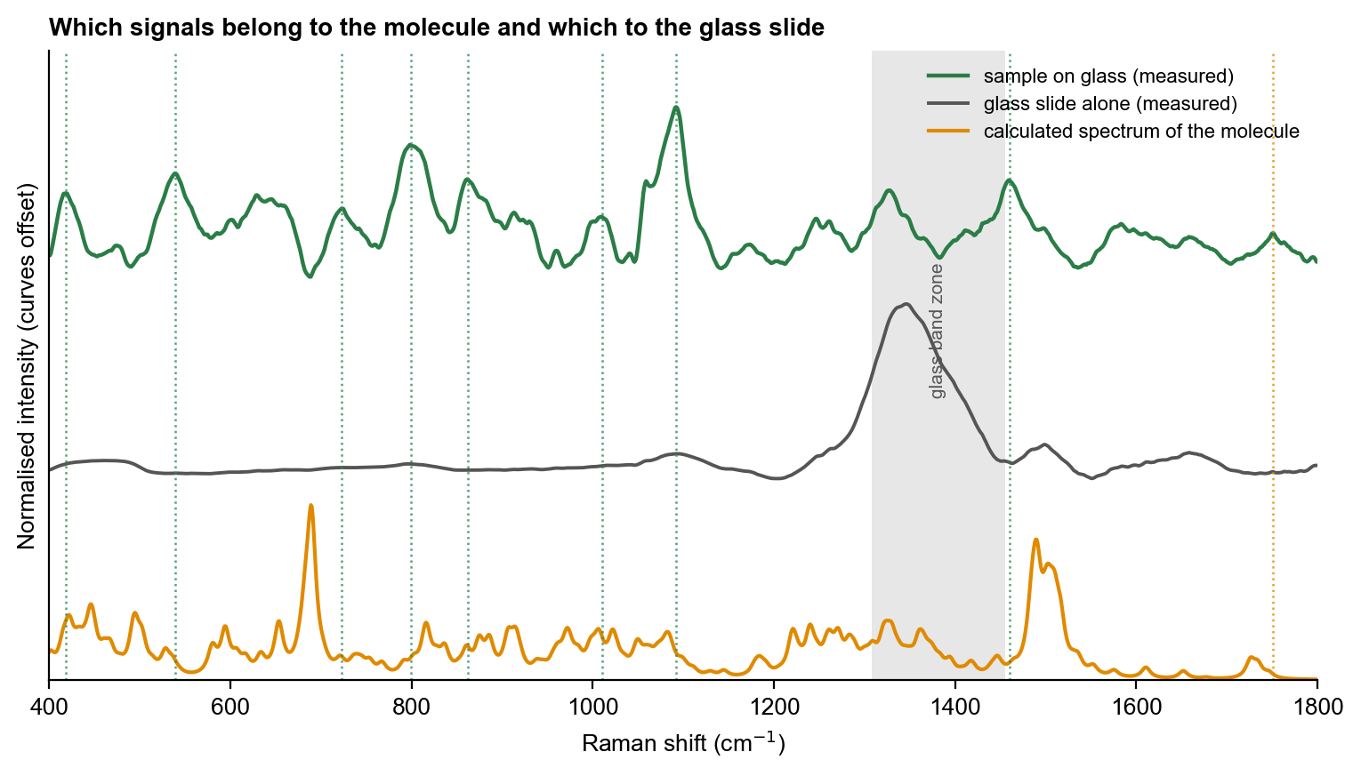
Figure 4. Measured sample on glass, glass slide alone and calculated spectrum. Grey: glass zone; dotted lines: measured molecular peaks. The calculated spectrum is for the molecule only and contains no glass signal.
Measured peaks that fall outside the glass zone and are absent from the blank slide, and that have a calculated molecular vibration at or near the same position, are attributed to the molecule. Peaks in the glass zone are not compared.

4.5 Assignment on the molecular structure
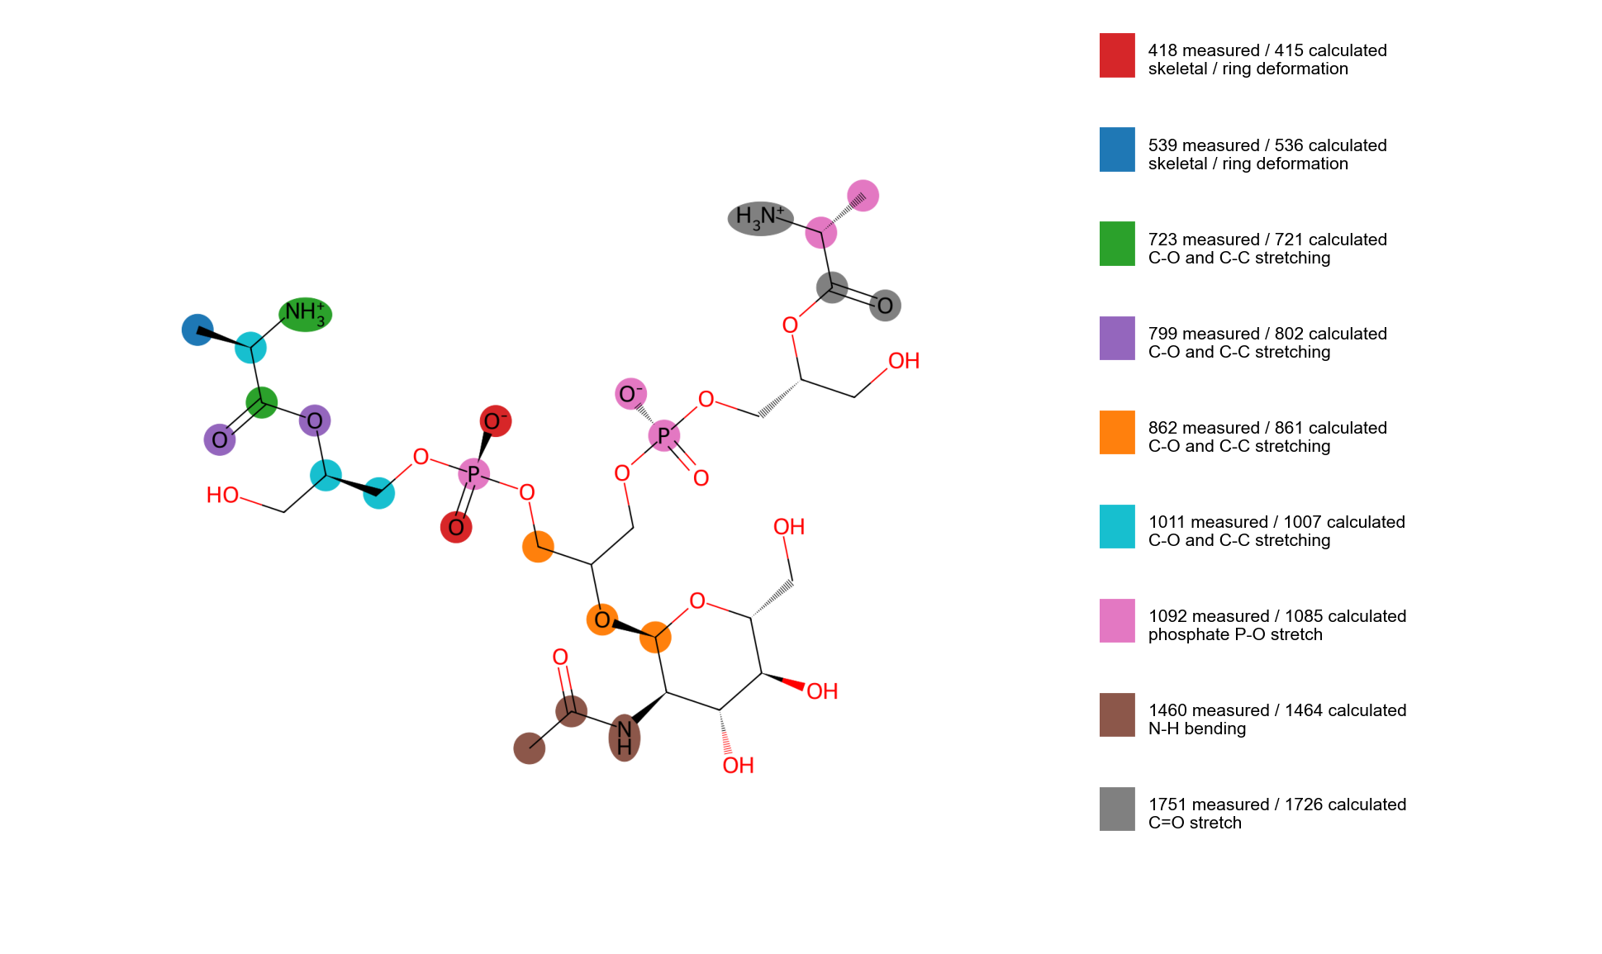
Figure 5. Atoms that move most in the calculated vibrations that correspond to measured peaks. Colours link each calculated vibration to its measured peak (key at right).
The phosphate group (pink) is responsible for the calculated peak that corresponds to the strong 1092 cm⁻¹ measured peak.

5. Interpretation
All measured LTA peaks except 1751 cm⁻¹ have a calculated vibration of the expected type within 7 cm⁻¹, including the strongest measured peak, 1092 cm⁻¹, which matches a phosphate P–O stretching vibration at 1085 cm⁻¹, and the 799 and 862 cm⁻¹ peaks, which match C–O and C–C stretching vibrations of the glycerol-phosphate backbone and sugar. The 1751 cm⁻¹ peak corresponds to a calculated ester C=O stretch at 1726 cm⁻¹ (shifted by 25 cm⁻¹): a lower calculated C=O frequency is likely related to the isolated, charged model with a small basis set, in which the carbonyl can interact with the nearby ammonium group; the powder environment is different. The nearest calculated peak to 1751 cm⁻¹ in position (1746 cm⁻¹) is an N–H motion and was not used, because it is not a C=O vibration. The calculated vibrations that match are weak in intensity, and the strongest calculated peaks (690 and 1490 to 1510 cm⁻¹) are not seen in the measurement, so the overall shape does not agree. In a test with randomly displaced calculated peaks (which counts the nearest calculated peak whatever its type), agreement at 5 cm⁻¹ was reached in fewer than 1 in 1000 trials, but at 10 cm⁻¹ about 1 in 14 (p = 0.07). The agreement therefore supports the phosphate, glycerol and ester assignments but does not identify LTA on its own.

6. Conclusion and next step
The calculation and the measurement agree on peak positions and vibration types for 9 of 9 LTA peaks, with the shifts explained by the isolated-molecule, small-model and gas-phase nature of the calculation. They do not agree on intensities or overall shape. The calculation is used as supporting evidence for peak assignment ('consistent with'), not as proof of identity; identification rests on the reproducible measured fingerprint and its separation from the other two molecules. Next step: Finish the higher-level calculation with water, then extend the chain to four or five units with counter-ions and the lipid anchor, and check which atoms move in the calculated peaks near 1085, 860 and 800 cm⁻¹.

