Calculated and Measured Raman Spectra of N-acetylmuramic acid (NAM)
Comparison of the simulation with the experimental bulk spectrum

1. Executive summary
The calculated Raman spectrum of the NAM model was compared with the measured spectrum of the neat powder (mean of 15 spectra). Of the 11 measured main and supporting peaks, 7 have a calculated vibration of the expected type within 10 cm⁻¹, 3 have one of the same type that is shifted by 10 to 50 cm⁻¹, and 1 have no calculated counterpart of that type. The two spectra agree in where the peaks fall and in the type of vibration behind them, but not in overall shape (correlation 0.12, glass zone excluded), because calculated intensities are unreliable. The calculation therefore supports the assignment of the measured peaks but does not by itself identify the molecule.

2. Objective
To test whether the peaks measured for the neat powder correspond to vibrations predicted for the molecular structure, and to explain peaks that are shifted or not reproduced, so the calculation can be used as supporting evidence for the identification of the molecule.

3. How the spectra were compared
- Alignment: No shift was applied to either spectrum. The calculated frequencies carry only the single scale factor described in the simulation report (a general correction for the method, not tuned to this measurement).
- Normalisation: Each spectrum was scaled to its own maximum between 400 and 1800 cm⁻¹, so only shape and position are compared, not absolute signal. In the close-ups each curve is scaled to its tallest peak in that window.
- Matching: The measured peaks are the main and supporting peaks of the reference spectrum (mean of repeated spectra). For each, the calculated vibration of the expected type (for example phosphate stretch, ring deformation, CH bending) nearest in position within 50 cm⁻¹ and with appreciable intensity was selected. 'Agrees' means a difference of 10 cm⁻¹ or less. 'Shifted' means 10 to 50 cm⁻¹ with the same type of vibration, so the peak is judged to come from the same bond or group but at a displaced position. 'Not reproduced' means no vibration of that type within 50 cm⁻¹.
- Glass: The glass zone (1308 to 1455 cm⁻¹) is shaded and not used.

4. Results

4.1 Whole spectrum
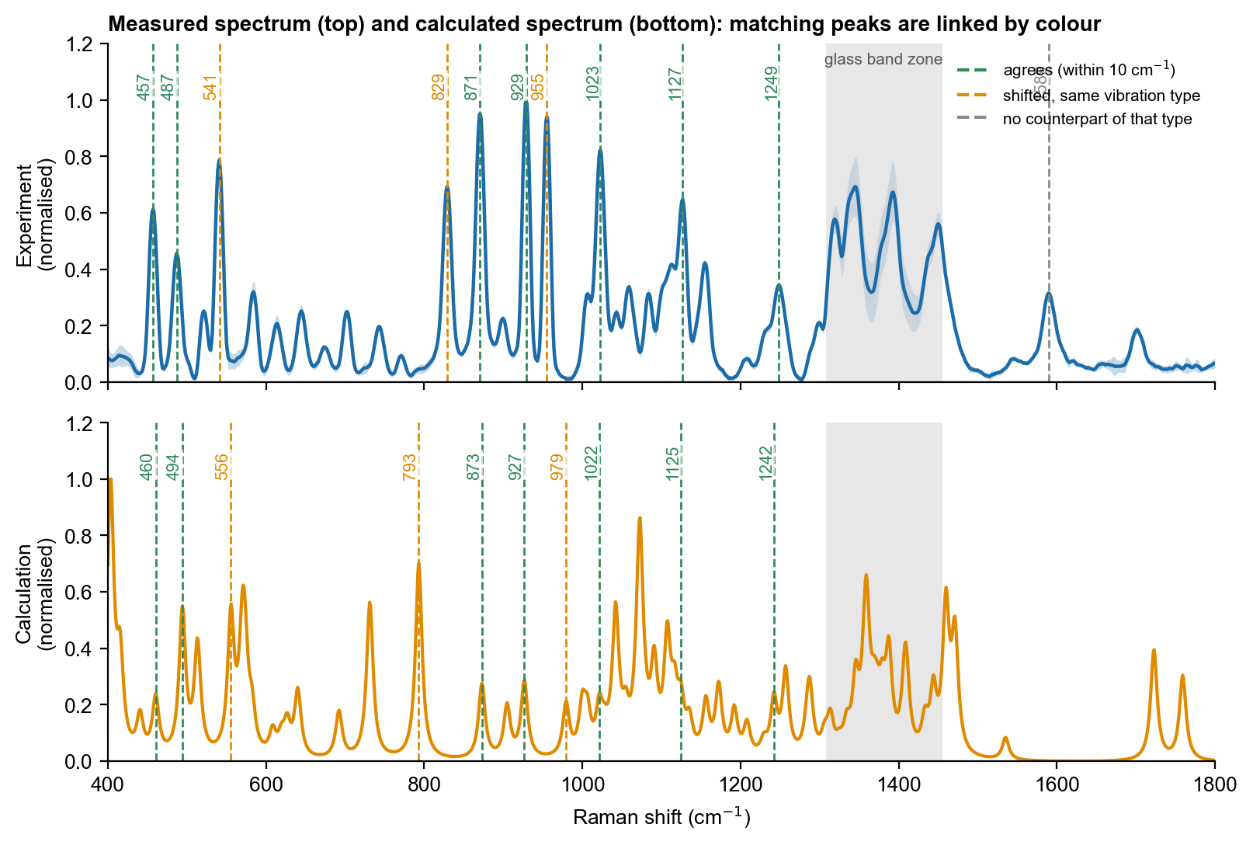
Figure 1. Measured spectrum (top, mean ± 1 standard deviation) and calculated spectrum (bottom), each normalised. Dashed lines join peaks that correspond: green, agree within 10 cm⁻¹; orange, shifted but of the same vibration type; grey, no counterpart of that type.
The calculated spectrum has more peaks than the measurement, because it lists every vibration while the measured peaks are broadened and overlap, and the calculated heights do not follow the measured heights. The overall correlation is therefore low (0.12) and is not used as evidence of identity. The meaningful comparison is peak by peak.

4.2 Peak-by-peak comparison
Table 1. Measured peaks and the corresponding calculated vibrations. Difference = measured minus calculated.
Measured (cm⁻¹) | Calculated (cm⁻¹) | Difference | Calculated vibration (type) | Result
457 | 460 | -3 | skeletal / ring deformation | Agrees
487 | 494 | -7 | skeletal / ring deformation | Agrees
541 | 556 | -15 | skeletal / ring deformation | Shifted, same vibration
829 | 793 | +36 | C-O and C-C stretching (backbone) | Shifted, same vibration
871 | 873 | -2 | C-O and C-C stretching (backbone) | Agrees
929 | 927 | +2 | C-O and C-C stretching (backbone) | Agrees
955 | 979 | -24 | C-O and C-C stretching (backbone) | Shifted, same vibration
1023 | 1022 | +1 | C-O and C-C stretching (backbone) | Agrees
1127 | 1125 | +2 | C-O and C-C stretching (backbone) | Agrees
1249 | 1242 | +6 | C-H bending / CH2 rocking and twisting | Agrees
1589 | — | — | nearest calculated peak 1535: N-H bending (ammonium / amide) | Not reproduced

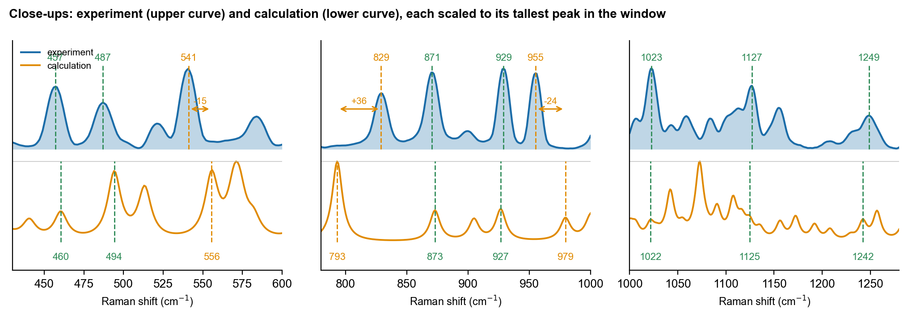
Figure 2. Close-ups of the important regions. Upper curve: measurement; lower curve: calculation. Dashed lines mark the measured peak (above) and the corresponding calculated peak (below); arrows and numbers give the size of the shift where it exceeds 10 cm⁻¹.

4.3 Shifted peaks: same vibration, different position
The following peaks do not coincide in position, but the calculated vibration that lies nearest is of the same type as the one expected for the measured peak, so they are treated as the same peak and the same bond or group, displaced:
- measured 541, calculated 556 (-15 cm⁻¹): skeletal / ring deformation. Expected assignment: ring deformation, C-C-O / C-C-C. The calculated peak lies at higher wavenumber than the measured one. This is the usual direction for a harmonic calculation of an isolated molecule, because hydrogen bonding and packing in the powder soften vibrations that the calculation does not include, and the scale factor is only approximate.
- measured 829, calculated 793 (+36 cm⁻¹): C-O and C-C stretching (backbone). Expected assignment: C-O-C and ring stretching (sugar "anomeric" region). The calculated peak lies at lower wavenumber than the measured one. A small basis set and isolated charged or hydrogen-bonded groups (no counter-ions or neighbouring molecules) can lower the calculated frequency, and the powder environment can raise the measured one. The offset is large, so the correspondence is tentative.
- measured 955, calculated 979 (-24 cm⁻¹): C-O and C-C stretching (backbone). Expected assignment: C-C stretching or CH3 rocking (tentative). The calculated peak lies at higher wavenumber than the measured one. This is the usual direction for a harmonic calculation of an isolated molecule, because hydrogen bonding and packing in the powder soften vibrations that the calculation does not include, and the scale factor is only approximate.
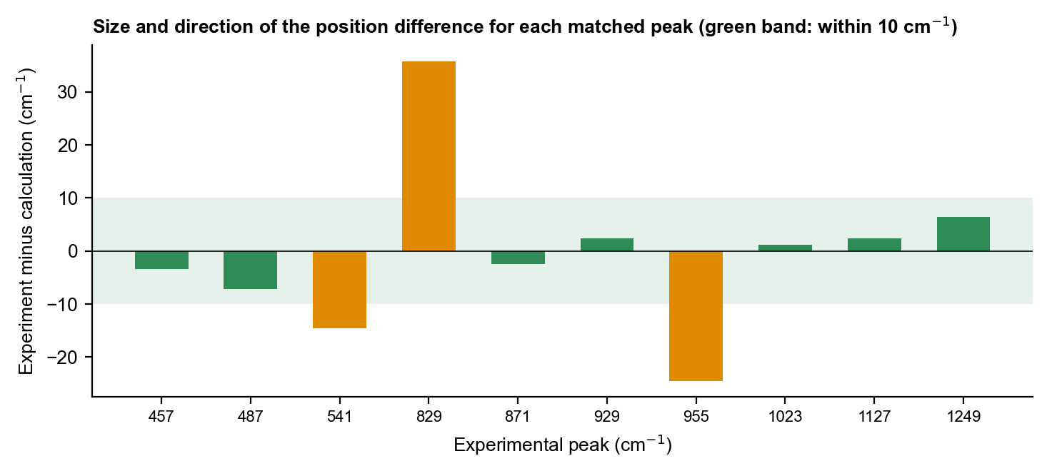
Figure 3. Position difference (measured minus calculated) for every matched peak. Green band: within 10 cm⁻¹.

4.4 Peaks not reproduced
- measured 1589: no firm assignment. No calculated vibration of this type lies within 50 cm⁻¹; the nearest calculated peak (1535) is a different type (N-H bending (ammonium / amide)). This peak is not explained by the present model.

4.5 Molecule or glass?
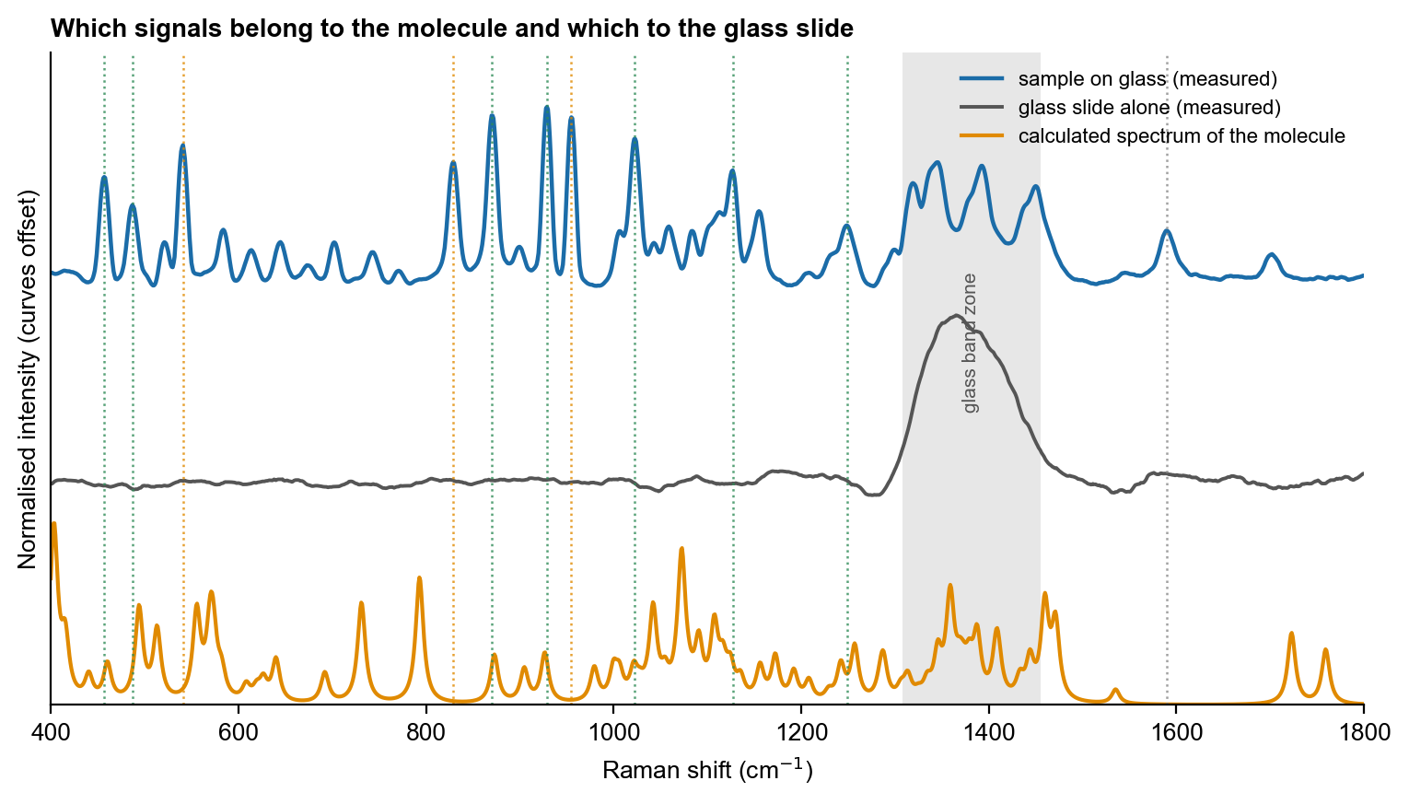
Figure 4. Measured sample on glass, glass slide alone and calculated spectrum. Grey: glass zone; dotted lines: measured molecular peaks. The calculated spectrum is for the molecule only and contains no glass signal.
Measured peaks that fall outside the glass zone and are absent from the blank slide, and that have a calculated molecular vibration at or near the same position, are attributed to the molecule. Peaks in the glass zone are not compared.

4.6 Assignment on the molecular structure
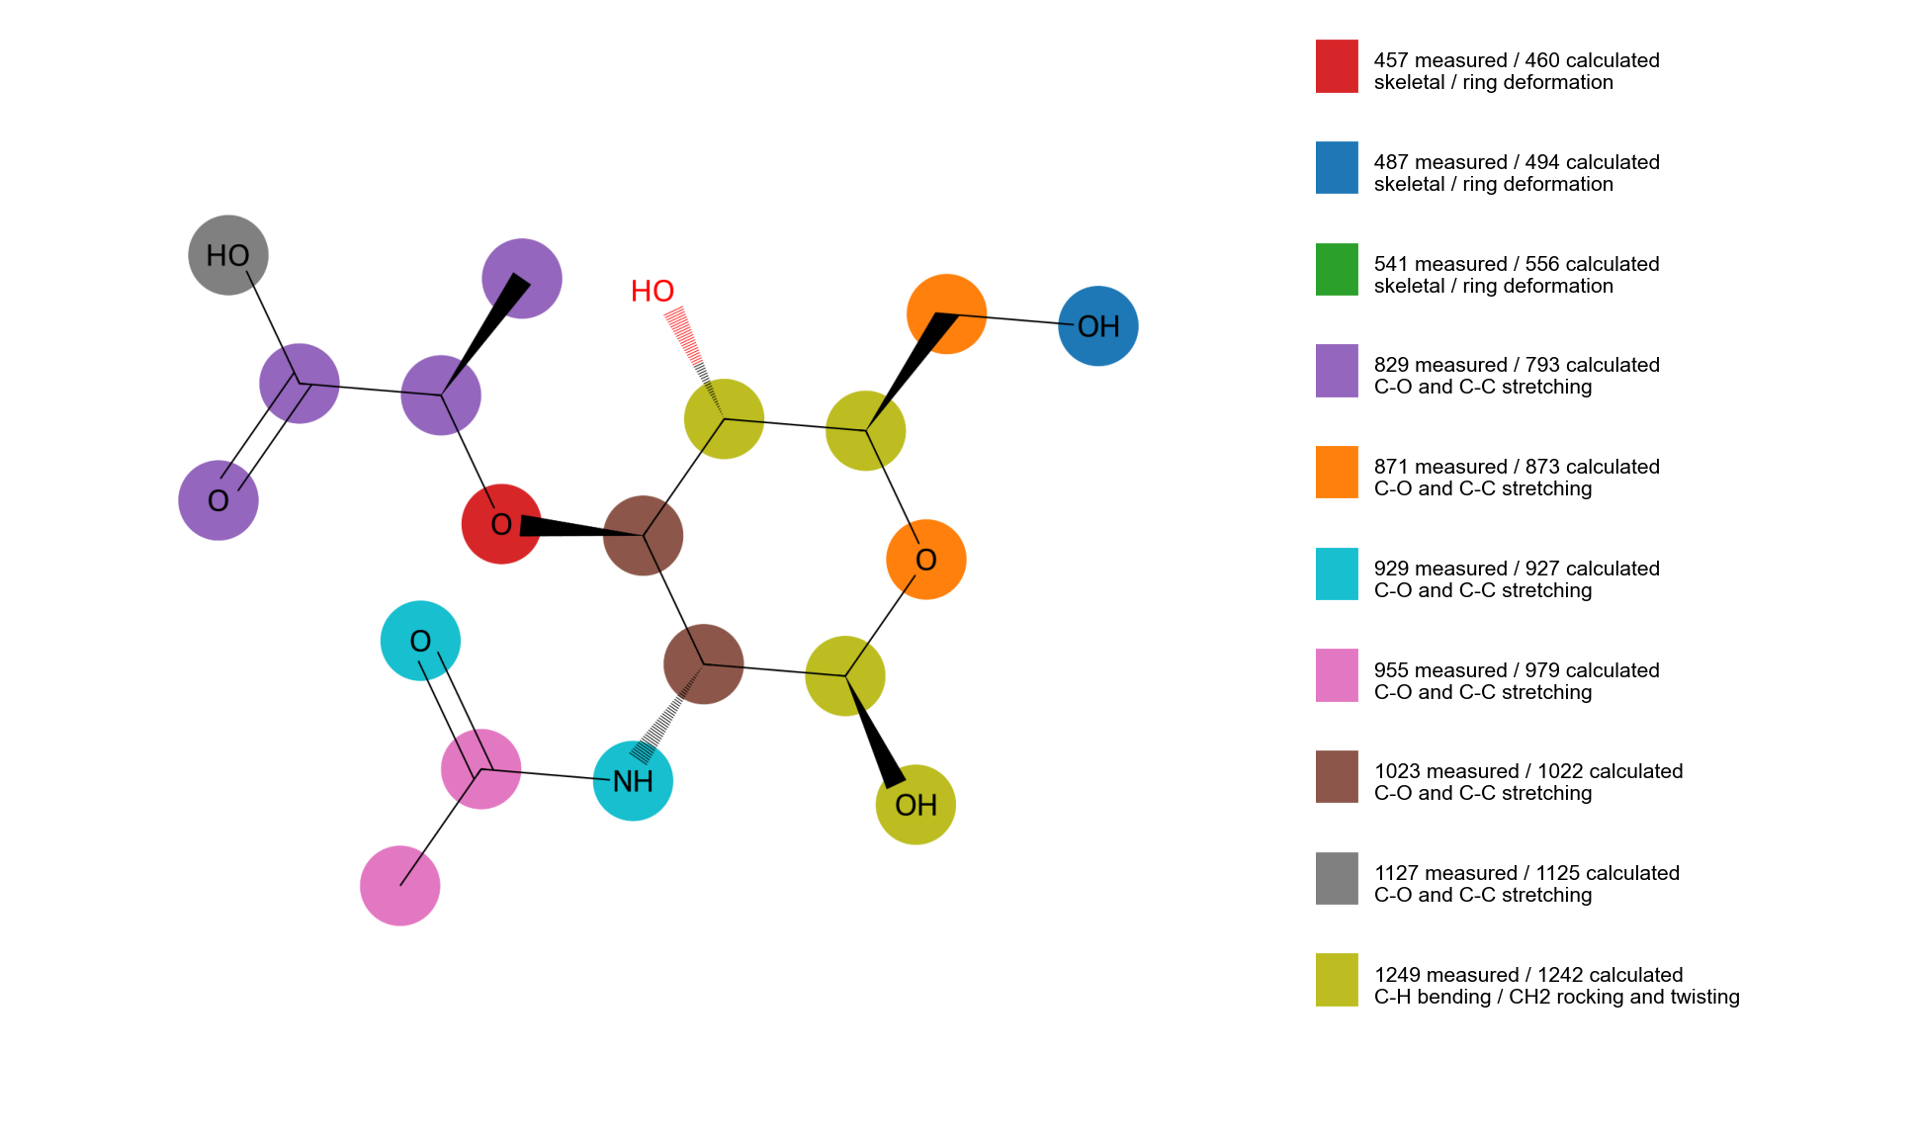
Figure 5. Atoms that move most in the calculated vibrations that correspond to measured peaks. Colours link each calculated vibration to its measured peak (key at right).
Many NAM vibrations involve the whole ring at once, so the highlighted atoms are broad groups rather than single bonds.

5. Interpretation
Seven of the eleven measured NAM peaks have a calculated vibration of the expected ring-deformation or C–O / C–C stretching type within 10 cm⁻¹ (457, 487, 871, 929, 1023, 1127 and 1249 cm⁻¹). The 541 and 955 cm⁻¹ peaks are matched with shifts of 15 and 24 cm⁻¹ and the 829 cm⁻¹ main peak with a shift of 36 cm⁻¹ to a strong calculated ring stretching mode at 793 cm⁻¹; this correspondence is the least certain and is the main unexplained feature of the NAM spectrum, and the 1589 cm⁻¹ peak has no counterpart. Because the sample is a mixture of alpha and beta forms and the calculation is for the beta form of a single molecule, some displacement of the sugar-ring modes is expected. The agreement is useful to assign the measured peaks to sugar-ring vibrations; it is not a stand-alone identification.

6. Conclusion and next step
The calculation and the measurement agree on peak positions and vibration types for 10 of 11 NAM peaks, with the shifts explained by the isolated-molecule, small-model and gas-phase nature of the calculation. They do not agree on intensities or overall shape. The calculation is used as supporting evidence for peak assignment ('consistent with'), not as proof of identity; identification rests on the reproducible measured fingerprint and its separation from the other two molecules. Next step: Calculate the alpha and beta forms together and combine them in proportion to their expected populations, and model a small cluster of NAM molecules to capture hydrogen bonding in the powder.

