Raman Simulation (DFT) of NAM, LPS and LTA: Software, Settings, Spectra Obtained and Approach
Software, settings, simulated spectra and the reasons for the fragment and shortened-molecule approaches
SERS Sepsis project, bulk-powder Raman spectral library. Version 1.1, 28 October 2026. Source files: C:\Users\sukes\Downloads\mtp (inventory in Section 10).
This document records the simulation work only; the comparison with the measured spectra is in a separate document. NAM was calculated as a whole molecule. For LPS there are two calculations: five separate fragments, and a model of the Kdo2-lipid A backbone with shortened acyl chains (201 atoms, run 27-28 Oct 2026). LTA was simulated as three separate fragments. The intact LPS and LTA molecules are too large and variable to calculate (Section 7), so no whole-LPS or whole-LTA spectrum was simulated. Settings that are not written in the available files are given as Not recorded.

1. Summary
 | NAM | LPS | LTA
What was simulated | The whole molecule (beta anomer); alpha anomer also run | Five separate fragments: KDO, heptose, D-glucosamine, myristic acid, phosphoric acid Also: one model of Kdo2-lipid A with shortened chains (2 glucosamines, 2 Kdo, 2 phosphates, 2 amides) | Three separate fragments: glycerol-phosphate (2 units), D-alanine, N-acetyl-D-glucosamine
Number of atoms per calculation | 39 | Not recorded for the fragments (small molecules). Lipid A model: 201 (C60H98N2O39P2, charge -4) | 35 for glycerol-phosphate; others Not recorded
Software | Gaussian 16 Rev C.01 | Gaussian (version Not recorded in files read). Lipid A model: Gaussian 16W Rev C.01 | Gaussian 16 Rev C.01 (log read for glycerol-phosphate)
Method and basis set | B3LYP-D3BJ / 6-311++G(d,p) (final) | B3LYP / 6-31G(d). Lipid A model: PM6 pre-optimisation, then B3LYP / 3-21G | B3LYP / 6-31G(d)
Environment | Gas phase | Gas phase (no solvent keyword in the documented route). Lipid A model: gas phase, no counter-ions | Implicit water (SMD)
Frequency scale factor | 0.980 below 1800 cm-1; 0.967 above | 0.9613. Lipid A model: 0.965 (not fitted for 3-21G) | 0.96 (0.96 to 0.97 evaluated)
Imaginary frequencies | None (true minimum) | Stated as none significant; logs Not found. Lipid A model: none (597 modes; true minimum) | None (glycerol-phosphate log); others Not found
Spectra obtained | 111 modes; broadened spectrum 400-1800 cm-1 | 375 discrete modes in total (5 files). Lipid A model: 597 modes (354 in 400-1800 cm-1), broadened 785 nm spectrum 200-3300 cm-1 | Broadened curves for 3 fragments; 99 modes for glycerol-phosphate
Why this approach | Small molecule, well defined | Intact LPS far too large and variable. Lipid A model: the largest piece of LPS that could be run on this PC with a whole-molecule calculation | Intact LTA a variable polymer

2. Software and hardware
Tool | Used for | Version / detail (as found in files)
Gaussian 16 | DFT geometry optimisation, harmonic frequencies and Raman activities (final NAM, NAM alpha, LTA glycerol-phosphate) and the LPS lipid A model | Revision C.01, EM64W-G16RevC.01, build date 30-May-2019, Windows 64-bit; lipid A model: Gaussian 16W (Windows) Revision C.01, C:\G16W\g16.exe
PubChem | Starting 3D structures (NAM conformer CID 5462244; LPS fragments in 3D format) | Online database
Avogadro | Structure checking, hydrogen addition, molecular-mechanics clean-up (named in the LTA settings document) | Version Not recorded. The LPS document does not name the program it used for the same steps.
RDKit (Python) | Building the shortened Kdo2-lipid A model (version 2026.03.3: SMILES, chain shortening, ionisation, 300 conformers, MMFF) and the earlier lipid A proxy; writing Gaussian and ORCA inputs | Version Not recorded
Python / Jupyter / Excel | Reading logs, scaling, broadening, normalising, combining fragment spectra | pandas, numpy, scipy, matplotlib; versions Not recorded
Raman-spectrum export for LPS and LTA fragments | Text files headed "Raman Scattering Spectrum", y-axis in 10-36 m2 cm/sr, "Harmonic Data" | Exporting program Not named in the files; the format is a Gaussian-output viewer export. Excitation wavelength and temperature used for the conversion are Not recorded.
ORCA | Free alternative considered for the lipid A proxy (inputs written only) | No ORCA output found

Run | Processors | Memory | Wall time
NAM final (beta), Gaussian 16 | 16 shared | 48 GB | 3 h 42 min (CPU 3 h 43 min)
NAM alpha anomer, Gaussian 16 | 20 shared | 50 GB | 3 h 42 min total (2 h 39 min optimisation, 1 h 03 min frequencies)
LTA glycerol-phosphate, Gaussian 16 | 16 shared | 56 GB | 1 h 30 min (CPU 1 h 31 min)
NAM earlier run, Gaussian 16 (6-31+G(d,p)) | Not recorded | Not recorded | 1 h 32 min
NAM earlier run (6-311+G(d,p)), laptop | Not recorded | Not recorded | CPU 18 h 54 min (a second job 16 h 30 min)
LPS shortened Kdo2-lipid A, Gaussian 16W (PM6, then B3LYP/3-21G) | 28 shared | 54 GB | PM6 about 55 min; 109 optimisation steps of about 8-9 min; frequencies 4 h 42 min (finished 28 Oct 2026, 08:57)

3. How a Raman spectrum is simulated (steps common to all three)
- Start structure. A 3D model of the molecule is taken from PubChem or built by hand, hydrogens are added and the geometry is tidied.
- Geometry optimisation. Gaussian moves the atoms to the lowest-energy arrangement for the chosen method. Frequencies are only meaningful at such a minimum.
- Frequency calculation. The second derivatives of the energy give the vibrational frequencies of all 3N-6 modes (N = number of atoms). "No imaginary frequency" confirms a true minimum.
- Raman activity. The keyword freq=raman also computes how the polarisability changes in each mode, giving a Raman activity.
- Scaling. Harmonic frequencies are too high on average, so every frequency is multiplied by a scale factor (0.96 to 0.98 here).
- Intensity and broadening. Each mode is drawn as a Lorentzian or Gaussian peak, to turn the stick list into a spectrum that can be laid over a measurement.
- Normalisation. Each simulated spectrum is scaled to 0 to 1 so that different molecules can be combined. No baseline correction is applied to simulated data because the calculation has no fluorescence or detector drift.
The result is the spectrum of an isolated molecule in a vacuum or an implicit solvent. It does not include crystal packing, hydrogen bonding between molecules, the glass slide, laser heating, or anharmonic effects.

4. NAM (N-acetylmuramic acid): whole-molecule simulation

4.1 Molecule and structure
NAM is C11H19NO8 (39 atoms, molecular weight 293.27 g/mol). The starting geometry was the PubChem 3D conformer CID 5462244 (beta anomer). The reagent used in the experiments (Sigma A3007-100MG, lot BCCK5768) does not specify the anomeric configuration and is an alpha/beta mixture; the main calculation models the beta anomer only. An alpha-anomer calculation was run separately.

4.2 The calculations that exist
Run | Software and level | Atoms | Result | Status
A | Gaussian, B3LYP/6-311+G(d,p), opt freq=raman (PubChem conformer, run on a laptop) | 39 | Normal termination (x2); CPU time about 19 h | Early run; not used
B | Gaussian 16 C.01, B3LYP/6-31+G(d,p), opt=tight freq=raman | 39 | Normal termination (x2); 1 h 32 min | Early run; not used
C (FINAL, beta) | Gaussian 16 C.01, B3LYP-D3BJ/6-311++G(d,p), opt=(calcfc,tight) freq=raman, int=ultrafine, scf=(tight,xqc) | 39 | Stationary point found; 111 modes; no imaginary frequency; lowest mode 34.8 cm-1; E = -1087.57064 Hartree; zero-point correction 0.317881 Hartree | USED for all comparisons
D (alpha) | Same route as C, alpha anomer | 39 | Stationary point found; no imaginary frequency; lowest mode 19.4 cm-1; E = -1087.56495 Hartree | Tested and rejected as an explanation of unmatched bands (11 Aug 2026)

Relative energy: with zero-point energy included, the alpha anomer lies about 0.0061 Hartree (about 3.8 kcal/mol) above beta in the gas phase. This is a calculation for an isolated molecule and does not predict the solid-state mixture.

4.3 Final settings explained
Setting | Value | What it does
Functional | B3LYP with Grimme D3 dispersion, Becke-Johnson damping (D3BJ) | Hybrid DFT functional plus a correction for weak attraction between parts of the molecule
Basis set | 6-311++G(d,p) | Triple-zeta basis with diffuse functions on all atoms and polarisation functions; 573 basis functions
opt=(calcfc,tight) | Compute force constants at start; tight convergence | Finds the minimum reliably
freq=raman | Frequencies and Raman activities | Gives the spectrum data
int=ultrafine; scf=(tight,xqc) | Fine integration grid; tight, quadratically convergent SCF | Needed for accurate low-frequency modes
Phase | Gas phase, no solvent model | Isolated molecule
Temperature and pressure | 298.15 K, 1 atm | For thermochemistry and the intensity conversion

4.4 Processing of the NAM calculation
Step | Detail
Parse | Frequencies, Raman activities, IR intensities and atomic displacement vectors read directly from the Gaussian log
Scale | x 0.980 below 1800 cm-1; x 0.967 above (scheme attributed to Ma et al. in the analysis protocol)
Intensities | Placzek expression at 785 nm and 298.15 K (converts Raman activity to a relative intensity)
Broaden | Lorentzian, FWHM 10 cm-1; output 400 to 1799.5 cm-1 in 0.5 cm-1 steps (2800 points)
Mode character | Fractions of H, C, N, O motion, ring fraction, C-O stretch fraction and the two strongest internal coordinates, from the displacement vectors, used to label each mode (for example hydroxymethyl wagging or ring breathing)

4.5 Spectrum obtained
The calculation gives 111 normal modes, of which 67 lie between 400 and 1800 cm-1 after scaling. The strongest calculated modes in this range are skeletal ring bending near 403 to 415 cm-1, skeletal deformation near 793 cm-1 and C-O stretching near 1070 cm-1. A pair of carbonyl stretches is calculated near 1720 and 1760 cm-1, and C-H and O-H stretches lie above 2800 cm-1, outside the instrument range.
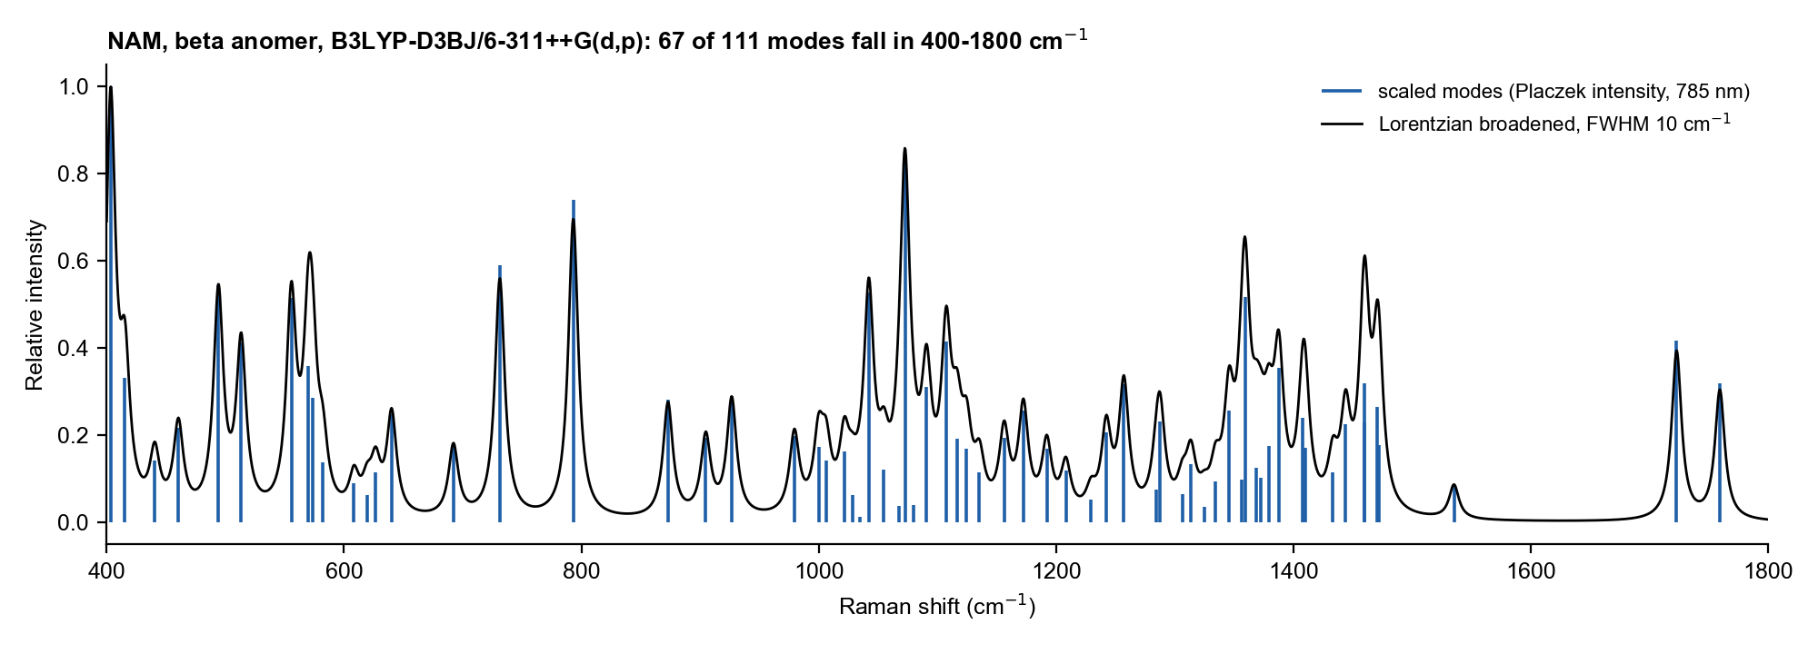
Figure 1. NAM: scaled calculated modes (blue sticks) and Lorentzian-broadened spectrum (black).

5. LPS: fragment simulation and whole-molecule model

5.1 Fragments chosen
Fragment | Role in LPS (as stated in the LPS documentation) | Discrete modes in the export (all / 400-1800 cm-1, unscaled) | Raman file
KDO (3-deoxy-D-manno-octulosonic acid) | Core oligosaccharide marker | 84 / 49 | 3-Deoxy-D-Manno-Octulosonic Acid_raman_act.txt
L-glycero-D-manno-heptose | Core sugar region | 78 / 44 | L-Glycero-D-Manno-Heptose-opt_raman_act.txt
D-glucosamine | Sugar of the lipid A backbone (glucosamine disaccharide) | 69 / 42 | D-glucosamine-opt_raman_act.txt
Myristic acid | Fatty-acid chain of lipid A | 126 / 76 | Myristic Acid-opt_raman_act.txt
Phosphoric acid | Phosphate functionality | 18 / 10 | Phosphoric acid-opt_raman_act.txt

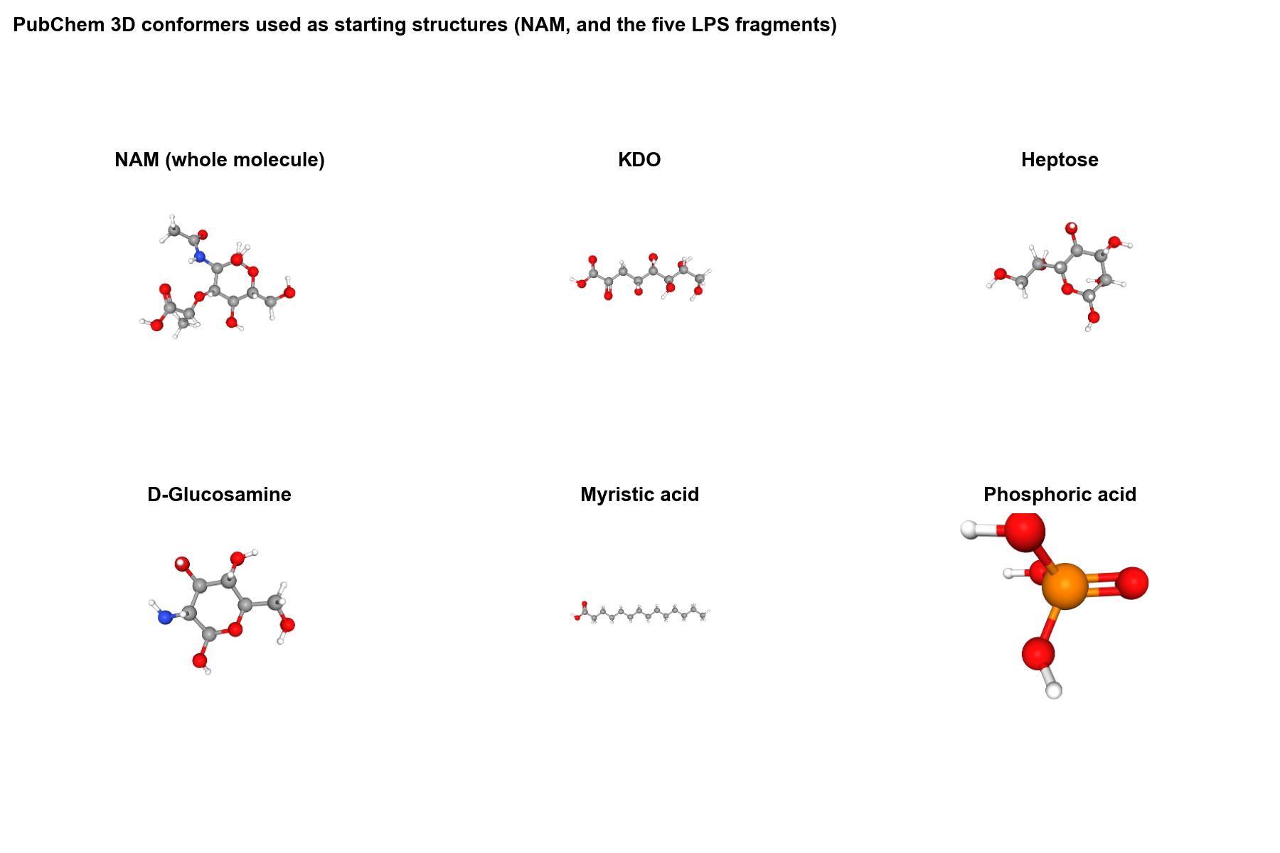
Figure 2. PubChem 3D conformers used as starting structures (NAM and the five LPS fragments). Images are the PubChem pictures stored in the project folder.

5.2 Settings
Setting | Value
Structure source | PubChem 3D structures, downloaded one by one
Preparation | Atom types and bonding checked, missing hydrogens added, valency corrected, cleanup, saved in Gaussian format
Pre-optimisation | Molecular mechanics: steepest descent 200 steps, then conjugate gradient 500 steps
Route | # opt freq=raman b3lyp/6-31g(d) scf=tight integral=ultrafine (example route in the LPS documentation)
Method and basis set | B3LYP / 6-31G(d)
Environment | No solvent keyword in the documented route, so gas phase
Charge, multiplicity, atom counts | Not recorded in the files read (Gaussian logs for the five fragments were not found)
Frequency scale factor | 0.9613
Output used | Frequencies and Raman activities exported as "Peak information (Harmonic)" lists; y-values in 10-36 m2 cm/sr; excitation wavelength for the conversion Not recorded
Post-processing | Scaled; each spectrum min-max normalised; interpolated onto a 200 to 2000 cm-1 grid at 1 cm-1; no baseline correction

5.3 Spectra obtained
Five stick spectra were obtained, 375 discrete modes in total (218 inside 400 to 1800 cm-1 after scaling). Their character differs: KDO has a very strong carbonyl-related mode near 1690 cm-1; glucosamine and heptose have many modes spread across 400 to 1500 cm-1; myristic acid is dominated by CH2 modes near 1285 and 1460 cm-1; phosphoric acid gives only ten modes in range, the strongest near 778 cm-1.
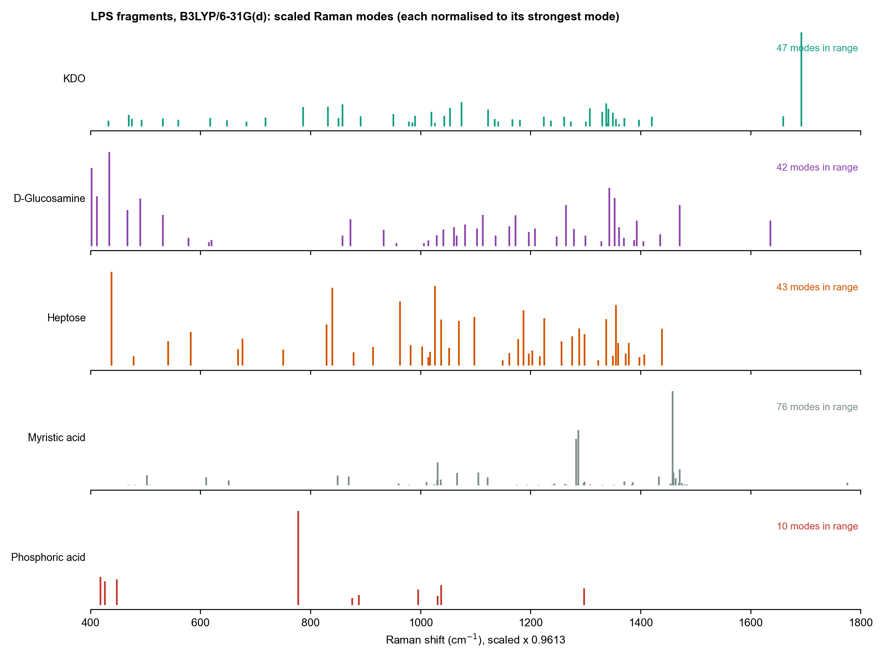
Figure 3. LPS fragments: scaled calculated modes, each normalised to its strongest mode.

5.4 How the fragments were combined
- Equal-weight composite: the normalised fragment spectra are averaged.
- Weighted composite by non-negative least squares (NNLS): each fragment gets a weight, not below zero, chosen to best reproduce an experimental spectrum. Weights are relative spectral contributions, not concentrations.
- Earlier LPS documentation reported weights for KDO 47.3 %, heptose 25.8 %, myristic acid 11.7 % and phosphoric acid 0.0 %. The 30 Aug 2026 corrected re-analysis (with glucosamine included) gave KDO 43.7 %, glucosamine 28.5 %, heptose 27.0 %, myristic acid 0.8 % and phosphoric acid 0.0 %. A weight of zero does not mean the group is absent; it means the fragment added no extra explanatory power.

5.5 Whole-molecule model: Kdo2-lipid A with shortened chains
Because fragments leave out the links between the parts of LPS, a model with the links in place was added. The full Kdo2-lipid A (355 atoms) was too large for a B3LYP/6-31+G(d,p) Raman calculation on this PC, so the acyl chains were shortened and the backbone kept complete. The intact LPS (core oligosaccharide and O-antigen of the O111 serotype) is not in the model.
Item | Detail
Structure source | PubChem CID 5771770 (Kdo2-lipid A, E. coli), 2D SDF; formula C110H202N2O39P2, 355 atoms, neutral, as expected (found through the GlyCosmos listing, LIPID MAPS LMSL02000001). CID 25244473 has a different formula and was not used.
Shortening | C14 acyl chains to butyryl, the C11 tails of the 3-acyloxy chains to propyl, the C12 acyl chain to butyryl. Kept: 2 glucosamines, 2 Kdo, 2 phosphates, 2 amides and the stereo tags given by PubChem.
Charge state | Ionised for water at near-neutral pH: both Kdo carboxylates as COO-, both phosphate monoesters with one negative charge each; net charge -4; no counter-ions.
Result | C60H98N2O39P2 (4-), 201 atoms
3D structure | 300 conformers by ETKDGv3 (random seed 7), each optimised with MMFF; the lowest (conformer 110, MMFF energy 139.7 kcal/mol) was the start geometry. PubChem leaves a few ring stereocentres open; the embedding set them, so this is one reasonable structure and not necessarily the lowest-energy one.
Software | Gaussian 16W Revision C.01 (C:\G16W\g16.exe); 28 processors and 54 GB memory (i7-14700, 64 GB)
Job 1 | # opt=loose pm6, gas phase, charge -4, singlet (about 55 min, finished 14:26 on 27 Oct 2026)
Job 2 | # opt freq=raman b3lyp/3-21g geom=allcheck guess=read, gas phase; optimisation converged at step 109 (all four criteria met); frequency step 4 h 42 min; normal termination 08:57 on 28 Oct 2026
Frequencies | 597 modes (3N - 6); no imaginary frequency, so the structure is a true minimum; lowest 11 cm-1, highest 3495 cm-1
Environment variables | GAUSS_EXEDIR=C:\G16W and GAUSS_SCRDIR=C:\G16W\Scratch had to be set on the command line (the first launch failed without them)
Earlier attempts | A PM6 run in water (PCM) was far too slow and a B3LYP/6-31G(d) in-water plan was replaced by this quick level; the abandoned PM6/PCM run is archived in old_pm6_pcm. The 119-atom lipid A proxy described in Section 7 gave no output.

5.6 Processing of the lipid A calculation
Step | Detail
Parse | Harmonic frequencies and Raman activities S read from the Gaussian log into lipidA_raman_act.csv (unscaled)
Scale | x 0.965, a typical B3LYP value; not fitted or tested for 3-21G here
Intensity | I = S (v0 - v)^4 / ( v (1 - exp(-hcv/kT)) ) at 785 nm and 298.15 K (v0 = 10^7/785 cm-1)
Broaden | Lorentzian, FWHM 12 cm-1; 200 to 3300 cm-1; normalised to the tallest peak
Script and outputs | make_spectrum.py (python make_spectrum.py lipidA) writes lipidA_spectrum_785nm.csv and .png

5.7 Spectrum obtained and its limits
Of the 597 modes, 354 lie between 400 and 1800 cm-1 after scaling. Compared with the SERS endotoxin reference bands used for this model, the calculation has modes at 845 and 856 (850, glycosidic), near 993 (989, Kdo/carbohydrate; the strongest mode in the 900 to 1000 region), a weak mode at 1139 (1131, lipid chain, weak because the chains are cut), and 1314 and 1338 (1330, phosphate/amide).
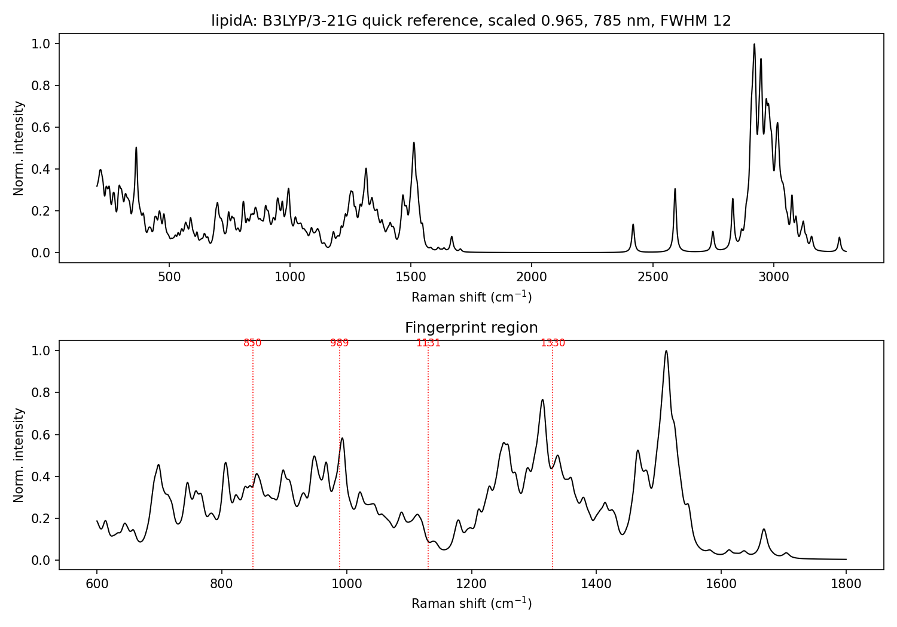
Figure 4. Whole-molecule lipid A model: calculated Raman spectrum at 785 nm (top, 200 to 3300 cm-1) and fingerprint region (bottom); red dotted lines mark the four reference bands.
- Quick level. Gas phase and B3LYP/3-21G (no diffuse or polarisation functions): positions are approximate and intensities, especially of charged groups, are distorted.
- Peaks near 2420, 2590 and 2750 cm-1 are artefacts: strongly hydrogen-bonded O-H stretches to the charged groups, which occur in the gas phase with no water. They lie outside the instrument range and should be ignored.
- The strong band at 1512 to 1516 cm-1 is probably an amide N-H / C-N mode that the small basis set overstates. This assignment was not checked, and its relative height should not be trusted.
- Cut chains: the CH2 and CH3 bands (about 1440 and 2850 to 3000 cm-1) are under-represented.
- Missing parts of the sample: the core oligosaccharide beyond Kdo and the O111 O-antigen. Counter-ions (Na+, Ca2+, Mg2+) and water are not included.
- Gaussian Raman activities are orientation-averaged, so they correspond to a powder or solution; peak positions are used for assignment, absolute intensities are not compared.

6. LTA: three-fragment simulation

6.1 Fragments chosen
Fragment | Role in LTA (as stated in the settings document) | What the files show
Glycerol-phosphate | Phosphate-rich polymeric backbone | 35 atoms (C6 H16 O11 P2), charge -2, singlet. This is two glycerol-phosphate units carrying two ionised phosphates (a dianion), titled "LTA backbone fragment optimization". Gaussian 16 log found.
D-alanine | Amino-acid substitution on the backbone | Raman curve only; Gaussian log, charge and atom count Not found
N-acetyl-D-glucosamine (GlcNAc) | Carbohydrate-associated unit | Raman curve only; Gaussian log, charge and atom count Not found

6.2 Settings
Setting | Value
Structure source | Public chemical databases (PubChem named for other work), refined in Avogadro with molecular-mechanics optimisation before Gaussian
Route (glycerol-phosphate log) | # opt freq=raman b3lyp/6-31g(d) scrf=(smd,solvent=water) int=ultrafine scf=tight
Settings document route | # opt freq=raman b3lyp/6-31g(d) scrf=(smd,solvent=water) nosymm int=ultrafine scf=(tight,maxcycle=512)
Method and basis set | B3LYP / 6-31G(d)
Solvent model | SMD, water (implicit)
Result (glycerol-phosphate) | Stationary point found; 99 modes; no imaginary frequency; lowest mode 20.0 cm-1; E = -1748.81207 Hartree; zero-point correction 0.259278 Hartree
Frequency scale factor | 0.96 used in the processing notebook (0.96 to 0.97 evaluated; a plot with 0.98 also exists)
Post-processing | Raman shift and intensity exported to Excel; scaled; min-max normalised; combined into LTA_combined_data.csv

6.3 Spectra obtained
Three broadened Raman curves (about 8 cm-1 spacing) were obtained, one per fragment, and one 99-mode list for the glycerol-phosphate fragment. Because the D-alanine and GlcNAc files hold curves, not mode lists, individual modes were found by peak picking, which can miss weak modes.
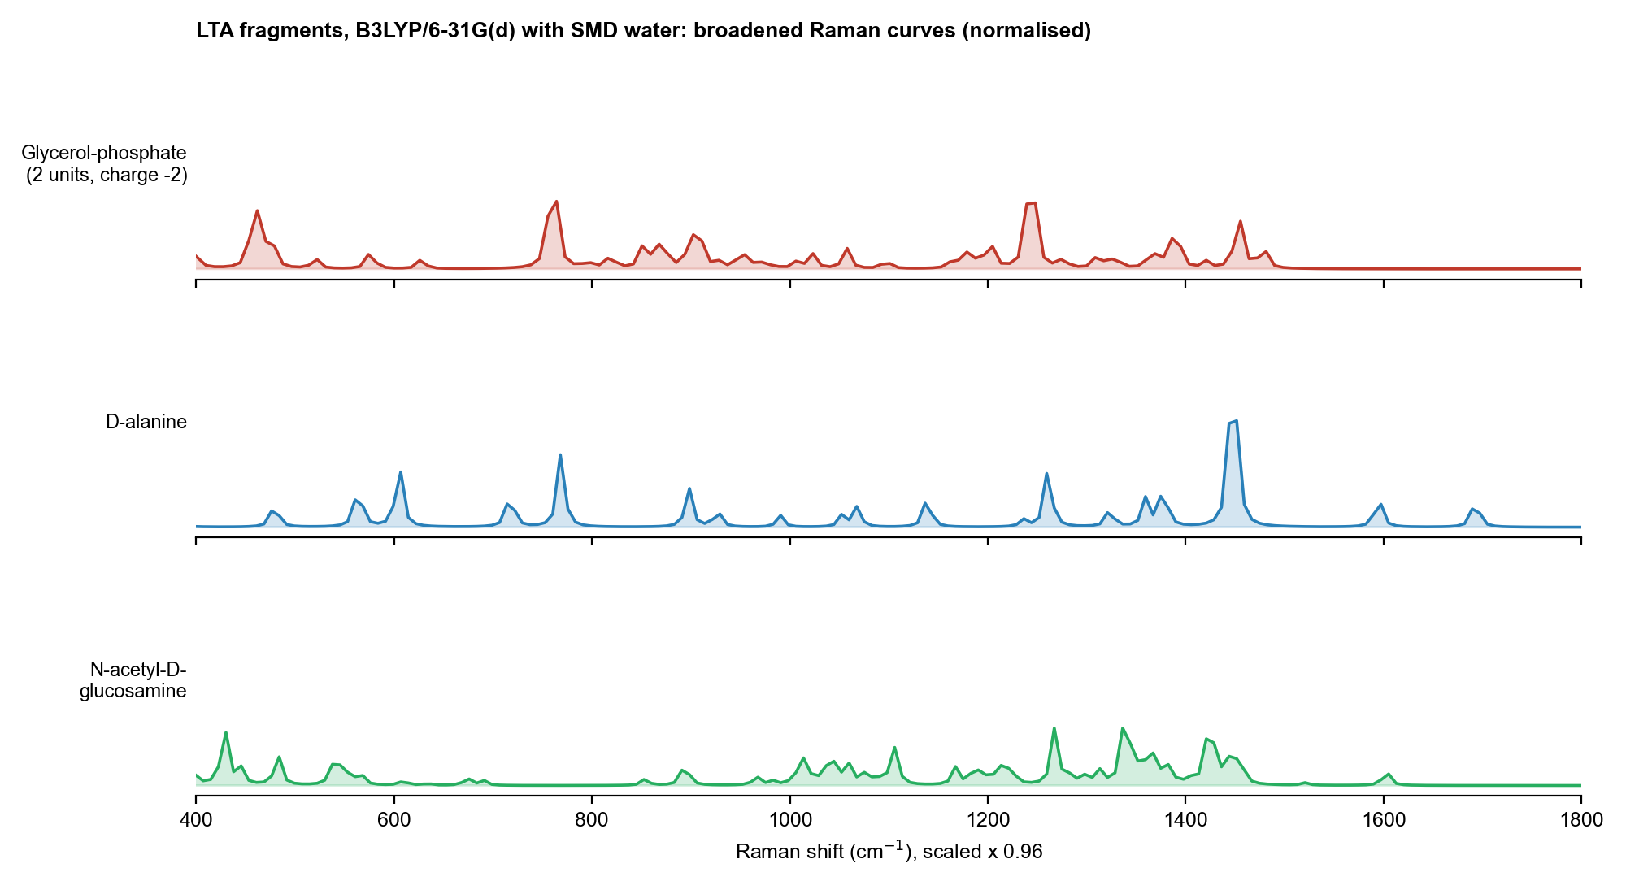
Figure 5. LTA fragments: broadened, scaled and normalised Raman curves.

6.4 How the fragments were combined
The three curves were averaged with equal weights and also fitted by NNLS to a measured LTA spectrum. The fitted weights were glycerol-phosphate 20.1 %, D-alanine 39.5 % and N-acetyl-D-glucosamine 40.4 %, with RMSE 0.193, MAE 0.136, R-squared -0.294 and Pearson r 0.345 (LTA_complete_results.xlsx). These numbers are the earlier fit to April data and are reported here as found.

7. Why intact LPS and LTA were not simulated whole
The reasons below come from the project files; general points are marked as such. For LPS, the shortened Kdo2-lipid A model of Section 5.5 is the largest whole-molecule calculation that was feasible; for LTA only fragments were run.
Reason | Evidence | Source
Size and flexibility | Intact LPS has a lipid A anchor, a core oligosaccharide and an O-antigen chain, and "high molecular size, structural heterogeneity, and multiple flexible linkages" make direct simulation of the complete molecule "computationally demanding". Intact LTA is a "large and structurally heterogeneous polymer" of glycerol-phosphate repeats with variable substitution. | LPS documentation; LTA settings document
Cost grows steeply with atoms | NAM with 39 atoms needed 3 h 43 min on 16 processors. A lipid A proxy of about 120 atoms (only a truncated piece of LPS) was estimated at 6 to 24 h for optimisation and 12 to 48 h for frequencies on 8 cores (1 to 3 days in total). Intact LPS or an LTA polymer is far larger than this proxy. (Cost scaling with size is general knowledge.) Measured on this PC: the 201-atom lipid A model took about 55 min (PM6) and 109 optimisation steps of 8 to 9 min plus 4 h 42 min of frequencies at B3LYP/3-21G. | GAUSSIAN_WORKFLOW_GUIDE.txt; NAM log
The best feasible LPS model is still a piece | A 119-atom lipid A proxy (charge -2, two phosphates, four hexanoyl chains, no O-antigen, no core oligosaccharide, no secondary chains) was prepared for B3LYP/6-31G(d) and for ORCA, but no output was found. The model that was run is Kdo2-lipid A with shortened chains (201 atoms, charge -4, B3LYP/3-21G; Section 5.5). It has no O-antigen, no core sugars beyond Kdo and no full-length chains, so it is still not whole LPS. | lipidA_*.gjf, lipidA_proxy_Ecoli_O111B4_v2.py
A whole-LTA-type attempt failed at the first step | A Gaussian job on a structure titled 137349712 (probably a PubChem CID, not confirmed; 124 atoms, C39 H70 N2 O13) at B3LYP/6-311++G(d,p) stopped after 2 seconds on 9 Feb 2026 with "Atoms too close" (two atoms 0.295 angstrom apart). The input coordinates are flat (z = 0.0 for all 124 atoms), i.e. a 2D drawing, not a 3D structure. No repeated attempt was found. | 10_Working_Archive\20-04\molecules\LTA Final\lta.gjf and LTA.LOG
The sample is not one molecule | Commercial LPS and LTA are mixtures of chains of different lengths and substitution (general knowledge), so no single calculated structure represents the powder measured. | General
Fragments give a clean attribution | Each fragment spectrum can be tied to one chemical group (sugar, phosphate, fatty acid, amino acid), so a combination can be fitted and discussed group by group. | LPS documentation
NAM is different | NAM is one defined molecule of 39 atoms, small enough for a high-level whole-molecule calculation. | NAM archive

7.1 What the fragment approach cannot capture
- The links between units (glycosidic, ester, phosphodiester) and any band that arises from them.
- Interaction between fragments, hydrogen bonding and packing in the powder.
- Charge state and counter-ions of a real salt form (the LPS fragments are modelled as neutral molecules as far as the files show; the LTA backbone fragment as a dianion in water).
- The relative amount of each fragment in the real molecule: the NNLS weights are fitted, not known.
- Different levels of theory per molecule: NAM used 6-311++G(d,p) with dispersion, LPS and LTA used the smaller 6-31G(d).

7.2 What would be needed for a larger model
- Build proper 3D structures (not flat drawings) and pre-optimise them.
- Rerun the lipid A model at B3LYP/6-31G(d) or B3LYP/6-31+G(d,p) with water (PCM) from the optimised geometry, expect days of run time; and run a two-to-three-unit glycerol-phosphate oligomer with D-alanine ester and counter-ions for LTA, on a workstation with enough memory.
- Test a conformer ensemble, because flexible chains can have many low-energy shapes.
- Record charge, basis set, solvent, software version and log files for every run.

8. Limitations of the simulation work
- Harmonic frequencies, one scale factor per molecule, no anharmonic correction.
- Isolated molecules or fragments, one conformer each; no solid-state or glass-slide effects.
- LPS fragment charge, atom counts, basis details beyond the documented route and the Gaussian logs are Not found; the D-alanine and GlcNAc logs are Not found.
- Lipid A model: gas phase, one conformer, B3LYP/3-21G, one scale factor not tested for this level, shortened chains, no counter-ions (details in Section 5.7).
- Raman intensity conversion for LPS and LTA used an export whose excitation wavelength is Not recorded; NAM used 785 nm explicitly.
- Different programs, levels and scale factors across the three molecules limit direct comparison between them.
- The LTA fit in Section 6.4 was to April data, not to the new library reference.

9. How to repeat the calculation
- Get the 3D structure (PubChem CID 5462244 for NAM).
- Write the Gaussian input with the route in Section 4.3 (charge 0, multiplicity 1 for NAM), run it and confirm Normal termination and no imaginary frequency.
- Extract frequencies and Raman activities from the log, apply the scale factors, convert to intensity at 785 nm and 298.15 K, and broaden with a Lorentzian of FWHM 10 cm-1.
- For LPS or LTA fragments use the route and scale factor in Sections 5.2 and 6.2, and record charge and solvent. For the lipid A model use the two-job input in lipidA_short.gjf and make_spectrum.py (Section 5.6).
- Compare with the library reference using the chance-test method in the comparison document.

10. File inventory (all under C:\Users\sukes\Downloads\mtp unless stated)
Content | Location
NAM final beta log, input and 111 modes | 05_Experimental_Data\NAM\NAM_Raman_Archive\02_DFT_Calculation\ (NAM_beta_Gaussian16_B3LYP-D3BJ_6-311++Gdp.log, NAM_beta_Gaussian16_input.gjf, NAM_calculated_modes_all_111.csv)
NAM alpha anomer | 05_Experimental_Data\NAM\NAM_Raman_Archive\nam-alpha.LOG, ALPHA_ANOMER_RESULT.md, ALPHA_ANOMER_HOWTO.md
NAM simulated spectrum | 05_Experimental_Data\NAM\NAM_Raman_Archive\03_Processed_Results\DFT_simulated_spectrum.csv; processing in 06_Analysis_Notebook\ANALYSIS_PROTOCOL.md
NAM early runs | 10_Working_Archive\20-04\NAM.LOG; 10_Working_Archive\review meeting\namfinal laptop simulation\CONFORMER3D_COMPOUND_CID_5462244.LOG
LPS fragment exports | 05_Experimental_Data\LPS\lps research\lps sim\*_raman_act.txt (5 files)
LPS simulation method write-up | 05_Experimental_Data\LPS\lps research\LPS documentation.docx; 05_Experimental_Data\LPS\lps research\reanalysis_2026-08-30\ and reanalysis_2026-08-30_v2\
LTA glycerol-phosphate input and log | 10_Working_Archive\review meeting\LTA-\LTA\LTA.gjf, LTA.LOG, LTA_raman_act.txt
LTA fragment curves and notebook | 06_Simulation_DFT\LTA-simulation-main\06_Simulation_DFT\LTA-simulation-main\ (xlsx, LTA_combined_data.csv, setup_notebook.ipynb); 10_Working_Archive\20-04\lta\simulation\
LTA settings write-up | 10_Working_Archive\20-04\Computational Simulation Settings Used for Lipoteichoic Acid.docx
Failed whole-LTA-type run | 10_Working_Archive\20-04\molecules\LTA Final\ (lta.gjf, LTA.LOG)
Lipid A proxy inputs and scripts | 06_Simulation_DFT\molecule building\ (lipidA_opt.gjf, lipidA_freq.gjf, LipidA_proxy_Ecoli_O111B4.*, GAUSSIAN_WORKFLOW_GUIDE.txt, convert_to_orca.py)
Figures in this document | SERS_Sepsis_Spectral_Library\04_Figures\Simulation_20261027 (S1 to S4)
LPS lipid A whole-molecule model | C:\Users\sukes\Downloads\sukesh\lps output simulation (copy in SERS_Sepsis_Spectral_Library\08_Methodology\simulation\LPS_LipidA_Model_20261028): lipidA_short.gjf (input), lipidA_short.out (Gaussian log, 34 MB), lipidA_short.sdf, lipidA_raman_act.csv, lipidA_spectrum_785nm.csv and .png, make_spectrum.py, Lipid_A_Raman_Methods.md

