Bulk Powder Raman Spectral Reference Library
N-Acetylmuramic Acid (NAM/MurNAc), Lipoteichoic Acid (LTA) and Lipopolysaccharide (LPS)
Traceable workflow from raw measurement to biomarker marker peaks — SERS-based sepsis project
Prepared by: Sukesh Periyasamy, Junior Research Fellow
Date / version: 28 September 2026 — library version 3.3 (pipeline v3; NAM reference final; LPS reference established)
Instrument: B&W Tek i-Raman Plus BWS465-785H (BTC665N-785H-SYS), 785 nm
Samples: Bulk (neat dry) powders measured directly on glass slides
Objective: Not recorded in the raw file headers (not invented here)
Executive summary
Biomarker | Reference condition | n | Bulk marker intensity* | SNR | Primary markers (cm⁻¹) | Status / decision
NAM | 90 % / 30 s / 5 acc | 15 (5 independent spots) + 21 validation spots (24 Sep) | 917 ± 37 counts | 51.1 ± 4.7 | 541, 829, 870.5, 929, 955, 1023, 1127 | FINAL reference (28 Sep 2026). Validated by 21 new independent spots (Section 15A); limitation: 6 independent spots at the reference condition
LTA | 80–95 % / 45 s / 2 acc | 4 | 1110 ± 98 counts | 28.5 ± 1.0 | 802, 861.5, 1092 (1459 supporting) | Preliminary. RE-ACQUIRE 10–15 spots at 80 % / 45 s / 2 acc
LPS | 60 % / 40 s / 5 acc | 10 | 425 cm⁻¹ band: median 680 counts (302–1631) | 38 (median) | 425, 1080 (supporting 766, 861, 997) | ESTABLISHED 28 Sep 2026 (Section 15C). E. coli O111:B4, Sigma L2630
*Strongest primary-marker band per spectrum (NAM 929 cm⁻¹, LTA 1092 cm⁻¹), baseline-corrected counts, mean ± SD, bulk powder on glass. Power = instrument power level (%), not mW. Values follow the v3 pipeline corrections (Section 5.8).
Decision chain applied to every marker: valid spectrum → reproducible spectrum → reproducible peak → not background → chemically plausible → literature-consistent. Only bands that pass every step are called primary markers. All molecular assignments are tentative, because no pure-compound normal-Raman reference spectrum of NAM, LTA or LPS was found in the literature.

1. Objective and scope
To build a bulk-powder Raman reference library for three bacterial sepsis biomarkers. Every decision should trace back to the raw measurement. The report shows why each spectrum is accepted or rejected, how it is processed, how the representative spectrum is calculated, why each peak is (or is not) a marker, what chemical group each marker most plausibly represents, how it compares with the literature, and which measurements must be repeated. Bulk spectra are the normal-Raman reference for the later SERS work.

2. Samples, instrument and metadata
Item | Value
Biomarkers | NAM (MurNAc, peptidoglycan sugar); LTA (Gram-positive envelope polymer); LPS (Gram-negative endotoxin)
Sample form | Neat dry powder placed directly on a glass slide; no other substrate
Spectrometer | B&W Tek i-Raman Plus BWS465-785H; 2048-pixel CCD, 16-bit (65 535 counts); software BWRam 4.15
Excitation | 785 nm (header 784.92 nm)
Laser power | Instrument power level in % (not converted to mW; sample power not measured)
Objective | Not recorded in any file header (probe_name empty) — must be recorded for new measurements
Analysis range | 400–1800 cm⁻¹
Glass background zone | 1308–1455 cm⁻¹ (empty-slide blank > 25 % of its maximum; maximum ≈ 1365 cm⁻¹)

3. Data inventory
All 689 raw files in the data folder were audited. 323 are bulk-powder or blank spectra and 366 belong to SERS/substrate experiments (out of scope, listed only). Renamed, byte-identical copies are in 01_Raw_Data_Renamed; original files are never modified.
Class | Valid | Valid – supporting | Low SNR | Review / flagged | Excluded | Library folder
NAM | 224 | 3 | 42 | 1 | 10 | NAM_Bulk (270); 10 distorted in Excluded
LTA | 9 | 0 | 2 | 1 | 0 | LTA_Bulk (12)
LPS | 0 | 0 | 0 | 14 (signal not established) | 0 | LPS_Bulk (14)
Glass blank | 5 | 0 | 0 | 0 | 0 | Glass_Blank (5)
NAM — session 24 Sep 2026 (added v3.1) | 21 | 0 | 0 | 0 | 20 (dark-reference ripple) | NAM_Bulk (41 files, NAM_Bulk_20260924_*)
Glass blank — 24 Sep 2026 (matched) | 16 | 0 | 0 | 0 | 0 | Glass_Blank (16; all saturated at the glass band)
LPS — screening 28 Sep 2026 (added v3.2) | 12 | 0 | 0 | 2 glass-dominated (review) | 5 (80 %, ripple) | LPS_Bulk (19 files, LPS_Bulk_20260928_*)
Glass blank — 28 Sep 2026 (matched) | 10 | 0 | 0 | 0 | 0 | Glass_Blank (10; saturated at the glass band)
LPS — reference 28 Sep 2026, 60 %/40 s/5 acc (added v3.3) | 10 | 0 | 0 | 1 glass-dominated (S13) | 3 ripple (70 %), 4 supporting | LPS_Bulk (18 files) + Glass_Blank (5) + Instrument_Checks (7)
Labelled “LTA”, polystyrene-like | 0 | 0 | 0 | 0 | 12 | Excluded (suspected contamination)

4. Workflow overview
The same sequence is applied to every biomarker. Each arrow is a documented step (Section 5 and 08_Methodology).
Bulk powder
↓
Glass-slide measurement (785 nm)
↓
Raw Raman spectra
↓
Initial QC (saturation in full range and 400–1800 cm⁻¹, distortion, contamination)
↓
Fixed hot-pixel correction
↓
Spectral cropping 400–1800 cm⁻¹
↓
Cosmic-ray / spike removal
↓
Savitzky–Golay smoothing (11/3)
↓
ALS baseline correction (λ 1e5, p 0.01)
↓
Min–max normalisation (shape only)
↓
Post-processing QC
↓
Replicate comparison (spot independence)
↓
10–15 valid independent spectra (or re-acquire)
↓
Mean + median comparison
↓
Representative reference spectrum
↓
Peak detection
↓
Peak reproducibility analysis
↓
Background screen
↓
Literature comparison
↓
Chemical / functional-group assignment (tentative)
↓
Final biomarker marker peaks
↓
Spectral reference library

5. Preprocessing — step by step
Every stage is stored as a separate column in each processed CSV (02_Processed_Spectra): Raw, DarkSubtracted, HotPixelFixed, Despiked, Smoothed, Baseline, BaselineCorrected, Normalised. Figure 1 shows each stage for one NAM reference spectrum. Parameter sensitivity was measured on the reference spectra (sheet 23).
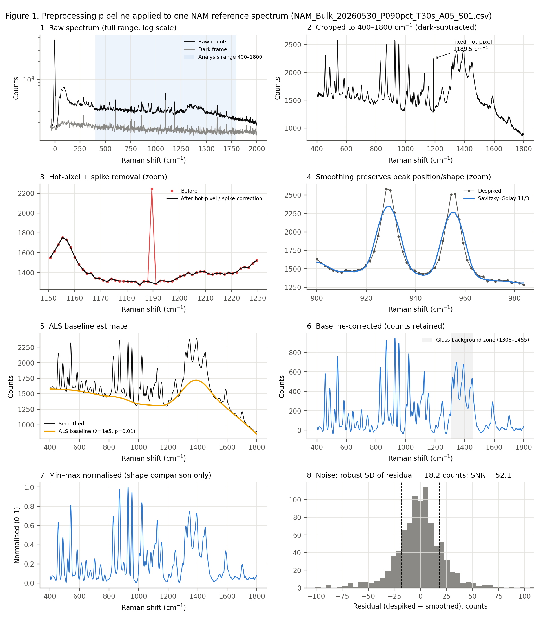
Figure 1. Raw spectrum → each preprocessing stage (NAM reference spectrum NAM_Bulk_20260530_P090pct_T30s_A05_S01.csv, 90 % / 30 s / 5 acc). Panel 8: residual used for the robust noise estimate.

5.1 Initial QC and fixed hot-pixel correction
What | Check saturation over the full range and inside 400–1800 cm⁻¹; check for negative counts / abnormal dark reference and contamination patterns. Replace CCD pixels 640 (1095.7 cm⁻¹) and 700 (1189.5 cm⁻¹) by the mean of their neighbours.
Why | Saturated or distorted data give false intensities. The two pixels are defective: the same pixel was flagged in ≥ 59 spectra on 6 dates and is elevated in the dark frames. In the NAM reference spectra pixel 700 carried ≈ +950 counts, and in the LPS spectra pixel 640 produced a sharp artificial “band” near 1095 cm⁻¹.
Method / mathematics | x₆₄₀ ← (x₆₃₉ + x₆₄₁)/2; x₇₀₀ ← (x₆₉₉ + x₇₀₁)/2
Parameters | Saturation limit 65 000 counts (16-bit detector)
Effect on the spectrum | Removes a one-pixel artefact; all other points unchanged.
QC check | Saturation flags and corrected pixels are written to the processed-file header and the QC sheet.
Limitations | The defect list must be re-checked with each new dark frame.

5.2 Spectral cropping (400–1800 cm⁻¹)
What | Keep only 400 ≤ Raman shift ≤ 1800 cm⁻¹ (≈ 750 pixels).
Why | This fingerprint region contains the skeletal, C–C/C–O, C–O–C, phosphate and CH-deformation bands of the biomarkers. Below 400 cm⁻¹ the laser line (≈ 0 cm⁻¹, saturates at long integration) and filter edge dominate; above 1800 cm⁻¹ detector response falls and C–H stretching (2800–3100 cm⁻¹) is outside the useful range of this system.
Parameters | Range 400–1800 cm⁻¹
Effect on the spectrum | Excludes the laser line and the edge regions.
QC check | Saturation is judged inside this range (laser-line-only saturation is not a rejection reason).
Limitations | Low-frequency lattice modes and C–H/N–H/O–H stretching bands are not used.

5.3 Cosmic-ray / spike removal
What | Detect and replace narrow, random, intense features (cosmic rays or detector events).
Why | A spike can be mistaken for a Raman band, distorts smoothing and inflates peak heights. Genuine Raman bands must not be removed.
Method / mathematics | First difference dᵢ = xᵢ₊₁ − xᵢ; MAD = median(|dᵢ − median(d)|); robust z-score zᵢ = 0.6745 (dᵢ − median(d)) / MAD. A point is a candidate if |zᵢ| > 6. Width guard (v3): the candidate is accepted only if ≤ 2 pixels exceed half of its local excursion (cosmic rays are 1–2 pixels wide; Raman bands here are ≥ 3–4 pixels). Accepted points (±1 pixel) are replaced by linear interpolation.
Parameters | z > 6 (project convention); width ≤ 2 pixels
Effect on the spectrum | After hot-pixel correction no spikes remain in the NAM or LTA reference spectra; LPS spectra average 0.6 spikes per spectrum.
QC check | Number and position of removed spikes are logged per spectrum.
Limitations | Without the width guard (v2.1) the test also fired on the steep flanks of the sharp NAM bands and clipped them (heights −11 to −12 %); corrected in v3.

5.4 Savitzky–Golay smoothing (window 11, order 3)
What | Fit a cubic polynomial by least squares in an 11-point sliding window; replace the centre point by the fitted value.
Why | Reduces detector/shot noise so that peak positions and heights can be measured reproducibly. Unlike moving averages, the local polynomial follows peak curvature, so position and shape are largely preserved.
Method / mathematics | ŷᵢ = Σₖ cₖ yᵢ₊ₖ (k = −5…5), with cₖ the SG convolution coefficients for a cubic fit.
Parameters | Window 11 points (≈ 20 cm⁻¹), polynomial order 3 (project convention)
Effect on the spectrum | Residual high-frequency noise falls to ≈ 25 % of the unsmoothed level. Peak positions shift ≤ 1 pixel (≤ 1.7 cm⁻¹). The apex of the narrow NAM bands (FWHM ≈ 10 cm⁻¹) is lowered to 84 % of the unsmoothed value (SG 7/3: 94 %); broad LTA bands to 97 %.
QC check | Peak positions compared before and after smoothing; every marker is also present in the unsmoothed spectra (sheet 21).
Limitations | Over-smoothing flattens and merges sharp bands (it does not create new ones). NAM absolute intensities are pipeline-specific; a 7/3 window could be considered for crystalline powders in future (PI decision).

5.5 ALS baseline correction (λ = 1×10⁵, p = 0.01)
What | Estimate and subtract the slowly varying background (fluorescence, glass background, instrument response).
Why | Band heights must be measured from a common zero. NAM sits on ≈ 1 360 counts of background; LTA on ≈ 8 300 counts of strong, curved fluorescence.
Method / mathematics | Baseline z minimises Σ wᵢ (yᵢ − zᵢ)² + λ Σ (Δ²zᵢ)². The first term keeps z close to the data; the second penalises curvature. Asymmetric weights: wᵢ = p if yᵢ > zᵢ (peaks almost ignored), 1 − p otherwise; 10 iterations.
Parameters | λ = 1×10⁵ (stiffness: larger λ → smoother baseline); p = 0.01 (asymmetry)
Effect on the spectrum | Removes fluorescence; counts are kept (not normalised). Across λ = 1e4–1e6 and p = 0.001–0.05, NAM marker heights change by < ±12 %, but LTA heights change from 60 % to 125 % of the default.
QC check | Baseline stored per spectrum; baseline mean, range and slope reported in QC.
Limitations | The baseline partly follows the ≈ 110 cm⁻¹-wide glass band, so a residual glass contribution remains in 1308–1455 cm⁻¹. LTA absolute intensities depend on the baseline parameters.

5.6 Min–max normalisation
What | x_norm = (x − x_min) / (x_max − x_min), applied to the baseline-corrected spectrum.
Why | Removes differences in overall intensity (focus, packing, power) so that spectral shapes can be compared and correlated.
Parameters | —
Effect on the spectrum | Scales each spectrum to 0–1.
QC check | Used only for correlation and shape figures.
Limitations | Never used to report bulk Raman counts; raw, baseline-corrected and normalised spectra are kept separately.

5.7 Noise and SNR
noise = 1.4826 × MAD(despiked − smoothed), a robust estimate of the high-frequency detector noise. SNR = height of the strongest marker band (baseline-corrected) / noise. The robust estimate replaces the plain standard deviation used in v2.1, which the residual of sharp peaks inflated.

5.8 Corrections introduced in pipeline v3
Item | v2.1 | v3 | Reason
Spike removal | MAD z > 6 on first difference; 7-pt median replacement | Same criterion + width guard (≤ 2 px) + linear interpolation | v2.1 clipped the apex of sharp NAM bands (flagged 5.2 points/spectrum at 460–960 cm-1); marker heights were under-estimated by 11–12 % on average
Hot pixels | Not handled | Fixed CCD pixels 640 (1095.7 cm-1) and 700 (1189.5 cm-1) interpolated | Same pixel flagged in ≥ 59 spectra on 6 dates and visible in dark frames (instrument artefact)
Noise estimate | SD of (despiked − smoothed) | Robust SD (1.4826 × MAD) of the same residual | Sharp peaks inflated the SD; robust estimate reflects detector noise
NAM strongest-marker intensity | 820 ± 42 counts | 917 ± 37 counts | Result of the spike-removal fix
NAM SNR | 31.7 ± 1.4 | 51.1 ± 4.7 | Result of robust noise + spike fix
LTA strongest-marker intensity | 1103 ± 94 counts | 1110 ± 98 counts | Broad LTA bands barely affected
LTA SNR | 27.6 ± 0.7 | 28.5 ± 1.0
NAM marker set | 541, 829, 870, 929, 955, 1023, 1127 | unchanged | Re-verified with v3 criteria
NAM supporting peaks | 457, 487, 1249 | 457, 487, 1249, 1589 | 1589 meets the supporting rule (100 % ref; 91 % overall detection)
The v3 values supersede those in earlier drafts. The marker sets are unchanged; intensities and SNR changed because of the spike-removal fix and the robust noise estimate.

6. Quality control

6.1 Acceptance and rejection criteria
Criterion | Rule | Basis
Saturation | Raw ≥ 65 000 counts inside 400–1800 cm⁻¹ → reject. Saturation at the laser line only → recorded, not rejected | Physical detector limit (16-bit)
Distortion | Negative dark-subtracted counts, abnormal dark reference or ripple (noise ≫ group) → reject | Acquisition artefact
Contamination | Foreign band pattern (e.g. polystyrene 620/1001/1031/1602 cm⁻¹) → reject, keep for review | Chemical identity
SNR | SNR < 10 → “Low SNR”: kept for parameter comparison, never used in a reference | Project convention
Consistency | Pearson r with the class mean (glass zone excluded) < 0.85 → review; the cause is checked before exclusion | Project convention
Spikes | Corrected (Section 5.3); not a rejection reason | —

6.2 Post-processing QC of the reference groups
Metric | NAM reference (n = 15) | LTA reference (n = 4)
SNR (mean, range) | 51.1 (39.3–57.8) | 28.5 (27.4–29.4)
Robust noise (counts) | 18.1 (16.0–23.5) | 38.9 (34.7–41.2)
Max raw counts, 400–1800 cm⁻¹ | 6 055 (≤ 6 977) — no saturation | 16 387 (≤ 22 619) — no saturation
Baseline mean (counts) | 1 360 (1 177–2 293) | 8 306 (5 247–11 895)
Baseline slope (counts / 100 cm⁻¹) | −34 (−106 to −7) — flat | −639 (−1 026 to −353) — strong fluorescence
Strongest-marker prominence (counts) | 945 (859–980) | 1 180 (1 024–1 269)
Spikes after hot-pixel correction | 0 | 0
Correlation with group mean | 0.98–1.00 | 0.97–0.99
QC decision | All 15 pass | All 4 pass
The per-spectrum QC table (all bulk, blank and suspect spectra) is sheet 22_QC_Extended; the exclusion table is sheet 5_Excluded_Data.

6.3 Excluded and re-audited data
- NAM 60 s × 5 acc (13): all 13 saturate only at the laser line. 3 × 70 % are valid (class A: SNR ≈ 61 with the v3 noise estimate, r = 0.999 against the reference) and are kept as a separate supporting group. 10 × 90 % are distorted (class C: abnormal dark reference, negative counts or strong ripple) and excluded.
- “LTA” folder, 9 Feb 2026 (12): polystyrene-like pattern; suspected contamination; excluded and kept for review.
- LTA 30 s / 50 % / 15 acc (1): distorted (r = 0.09 against the LTA mean); flagged. LTA 5 s (2): low SNR.
- LPS (14): valid acquisitions, but no LPS band established (Section 13).

7. Are the existing data sufficient? (analysis before any new measurement)

7.1 Evidence per biomarker
Aspect | NAM | LTA | LPS
Signal quality | SNR 51 ± 5; flat baseline; dynamic range ≈ 51 | SNR 28.5 ± 1.0; strong fluorescence (≈ 8 300 counts) | Strongest feature = glass band
Spot independence | 5 different points + 10 repeats of one spot (30 May); independent validation: 10 different spots at 70 %/10 s/5 acc | 4 spectra; spot positions not recorded | —
Reproducibility (pairwise r, glass zone excluded) | all 15: 0.994 (min 0.976); different points: 0.990; same spot: 0.998; independent set: 0.987 | 0.952 (min 0.923) | 0.33 (down to −0.47)
Mean vs median | r = 0.9991; |mean − median| < 1 SD everywhere | r = 0.9990; < 1 SD everywhere | Not meaningful
Marker consistency | 7 markers in 15/15 reference spectra, 10/10 independent spots and ≥ 98 % of valid spectra on each of 4 days; CV 4–6 % (all 15), 5–7 % (different points), 1–2 % (same spot) | 3 markers in 4/4 and ≥ 8/9 valid spectra; CV 9–13 % | None
Background | Markers outside glass zone; 93–95 % retained after glass correction; hot pixels corrected | 1367 glass-associated; 1459 on the glass shoulder; intensities sensitive to baseline settings | Glass-dominated
Saturation | None in 400–1800 cm⁻¹ at the reference condition | None | None

7.2 Formal GO / RE-ACQUIRE decision
Biomarker | Existing n | Quality | Reproducibility | Marker consistency | Background | Decision
NAM | 15 at reference condition (5 independent points + 10 repeats of one spot); 224 valid NAM spectra on 4 days | High: SNR 51.1 ± 4.7; no saturation in 400–1800; stable baseline (~1360 counts) | High: pairwise r 0.994 (min 0.976); mean≈median (r 0.9991); 10 independent spots at 70 %/10 s: r 0.987 | 7/7 primary markers in 15/15 reference spectra, ≥ 98 % of valid spectra on every day and 10/10 independent spots; CV 4–6 % | Markers outside glass zone; 93–95 % of height retained after glass-template correction; hot pixels corrected | GO for spectral identity and marker peaks; TOP-UP RE-ACQUIRE for the final intensity reference
LTA | 4 at reference condition (spot independence not recorded); 9 valid in total; 1 day | Adequate: SNR 28.5 ± 1.0; strong fluorescence background (~8 000 counts) | Moderate: pairwise r 0.952 (min 0.923); mean≈median (r 0.9990) but n = 4 | 3 primary markers in 4/4 reference and ≥ 8/9 valid spectra; CV 9–13 % | 1367 glass-associated; 1459 on glass shoulder (82 % retained); absolute intensities depend on ALS settings (−40 % to +25 %) | RE-ACQUIRE
LPS | 14 (10–20 % power only); 0 at a suitable condition | Insufficient: strongest feature is the glass band; no LPS-specific band above noise after glass comparison | Poor: pairwise r 0.33 (range −0.47 to 1.0) | No reproducible candidate band | Dominated by glass band (1308–1455); fixed hot pixels at 1095.7 and 1189.5 cm-1 | RE-ACQUIRE
NAM: Only 5 of the 15 reference spectra are independent spots and all come from one session, so spot-to-spot and day-to-day intensity variation at 90 %/30 s/5 acc is not yet established.
LTA: n = 4 < 10, single day, spot independence unknown; intensities strongly baseline-dependent.
LPS: No LPS fingerprint established; power too low; no matched blanks.
NAM: the band pattern, marker set and spectral shape are established with high confidence. They were confirmed on four measurement days and in 10 independent spots. What is not yet established is spot-to-spot intensity variation at the reference condition, because 10 of its 15 spectra repeat one spot. A top-up of ≥ 10 independent spots at the same condition completes the reference without changing parameters.

8. Final spectrum selection and representative spectra

8.1 Selection rule
The final set is not chosen for the highest intensity. Every spectrum acquired at the reference condition that passes QC is retained, and none were dropped to improve the statistics. If fewer than 10 independent spectra pass, re-acquisition is recommended; the set is never filled with spectra from other conditions.
Biomarker | Acquired at reference condition | Passed QC | Rejected | Independent spots | Final set | Status
NAM | 15 | 15 | 0 | 5 (+ 10 repeats of one spot) | 15 (interim) | Top-up to ≥ 10 independent spots
LTA | 4 | 4 | 0 | not recorded | 4 | Below 10 → re-acquire 10–15
LPS | 0 (no suitable condition) | — | — | — | none | Re-acquire

8.2 NAM
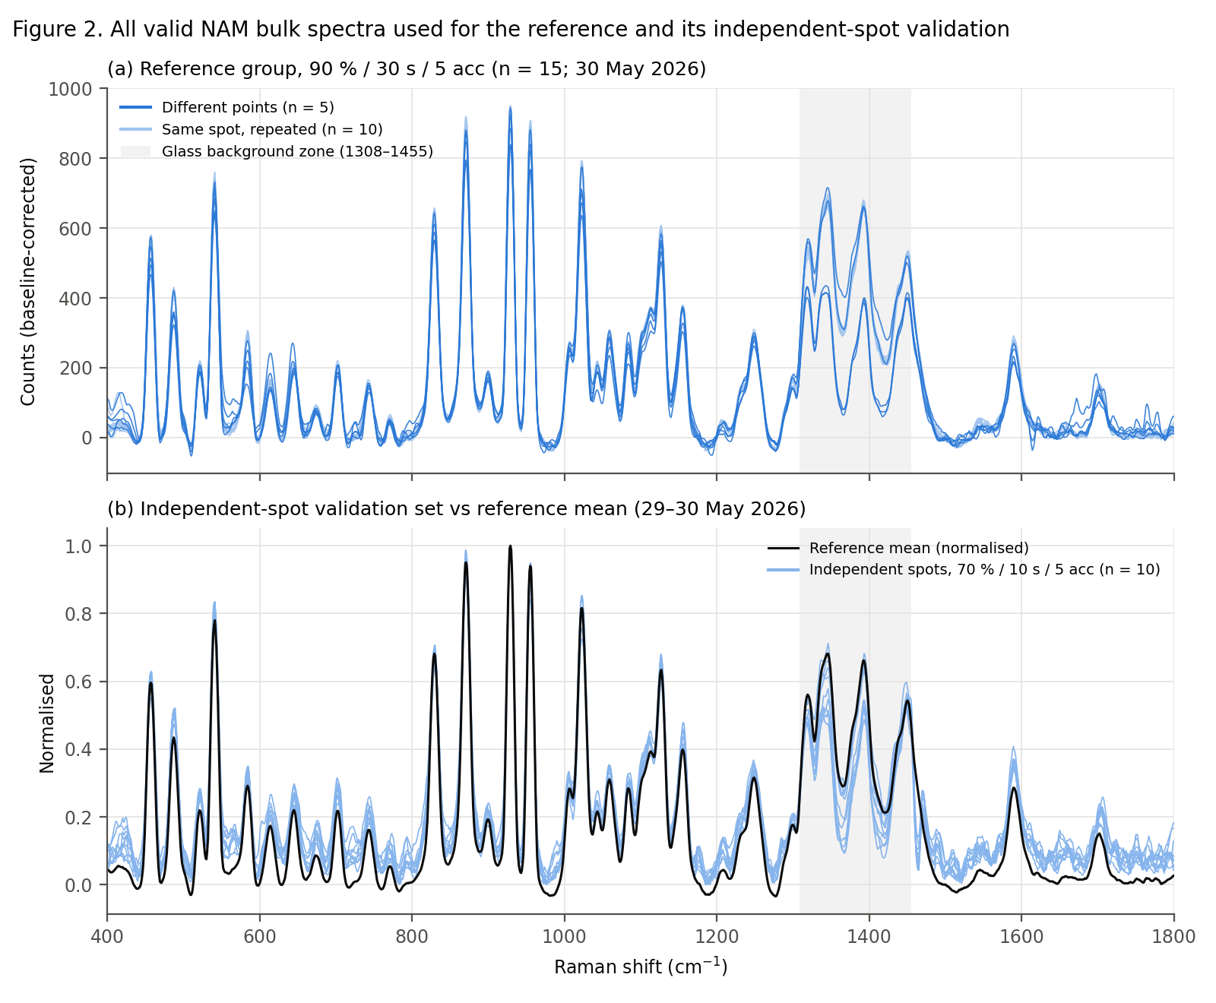
Figure 2. All valid NAM spectra: (a) reference group (n = 15; dark = different points, light = same-spot repeats); (b) independent-spot validation set (n = 10, 70 % / 10 s / 5 acc) against the reference mean.
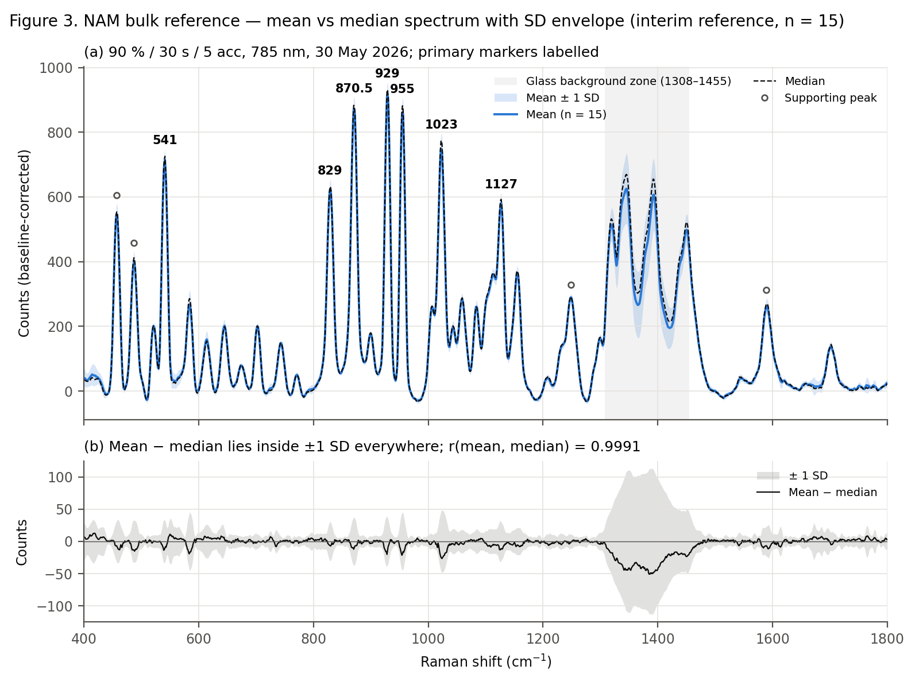
Figure 3. NAM mean vs median with ± 1 SD envelope and the mean − median difference (n = 15).

8.3 LTA
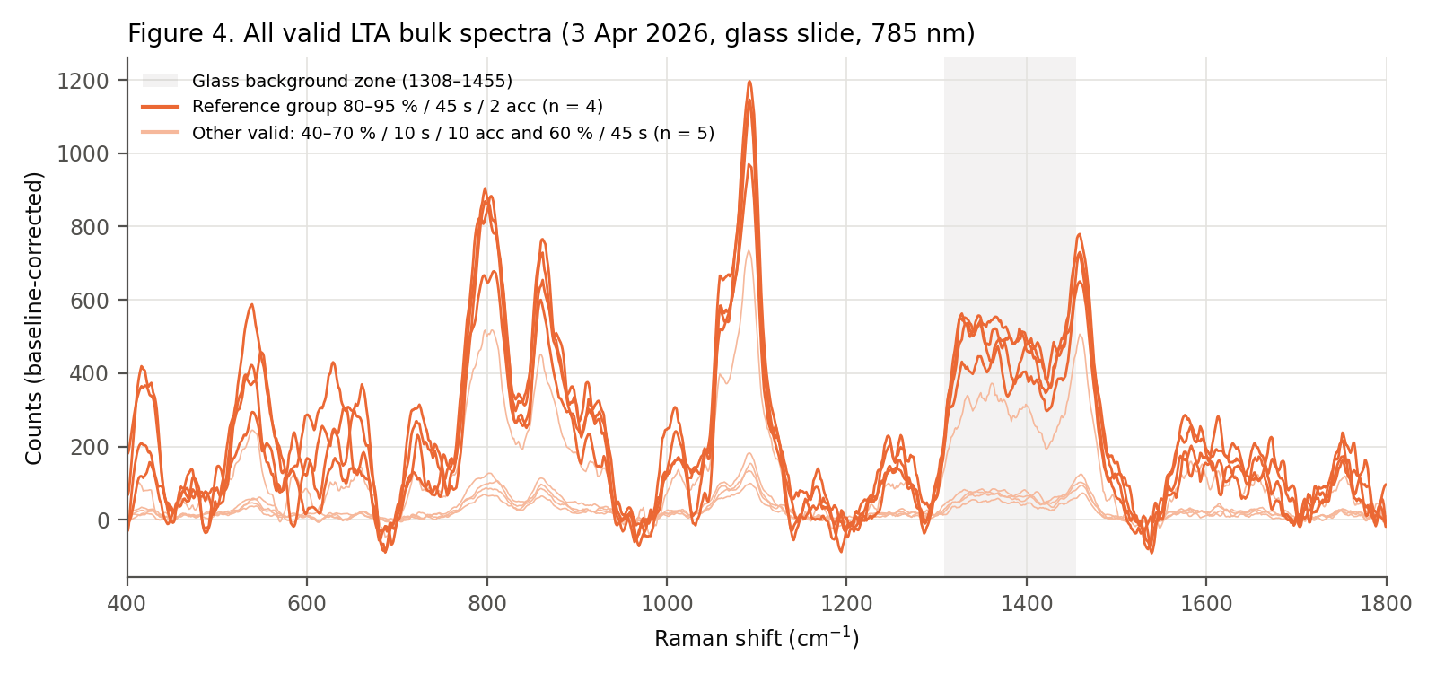
Figure 4. All valid LTA spectra (reference group in dark orange).
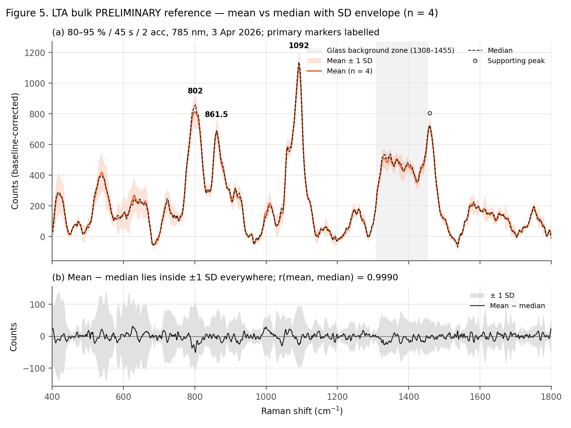
Figure 5. LTA mean vs median with ± 1 SD envelope (n = 4; preliminary).

8.4 Mean or median?
Mean: x̄(ν) = (1/n) Σ xᵢ(ν). Median: x_med(ν) = median(x₁(ν), …, xₙ(ν)). The mean uses all data and is efficient when spectra scatter symmetrically; the median is robust to outliers. Decision rule: if r(mean, median) ≥ 0.999 and |mean − median| < 1 SD at every wavenumber and marker, the population is consistent and the mean is used, with the median stored alongside.
Group | n | r(mean, median) | max |mean − median| / max(mean) | Points with |mean − median| > 1 SD | Choice
NAM reference | 15 | 0.9991 | 0.056 | 0 % | Mean (median agrees)
LTA reference | 4 | 0.9990 | 0.046 | 0 % | Mean (median agrees; n = 4, so the median = average of the middle two)
LPS (all) | 14 | 0.9711 | 0.259 | — | No representative spectrum (spectra not mutually consistent)
The largest NAM mean − median difference (≈ −50 counts) lies inside the glass zone, where the same-spot and different-point spectra carry different glass contributions. This is another reason the glass zone is excluded from marker selection.

9. Peak detection, reproducibility and background screen
In each replicate, peaks with prominence ≥ 5 × noise were detected. For every candidate band the position (mean ± SD), intensity (mean ± SD, CV), SNR, prominence and detection frequency were measured in the reference group, on each measurement day and in the independent-spot set (sheets 8, 14, 19).
Promotion criteria (thresholds are project conventions)
- C1 Reproducibility — detected in all reference spectra; ≥ 95 % of valid spectra on every day (NAM) or ≥ 8/9 valid spectra (LTA); all independent spots (NAM).
- C2 Signal — SNR ≥ 15 and intensity CV ≤ 15 %.
- C3 Background separation — outside the glass zone; ≥ 90 % of height retained after exploratory glass-template correction; ≥ 75 cm⁻¹ from the range edges (ALS end effects); not a fixed pixel or contamination band.
- C4 Chemical plausibility — lies in a documented group-frequency region of a functional group present in the molecule.
Primary = C1 + C2 + C3 + C4. Supporting = in all reference spectra and ≥ 90 % overall, but fails ≥ 1 criterion. Glass/background = inside the glass zone and removed by glass correction. Uncertain = everything else.
Biomarker | Band | Position | Ref. | Min day % | Indep. % | SNR | CV % | C1 | C2 | C3 | C4 | Category
NAM | 541 | 541.0 ± 0.0 | 15/15 | 100 | 100 | 39.9 | 4.6 | Yes | Yes | Yes | Yes | Primary marker
NAM | 830 | 829.0 ± 0.0 | 15/15 | 100 | 100 | 34.8 | 4.8 | Yes | Yes | Yes | Yes | Primary marker
NAM | 870 | 870.5 ± 0.5 | 15/15 | 100 | 100 | 48.6 | 4.3 | Yes | Yes | Yes | Yes | Primary marker
NAM | 929 | 929.0 ± 0.0 | 15/15 | 100 | 100 | 51.1 | 4.0 | Yes | Yes | Yes | Yes | Primary marker
NAM | 955 | 955.0 ± 0.0 | 15/15 | 100 | 100 | 48.1 | 5.1 | Yes | Yes | Yes | Yes | Primary marker
NAM | 1023 | 1022.7 ± 0.5 | 15/15 | 100 | 100 | 41.8 | 6.2 | Yes | Yes | Yes | Yes | Primary marker
NAM | 1127 | 1127.0 ± 0.0 | 15/15 | 98 | 100 | 32.4 | 5.2 | Yes | Yes | Yes | Yes | Primary marker
NAM | 458 | 457.0 ± 0.4 | 15/15 | 97 | 100 | 30.5 | 5.8 | Yes | Yes | No | Yes | Supporting peak
NAM | 487 | 487.0 ± 0.0 | 15/15 | 87 | 100 | 22.2 | 8.3 | No | Yes | Yes | Yes | Supporting peak
NAM | 1249 | 1248.7 ± 0.5 | 15/15 | 72 | 100 | 16.2 | 3.7 | No | Yes | No | No | Supporting peak
NAM | 584 | 583.8 ± 0.6 | 14/15 | 70 | 50 | 15.1 | 16.3 | No | No | No | No | Uncertain
NAM | 1059 | 1058.9 ± 0.3 | 15/15 | 0 | 0 | 15.8 | 6.4 | No | Yes | No | No | Uncertain
NAM | 1155 | 1155.0 ± 0.0 | 15/15 | 52 | 90 | 20.4 | 5.8 | No | Yes | No | No | Uncertain
NAM | 1589 | 1589.5 ± 0.5 | 15/15 | 66 | 100 | 14.7 | 8.9 | No | No | No | No | Supporting peak
NAM | 1346 | 1344.9 ± 1.3 | 15/15 | 74 | 100 | 35.2 | 17.1 | No | No | No | No | Uncertain
NAM | 1393 | 1392.5 ± 0.5 | 15/15 | 84 | 100 | 34.1 | 18.3 | No | No | No | No | Uncertain
NAM | 1451 | 1450.0 ± 0.5 | 15/15 | 86 | 100 | 27.9 | 10.0 | No | Yes | No | No | Uncertain
LTA | 802 | 802.2 ± 5.1 | 4/4 | 89 | — | 21.4 | 12.6 | Yes | Yes | Yes | Yes | Primary marker
LTA | 861 | 861.5 ± 1.0 | 4/4 | 89 | — | 17.6 | 10.8 | Yes | Yes | Yes | Yes | Primary marker
LTA | 1092 | 1091.8 ± 0.5 | 4/4 | 100 | — | 28.5 | 8.8 | Yes | Yes | Yes | Yes | Primary marker
LTA | 1459 | 1458.8 ± 0.5 | 4/4 | 100 | — | 18.5 | 7.4 | Yes | Yes | No | Yes | Supporting peak
LTA | 541 | 541.2 ± 5.2 | 4/4 | 78 | — | 11.3 | 27.5 | No | No | No | No | Uncertain
LTA | 1367 | 1367.2 ± 2.2 | 1/4 | 11 | — | 13.2 | 6.8 | No | No | No | No | Glass/background
Background-origin screen of the final markers
For each primary marker the alternative origins were checked (sheet 21). Glass: the empty-slide blank is ≤ 11 % of its maximum at every primary marker (22 % at LTA 1459). Instrument: not in the blank, not at a fixed pixel, and at the same position across powers and days. Fluorescence: broad and removed by ALS; the markers are 10–50 cm⁻¹ wide Raman-like bands. Cosmic ray: present in 100 % of spectra, whereas spikes are random. Contamination: no polystyrene pattern. Processing artefact: every marker is present in 100 % of the unsmoothed (despiked only) spectra, so it is not created by smoothing.
Final hierarchy
Biomarker | Primary marker peaks | Supporting peaks | Glass/background | Uncertain
NAM | 541, 829, 870.5, 929, 955, 1023, 1127 | 457 (range edge), 487 and 1249 (day-dependent detection), 1589 (unassigned) | Broad band 1308–1455 (max ≈ 1365) | 584, 1059, 1155; 1345, 1392, 1450 (inside glass zone)
LTA (preliminary) | 802, 861.5, 1092 | 1459 (82 % retained after glass correction; non-specific δCH₂) | 1367; broad band 1308–1455 | 541 (CV 27 %)
LPS | None | None | Broad band 1308–1455 | —

10. Chemical and functional-group interpretation
N-Acetylmuramic acid (MurNAc)
2-Acetamido-3-O-[(R)-1-carboxyethyl]-2-deoxy-D-glucopyranose (C₁₁H₁₉NO₈). Groups that can give Raman bands in 400–1800 cm⁻¹: the pyranose ring (C–C, C–O, ring C–O–C, anomeric C1–OH), hydroxyl-bearing carbons (C–OH), the N-acetyl amide (CH₃–C(=O)–NH–; amide I ≈ 1650, amide III ≈ 1250–1300 cm⁻¹, C–N), the 3-O-lactyl ether (C–O–C) and its carboxylic acid (C=O ≈ 1700–1730 cm⁻¹), and methyl groups (CH₃ deformation ≈ 1450, rocking ≈ 950–1000 cm⁻¹). The observed primary markers all lie in the 400–1200 cm⁻¹ carbohydrate region. Amide-region bands are weak: 1249 cm⁻¹ is supporting and unassigned, and a weak band near 1700 cm⁻¹ was not selected.
Lipoteichoic acid (LTA)
A poly(1,3-glycerol-phosphate) chain whose glycerol C2 positions carry D-alanine esters and/or glycosyl groups, anchored in the membrane by a glycolipid (diacylglycerol with fatty-acyl chains). Raman-relevant groups: phosphodiester (PO₂⁻ symmetric stretch ≈ 1090–1095; O–P–O stretch ≈ 810 cm⁻¹), glycerol/polyol C–C and C–O, glycosidic C–O–C, and acyl-chain CH₂ (δCH₂ ≈ 1440–1460 cm⁻¹).
Lipopolysaccharide (LPS)
Lipid A (phosphorylated glucosamine disaccharide with acyl chains), core oligosaccharide and O-antigen polysaccharide. No experimental LPS band is established, so no assignment is made.
Biomarker | Raman shift (mean ± SD, cm⁻¹) | Observed intensity; SNR | Literature region [ref] | Functional group | Molecular vibration | Chemical component | Confidence
NAM | 541.0 ± 0.0 | 715 ± 33 counts (rel. 0.78); SNR 39.9 | 400–600 (region) [L6] | Pyranose-ring skeleton | Skeletal ring deformation δ(C–C–O)/δ(C–C–C) | Glucopyranose ring of MurNAc | Low — tentative assignment
NAM | 829.0 ± 0.0 | 625 ± 30 counts (rel. 0.68); SNR 34.8 | 800–950 (region) [L6] | Pyranose ring / anomeric centre | ν(C–O–C) ring and/or δ(C1–H) (anomeric region) | Ring C–O–C and anomeric C1 | Low — tentative assignment
NAM | 870.5 ± 0.5 | 872 ± 37 counts (rel. 0.95); SNR 48.6 | 800–950 (region) [L6] | Pyranose ring | ν(C–C)/ν(C–O–C) ring stretching | Glucopyranose ring | Low — tentative assignment
NAM | 929.0 ± 0.0 | 917 ± 37 counts (rel. 1.00); SNR 51.1 | 800–950 (region) [L6, L5] | Ring C–O–C / C–C; possibly lactyl C–C(OOH) | ν(C–O–C)/ν(C–C); lactyl contribution not verified | Ring and/or 3-O-lactyl side chain | Low — tentative assignment
NAM | 955.0 ± 0.0 | 862 ± 44 counts (rel. 0.94); SNR 48.1 | ~950–960 (edge of 800–950 region) [L5, L6] | C–C skeleton / CH3 | ν(C–C) and/or CH3 rocking (N-acetyl or lactyl methyl) | Ring C–C; N-acetyl / lactyl CH3 | Low — tentative assignment
NAM | 1022.7 ± 0.5 | 749 ± 47 counts (rel. 0.82); SNR 41.8 | 1000–1200 (region) [L6] | C–O (C–OH) | ν(C–O)/ν(C–C), C–OH stretching | Ring hydroxyl-bearing carbons (C4, C6) | Low — tentative assignment
NAM | 1127.0 ± 0.0 | 581 ± 30 counts (rel. 0.63); SNR 32.4 | 1000–1200 (region) [L6] | C–O–C ether / C–C | ν(C–O–C) (ring / 3-O-lactyl ether) or ν(C–C) | Ring oxygen and ether linkage | Low — tentative assignment
LTA | 802.2 ± 5.1 | 834 ± 105 counts (rel. 0.75); SNR 21.4 | ~813 [L5] | Phosphodiester | ν(O–P–O) symmetric stretch | Poly(glycerol-phosphate) backbone | Low — tentative assignment
LTA | 861.5 ± 1.0 | 687 ± 74 counts (rel. 0.62); SNR 17.6 | 800–950 (region) [L6] | Polyol / glycosyl C–C, C–O–C | ν(C–C)/ν(C–O–C) | Glycerol units and sugar substituents | Low — tentative assignment
LTA | 1091.8 ± 0.5 | 1110 ± 98 counts (rel. 1.00); SNR 28.5 | 1090–1095 [L5, L7 (+L8 IR, whole cells)] | Phosphodiester (PO2−) | ν_s(PO2−) symmetric stretch | Poly(glycerol-phosphate) backbone | Moderate — tentative assignment
LTA | 1458.8 ± 0.5 | 721 ± 53 counts (rel. 0.65); SNR 18.5 | 1440–1460 [L7] | CH2 (acyl chains, glycerol) | δ(CH2) scissoring | Glycolipid anchor fatty-acyl chains; glycerol CH2 | Low — tentative assignment
Biomarker relevance: NAM bands are carbohydrate-ring modes shared with other hexosamines (929 cm⁻¹ may include a lactyl contribution, unverified); LTA 802/1092 cm⁻¹ reflect the phosphodiester backbone that distinguishes teichoic-acid-type polymers from NAM; LTA 1459 cm⁻¹ (δCH₂) is non-specific.
All assignments are tentative. They place each band in a published group-frequency region for a functional group present in the molecule; they do not identify a unique vibration. The NAM carbohydrate bands in particular are shared by other hexoses and hexosamines. The combination of all seven primary markers, not any single band, characterises the NAM powder spectrum.

11. Literature comparison
Searches covered N-acetylmuramic acid / MurNAc Raman, vibrational spectroscopy and SERS; peptidoglycan Raman; lipoteichoic acid Raman, SERS and vibrational spectroscopy (including S. aureus); lipopolysaccharide / LPS / E. coli LPS / lipid A Raman and SERS. The evidence types are kept separate and are not interchangeable:
Evidence type | NAM | LTA | LPS
Pure-compound normal Raman of the biomarker | None found | None found | None found
Pure related compounds (reviews) | Carbohydrate review L6; related amino-sugar polymers L10 (not accessed) | Lipid review L7 | Lipid review L7
Band compilations from biological tissue | L5 | L5 | L5
Biological-sample Raman / FTIR | — | FTIR of wall teichoic acid in S. aureus cells L8 | Whole-cell Raman L3
SERS | — | L2 (B. subtilis LTA: 894, 1333), L4 | L1, L2
Other vibrational | NIR + DFT-calculated IR L9; UV resonance Raman L11 (not accessed) | — | —
Because no pure-compound normal-Raman reference exists, the best available support for NAM is group-frequency regions (confidence Low), and for LTA 1092 cm⁻¹ an established phosphodiester frequency consistent with the known backbone (confidence Moderate). SERS bands are not used to assign bulk bands, because surface selection rules change positions and intensities. For example, the SERS LTA bands at 894 and 1333 cm⁻¹ [L2] have no bulk counterpart within ±12 cm⁻¹. Full table: 06_Literature/Literature_Peak_Assignments.xlsx.
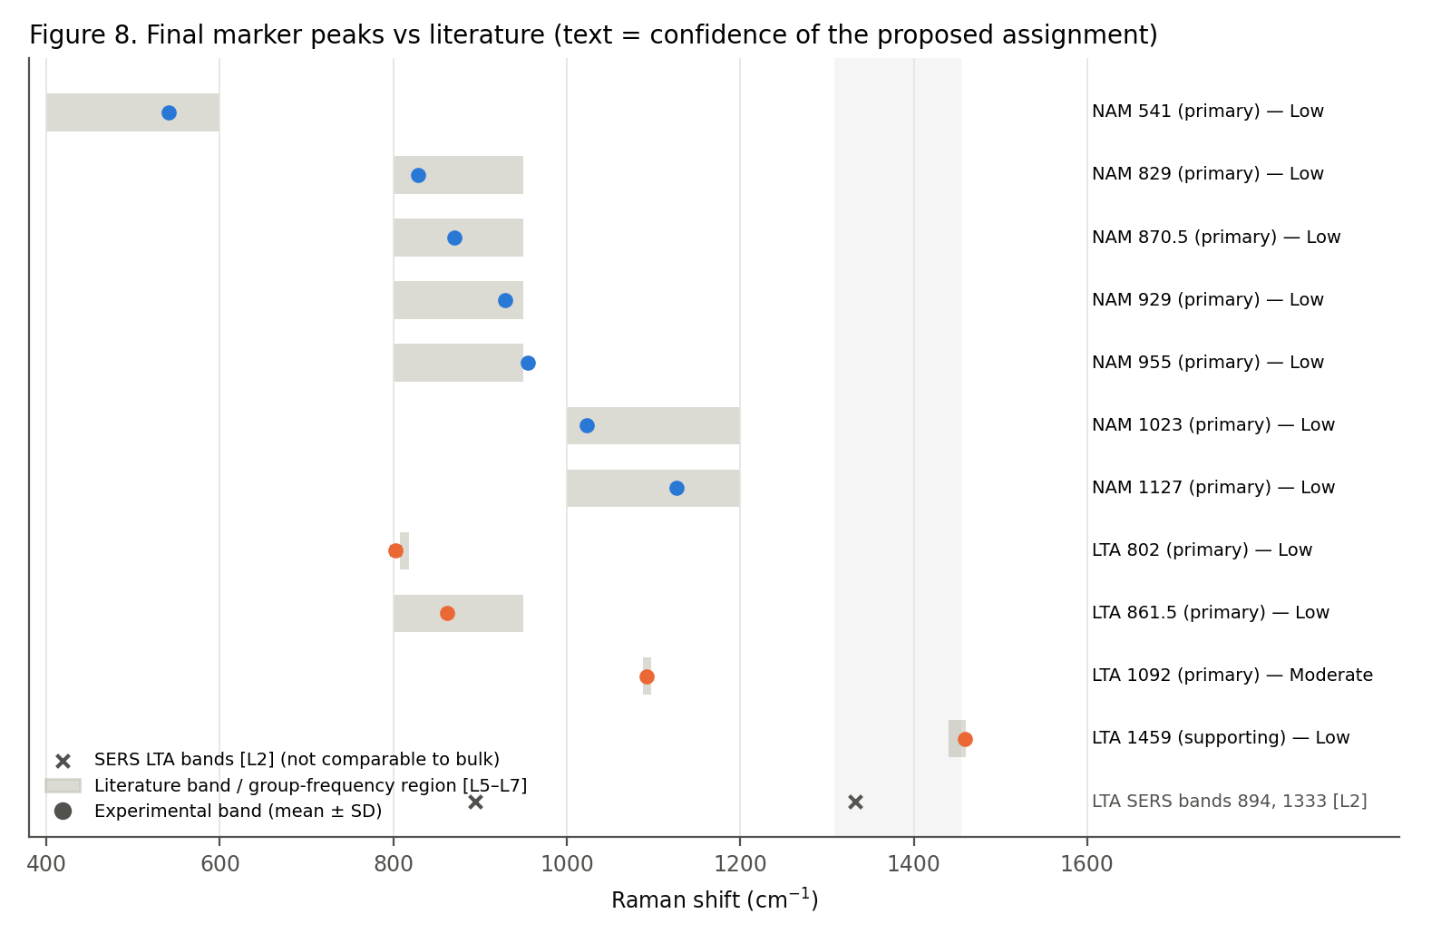
Figure 8. Final marker peaks (mean ± SD) against literature bands / group-frequency regions, with the confidence of each proposed assignment.

12. Central traceability table
For every final marker, the chain from QC-passed spectra to literature (sheet Traceability_Table in the workbook).
Biomarker | Category | Peak ± SD (cm⁻¹) | Intensity (counts) | SNR | Replicate frequency | Literature | Assignment (tentative) | Evidence type | Ref. | Conf.
NAM | Primary | 541 ± 0.0 | 715 ± 33 | 39.9 | 15/15 ref; min day 100 %; indep. spots 100 % | 400–600 (region) | pyranose-ring skeletal deformation δ(C-C-O)/δ(C-C-C) | Related pure carbohydrates (review) | L6 | Low
NAM | Primary | 829 ± 0.0 | 625 ± 30 | 34.8 | 15/15 ref; min day 100 %; indep. spots 100 % | 800–950 (region) | ν(C-O-C)/ring mode in the carbohydrate anomeric region | Related pure carbohydrates (review) | L6 | Low
NAM | Primary | 870.5 ± 0.5 | 872 ± 37 | 48.6 | 15/15 ref; min day 100 %; indep. spots 100 % | 800–950 (region) | ν(C-O-C)/ν(C-C) ring mode (anomeric region) | Related pure carbohydrates (review) | L6 | Low
NAM | Primary | 929 ± 0.0 | 917 ± 37 | 51.1 | 15/15 ref; min day 100 %; indep. spots 100 % | 800–950 (region) | ν(C-O-C)/ν(C-C); possible lactyl C-COOH contribution | Related pure carbohydrates (review); Tissue band compilation | L6, L5 | Low
NAM | Primary | 955 ± 0.0 | 862 ± 44 | 48.1 | 15/15 ref; min day 100 %; indep. spots 100 % | 800–950 (upper edge) | ν(C-C) / CH3 rocking (N-acetyl or lactyl methyl) – tentative | Tissue band compilation; Related pure carbohydrates (review) | L5, L6 | Low
NAM | Primary | 1023 ± 0.5 | 749 ± 47 | 41.8 | 15/15 ref; min day 100 %; indep. spots 100 % | 1000–1200 (region) | ν(C-O)/ν(C-C) (C-OH stretching) of sugar ring | Related pure carbohydrates (review) | L6 | Low
NAM | Primary | 1127 ± 0.0 | 581 ± 30 | 32.4 | 15/15 ref; min day 98 %; indep. spots 100 % | 1000–1200 (region) | ν(C-O-C) (3-O-lactyl ether / ring) or ν(C-C) | Related pure carbohydrates (review) | L6 | Low
NAM | Supporting | 457 ± 0.4 | 547 ± 32 | 30.5 | 15/15 ref; min day 97 %; indep. spots 100 % | 400–600 (region) | pyranose-ring skeletal deformation | Related pure carbohydrates (review) | L6 | Low
NAM | Supporting | 487 ± 0.0 | 398 ± 33 | 22.2 | 15/15 ref; min day 87 %; indep. spots 100 % | 400–600 (region) | skeletal deformation | Related pure carbohydrates (review) | L6 | Low
NAM | Supporting | 1249 ± 0.5 | 290 ± 11 | 16.2 | 15/15 ref; min day 72 %; indep. spots 100 % | — | No assignment proposed (possible amide III / CH deformation region; not verified) | — | — | Uncertain
NAM | Supporting | 1589.5 ± 0.5 | 263 ± 23 | 14.7 | 15/15 ref; min day 66 %; indep. spots 100 % | — | No assignment proposed (unassigned; reproducible) | — | — | Uncertain
LTA | Primary | 802 ± 5.1 | 834 ± 105 | 21.4 | 4/4 ref; min day 89 % | ~813 (ν O-P-O) | ν(O-P-O) phosphodiester stretch | Tissue band compilation | L5 | Low
LTA | Primary | 861.5 ± 1.0 | 687 ± 74 | 17.6 | 4/4 ref; min day 89 % | 800–950 (region) | ν(C-C)/ν(C-O-C) of glycerol / sugar substituents | Related pure carbohydrates (review) | L6 | Low
LTA | Primary | 1092 ± 0.5 | 1110 ± 98 | 28.5 | 4/4 ref; min day 100 % | 1090–1095 (ν_s PO2−) | ν_s(PO2−) of phosphodiester (poly-glycerophosphate backbone) | Tissue band compilation; Related pure lipids (review); Whole-cell FTIR | L5, L7, L8 | Moderate
LTA | Supporting | 1459 ± 0.5 | 721 ± 53 | 18.5 | 4/4 ref; min day 100 % | 1440–1460 (δ CH2) | δ(CH2) scissoring (acyl chains of glycolipid anchor); non-specific | Related pure lipids (review) | L7 | Low

13. LPS: status and controlled experiment
LPS reference spectrum pending controlled glass-slide measurement. The 14 existing spectra (13 Apr 2026) were recorded at 10–20 % power only. The dominant feature (≈ 1360–1370 cm⁻¹) coincides with the empty-glass blank and is not classified as an LPS peak. After exploratory subtraction of a glass template, no reproducible band remains. The spectra are not mutually consistent (pairwise r 0.33, down to −0.47). No LPS identity is forced and no reference spectrum is generated.
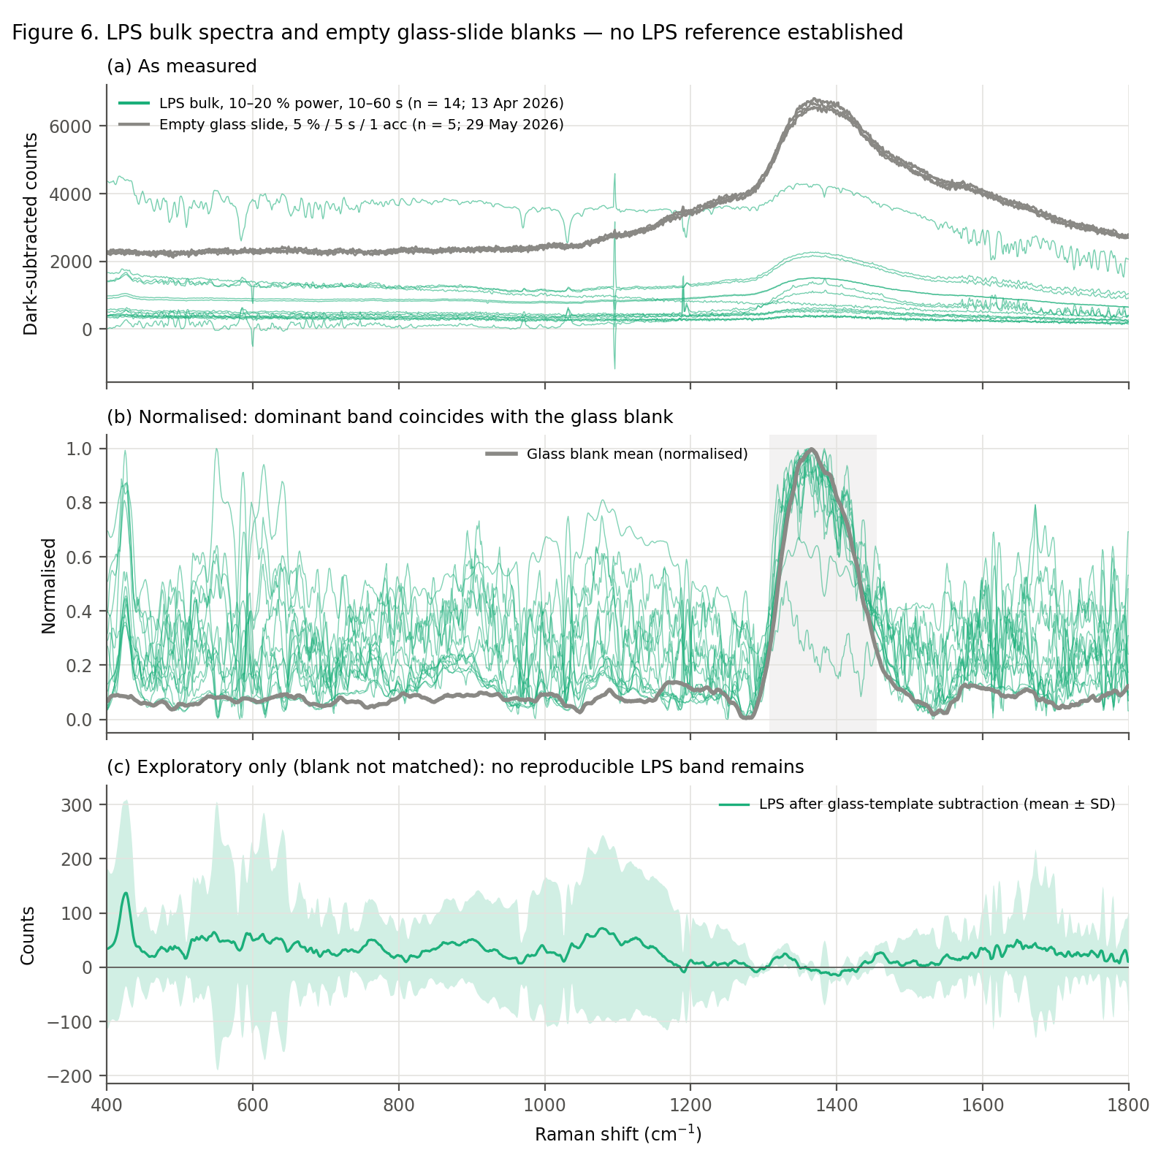
Figure 6. LPS spectra and empty glass-slide blanks: (a) as measured; (b) normalised; (c) after exploratory glass-template subtraction (blank not matched — indicative only).
Step | Sample | Condition | Replicates
1 | LPS powder on glass slide | 785 nm, 70 %, 30 s, 5 acc | ≥ 5 independent spots
2 | Empty glass slide (same type/lot) | identical to step 1 | ≥ 3
3 | LPS powder | 785 nm, 80 %, 30 s, 5 acc | ≥ 5
4 | Empty glass slide | identical to step 3 | ≥ 3
5 | LPS powder | 785 nm, 90 %, 30 s, 5 acc | ≥ 5
6 | Empty glass slide | identical to step 5 | ≥ 3
7 | LPS powder at the selected power | 30 s, 5 acc | 10–15 independent spots + 3 blanks
Selection of the LPS reference condition: SNR + reproducibility + intensity + no saturation + separation from the glass background. Only bands present in LPS + glass, absent from the matched blank, found in most spots and with SNR ≥ 10 after blank comparison can become LPS marker candidates. They then pass through the same C1–C4 criteria. Literature bands to check (mostly SERS, so bulk positions may differ): ≈ 543–550, 680, 735, 794, 850, 894, 917, 981–988, 1003, 1103, 1131, 1592, 1614 cm⁻¹. The ≈ 1330 cm⁻¹ band lies inside the glass zone.

14. Reference library, bulk intensity and reproducibility
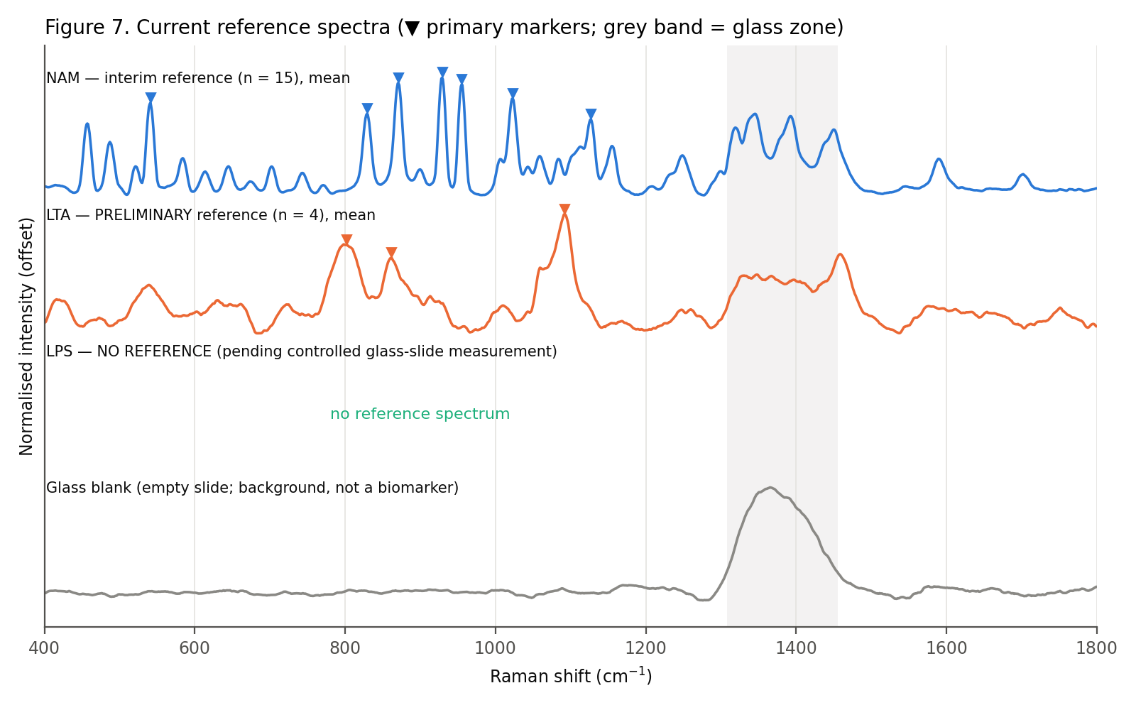
Figure 7. Current reference spectra: NAM (interim, n = 15), LTA (preliminary, n = 4), LPS (none), and the glass blank.
Biomarker | Condition | n | Max raw counts (400–1800) | Baseline (counts) | Strongest marker (net counts) | CV % | SNR
NAM | 90% / 30 s / 5 acc | 15 | 6055 ± 323 | 1358 | 917 ± 37 (929 cm⁻¹) | 4.0 | 51.1 ± 4.7
LTA | 80-95% / 45 s / 2 acc | 4 | 16387 ± 4560 | 8000 | 1110 ± 98 (1092 cm⁻¹) | 8.8 | 28.5 ± 1.0
LPS | 60 % / 40 s / 5 acc | 10 | — | — | 680 median (302–1631) (425 cm⁻¹); under-estimated 3–34 % (dark light) | — | 38 (median)
These are bulk powder Raman counts measured on glass slides with this instrument and pipeline. They are not normalised values and not mW-calibrated, and they depend on the smoothing and baseline settings (Section 5). The reference files (03_Reference_Spectra) store the mean, median and SD of the baseline-corrected counts, the mean dark-subtracted counts and the normalised mean/median/SD.
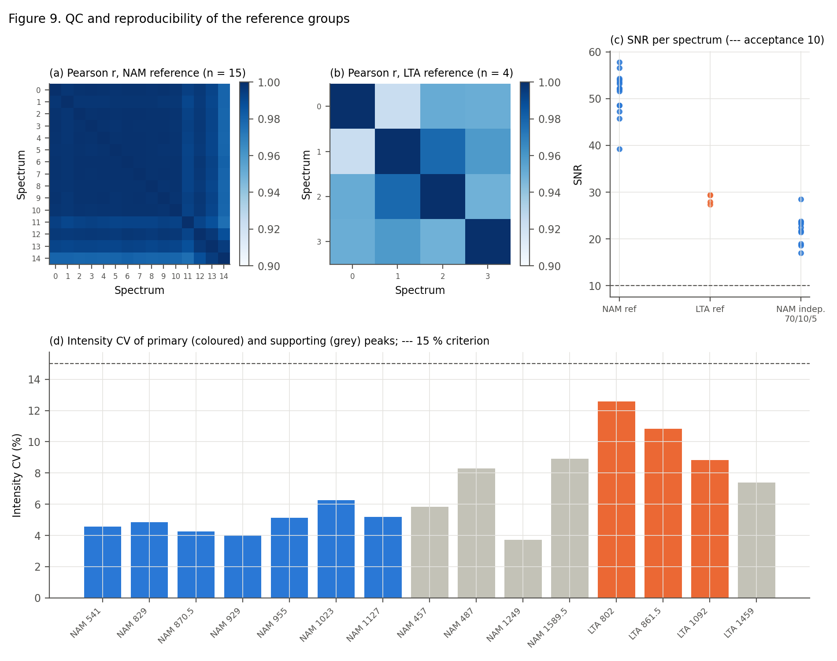
Figure 9. QC and reproducibility: (a, b) pairwise correlation matrices; (c) SNR per spectrum; (d) intensity CV of primary and supporting peaks.

15. Final acquisition decision and next laboratory experiment
Biomarker | Existing data sufficient? | Why? | Re-acquisition needed? | Recommended condition | Target n
NAM | YES – accepted as FINAL (28 Sep 2026) | Excellent quality; 6 independent spots at the reference condition, plus 31 independent spots at other conditions confirming all markers (Section 15A) | NO (closed by decision) | 785 nm, 90 %, 30 s, 5 acc (unchanged; no saturation, SNR ≈ 51) | —
LTA | NO | n = 4, single day, spot independence unknown; baseline-sensitive intensities | YES | 785 nm, 80 %, 45 s, 2 acc (lowest power in the 80–95 % plateau; SNR ≈ 27–28; max raw ≈ 16 000 counts). Check the first 2–3 spots for high-power ripple (seen at ≥ 80 % in Sep 2026); fallback 70 % / 45 s / 2 acc | 10–15 independent spots + 3 matched glass blanks
LPS | YES – reference established 28 Sep 2026 | 10 independent spots at 60 % / 40 s / 5 acc; ripple-free; primary markers 425 and 1080 cm⁻¹ (Section 15C) | NO | 785 nm, 60 %, 40 s, 5 acc; dark with shutter closed by hand | —
Why these conditions: they are the conditions the existing data identified as best, and they are not changed at random. NAM 90 % / 30 s / 5 acc gives SNR ≈ 51 without saturation (max raw ≈ 6 000 counts). The 60 s acquisitions at 90 % were distorted. LTA 80 % / 45 s / 2 acc is the lowest power on the 80–95 % SNR plateau (SNR 27–28) and stays well below saturation. LPS needs higher power than the 10–20 % tried so far, and its choice must be made against matched blanks.
Recording and naming (08_Methodology/05_Acquisition_SOP.md, Acquisition_Log_Template.csv): date, biomarker, power, integration, accumulations, spot/replicate, glass-slide type/lot, spot position, sample preparation, objective and saturation check for every spectrum. File names: NAM_Bulk_YYYYMMDD_P090pct_T30s_A05_S01.csv … S15; blanks Glass_Blank_YYYYMMDD_P090pct_T30s_A05_S01.csv. Use a new spot for every replicate; same-spot repeats do not increase n.

15A. Update (27 Sep 2026): NAM independent-spot validation session, 24 Sep 2026
What was measured. 41 independent NAM spots at 60, 70, 80 and 90 % laser power (30 s × 5 acc) with 16 matched empty-glass blanks. The raw folder was named "bulk-lps-24-09-26" by mistake; the spectra matched NAM, and the operator confirmed on 27 Sep 2026 (by checking the bottle) that the powder was NAM. The files were renamed NAM_Bulk_20260924_* and the withdrawn LPS-labelled outputs are kept in _to_delete. Full details: NAM_Bulk_Validation_Report_20260924.docx.
QC. 21 of 41 spectra pass (60 %: 11/11, 70 %: 5/8, 80 %: 4/9, 90 %: 1/13). All 20 failures come from dark-reference ripple: the dark level rose from about 1 420 to about 4 470 counts during the roughly 10-hour session, so the fixed detector pattern was no longer cancelled. No spectrum saturated. All 16 blanks saturate across the glass band.
Set | n | r vs reference mean | Pairwise r | 929 cm⁻¹ height (CV) | SNR (929)
Reference 30 May, 90 % | 15 | 1.000 | 0.994 | 919 (3.9 %) | 51.2
Reference, independent spots only | 5 | 0.999 | 0.989 | 888 (5.3 %) | 47.6
24 Sep, 60 % | 11 | 0.982 | 0.987 | 473 (15.9 %) | 29.9
24 Sep, 70 % | 5 | 0.991 | 0.992 | 569 (10.6 %) | 34.1
24 Sep, 80 % | 4 | 0.990 | 0.958 | 718 (10.4 %) | 33.4
24 Sep, 90 % | 1 | 0.994 | — | 709 (n = 1) | 27.5
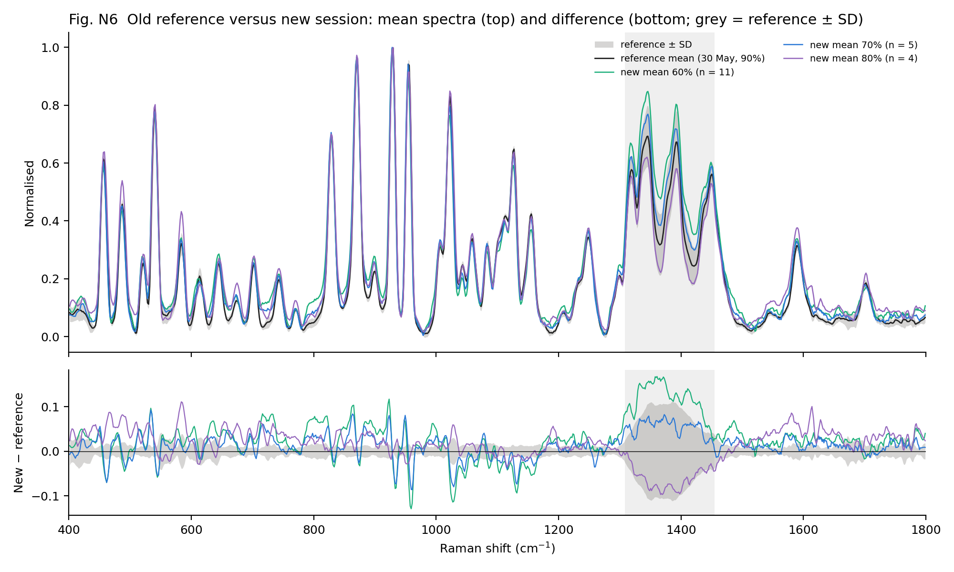
Figure 15A-1. Reference mean ± SD (30 May, 90 %) versus the new 60/70/80 % means (24 Sep) and their differences.
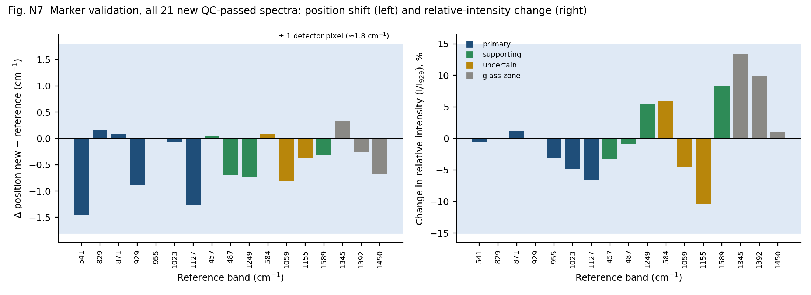
Figure 15A-2. Marker validation, 21 new spectra: position shift (left; shaded = ±1 detector pixel) and change in relative intensity I/I929 (right).
Result. All 7 primary markers and 4 supporting peaks were detected in 21/21 new spectra. Every position is within 1.5 cm⁻¹ of the reference (less than one detector pixel). Relative intensities agree within ±7 % for the primary markers and ±11 % for the other bands outside the glass zone. The v3 marker hierarchy and the tentative assignments are unchanged.
Decision. The new data support the existing reference. The reference condition (90 % / 30 s / 5 acc) and the reference files are unchanged. Absolute intensity at 90 % was lower on 24 Sep (709 counts, n = 1, vs 919 counts); relative intensities agree, so this is a session-level difference, not a reason to change the condition. Final status (28 Sep 2026): the existing data were judged sufficient and the NAM reference was declared FINAL, with no further NAM acquisition. Documented limitation: 6 independent spots at the reference condition (target 10). This is accepted because 31 independent spots at other conditions confirm every marker position and relative intensity. The LPS "70 % provisional" recommendation made earlier from these data is withdrawn; LPS still needs its own 70/80/90 % screening.

15B. Update (28 Sep 2026): LPS power screening
What was measured. LPS bulk powder on glass at 60, 70 and 80 % × 30 s × 5 acc: 19 spectra and 10 matched blanks. 90 % was not measured because 80 % failed (see below). Raw folder: 28-9-26-lps-bulk (unchanged); library copies LPS_Bulk_20260928_* / Glass_Blank_20260928_*.
Power | Spectra | Core (used) | Review / fail | Pairwise r | 425 cm⁻¹: counts (CV), SNR
60 % | 9 | 8 | 1 glass-dominated | 0.938 | 282 (25 %), 20
70 % | 5 | 4 | 1 glass-dominated | 0.963 | 345 (12 %), 25
80 % | 5 | 0 | 5 fail (fixed-pattern ripple) | — | —
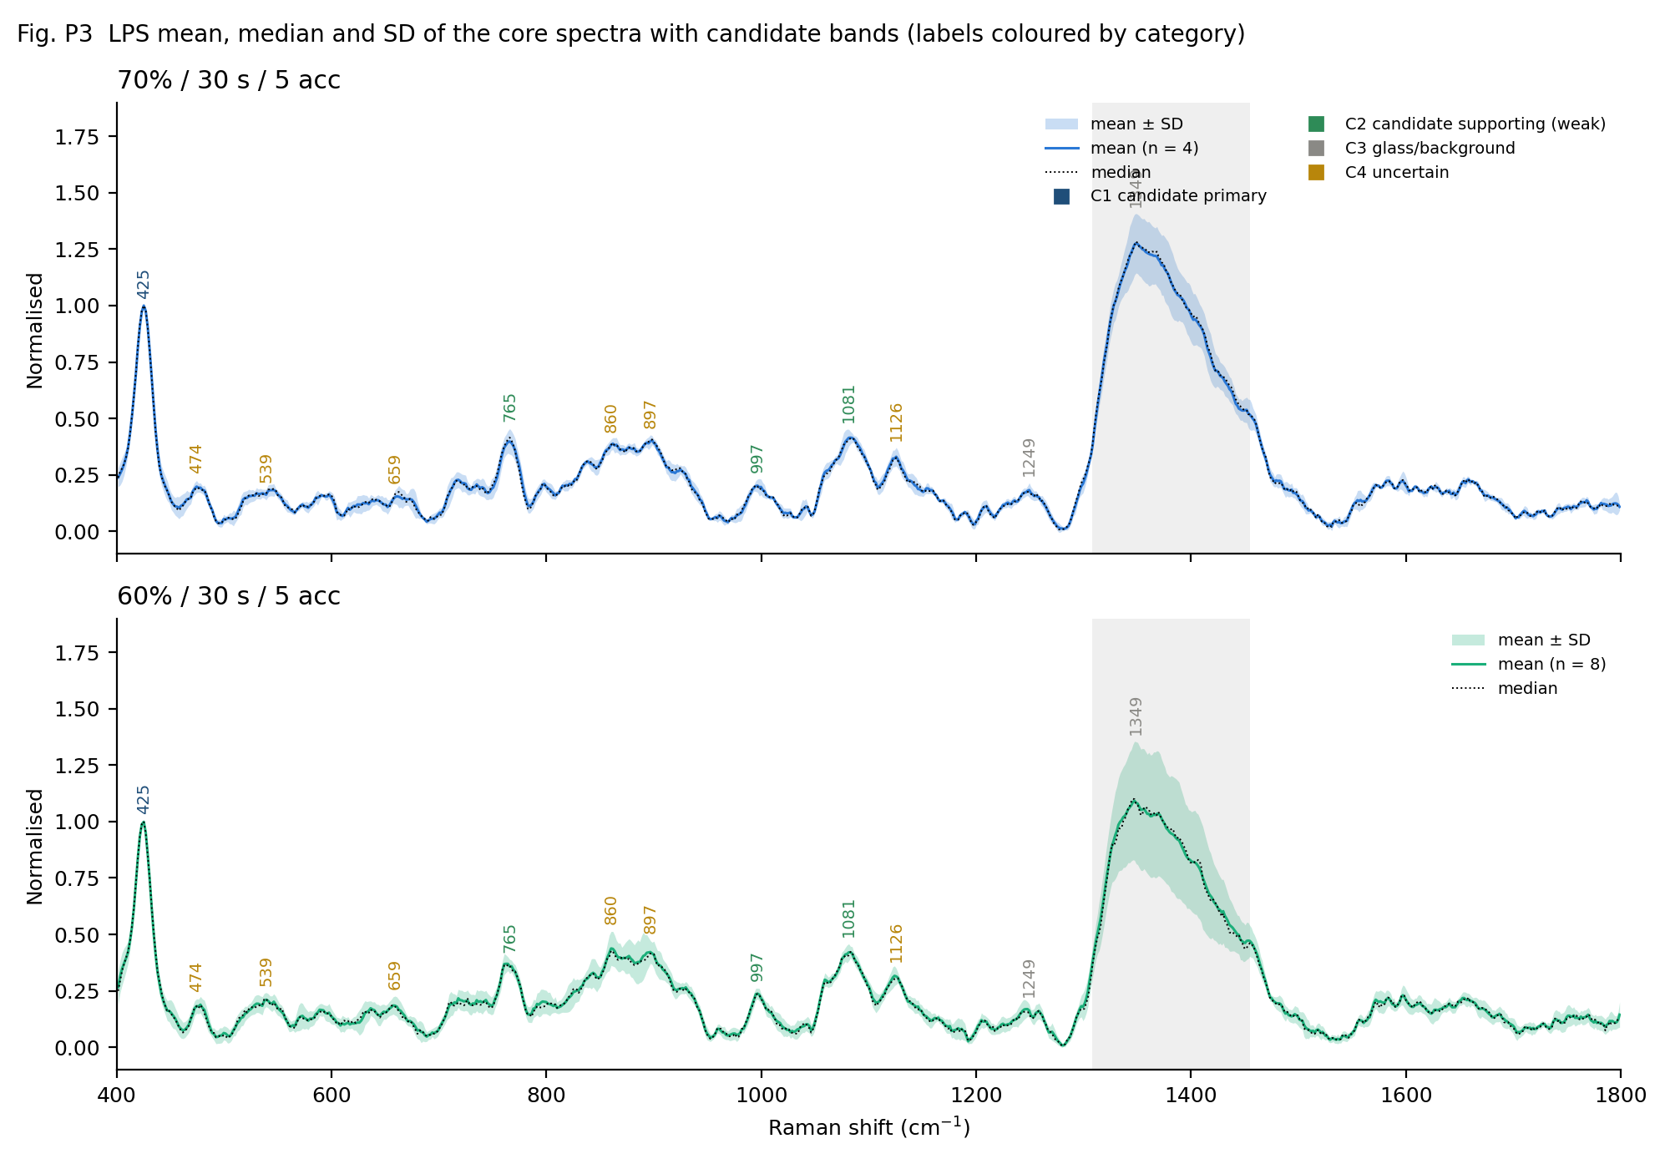
Figure 15B-1. LPS core spectra at 70 % (top) and 60 % (bottom): mean, median, ± SD and candidate bands.
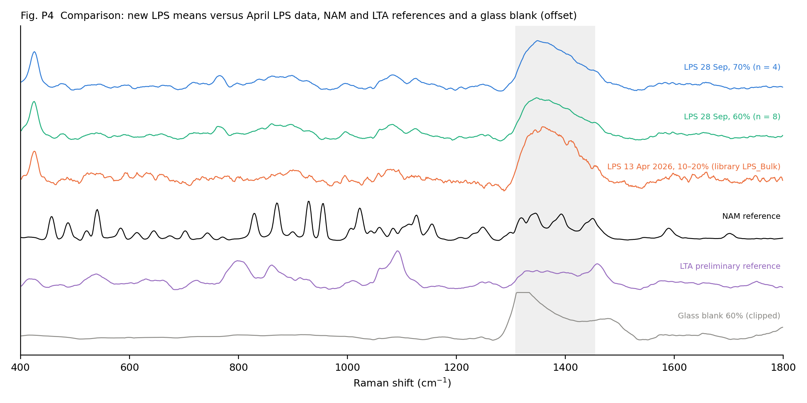
Figure 15B-2. New LPS means compared with the April 2026 LPS data, the NAM and LTA references and a glass blank.
Findings. The spectra match the April 2026 LPS data (r = 0.75–0.82) and not NAM (r < 0.2), so the sample identity is consistent. One strong candidate band is found at 425 cm⁻¹ (SNR 20–25). It is confirmed in the raw data and is absent from the blanks. Weak candidate bands at 765, 997 and 1081 cm⁻¹ have SNR 4–10. 1249 cm⁻¹ may come from the glass, and 1308–1455 cm⁻¹ is dominated by glass. At 80 %, every spectrum showed a fixed-pattern ripple that a fresh dark did not remove; NAM showed the same behaviour at 80–90 % on 24 Sep. Mean and median agree (r ≥ 0.999).
Decision. 70 % is selected. The LPS reference is not yet established: collect 10–15 independent spots at 70 % / 30 s / 10 acc (same frame, more averaging, about 1.4× better SNR), with thick packed powder, a fresh dark before every spectrum, 3 matched blanks and 1 short blank. Details: workbook sheets 33–36 and 03_Reference_Spectra/LPS (screening means marked NOT_REFERENCE).

15C. Update (28 Sep 2026): LPS reference established
Sample and condition. LPS from E. coli O111:B4 (Sigma-Aldrich L2630, lot 0000442391; phenol-extracted, smooth LPS), bulk powder on glass, 60 % / 40 s / 5 acc. The condition was reached after the screening in Section 15B and bench troubleshooting. At 70–90 % the instrument produced a fixed-pattern ripple inside the collected light, and the software dark step let sample light through unless the shutter was closed by hand. At 60 % the spectra were ripple-free, and 40 s raised the SNR of the 425 cm⁻¹ band to 19–63.
Item | Result
Reference set | 10 independent spots (S10–S12, S14–S20); S13 excluded (glass-dominated)
Reproducibility | pairwise r (glass zone excluded) 0.916 (min 0.789); mean vs median r 0.982, within 1 SD everywhere
Identity | r = 0.98 vs LPS screening; 0.80 vs April 2026 LPS; 0.52 vs LTA; 0.17 vs NAM
Primary markers | 425 cm⁻¹ (424.8 ± 0.9; 10/10; SNR 38; unassigned) and 1080 cm⁻¹ (1080.5 ± 1.1; broad; 10/10; SNR 15; ≈ 14 % glass)
Supporting | 766, 861, 997 cm⁻¹
Bulk intensity | 425 cm⁻¹ band median 680 counts (302–1631); 3–5× spread from focus and packing; relative intensities stable (CV ≈ 11–12 %)
Limitations | Darks contained some sample light (dark 1 845–2 090 vs true ≈ 1 480–1 525 counts), so intensities are under-estimated by 3–34 %; glass zone 1308–1455 cm⁻¹ not separable; weak supporting bands
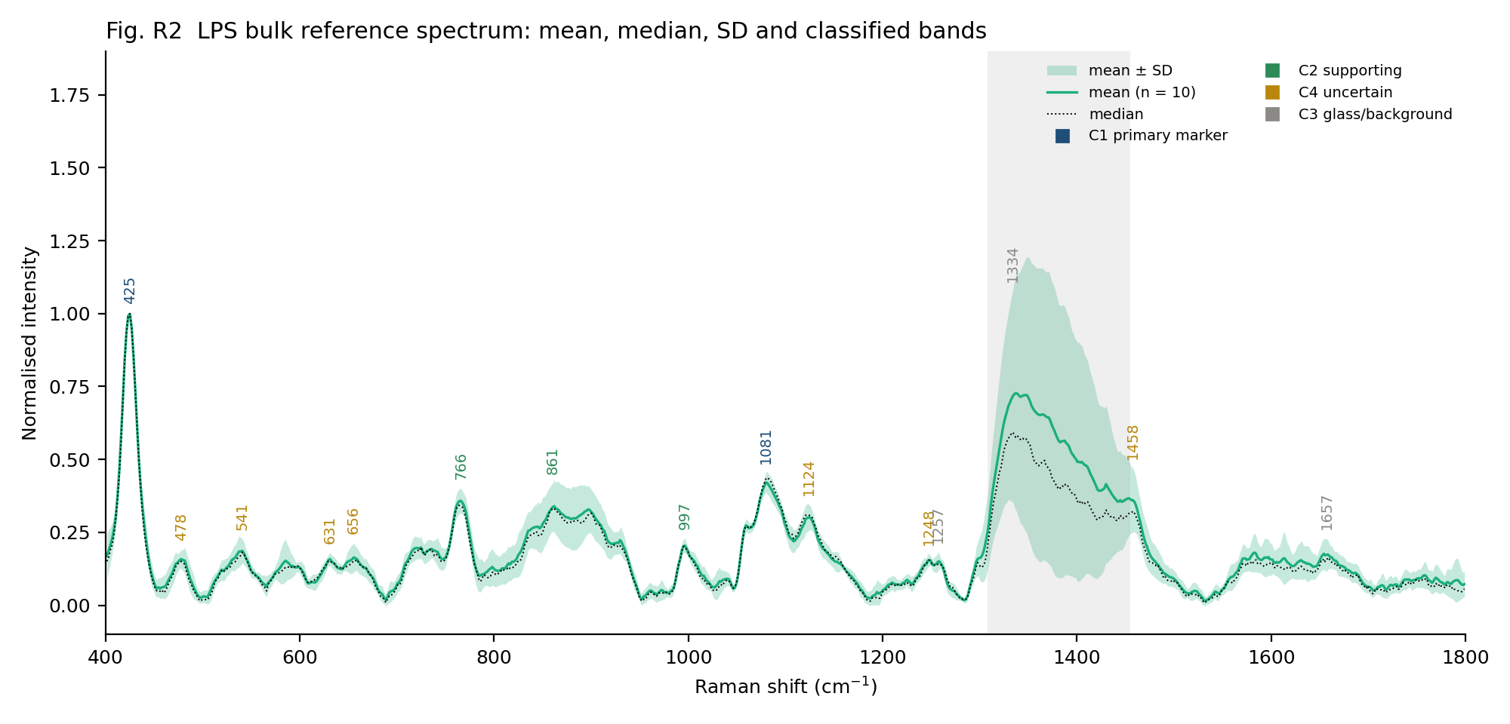
Figure 15C-1. LPS bulk reference: mean (n = 10), median, ± SD and classified bands.
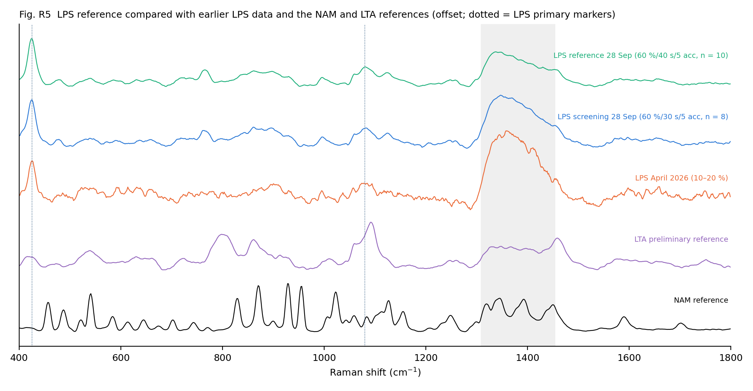
Figure 15C-2. LPS reference compared with earlier LPS data and the NAM and LTA references.
Full details: LPS_Bulk_Reference_Report_20260928.docx; workbook sheets 38–42; 03_Reference_Spectra/LPS.

16. Limitations
- No pure-compound normal-Raman literature spectrum of NAM, LTA or LPS was found; all assignments are tentative (NAM Low; LTA 1092 Moderate).
- NAM reference: 5 independent spots at the reference condition (30 May) plus 1 new clean spot (24 Sep); validation sets (70 % / 10 s, and 60/70/80 % / 30 s on 24 Sep) are at other conditions and confirm band positions and relative intensities, not the absolute reference intensity.
- Dark-reference drift during long sessions caused 20 of 41 spectra on 24 Sep to fail QC; a fresh dark before every spectrum is now required.
- LTA reference: n = 4 from one day; intensities depend strongly on the baseline settings because of fluorescence.
- Glass blanks from May (5 % / 5 s / 1 acc) are not matched to any sample. The 16 matched blanks from 24 Sep saturate across the glass band, so glass correction remains exploratory and bands inside 1308–1455 cm⁻¹ stay uncertain.
- SG 11/3 lowers narrow NAM band apices by ≈ 16 %; positions are unaffected. Absolute intensities are pipeline-specific.
- Objective and sample-plane power (mW) are not recorded.
- The v3 corrections changed intensities and SNR compared with earlier drafts (Section 5.8).

17. Library contents
Folder | Contents
01_Raw_Data_Renamed | Byte-identical renamed raw copies: NAM_Bulk 311, LTA_Bulk 12, LPS_Bulk 51, Glass_Blank 36, Instrument_Checks 7, Excluded 22
02_Processed_Spectra | One CSV per spectrum with every preprocessing stage as a column (pipeline v3)
03_Reference_Spectra | NAM (final; + NAM_Validation_20260924 files), LPS (established 28 Sep 2026) and LTA (preliminary): mean, median, SD, members, marker peaks
04_Figures | Fig01–Fig09 (workflow figures); NAM_Session_20260924/FigN1–N9; LPS_Session_20260928/FigP1–P4; LPS_Reference_20260928/FigR1–R5; v2.1 figures in _archive_v2.1
05_Tables | Spectral_Library_Metadata_and_Peaks.xlsx — Traceability_Table (central) plus sheets 1–42 (26–32: NAM session 24 Sep; 33–36: LPS screening; 37: NAM final status; 38–42: LPS reference)
06_Literature | Literature_Peak_Assignments.xlsx (evidence types, confidence), references, band lists
07_QC_and_Exclusions | QC log, exclusion list, 60 s re-audit, QC figures, processed excluded spectra
08_Methodology | Workflow, preprocessing, QC and peak-selection methodology; acquisition SOP; log template; analysis code

References
[L1] Wu X., Zhao Y., Zughaier S.M. Highly sensitive detection and differentiation of endotoxins derived from bacterial pathogens by surface-enhanced Raman scattering. Biosensors 2021, 11(7), 234. https://doi.org/10.3390/bios11070234 (SERS; Band table read from publisher page (MDPI))
[L2] Yang Y., Xu B., Haverstick J., Ibtehaz N., Muszyński A., Chen X., Chowdhury M.E.H., Zughaier S.M., Zhao Y. Differentiation and classification of bacterial endotoxins based on surface enhanced Raman scattering and advanced machine learning. Nanoscale 2022, 14(24), 8806–8817. https://doi.org/10.1039/d2nr01277d (SERS, 785 nm, Ag nanorod array; Read from publisher PDF (RSC); detailed assignments in their Table S6 (not accessed))
[L3] Saikia D., Tanan C.B., Dhananjaya G., Hungund B.S., Mahanta N., Singh S.P. Validating phosphoethanolamine modification as a potential spectral marker of colistin resistance. Analyst 2025, 150, 281–289. https://doi.org/10.1039/d4an01228c (Raman, 532 nm, whole bacterial cells; Read from publisher PDF (RSC))
[L4] Kumar A., Islam M.R., Zughaier S.M., Chen X., Zhao Y. Precision classification and quantitative analysis of bacteria biomarkers via surface-enhanced Raman spectroscopy and machine learning. Spectrochim. Acta A 2024, 320, 124627. https://doi.org/10.1016/j.saa.2024.124627 (SERS; Abstract only; LTA band positions not accessible)
[L5] Movasaghi Z., Rehman S., Rehman I.U. Raman spectroscopy of biological tissues. Appl. Spectrosc. Rev. 2007, 42(5), 493–541. https://doi.org/10.1080/05704920701551530 (Raman review; Citation verified (Crossref))
[L6] Wiercigroch E., Szafraniec E., Czamara K., Pacia M.Z., Majzner K., Kochan K., Kaczor A., Baranska M., Malek K. Raman and infrared spectroscopy of carbohydrates: a review. Spectrochim. Acta A 2017, 185, 317–335. https://doi.org/10.1016/j.saa.2017.05.045 (Raman/IR review; Citation verified (Crossref))
[L8] Grunert T., Jovanovic D., Sirisarn W., et al. Analysis of Staphylococcus aureus wall teichoic acid glycoepitopes by Fourier Transform Infrared Spectroscopy provides novel insights into the staphylococcal glycocode. Sci. Rep. 2018, 8, 1889. https://doi.org/10.1038/s41598-018-20222-6 (FTIR, intact S. aureus cells; Read from publisher page (Nature))
[L9] Zou B., Zhao X., Liao J., Zhao Y. Near-infrared activity analysis and identification of fungal and bacterial markers. Microchem. J. 2025, 208, 112552. https://doi.org/10.1016/j.microc.2024.112552 (NIR + DFT-calculated IR; Abstract/summary only; no Raman band positions reported)
[L7] Czamara K., Majzner K., Pacia M.Z., Kochan K., Kaczor A., Baranska M. Raman spectroscopy of lipids: a review. J. Raman Spectrosc. 2015, 46, 4–20. https://doi.org/10.1002/jrs.4607 (Raman review; Citation verified (Crossref))
[L10] Bansil R., Yannas I.V., Stanley H.E. Raman spectroscopy: a structural probe of glycosaminoglycans. Biochim. Biophys. Acta 1978, 541, 535–542. https://doi.org/10.1016/0304-4165(78)90163-0 (Normal Raman, pure polysaccharides; Citation verified (Crossref); full text not accessed – band values not extracted)
[L11] Study of N-acetylamino saccharides with synchrotron-based ultraviolet resonance Raman spectroscopy: in combination with ATR far-ultraviolet spectroscopy. J. Phys. Chem. Lett. 2025, 16(7), 1769–. https://doi.org/10.1021/acs.jpclett.4c03435 (UV resonance Raman (not 785 nm normal Raman); Identified via Crossref/ACS; full text not accessible (403) – not used for assignments)
Method references: Savitzky A., Golay M.J.E. Anal. Chem. 1964, 36, 1627–1639 (smoothing). Eilers P.H.C., Boelens H.F.M. Baseline correction with asymmetric least squares smoothing, 2005 (ALS). Whitaker D.A., Hayes K. Chemometr. Intell. Lab. Syst. 2018, 179, 82–84 (modified-z spike detection). Iglewicz B., Hoaglin D.C. How to Detect and Handle Outliers, 1993 (modified z-score, 0.6745 constant).

