Molecular Simulation of N-acetylmuramic acid (NAM)
Calculated Raman spectrum and assignment of the main vibrations

1. Executive summary
A computer calculation of the Raman spectrum of the whole N-acetylmuramic acid molecule in its beta form (39 atoms: C₁₁H₁₉NO₈) was carried out to predict which Raman peaks this structure should give and which part of the molecule each peak comes from. The calculation gives 67 vibrations between 400 and 1800 cm⁻¹. Its main product is a list of calculated peak positions with the atoms that move in each, which lets the measured peaks be assigned to groups such as the phosphate, the sugar ring or the ester carbonyl. The calculation reproduces peak positions more reliably than peak heights.

2. Objective
Raman peaks depend on how the atoms of a molecule vibrate. The experimental spectrum of N-acetylmuramic acid (NAM) shows several reproducible peaks but their origin is not documented in the literature for the pure compound. The simulation was run to predict the Raman spectrum from the molecular structure, so that measured peaks can be linked to specific vibrations and the identification of the molecule is supported by an independent line of evidence.

3. Molecular model and approach
Model: the whole N-acetylmuramic acid molecule in its beta form (39 atoms: C₁₁H₁₉NO₈). Method: density functional theory (B3LYP with dispersion correction) with a large basis set (6-311++G(d,p)), for the isolated molecule. In plain terms, the computer first finds the lowest-energy shape of the molecule, then calculates how each group of atoms vibrates and how strongly each vibration would scatter laser light. A calculated spectrum is therefore a prediction of the Raman signals expected from the structure.
Table 1. Calculations carried out and the one used.
Step | What was calculated | Outcome
1 | Early runs at smaller basis sets (6-311+G(d,p) and 6-31+G(d,p)) | Showed the workflow worked; not used for comparison
2 | Final calculation at the large basis set with tight geometry optimisation | Used for all comparisons: 111 vibrations, none unstable, 67 between 400 and 1800 cm⁻¹
3 | Alpha form of the molecule calculated at the same level | Tested as a possible explanation for unmatched peaks and did not explain them

3.1 Why the final calculation is suitable
NAM is small enough (39 atoms) for a high-level calculation of the whole molecule. A larger basis set and a dispersion correction describe the hydrogen-bonded sugar ring more reliably, and the optimised structure is a true energy minimum, so every calculated vibration is real.

3.2 From vibrations to a spectrum
Calculated frequencies from this kind of calculation are slightly too high, so they were multiplied by 0.98 below 1800 cm⁻¹ and 0.967 above. Each vibration was drawn as a Lorentzian peak 10 cm⁻¹ wide. The nature of each vibration (for example phosphate stretch, ring deformation or CH bending) was assigned by measuring which atoms move most in it; these labels are tentative.

4. Results

4.1 Molecular structure
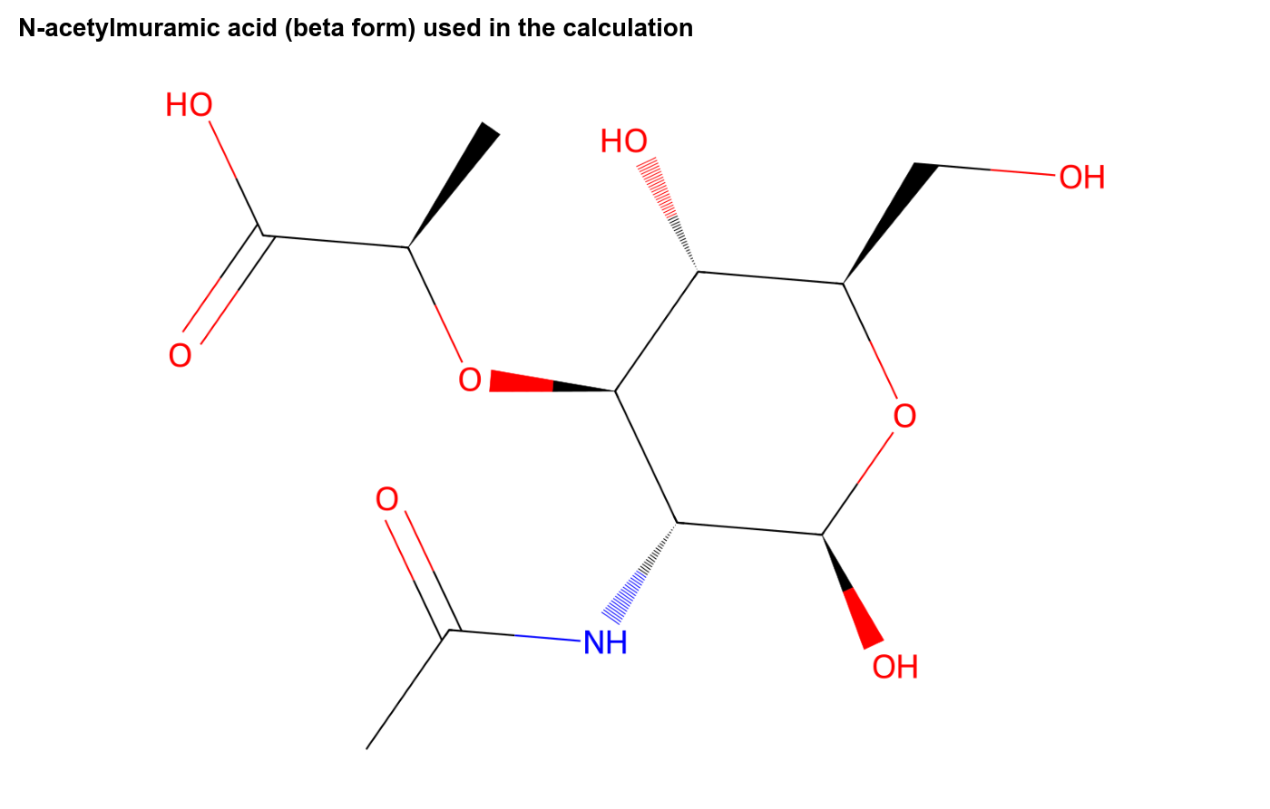
Figure 1. Structure of the model that was calculated.

4.2 Calculated Raman spectrum
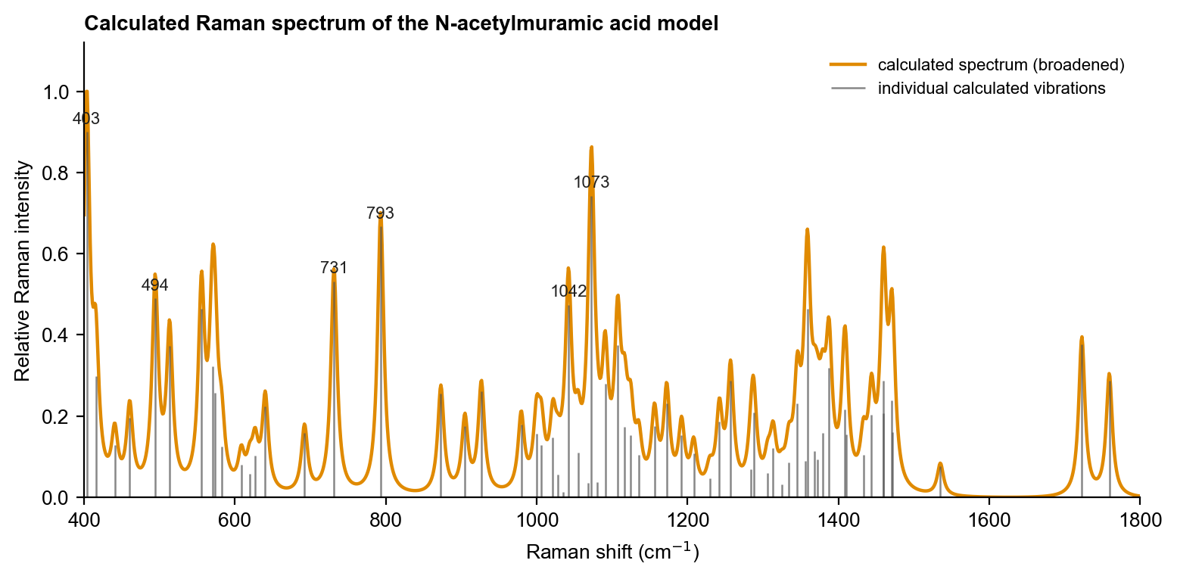
Figure 2. Calculated Raman spectrum. Orange curve: all vibrations broadened to peaks; grey lines: the individual calculated vibrations (heights are relative Raman intensities); numbers: the six strongest.

4.3 Important calculated peaks and their assignment
Table 2. The eight strongest calculated vibrations between 400 and 1800 cm⁻¹ (intensity 1.0 = strongest).
Calculated peak (cm⁻¹) | Type of vibration | Relative intensity | Counterpart in the measured spectrum
403 | skeletal / ring deformation | 1.00 | not seen as a distinct peak
494 | skeletal / ring deformation | 0.54 | yes (487)
556 | skeletal / ring deformation | 0.52 | yes (541)
731 | C-O and C-C stretching (backbone) | 0.59 | not seen as a distinct peak
793 | C-O and C-C stretching (backbone) | 0.74 | not seen as a distinct peak
1042 | C-O and C-C stretching (backbone) | 0.53 | not seen as a distinct peak
1073 | C-O and C-C stretching (backbone) | 0.82 | not seen as a distinct peak
1359 | C-H / O-H bending (CH2, CH3) | 0.52 | not seen as a distinct peak

The strongest calculated peaks are not always the strongest measured peaks; Raman intensities from small calculations are only a rough guide. The comparison report matches calculated peaks to measured ones by position and by type of vibration.

4.4 Assignment of the peaks seen in the measurement
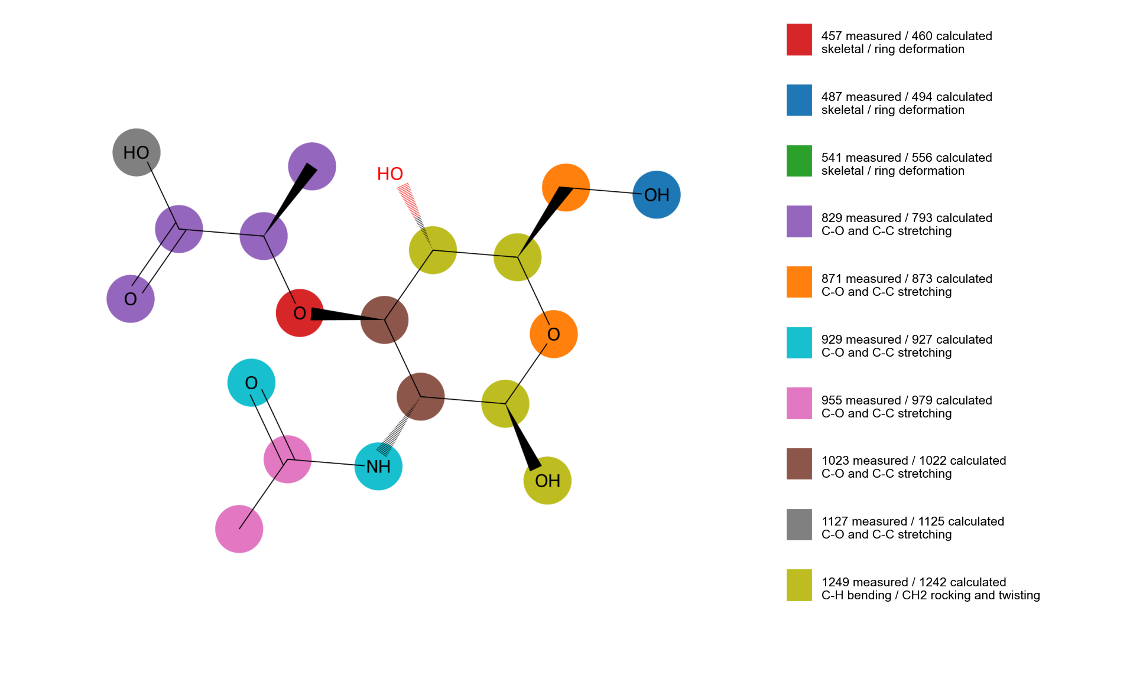
Figure 3. Atoms that move most in the calculated vibrations that correspond to measured peaks. Each colour is one vibration (key at right); the highlighted atoms carry most of the motion. Hydrogen atoms are assigned to the atom they are bonded to.
Table 3. Calculated vibrations matched to measured peaks. 'Confident' means the calculated peak lies within 10 cm⁻¹ of the measured peak and has the expected type of motion; 'tentative' means larger offset (see the comparison report).
Calculated (cm⁻¹) | Matching measured (cm⁻¹) | Assignment (type of vibration) | Confidence
460 | 457 | skeletal / ring deformation | confident
494 | 487 | skeletal / ring deformation | confident
556 | 541 | skeletal / ring deformation | tentative
793 | 829 | C-O and C-C stretching (backbone) | tentative
873 | 871 | C-O and C-C stretching (backbone) | confident
927 | 929 | C-O and C-C stretching (backbone) | confident
979 | 955 | C-O and C-C stretching (backbone) | tentative
1022 | 1023 | C-O and C-C stretching (backbone) | confident
1125 | 1127 | C-O and C-C stretching (backbone) | confident
1242 | 1249 | C-H bending / CH2 rocking and twisting | confident

5. Interpretation and limitations
The calculation supports the assignment of the measured peaks to the vibration types listed above and shows which groups of the molecule are responsible. It does not by itself prove the identity of the sample.
- The calculation is for one isolated molecule in its beta form; the sample is a mixture of alpha and beta forms and is a crystalline powder, where molecules hydrogen-bond to each other.
- Calculated intensities (how strong each peak should be) are less reliable than calculated positions.
- Only the beta form is used in the comparison; the alpha form lies about 3.6 kcal/mol higher in electronic energy for the isolated molecule.

6. Conclusion and next step
The calculation gives a usable prediction of the positions and types of the Raman vibrations of N-acetylmuramic acid (NAM) between 400 and 1800 cm⁻¹ and is the simulation used in the comparison with the measured spectrum. Next step: Calculate the alpha and beta forms together and combine them in proportion to their expected populations, and model a small cluster of NAM molecules to capture hydrogen bonding in the powder.

